CSS Design Decision Card — Visual Guide Edition
Run top → bottom. Every step includes a visual guide. Fix ONE category at a time. If lost, restart at Step 1.

CSS Design Decision Card — Visual Guide Edition
Use this together with the detailed card.
Read the step → look at the visual → apply.

STEP 1 — Reading Width (Why max-width matters)
What you’re fixing visually:
Eyes getting tired → hard to track long lines.
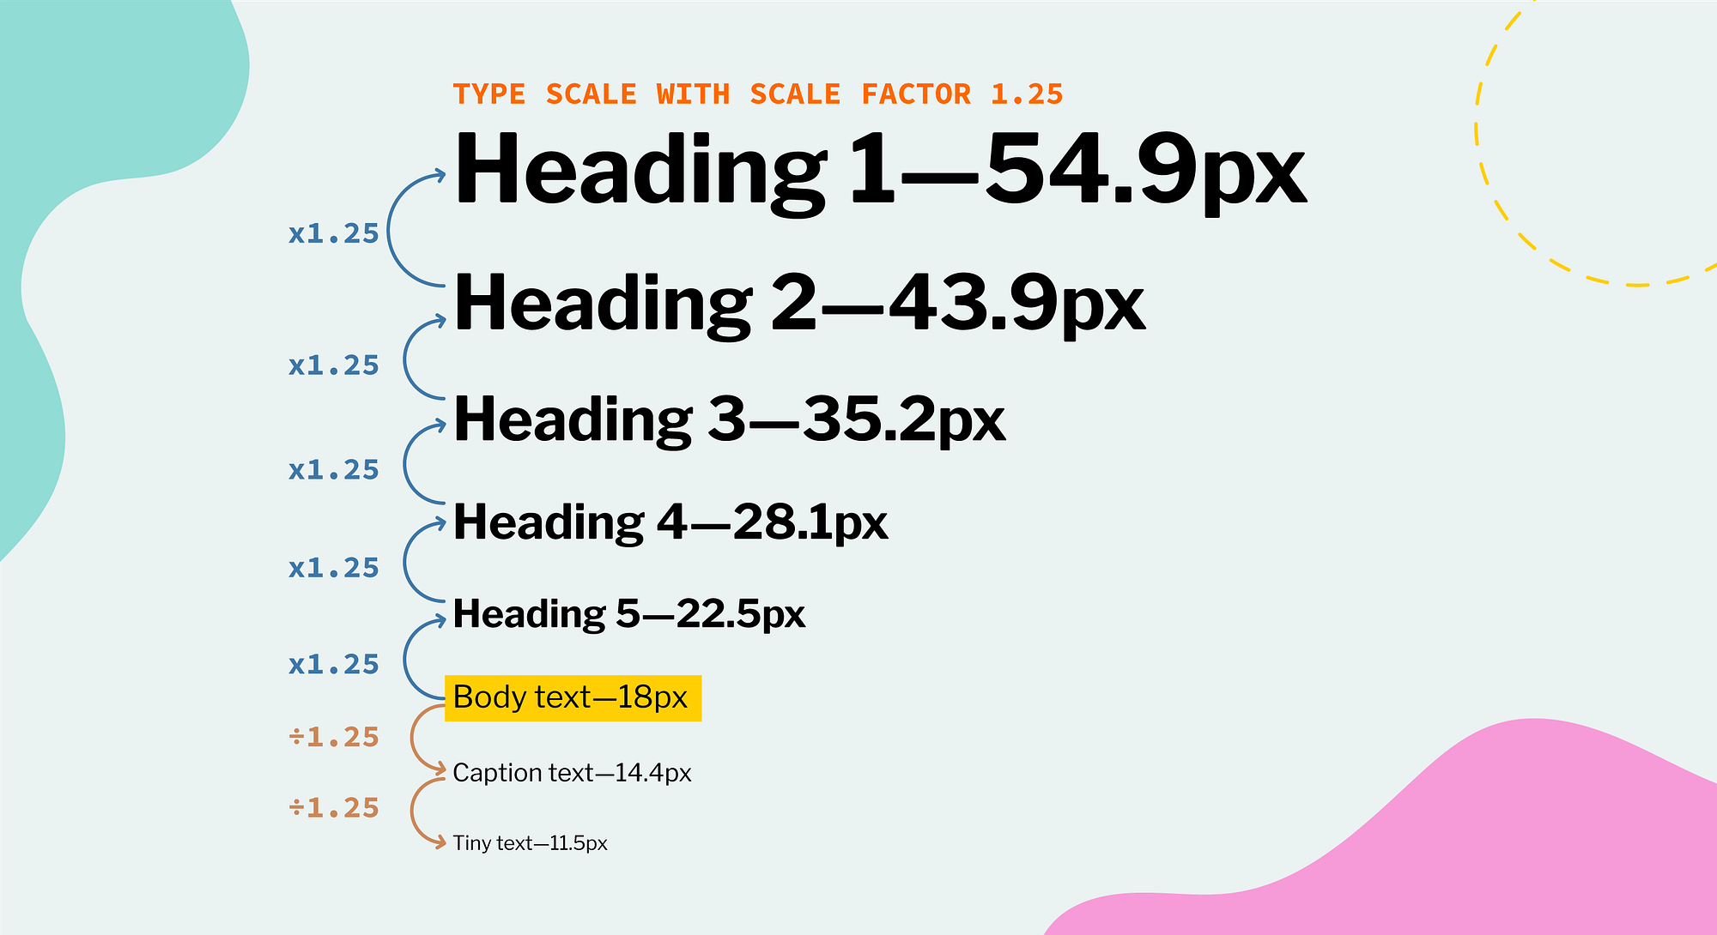
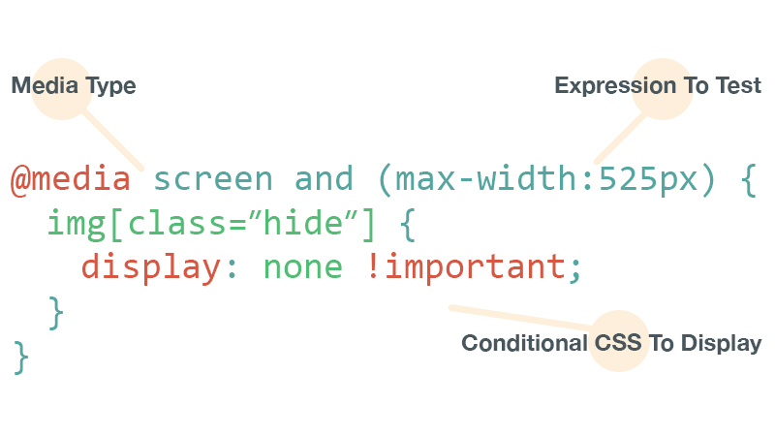
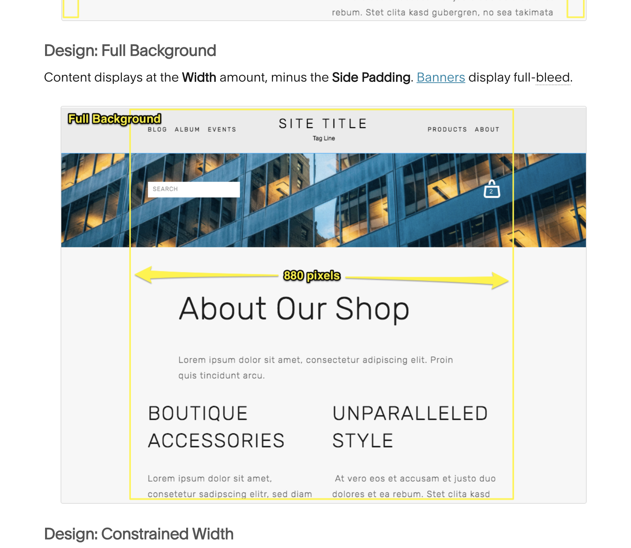
What to notice in the images:
- Full-width text feels overwhelming
- Constrained text feels calm and readable
- The design already looks “professional” with zero styling
Mental shortcut:
If text looks like a newspaper column → good
If it looks like a spreadsheet → bad

STEP 2 — Vertical Spacing (The #1 fix)
What you’re fixing visually:
Cramped or chaotic layouts.
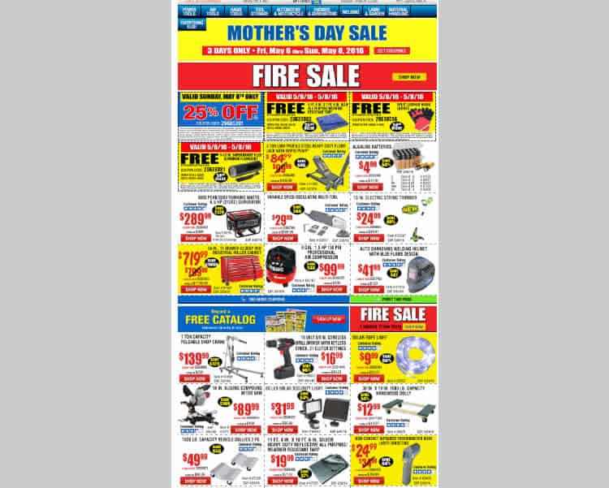

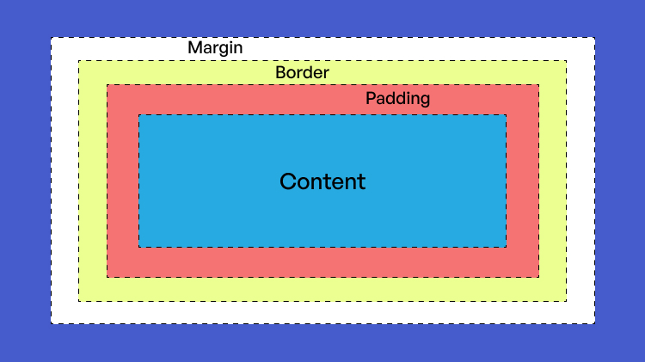
What to notice:
- Good examples repeat the same gaps
- Bad examples use random spacing
- White space makes content feel intentional, not empty
Mental shortcut:
When in doubt, add space, not decoration

STEP 3 — Grouping (Proximity = meaning)
What you’re fixing visually:
Not knowing what belongs together.
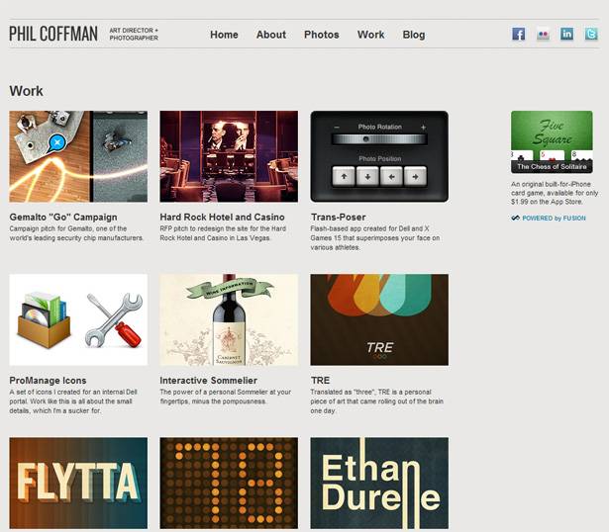

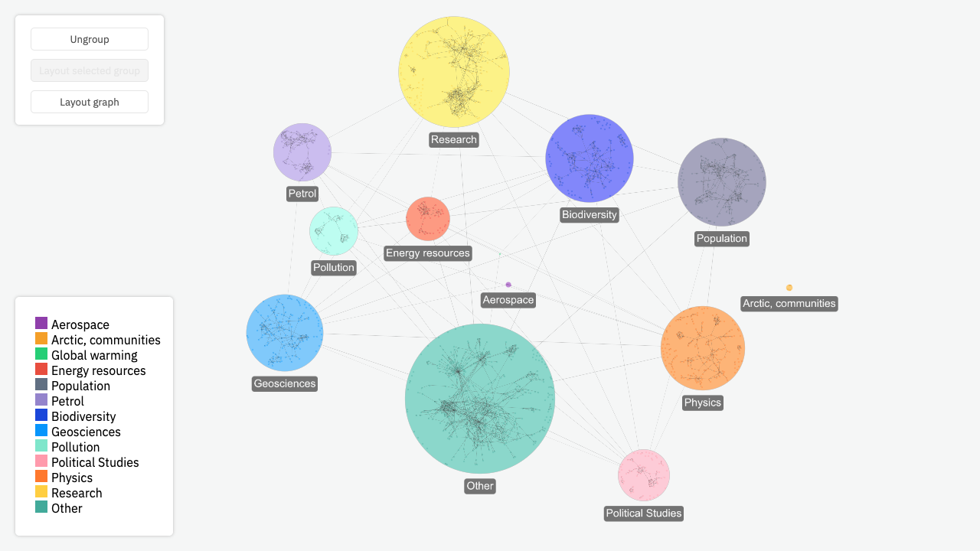
What to notice:
- Related items sit closer
- Sections are separated by larger gaps
- No borders needed — space does the job
Mental shortcut:
Space is how the page “explains itself”

STEP 4 — Hierarchy (What matters first?)
What you’re fixing visually:
Everything feels equally important.
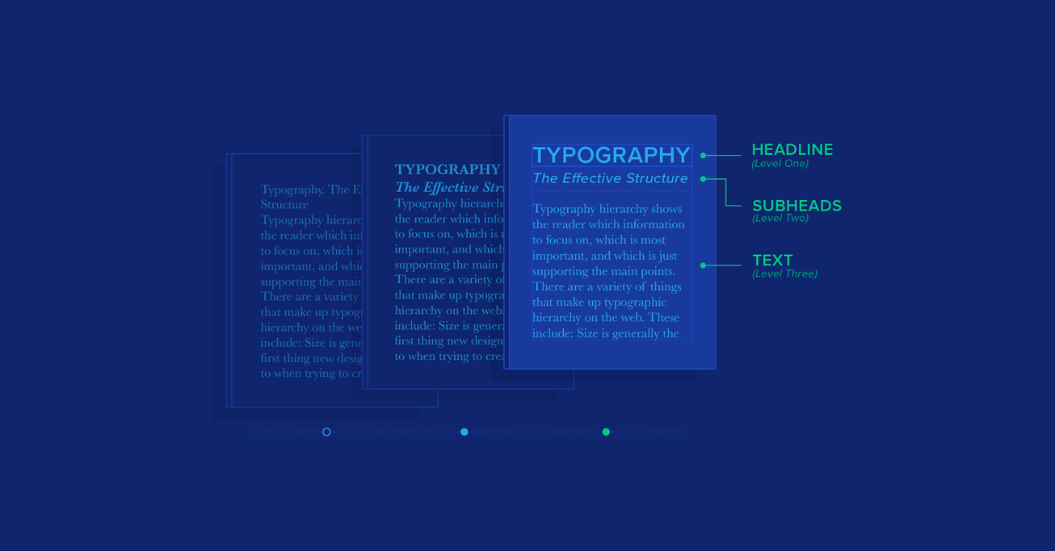
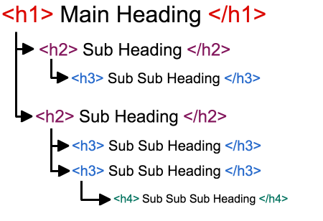
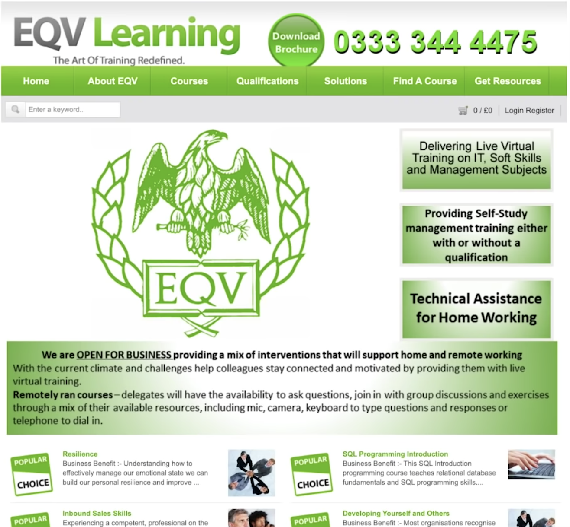
What to notice:
- You can scan headings instantly
- Headings have space above them
- Size + space do most of the work (not color)
Mental shortcut:
If I squint, can I still tell what’s important?

STEP 5 — Alignment (Binary: right or wrong)
What you’re fixing visually:
Layouts that feel “off” or amateur.

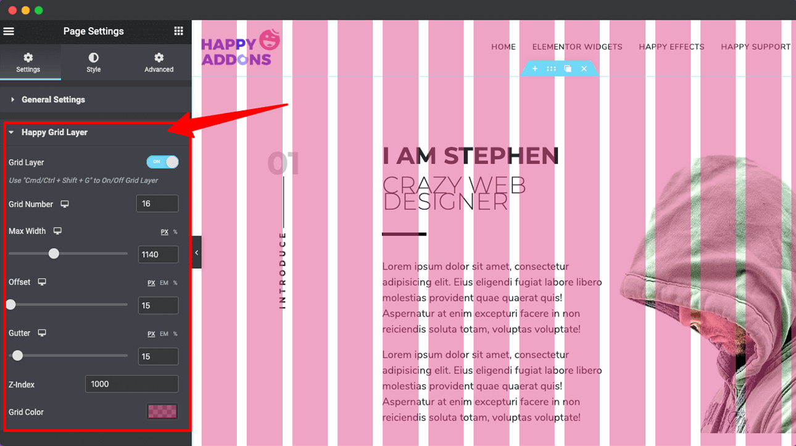
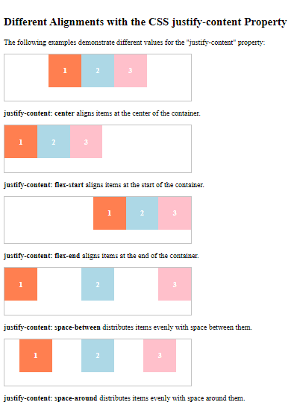
What to notice:
- Clean edges feel calm
- Misalignment creates visual anxiety
- Alignment communicates competence
Mental shortcut:
Alignment isn’t style — it’s hygiene

STEP 6 — Remove Before Adding (Subtraction)
What you’re fixing visually:
Overdesigned, noisy pages.
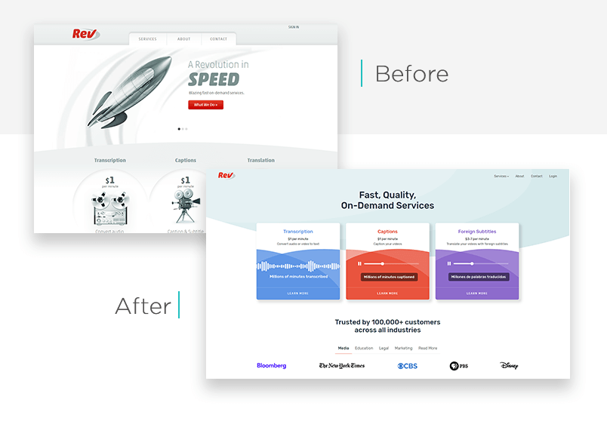
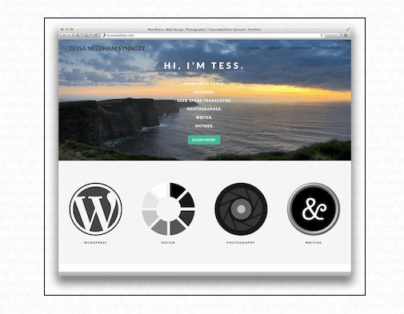

What to notice:
- Cleaner versions feel more confident
- Borders, shadows, and colors are often unnecessary
- The design improves by removing things
Mental shortcut:
If it still works without it, delete it

STEP 7 — Color (Always last)
What you’re fixing visually:
Using color as a crutch.
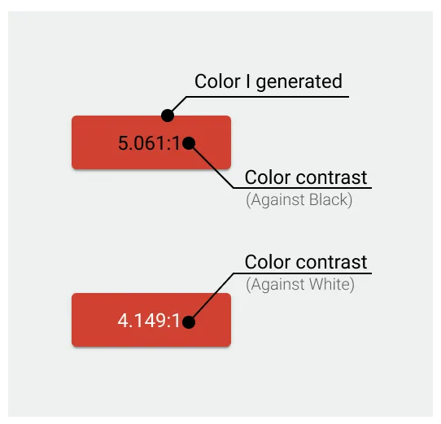
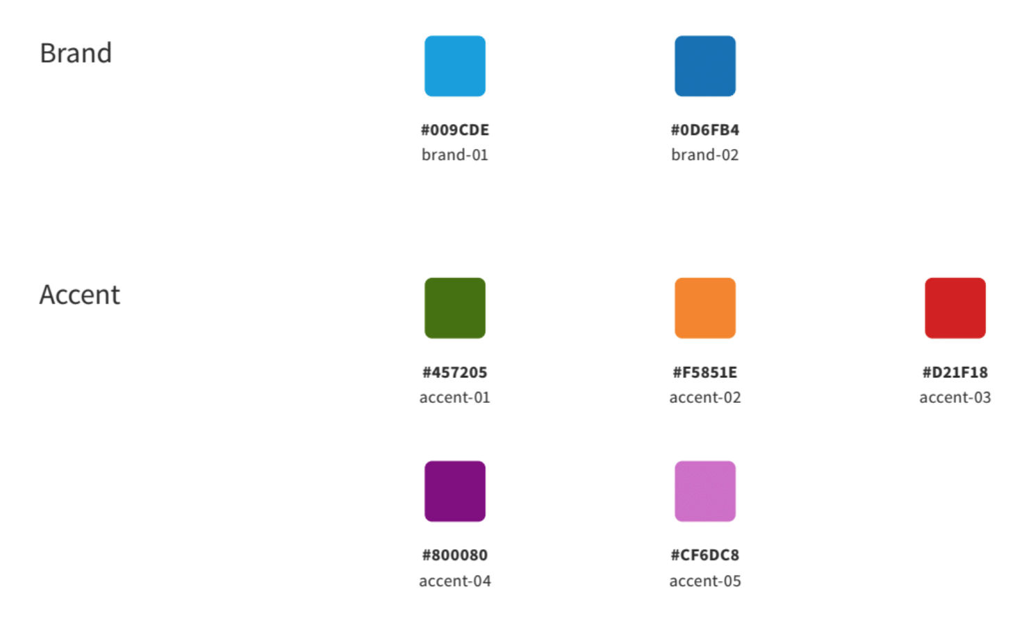
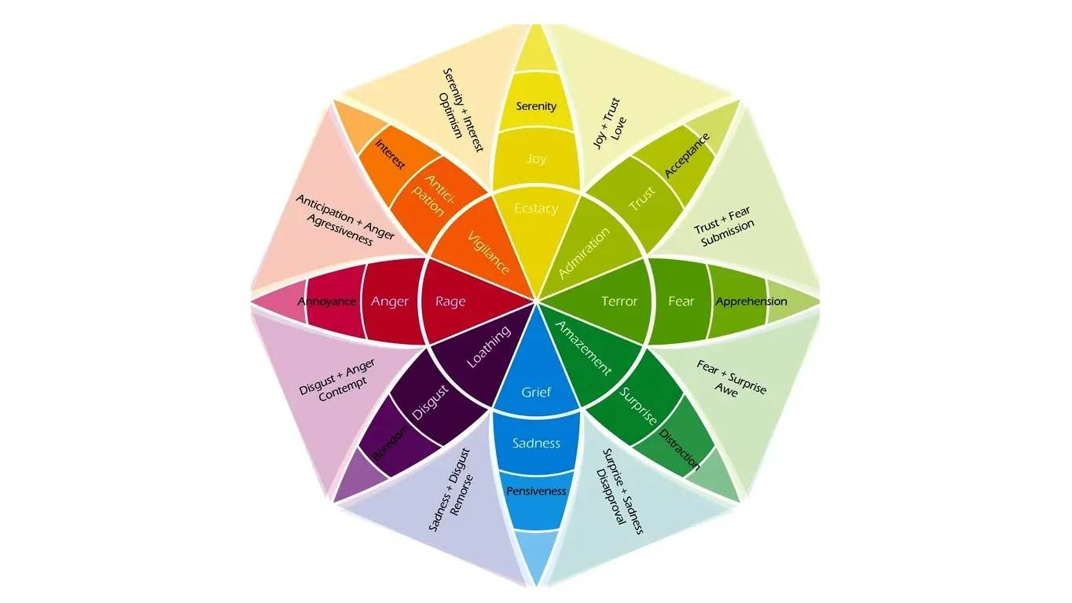
What to notice:
- Good designs work in grayscale
- One accent color is enough
- Color highlights existing structure — it doesn’t create it
Mental shortcut:
Color is seasoning, not the meal

STEP 8 — Final Checks (Stop styling)
What you’re verifying visually:
That you’re done.
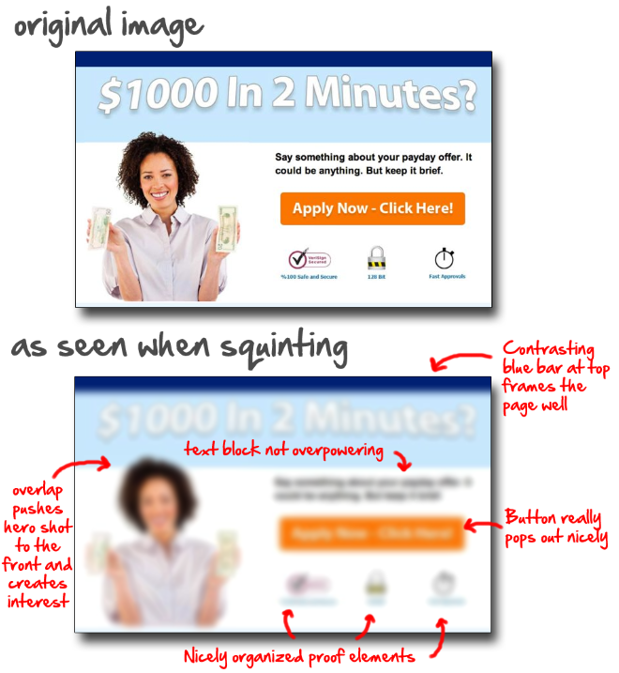
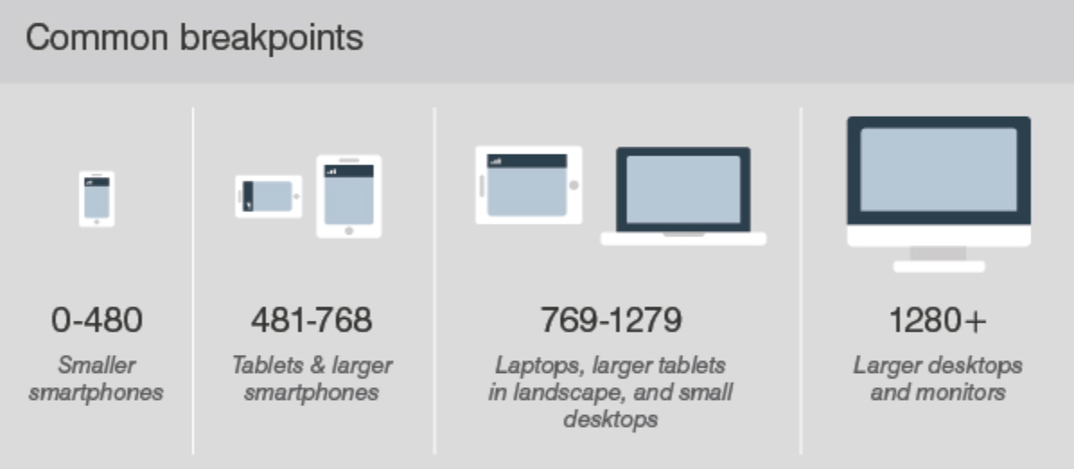
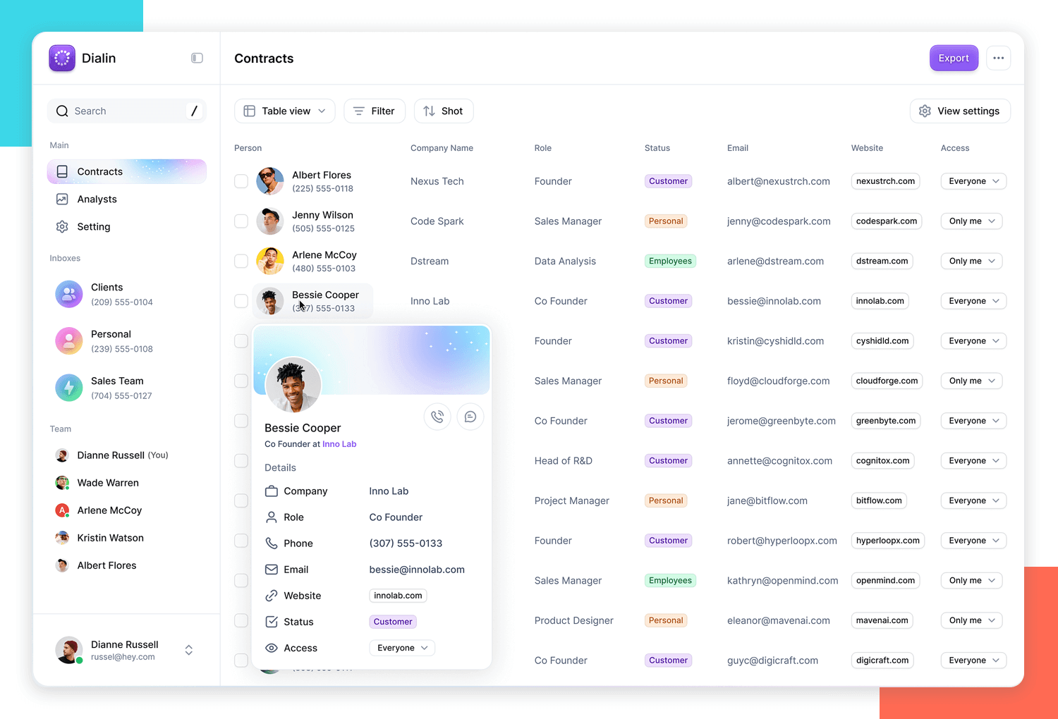
What to notice:
- Structure survives zooming out
- Layout still works on narrow widths
- Nothing feels accidental
Mental shortcut:
If changes are tiny and pointless — stop

How to use this in practice (important)
When styling:
- Keep the Decision Card PDF open
- Keep this visual guide in mind
- Fix one step only
- Stop when the step’s visual goal is met
This prevents:
- random tweaking
- over-styling
- design paralysis

