Pembelajaran Mesin

( Praktikum )

TI -C4

Fakultas Vokasi

Universitas Airlangga

[152111283042] | [NELA ANJANI P P A] | [05 November 2023]

**TUGAS INDIVIDU DATA IRIS SVM**

1. menampilkan data iris

import numpy as np

import pandas as pd

from sklearn import datasets

from sklearn.metrics import confusion_matrix

from sklearn.metrics import accuracy_score

from sklearn.model_selection import train_test_split, cross_val_score

from sklearn.svm import SVC

df = pd.read_csv('IRIS.csv')

print(" Data Awal ".center(100, "="))

print(df)

print("============================================================")

# Separate features (x) and target (y)

X = df.drop(columns=['sepal_length','sepal_width','petal_length','petal_width'])

print(X)

y = df['species']

print(y)

Hasil

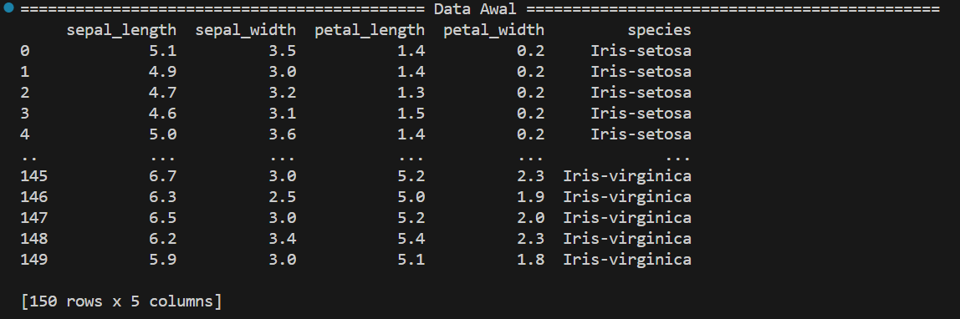

1. grouping variable

print("GROUPING VARIABEL".center(100, "="))

X=df.iloc[:,0:4].values

y=df.iloc[:,4].values

print("data variabel".center(75,"="))

print(X)

print("data kelas".center(75,"="))

print(y)

Hasil

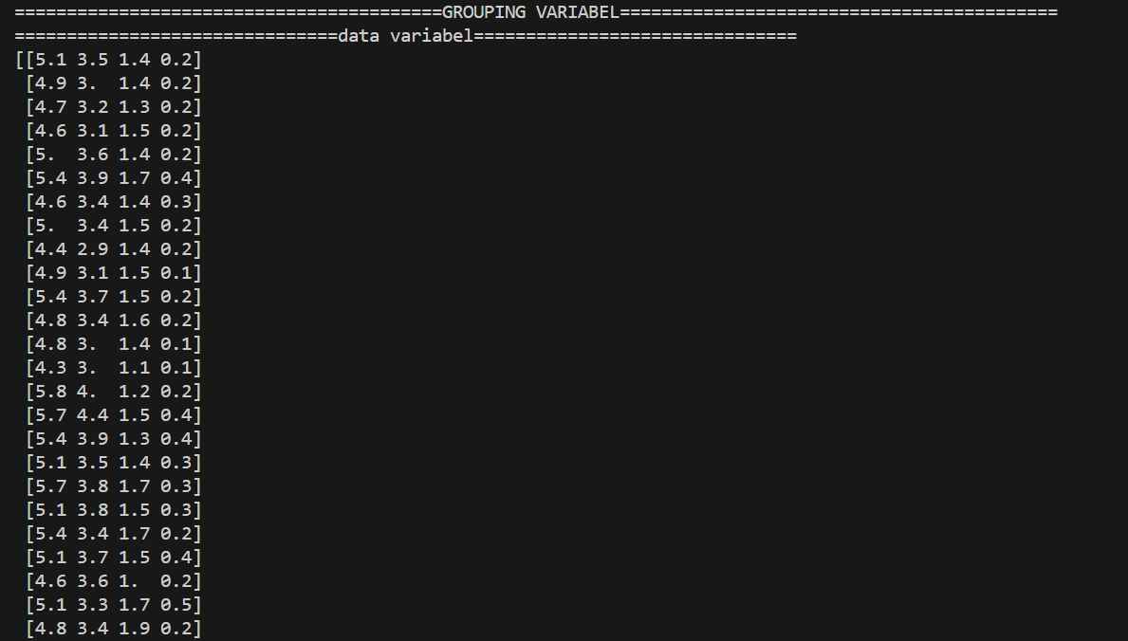

1. membagi data training dan testing

# Split data into training and testing

x_train, x_test, y_train, y_test = train_test_split(X, y, test_size=0.30, random_state=100)

print("Instance variabel data training".center(75, "="))

print(x_train)

print("Instance kelas data training".center(75, "="))

print(y_train)

print("Instance variabel data testing".center(75, "="))

print(x_test)

print("Instance kelas data testing".center(75, "="))

print(y_test)

print("============================================================")

print()

Hasil

1. Variable data training

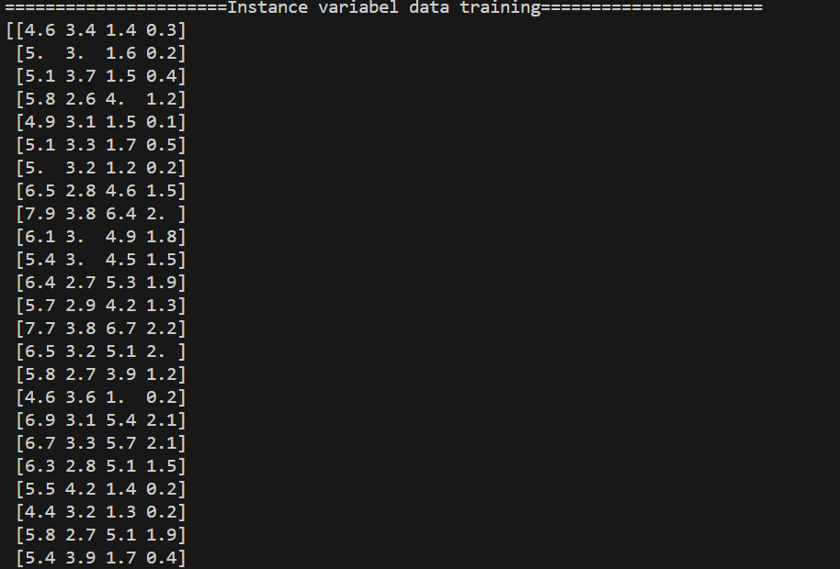

1. Instance kelas data training

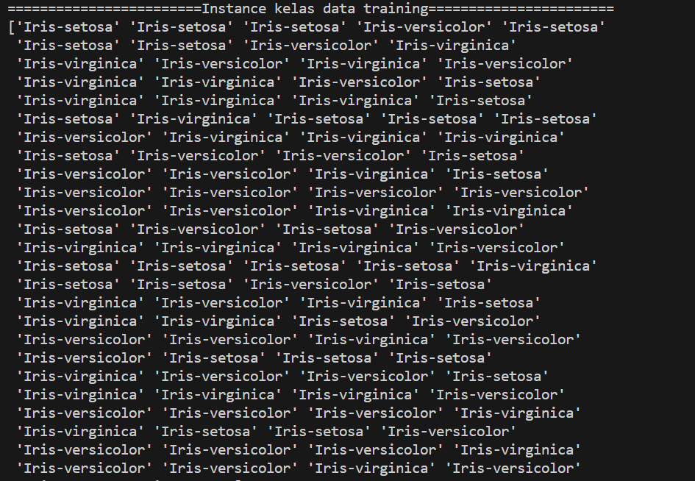

1. Variable data testing

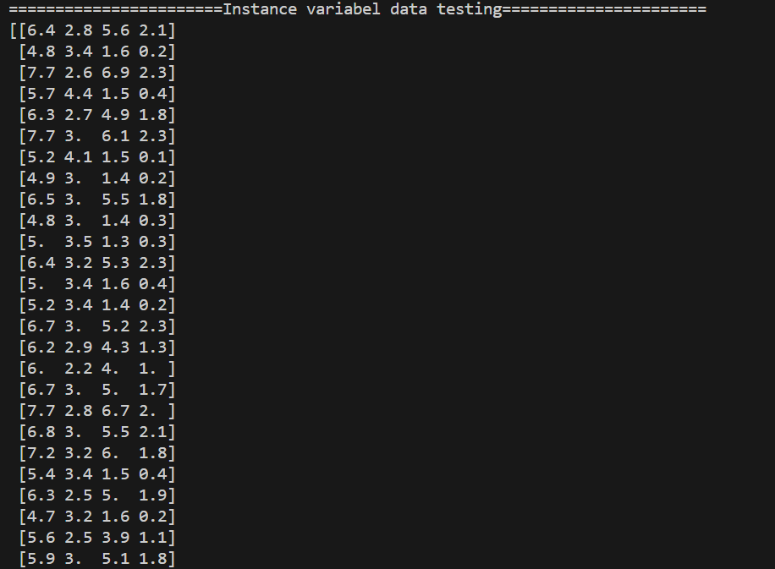

1. Instance kelas data testing

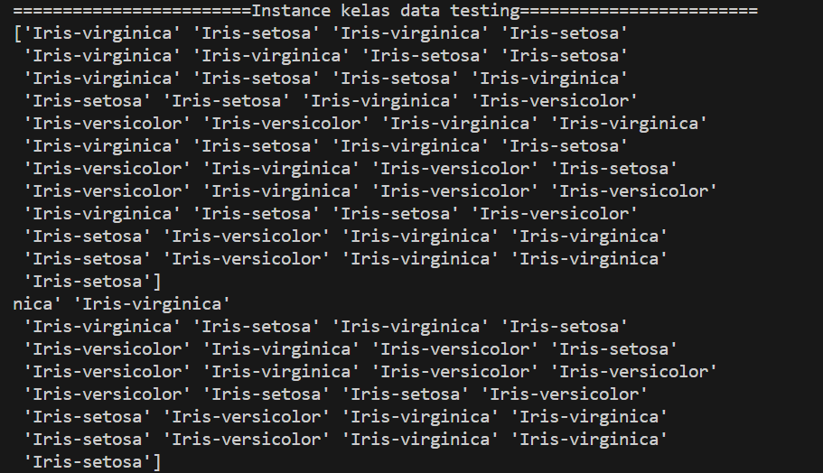

1. Hasil confusion Matrix

#Pemodelan SVM

model = SVC()

model.fit(x_train, y_train)

y_pred = model.predict(x_test)

print("hasil prediksi SVM")

print(y_pred)

#Evaluasi Confusion Matrix dan Evaluasi Akurasi Python

print("Hasil Confusion Matrix")

print(confusion_matrix(y_test, y_pred))

print("Hasil Akurasi Pemodelan SVM : ", accuracy_score(y_test, y_pred))

Hasil

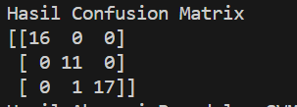

1. Hasil Akurasi pemodelan SVM

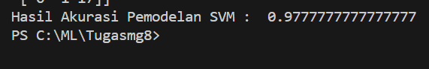

**TUGAS KELOMPOK LANJUTAN UTS SVM DAN NN**

1. menampilkan data awal

import pandas as pd

from sklearn.metrics import confusion_matrix

from sklearn.metrics import accuracy_score

from sklearn.model_selection import train_test_split

from sklearn.svm import SVC

from sklearn.neural_network import MLPClassifier

# Import MLPClassifier from scikit-learn

# Load data from Excel file

df = pd.read_csv('lung_cancer_examples.csv')

print(" Data Awal ".center(100, "="))

print(df)

print("============================================================")

# Separate features (x) and target (y)

x = df.drop(columns=['Name','Surname','Age','Smokes','AreaQ','Alkhol',])

y = df['Result']

Hasil

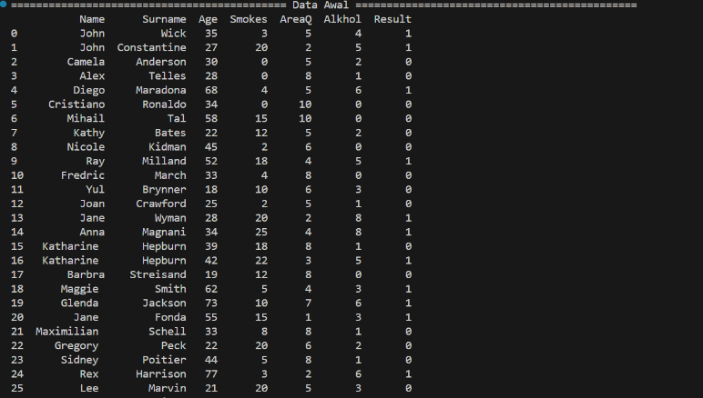

1. Grouping 2 variable

# Grouping yang dibagi menjadi dua

print("GROUPING VARIABEL".center(100, "="))

X=df.iloc[:,0:6].values

y=df.iloc[:,6].values

print("data variabel".center(75,"="))

print(X)

print("data kelas".center(75,"="))

print(y)

Hasil

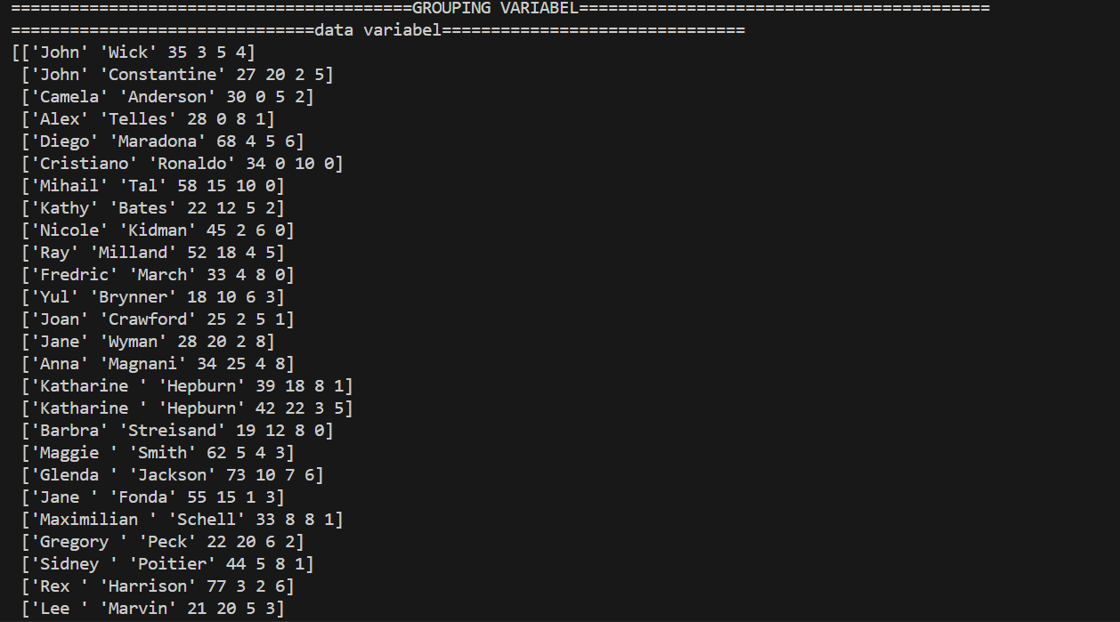

1. Pembagian data training dan testing

# Split data into training and testing

x_train, x_test, y_train, y_test = train_test_split(x, y, test_size=0.30, random_state=100)

print("Instance variabel data training".center(75, "="))

print(x_train)

print("Instance kelas data training".center(75, "="))

print(y_train)

print("Instance variabel data testing".center(75, "="))

print(x_test)

print("Instance kelas data testing".center(75, "="))

print(y_test)

print("=====================================================")

print()

Hasil

1. Variable data training

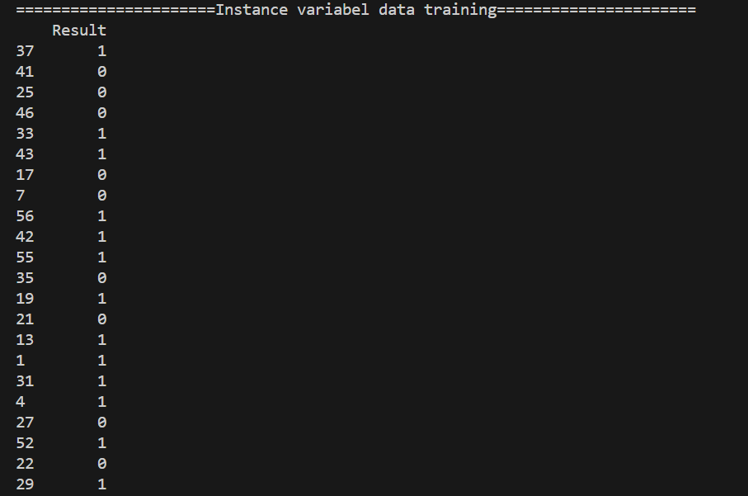

1. Kelas data training



1. Variable data testing

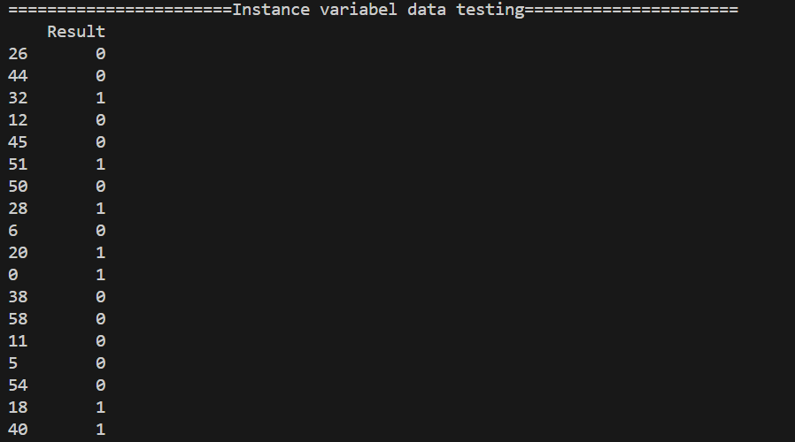

1. Kelas data testing



1. Cofusion Matrix SVM

# Evaluasi confusion matrix dan evaluasi akurasi SVM

print("Hasil confusion matrix SVM".center(75, "="))

print(confusion_matrix(y_test, y_pred_svm))

print("Hasil akurasi pemodelan SVM:", accuracy_score(y_test, y_pred_svm))

print("====================================================")

print()

Hasil



1. Hasil prediksi SVM dan Akurasi

# Pemodelan SVM

svm_model = SVC()

svm_model.fit(x_train, y_train)

y_pred_svm = svm_model.predict(x_test)

print("Hasil prediksi SVM".center(75, "="))

print(y_pred_svm)

print("======================================================")

print()

Hasil





1. Cofusion Matrix NN

# Evaluasi confusion matrix dan evaluasi akurasi Neural Network

print("Hasil confusion matrix Neural Network".center(75, "="))

print(confusion_matrix(y_test, y_pred_nn))

print("Hasil akurasi pemodelan Neural Network:", accuracy_score(y_test, y_pred_nn))

print("======================================================")

print()

Hasil



1. Hasil prediksi NN dan Akurasi

# Pemodelan Neural Network (Multilayer Perceptron)

nn_model = MLPClassifier(hidden_layer_sizes=(100, 50), max_iter=1000, random_state=100)  # Adjust the parameters as needed

nn_model.fit(x_train, y_train)

y_pred_nn = nn_model.predict(x_test)

print("Hasil prediksi Neural Network".center(75, "="))

print(y_pred_nn)

print("=====================================================")

print()

Hasil

