**Understanding Nighttime Surveillance Camera Coverage in New York City**

Nada Elgamal

Department of Geography, Hunter College, 695 Park Ave, New York, NY, 10065

July 25, 2018

**Abstract:** Camera surveillance of public spaces in New York City continues to become denser with ongoing urban and political developments. While its widespread use might instill the public with sentiments of security, it is also common to have some level of distrust towards the extent of their operability. Ideally, a fully operational camera is able to produce good quality images during the darkest hours of day. This article makes use of the near infrared feature of night-vision cameras to detect the quality of their field of view, thus revealing a more realistic basis to perceiving privacy or protection. Actual area coverage of CCTV, or lack thereof, can be compared with social, economic, and political factors in future studies as well as determining decisions towards educated actions in present practices.

**Keywords:** Camera, CCTV, Near Infrared, NYC, Surveillance

**Introduction**

The past few decades have seen an alarming rise in surveillance in general, raising debates on the efficacy of security at the expense of privacy. Closed Circuit Television (CCTV) in public spaces has become criminology’s model organism for exploring its effects on public perception and the deterrence of terrorism, crime, or minor incivilities. However, it remains questionable whether or not it is successful in eliminating unfavorable behavior or the fear of its encounter (Gill & Spriggs, 2005; Flight, Heerwaarden & Soomeren, 2003).

One study suggested that it was only effective in parking lots, but not so much in city centers or public housing, adding that lighting and good camera placement highly contribute to their efficacy (Farrington et al., 2007). Another found that CCTV displaced different types of crime disproportionately, where some crimes such as bike thefts, decreased and others, such as mugging and burglary, showed no change or slight increase, but in general, CCTV areas observed about 23% net reduction in incidents (Flight, Heerwaarden & Soomeren, 2003). Although crime prevention is not empirically established, the investigative applications of CCTV were highlighted for increasing the likelihood of cases being solved (Ashby, 2017). Interviews with convicted prisoners on their opinions regarding CCTV concluded that those who had been negatively impacted by cameras in the past, given their awareness of its role, were more likely to factor it into their judgement in the future (Gill & Loveday, 2003). Understandably, the effectiveness of deterrence results from the perception of punishment. Exploring this further, researchers reported the most successful examples of crime reduction were those in areas actively surveilled by officers who reported offenders to nearby patrol cars (Piza, Caplan & Kennedy, 2014). Generally, there is a consensus of importance placed on the availability of usable, good quality footage either through proper area coverage, image quality, or surrounding light conditions (Gill & Spriggs, 2005; Ashby, 2017).

On the other hand, a notable portion of the law-abiding public feel threatened by what they perceive as an intrusive violation to their rights of privacy and psychological well-being, who argue that surveillance is used to profile and target individuals or groups. This is no longer a matter of appearance or skin color, but recently about more sophisticated sensors that are able to record information on body temperature and predict behaviors, the use of which has undoubtedly further increased risks of losing the public’s trust if not properly employed (Sutrop & Laas‐Mikko, 2012). Yet widespread use of artificial intelligence software, such as facial recognition, that is accessible to almost anyone, can process stored images from a camera to identify individuals.

Regardless of surveillance’s success or the different opinions surrounding it, the scope and extent of its prevalence is unknown. Data previously collected on CCTV cameras had been of their angle, mobility, location, or type, all under the common assumption that they are all fully functioning at all times. Yet, clearly, the presence of a camera is not indicative of its ability to capture good footage in an area it appears to be covering, or that it is even truly covering the area in question at all. Furthermore, recording good quality surveillance images during night hours presents more of a challenge than the daytime, but it is also when a sense of safety is most necessary.

Many of the cameras in public spaces are now equipped with near-infrared (NIR) light emitting diodes (LEDs) which allow them to see in the dark but are invisible to the human eye. A digital camera was modified by removing the infrared filter behind the lens such that wavelengths of visible light and NIR are detected in an image. This camera is able to detect the light emitted by the CCTV LEDs as well as the illuminated area, or in other words, where the highest quality images can be captured at night. The work in this article is not meant to advocate for any one side of the debate, the sole intent is to produce knowledge that is more representative of reality by using a homemade tool to shed some light on the actual extent of nighttime surveillance as opposed to the assumed existing one.

**Past Works**

Many have taken it into their own hands to know and share the knowledge of where one might be watched in public. In 1996, a theatre group called the Surveillance Camera Players (SCP) used signs to perform silent anti-surveillance themed plays that were initially targeted towards the audience that was watching them through the camera, but later shifted their aim to the audience of crowds whose attention they drew with performances and walking tours (NOT BORED!, 2000). They were based in New York but produced a series of maps showing surveillance camera locations in the neighborhoods of several other US cities, including Boston, Chicago, and Portland. In 1998, a group of volunteer activists from the New York Civil Liberties Union (NYCLU) spent several months mapping 2,380 cameras in Manhattan under the Surveillance Camera Project, and provide the option on their website for users to input their own data (NYC Surveillance Camera Project).

The Institute for Applied Autonomy (IAA) was founded the same year by anonymous activists. Their most controversial work was an interactive map launched in 2001 called iSee that is no longer available (Vimeo, 2009). This tool used their own data along with those of the above two groups to plot a path that encounters the least amount of surveillance from user-entered start and destination points. A static map they produced on the “Routes of Least Surveillance” in Manhattan was featured, along with an essay they wrote, in Chapter 2 of the Atlas of Radical Cartography (Bhagat & Mogel, 2007). In 2013, Surv (Kickstarter, 2012), a start-up iPhone app that failed to procure sufficient funding, and CommunityCam (VideoSurveillance.com), an interactive map service created by an online security company, focused their efforts on developing platforms dependent on crowdsourcing their data.

The information produced from the above, and other, attempts was often too little and too specific to be applicable in much more than the work they were intended for, but ironically, most produced maps with vague camera locations. The NYCLU recorded the street intersections and how many cameras were on each corner or side of the street but did not represent this visually on their map and instead aggregated them into a single point per street/intersection. This representation was also used by the SCP (mostly) and the IAA to visualize the extent of surveillance. CommunityCam, on the other hand, has more specific information on the side of the street and building where the camera is located, which could possibly be accredited to the advancements in technology and software that have enabled the documentation, input, processing, and display of this level of detail at the respective study area’s spatial scale.

Moreover, the frequency and update of this data is nearly non-existent, and when taking into account the turnover rate of businesses or inhabitants in New York neighborhoods, the information becomes practically unusable after a relatively short amount of time. So far, those who have provided options for users to update CCTV data failed to make it convenient to do so, therefore, attempts that have tried to keep track of cameras, in whatever context, have all been brief and quickly neglected. Yet the practice of viewing and participating in map-making is in itself powerful and meaningful on many levels and to all sides. The shift of the map from a noun to a verb (Crampton, 2009) then starts to pave its evolution towards becoming a philosophy (Kitchin & Dodge, 2007). Especially in this specific case, where there is power in the mere knowledge of whether one is being watched or deceived with promises of security or repercussions. Knowledge that was previously only available to those operating surveillance, whose best interests are in confirming a camera’s operability if asked, and thus also serves to level the social power hierarchy. Additionally, a contributing individual is further empowered knowing their community is active in maintaining their spirit of self-protection, self-governance and truth-seeking. It can also feel like a leap of faith to make available information that one understands has potential for misuse and still trust in the freedom of choice to do so provided the option.

**Data and Methodology**

Development of a study plan was crucial to preparing for data collection. In order to begin understanding the types of neighborhoods and their distributions, the information on NYC Department of City Planning (DCP) website on zoning descriptions was thoroughly studied. As a brief introduction, the three types of zones are residential, commercial, and manufacturing, denoted as R, C, and M respectively. Each zone type is further broken down, denoted by a numerical scale starting from 1 following the zone letter (for example, R1) indicative of the type and level of activity in that area. The residential zone is categorized by housing density on a scale of 1 to 10, R1 being the lowest density (e.g. single family detached houses) and R10 as the highest density (e.g. mid/high-rise apartment buildings). The commercial zone is categorized from 1 to 8 by the population being serviced, with a few exceptions that serve specific purposes, namely, waterfront recreation (C3), amusement parks (C7), and heavy repair shops and automotive uses (C8). Otherwise, on the scale of 1 to 6, C1 serves its immediate surroundings (e.g. restaurants or local stores) and going up to C6, a central business district serving a much larger population (e.g. department stores or large office buildings). It is worth noting that C1 and C2 are special in that they are also mapped within residential districts, referred to as C1 and C2 Overlays. The manufacturing zone is categorized on a scale of 1 to 3 depending on the level of noise or other pollutants produced, M1 being of low level (e.g. storage facilities or wholesale services) and M3 being high (e.g. recycling or power plants). Each zone’s districts were then classified into groups of low/med/high based on their properties (for example, R-low/R-med/R-high). Based on this information, some districts were excluded from observations due to their inapplicability. The remaining districts were ones that largely represented the core activities of their respective zones (residential: R6 & R7, commercial: C4, C5, & C6, and manufacturing: M1 & M2). To examine their distributions, the ZoLa map was used initially but did not visualize the information in a clear enough manner. Therefore, zoning data was downloaded and plotted with subway lines and parks for reference and planning. Each district was plotted individually and in combination with other groups of districts and considered in relation to the referencing features or landmarks.

In an attempt to further reduce the inevitable bias of conducting research, it was preferable that the study areas have as much diversity of district types as possible. This would also allow the option of comparing the nighttime coverage of different districts within the same neighborhood or similar districts in different neighborhoods. The study areas were picked for having all three zone types in close proximity to one another and to a subway line. The regions that best demonstrated these criteria were chosen and further narrowed down favoring a dispersed spatial distribution within a borough. Although several areas appeared as acceptable candidates, three neighborhoods were finally chosen in Queens and Brooklyn (Figure 1).

A free iPhone application called “Coordinates” was used to record spatial information. This was done without the use of location services to reserve battery power; however, the option to do so was available. The app is able to record any number of points in several different units, and upload them in plain text format to most popular file-sharing applications or locally on the device. In this case, the units used were latitude and longitude and the file sharing application was Dropbox. Attribute data was recorded by filling a short questionnaire on Google Forms for each feature. The surveillance cameras, or features, were detected by walking through neighborhoods with the NIR-sensing camera pointed towards buildings alongside observations done with the naked eye. The approximate locations of actual and hypothetical spotlights cast by a camera’s LEDs were plotted with reference to the basemap used by the “Coordinates” app.

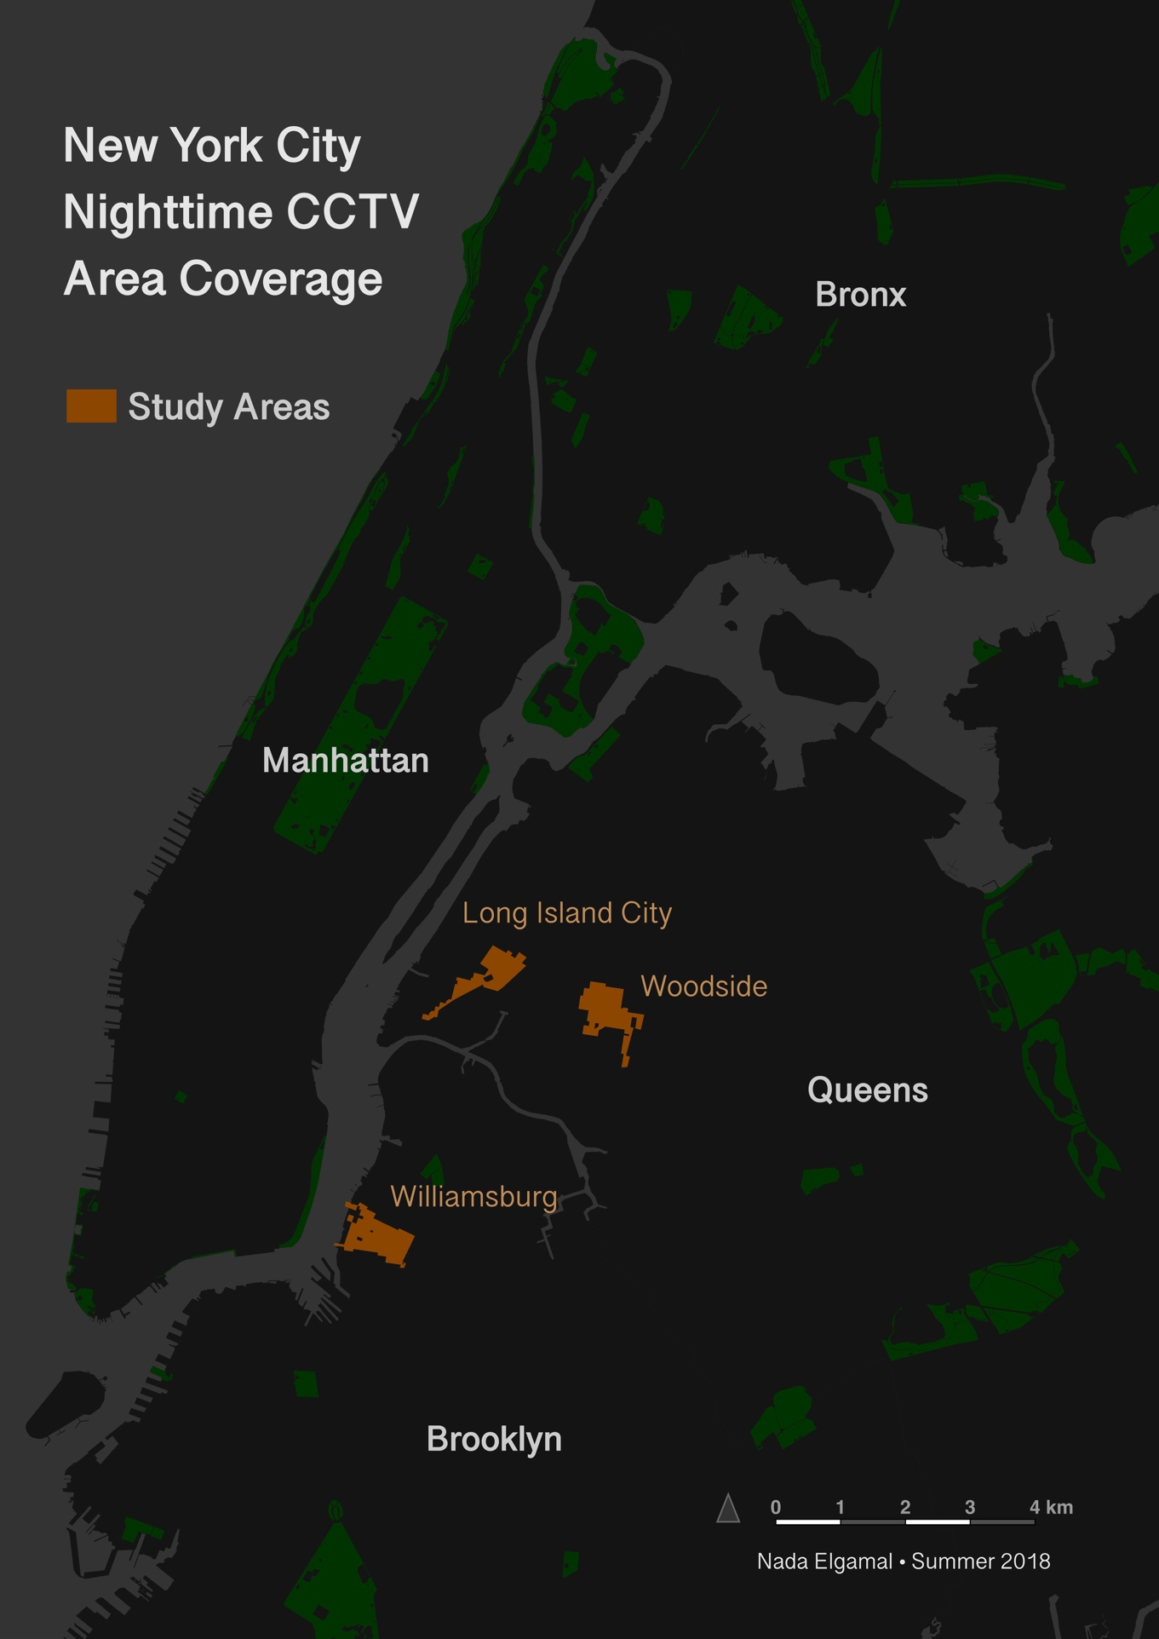

Figure 1. Study area neighborhoods with all three districts in close proximity.

The majority of the processing and analysis work was done using ‘geopandas’, a Python library optimized for handling spatial data in a tabular format. The only exception was during freehand selection of districts or buildings, which was done in QGIS or ArcGIS. For each trip, the point coordinates were buffered by four feet and merged with the attributes such that the feature locations matched up with their respective descriptions. The buffers were then clipped, or erased, from the extent of building footprints to represent any partial spotlights. The amount and total area of the resulting buffers for each district was grouped to represent the theoretical field of view (FOV), which assumes all surveillance cameras are fully operational. To select for those that were not operational or have low quality FOV, features were filtered for being largely oriented towards foliage, blocked by signs or scaffolding, or if the camera did not emit NIR and its hypothetical FOV area was not lit. The number and total area of filtered features with low quality FOV were then calculated. Finally, a percentage of surveillance cameras not working as well as the actual area with good FOV was derived for each zone, neighborhood, and overall.

**Results**

On average, and in individual neighborhoods, the actual FOV coverage was about 70% of the assumed or theoretical FOV area. In each neighborhood, the commercial districts seemed to have the highest proportions of non-operational or low quality cameras, while the manufacturing and residential districts were largely consistent with each other and the overall average (Table 1).

Maps created for each area reflect the different qualities of FOVs and their distributions amongst the buildings surveyed within the different districts (Figure 2). Certain districts had much smaller areas in some neighborhoods, such as Long Island City’s commercial district (Figure 3), and Woodside’s manufacturing district (Figure 4) This was not as much of a limitation in Williamsburg, where none of the districts were small enough to be completely surveyed (Figure 5).

*Table 1.* Assumed and actual nighttime coverage area of cameras by neighborhood and district.

|  |  |  |  |  |  |  |
| --- | --- | --- | --- | --- | --- | --- |
| Neighborhood | District type | All cameras | | Low quality cameras | | Percentage good quality area coverage |
| Count | Area (ft2) | Count | Area (ft2) |
| Long Island City, Queens | Residential | 80 | 3,564.90 | 14 | 605.71 | 83 |
| Commercial | 4 | 198.52 | 2 | 98.15 | 51 |
| Manufacturing | 98 | 4,612.73 | 29 | 1,388.15 | 70 |
| All | **182** | **8,376.15** | **45** | **2,092.01** | **75** |
| Woodside, Queens | Residential | 101 | 4,810.49 | 30 | 1,439.09 | 70 |
| Commercial | 27 | 1,235.89 | 13 | 567.00 | 54 |
| Manufacturing | 37 | 1,755.52 | 5 | 250.92 | 86 |
| All | **165** | **7,801.90** | **48** | **2,257.01** | **71** |
| Williamsburg,  Brooklyn | Residential | 47 | 2,067.03 | 13 | 702.59 | 66 |
| Commercial | 88 | 3,575.53 | 36 | 1,535.27 | 57 |
| Manufacturing | 71 | 3,242.57­­ | 19 | 962.79 | 70 |
| All | **206** | **8,885.13** | **68** | **3,200.64** | **64** |
| All districts | Residential | 228 | 10,442.42 | 57 | 2,747.39 | 74 |
| Commercial | 119 | 5,009.94 | 51 | 2,200.41 | 56 |
| Manufacturing | 206 | 9,610.82 | 53 | 2,601.86 | 73 |
| All | **553** | **25,063.18** | **161** | **7,549.66** | **70** |

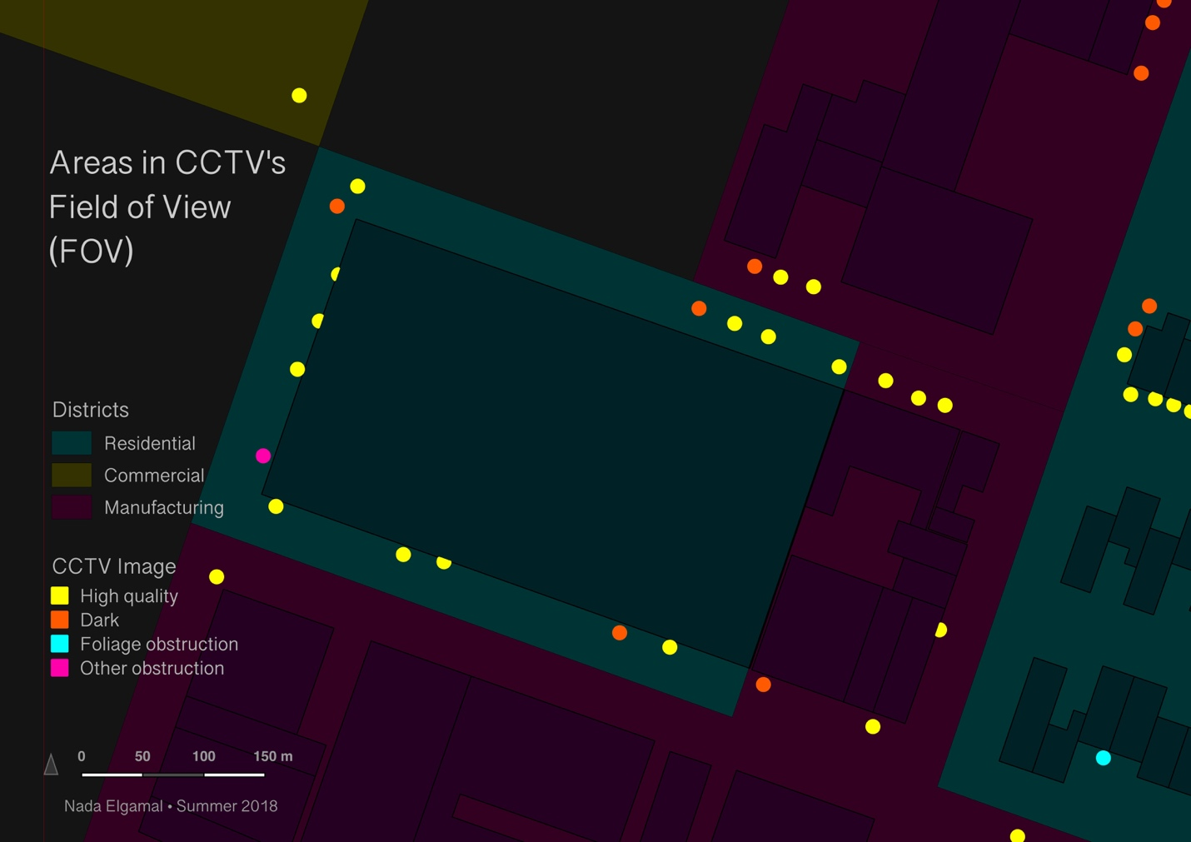

Figure 2. Each cameras field of view relative to the buildings they are placed on.

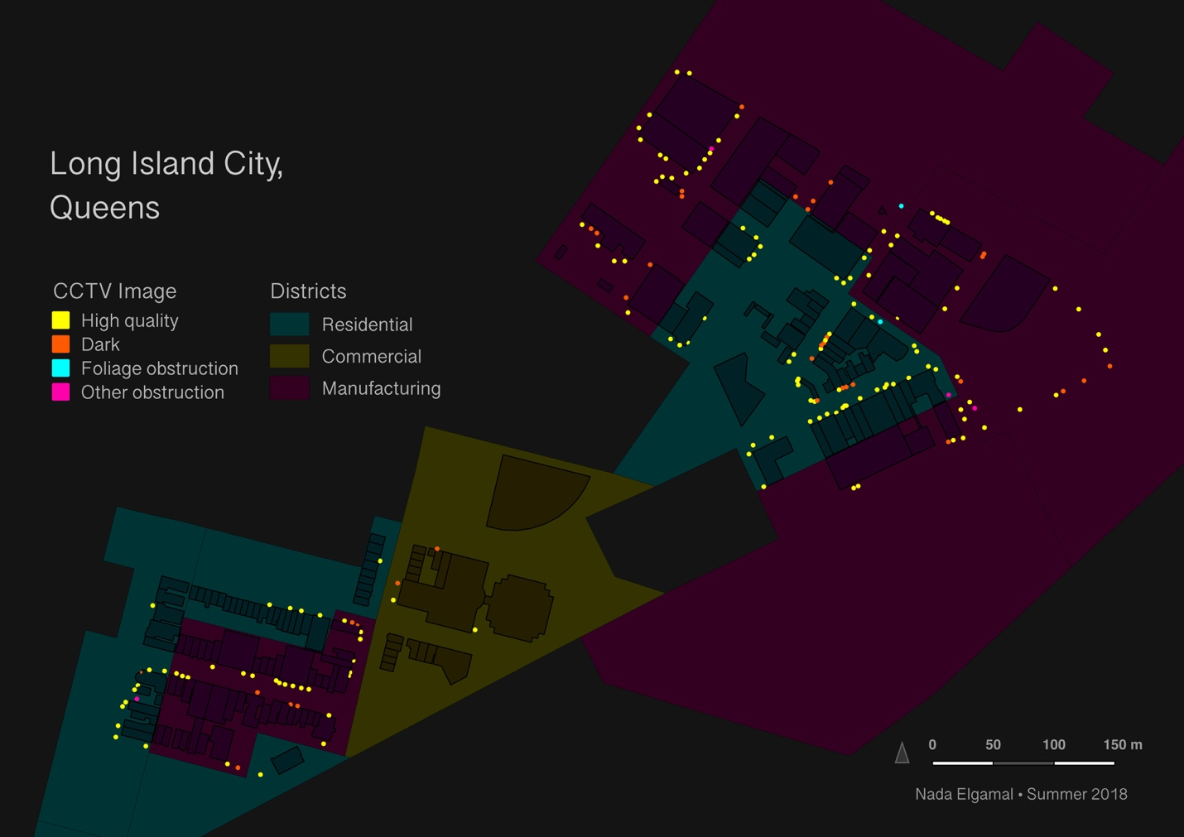

Figure 3. A map of Long Island City's coverage of shown buildings.

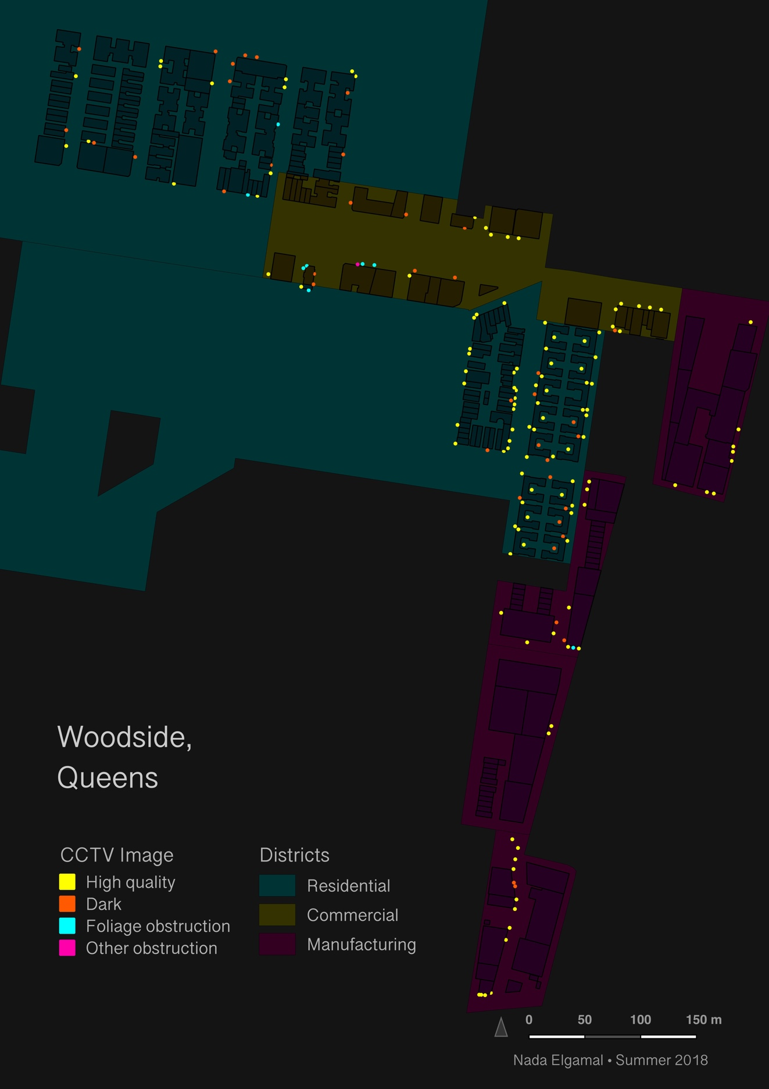

Figure 4. Another neighborhood in Queens showing differences in residential coverage.

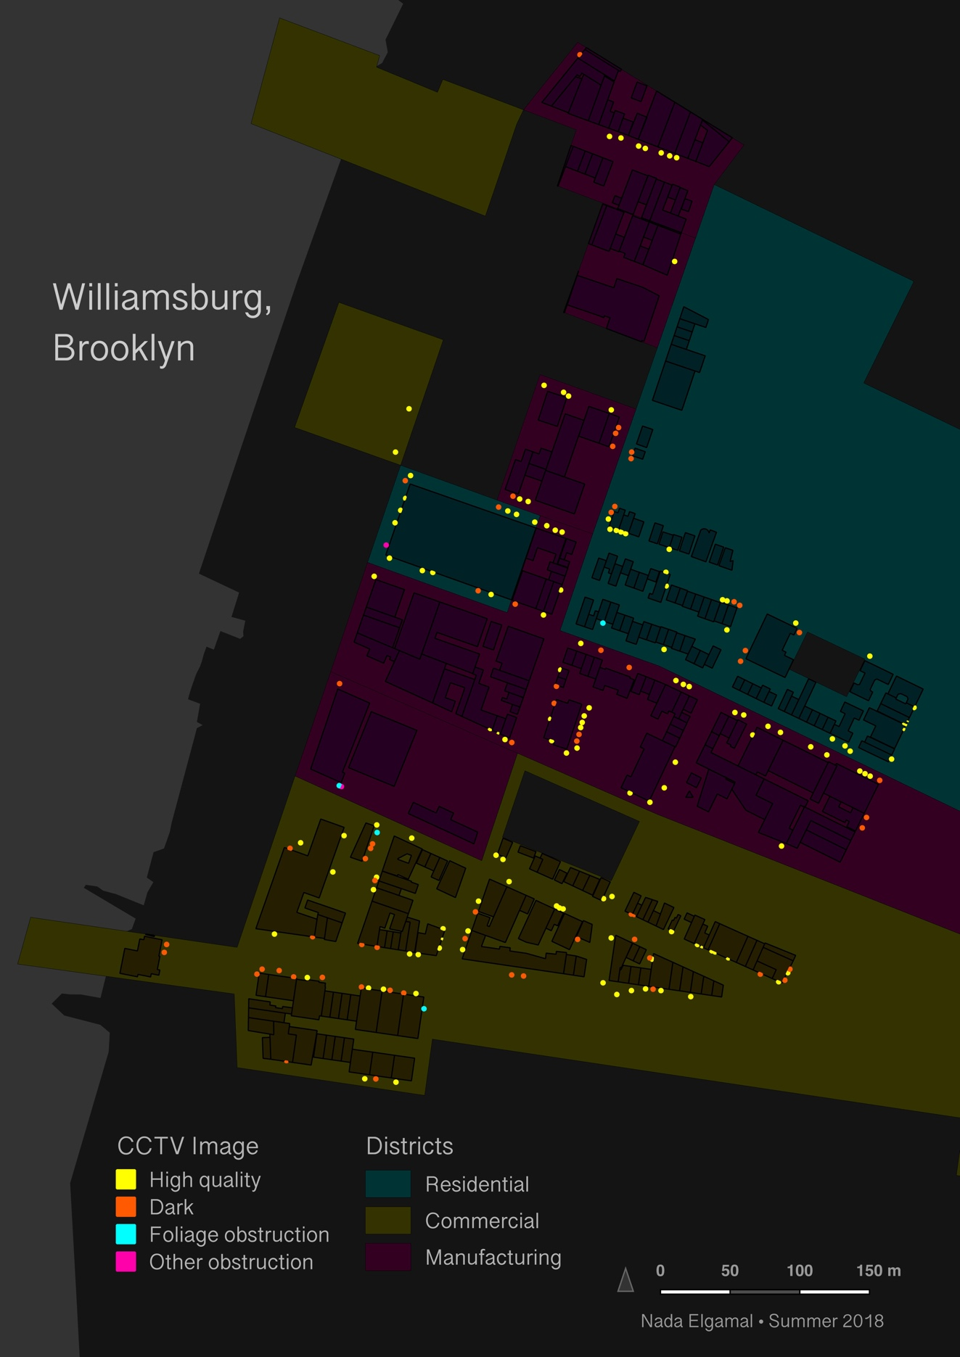

Figure 5. A quickly developing neighborhood with waterfront in Brooklyn coverage.

**Discussion and Conclusion**

**The nature of tools and data**

The NIR sensing camera used to collect data has proven useful for this endeavor for a few significant reasons. The first, and most important one, is that it is excellent at detecting surveillance cameras equipped with NIR LEDs (Figures 5). With NIR, surveillance cameras appear as a flashlight shining a bright purple spotlight (Figure 6). This NIR LED light is visible during daylight and almost perfectly distinguishable from any other surrounding light source; however, yellow street lights may bear a close resemblance to the untrained eye. The buffer for this analysis was determined by roughly measuring and averaging several spotlights’ radii from the central point of maximum illumination.

Some cameras were pointed in a way such that their FOV was interrupted by a building or structure, casting only a partial spotlight. Although not all spotlights are mostly circular in shape, as one might expect, a surveillance camera pointed at an angle will produce an ellipse. While this is true for some instances, the edges of elliptical spotlights are more poorly lit than those of circular ones. When the edges are ignored, the central well-lit area becomes more rounded and its dimensions fall more or less within the same range as those of already circular spotlights. There are instances where only the LED can be detected but the FOV spotlight cannot be seen on account of the neighboring light sources reflecting off of the same surfaces more dominantly. In some cases, objects such as metal railing or door frames can provide reference on the location and/or shape of the FOV when the spotlight is invisible. NIR emitting surveillance cameras that are in physically inaccessible spaces, such as behind gates or fences can also be easily detected. The purple light can be seen from about 50-60 feet away, or half a block, even when amidst strong lighting conditions.

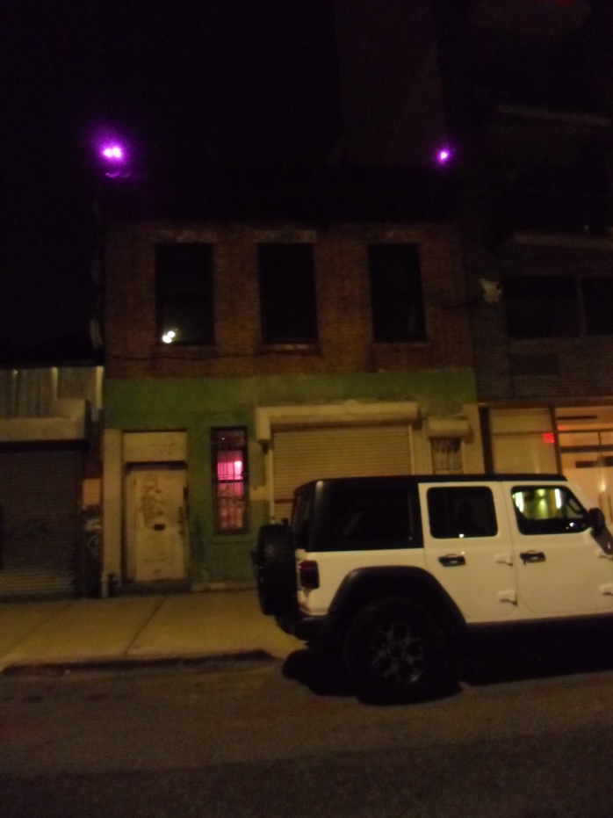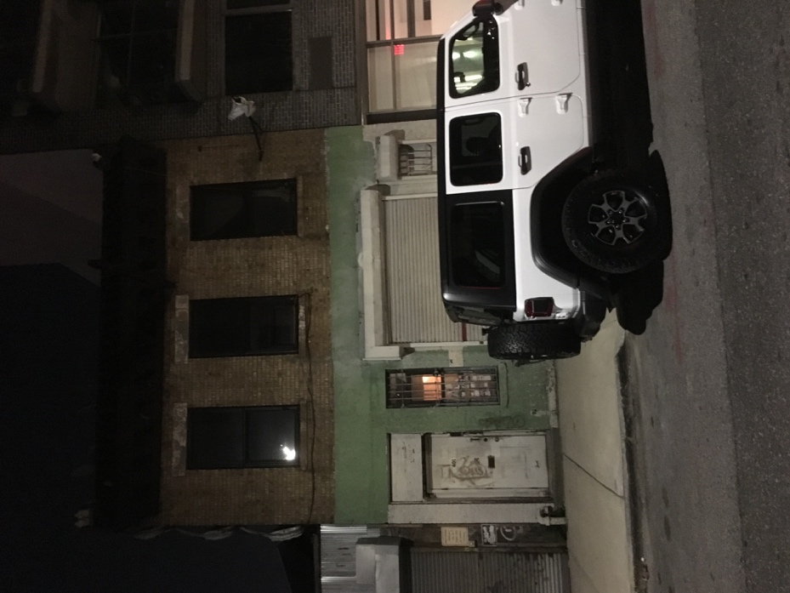*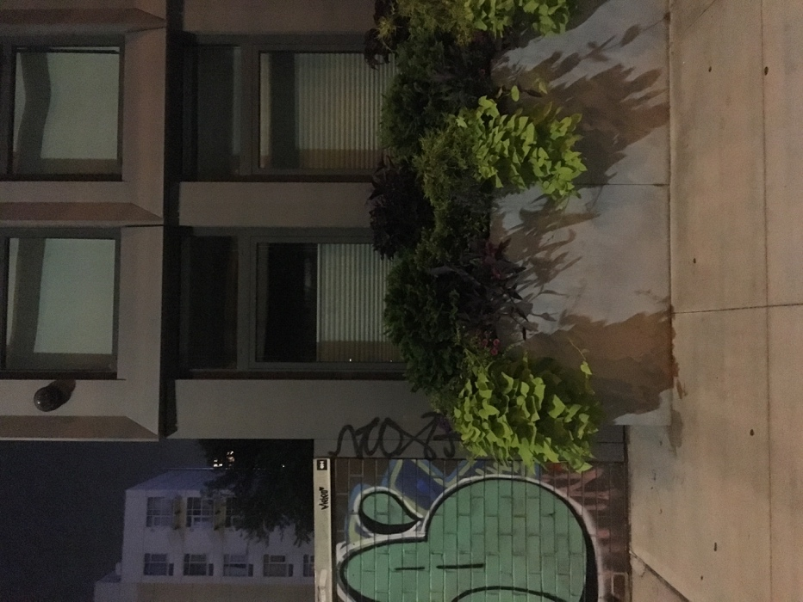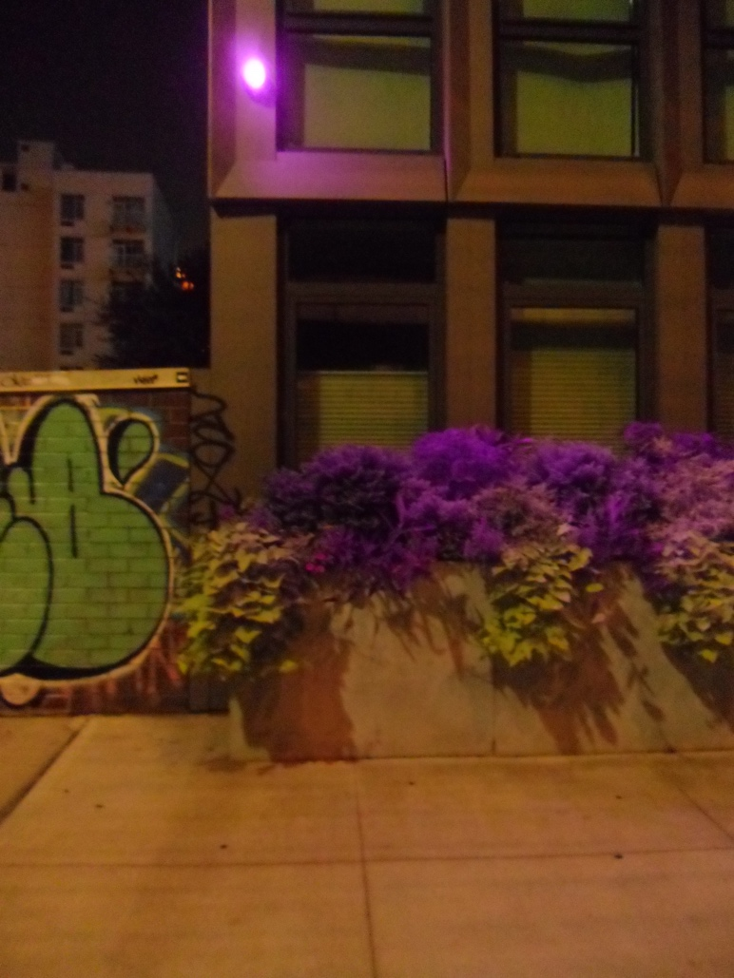Figure 6.* Photographs from an iPhone camera (left) and NIR-sensing camera (right) revealing the LEDs of operational CCTV surveillance cameras.

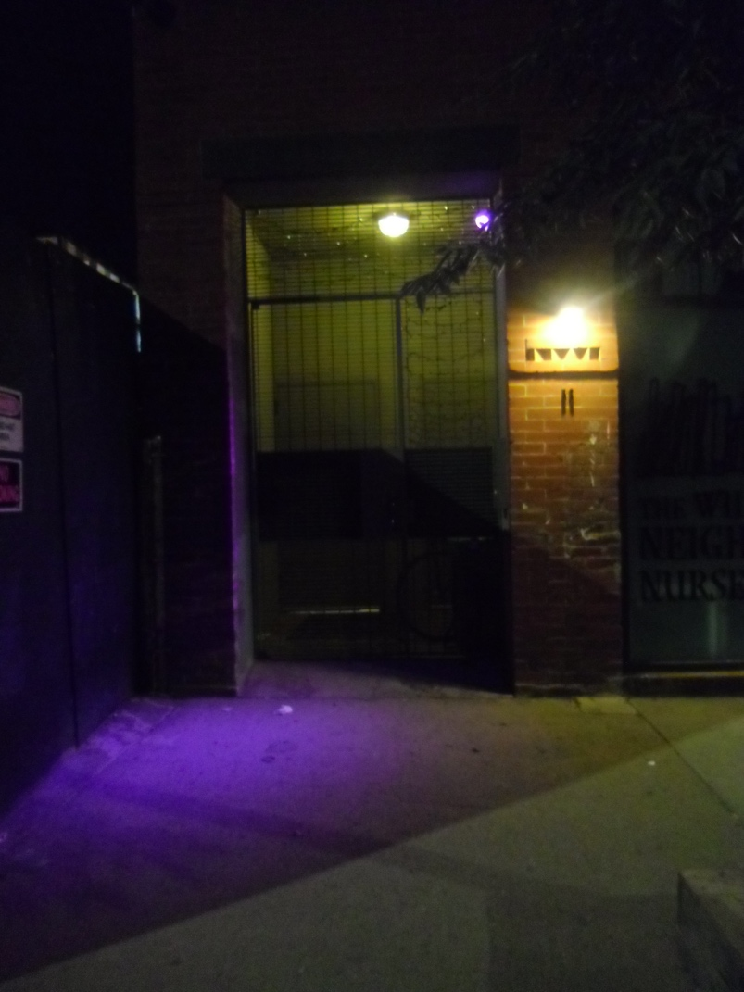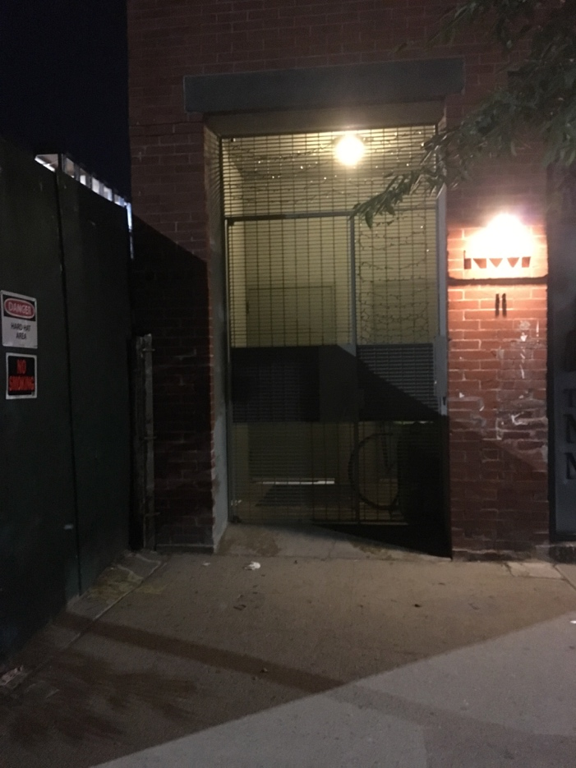

*Figure 7.* The visible bright purple (partial) spotlight created by the NIR LEDs seen through branches.

Data collected on each surveillance camera were intended to reflect its performance during the nighttime in such a way that could not be determined by the naked eye. Essentially, the goal was to characterize each camera’s quality of view into two general groups (good/bad) based on what their FOV illuminates the most, if at all. It was clear during initial observations that some spotlights were obstructed by trees or fell largely or completely on hedges or within fenced grassy areas (Figure 7). Other obstructions that blocked the field of view were mostly scaffoldings, awnings, or signs (Figure 8). If the camera emitted NIR light, the intensity of that light was recorded as low, medium, or high. If the camera did not emit NIR light, the presence of *good* light in its surrounding area was recorded. Only cameras that did not emit NIR and did not have good lighting were considered to produce a bad quality image.

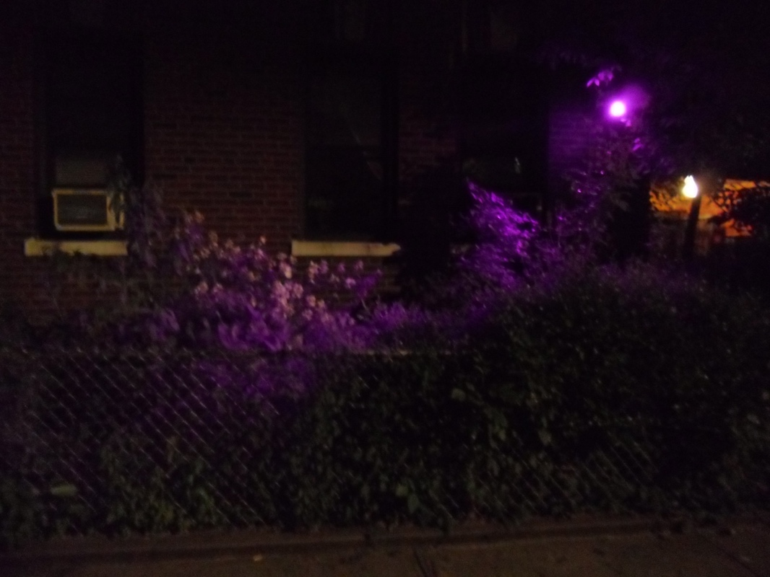*Figure 8.* Field of view (FOV) of NIR-emitting camera overlooking hedges and producing non-useful imagery.

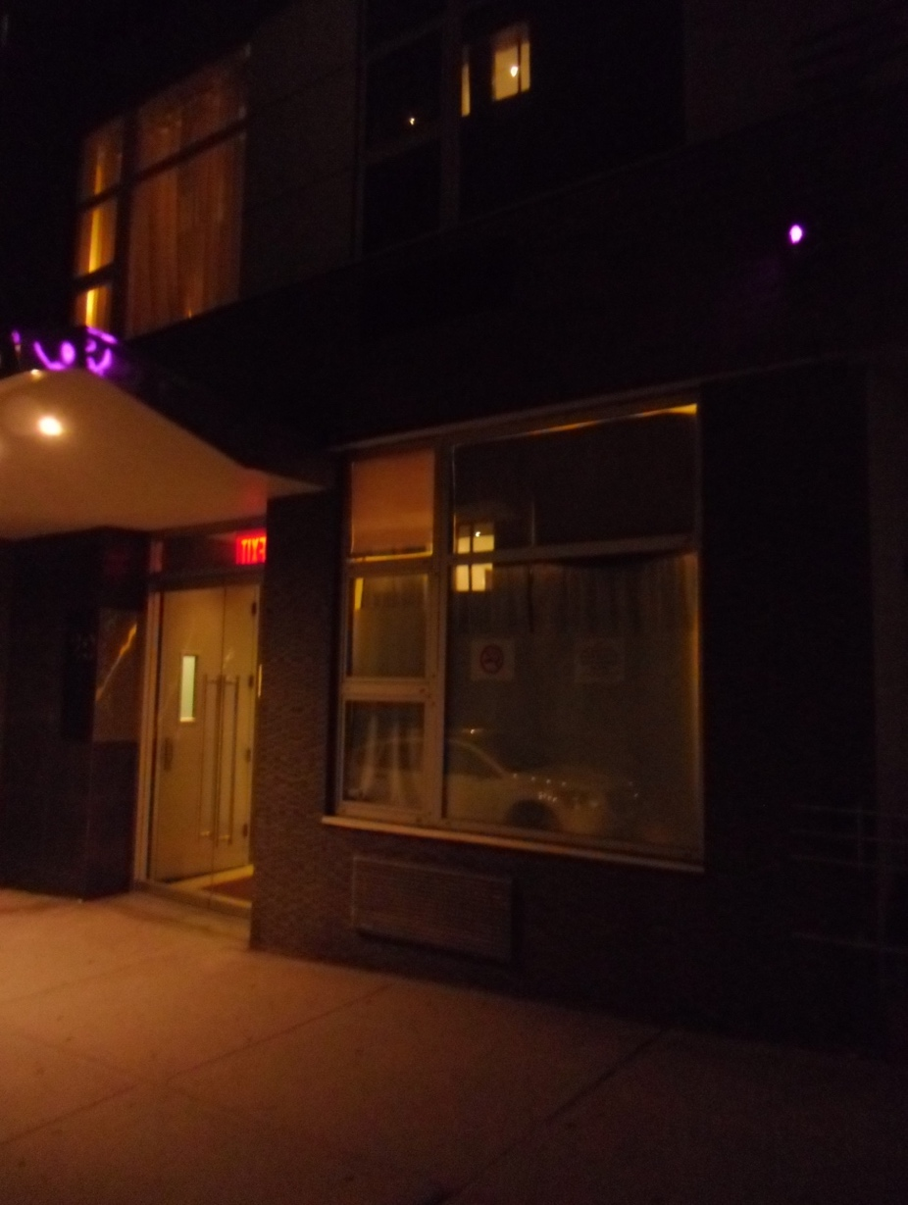

*Figure 9.* Spotlight reflected over awning blocking the camera’s field of view.

The caveat is that information assembled for this study, as a result of its specificity, has a relatively short shelf-life because of the instability of the conditions recorded as attributes, such as the seasonal change of foliage density or the addition/removal of a light source. The data and results aim to give the average user a better indication of what is normally an overlooked aspect of everyday life.

**Consideration of results**

Results were found to be consistent for each neighborhood, district type, and as a whole, with the exception of the commercial district. Each neighborhood, composed of all three districts, had an average of 70% of the area covered by cameras capturing relatively good quality footage at night. Residential and manufacturing districts both showed an average of 73% actual coverage, while commercial districts experienced about 56% actual coverage in all neighborhoods. The residential district is possibly so because of the social expectation for security, while the manufacturing districts’ results may stem from the heightened threat of isolation, being that these districts often contain less street lighting in general and tend to be further away from major roads or transportation.

All three neighborhoods were considered up-and-coming, with Long Island City, Queens and Williamsburg, Brooklyn more actively developing to newer mid to high-rise residential or commercial buildings. This is noted because of the abundance of construction projects and, on a few occasions, finished buildings, that were installed with cameras but were not internally renovated for use, a factor that might have contributed to the overestimation of the amount of non-operational cameras. There is a chance that the FOV, in reality, is even lower because of the glare from light sources that are too close to cameras, which might themselves obstruct a large part of its images, a factor that might have contributed to the underestimation of the amount of non-operational or low quality cameras expressed in these results. It was also noted on initial trips that signs saying that the area is under surveillance were rarely accompanied by a working camera, or often, no camera at all. An informal count that was taken on a trip to Williamsburg revealed that four out of seven signs were decoys.

**Handling human error**

Data collection was done only during nighttime, which means it is likely that a non-NIR emitting surveillance camera may have been missed. Luckily, this study was conducted in the summer during times of peak foliage density, making it possible to observe any obstructions it may be causing. A file of attributes (.csv) and another of coordinates (.txt) was saved for each trip separately and then merged with other trips within the same neighborhood. This was done to minimize the risk of accidental loss as well as make preparatory maps for future trips to avoid duplicate entries. Since recorded locations were approximated based on their position relative to the building or surrounding reference points on the basemap, there exists a degree of error. It is doubtful that the use of location services would have enhanced this approximation by much, if at all, because the GPS signals fluctuated very often. This might be attributed to the signal’s path bouncing off of adjacent buildings to and from the satellite, the app’s possibly poor capabilities to estimate that information, or both. However, very special attention was given to the locations of partial spotlights that were interrupted by buildings such that during analysis the buffered point is not completely erased, nor is it a fuller circle than it should be. Finally, the “well-lit” attribute was added after the first trip in Woodside, Queens and so all non-NIR cameras that had been previously recorded were considered of bad quality, which ignored about two to four cases that may have been well lit.

**Possible reasons for non-operational cameras**

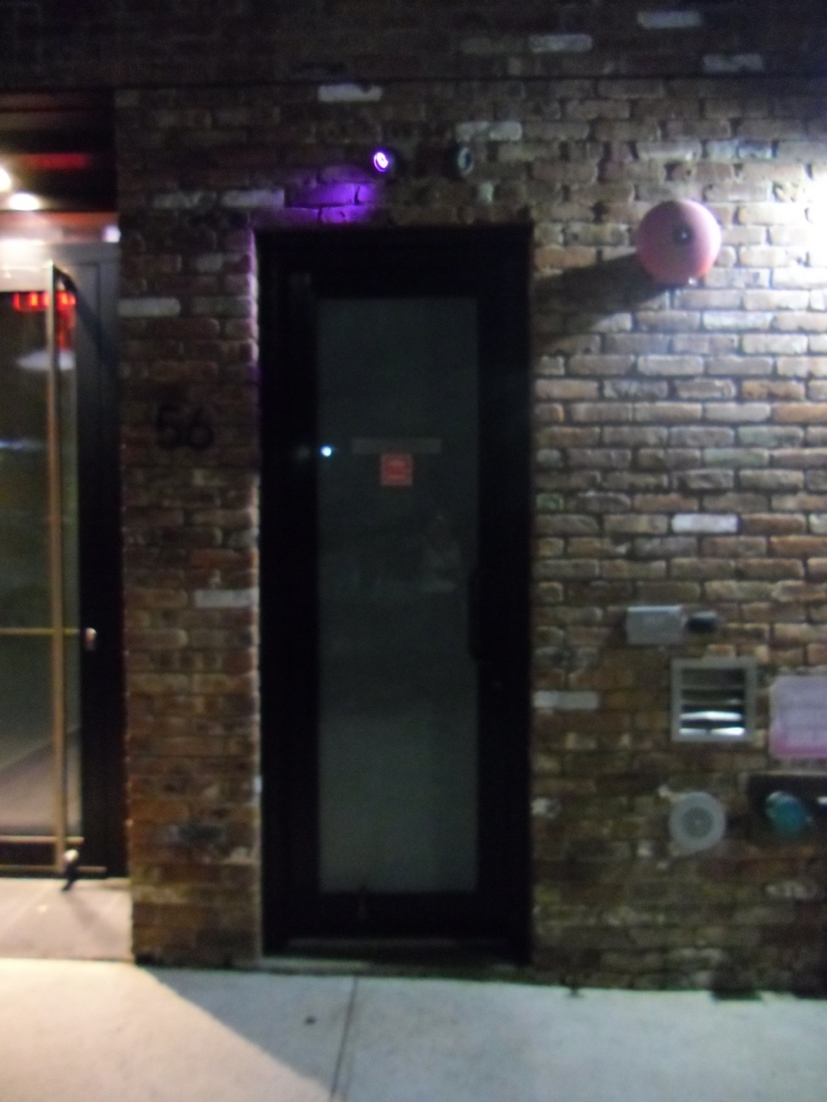Some surveillance cameras were found on shops or building spaces that were for rent, abandoned, or not yet fully built/renovated. It is also possible that a surveillance camera is designed with a light sensor that serves to switch on the LEDs when it becomes dark. Therefore, when placed close to a light source or in a well-lit area, the LED lights may not be on. This might not necessarily mean that the camera non-operational; however, there were a few instances where the NIR LEDs were on despite being positioned right next to a light source, or two ‘sister’ cameras in similar lighting conditions where one worked and the other did not (Figure 10).

*Figure 10.* Identical cameras with similar environments exhibiting different behaviors suggesting a non-responsiveness to the surrounding lighting.

**Applications of produced knowledge**

The NIR-sensing camera offers a solution for future studies on CCTV, as expressed by an article that had itself attempted to circumvent an issue after critiquing it as a limitation of another similar study where circular buffers were created in the camera’s target areas without knowledge of their actual viewsheds, or FOVs (Ratcliff, Taniguchi & Taylor, 2009). This knowledge, and the findings of this study, may be useful to works that focus on the availability vs. usability of CCTV footage, as suggested by Matthew Ashby (Ashby, 2017). This data can also be compared or analyzed with a variety of social, economic, or political variables to possibly uncover trends that are otherwise difficult to define or measure.

In terms of the average user, this information portrays a more detailed picture on routes of most or least surveillance at night. It also serves to identify large stretches of unseen or poor-quality FOV areas, which, admittedly, can result in the area becoming unsafe, but can similarly result in taking measures to making it safer, acting either in prevention or, in the worst case scenario, as a consequence of the abuse of this information. Furthermore, FOVs can assist during camera installation in finding the optimal placement to observe the area in question as well as how it might fit in with its neighboring observation areas to prevent redundancy.

Finally, the biggest limitation to the reproducibility of this work is creating or coming across an NIR-sensing camera that is able to detect CCTV. Despite the availability of tutorials on how to modify a digital camera, it is still a process of trial, error, and luck. However, future attempts of this kind would have to consider how this data can be known, accessed, and enriched. More importantly, the validity of the assumptions made by this study that defined poor quality cameras must be ensured through cross-referencing actual images taken by them and assessing their true quality.

**References**

Ashby, M. P. (2017). The value of CCTV surveillance cameras as an investigative tool: an empirical analysis. *European Journal on Criminal Policy and Research*, *23*(3), 441-459. [doi:10.1007/s10610-017-9341-6](http://dx.doi.org/10.1007/s10610-017-9341-6).

Building Footprints (2016) [shapefile]. Department of Information Technology & Telecommunications (DoITT). <https://data.cityofnewyork.us/Housing-Development/Building-Footprints/nqwf-w8eh> (accessed June 1st, 2018).

Crampton, J. W. (2009). Cartography: performative, participatory, political. *Progress in human geography*, *33*(6), 840-848. [doi:10.1177/0309132508105000](http://dx.doi.org/10.1177/0309132508105000).

Farrington, D. P., Gill, M., Waples, S. J., & Argomaniz, J. (2007). The effects of closed-circuit television on crime: Meta-analysis of an English national quasi-experimental multi-site evaluation. *Journal of Experimental Criminology*, *3*(1), 21-38. [doi:10.1007/s11292-007-9024-2](http://dx.doi.org/10.1007/s11292-007-9024-2).

Flight, S., Heerwaarden, Y. V., & Soomeren, P. V. (2003). Does CCTV Displace Crime? An evaluation of the evidence and a case study from Amsterdam. *CCTV*, 93-108. Retrieved from <https://publicaties.dsp-groep.nl/getFile.cfm?file=Displacement%20Amsterdam_CCTC_SF.pdf&dir=rapport>.

Gill, M., & Loveday, K. K (2003). “What do Offenders Think about CCTV?”. *Crime Prevention and Community Safety: An International Journal*, *5*(3), 17-25.

Gill, M., & Spriggs, A. (2005). *Assessing the impact of CCTV* (pp. 1-176). London: Home Office Research, Development and Statistics Directorate. Retrieved from <http://www.no-cctv.org.uk/caseagainst/docs/Assessing_the_impact_of_CCTV-HO_study292.pdf>.

Kickstarter. (2012). Surv App for iPhone. <https://www.kickstarter.com/projects/kazarazat/surv-app-for-iphone> (accessed June 1st, 2018).

Kitchin, R., & Dodge, M. (2007). Rethinking maps. *Progress in human geography*, *31*(3), 331-344.  [doi:10.1177/0309132507077082](http://dx.doi.org/10.1177/0309132507077082).

Mogel, L., & Bhagat, A. (2007). Tactical Cartographies. In *An Atlas of Radical Cartographies* (pp. 28-37). Los Angeles, CA: Journal of Aesthetics and Protest. Retrieved from <http://cril.mitotedigital.org/sites/default/files/content/iaa_tactical_cartographies.pdf>.

New York Civil Liberties Union. (1998). NYC Surveillance Camera Project. <http://www.mediaeater.com/cameras/> (accessed June 1st, 2018).

NOT BORED! (2000). Surveillance Camera Players. <http://www.notbored.org/the-scp.html> (accessed June 1st, 2018).

NYC Department of City Planning (DCP). Zoning and Land Use Map (ZoLa). <https://zola.planning.nyc.gov/#10.99/40.7428/-73.949> (accessed June 1st, 2018).

NYC GIS Zoning Features (2018) [shapefile]. Department of City Planning (DCP). <https://www1.nyc.gov/site/planning/data-maps/open-data/dwn-gis-zoning.page#metadata> (accessed June 1st, 2018).

Parks Properties (2018) [shapefile]. Department of Parks and Recreation (DPR). <https://data.cityofnewyork.us/City-Government/Parks-Properties/k2ya-ucmv> (accessed June 1st, 2018).

Piza, E. L., Caplan, J. M., & Kennedy, L. W. (2014). Is the punishment more certain? An analysis of CCTV detections and enforcement. *Justice Quarterly*, *31*(6), 1015-1043. [doi:10.1080/07418825.2012.723034](http://dx.doi.org/10.1080/07418825.2012.723034).

Ratcliffe, J. H., Taniguchi, T., & Taylor, R. B. (2009). The crime reduction effects of public CCTV cameras: a multi‐method spatial approach. *Justice Quarterly*, *26*(4), 746-770. [doi:10.1080/07418820902873852](http://dx.doi.org/10.1080/07418820902873852).

Subway Lines (2017) [shapefile]. Metropolitan Transportation Authority (MTA). <https://data.cityofnewyork.us/Transportation/Subway-Lines/3qz8-muuu> (accessed June 1st, 2018).

Sutrop, M., & Laas‐Mikko, K. (2012). From identity verification to behavior prediction: Ethical implications of second generation biometrics. *Review of policy research*, *29*(1), 21-36. Retrieved from <https://onlinelibrary-wiley-com.proxy.wexler.hunter.cuny.edu/doi/epdf/10.1111/j.1541-1338.2011.00536.x>.

VideoSurveillance.com. CommunityCam: Mapping Security Cameras for Safe Cities. <https://www.videosurveillance.com/communitycam/> (accessed June 1st, 2018).

Vimeo. (2009). iSee – Institute for Applied Autonomy. <https://vimeo.com/6163268> (accessed June 1st, 2018).