INTRODUCTION

The Home & Away Institute (H&AI) is an Educational Institution that specializes in offering Distance Learning courses. The system facilitates students within the distance learning group to take multiple choice online tests.

This manual will give an easy to follow directions of how use the HAI Assessment System to enrol in a programme, select courses and take the required tests chosen that are set by members of staff along with viewing your test results. For staff members HAI Assessment System will allow easy access to test materials as well as allow enough management so that tests may be set according to specifications.



TABLE OF CONTENTS

Contents

Getting Started 4

MAIN MENU 5

SELECT PROGRAM 11

SELECT COURSE 12





# Getting Started

Since HAI is an important portal for students that will handle the sensitive information such as course information, the Home & Away Institute’s (H&AI) will allow the user to register by creating identification name and password or log in to access the main menu which is particular to each student and members of staff.



# MAIN MENU



By opening the portal, the user has the option to register or login as a student or staff. The figure below illustrates the splash/landing page.

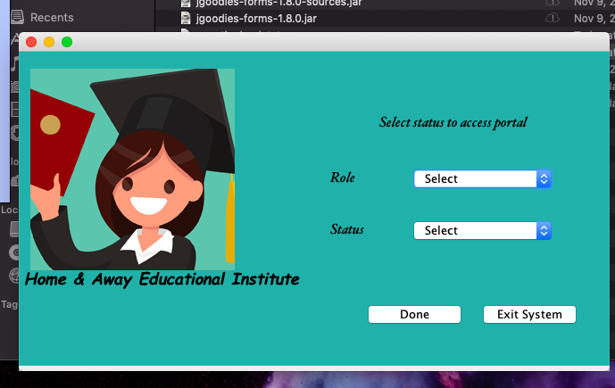

Staff Registration:

Once the staff has selected the “staff” role and “new” to registration, the following screen will be shown for the user to enter the information.

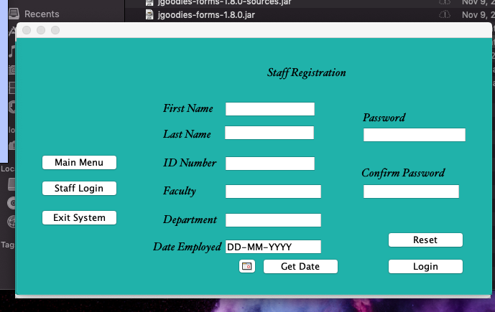

*The user can manually enter the date or select the calendar button and then “Get Date” to prefill the text area.

Once you have entered all the required fields and registered successfully, the user will have the option to log in to their new account via the log in screen:

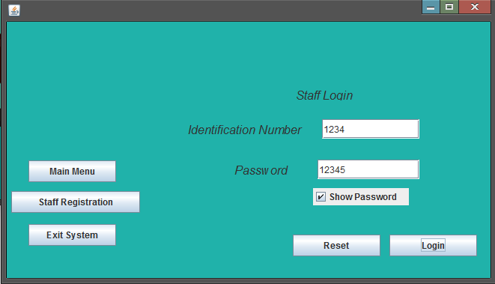

If the user credentials doesn’t match the ones stored in the system, the following prompt will be shown:

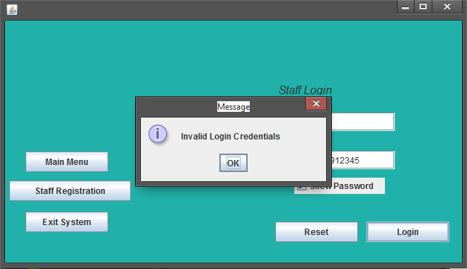

On the other hand, if the user has been successfully logged in they will get the option to:

**Select course to set test from a dropdown menu**



**View Test Result**



* **Switch User**
* **Log out**
* **Exit Syste****m**

Student Registration:

Once the staff has selected the “student” role and “new” to registration, the following screen will be shown for the user to enter the information.

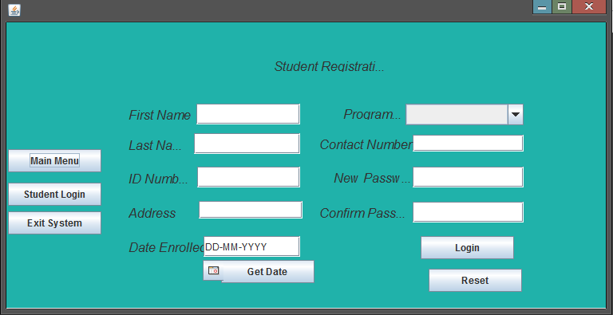

*The user can manually enter the date or select the calendar button and then “Get Date” to prefill the text area.Once you have entered all the required fields and registered successfully, the user will have the option to now log in to their newly created account.

Student Login

Once you have entered all the required fields and registered successfully, the user will have the option to log in to their new account via the log in screen:

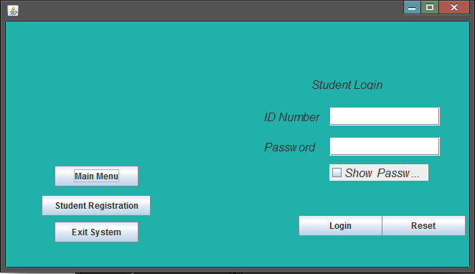

If the user credentials doesn’t match the ones stored in the system, the following prompt will be shown:

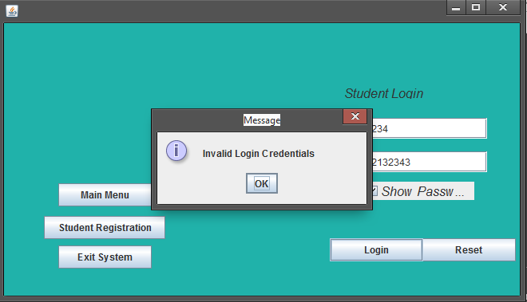

On the other hand, if the user has been successfully logged in they will be prompted the list of courses they are currently enrolled in to take a test or to view results. The student will also get the option to go back to the main menu, exit system or switch user.

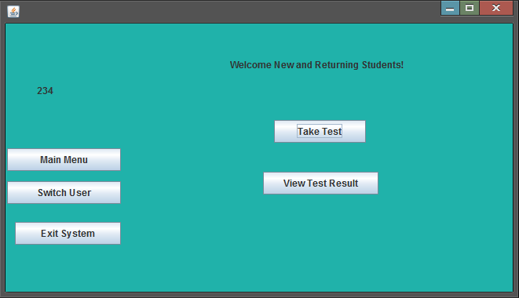



# SELECT PROGRAM

When you are a new student registering you will be able to select your desired programme.

There are currently three programmes available to select from. These are:

**Certificate:**

**The courses offered are English Language", "Mathemathics", "General Knowledge", "Information Technology”**

**Diploma**

**The courses offered are English Language", "Mathematics", "General Knowledge", "Information Technology", "Project Management", "Principles of Business"**

**Associate Degree**

**The courses offered are "English Language", "Mathematics", "General Knowledge", "Information Technology", "Project Management", "Principles of Business", "Principles of Accounts", "Economics"**

**NB. You may only be enrolled in one course at a time.**

# SELECT COURSE



To set a test for a course, the staff member chooses the “**Select Program”** and “Set Test”

Set Test

Once selected the user will be given the option to enter the questions, selections and answers. The user MUST select the coursecode from the dropdown menu. The selections MUST be separated by “&” for eg: “smile&smiles&smiling&smiled”. The answer tab should only have one letter answer – A, B, C or D. The staff must select the Date for the test at the top right of the screen. The user can manually enter the date or select the calendar button and then “Get Date” to prefill the text area. Once all the fields are filled the user MUST select Add question. The members of staff also has the option to go to the Main Menu, Logout or Exit the System

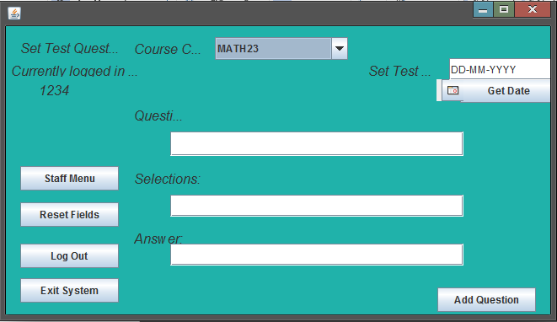

Once the question has been successfully added, the user will get the following prompt:

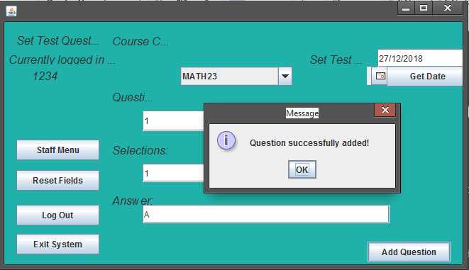

**Take Test**

Choosing the **Take Test** option will direct you to a specialized page which will display a multiple choice test set by your course teacher for the course chosen. Once the test has been complete you will be returned to the **student menu** where you will be able to choose another course and take another test or view the results

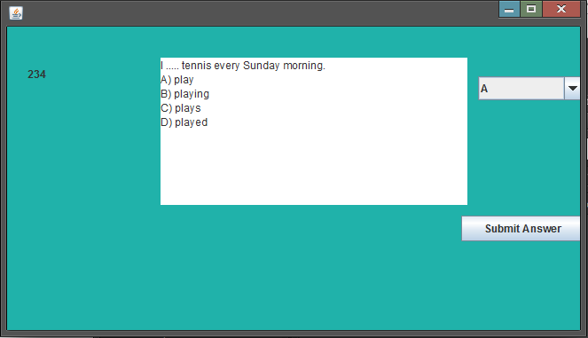

To do the test, the student can select the letter answer from the dropdown menu and select on submit answer. After selecting on “Submit answer” the user will get the prompt that the answer was successful submitted.

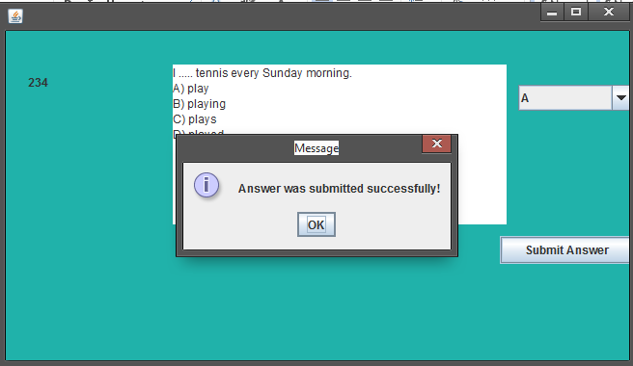

The next question will automatically load after the answer was submitted.

**View Test Result**

The **View Test Result** option will allow you view your entire test results including the grades for all the tests you have completed. A report will be generated to view score of the previous test(s).



