G16 Toolbox for MATLAB
User Manual — Version 1.0

A MATLAB library for parsing Gaussian 16 output files

Compatible with: Gaussian 16 (Rev. A.03 – C.02)
MATLAB: R2021b or later (tested on R2024b)
Generated by: Claude Sonnet 4.6 (Anthropic, 2026)
Author: Sebastiano Trusso — CNR-IPCF, Messina, Italy
Date: June 2026

1. Introduction

The G16 Toolbox is a collection of MATLAB functions for extracting and visualising data from Gaussian 16 output files (.out / .log). Each function is named G16_XXXX.m and returns a structured MATLAB struct that can be used directly in further analysis pipelines.
All functions were developed and debugged iteratively against real Gaussian 16 output files (violacein, zeatin conformers) with the assistance of Claude Sonnet 4.6 (Anthropic, 2026).

Quick-start example
mol = G16_structure('my_calc.out');
G16_draw_molecule(mol);
sp = G16_spectra('my_calc.out', 'FWHM', 10, 'plot', true);
en = G16_energy('my_calc.out');

Function overview
Function | Description
G16_structure | Optimised geometry: atomic symbols + XYZ coordinates
G16_draw_molecule | 3D CPK ball-and-stick visualisation from mol struct
G16_draw_mode | 3D normal mode visualisation with cone arrows
G16_spectra | IR and Raman stick spectra + Lorentzian broadening
G16_energy | SCF energy, ZPE, thermal corrections, H, G, S
G16_nmodes | Normal mode displacement vectors [Natoms×3×Nmodes]
G16_tddft | TD-DFT excited states: λ, f, MO transitions, UV-Vis
G16_route | Route section string
G16_charge_mult | Molecular charge and spin multiplicity
G16_convergence | Geometry optimisation convergence criteria + plot
G16_dipole_polar | Dipole moment μ and polarisability α (static + dynamic)
G16_hyperpolar | First hyperpolarisability β (static + dynamic + vibrational)
G16_charges | Mulliken / APT charges visualised on 3D structure
G16_restart | Generate a .gjf restart input from an existing .out file

2. Installation

Copy all G16_*.m files to a directory on the MATLAB path, or add it explicitly:
addpath('/path/to/G16_toolbox')

No additional toolboxes are required. All functions use only MATLAB built-ins. G16_draw_molecule, G16_draw_mode and G16_charges require a display (figure windows).
📌 The functions G16_draw_molecule, G16_draw_mode and G16_charges call each other internally. Keep all .m files in the same directory.

3. Function Reference

G16_structure

Synopsis
mol = G16_structure(filename)
mol = G16_structure(filename, 'orientation', 'standard')
mol = G16_structure(filename, 'step', 'last')
mol = G16_structure(filename, 'step', N)

Reads all geometry blocks and returns the selected step as a struct. Supports Standard and Input orientation, falls back automatically if Standard is absent (NoSymm).

Parameters
Parameter | Default | Description
'orientation' | 'auto' | 'standard' | 'input' | 'auto'
'step' | 'last' | 'first' | 'last' | integer N

Output fields
Field | Type | Description
.symbols | {Natoms×1 cell} | Atomic symbols, e.g. {'C','H','N',...}
.xyz | [Natoms×3] | Cartesian coordinates in Ångström
.Z | [Natoms×1] | Atomic numbers
.Natoms | int | Number of atoms
.n_steps | int | Total geometry blocks in file

Example
mol = G16_structure('V_E00t.out');
mol.symbols{8} % 'N'
mol.xyz(1,:) % [-5.522 0.659 -0.439]

Relevant section in .out file
Input orientation:
--------------------------------------------------
Center Atomic Atomic Coordinates (Angstroms)
Number Number Type X Y Z
--------------------------------------------------
1 6 0 -5.52227 0.65882 -0.43869
2 6 0 -4.94430 1.90648 -0.67027

G16_spectra

Synopsis
sp = G16_spectra(filename)
sp = G16_spectra(filename, 'FWHM', 10, 'xmin', 400, 'plot', true)
sp = G16_spectra(filename, 'normalize', true)

Extracts IR and Raman stick spectra from the last Harmonic frequencies section and generates Lorentzian-broadened continuous spectra. For opt+freq jobs, the last section (with Raman data) is used automatically.

Parameters
Parameter | Default | Description
'FWHM' | 10 | Lorentzian FWHM (cm⁻¹)
'xmin'/'xmax' | 0 / 4000 | Wavenumber range (cm⁻¹)
'dx' | 1 | Grid step (cm⁻¹)
'normalize' | false | Normalise to max = 1
'plot' | false | Generate subplot figure
'section' | 'last' | 'last' | 'first'

Output fields
Field | Type | Description
.freq | [Nmodes×1] | Frequencies (cm⁻¹)
.IR | [Nmodes×1] | IR intensities (KM/Mole)
.Raman | [Nmodes×1] | Raman activities (Å⁴/AMU)
.x | [Ngrid×1] | Wavenumber grid
.IR_cont | [Ngrid×1] | Broadened IR spectrum
.Raman_cont | [Ngrid×1] | Broadened Raman spectrum

Example
sp = G16_spectra('V_E00t.out', 'FWHM', 10, 'plot', true);
[~,i] = max(sp.Raman_cont);
fprintf('Peak Raman: %.1f cm-1\n', sp.x(i)) % 1582.8 cm-1

Relevant section in .out file
Frequencies -- 21.5328 28.5347 47.3384
IR Inten -- 0.5255 3.1830 1.0410
Raman Activ -- 8.1621 2.6841 4.3612
...
Frequencies -- 1582.7523 1615.9666 1621.3978
IR Inten -- 581.2700 128.4400 64.3300
Raman Activ -- 21803.1000 1042.7500 1637.2000

Example output plot
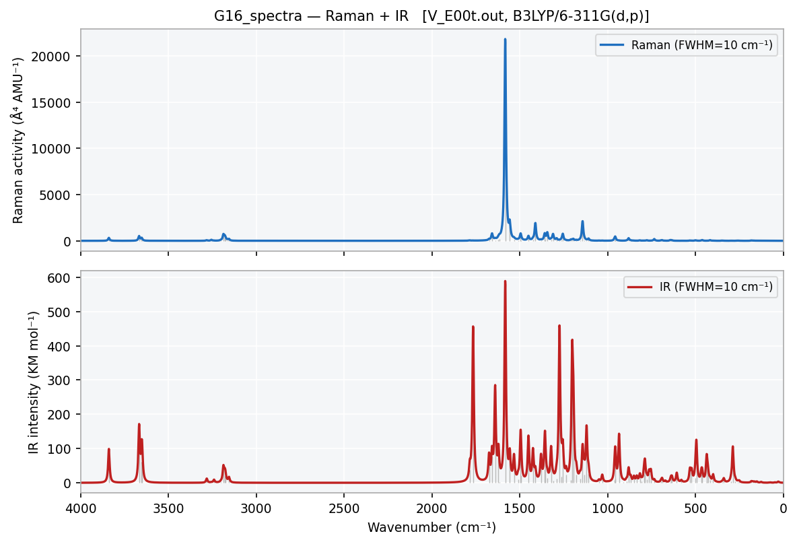
Figure 1 — G16_spectra output: Raman (top) and IR (bottom) with Lorentzian broadening (FWHM=10 cm⁻¹). Grey sticks = harmonic intensities.

G16_energy

Synopsis
en = G16_energy(filename)
en = G16_energy(filename, 'step', 'last')

Extracts SCF energy and full thermochemistry. Prints a formatted summary automatically. For opt+freq jobs the last SCF value is used by default.

Parameters
Parameter | Default | Description
'step' | 'last' | 'first' | 'last' | integer N

Output fields
Field | Type | Description
.SCF | double | SCF energy (Hartree)
.method | char | Functional, e.g. 'RB3LYP'
.ZPE_corr | double | Zero-point correction (Hartree)
.H / .G | double | Enthalpy / Gibbs free energy (Hartree)
.S_JmolK | double | Entropy S (J mol⁻¹ K⁻¹)
.T / .P | double | Temperature (K) / Pressure (atm)
.has_thermo | logical | True if thermochemistry section found

Example
en = G16_energy('V_E00t.out');
% SCF = -1160.20276010 Ha
% G = -1159.96045200 Ha
dG = (en.G - en_ref.G) * 2625.5; % kJ/mol

Relevant section in .out file
SCF Done: E(RB3LYP) = -1160.20276010 A.U. after 11 cycles
Zero-point correction= 0.291821 (Hartree/Particle)
Thermal correction to Enthalpy= 0.312880
Thermal correction to Gibbs Free Energy= 0.242309
Sum of electronic and thermal Free Energies= -1159.960451

Example output plot
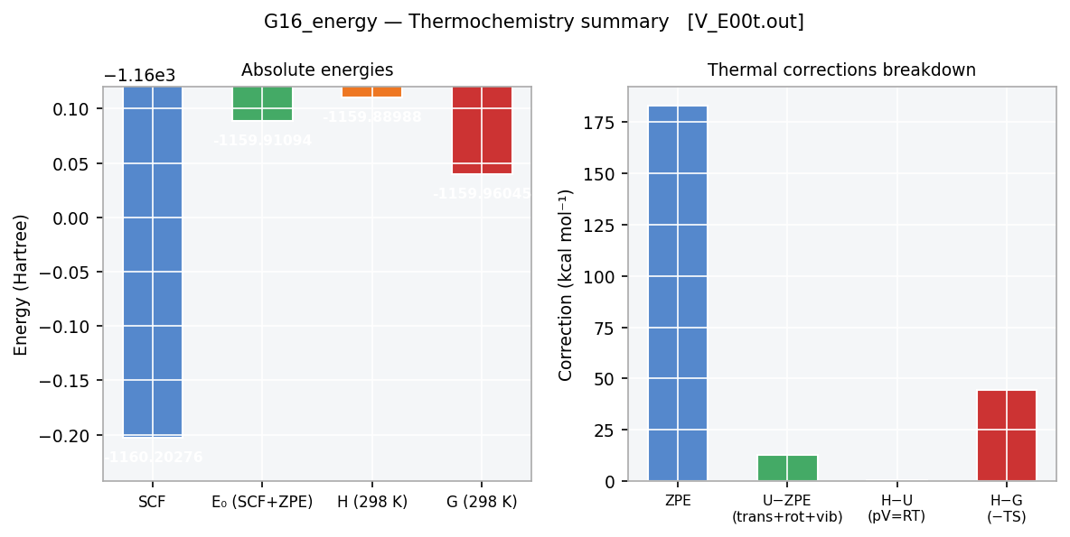
Figure 2 — G16_energy: absolute energies (left) and breakdown of thermal corrections (right).

G16_nmodes

Synopsis
nm = G16_nmodes(filename)
nm = G16_nmodes(filename, 'modes', [1 5 91])

Extracts all normal-mode displacement vectors, frequencies, symmetry labels, reduced masses and force constants. The array nm.disp has dimensions [Natoms × 3 × Nmodes].

Parameters
Parameter | Default | Description
'section' | 'last' | 'first' | 'last'
'modes' | [] | Integer vector of modes to keep ([] = all)

Output fields
Field | Type | Description
.freq | [Nmodes×1] | Frequencies (cm⁻¹)
.disp | [Natoms×3×Nmodes] | Displacement vectors
.symmetry | {Nmodes×1 cell} | Symmetry labels
.redmass | [Nmodes×1] | Reduced masses (AMU)
.frcconst | [Nmodes×1] | Force constants (mDyne/Å)

Example
nm = G16_nmodes('V_E00t.out');
nm.freq(91) % 1582.75 cm-1
U = squeeze(nm.disp(:,:,91)); % [39×3]
mol = G16_structure('V_E00t.out');
G16_draw_mode(mol, nm, 91)

Relevant section in .out file
Atom AN X Y Z X Y Z
1 6 -0.00 -0.05 -0.14 0.02 -0.07 -0.22
2 6 -0.01 -0.02 -0.01 0.01 -0.07 -0.23
...
39 1 -0.07 -0.03 0.19 -0.04 0.05 -0.20

Example output plot
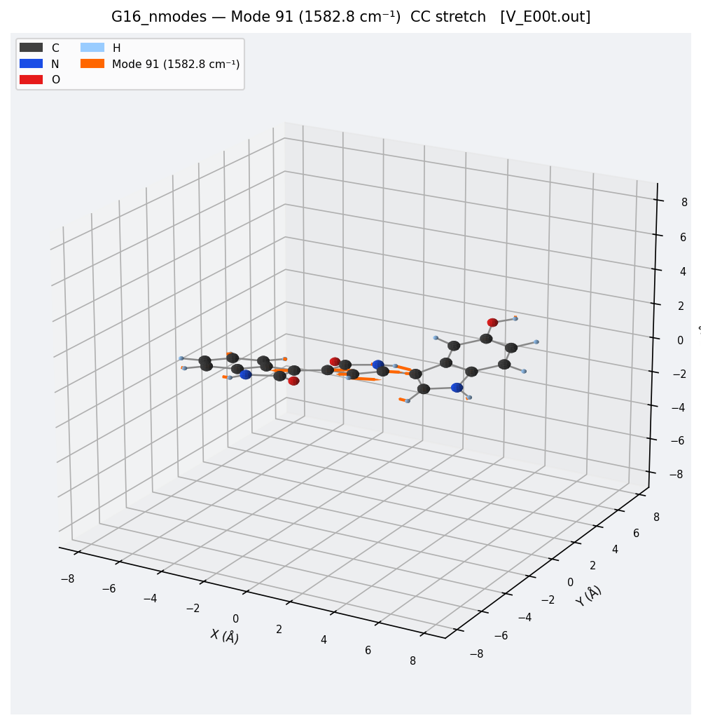
Figure 3 — G16_nmodes: CPK molecular structure of violacein with cone arrows showing the displacement vectors of mode 91 (CC aromatic stretch, 1582.8 cm⁻¹). Arrow length is proportional to per-atom displacement; atoms below 5% threshold are not shown.

G16_convergence

Synopsis
cv = G16_convergence(filename)
cv = G16_convergence(filename, 'plot', true)

Reads all optimisation convergence blocks. Returns per-step arrays for Maximum Force, RMS Force, Maximum Displacement and RMS Displacement. The green star marks the convergence step.

Parameters
Parameter | Default | Description
'plot' | false | Generate 2×2 semilog convergence plot

Output fields
Field | Type | Description
.MaxForce / .RMSForce | [Nsteps×1] | Force criteria per step (a.u.)
.MaxDisp / .RMSDisp | [Nsteps×1] | Displacement criteria per step (a.u.)
.converged | logical | True if all four criteria satisfied
.conv_step | int | Step at which convergence was achieved
.Nsteps | int | Total steps read

Example
cv = G16_convergence('V_E00t.out', 'plot', true);
cv.converged % true
cv.conv_step % 2

Relevant section in .out file
Item Value Threshold Converged?
Maximum Force 0.000014 0.000450 YES
RMS Force 0.000002 0.000300 YES
Maximum Displacement 0.001589 0.001800 YES
RMS Displacement 0.000370 0.001200 YES
Optimization completed.

Example output plot
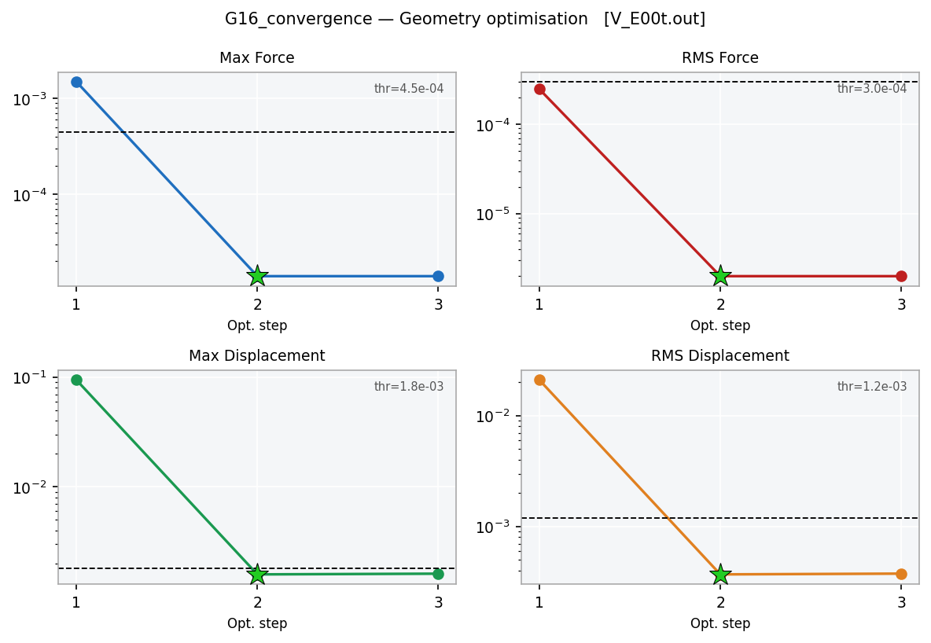
Figure 4 — G16_convergence: semilog plot of the four convergence criteria vs. optimisation step. Dashed line = Gaussian threshold; star = convergence point.

G16_dipole_polar

Synopsis
dp = G16_dipole_polar(filename)
dp = G16_dipole_polar(filename, 'units', 'Debye')

Extracts dipole moment vector and full polarisability tensor α. Returns static α(0;0) and all dynamic α(−ω;ω) entries. The tensor is stored as a symmetric [3×3] matrix.

Parameters
Parameter | Default | Description
'units' | 'au' | 'au' | 'Debye' (μ only) | 'SI'

Output fields
Field | Type | Description
.mu_tot | double | Dipole magnitude
.alpha_iso / .alpha_aniso | double | Isotropic / anisotropic α
.alpha_tensor | [3×3] | Full α tensor
.alpha_dyn | struct array | One entry per laser λ: .lambda_nm .iso .aniso .tensor
.N_dyn | int | Number of dynamic frequencies

Example
dp = G16_dipole_polar('V_E00t.out', 'units', 'Debye');
dp.mu_tot % 6.1584 D
dp.alpha_iso % 323.73 au
dp.alpha_dyn(1).lambda_nm % 785.0 nm
dp.alpha_dyn(1).iso % 395.63 au

Relevant section in .out file
Dipole moment (field-independent basis, Debye):
X= 6.1581 Y= -0.0682 Z= -0.0082 Tot= 6.1584
Alpha(0;0):
iso 0.323734D+03 aniso 0.442268D+03
xx 0.542985D+03 yy 0.320270D+03 zz 0.107947D+03
Alpha(-w;w) w= 785.0nm:
iso 0.395627D+03 aniso 0.636443D+03

Example output plot
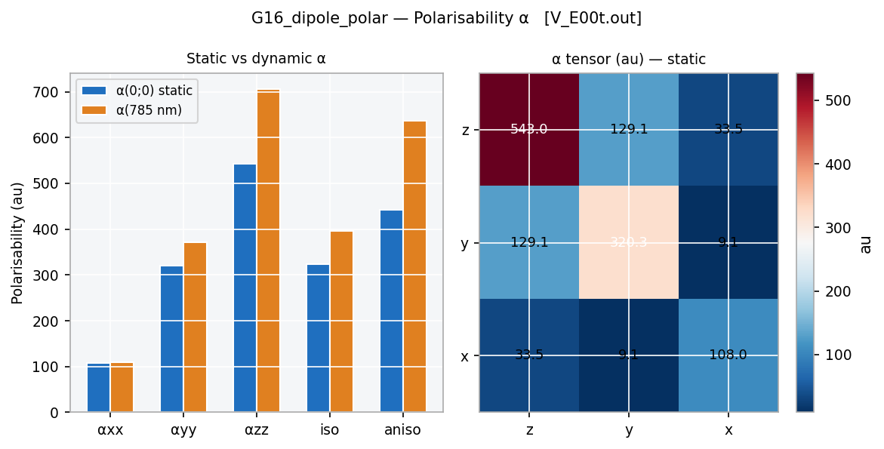
Figure 5 — G16_dipole_polar: static vs dynamic α components (left); α tensor heatmap (right). Note the resonance enhancement at 785 nm.

G16_hyperpolar

Synopsis
hp = G16_hyperpolar(filename)
hp = G16_hyperpolar(filename, 'units', 'esu')

Extracts β(0;0,0), β(−ω;ω,0) at all computed frequencies, and the diagonal vibrational hyperpolarisability. |β_vec| = √(βx²+βy²+βz²) is computed automatically.

Parameters
Parameter | Default | Description
'units' | 'au' | 'au' | 'esu' (10⁻³⁰) | 'SI' (10⁻⁵⁰)

Output fields
Field | Type | Description
.beta0.beta_vec | double | Static |β|
.beta0.par_z | double | Parallel component β‖ (z)
.beta0.tensor | struct | All Cartesian components xxx…zzz
.beta_dyn | struct array | One per frequency: .lambda_nm .beta_vec
.beta_vib | [1×3] | Diagonal vibrational β
.has_vib | logical | True if vibrational β found

Example
hp = G16_hyperpolar('V_E00t.out');
hp.beta0.beta_vec % 26572 au
hp.beta_dyn(1).lambda_nm % 785.0 nm
hp.beta_vib % [3818.6 182.6 -461.6] au

Relevant section in .out file
Beta(0;0,0):
|| (z) -0.608664D+03 _|_(z) -0.202888D+03
x -0.246462D+05 y -0.945637D+04 z -0.304332D+04
xxx -0.714181D+04 xxy -0.256445D+04
Diagonal vibrational hyperpolarizability:
3818.5527 182.5597 -461.5889

Example output plot
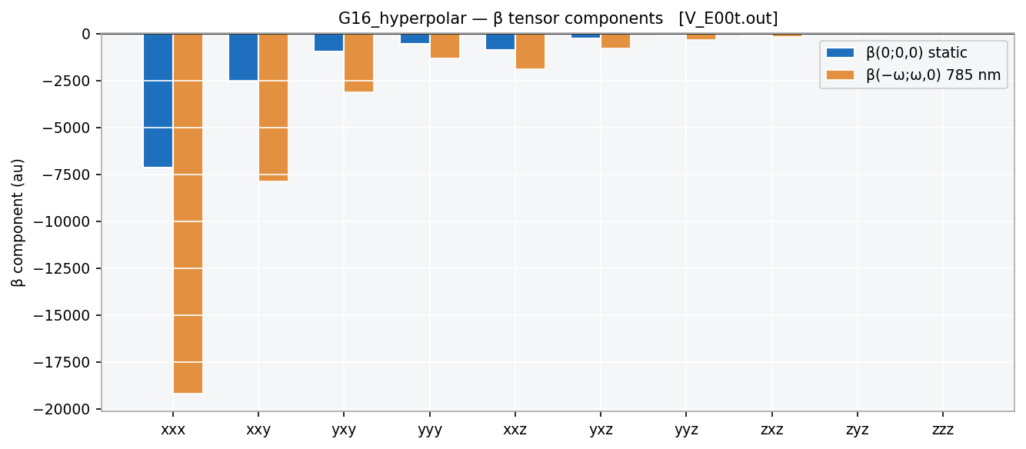
Figure 6 — G16_hyperpolar: β tensor components, static (blue) and at 785 nm (orange). The xxx component dominates due to the strong CT along the molecular axis.

G16_charges

Synopsis
ch = G16_charges(filename)
ch = G16_charges(filename, 'mode', 'heavy', 'threshold', 0.05)
ch = G16_charges(filename, 'type', 'APT', 'ColorScale', 'none')

Extracts Mulliken or APT charges and displays them as colour-coded labels on the 3D structure. RdBu scale: blue = negative, red = positive. In 'heavy' mode, H charges are summed onto the bonded heavy atom.

Parameters
Parameter | Default | Description
'type' | 'Mulliken' | 'Mulliken' | 'APT'
'mode' | 'atom' | 'atom' | 'heavy'
'ColorScale' | 'RdBu' | 'RdBu' | 'none'
'threshold' | 0 | Hide labels with |q| < threshold (e)
'FontSize' | 8 | Label font size

Output fields
Field | Type | Description
.charges | [Natoms×1] | Charge per atom (e)
.charges_H | [Nheavy×1] | H-summed charges on heavy atoms
.sum_q | double | Total charge (≈ 0 for neutral)
.type | char | 'Mulliken' or 'APT'

Example
ch = G16_charges('V_E00t.out');
ch.charges(8) % N8: -0.489 e
ch.charges(9) % C9: +0.414 e (carbonyl C)

Relevant section in .out file
Mulliken charges:
1
1 C -0.087530
8 N -0.488707
9 C 0.414191
10 O -0.353042
...
Sum of Mulliken charges = -0.00000

Example output plot
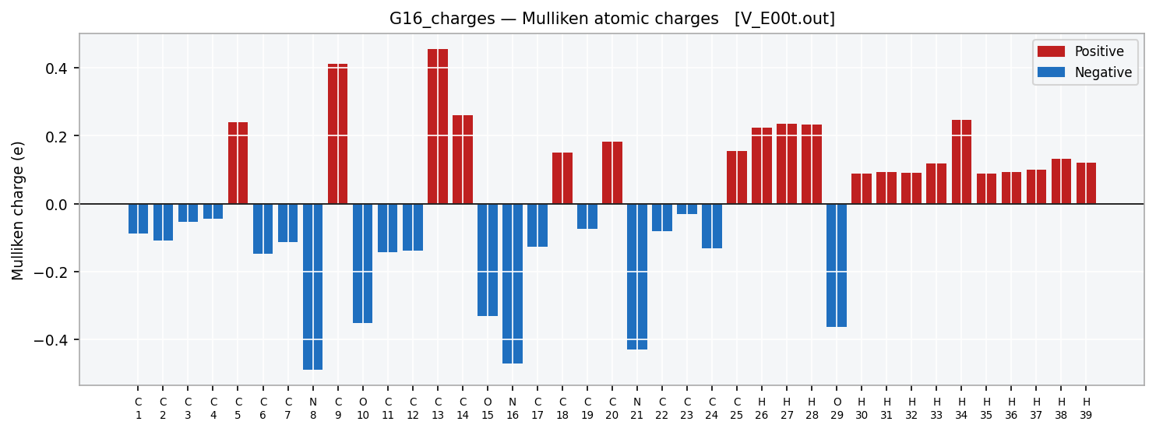
Figure 7 — G16_charges: Mulliken charge bar chart for all 39 atoms. Red = positive, blue = negative. The N and O atoms carry the largest negative charges.

G16_route

Synopsis
route = G16_route(filename)

Returns the complete route section as a single char string. Continuation lines are concatenated.

Output fields
Field | Type | Description
.return | char | Full route string

Example
r = G16_route('V_E00t.out');
→ output:
# opt=calcall freq=raman CPHF=Rdfreq b3lyp/6-311g(d,p) nosymm ...

Relevant section in .out file
-------------------------------------------------------
# opt=calcall freq=raman CPHF=Rdfreq b3lyp/6-311g(d,p) nosymm
-------------------------------------------------------

G16_charge_mult

Synopsis
[charge, mult] = G16_charge_mult(filename)

Extracts molecular charge and spin multiplicity from the first occurrence of the standard Gaussian line.

Output fields
Field | Type | Description
charge | int | Molecular charge (0, +1, −1, …)
mult | int | Spin multiplicity (1=singlet, 2=doublet, …)

Example
[q, m] = G16_charge_mult('V_E00t.out'); % q=0, m=1

Relevant section in .out file
Charge = 0 Multiplicity = 1

G16_restart

Synopsis
gjf = G16_restart(filename)
gjf = G16_restart(filename, 'step', 'last')
gjf = G16_restart(filename, 'step', 'first')
gjf = G16_restart(filename, 'step', N, 'extra_route', 'restart')
gjf = G16_restart(filename, 'nproc', 32, 'output', 'my_restart.gjf')

Generates a Gaussian 16 input file (.gjf) for restarting a calculation from any geometry stored in an existing .out file. The route section, Link 0 commands (%chk, %nprocshared, %mem), charge and multiplicity are copied verbatim from the original output file. The checkpoint filename receives the suffix '_restarted'. An informative comment block at the top of the .gjf records the source file and the generation tool. The title line identifies the job as a restart and reports which geometry step was used.

Parameters
Parameter | Default | Description
'step' | 'last' | 'last' | 'first' | integer N — which geometry block to use
'orientation' | 'auto' | 'auto' | 'standard' | 'input' — orientation to read from
'output' | '' | Output .gjf path (default: <source_base>_restarted.gjf)
'extra_route' | '' | Additional keywords appended to the route section
'nproc' | 0 | Override number of processors (0 = keep original)
'mem' | '' | Override memory string, e.g. '32GB' ('' = keep original)

Output fields
Field | Type | Description
.return | char | Full path of the generated .gjf file

Example
% Restart from optimised geometry (default — last step):
gjf = G16_restart('V_E00t.out');

% Restart from initial geometry:
gjf = G16_restart('V_E00t.out', 'step', 'first');

% Add 'restart' keyword to route (e.g. for SCF restart):
gjf = G16_restart('V_E00t.out', 'extra_route', 'restart');

% Override processors and save to a specific path:
gjf = G16_restart('V_E00t.out', 'nproc', 32, ...
'output', '/work/viol_restarted.gjf');
→ output:
── G16_restart ──
Source file : V_E00t.out
Geometry step : last (4 blocks total)
Orientation : Input orientation
Atoms : 39
Charge / Mult : 0 / 1
Route : # opt=calcall freq=raman CPHF=Rdfreq b3lyp/6-311g(d,p) ...
Checkpoint : /home/trusso/Viol_R/E02/out/V_E00t_restarted.chk
Output .gjf : V_E00t_restarted.gjf

Relevant section in .out file
! Restarted from: V_E00t.out
! Generated by G16_restart (G16 Toolbox / MATLAB)
!
%chk=/home/trusso/Viol_R/E02/out/V_E00t_restarted.chk
%nprocshared=24
----------------------------------------------------------------------
# opt=calcall freq=raman CPHF=Rdfreq b3lyp/6-311g(d,p) nosymm
cphf=grid=fine int=grid=ultrafine
----------------------------------------------------------------------

V_E00t_restarted from V_E00t.out (last geometry)

0 1
C -5.52266478 0.65882300 -0.43869200
C -4.94429700 1.90647600 -0.67026900
... (39 atoms total)

4. Gaussian 16 Keywords Required

The following table maps each function to the Gaussian 16 route keywords needed to produce the relevant output.

Function(s) | Required keyword(s) | Notes
G16_structure | opt or freq | Any job printing an orientation block
G16_spectra (IR only) | freq | Standard harmonic frequencies
G16_spectra (IR + Raman) | freq=Raman | Adds Raman activities
G16_nmodes | freq | Normal coordinates always printed
G16_energy (thermo) | freq | Thermochemistry requires freq
G16_convergence | opt | Printed only during optimisation
G16_tddft | td=(nstates=N) | TD-DFT excited states
G16_dipole_polar (α) | polar or freq=Raman | CPHF=Rdfreq for dynamic α
G16_hyperpolar (β) | polar=cubic or freq=Raman CPHF=Rdfreq | Cubic response needed
G16_charges (Mulliken) | (always printed) | Default pop in Gaussian
G16_charges (APT) | freq | APT charges from freq job
G16_restart | (reads from existing .out) | Requires G16_structure internally

5. Typical Workflows

5.1 Geometry + Spectroscopy

mol = G16_structure('calc.out');
G16_draw_molecule(mol, 'ShowLabels', false);
sp = G16_spectra('calc.out', 'FWHM', 10, 'plot', true);
nm = G16_nmodes('calc.out');
G16_draw_mode(mol, nm, 91);

5.2 Boltzmann-Weighted Raman (conformer ensemble)

files = {'conf1.out','conf2.out','conf3.out'};
sp_avg = zeros(4001,1); E0_ref = NaN; W_tot = 0;
for i = 1:numel(files)
en = G16_energy(files{i});
if isnan(E0_ref), E0_ref = en.G; end
dG = (en.G - E0_ref) * 2625.5; % kJ/mol
w = exp(-dG*1000/(8.314*298));
sp_i = G16_spectra(files{i});
sp_avg = sp_avg + w * sp_i.Raman_cont;
W_tot = W_tot + w;
end
plot(sp_i.x, sp_avg / W_tot)

5.3 SERS / NLO Analysis

dp = G16_dipole_polar('calc.out');
hp = G16_hyperpolar('calc.out');
ch = G16_charges('calc.out', 'mode','heavy', 'threshold', 0.05);
fprintf('mu = %.4f D\n', dp.mu_tot)
fprintf('alpha(785) = %.2f au\n', dp.alpha_dyn(1).iso)
fprintf('|beta| = %.1f au\n', hp.beta0.beta_vec)

5.4 Restart a Calculation

Restart from optimised geometry (identical route):
gjf = G16_restart('V_E00t.out');
% → V_E00t_restarted.gjf with last geometry, same route

Restart from the initial (input) geometry:
gjf = G16_restart('V_E00t.out', 'step', 'first');

Append extra keywords to the route:
gjf = G16_restart('V_E00t.out', 'extra_route', 'scf=qc');

Pipeline: check convergence, then restart if needed:
cv = G16_convergence('run1.out');
if ~cv.converged
gjf = G16_restart('run1.out', 'extra_route', 'scf=qc maxcycles=200');
fprintf('Restart input written to: %s\n', gjf)
else
fprintf('Converged at step %d.\n', cv.conv_step)
end

6. Version Information

Item | Value | Notes
Toolbox version | 1.0 (June 2026) | Initial release
Gaussian version | Gaussian 16 Rev. A.03–C.02 | Tested on Rev. C.02
MATLAB version | R2021b or later | Tested on R2024b; uses containers.Map, inputParser
Generated by | Claude Sonnet 4.6 | Anthropic, 2026
Institution | CNR-IPCF Messina | Istituto per i Processi Chimico-Fisici
Author | Sebastiano Trusso | trusso@ipcf.cnr.it
Test file | V_E00t.out | Violacein, B3LYP/6-311G(d,p), opt=calcall freq=raman CPHF=Rdfreq

📌 All parsers validated against V_E00t.out (violacein, 39 atoms, 111 normal modes). All plots in this manual are generated from real data extracted from that file.

