Week 1 Assignment Report
Java Fundamentals

Name: Mounika
College: Narayana Engineering College, Gudur
Branch: Computer Science and Engineering
Internship: Java Internship
Submitted By: Mounika

Objective

The main objective of this assignment is to understand the fundamental concepts of Java programming and develop basic programming skills. This assignment focuses on learning Java syntax, variables, data types, user input using the Scanner class, arithmetic operators, and type casting. It also helps in understanding how to write, compile, and execute Java programs in a proper development environment. By completing these tasks, students gain practical experience in writing simple Java programs, improve logical thinking and problem-solving skills, and build a strong foundation for advanced Java programming concepts that will be covered in future assignments.

Task 1: java setup & Hello World
Code:
public class Task1 {
public static void main(String[] args) {
System.out.println("Name: Mounika");
System.out.println("College Name: Narayana Engineering College, Gudur");
System.out.println("Branch: Computer Science and Engineering");
System.out.println("Welcome to Java Programming!");
}
}
Output:

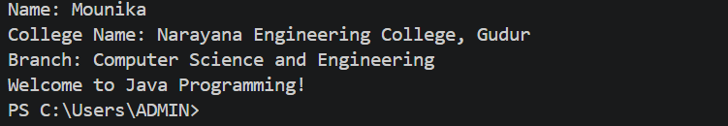
Explanation:
This program is the first Java program that demonstrates the basic structure of a Java application. It displays the student's name, college name, branch, and a welcome message using System.out.println(). It helps in understanding the basic syntax and output statements in Java.

Task 2 : Variable & Data Types
Code:
public class Task2 {
public static void main(String[] args) {

// Variables
String name = "Mounika";
int age = 20;
float height = 5.3f;
double weight = 52.5;
double cgpa = 9.33;
char gender = 'F';
boolean isStudent = true;

// Display Output
System.out.println("Name: " + name);
System.out.println("Age: " + age);
System.out.println("Height: " + height + " feet");
System.out.println("Weight: " + weight + " kg");
System.out.println("CGPA: " + cgpa);
System.out.println("Gender: " + gender);
System.out.println("Is Student: " + isStudent);
}
}

Output:

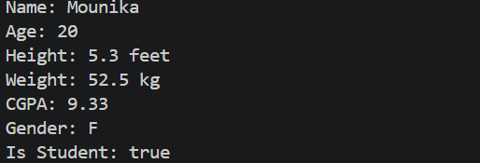
Explanation:
This program demonstrates the use of Java variables and different data types such as String, int, float, double, char, and boolean. Each variable stores a specific type of information and the program displays all the stored values in a neat format. This helps in understanding how data is stored and used in Java.

Task 3 : Scanner class
Code:
import java.util.Scanner;
public class Task3 {
public static void main(String[] args) {
Scanner sc = new Scanner(System.in);
System.out.print("Enter Full Name: ");
String name = sc.nextLine();
System.out.print("Enter Age: ");
int age = sc.nextInt();
sc.nextLine();
System.out.print("Enter College Name: ");
String college = sc.nextLine();
System.out.print("Enter Branch: ");
String branch = sc.nextLine();
System.out.print("Enter City: ");
String city = sc.nextLine();
System.out.println("\n----- Student Details -----");
System.out.println("Full Name : " + name);
System.out.println("Age : " + age);
System.out.println("College : " + college);
System.out.println("Branch : " + branch);
System.out.println("City : " + city);
sc.close();
}
}
Output:
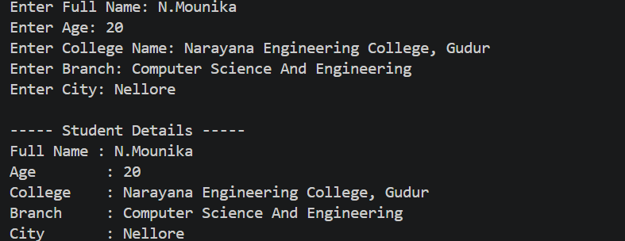
Explanation:
This program uses the Scanner class to accept input from the user through the keyboard. It collects details such as name, age, college, branch, and city, and then displays them in a formatted manner. This helps in learning user input handling and output formatting in Java.

Task 4 : Operators Practice
Code:
import java.util.Scanner;
public class Task4 {
public static void main(String[] args) {
Scanner sc = new Scanner(System.in);
System.out.print("Enter First Number: ");
int num1 = sc.nextInt();
System.out.print("Enter Second Number: ");
int num2 = sc.nextInt();
System.out.println("\n----- Calculator Results -----");
System.out.println("Addition = " + (num1 + num2));
System.out.println("Subtraction = " + (num1 - num2));
System.out.println("Multiplication = " + (num1 * num2));
System.out.println("Division = " + (num1 / num2));
System.out.println("Modulus = " + (num1 % num2));
sc.close();
}
}
Output :

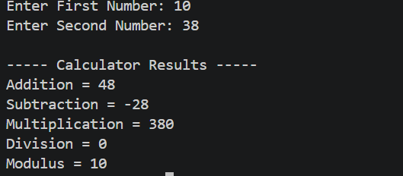

Explanation:
This program performs basic arithmetic operations using two numbers entered by the user. It calculates addition, subtraction, multiplication, division, and modulus using Java operators. This task helps in understanding arithmetic operators and mathematical calculations in Java.

Task 5 : Type Casting
Code:
public class Task5 {
public static void main(String[] args) {
// Implicit Type Casting
int number = 25;
double doubleNumber = number;
System.out.println("Implicit Type Casting");
System.out.println("Before Casting (int): " + number);
System.out.println("After Casting (double): " + doubleNumber);
System.out.println();
// Explicit Type Casting
double marks = 95.75;
int intMarks = (int) marks;
System.out.println("Explicit Type Casting");
System.out.println("Before Casting (double): " + marks);
System.out.println("After Casting (int): " + intMarks);
}
}

Output:

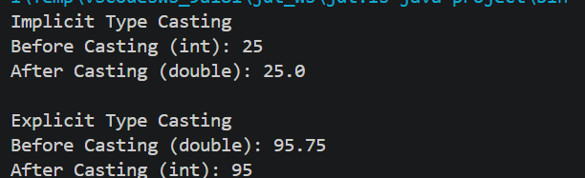

Explanation:
This program demonstrates both implicit and explicit type casting in Java. Implicit type casting automatically converts a smaller data type into a larger one, while explicit type casting manually converts a larger data type into a smaller one. This task helps in understanding data type conversion and how it affects values during execution.

Task 6 : Java Fundamentals Practices
Code:
import java.util.Scanner;
public class Task6 {
public static void main(String[] args) {
Scanner sc = new Scanner(System.in);
// Input
System.out.print("Enter an Integer value: ");
int intValue = sc.nextInt();
System.out.print("Enter a Float value: ");
float floatValue = sc.nextFloat();
System.out.print("Enter a Double value: ");
double doubleValue = sc.nextDouble();
// Display Original Values
System.out.println("\n----- Original Values -----");
System.out.println("Integer : " + intValue);
System.out.println("Float : " + floatValue);
System.out.println("Double : " + doubleValue);
// Implicit Type Casting
double implicitCast = intValue;
// Explicit Type Casting
int explicitCast = (int) doubleValue;
// Display Type Casting
System.out.println("\n----- Type Casting -----");
System.out.println("Implicit Casting (int to double): " + implicitCast);
System.out.println("Explicit Casting (double to int): " + explicitCast);
sc.close();
}
}
Output:

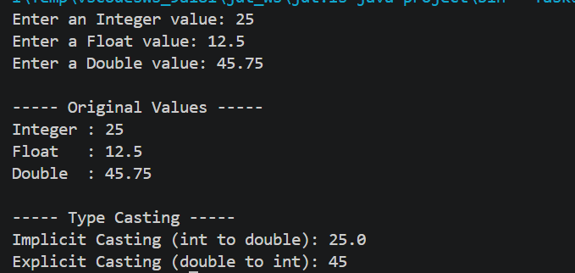
Explanation:
This program accepts integer, float, and double values from the user and demonstrates both implicit and explicit type casting. It displays the values before and after conversion, making it easy to understand the changes that occur during type casting. This task improves knowledge of data conversion techniques used in Java programming.

Conclusion:
This Week 1 assignment helped me understand the fundamental concepts of Java programming. I learned how to write and execute Java programs, use variables and different data types, accept user input using the Scanner class, perform arithmetic operations using operators, and apply both implicit and explicit type casting. By completing these tasks, I improved my programming skills and gained confidence in writing simple Java programs. This assignment has provided a strong foundation for learning advanced Java concepts in the upcoming weeks.

