Entity Relationship Diagram (Team 11)

Lucid Chart Link
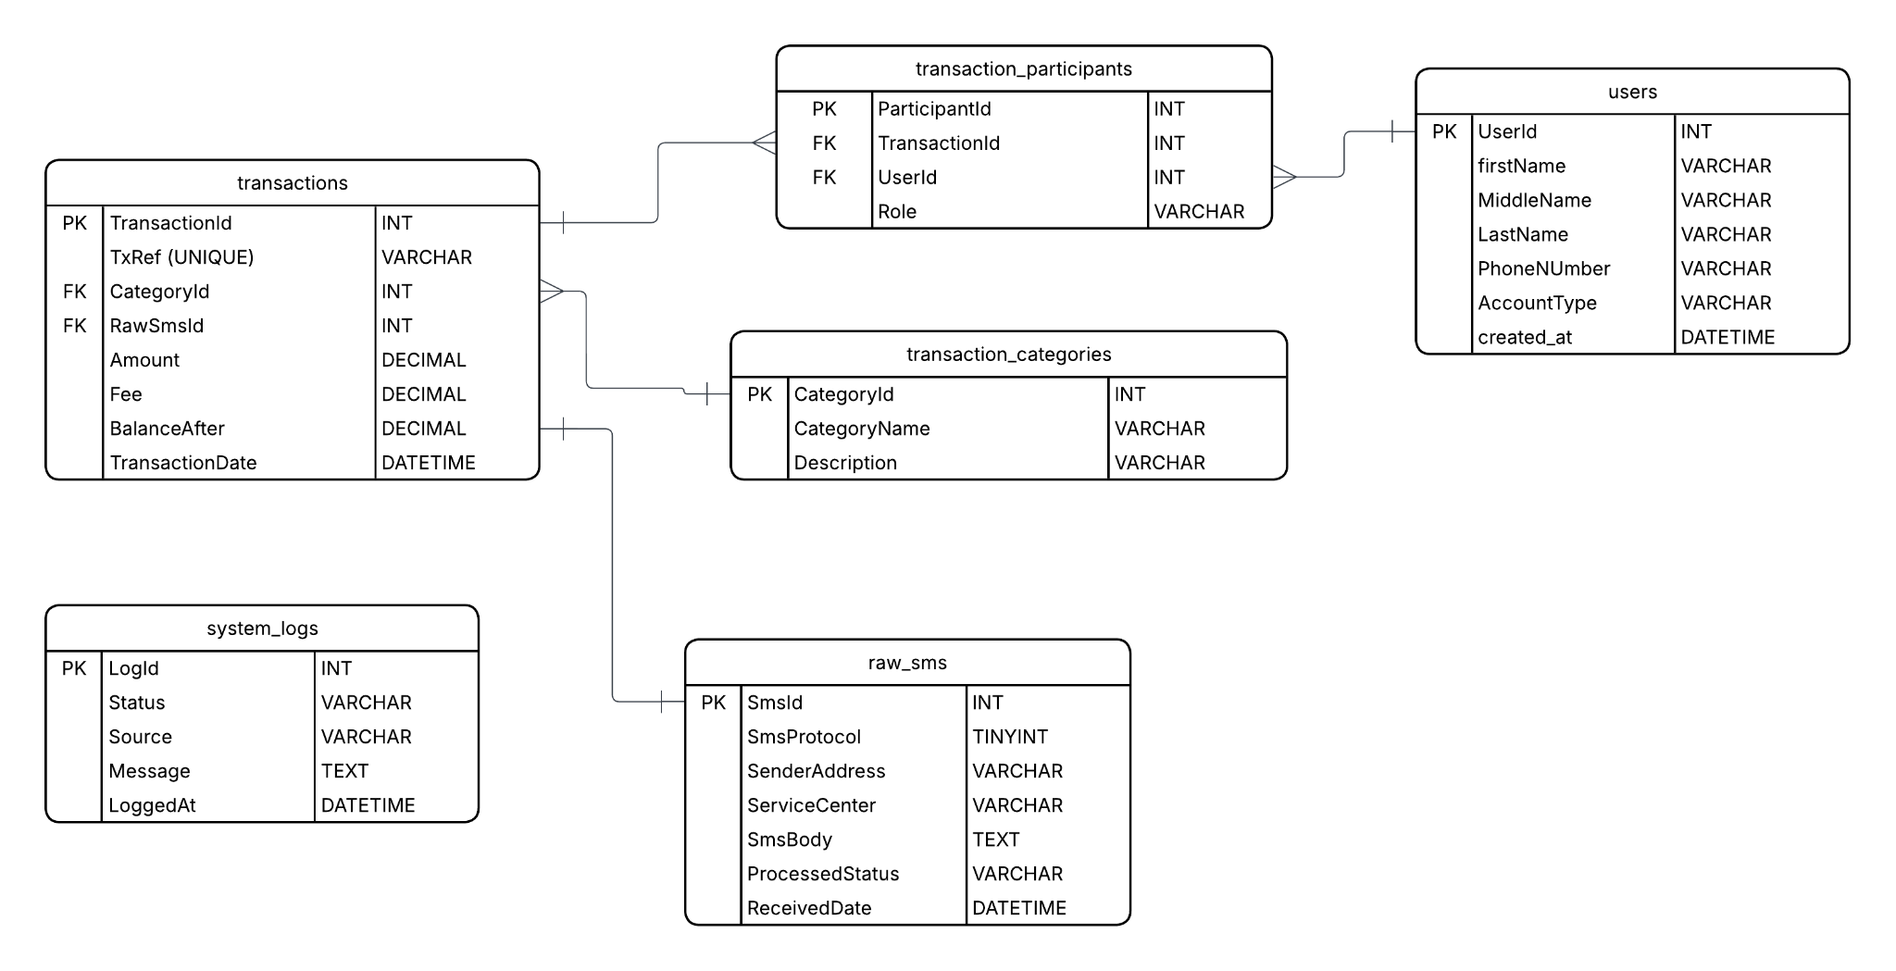
Design Process Explanation

When we went to design this database, we wanted to ensure that every piece of a MoMo SMS could be saved properly without losing any critical data. We started by looking at the XML data and realized that a single text message actually has a lot of different parts, like the transaction ID, the amount, and the people involved.

So we decided to create a table called raw_sms to hold the original text exactly how it comes in(most of it anyway). We did this because if something goes wrong when we are trying to process the data, we can go back to read the original message.

The tricky part was figuring out how to handle transaction tables and users but since one transaction always involves two people (like Jane Smith and Robert Brown in XML), we used a "junction table" called transaction_participants. This allowed us to link one transaction to two different users and give them "roles" like sender or receiver.

To properly normalize our dbs we decided to implement foreign keys wherever was appropriate so we also made a transaction_categories table. This helps the system know if a transaction is a simple transfer, a bank deposit, or a payment. We also added a system_logs table because, in a real system, you need a way to track errors or see if the data processing is actually working. And finally for the money, like the balance and fees, we used the DECIMAL type to make sure the math stays exact and doesn't have rounding errors.

One last conflict was knowing whether to store the user’s balance we create an account table with their user_id, account number and balance but we ended up adding that column to the transactions table instead and calling it “balance_after”.

Tables identified from XML data structure document shared:

Tables / Entities | Why they matter
raw_sms | It stores the original xml sms data
transactions | Financial events extracted from SMS
transaction_categories | For transaction type categories
users | Stakeholders in the system
transaction_participants (junction table) | This table will connect users and their transactions
system_logs | It’s for tracking actions called out in the system

Tables Entities Defined:

- Raw_sms

Column | DataType | Constraints | Description
SmsId | INT | Primary Key, Auto Increment | Unique id for every received sms
SmsProtocol | TINYINT | UNIQUE, NOT NULL | Protocol value extracted from the xml
SenderAddress | VARCHAR | FOREIGN KEY | Sender of the sms
ServiceCenter | VARCHAR | FOREIGN KEY | SMS service center number
SmsBody | TEXT | CHECK(amount >= 0 ) | Message body content
ProcessedStatus | VARCHAR | Default 0 | Flag to track if the message was parsed yet.
ReceivedDate | DATETIME | NULL Allowed | Human readable date and time for when the user received sms
created_at | DATETIME | NOT NULL | Date and time this entry was made into the db

- Users

Column | DataType | Constraints | Description
UserId | INT | Primary Key, Auto Increment | This is the primary key for this table to uniquely identify each user
firstName | VARCHAR | NOT NULL | First name extracted from sms
MiddleName | VARCHAR | NULL ALLOWED | Second name extracted from sms
LastName | VARCHAR | NOT NULL | Last name extracted from sms
PhoneNumber | VARCHAR | NULL ALLOWED | Stores phone numbers if they are available
AccountType | VARCHAR | ‘Customer’, ‘merchant’ or ‘system’ | Stores the role of the user
created_at | DATETIME | NOT NULL | Date and time of the record entry in the db

- Transaction_categories

Column | DataType | Constraints | Description
CategoryId | INT | Primary Key, Auto Increment | This is the primary key for this table to uniquely identify categories
CategoryName | VARCHAR | UNIQUE, NOT NULL | This carries the category name
Description | VARCHAR | FOREIGN KEY | Explanation of the transaction type

- Transactions

Column | DataType | Constraints | Description
TransactionId | INT | Primary Key, Auto Increment | This is the primary key for this table to uniquely identify the transaction records.
TxRef | VARCHAR | UNIQUE, NOT NULL | Transaction reference number (TxId)
CategoryId | INT | FOREIGN KEY | Links to transaction category
RawSmsId | INT | FOREIGN KEY | Links transactions to the original sms source
Amount | DECIMAL(12,2) | CHECK(amount >= 0 ) | Amount transferred or paid
Fee | DECIMAL | Default 0 | Transaction fee charged
BalanceAfter | DECIMAL | NULL Allowed | Balance after transaction
TransactionDate | DATETIME | NOT NULL | Date and time of the transaction
created_at | DATETIME | NOT NULL | Date and time this entry was made into the db

- Transactions_Participants

Column | DataType | Constraints | Description
ParticipantId | INT | Primary Key, Auto Increment | This column is for unique identification of the primary key for this table.
TransactionId | INT | PRIMARY KEY, FOREIGN KEY | Transaction reference number (TxId)
UserId | INT | PRIMARY KEY, FOREIGN KEY | References the user involved
Role | VARCHAR | ‘sender’,’receiver’ | It is an enum types and it defines if the user sent or received the money

- System_logs

Column | DataType | Constraints | Description
LogId | INT | Primary Key, Auto Increment | This is the primary key for this table to uniquely identify the transaction records.
Status | VARCHAR | ‘info’,’warn’,’error’ | Enum type, helps developers access system failure level
Source | VARCHAR | Null Allowed | Will be useful for error handling to know where the error came from whether backend code or from parsing the sms.
Message | TEXT | Not null | Description of what happened
LoggedAt | DATETIME | DEFAULT CURRENT_TIMESTAMP | Automatic timestamp of the log entry

Sample queries demonstrating your database functionality

- SELECT user_id, CONCAT(first_name, ' ', COALESCE(middle_name, ''), ' ', last_name) AS full_name, phone_number, account_type, created_at FROM users ORDER BY user_id;
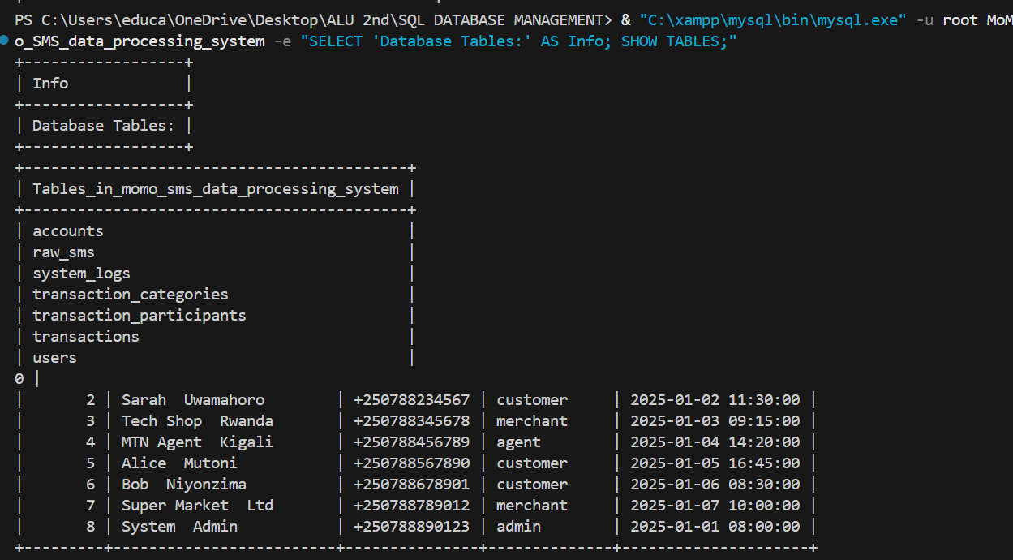
- SELECT a.account_id, CONCAT(u.first_name, ' ', u.last_name) AS account_holder, a.miadn, a.provider, a.currency, a.first_seen_at FROM accounts a INNER JOIN users u ON a.user_id = u.user_id ORDER BY a.account_id;
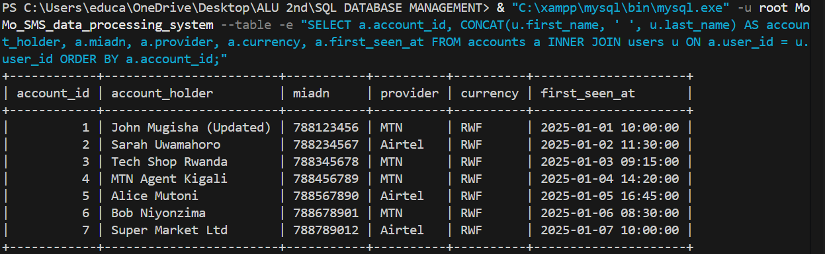
- SELECT category_id, category_name, description FROM transaction_categories ORDER BY category_name;
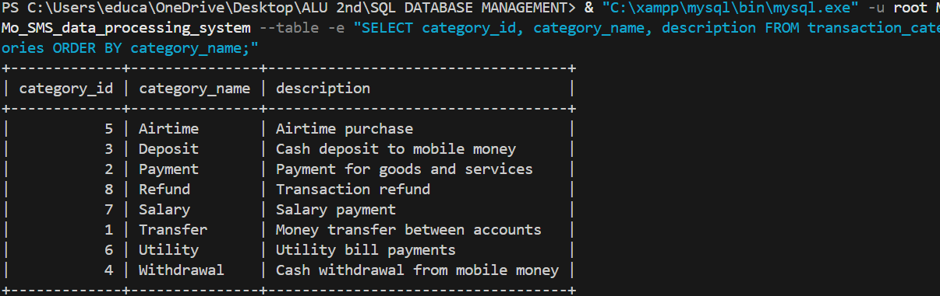
- SELECT t.transaction_id, t.tx_reference, t.amount, t.fee, t.balance_after, tc.category_name, t.transaction_date FROM transactions t LEFT JOIN transaction_categories tc ON t.category_id = tc.category_id ORDER BY t.transaction_date DESC;
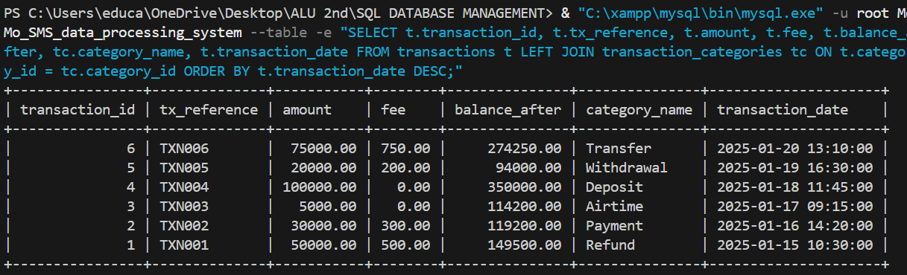
- INSERT INTO users (first_name, middle_name, last_name, phone_number, account_type) VALUES ('David', NULL, 'Habimana', '+250788555666', 'customer'); SELECT user_id, CONCAT(first_name, ' ', COALESCE(middle_name, ''), ' ', last_name) AS full_name, phone_number, account_type, created_at FROM users WHERE phone_number = '+250788555666';
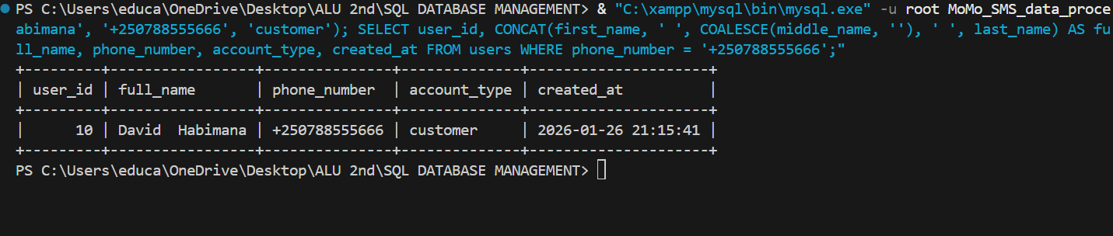

7. UPDATE users SET phone_number = '+250788123777', account_type = 'merchant' WHERE user_id = 6; SELECT user_id, CONCAT(first_name, ' ', last_name) AS full_name, phone_number, account_type FROM users WHERE user_id = 6
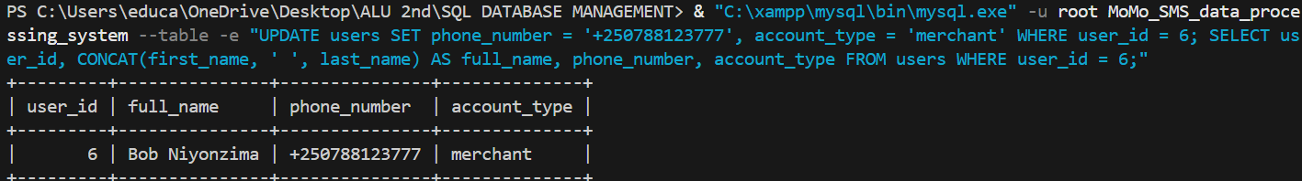
Unique rules added to enhance security and accuracy of the DB

- SHOW CREATE TABLE users\G
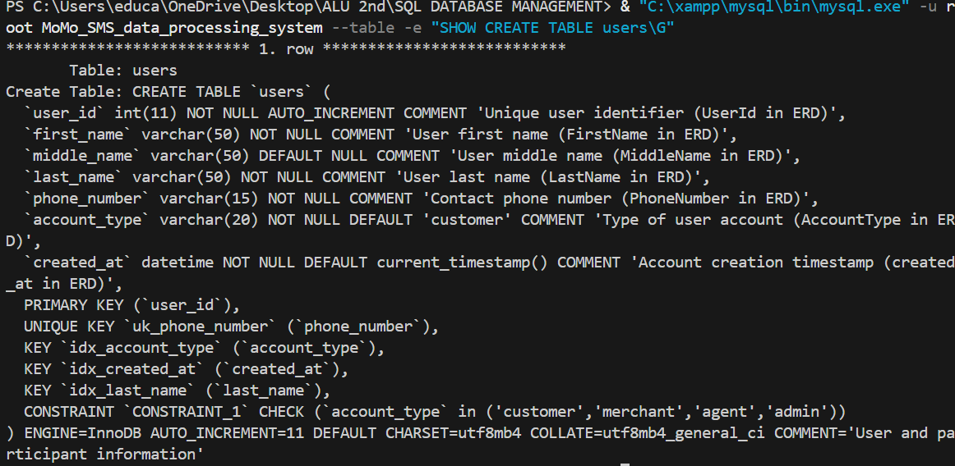
- SHOW CREATE TABLE transactions\G
