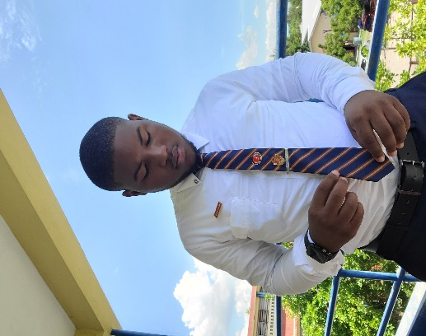 **MY RESUME**

**Adrian Dacosta**

[144 Patrick Drive]  
[Kingston 20]  
[adriandacosta4321@gmail.com | [876-784-4594]

**Objective**

Highly motivated and detail-oriented individual with a strong background in leadership, community service, and technical skills. Seeking to leverage my experience and academic background in a dynamic environment while pursuing a degree in Computer Science at the University of Technology, Jamaica.

**Education**

**University of Technology, Jamaica**  
*Bachelor of Science in Computer Science*  
Expected Graduation: [2028]

**St. Andrew Technical High School**  
*High School Diploma*  
Graduated: 2024

**Certifications:**

* City and Guilds Math Level 3
* City and Guilds English Level 3
* School leaving certificate (5 years of engineering)

**MOST OUSTANDING STUDENT IN:**

* ENGLISH LANGUAGE (2022)
* INFORMATION TECHNOLOGY(2022)

**Subjects:**

* CAPE UNIT 2 (Completed): Information Technology, Environmental Science, Entrepreneurship, Communication Studies
* CAPE UNIT1(Pending): Information Technology, Environmental Science, Entrepreneurship, Caribbean Studies
* CSEC: English Language, Mechanical Engineering, Information Technology, Physical Education, AutoCAD

**Experience**

**Head Boy**  
*St. Andrew Technical High School*   
[2023-2024]

* Provided leadership and represented the student body at various school functions and meetings.
* Facilitated communication between students and school administration.
* Organized and led school events and initiatives to enhance student engagement.

**Youth Counselor**  
*KSAMCJC Youth Council*  
2023 - 2024

* Counseled and mentored youth on personal and academic development.
* Organized workshops and seminars to address youth-related issues.
* Collaborated with community organizations to provide support and resources for young people.

**President, Key Club**   
[*St. Andrew Technical High School*]  
[2020-2021, 2023-2024]

* Led a team of [number] members to organize and execute various community service projects.
* Coordinated with local organizations to provide volunteer opportunities for club members.
* Implemented new initiatives to increase member participation and engagement.

**Brand Ambassador**  
*Beyond All Doubt Foundation*

* Represented the foundation at various events and functions.
* Assisted in promoting the foundation’s mission and programs through social media and public speaking engagements.
* Collaborated with the marketing team to develop strategies for increasing brand awareness.

**Community Service Volunteer**  
*Flow*  
2023

* Participated in community service projects to support local initiatives.
* Assisted with organizing and executing events and activities.
* Engaged with community members to provide support and resources.

**Skills**

* **Technical:** Proficient in [list programming languages, software, tools, etc.].
* **Leadership:** Strong leadership and team management skills, developed through roles as Head Boy and President of the Key Club.
* **Communication:** Excellent verbal and written communication skills, honed through public speaking and roles as an MC.
* **Problem-Solving:** Demonstrated ability to identify problems and develop effective solutions.

**Activities and Honors**

* **Valedictorian:** 2022
* **Master of Ceremonies:** Grandfather’s 77th Birthday Celebration, School Leaving Sixth Form Banquet
* **Volunteer:** [Any other volunteer work or community service]
* **Awards:** Most Outstanding Student in Information Technology and English Language, Most Punctual, Most Congenial

**References**

Available upon request.