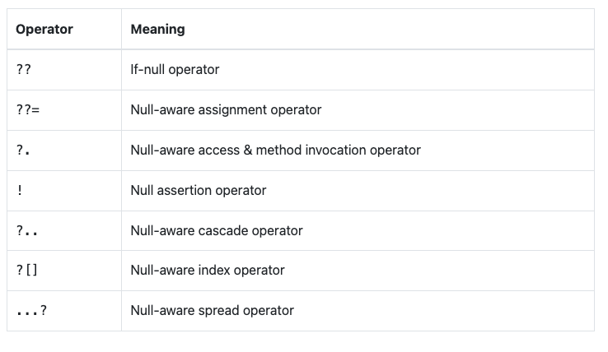

**If-null operator**

In Flutter, the null-aware operators are used to handle situations where a variable might be null. There are two main null-aware operators: the null-aware access (**?.**) and the null-aware assignment (**??**).  
  
var fullName = name ?? 'John Doe'

**Null-aware assignment operator**

The null-aware assignment operator (**??=**) in programming languages like Dart and some others provides a concise way to assign a value to a variable only if the variable is currently null. If the variable is not null, the assignment operation is skipped, and the existing value of the variable remains unchanged

name ??= 'John Doe';

* **NullAware Access & method Invocation operator**The null-aware access operator is used to invoke a method or access a property of an object only if the object is non-null.
* If the object is null, the entire expression evaluates to null instead of causing a null reference error.

String message = name?.toUpperCase() ?? 'Default Message';

**Null assertion Operator**

The null assertion operator (**!**) in Dart is used to assert to the Dart type system that an expression with a nullable type is non-null. It essentially tells the compiler to treat a nullable expression as non-nullable, even if it might result in a runtime null reference error.

String greeting = 'Hello, ' + nullableName!;

**Nu**   
The null-aware cascade operator (**..?**) in Dart is a convenient tool for chaining multiple method calls or property accesses on an object while handling null gracefully. It allows you to perform a sequence of operations on an object, even if that object is null, without causing null reference errors.**ll-aware casacde operator**

myObject..?method1()..?method2()..?property1;

**Null Aware index operator**

* When accessing elements in a list or values in a map, you can use the **??** operator to provide a default value if the index or key is not present or if it evaluates to null.
* This helps prevent null reference errors when working with collections.

String value = data?[key] ?? defaultValue;

**Null Aware spread operator**

The spread operator (**...**) is used to insert all the elements of a list or all the key-value pairs of a map into another list or map.

List<int> destinationList = [...?sourceList];