Article
A Remote Sensing and Machine Learning Framework for Evaluating Urban Greening–Energy Trade-Offs in Desalination-Dependent Cities: Spatial Validation and Metric Diagnostics in a Jeddah Case Study
Nelly F. Almaktoum ¹
¹[AUTHOR TO COMPLETE: university or institution, department, country, city; e-mail]
Abstract: Urban greening can lower surface temperature, but in desalination-dependent cities the irrigation that sustains it has an energy cost. We present a reproducible remote sensing and machine learning framework for evaluating this trade-off, demonstrated on Jeddah. Landsat 8 composites processed in Google Earth Engine form a panel of 90 m cells. An XGBoost model predicts land surface temperature (LST) and is scored by spatial GroupKFold (R² = 0.795, RMSE = 1.184 °C on 19,650 non-greened cells). Before its predictions are used for greening scenarios or for the Normalized Environmental Gain Index (NEGI), they must pass two further gates: a feature-space support screen and a comparison with measured matched contrasts. Matching 1,006 greened cells outside the built-up area to never-vegetated controls gives −1.181 °C per greened pixel, with 55.7% of leverage in one spatial block. An own-only slope of −1.925 decomposes exactly into a joint own coefficient near −1.0 plus co-varying neighbour greening. The model failed the gates: it had support for 14 of 744 outside validation cells and under-predicted measured cooling by 1.01–7.24 °C, so no scenario or NEGI values are reported. Absolute-LST skill does not establish counterfactual validity. We also show that NEGI's cost term is a shape assumption shared by all pathways and that its maximum is fixed by position. A hypothetical ledger converts assumed irrigation into desalination energy per degree of measured cooling. Water and energy quantities are assumed, not measured; interval coverage is unproven; and transfer to other cities is untested.
Keywords: urban greening; land surface temperature; remote sensing; XGBoost; spatial cross-validation; matched difference-in-differences; Normalized Environmental Gain Index; seawater desalination

1. Introduction

1.1. Urban Greening and the Water–Energy–Thermal Nexus
Rapid urbanization has intensified urban heat, increasing thermal exposure and cooling demand. Urban vegetation is widely used as a nature-based mitigation strategy because shading, evapotranspiration and modification of the surface energy balance can reduce surface temperatures [1–4]. The size of these effects depends on climate, urban form, vegetation type and water availability. In arid environments, sustaining vegetation usually requires irrigation, which creates a trade-off between thermal benefit and resource demand [5].
The trade-off is sharper where irrigation water comes from seawater desalination. Desalination relieves freshwater scarcity, but producing and delivering the water requires energy [6,7]. We use the term desalination-dependent city for a city whose municipal water supply relies predominantly on desalination; the cities we have in mind are hot, arid and coastal. Global installed desalination capacity is concentrated in such regions [8], and reported energy use for seawater reverse osmosis is of the order of a few kilowatt-hours per cubic metre [7,9]. Additional vegetation in such a city may therefore improve surface thermal conditions while raising the energy needed for irrigation.
Jeddah, Saudi Arabia, is the case study. Its hot-arid coastal climate, rapid urban development, freshwater scarcity and reliance on desalinated water couple urban heat mitigation with resource use [10–12]. Electricity demand for cooling in Saudi Arabia is closely tied to temperature [13].

1.2. Remote Sensing and Machine Learning for Urban Thermal Assessment
Satellite remote sensing gives spatially consistent measurements of urban surfaces. The Normalized Difference Vegetation Index (NDVI) summarises vegetation greenness from red and near-infrared reflectance, the Normalized Difference Built-up Index (NDBI) summarises built-up surfaces from shortwave-infrared and near-infrared reflectance, and thermal bands give land surface temperature (LST), the radiative temperature of the ground surface [1,14–16]. LST is not air temperature and is not a measure of human thermal comfort.
Machine-learning regressors can capture nonlinear relations and interactions in such data [17,18]. Extreme Gradient Boosting (XGBoost), an ensemble of regression trees fitted by gradient boosting [19], is widely used for urban thermal modelling [20–22]. Once fitted, such a model can act as a fast surrogate for evaluating many hypothetical surface states [23]. A surrogate of this kind is empirical: it reproduces associations in the training data, and its predictions for changed inputs are not causal effects unless further assumptions hold.
Two validation questions follow, and they are the computational core of this paper. First, pixels close together are statistically dependent, so a random train–test split overstates skill; validation must hold out whole spatial blocks [24–26]. Second, a prediction for a modified surface is only as good as the training data near that point in feature space, which motivates an explicit support screen in the spirit of the area of applicability [27]. Neither check tells us whether a predicted change is correct; for that, predictions must be compared with measured changes.

1.3. Aim, Scope and What Is Not Measured
The aim of this study is to develop a remote sensing and machine learning framework for evaluating urban greening–energy trade-offs in desalination-dependent cities. That statement needs three qualifications. (i) Trade-offs are evaluated through illustrative scenarios with an assumed irrigation-energy cost. No irrigation volumes, building energy use or desalination energy are measured anywhere in the study. (ii) Jeddah is the single demonstration site. (iii) Applicability to other desalination-dependent cities is a design intent that has not been tested: the pipeline takes city-specific inputs and parameters, but the estimates, the fitted model and the scenario ledger reported here must be recalibrated for another city and do not transfer (Section 4.3).
LST and irrigation energy are physically different quantities. A predicted LST reduction is not a building-energy saving, and the framework does not convert one into the other. It defines a dimensionless index whose assumptions are written out, and it tests the predictive model against an independent, measurement-based analysis before any model-based comparison is allowed.

1.4. Research Questions and Contributions
The study addresses four research questions.
RQ1: How well can XGBoost predict urban LST from satellite-derived surface predictors under spatially structured validation?
RQ2: How does measured LST change where vegetation was established, and do model-predicted changes agree with those measurements?
RQ3: How can cooling be set against an assumed desalination-energy cost of irrigation in one normalized metric, and what are that metric's mathematical limits?
RQ4: How robust are the estimates to spatial leverage, neighbour exposure, feature-space support and analysis choices?
The contributions are computational and mathematical. (a) An end-to-end, scripted pipeline from satellite export to tables and figures, with seeds, hashes and tests. (b) Three validation gates that decide when model predictions may be used: spatial GroupKFold, a feature-space support screen and a matched-contrast benchmark. (c) NEGI as a defined normalized metric with every assumption stated, together with its documented limits. (d) Evidence that skill in predicting absolute LST does not give counterfactual validity. (e) Estimand and identifiability diagnostics: the exact relation between own-only and joint regression coefficients, dose-squared leverage and collinearity. (f) Tests, export reconciliation checks and a synthetic recovery test in which the true effect is known.

2. Materials and Methods

2.1. Overview of the Framework
Table 1 lists the stages. The order matters: the model is trained and scored first, the matched-contrast benchmark is built independently of it, and model-based scenarios and the index are evaluated only if the model passes the gates of stage 4. Populations differ between stages and are stated with every result; their numbers are never pooled.
Table 1. Stages of the framework, their inputs and outputs.
Stage | Input | Method | Output
1. Satellite processing | Landsat 8 Collection 2 Level-2, Google Earth Engine | Cloud masking, seasonal compositing, index calculation, cell classification | 90 m cell panel, 2014–2025
2. Machine-learning model | Non-greened cells of the panel | XGBoost; spatial GroupKFold; spatial refits | LST predictor and skill metrics
3. Matched-contrast benchmark | Greened cells and never-vegetated controls | Stratified matching, zero-intercept slopes, spatial block bootstrap, joint-ring regressions | Measured contrasts and diagnostics
4. Counterfactual gates | Stages 2 and 3 | Feature-space support screen; model-minus-measured comparison | Pass or fail for model-based use
5. Pathways and NEGI | Model predictions, if stage 4 is passed | Normalized benefit minus normalized cost | Index trajectories
6. Water–energy ledger | Measured contrasts, assumed irrigation and energy intensities | Scenario accounting | Hypothetical water and energy per degree

2.2. Case Study and Data
The data are Landsat 8 Collection 2 Level-2 surface reflectance and surface temperature [28,29] processed in Google Earth Engine [30] for Jeddah. The unit of analysis is a 90 m cell made of 9 optical pixels of 30 m. May–September composites were exported for 2014, 2015, 2018, 2019, 2024 and 2025. A pixel is called greened if it was bare in both 2014 and 2015 and has NDVI of at least 0.30 in both 2024 and 2025; a cell enters the greened class only if all nine pixels were bare at baseline. The export holds 1,333 greened cells, 2,988 never-vegetated ring cells within 150 m of greening, 16,363 never-vegetated control cells more than 300 m from greening (a random 10% sample) and 4,892 cells from a separate random 10% sample of other land. Greening is a spectral transition; it is not verified managed irrigation. Figure 1 shows the classes.
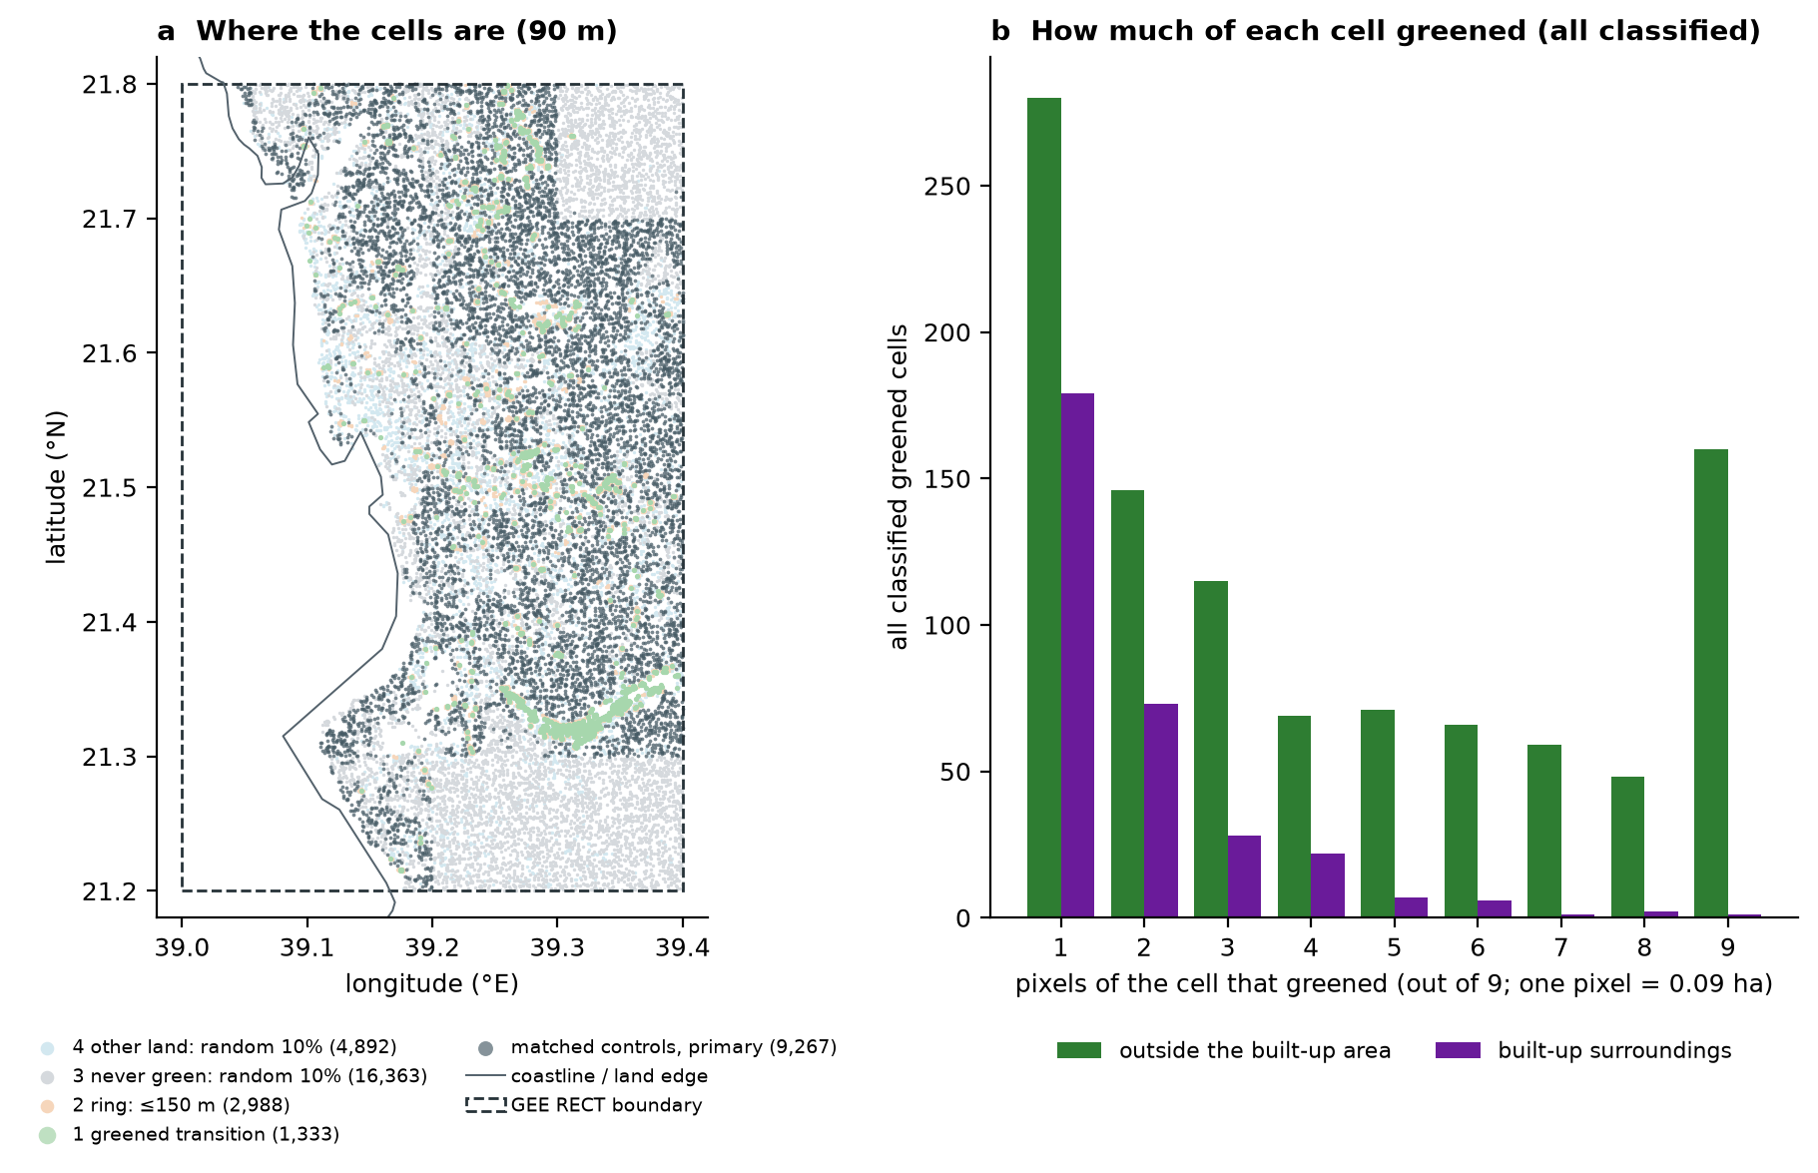
Figure 1. Cell classes of the panel. (a) All four exported classes, with primary matched controls highlighted; empty areas may be outside the analysis domain or excluded by classification and sampling. (b) All classified greened cells by number of greened pixels. Greening is a spectral transition, not verified managed irrigation.

2.3. Machine-Learning Model and Spatial Validation
An XGBoost model predicts endpoint-period LST of a cell from NDVI, NDBI, elevation, surface emissivity, distance to the coast, longitude and latitude. It is trained on the representative sample with greened cells excluded, so it never sees a treated cell. Hyperparameters are fixed (600 trees, depth 6, learning rate 0.05). Skill is measured by 5-fold spatial GroupKFold on blocks of a 0.05° grid (Eq. (11)). Two training sets are used. Model A uses all eligible non-greened cells; Model B also excludes training cells within 300 m of greening, so that it cannot learn from land next to treated cells. Uncertainty uses 200 refits on spatial block resamples.

2.4. Matched-Contrast Benchmark
Greened cells are compared with never-vegetated control cells in the same stratum. Strata are formed before treatment from the setting (outside the built-up area or built-up surroundings, by building cover within 500 m in 2015), a 0.10° region, distance-to-coast band, own building cover and emissivity class; a stratum is used if it has at least 3 controls. The matched contrast of a cell (Eq. (6)) is summarised per greened pixel by a zero-intercept slope (Eq. (7)), with intervals from a spatial block bootstrap on a 0.05° grid (Eq. (13)). The primary match retains 1,006 outside-built-up cells and 313 built-up cells. A narrower match that also conditions on concurrent neighbourhood development is used as a sensitivity and for the model comparison.

2.5. Counterfactual Gates, Pathways and NEGI
For each matched greened cell the model predicts the LST difference between its observed surface and its baseline surface, changing NDVI and NDBI only. Gate 1 is spatially blocked skill for absolute LST. Gate 2 is the support rule (Eq. (12)) applied to both the baseline and the changed surface. Gate 3 is agreement between the predicted difference and the measured matched contrast within a tolerance set in advance. No tolerance was prespecified in this study, so gate 3 cannot be declared passed; the comparison is reported as a diagnostic.
If the gates are passed, the framework evaluates two pathways from a common baseline, indexed by an intervention fraction f between 0 and 1. In the vegetation-only pathway NDVI is raised while NDBI is held. In the coordinated pathway NDVI and NDBI change together; in the validation package the change applied to a candidate bare cell is the paired NDVI and NDBI change observed at a real greened cell, not two independent marginal values. A coordinated pathway built this way is an observed co-variation, not an observed intervention. The pathways are compared with NEGI (Eqs. (1)–(4)).

2.6. Formal Definitions
Symbols are defined once here. T̂(x) is the model's predicted LST at predictor vector x; x₀ is the baseline; xⱼ(f) is pathway j at fraction f.
ΔTⱼ(f) = T̂(x₀) − T̂(xⱼ(f)) (1)
Predicted cooling; positive means cooler than baseline. Assumes the model may be evaluated at xⱼ(f), which is what the gates test.
c(f) = fᵖ / maxₖ fₖᵖ (2)
Normalized cost with exponent p = 0.5 by default and p = 1.0 as an alternative. The maximum is over the evaluated grid.
S = maxⱼ maxₖ max(ΔTⱼ(fₖ), 0) (3)
Benefit scale: the largest positive predicted cooling over all pathways in the primary fit. S is fixed from the primary fit and reused unchanged in every refit.
NEGIⱼ(f) = α · max(ΔTⱼ(f), 0) / S − β · c(f) (4)
Weights α = 1.0 and β = 1.0 are defaults without empirical calibration. Predicted warming is clipped to zero benefit.
Four properties follow directly from Eqs. (2)–(4).
Property 1 (the cost is a shape assumption). In the code the raw cost is w₀ · η · fᵖ, with w₀ an irrigation scaling coefficient (200) and η a desalination energy intensity (3.5 kWh per cubic metre), divided by its own maximum at the reference w₀. At the reference setting w₀ and η cancel, leaving fᵖ / max fᵖ. The cost term is therefore the assumed shape fᵖ and not a measured or estimated energy quantity. No irrigated area, land cover or pathway-specific input enters it.
NEGI₂(f) − NEGI₁(f) = α · [max(ΔT₂(f), 0) − max(ΔT₁(f), 0)] / S (5)
Property 2: all pathways are charged the same cost at the same f, so the cost cancels in any comparison between them.
Property 3 (bounds). In the primary fit the normalized benefit lies in [0, 1], so −β ≤ NEGI ≤ α. The sign at a point is positive exactly when α · max(ΔT, 0) / S exceeds β · c(f); only the ratio α/β matters. In refits the benefit can exceed 1 because S is fixed.
Property 4 (the maximum is fixed by position). At the point where the largest positive cooling occurs, the normalized benefit equals 1 and NEGI equals α − β · fᵖ, whatever the size of the cooling. Because NEGI is a composite index, any conclusion drawn from it is conditional on these choices and should be reported with its sensitivity to them [31].
The benchmark uses the following quantities. For greened cell i, ΔYᵢ is its LST change from the baseline years to the endpoint years, C(i) is the set of eligible never-vegetated control cells in its stratum, dᵢ is its number of greened pixels and xᵢₖ is the number of greened pixels outside the cell in distance ring k.
τᵢ = ΔYᵢ − (1/|C(i)|) Σₖ∈C(i) ΔYₖ (6)
Matched contrast. Interpreting it as an effect assumes that, within a stratum, greened and control cells would have had the same LST change without greening (conditional parallel trends [32]).
b = Σᵢ dᵢ τᵢ / Σᵢ dᵢ² (7)
Zero-intercept least-squares slope of contrast on dose. It is a per-pixel summary of sampled cells, not the marginal effect of one more pixel.
L(G) = Σᵢ∈G dᵢ² / Σᵢ dᵢ² (8)
Leverage share of a group G of cells (a spatial block or a dose class) in the denominator of the slope.
τᵢ = β_own dᵢ + Σₖ βₖ xᵢₖ + εᵢ (9)
Joint zero-intercept model with own dose and external ring counts. The split between own and external terms is descriptive; it is not causally identified.
b = β_own + Σₖ βₖ γₖ, γₖ = Σᵢ dᵢ xᵢₖ / Σᵢ dᵢ² (10)
Exact least-squares identity on a fixed set of cells (the omitted-variable formula [33]). γₖ is the zero-intercept slope of ring-k count on own dose.
R² = 1 − Σᵢ (yᵢ − ŷᵢ)² / Σᵢ (yᵢ − ȳ)², ŷᵢ from the model trained without block g(i) (11)
Spatial GroupKFold: blocks are partitioned into folds, and every prediction comes from a model that saw no cell of the same block. Adjacent blocks can still share boundaries.
D(x) = (1/k) Σₘ₌₁..ₖ ‖z(x) − z(x₍ₘ₎)‖; supported if D(x) ≤ q (12)
Support rule: z standardizes each feature by the training mean and standard deviation; x₍ₘ₎ are the k = 5 nearest training cells (a cell's own row excluded); q is the 95th percentile of D among training cells. Support says the point resembles training data; it does not say the prediction is right.
w ∼ Multinomial(B; 1/B, …, 1/B); interval = [q₀.₀₂₅, q₀.₉₇₅] of the re-estimates (13)
Spatial block bootstrap: B blocks are resampled with replacement, every cell takes its block's weight, and matching and estimation are repeated (2,000 draws). Coverage of the percentile interval is not established here; with few or unequal clusters it can be poor [34].

2.7. Hypothetical Water and Energy Ledger
The ledger is scenario accounting, not measurement. Annual irrigation depth is reference evapotranspiration (2,264 mm over the greened land) multiplied by a landscape coefficient (0.50, 0.60 or 0.85) and divided by an irrigation efficiency (0.90, 0.75 or 0.60); the central case gives 1.81 m per year. Energy is that volume multiplied by a source intensity: 2.5–4.0 kWh per cubic metre for seawater reverse osmosis [9]. Water per degree is the assumed annual volume on a cell's greened area divided by its measured matched contrast. The same irrigation per hectare is assumed everywhere, and whether the greened cells are irrigated at all is unverified.

2.8. Implementation, Tests and Reproducibility
The pipeline is a set of small Python modules for the panel, matching, model, validation and ledger, with one configuration file, plus Earth Engine export scripts. The index is implemented in a separate module of the same repository. The code follows common practices for scientific software: version identifiers, fixed seeds, automated checks and no manual editing of outputs [35].
The package has 62 automated tests, which passed in the author's local run. They include a synthetic recovery test: a simulated panel with a known per-pixel effect and deliberate confounding, on which the matching estimator must recover the truth and a deliberately wrong model must fail. Export reconciliation checks compare independent pixel-count exports cell by cell; for the 1,333 greened cells they report no discrepancy in identifiers, own counts or nested ring counts. Two algebraic checks were added for this paper (Table S1 and Table S2), and every number in the text is generated from its source table by the manuscript build script.

3. Results

3.1. Matched Contrasts (Primary Match: 1,006 Outside and 313 Built-Up Cells)
Figure 2 shows the matched contrasts and Table 2 the own-only slopes (Eq. (7)) by dose class for outside cells (Table S3, Table S4).
Table 2. Outside-built-up primary matched own-only slopes by dose class. Intervals are spatial-block percentile intervals; the last column deletes the block with the largest pooled leverage.
Greened pixels | Matched cells | Blocks | °C per pixel [interval] | Leverage share | Dominant block deleted
1–2 | 419 | 32 | −1.925 [−2.271, −1.477] | 0.033 | −1.697
3–4 | 183 | 21 | −1.307 [−1.468, −0.998] | 0.082 | −1.192
5–8 | 244 | 19 | −1.062 [−1.147, −0.779] | 0.388 | −0.918
9/9 | 160 | 9 | −1.203 [−1.265, −0.881] | 0.497 | −1.028

Among the 419 outside cells with 1–2 greened pixels the own-only slope is −1.925 [−2.271, −1.477] °C per pixel. This slope absorbs neighbouring greening that co-varies with own dose and is not a larger per-pixel effect (Section 3.2). The other rows apply the same estimator to different populations.
The pooled slope over all 1,006 outside cells is −1.181 °C per greened pixel (bootstrap median −1.170, interval [−1.252, −0.925]; block-jackknife interval [−1.465, −0.896]). It describes sampled contiguous greening blocks, not the marginal effect of a new small patch. One spatial block holds 55.7% of the pooled dose-squared leverage (Eq. (8); recomputed in Table S1); deleting it leaves 641 cells and −1.042 °C per pixel. The built-up pooled slope is −0.783 [−0.916, −0.659] on 313 cells.
A placebo on 375 late-greening outside cells, measured before they greened, gives −0.050 [−0.096, 0.016] °C per pixel (Table S5). It covers only part of the sample and an early period, so it cannot verify parallel trends for all cells.
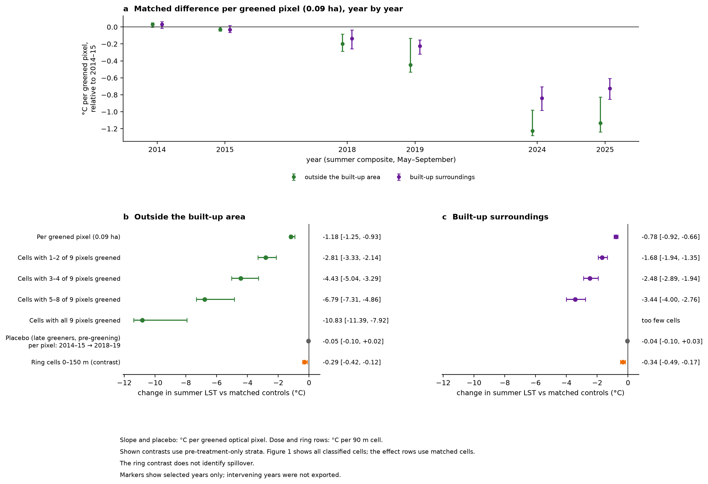
Figure 2. Primary pre-treatment-only matched temperature contrasts. (a) Per-pixel contrast by year relative to the baseline years. (b) Outside the built-up area and (c) built-up surroundings: slope and placebo rows are °C per greened optical pixel; dose and ring rows are °C per cell. The ring row is a contrast, not identified spillover. Year markers omit unexported intervening years.

3.2. Estimand Diagnostics (419 Outside Cells with 1–2 Greened Pixels)
Five joint-ring models (Eq. (9)) were fitted on the same 419 cells. Their own coefficients are −1.002, −1.036, −0.988, −1.014 and −1.013 °C per pixel for the full, far-ring-omitted, outer-rings-merged, fine-inner and coarse-inner specifications; they span −1.036 to −0.988 (Table S6, Table S7). Table 3 verifies Eq. (10) numerically: in every specification the own coefficient plus the external coefficients weighted by γ reproduces the own-only slope −1.925 to within rounding error (Table S2).
Table 3. Own-only slope as the sum of the joint own coefficient and the external terms (°C per own pixel).
Joint specification | β_own | Σ βₖ γₖ | Sum | Own-only b
Full: 0–90, 90–180, 180–300 m | −1.002 | −0.923 | −1.925 | −1.925
Far ring omitted | −1.036 | −0.889 | −1.925 | −1.925
Outer rings merged: 90–300 m | −0.988 | −0.937 | −1.925 | −1.925
Fine inner: 0–30, 30–60, 60–90 m | −1.014 | −0.912 | −1.925 | −1.925
Coarse inner: 0–30, 30–90 m | −1.013 | −0.912 | −1.925 | −1.925

The external terms have negative point estimates as a group, but their allocation by distance is specification sensitive. The ring counts are strongly collinear: pairwise uncentred cosines are 0.832, 0.725 and 0.897, and the design condition number rises from 38.4 for the four-term model to 71.0 for the six-term model (Table S8, Table S9). The within-90 m pattern is not resolved: the difference between the innermost two ring coefficients is +0.061 [−0.377, +0.445] °C per pixel, and all three paired inner-ring intervals include zero (Table S10). No mechanism is identified: thermal-pixel blur, edge effects, neighbourhood confounding and site selection all remain possible.
Cells with no external greening nearby give own-only slopes of −1.136, −0.879 and −0.891 [−1.410, −0.425] °C per pixel at exclusion radii of 90, 180 and 300 m, on 76, 38 and 26 cells (Table S11). These are different, selected sites, so the gap from the full-sample slope has no causal reading.

3.3. Predictive Skill of the Model (19,650 Non-Greened Cells)
Gate 1 is passed. Spatial GroupKFold gives R² = 0.795, RMSE = 1.184 °C and MAE = 0.903 °C on 19,650 non-greened cells (Table S12; Figure 3a). Gain shares in the fitted model are 33.7% for NDBI, 21.7% for emissivity, 14.5% for coast distance, 9.6% and 7.2% for longitude and latitude, 9.5% for elevation and 3.9% for NDVI (Table S13). NDVI, the variable that greening changes most, carries the smallest share of the model's gain.
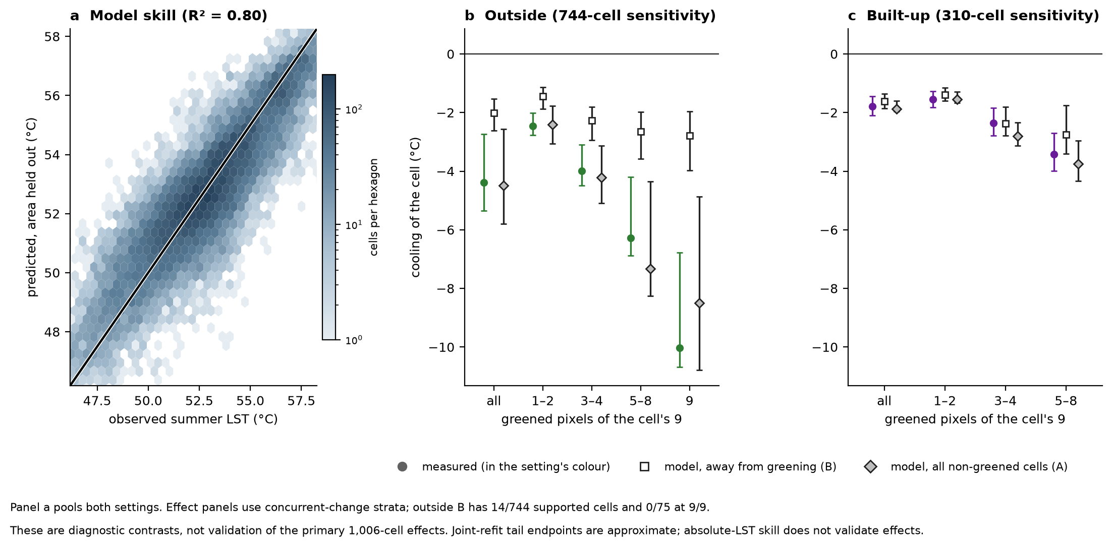
Figure 3. Model diagnostics. (a) Observed against spatially held-out predicted LST for non-greened cells, both settings pooled. (b) Outside the built-up area and (c) built-up surroundings: measured matched contrast and model-predicted contrast by dose class in the concurrent-change sensitivity match, for Model A (all non-greened training cells) and Model B (training cells near greening excluded). Most outside predictions lack feature-space support. Absolute-LST skill does not validate predicted effects.

3.4. Counterfactual Gates (744 Outside and 310 Built-Up Sensitivity Cells)
Gates 2 and 3 are not passed. These checks were run on the narrower concurrent-change match of 744 outside and 310 built-up cells; support was not computed for the primary match. Model B has feature-space support for 14 of the 744 outside cells and for 0 of 75 fully greened cells (Table S14). Its predicted cooling falls short of the measured contrast in every outside dose class, by +1.01, +1.72, +3.63 and +7.24 °C for 1–2, 3–4, 5–8 and 9/9 pixels, and each interval excludes zero (Table S15; Figure 3b). For fully greened cells the model predicts −2.79 °C against a measured −10.03 °C. In built-up surroundings, the 58 supported cells with 1–2 pixels give a model-minus-measured difference of +0.31 [−0.21, +0.77] °C (Table S16).
The framework therefore released no model-based candidate site: the candidate table is empty (Table S17). Pathway predictions and NEGI values are not reported for Jeddah, because the model whose predictions they would rest on did not pass the gates. These comparisons are diagnostics of the model; they do not corroborate the matched estimates.

3.5. Calendar Sensitivity (971 Cells; 957 Shared Cells)
With June–September composites the pooled outside slope is −1.212 °C per pixel on 971 matched cells, against −1.181 on 1,006 cells with May–September composites (Table S18). On 957 shared cells the paired change is −0.005 [−0.019, +0.005] °C per pixel (Table S19). The classified population changes between the two panels, so this is a sensitivity check and not a general robustness claim.

3.6. Hypothetical Water and Energy Ledger
Table 4 sets the assumed irrigation of each outside dose class against its measured matched contrast (Table S20; alternative water and energy cases in Table S21, Table S22 and Table S23). Under the central assumptions the accounting gives between 889 and 1,634 cubic metres of water per year, or 2.9 to 5.3 MWh per year of desalination energy, for each degree of measured cell cooling. Every figure in the table is hypothetical. The differences between rows follow from the assumption of equal irrigation per hectare and from the per-pixel slopes of Table 2, which Section 3.2 shows are not per-pixel effects; the table is not a ranking of options.
Table 4. Hypothetical water and desalination energy per degree of measured matched cooling, outside the built-up area, concurrent-change match, central irrigation case. Energy uses the central seawater reverse osmosis intensity. Not a ranking.
Greened pixels | Cells | Measured contrast (°C per cell) | Assumed water (m³ per year) | m³ per °C | MWh per °C
1–2 | 355 | −2.46 | 2,186 | 889 | 2.9
3–4 | 147 | −3.99 | 5,446 | 1,364 | 4.4
5–8 | 167 | −6.27 | 10,251 | 1,634 | 5.3
9/9 | 75 | −10.03 | 14,673 | 1,463 | 4.8

4. Discussion

4.1. What the Gates Show About Machine-Learning Surrogates
RQ1 and RQ2. The model predicts absolute LST well under spatially blocked validation. That figure does not answer the question that matters for scenario analysis, which is whether a predicted change in LST after a change in NDVI and NDBI is correct. The matched benchmark answers it, and the answer is no: the model had support for under two percent of outside validation cells and under-predicted measured cooling in every outside dose class, by more as dose rose. Absolute-LST skill does not give counterfactual validity.
The reason is visible in the model itself. Most of its gain comes from built-up intensity, emissivity and location, which explain where the city is hot; little comes from NDVI. A model can rank places by temperature from such features and still be wrong about what happens when one of them changes at a fixed place. The practical rule of the framework is that a surrogate's scenario predictions are used only after three gates: blocked validation, a support screen for the scenario points, and agreement with measured contrasts within a tolerance set in advance.

4.2. NEGI as a Metric
RQ3. NEGI puts predicted cooling and an assumed cost on one dimensionless scale, and its algebra makes its limits explicit. The cost is an assumed curve common to all pathways; pathway comparisons reduce to clipped predicted cooling; predicted warming is discarded; the benefit scale depends on every pathway evaluated; the weights are uncalibrated; and the largest value is fixed by where the largest cooling falls. NEGI comparisons are therefore indicative under stated assumptions. They are not a ranking of options and not an investment result, and they are only as good as the predicted cooling that enters them.
For that reason no NEGI value is reported for Jeddah. Scenario and index values given in earlier versions of this work rested on a surrogate that had not been tested against measured change; they are withdrawn. The trade-off is instead shown through the ledger, which uses measured contrasts and labels every water and energy figure as an assumption.

4.3. Portability and Scope
The framework is designed for desalination-dependent cities and has been run on one. Applying it elsewhere requires, as inputs, a Landsat LST and NDVI series, a land and coastline boundary, a built-up mask and a land-cover layer for the new city. The following must be recalibrated rather than copied: the analysis extent and seasonal window, NDVI thresholds for bare and vegetated pixels, donor-distance and ring thresholds, matching strata and calipers, the block size for validation and bootstrap, the definition of any sub-region such as the southern belt used here, the model features and support screen, and all scenario and cost assumptions. The analysis-side settings are centralised in one configuration file; the Earth Engine export settings, the coastline file and several population checks are not. A companion audit lists each hard-coded element. The Jeddah estimates, the fitted model and the hypothetical ledger must not be transferred to another city.

4.4. Limitations
RQ4. Interval coverage is unproven. The spatial block bootstrap and the block jackknife are reported, but no simulation establishes their coverage here, and one block holds 55.7% of pooled leverage. Irrigation identity is unverified: the vegetation transition is spectral, and vegetation may be sustained by groundwater, wadi flow or discharge. Confounding, thermal blur and edge effects, and neighbourhood confounding are unresolved; planting dates and untreated-trend histories are unavailable, so parallel trends cannot be verified. The Landsat surface temperature product has retrieval dependencies, including emissivity [36]. No effect-error tolerance was prespecified. Model support was computed for the concurrent-change match and not for the primary match. LST is not air temperature, thermal comfort or population benefit. Water and energy figures are hypothetical. The framework has been run on Jeddah only.

5. Conclusions
This paper presents a remote sensing and machine learning framework for evaluating urban greening–energy trade-offs in desalination-dependent cities, with Jeddah as the case study, and subjects it to the checks a computational method should pass before its outputs are used. The framework combines scripted satellite processing, an XGBoost model scored by spatial cross-validation, a matched-contrast benchmark, explicit gates for model-based use, a normalized index with stated assumptions and a hypothetical water–energy ledger. The main findings are methodological. Spatially blocked skill for absolute LST did not carry over to predicted change, so the gates withheld model-based scenarios and index values. The index's cost term is a shape assumption shared by all pathways, and its maximum is determined by position. A large own-only per-pixel slope decomposes exactly into a smaller joint coefficient and co-varying neighbour greening, and more than half of the pooled leverage sits in one spatial block. The evidence supports the framework as a reproducible way to ask the question and to see when a model's answer should not be trusted; it does not support a preferred greening level, a ranking of options or transfer of the Jeddah numbers to another city.
Author Contributions: [AUTHOR TO COMPLETE]
Funding: [AUTHOR TO COMPLETE]
Informed Consent Statement: [AUTHOR TO COMPLETE]
Data Availability Statement: Subject to the release being published, the code, the result tables listed in Appendix A and the build scripts for this manuscript will be available at https://github.com/nelmkt/NEGI-Framework [COMMIT HASH / RELEASE TAG TO ADD AFTER PUSH]. Landsat imagery is publicly available through Google Earth Engine. [AUTHOR TO COMPLETE: access terms for the exported datasets, licence and any restrictions.]
Acknowledgments: [AUTHOR TO COMPLETE]
Declaration of Generative AI and AI-Assisted Technologies: [AUTHOR TO COMPLETE: list every AI tool used for code, analysis and writing]
Conflicts of Interest: [AUTHOR TO COMPLETE]
Appendix A
Supplementary tables cited in the text and the files that hold them.
Table S1: leverage_share_check_v11.csv (folder tables_revision_v11)
Table S2: own_only_vs_joint_identity_v11.csv (folder tables_revision_v11)
Table S3: headline_block_v8.csv (folder tables)
Table S4: logic_primary_class_estimates.csv (folder tables)
Table S5: logic_primary_figure2_estimates.csv (folder tables)
Table S6: ring_reduced_coefficients_v8_followup6.csv (folder tables)
Table S7: pixel_subring_regression_v8_followup6.csv (folder tables)
Table S8: ring_pair_collinearity_v8_followup4.csv (folder tables)
Table S9: pixel_subring_collinearity_v8_followup6.csv (folder tables)
Table S10: pixel_subring_pair_differences_v8_followup7.csv (folder tables)
Table S11: isolation_balance_v8_followup2.csv (folder tables)
Table S12: model_cv.csv (folder tables)
Table S13: model_importance.csv (folder tables)
Table S14: test_support_counts.csv (folder tables)
Table S15: test_by_dose.csv (folder tables)
Table S16: test_supported_by_dose.csv (folder tables)
Table S17: decision_bare_places_model.csv (folder tables)
Table S18: gee_common_month_primary_v6.csv (folder tables)
Table S19: gee_common_month_paired_v6.csv (folder tables)
Table S20: decision_summary.csv (folder tables)
Table S21: decision_scenarios.csv (folder tables)
Table S22: water.csv (folder tables)
Table S23: energy.csv (folder tables)

References
1. Weng, Q. (2009). Thermal infrared remote sensing for urban climate and environmental studies: Methods, applications, and trends. ISPRS Journal of Photogrammetry and Remote Sensing, 64(4), 335–344. https://doi.org/10.1016/j.isprsjprs.2009.03.007
2. Ng, E., Chen, L., Wang, Y., & Yuan, C. (2012). A study on the cooling effects of greening in a high-density city: An experience from Hong Kong. Building and Environment, 47, 256–271. https://doi.org/10.1016/j.buildenv.2011.07.014
3. Norton, B. A., Coutts, A. M., Livesley, S. J., Harris, R. J., Lambert, A. M., & Bekessy, S. A. (2015). Planning for cooler cities: A framework to prioritise green infrastructure to mitigate urban heat islands in Australian cities. Landscape and Urban Planning, 134, 127–138. https://doi.org/10.1016/j.landurbplan.2014.10.018
4. Bowler, D. E., Buyung-Ali, L., Knight, T. M., & Pullin, A. S. (2010). Urban greening to cool towns and cities: A systematic review of the empirical evidence. Landscape and Urban Planning, 97(3), 147–155. https://doi.org/10.1016/j.landurbplan.2010.05.006
5. Cuthbert, M. O., Rau, G. C., Ekström, M., O'Carroll, D. M., & Bates, A. J. (2022). Global climate-driven trade-offs between the water retention and cooling benefits of urban greening. Nature Communications, 13(1). https://doi.org/10.1038/s41467-022-28160-8 [AUTHOR TO VERIFY: article number]
6. Ghaffour, N., Missimer, T. M., & Amy, G. L. (2013). Technical review and evaluation of the economics of water desalination: Current and future challenges for better water supply sustainability. Desalination, 309, 197–207. https://doi.org/10.1016/j.desal.2012.10.015
7. Elimelech, M., & Phillip, W. A. (2011). The future of seawater desalination: Energy, technology, and the environment. Science, 333(6043), 712–717. https://doi.org/10.1126/science.1200488
8. Jones, E., Qadir, M., van Vliet, M. T. H., Smakhtin, V., & Kang, S. (2019). The state of desalination and brine production: A global outlook. Science of the Total Environment, 657, 1343–1356. https://doi.org/10.1016/j.scitotenv.2018.12.076
9. Voutchkov, N. (2018). Energy use for membrane seawater desalination – current status and trends. Desalination, 431, 2–14. https://doi.org/10.1016/j.desal.2017.10.033
10. Mohamed, M., Othman, A., Abotalib, A. Z., & Majrashi, A. (2021). Urban heat island effects on megacities in desert environments using spatial network analysis and remote sensing data: A case study from western Saudi Arabia. Remote Sensing, 13(10), 1941. https://doi.org/10.3390/rs13101941
11. Miky, Y., Al Shouny, A., & Abdallah, A. (2023). Studying the impact of urban management strategies and spatiotemporal dynamics of LULC on land surface temperature and SUHI formation in Jeddah, Saudi Arabia. Sustainability, 15(21), 15316. https://doi.org/10.3390/su152115316
12. Munir, S., Habeebullah, T. M. A., Zamreeq, A. O., Alfehaid, M. M. A., Ismail, M., Khalil, A. A., Baligh, A. A., Islam, M. N., Jamaladdin, S., & Ghulam, A. S. (2025). Cooling of maximum temperatures in six Saudi Arabian cities (1994–2024)—Reversal of urban heat islands. Urban Science, 9(11), 445. https://doi.org/10.3390/urbansci9110445
13. Howarth, N., Odnoletkova, N., Al Shehri, T., Almadani, A., & Patzek, T. W. (2020). Staying cool in a warming climate: Temperature, electricity and air conditioning in Saudi Arabia. Climate, 8(1), 4. https://doi.org/10.3390/cli8010004
14. Tucker, C. J. (1979). Red and photographic infrared linear combinations for monitoring vegetation. Remote Sensing of Environment, 8(2), 127–150. https://doi.org/10.1016/0034-4257(79)90013-0
15. Zha, Y., Gao, J., & Ni, S. (2003). Use of normalized difference built-up index in automatically mapping urban areas from TM imagery. International Journal of Remote Sensing, 24(3), 583–594. https://doi.org/10.1080/01431160304987
16. Patel, S., Indraganti, M., & Jawarneh, R. N. (2024). A comprehensive systematic review: Impact of land use/land cover (LULC) on land surface temperatures (LST) and outdoor thermal comfort. Building and Environment, 249, 111130. https://doi.org/10.1016/j.buildenv.2023.111130
17. Alonso, L., & Renard, F. (2020). A new approach for understanding urban microclimate by integrating complementary predictors at different scales in regression and machine learning models. Remote Sensing, 12(15), 2434. https://doi.org/10.3390/rs12152434
18. Li, Y., Zhang, Y., Wu, Q., Xue, R., Wang, X., Si, M., & Zhang, Y. (2023). Greening the concrete jungle: Unveiling the co-mitigation of greenspace configuration on PM2.5 and land surface temperature with explanatory machine learning. Urban Forestry & Urban Greening, 88, 128086. https://doi.org/10.1016/j.ufug.2023.128086
19. Chen, T., & Guestrin, C. (2016). XGBoost: A scalable tree boosting system. In: Proceedings of the 22nd ACM SIGKDD International Conference on Knowledge Discovery and Data Mining, pp. 785–794. https://doi.org/10.1145/2939672.2939785
20. Bushenkova, A., Soares, P. M. M., Johannsen, F., & Lima, D. C. A. (2024). Towards an improved representation of the urban heat island effect: A multi-scale application of XGBoost for Madrid. Urban Climate, 55, 101982. https://doi.org/10.1016/j.uclim.2024.101982
21. Cheng, J., Yang, D., Qie, K., & Wang, J. (2025). Analysis of land surface temperature drivers in Beijing's central urban area across multiple spatial scales: An explainable ensemble learning approach. Energy and Buildings, 338, 115704. https://doi.org/10.1016/j.enbuild.2025.115704
22. Yang, J., Li, H., Xin, J., Yu, W., Ren, J., Yu, H., Xiao, X., & Xia, J. C. (2025). Investigating the effect of urban form on land surface temperature at block and grid scales based on XGBoost-SHAP. Environmental Modelling & Software, 106738. https://doi.org/10.1016/j.envsoft.2025.106738
23. Zhao, Z., Li, H., & Wang, S. (2024). Machine learning-based surrogate models for fast impact assessment of a new building on urban local microclimate at design stage. Building and Environment, 266, 112142. https://doi.org/10.1016/j.buildenv.2024.112142
24. Roberts, D. R., Bahn, V., Ciuti, S., Boyce, M. S., Elith, J., Guillera-Arroita, G., Hauenstein, S., Lahoz-Monfort, J. J., Schroder, B., Thuiller, W., Warton, D. I., Wintle, B. A., Hartig, F., & Dormann, C. F. (2017). Cross-validation strategies for data with temporal, spatial, hierarchical, or phylogenetic structure. Ecography, 40(8), 913–929. https://doi.org/10.1111/ecog.02881
25. Valavi, R., Elith, J., Lahoz-Monfort, J. J., & Guillera-Arroita, G. (2019). blockCV: An R package for generating spatially or environmentally separated folds for k-fold cross-validation of species distribution models. Methods in Ecology and Evolution, 10(2), 225–232. https://doi.org/10.1111/2041-210X.13107
26. Ploton, P., Mortier, F., Réjou-Méchain, M., Barbier, N., Picard, N., Rossi, V., Dormann, C., Cornu, G., Viennois, G., Bayol, N., Lyapustin, A., Gourlet-Fleury, S., & Pélissier, R. (2020). Spatial validation reveals poor predictive performance of large-scale ecological mapping models. Nature Communications, 11(1), 4540. https://doi.org/10.1038/s41467-020-18321-y
27. Meyer, H., & Pebesma, E. (2021). Predicting into unknown space? Estimating the area of applicability of spatial prediction models. Methods in Ecology and Evolution, 12(9), 1620–1633. https://doi.org/10.1111/2041-210x.13650
28. Roy, D. P., Wulder, M. A., Loveland, T. R., Allen, R. G., Anderson, M. C., Helder, D., Irons, J. R., Johnson, D. M., Kennedy, R., Scambos, T. A., Schaaf, C. B., Schott, J. R., Sheng, Y., Vermote, E. F., Belward, A. S., Bindschadler, R., Cohen, W. B., Gao, F., Hipple, J. D., Hostert, P., Huntington, J., Justice, C. O., Kilic, A., Kovalskyy, V., Lee, Z. P., Lymburner, L., Masek, J. G., McCorkel, J., Shuai, Y., Trezza, R., Vogelmann, J., Wynne, R. H., & Zhu, Z. (2014). Landsat-8: Science and product vision for terrestrial global change research. Remote Sensing of Environment, 145, 154–172. https://doi.org/10.1016/j.rse.2014.02.001
29. Earth Resources Observation and Science (EROS) Center. (2020). Landsat 8–9 Operational Land Imager / Thermal Infrared Sensor Level-2, Collection 2 [Data set]. U.S. Geological Survey. https://doi.org/10.5066/P9OGBGM6
30. Gorelick, N., Hancher, M., Dixon, M., Ilyushchenko, S., Thau, D., & Moore, R. (2017). Google Earth Engine: Planetary-scale geospatial analysis for everyone. Remote Sensing of Environment, 202, 18–27. https://doi.org/10.1016/j.rse.2017.06.031
31. Saltelli, A., Ratto, M., Andres, T., Campolongo, F., Cariboni, J., Gatelli, D., Saisana, M., & Tarantola, S. (2008). Global Sensitivity Analysis: The Primer. Wiley. https://doi.org/10.1002/9780470725184 [VERIFY YEAR: the Crossref record gives 2007]
32. Abadie, A. (2005). Semiparametric difference-in-differences estimators. The Review of Economic Studies, 72(1), 1–19. https://doi.org/10.1111/0034-6527.00321
33. Angrist, J. D., & Pischke, J.-S. (2009). Mostly Harmless Econometrics. Princeton University Press. https://doi.org/10.1515/9781400829828
34. Cameron, A. C., Gelbach, J. B., & Miller, D. L. (2008). Bootstrap-based improvements for inference with clustered errors. Review of Economics and Statistics, 90(3), 414–427. https://doi.org/10.1162/rest.90.3.414
35. Wilson, G., Aruliah, D. A., Brown, C. T., Chue Hong, N. P., Davis, M., Guy, R. T., Haddock, S. H. D., Huff, K. D., Mitchell, I. M., Plumbley, M. D., Waugh, B., White, E. P., & Wilson, P. (2014). Best practices for scientific computing. PLoS Biology, 12(1), e1001745. https://doi.org/10.1371/journal.pbio.1001745
36. U.S. Geological Survey. (n.d.). Landsat Collection 2 Surface Temperature. https://www.usgs.gov/landsat-missions/landsat-collection-2-surface-temperature

