Enrich Your Friendships with Lavende

Alex Ho1, Angel Xie2, Nelson Chang3

1. Computer Science, 2. Quantitative Theory and Method, 3. Linguistics

Emory University, Atlanta, GA 30322

{dho4, angel.xie, nelson.chang}@emory.edu

# Abstract

The primary focus of this project is to relieve stress of the users, typically college students. According to the National College Health Assessment (NCHA), more than 75 percent of the college students are experiencing overwhelming stress and anxiety, while the majority of the stress is school-related. In light of this finding, we aim to create a chatbot that acts as a friendly companion who provides a comfortable chatting environment for the user. Unlike psychological counseling, the chatbot does not evaluate the users’ situation and give advice or recommendation.

The chatbot starts a conversation with the user by asking why the user is stressed. The chatbot typically identifies the specific stressor within the first turn, and it then takes several turns to figure out the underlying reason of stress, whether the stress is mainly caused by the user’s internal personality or evoked by external factors or events. The chatbot has three different personalities, savage, agreeable, and optimistic, and one of the three personalities is chosen randomly at the start of the conversation. This is to create a variation of possible conversations that keeps the user engaged given that the users are likely to be stressed over the same stressor. Throughout the conversation, the chatbot will analyze the user’s personality based on his or her response and gives the user a customized encouragement at the end of the conversation. The level of users extraversion and neuroticism is evaluated based on the big-five personality model in psychology.

The main approach to accomplish the task is by matching the user’s responses with our pre-trained dataset and determining his or her potential personality. A score is assigned to the user's responses and the final score is calculated before the last turn of the conversation. There are a total of 4 possible combinations/outcomes: high extraversion with high neuroticism, high extraversion with low neuroticism, low extraversion with high neuroticism, and low extraversion with low neuroticism.

1. **Introduction**

Living in a modern world, the information explosion has benefited and harmed humanity both knowingly and unknowingly. The rapid increase and disbursement of information, news, and data does improve the way humans learn and communicate with each other; humans are now able to receive and acquire new knowledge in a short period of time with the help of technology. However, getting overwhelmed by an unstoppable flow of news could be devastating. People check their phones, text messages, and emails constantly to stay on top of the current trend. Most importantly, this tendency has become a consequential issue for a large population of college students. College students use many technological resources to perform well in school, fit into the crowd, find a decent internship or job, etc. In order to perform well and achieve determined goals, college students tend to over-pressure themselves in an unreasonable way; it could be due to self, peer, or family pressure. Therefore, being stressed or having mental health issues is a common thing in a college environment. According to a report published by American College Health Association in 2018, more than 60% of college students reported they had experienced “overwhelming stress or anxiety” in their college career. Even though these students did reach out for counseling sessions, the student-to-counseling-staff ratio is poor (1731:1) which causes numerous students not be able to have proper mental treatments. Most importantly, approximately 24,000 college students (between the ages of 18 to 24) attempt to suicide, and roughly 1,100 college students commit suicide; the most common reason is due to high workload and overwhelming stress. This finding motivates us to create a chatbot that will mimic the role of a friend or peer to listen to the user’s concerns, which would further prevent and resolve students from getting mental health problems. Moreover, the chatbot also helps an individual to avoid damaging his or her interpersonal relationships due to behaviors such as bickering and argument with those around him or her as a result of the stress.

Our target audience would be college students who are stressed (for whatever reasons). There are six categories that college students are most stressed about: school performance, relationship/friendship, social events, job/internship, health/exercise, financial situation, etc.; these reasons would be our sole focus for the potential conversations with the user.

One of the unique features that the chatbot has is having three distinct personalities: savage, agreeable, and optimistic. It is reasonable and common for the same users to have multiple conversation topics with the chatbot; however, having ordinary responses and tones would surely bored people out. Therefore, one of the three personalities will be randomly chosen when the program is initialized. The tone and responses of the chatbot would vary each time to give users a refreshing experience.

The major goal of the chatbot is to relieve college students’ stress. The secondary goal is to mine out the users’ personality based on the users’ reactions and responses to stressful events. People with different personalities tend to behave differently, so it is reasonable for us to presume that they will be stressed and bothered by different things. The purpose of the chatbot is to have a conversation with the user and serves as a tool to comfort the users, instead of recommending the user what to do. We believe that the creation of this chatbot is beneficial and certainly being a breakthrough in the AI community. It will not only lower the rate of self-harming and reduce suicidal thoughts for people with mental health problems, but act as an outlet for people with stressful thoughts in general. Such creation will improve the quality of life for many individuals; any potential damages to their relationships would be prevented by the chatbot.

1. **Related Work**

Our chatbot helps the user to develop self-compassion implicitly, by demonstrating and instilling the idea of self-compassion to the user through the conversation. The general idea of self-compassion is that one should embrace painful lessons instead of avoiding them. In this situation, pain is defined in a broader sense. It is a common feeling, such as missing expectations or being disappointed, that could exist in our daily lives. There are three steps that one could develop and achieve self-compassion. First, recognize the pain. Second, recall that pain is a common experience to all humanity. Third, respond with self-kindness instead of self-criticisms or self-judgments (2). The psychologists from University of Salford and University of Bolton conducted a quantitative study that measured relationships between self-compassion and burnout rate among UK community nurses. Results of this study show that nurses who have a high level of self-compassion is negatively correlated with less probability of burnout. The psychologists also discovered that a higher self-compassion is correlated with a higher level of compassion to their colleagues (1). This shows that the practice of self-compassioning can be helpful to college students, who are similar to nurses because they are also constantly under overwhelming workload and high pressures. Self-compassion can be compared to how one responds to a three-year-old making a mistake by reassuring him that things will still be fine despite the mistake. If the user learns to use such an approach when he fails to meet certain standards he set for himself, he or she will admit his frustration and accept his failure without any harsh judgements, and then will continue to try his best to strive for his goals (2).

An experiment using randomized controlled trials, conducted by Stanford School of Medicine, shows that the use of chatbot is highly effective in enhancing a user’s motivation and supports to reduce stress. Chatbots can also be meaningful in self-guided mental healthcare courses (3). While many other chatbots such as WoeBot, developed by Stanford, leverage that advantage of chatbots to help people learn about how to conduct a Cognitive Behavior Therapy for self-help, our chatbot wants to experiment with a Self-Compassion approach to see if our approach will have a higher efficacy in comparison to their Cognitive Behavior Therapy Approach to help the user destress (4).

1. **Conversation Design**

The chatbot begins the conversation by asking why the user is stressed; we presume the majority of the people who are stressed are college students. At the beginning of the conversation, one of the three chatbot’s personalities is randomly chosen (savage, agreeable, and optimistic). After the user identifies a reason that he or she is stressed, the chatbat will then have a casual conversation regarding the stress with the user. The conversation serves the purpose of detecting the user’s personality traits. For example, at each turn of the conversation, a personality trait was being detected and analyzed. Throughout the entire conversation, regardless of the path the user goes into, there are typically 2 to 3 questions evaluating the user's neuroticism level and 3 to 4 questions evaluating the user’s extraversion level; unless the user’s reason for stress is solely due to anxiety around covid19. At the end of the conversation, the chatbot finishes the chat with the user by implicitly informing the users’ personality through an encouragement pointing out the strength of the user’s character. The chatbot does not make any recommendation or advice to the user, but does help the user to relieve their stress by acting as a peer who provides emotional support. The chatbot shares its own experience related to the stress and replies the user with its own opinion before transitioning to the next turn. Figures 2 to 5 are the demonstrations of some conversations with different chatbot personalities.

Even though the three personalities might seem to carry different tones in their responses, they all talk to the user following the same idea and principles of self-compassion. The bot helps the user to achieve the three steps of self-compassion mentioned above. First, making the user fully aware of the pain of his or her struggle by acknowledging how stressful and awful it is in a savage, optimistic, or agreeable tone. Second, reminding the user that he or she is not the only one suffering by sharing an experience or perspective that is related to what the user is currently stressed about. Third, reassuring the user that things will be fine and that the user should not judge him or herself harshly due to the failure of accomplishing or feeling in control of something important to him in a savage, optimistic, or agreeable way. The responses of the different chatbot personalities were carefully designed to prevent the user from viewing the bot as an lecturing individual. The user can feel that the bot is also a struggling college student and not judging the user in any way while helping the user to embrace his struggle.

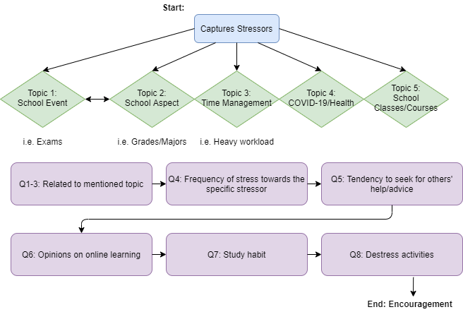

[Figure 1: Above is the conversation flow that includes the potential conversation topics]

S: Hi! Tell me what you are stressed about.

U: my cs class

S: Hey no pain no gain! The fact that you find this cs class hard probably means that you are learning a lot. Is it a requirement for your major?

U: yes

S: What major are you?

U: cs

S: Being an expert in the field of cs will lead you to so many great options for your future career! How often do you find your cs class stressful?

U: sometimes

S: A little stress once in a while can make your life more productive. That is the case for me haha. Anyone you can ask for help or advice on that cs class ?

U: my professor

S: Have you talked to your professor yet then?

U: yes

S: I hope talking with your professor has been helpful to you. How is your experience with online learning so far?

U: bad

S: It is totally reasonable for you to feel that way about online learning. What do you not like about it?

U: do not feel connected with others

S: I am still thankful that technology allows us to stay somewhat connected to each other. Where do you usually study at home?

U: dining area

S: I just love studying in the dining area with a cup of coffee next to my laptop pretending as if I am at Starbucks. Have you tried studying while having a zoom meeting with your friends?

U: not yet

S: Interesting. What do you do to destress during quarantine?

U: I play badminton in my backyard

S: Oh what a coincidence, my friend just asked me if I want to play basketball this weekend. You should join us!

U: sure

S: Your ability to handle stress is beyond impressive. See you!

U: bye

[Figure 2: A conversation with the optimistic friend]

S: Hi! Tell me what you are stressed about.

U: my exam

S: You only think of me when you have problems dont you？ Just Kidding. Is that exam for a class that you are taking？

U: yes

S: What class is it?

U: my adult abnormal psyc class

S: Bruhh why would you torture yourself by taking a psyc class ? Is it a requirement for your major?

U: kind of

S: Are you trying to raise your stress tolerance with that psyc class lol? How often do you have a psyc class like that?

U: twice a week

S: Do you have a psyc class so often that getting stressed about a psyc class has become a habit of yours lol? How often do you find that psyc class stressful?

U: pretty often

S: You could be addicted to many other things but you choose to be addicted to stress? No judgment. I am a stress addict myself. Anyone you can ask for advice on that psyc class ?

U: my mentors

S: Have you talked to your mentors yet then?

U: no

S: Do you think you are too smart to seek mentoring from others? Honestly I feel that way sometimes haha. How is your experience with online learning?

U: not so great

S: Do you miss your classmates? Or are you heartless? Kidding. What do you enjoy the most about it?

U: sleeping

S: Do you have a hard time distinguishing weekdays from weekends? Morning from nights lol? Where is your study area at home?

U: the dining area

S: I just love studying in the dining area with a cup of coffee next to my laptop pretending as if I am at Starbucks. Have you tried studying while having a zoom meeting with your friends?

U: yes

S: I guess we are quite similar in our study habits lol. I recently feel so stressed about many things. What do you do to destress during quarantine?

U: i go for a run

S: Oh what a coincidence, my friend just asks me if I want to play basketball this weekend. You should join us!

U: sure

S: You have such a bubbly personality. I am sure you will succeed at anything you do. Talk to you later!

[Figure 3: A conversation with the savage friend]

S: Hi! Tell me what you are stressed about.

U: my girlfriend broke up with me

S: You will find someone better! How long had you guys been together?

U: umm around 3 years

S: Sometimes you just gotta end a story and start another one! Did this breakup happen because of the coronavirus?

U: not really

S: I guess the coronavirus is not the one to blame. Let me try to make use of what I learned from my psychology class. The theory of love suggests that love is composed by intimacy, passion, and commitment. Which one do you think is lacking from your relationship?

U: i think its commitment

S: A relationship without commitment is kinda similar to a romantic affair. At least you know what to do in your next relationship! Just curious, do you want to get back together?

U: umm yeah

S: I wish you the best of luck! However, don't forget to love yourself. During quarantine, I really enjoy trying new stuff. What activity do you like to do while in quarantine?

U: playing video games

S: I do like to play games too! Playing games is so stress relieving. All of my friends are playing animal crossing, and they even skip the online lecture just to play it... Speaking of that, are you also taking online classes?

U: yeah i am

S: Nice! Feels so good to know someone is also suffering with me. How are you feeling about this transition to remote learning?

U: i dont like it

S: I personally hate it so much. Can you imagine taking classes at 4 am? Ugh... You know what? I really enjoy talking to you and I bet others do too! Sometimes life gives you lemon, just make lemonade! Talk to you later.

[Figure 4: A conversation with the optimistic friend]

S: Hi! Tell me what you are stressed about.

U: my boyfriend

S: You must be stressed about love sometimes right? Are you currently in a relationship?

U: yeah

S: That is so nice! How long have you guys been together?

U: a couple months

S: You just started dating? That is so sweet. How often do you feel stressed about your relationship?

U: once in a while

S: I sometimes feel stressed about relationships too! Is the coronavirus causing any stress in your relationship?

U: not really

S: I guess the coronavirus is innocent. Let me try to make use of what I learned from my psychology class. The theory of love suggests that love is composed by intimacy, passion, and commitment. Which one do you think is lacking from your relationship?

U: none of those

S: Oh I see. Last year I felt like my girlfriend and I are losing passion because of long distance. Guess what safe our relationship? A lot of s...I think you know the answer. Have you ever talked about your stress with your boyfriend or girlfriend?

U: umm yeah i did

S: Oh really? And it did not work out? Then I think you should do something relaxing to relieve your stress. What activity do you like to do during quarantine?

U: i eat a lot lol

S: You are a foodie huh? I do not know why but I feel so happy while eating. Cook, eat, sleep, taking online classes, that is basically the summary of my life now. Are you also taking online classes?

U: yeah i am

S: Nice! Feels so good to know someone is also suffering with me. How are you feeling about this transition to remote learning?

U: i love it

S: I personally hate it so much. Can you imagine taking classes at 4 am? Ugh... You know what? I really enjoy talking to you! Sometimes life gives you lemon, just make lemonade! Talk to you later.

[Figure 5: A conversation with the agreeable friend]

1. **Approach**

The main techniques were used to develop the chatbot: WordNet, POS/NER tags, and hardcoding. WordNet and POS/NER tags were utilized to detect and fish out the specific keywords that the chatbot was looking for within the user’s response, so a personality score could be further assigned (on a scale of 0 to 100) to the response. In order to assign a score, Macros were used to create, store, and update the variables within the “vars” dictionary. To then use those variables as transition requirements, additional Macros would be created to check which personality trait has the dominating value among others with the emora_stdm package. On the other hand, hardcoding was heavily needed to build the dictionary that captures different responses and keywords for different personality traits; the keywords will be classified based on the confidence level/score. Furthermore, a personality data was involved to analyze what each personality will mostly like to answer under the same setting.

To further demonstrate how people’s responses and stressors were captured, two surveys were sent out to college students (most of the respondents go to Emory University and have Computer Science related majors) and were able to get 55 valid responses. The first survey focused on what stresses the respondent out in college. As shown in the figure 6 and 7, over 50% of the respondents were stressed because of school (then followed with relationship/friendship and social events), and the fundamental cause of such stress was due to high workload and grades. On the other hand, the second survey emphasized on people’s thoughts on COVID-19. Everyone is going through a stressful period of time, and many individuals are surely being affected by the virus either emotionally or psychologically. As shown in figure 8 and 9, COVID-19 had a negative impact on approximately 70% of the respondents. Among those who felt negatively impacted, afraid of getting infected, dislike online courses, and missing family/friends were the three biggest factors that caused people to respond this way. As a result, the surveys prompted the chatbot to focus on the following stressors: school, social event, relationship/friendship, and COVID-19, since these were the topics that people cared about the most at the moment.

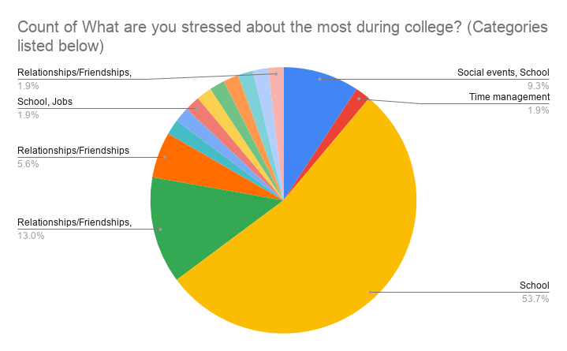

[Figure 6: The distribution of common stressors in college; school was frequently mentioned]

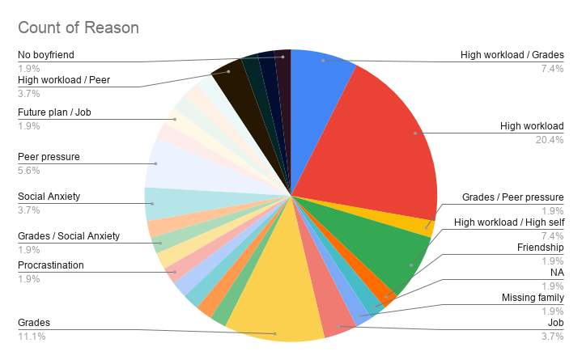

[Figure 7: The distribution of reasons behind stressors; high workload was frequently mentioned]

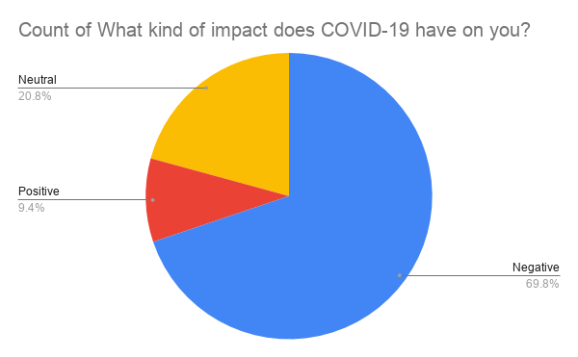

[Figure 8: The distribution of COVID-19’s impact on respondents; negative was frequently mentioned]

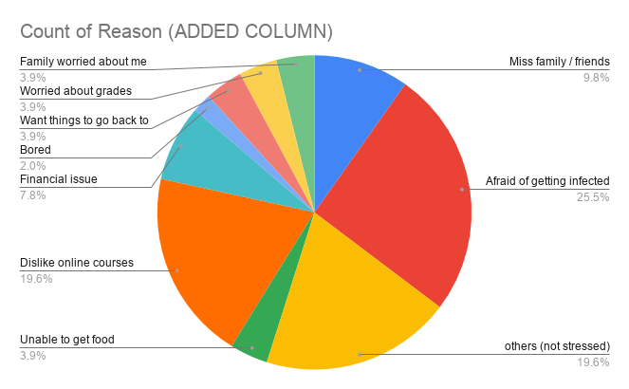

[Figure 9: The distribution of stressors due to COVID-19; being infected was frequently mentioned]

The chatbot had a few unique and distinct features. First, the chatbot responded to the users differently based on the user’s stressors. The purpose of the bot is to mimic the role of a friend or peer, so the tone and motif of the bot would change accordingly. For instance, if the bot detects the user to have an introverted personality during the conversation, then the bot will not ask any question that is too upfront or direct. Whereas, if the user had an extroverted personality, then the bot would ask questions in a more explicit manner. Last but not least, the chatbot fully analyzed the user’s two out of five big personality traits: extraversion and neuroticism, and implicitly told the user about this finding. In other words, if the stressed user was easy going, the bot would say something along the lines of “you are stressed because you always care about other people’s feelings and listen to their problems, but that could be overwhelming and stressful for you sometimes”. All in all, the end goal of the conversation was to give the user a relief as if he or she was talking to a friend or psychiatrist.

1. **Analysis**

At the end of each conversation, the chatbot would come up with the individual’s potential personality and inform him or her implicitly. The personality that the chatbot detected at this stage was not particularly accurate for three main reasons. First, the chatbot only analyzed two out of the big five personality traits: extraversion and neuroticism, whereas a healthy individual’s personality consisted with five big traits: openness, conscientiousness, extraversion, agreeable, and neuroticism. Therefore, the personality analysis would only be valid to a certain extent and could be slightly biased since some factors are left out. Second, it was difficult for the chatbot to capture all stressors, keywords, or reasons mentioned throughout the conversation (since people tend to talk and express themselves differently). Even though two surveys were sent out and collected decent valid responses, being able to capture all reasoning possibilities was nearly impossible. For example, if the user inputted a word with an “s” or “ing” at the end, but the word in the dictionary was in its regular form, then the chatbot would miss it (even if the meanings were the same). Third, the personality scoring system was vague. A score was assigned to each of the user's responses, mainly by specific keywords he or she used, to determine their personality traits. However, how to dictate the cut off range for each trait was debatable. At the current stage, there were no rules to decide the scoring range for each personality. However, the sole purpose of the chatbot was being able to carry a relaxed conversation with any stressed users to help them destress; therefore, the accuracy of personality detecting was only a byproduct.

1. **Conclusion and Future Work**

The successfulness of the chatbot was hard to measure quantitatively. The chatbot helped stressed individuals to destress, and more importantly, to feel more compassionate towards themselves. An increase in self-compassion contributed to help individuals to sustain long-term mental well-being. Having overwhelming stress and getting a high workload were common issues in this modern era. It was effortless to be stressed and have mental illness, but being able to receive treatments was challenging. Therefore, the creation and existence of such chatbots could be beneficial and a solution to this modern problem. Being able to see the decrease in suicide attempts and number of students with mental health problems would be a perfect example to show the value of the chatbot.

Going forward, with the help of artificial intelligence/machine learning, more stressors and reasonings could be captured accurately into the database. Some implicit and unknown stressors could be detected early on, so the individual can receive necessary emotional support and customized guidance on practicing self-compassion. If the chatbot is able to contain more stressors and define common people’s expressions, then the conversation topics would not be limited in a few areas. Therefore, to further improve the quality and conversation coverage of the chatbot, a better natural language system must be used, especially when it comes to matching words with similar meanings.

**References**

1. <https://www.researchgate.net/publication/307894807_A_pilot_study_exploring_the_relationship_between_self-compassion_self-judgement_self-kindness_compassion_professional_quality_of_life_and_wellbeing_among_UK_community_nurses>
2. <https://mental.jmir.org/2017/2/e19/>
3. https://www.hindawi.com/journals/misy/2019/9517321/
4. <https://greatergood.berkeley.edu/article/item/the_five_myths_of_self_compassion>