**#tweetscomehome**

Using tweets to understand the city we live in

By Nelson Auner

nelsonauner.com/tweetscomehome

# What is **#tweetscomehome?**

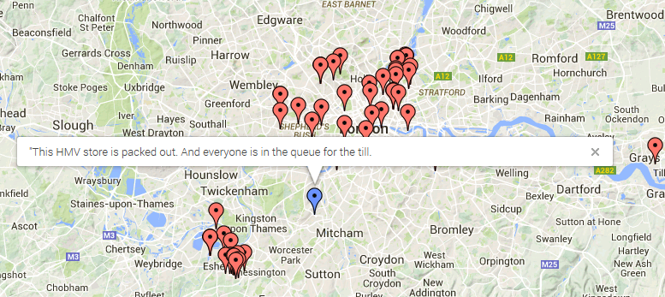

It’s time we harness twitter to understand how and why people feel about where they live. **#tweetscomehome** is a web-based visualization tool that aggregates, analyzes, and plots **twitter data** and **real estate prices** across London to find neighborhood trends and issues relevant to businesses and local government

[GRAPH OF HOUSING PRICES AND TWITTER VOLUME]

The site is hosted completely on github and uses various interfaces to google map’s API to synthesize and plot trending tweets-and housing trends. The main data was parsed on a powerful 8-core linux virtual machine, and some of the interactive elements are rendered on the user’s browser through javascript.

To connect tweets with real estate prices, we use cutting-edge machine learning algorithms, namely, the gamma lasso, which allows a quick and robust inference between housing prices and the contents of nearby tweets. The

# Next steps for **#tweetscomehome**

We hope that you’re as excited about **#tweetscomehome** as we are. There’s limitless potention, from

# Questions about **#tweetscomehome?**

The creator can be reached at nelson@nelsonauner.com