1. Give examples of different integration protocols:

HTTP, or Hypertext Transfer Protocol, is the foundation of data communication for the World Wide Web. It is an application protocol for distributed, collaborative, hypermedia information systems.

REST or Representational state transfer is a software architectural style that defines a set of constraints to be used for creating web services. Web services that use the REST architectural style are called RESTful web services

SOAP, or Simple Object Access Protocol, is a messaging protocol specification for exchanging structured info in the implementation of web services in computer networks. It uses XML Information Set for its message format.

1. data streaming application sending one million notifications every hour

the application will be grouped it these categories:

1. client
2. server
3. business logic
4. push message queue
5. database

the connection between the sever and the client will be handled with websockets , this will ensure that the connection will be real time and only will be disconnected if one between the two terminates the connection

when a client send a request (comments during a live stream),the request is sent to the server, then the server will then send the request for processing in the business logic. In the business logic all the required data is taken from the request body and now where to send the message to(in a live stream, either to an individual or everyone)

After the request has been processesed. A notification is sent to the push message queue in which will be used to improve the speed of sending the notification and handling delays.

For the system above the technologies that are going to be used include:

WebSocket’s = Socket.IO is a transport protocol that enables real-time bidirectional event-based communication between clients and a server.

Database = PostgreSQL or MySQL any relationship database will be used because you can create a schema that allows querying from different fields

push message queue - APACHE KAFKA, is a distributed event store and stream-processing platform

1. examples of different encryption/hashing methods

1 The algorithm of Caesar cipher holds the following features −

* Caesar Cipher Technique is the simple and easy method of encryption technique.
* It is simple type of substitution cipher.
* Each letter of plain text is replaced by a letter with some fixed number of positions down with alphabet.

2 Affine Cipher is the combination of Multiplicative Cipher and Caesar Cipher algorithm. The basic implementation of affine cipher is as shown in the image below −

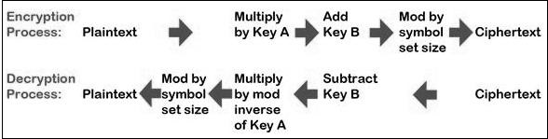

3. Fernet guarantees that a message encrypted using it cannot be manipulated or read without the key. Fernet is an implementation of symmetric (also known as “secret key”) authenticated cryptography.

4. **Hashlib** module is used for storing passwords in a database. module implements a common interface to many different secure hash and message digest algorithms. Included are the FIPS secure hash algorithms SHA1, SHA224, SHA256, SHA384, and SHA512