**Life Cycle Assessment of a metallic kettle**

**Term Project Report**

**ENVS 3303-001**

**Mount Royal University**

**Submitted by:**

**Violet & Asia**

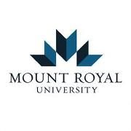

**Table of Contents**

**1.0 Introduction**…………………………………………………………………………….3

1.1 Figure 1…………………………………………………………………...........4

**2.0 Goal & scope definition**………………………………………………………………..5

2.1 The goal of the LCA…………………………………………………………...5

2.2 Function of the system………………………………………………………….

2.3 Functional unit…………………………………………………………………..

2.4 Process maps……………………………………………………………………

2.5 Impact categories considered……………………………………………………

2.6 System boundaries and basis of selection……………………………………….

2.7 Values……………………………………………………………………………

2.8 Data quality requirements……………………………………………………….

2.9 Assumptions & limitations………………………………………………………

**3.0 Life Cycle Inventory**……………………………………………………………………

3.1 Weight of metallic kettle…………………………………………………………

3.2 Method of data collection………………………………………………………..

3.3 Sources of data collected…………………………………………………………

3.4 Table 2……………………………………………………………………………

**4.0 Life Cycle Impact Analysis**……………………………………………………………..

4.1 Table 3……………………………………………………………………………

4.2 Individual impact categories……………………………………………………..

**5.0** **Lifecycle Interpretation**…………………………………………………………………

5.1 Identification of significant environmental issues……………………………….

5.2 Evaluation of completeness, sensitivity & consistency of data…………………

5.3 Conclusion & recommendations…………………………………………………

**6.0 Conclusion**………………………………………………………………………………..

**1.0 Introduction**

Stages of a metallic kettle life-cycle as well as other electronic and electrical substances include: 1) Raw material assets, 2) Material Manufacture, 3) Product purchase, 4) Use & Service and 5) Termination & Mitigation of wastes (Dunmade., 2022). The first metallic kettle was created by Arthur Leslie Large in 1891 (National Maglab., 2014). Prior to the 1920’s, the water was independent of the heated component (National Maglab., 2014). National Maglab., (2014) also suggests the metallic compartment was covered and added into the water by the Swan Company in the 1920’s. Metallic kettles are comprised/can be comprised of aluminum, brass, copper, iron and stainless steel (Azapagic et al., 2018; Harvey., n.d). Aluminum is beneficial from its heat conductivity and resistance (Harvey., n.d). However, aluminum based metallic kettles are strongly suggested to not be utilized as aluminum is a neurotoxin that can disrupt the passing of toxins towards the brain (Exton., 2019).

A brass metallic kettle is able to withstand damage, can expand and could last for an extensive amount of time (Sophie., 2021). Copper metallic kettles tend to heat and boil water relatively promptly in contrast to stainless steel metallic kettles due to having a higher conductivity as well as being more energy efficient and time effective (Lyu., 2019). The downside of having a copper metallic kettle compared to other metallic kettles is the high cost of copper as well as the maintenance as copper tends to scratch and damage when in aerobic conditions (Lyu., 2019). Iron dispenses heat equivalently and steel is durable and rust-resistant (Harvey., n.d). Although an iron metallic kettle has a high conductivity, durability and can keep the water hotter for longer periods, an iron metallic kettle can lead to iron draining into the water as well iron can rust if the water is left in the kettle for extended periods of time (Lisa., 2021). Steel metallic kettles are cost-effective and are durable, however, rusting could occur when used for extended periods of time (Kumar., 2021).

The size of a metallic kettle usually ranges from 1.5 and 1.7 liters of water (Mendelsohn & Salvoni., 2021). Metallic kettle makers (manufacturers) include Phillips, Bariton, Buydeem, Comfee’, Cosori, Elite Gourmet, Haden, Hamilton Beach, KitchenAid and Oster (Best Products Canada., 2022). However, there are many more brands that create metallic kettles. With regards to metallic kettles composed of brass, the weight usually averages about 24 g; metallic kettles composed of copper generally weigh 19 g (Azapagic et al., 2018). Metallic kettles composed of stainless steel roughly weigh 645 g and 1201 g is the sum of the weight of a metallic kettle with brass, copper and stainless steel making up 688 g of the kettle (Azapagic et al., 2018). Azapagic et al., (2018) states that stainless steel consists of the heating plate, the overall body of the metallic kettle, the screws as well as the springs and composes 295 g of the kettle.

Individually, brass makes-up the power cord plug, the socket as well as the thermal plug while copper makes-up the wire cables, the thermal socket, the power cord and the plugs (Azapagic et al., 2018). The manufacturing process used to produce metallic kettle involves a punch press die that has a sheet steel put inside of it (How products are made., n.d). A kettle bottom shape is made once a water punch is discharged and extracted (How products are made., n.d). In order to clasp the heated segment, the second steel sheet is put into a punch press (How products are made., n.d). Component parts found in a metallic kettle composed of the body, heating segment, on/off switch, power connection and the thermostat (Smyth., 2019). Material removal, manufacturing, packaging and transfer, utilization and termination are the five life cycle stages involved in the production of electronic and electrical substances (Azapagic et al., 2018). Azapagic et al., (2018) suggests kettles have been used in life cycle assessment (LCA) experimentation and evaluation. Azapagic et al., (2018) also states that ingestion of water and power usage have been examined in regards to the environmental effects of heated drinks.

Major distribution locations include factories in 1) Shanghai, China (the manufacturer’s and supplier’s location), 2) Rotherham, UK and from Rotherham, UK to the distribution site in 3) Munich, Germany (Azapagic et al., 2018). Ecoinvent data established in Shanghai, China has been utilized for the creation of metallic kettles (Azapagic et al., 2018). Azapagic et al., (2018) describes how steel stamping and aluminum deformation are involved in the aluminum and steel parts of the kettle. Azapagic et al., (2018) states that in terms of transportation, the raw items are 1) transferred by truck to the factory, 2) shipped by a freight ship to Rotherham following manufacturing and packing, 3) a distribution area in Munich then receives the metallic kettles by truck. It is implied by Azapagic et al., (2018) that the amount of energy absorbed by a metallic kettle is 188.5 kWh/yr and roughly 829 kWh using electricity as an energy source. Azapagic et al., (2018) suggest that a stainless steel metallic kettle uses 2.3 MJ of heat-based injection molding, 0.8 kWh of electricity-based injection molding, 0.03 MJ of heat-based metal stamping and 0.3 kWh of electricity-based metal stamping. In total, Azapagic et al., (2018) explains that 2.54 MJ of heat and 0.3 kWh of electricity is utilized for the raw materials of a metallic kettle.

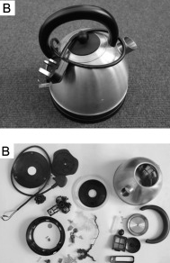

***Figure 1.*** *Metallic kettle prior to disassembly and after disassembly (Azapagic et al., 2018).*

**2.0 Goal & Scope Definition (Violet)**

The overall goal of the project is two-pronged. Firstly, the goal of the project is to offer a comprehensive life cycle inventory and compare with the life cycle environmental impacts of metallic kettles in addition to identifying the existing opportunities for improvement. Secondly, the study aims to evaluate environmental effects of the proposals to implement eco-designs in relation to energy and water efficiency as well as their durability.

**2.1 The goal of the LCA (3 points) (Asia)**

The purpose of this project is to evaluate a metallic kettle from the beginning of the making of the kettle towards the end and disposal of the kettle (Azapagic et al., 2018). The goal of the LCA for use of a metal kettle is to determine and assess the environmental effectiveness and efficiency of metal. This project will assist in recognizing the environmental effects of metallic kettles (Azapagic et al., 2018). Therefore, improvement and development of alternative environmental products can be created. This project can inform fellow peers and the rest of society to make more eco-friendly decisions within their home. Included in this project is the evaluation of the metallic kettle, distribution methods and future explanations (Dunmade., 2022). Applications/utilization of a metallic kettle include boiling water, boiling eggs, cooking rice, heating soup and making oatmeal (Kolli., 2021).

**The scope of the LCA (9 points) (Asia & Violet)**

**2.2 Function of the system**

Functionality of kettle heating pieces include the kettle wire being connected to an electrical current allowing heat to flow through the kettle body, therefore warming up the cold water by the process of conduction (Kettle Heating Elements., n.d).

**2.3 Functional unit**

The functional unit of a metallic kettle solely depends on the kettle specifications (specifically filling up the kettle up to a maximum quantity in liters). Studies show how roughly 50% of excess water is added to a kettle that is only supposed to take and heat 1028 L (Azapagic et al., 2018).

**2.4 Process maps (how it is going to be made) —> block diagram** (violet)

The process map (fig.2) below shows the environmental impact of the manufacturing phases of electric kettle. As shown in the diagram, the thick arrows indicate the impacts of the part electric kettle’s part of the environment – as an individual part. Importantly, the thickest arrows show nickel and polypropylene weighing 71 and 758 grams, respectively. A comparison of the mass shows that the amounts of nickel used in the electric kettle have a directly proportionate impact on the environment, which necessitates the finding of an alternative material to nickel. The process map for the electric kettle’s life cycle is shown in fig.1 below. The environmental impact of the kettle’s life cycle is linked to its energy consumption during its usage. The phase of the production of the kettle has approximately 7% contribution to its environmental impacts (Marcinkowski & Zych, 2017). Additionally, the waste and disposal and transportation phases contribute a negligible impact to the environment. Therefore, it is the usage of the electric kettle, as shown in the process map, that significantly impacts the environment

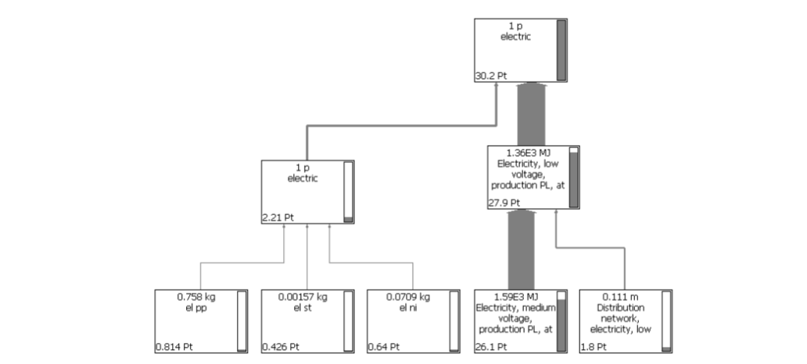

Figure 1: Process Map for Electric Kettle's Life Cycle (Marcinkowski & Zych, 2017).

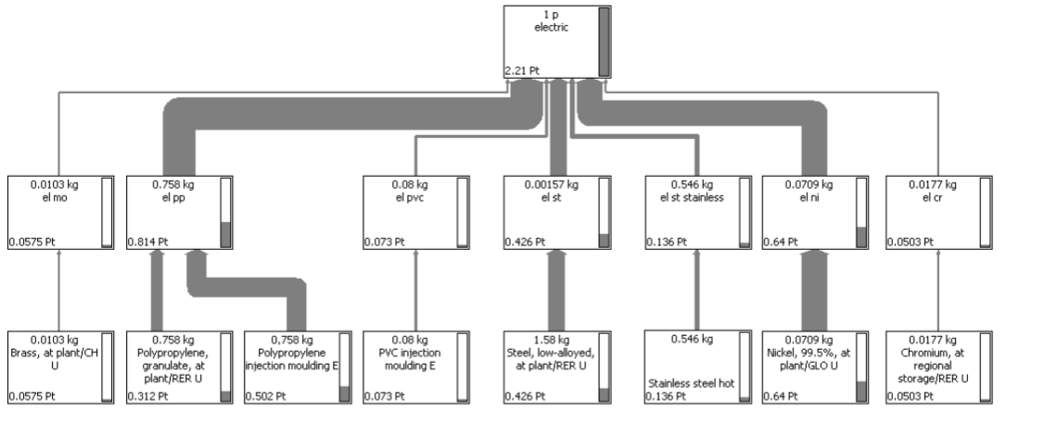

Figure 2: Process Map for Assembly of Electric Kettle (Marcinkowski & Zych, 2017).

**2.5 Impact categories considered → environmental impact of metallic kettle (5)→ GWP, ozone, photochemical**

Impact categories considered for the metallic kettle include the global warming potential (GWP) impact, the ozone depletion potential impact, the photochemical ozone depletion impact as well as the acidification and eutrophication potential impact.

**2.6 System boundaries and basis of selection: mass, energy and/or economic**

The system boundary for our project will revolve around the mass basis of selection.

**2.7 Values – available technologies (Violet)**

There is consensus on the best available technologies for the improvement of the electric kettles functionality and the reduction of their environmental impacts. However, features used in the manufacturing of the kettles can be used, including the pre-set temperature and keeping warm functionalities. The quality of the individual components can also be improved to increase the quality of the products available in the market (EU Report, 2019). The available technologies include cordless and corded. In the corded technology, the values are construction, design, its lid, material used, capacity of the kettle, and related components (filters and water filling indicators, among others). Rated input power, immersed heating elements, underfloor heating elements, composition (either tubular or conventional), and thick film heating elements are the applicable individual components that can be targeted by technologies for the improvement of functionality.

**2.8 Data quality requirements: geographical, temporal, technological (Violet)**

Since the scope of the study is the cradle-to-grave approach, the stages of data collection will include raw materials (metals, plastics, and cardboard) used, geographical location (Canada), production, use, end of life, and transport.

**2.9 Assumptions and limitations: data certainty, consistency, completeness, treatment of missing data, etc (Violet)**

The assumptions that will be used in filling up the data gap and the adaptation of other datasets include, first, for the electric cord, sockets, and plugs, Eco-invent data for the production of plugs and cables will be used. The assumption here is that the cords are similar for the kettles used in the study at H05VVH2-F 2 x 0.75 mm2. The copper weight of the power cords will be measured and the Eco-convenient dataset will be used for the mass of the raw material and PVC used in the manufacturing of the electric kettle. Additionally, due to the lack of data on the amount of electricity consumed when assembling the electric kettle, the data will not be used as a variable but the water consumption data will be used.

**3.0 Life Cycle Inventory (Asia & Violet)**

**3.1 Weight of metallic kettle → primary, secondary → data collected from database (Violet)**

The metallic kettles used in the study have an individual weight of 1.2kgs. The metallic parts weigh 700g, and their components are stainless steel for the main body, the screws and springs, and the heating plate. Brass includes the socket, thermal plug, and power cord plug and copper is used in the making of the plugs, power cords, wires, and thermal socket. The plastic components weigh 500g are manufactured using PVC for the insulating of wire cables, plugs, and power cord, PP for the lid handle, bottom cover, enclosures, base and filter, and the water gauge and nylon is used for the sockets and thermal plugs, and silicone is used in the manufacturing of the glass fiber tube.

**3.2 Method of data collection (Violet)**

To attain the objective of the study, the lifecycle environmental impacts of the electric kettles have been obtained using lifecycle environmental assessment as a tool.

The conceptual framework has been borrowed from a study conducted by Gallego-Schmid et al. (2018). The kettle’s life cycle was assumed to involve three stages, including assembly (which includes the environmental impact of the extraction of resources, processing of raw materials, and production of the kettle to fit within the cradle-to-grave model), the usage (electricity consumption) stage, and waste disposal stage that mainly links to environmental impact.

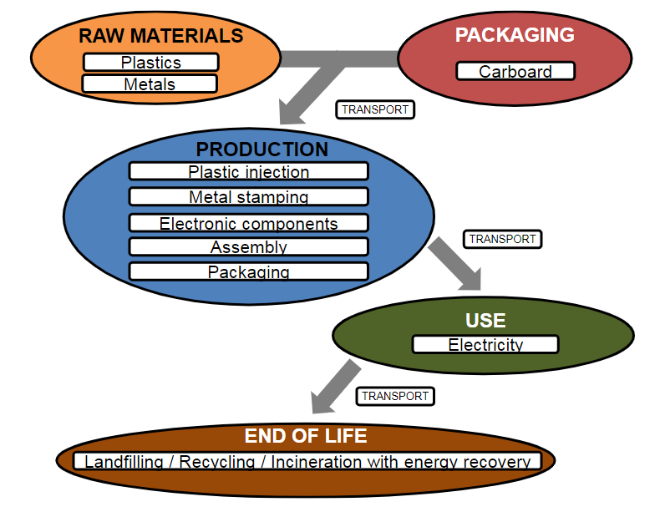

Figure 3: System Boundaries for the Kettles Gallego-Schmid et al. (2018).

**3.3 Sources of data collected**

**3.4 Table 2 (LCI table)**

**4.0 Life Cycle Impact Assessment ( Asia & Violet) (13 points)**

**4.1 Table 2 (A summary table showing stressors, impact categories, contribution of each stressor to) (Violet)**

**Table 2.** The stressors, impact categories and contribution of each stressor.

| **Stressor** | **Impact categories** | **Contribution** | **Reason** |
| --- | --- | --- | --- |
| Acquisition of raw material | Environmental | Environmental degradation | Exhaustion of raw materials |
| Production of raw material |  |  |  |
| Final product manufacturing | Environmental | Environmental degradation | Product manufacturer uses the raw materials |
| Packaging |  |  |  |
| Product distribution | Environmental | Transportation | Satisfying the entire supply chain |
| Product Usage | Environmental | Energy consumption | Materials needed |
| Waste disposal | Environmental | Product disposal | Waste incineration, landfills, re-use and recycling |

**4.2 Individual impact categories, total value of each impact category**

The environmental impact obtained from the electric Kettle LCA measures the impacts on the Likert Scale (1 – no environmental impact and 5- high environmental impact). Production of raw material and packaging have the least ecological footprint in the metallic kettles’ life cycle. Acquisition of raw material scores 4 (environmental impact) due to the existence of iron ores that are extracted for production. Product manufacturing has a 5 score (high impact) due to the manufacturing processes with a high carbon footprint in the industries. Product distribution scores 5 (high impact) due to the transportation of the manufactured products to retailers. Product usage also scores 5 (high impact) due to energy consumption throughout the use of the kettle. Disposal of the product also scores 5 (high impact) due to the disposal of non-biodegradable material and the pollution it causes.

**5.0 Lifecycle Interpretation (Violet) (10 points)**

The life cycle interpretation of electric kettles shows that it begins from acquisition of resources, including crude oil, metal ores, and coal extraction. The second stage is the production of raw materials from these resources, including metals, ceramic, plastic, among others. The raw materials are the next stage involving the transportation of the materials to the site of production. The process of manufacturing the final product involves the use of the raw materials to create the electric kettles. Product packaging and distribution are the other related stages of the lifecycle, which has environmental impacts relating to transportation. Product usage phase involves energy consumption that forms a major part of the environmental impacts of the electric kettles’ production. Waste disposal in the cradle-to-grave is also a phase in the lifecycle that has major environmental impacts (Marcinkowski & Zych, 2017).

**5.1 Identification of significant environmental issues: contribution, dominance, anomaly analysis**

**5.2 Evaluation of completeness, sensitivity and consistency of data**

Sensitivity of the data used involves the data on the electric kettles sold in the market and the water usage. The combined effect of the reduction of the total number of electric kettles in Canadian market and volume of water consumed with the goal of determining the environmental benefits of improving the designs of the electric technologies using the best available technologies.

**5.3 Conclusions and recommendations (what you learned from the product analysis)**

The electric kettle product LCA shows that the environmental impact of its entire production, distribution, usage, and disposal phases can be alleviated using changes in the raw materials used, design, and behavioral changes among consumers (complementing with alternatives). The recommendations, apart from the introduction of thermos products, is that water and electricity consumption can be reduced by focusing on the phases of its life cycle, including reduced production and improvements in the electric consumption technologies.

**6.0 Conclusion (Violet)**

**summary of your findings from the analysis (10 points)**

Based on the results of the LCA, various improvements of the technologies and usage of the electric kettles can be improved. The kettles used in the project show that the most significant life cycle phase involves electricity consumption when boiling water. Therefore, the main mitigation approach is the reduction of the environmental impacts of the product is associated with natural sources of energy (gas) and electricity consumption. While the electric kettles’ manufacturers do not directly affect this phase, redesigning the products with the aim of attaining energy use efficiency.

The other possibilities in the LCA analysis is the introduction of a change in the production of the kettles in the design of thermos to improve energy efficiency. Since the usage of kettles is an average of thrice a day, the water that remains after boiling can be stored in a thermos to maintain its temperature, which also ensures that re-boiling begins at a high temperature with the goal of reducing the amount of energy consumed when boiling the water.

**References**

Azapagic, A., Gallego-Schmid, A., Jeswani, H & Mendoza, J. (2018). Life cycle environmental evaluation of kettles: Recommendations for the development of eco-design regulations in the European Union, *Science of The Total Environment*, 625, 135-146, 0048-9697, <https://doi.org/10.1016/j.scitotenv.2017.12.262>

Best Products Canada. (2022). 10 Best all metal electric kettle in Canada-March 2022. Retrieved March 27, 2022 from <https://www.bestproductscanada.com/all-metal-electric-kettle?targetid=dsa-534183157358&matchtype=&device=c&campaignid=16074897750&creative=579576958950&adgroupid=132126366639&feeditemid=222434279826&loc_physical_ms=9001320&loc_interest_ms=&network=g&devicemodel=&placement=&keyword=$&target=&aceid=&adposition=&trackid=ca_all_top_2_1&mId=407-132-4411&trackOld=true&gclid=CjwKCAjwloCSBhAeEiwA3hVo_dtgc-m44eqzMOKbmxwBPPHVsRadM4MsZsaBpPV77c0Ol0Vl9iYQchoCwK4QAvD_BwE>

Dunmade, I. (2022). Lecture 3: LCA and its link to sustainability. Course Documents Section. Retrieved from the Lecture notes section of ENVS 3303-001.

Dunmade, I. (2022). Lecture 4: Overview of ISO Standard for Life Cycle Assessment. Course Documents Section. Retrieved March 30, 2022 from the Lecture notes section of ENVS 3303-001.

Exton, J. (2019). My tea has what in it? Avoiding a toxic kettle- Part 4. *Chemical Free Community*. Retrieved March 27, 2022 from <http://www.chemfreecom.com/avoiding-a-toxic-kettle/>.

EU Report. (2019). Preparatory study for Kettles implementing the Ecodesign Working Plan 2016-2019. Task 4: Technologies. https://www.energimyndigheten.se/globalassets/energieffektivisering_/lagar-och-krav/ekodesign--energimarkning/ecodesign_kettles_task_4_20201214_v16_final.pdf.

Gallego-Schmid, A., Jeswani, H. K., Mendoza, J. M. F., & Azapagic, A. (2018). Life cycle environmental evaluation of kettles: Recommendations for the development of eco-design regulations in the European Union. *Science of the Total Environment*, *625*, 135-146.

Harvey, S. (n.d). What metals are used in kettles? *eHow*. Retrieved on February 8, 2022 from <https://www.ehow.co.uk/how_7200707_season-wok-electric-stove.html>

How products are made. Electric Tea Kettle. Retrieved on March 27, 2022 from <http://www.madehow.com/Volume-7/Electric-Tea-Kettle.html#:~:text=In%20the%20factory%2C%20the%20sheet,to%20hold%20the%20heating%20element>.

Kettle Heating Elements. (n.d). The functionality of Kettle Heating Elements. Retrieved March 30, 2022 from https://kettleheatingelements.weebly.com/functionality-and-materials.html

Kumar, S. (2021). Stainless steel vs. Glass electric kettle: Advantages and Disadvantages. *India’s Stuffs*. Retrieved on March 28, 2022 from <https://www.indiasstuffs.com/stainless-steel-vs-glass-electric-kettle/>

Kolli, G. (2021). 10 uses of electric kettle in the kitchen. *Solara*. Retrieved March 30, 2022 from https://www.solara.in/blogs/kitchen/uses-of-electric-kettle-in-the-kitchen

Lisa, B. (2021). Benefits of a cast iron tea kettle and why you need one. *My tea vault*. Retrieved on March 27, 2022 from https://myteavault.com/how-to-pick-the-best-cast-iron-kettle/

Lyu, D. (2019). The pros and cons of copper tea kettles and teapots. *Housetipster*. Retrieved on March 27, 2022 from https://housetipster.com/housetips/1632/the-pros-cons-of-copper-tea-kettles-and-teapots

Marcinkowski, A., & Zych, K. (2017). Environmental performance of kettle production: product life cycle assessment. *Management Systems in Production Engineering*. https://sciendo.com/article/10.1515/mspe-2017-0037

Mendelsohn, H & Salvoni, F. (2021). 12 best kettles to buy in 2022. *Good housekeeping*. Retrieved March 27, 2022 from https://www.goodhousekeeping.com/uk/product-reviews/electricals/g26060049/best-kettles/

National MagLab. (2014). Kettle - 1891. *Magnet Academy*. Retrieved on February 8, 2022 from <https://nationalmaglab.org/education/magnet-academy/history-of-electricity-magnetism/museum/kettle#:~:text=The%20kettles%20were%20usually%20constructed,with%20inventing%20the%20electric%20kettle>.

Smyth, D. (2019). Parts of an Electric Kettle. *Home Steady*. Retrieved on March 27, 2022 from <https://homesteady.com/12003908/parts-of-an-electric-kettle>

Sophie. (2021). What are the advantages and disadvantages of brass jewelry? *Churinga*. Retrieved March 27, 2022 from <https://unecklace.com/what-are-the-advantages-and-disadvantages-of-brass-jewelry.html#:~:text=Brass%20metal%20is%20known%20for,excellent%20due%20to%20its%20malleability>.

**Appendix A.**

**(Network and LCI downloaded from Simapro)**