GO GREEN CAMPUS ANDROID APPLICATION

A PROJECT REPORT

Submitted
in partial fulfillment for the award of the

DIPLOMA IN COMPUTER SCIENCE AND ENGINEERING



Submitted By
Nelson Lobo
Owais Shaikh
Aruna Kadalagi
Bharata Patil

Under the guidance of
Dr. Vijay H. Kalmani, Principal, Jain Polytechnic, Belagavi

JAIN POLYTECHNIC BELAGAVI
(Approved by AICTE, New Delhi and recognized by DTE, Begaluru)
Peeranwadi, Belagavi – 590014

April 2018

A PROJECT REPORT

on

GO GREEN CAMPUS ANDROID APPLICATION

Submitted
in partial fulfillment for the award of the
DIPLOMA IN COMPUTER SCIENCE AND ENGINEERING

SUBMITTED BY
Nelson Lobo (573CS15024), VIth Sem.
Owais Shaikh (573CS15029), VIth Sem.
Aruna Kadalagi (573CS15010), VIth Sem.
Bharata Patil (573CS15013), VIth Sem.

Under the guidance of
Dr. Vijay H. Kalmani,
Principal, Jain Polytechnic, Belagavi

Department of Computer Science and Engineering
JAIN POLYTECHNIC BELAGAVI
Peeranwadi, Belagavi

Contents

Candidate’s Declaration … i
Project Guide Certification … ii
Certificate … iii
Acknowledgement … iv
List of Diagrams and Activities … v
List of Test Cases and Charts … vi
Abstract … vii
1. Introduction
1.1 Background … 1
1.2 Motivation … 1
1.3 Problem Statement … 2
1.4 Objectives … 2
2. System Survey
2.1 Survey of Existing Systems … 3
2.2 Scope for Improvement … 3
2.3 Summary … 3
2.4 Proposed System … 3
3. Requirement Specifications
3.1 Project Requirement Specifications … 4
3.1.1 Software Requirements … 4
3.1.2 Hardware Requirements … 4
3.2 Functional Requirements … 4
3.2.1 User Domain … 4
3.2.2 Institute Domain … 4
3.3 Non-functional Requirements … 5

4. Project Design
4.1 Data Flow Diagram … 6
4.2 ER Diagram … 7
4.3 Use Case Diagrams … 8
5. Implementation and Testing
5.1 Implementation Details … 9
5.1.1 Software Frontend … 9
5.1.2 Software Backend … 9
5.2 Modules … 10
5.2.1 Waste Segregation … 10
5.2.2 Data Processing and Calculation … 10
5.2.3 Graphing and Display … 10
5.3 Application Activities and Programs … 11
5.3.1 Login … 11
5.3.2 Forgot Password … 21
5.3.3 User Sign Up … 25
5.3.4 Institute Registration … 36
5.3.5 Dashboard … 47
5.3.6 Add Data … 57
5.3.7 Spectate … 75
5.3.8 Drawer … 82
5.4 Test Cases and Profiles … 83
5.4.1 User Login Attempt … 83
5.4.2 Password Recovery Attempt … 83
5.4.3 New User Registration … 83
5.4.4 New Institute Registration … 84
5.4.5 Addition of Data … 84
5.4.6 Searching for Existing Data Entries … 84
5.4.7 Checking connectivity to server in specific scenarios … 85
5.4.8 Application performance profile … 85
6. Screenshots … 86
7. Advantages … 91
8. Applications … 92
9. Further Scope and Enhancements … 93
10. Conclusion …94
Bibliography
References … viii

CANDIDATE’S DECLARATION

I, Aruna Kadalagi, student of Diploma in Computer Science and Engineering, bearing the Register No.: 573CS15010 of Jain Polytechnic Belagavi, hereby declare that I own full responsibility for the information, result and conclusion provided in this project work titled “GoGreenCampus”, submitted to the Board of Technical Examinations, Government of Karnataka, for the award of the Diploma in Computer Science and Engineering.

To the best of my knowledge, this project has not been submitted in part or fully elsewhere in any institution or organization for the award of my certificate/diploma/degree. I further declare that in case of any violation of intellectual property or rights and particulars declared, found at any stage, I, Aruna Kadalagi, as the candidate will be solely responsible for the same.

Date:

Place:

Signature of Candidate

Name: Aruna Kadalagi
Register No.: 573CS15010

i

PROJECT GUIDE CERTIFICATE

JAIN POLYTECHNIC BELAGAVI
Department of Computer Science and Engineering

BONAFIDE CERTIFICATE
Certified that this project report “GoGreenCampus Android Application” is the bonafide work of “Aruna Kadalagi” bearing Register Number “573CS15010” of this institution who carried out the project work under my supervision.

Dr. Vijay H. Kalmani Mr. Chetan Patil
Guide Head of Department

ii
JAIN POLYTECHNIC BELAGAVI
19/1, Peeranwadi, Belagavi – 590014

Department of Computer Science and Engineering

CERTIFICATE

Certified that this project report titled “GoGreenCampus” is the bonafide work carried out by Aruna Kadalagi, 573CS15010, Sixth Semester, for the partial fulfillment of the Diploma in Computer Science and Engineering of the Board of Technical Examinations, Bengaluru, Government of Karnataka during the year 2015-2016. It is certified that all corrections and suggestions indicated for internal assessment have been incorporated in this report and one copy of it is being deposited in the library.

The project has been approved as it satisfies the academic requirements in respect of Project Work prescribed for the Diploma in Computer Science and Engineering.

It is further understood that by this certificate, the undersigned do not endorse or approve any statements made, opinions expressed or conclusions drawn therein, but approve the project only for the purpose for which it is submitted.

Dr. Vijay H. Kalmani
Guide
Prof. Chetan Patil
Head of Department
Dr. Vijay H. Kalmani
Principal

Name of Examiners

1. _________________

2. _________________
Signature (with date)

_________________

_________________

ii
iii
ACKNOWLEDGEMENT

“All experiences are an oppurtunity for us to learn and grow”

Gratitude takes three forms, “a feeling from the heart”, “an expression in words” and “giving in return”. It is our human bound duty to acknowledge the following personalities for their efforts in guiding us in the right direction. The sense of contentment and elation that accompanies the successful completion f our project and it’s report would be incomplete without mentioning the names of the people who helped us in accomplishing this.

First and foremost, we would like to extend our cordial regards and thanks to our principal, Dr. Vijay H. Kalmani, for providing a healthy learning environment in the college, which helped us in developing our skills and concentrating on the task at hand. We express a deep sense of gratitude to our Head of Department, Mr. Chetan Patil for his valuable guidance, cooperation and timely help. We would also like to express our heartfelt thanks to all the staff at the Department of Computer Science and Engineering for their valuable support.

It has been a fortune to associate with our guide, Dr. Vijay H. Kalmani, as our guide during the course of this project undertaken. He has been kind enough to help us all in the fronts of development of this project when we required his help and has been continuous source of inspiration. Hence, it is our bountiful duty to offer our gratefulness to him.

Nelson Lobo
Owais Shaikh
Aruna Kadalagi
Bharata Patil

iv
List of diagrams and activities

Diagram 1. Data Flow Diagrams … 6
Diagram 2. Entity Relationships (ER) Diagrams … 7
Diagram 3. Use Case Diagrams … 8
Activity 4. Login … 11
Activity 5. Forgot Password … 21
Activity 6. User Sign Up … 25
Activity 7. Register Institute … 36
Activity 8. Dashboard … 48
Activity 9. Add Data … 57
Activity 10. Spectate … 75
Activity 11. Drawer … 82

v
List of test cases and charts

Table 1. User Login Attempt … 83
Table 2. Password Recovery Attempt … 83
Table 3. New User Registration … 83
Table 4. New Institute Registration … 84
Table 5. Addition of Data … 84
Table 6. Searching for Existing Data Entries … 84
Table 7. Checking Connectivity to server and database in specific scenarios … 85
Chart 1. Application performance profile … 85

vi
ABSTRACT

The aim of our project is to make an Android Application that takes some input about the waste that has been generated in a university, college or school campus and the amount of waste that has been treated throughout the month and time, process the data to find the ratio of waste generated to waste treated and represent it with the help of graphical, visual and textual information and to assign ranking to the institute on based on the LEED index and green rating given. This application monitors and keeps track of the amount of waste generated and recycled and find out ways to improve the quality of our environment by finding out efficient ways of waste treatment and encourages environmentally-friendly practices by creating a competitive, community-based ambience.

vii
Chapter 1. Introduction

1.1 Background

Go Green Campus Waste Management (GGC) Android App is an easy to use Android application with interactive Graphical User Interface (GUI). This application can be used by Universities, Colleges and Schools to keep track record of the waste that is generated in the campus and the waste that is been treated. The information is represented in the form of text and graph.
More and more of us are realizing that our future depends on protecting the health and wellbeing of ourselves and our home planet, Earth. To do so, we must educate a new generations of citizens with the skills to solve the global environmental problems we face and to have a green future or a green economy with green universities, colleges, and schools and their campuses.
Mobile Applications have a unique model in order to provide top-quality customized solutions to such an issue and to big masses and price-ranges that are affordable. For example, according to available statistics, over 80% of startups today are actively looking into creating a mobile applications for such situations.

1.2 Motivation

Safeguarding the health of India’s schoolchildren must be central to a high-quality education. Research shows that greener school environments can improve children’s health and learning. Yet our institutes get dismal grades in environmental practices.

Schools use non-biodegradable and recyclable waste contain toxins, which are irreversible and dangerous to life forms on Earth. Poor indoor air quality, air pollution and low-visibility are linked to various health issues like soaring asthma and direct environmental impact. Most schools consume enormous quantities of paper and energy, produce tons of waste and carbon emissions, and rarely purchase environmentally-friendly products. Research shows that green schools save more money due to efficiency and affordability of materials, while improving employees and students’ health. A 2006 LEED Green Building Council report showed that green schools cost ₹195 more per square meter, but generated ₹4800 per square meter in benefits from energy savings, increased attendance, and employee retention.

1
1.3 Problem Statement

The main objective of GoGreenCampus Android App is to provide users with an easy to use application with interactive GUI that can be used to monitor and keep track of waste generated and waste treated throughout the day in University/College/School Campus.

This information can be further used by the University/College/School Authority to enhance the waste treatment facility in the campus thus reducing the generation of waste and keeping the surrounding clean.

1.4 Objectives

- To develop an Android mobile application to simplify waste collection.
- To process and display precise data for evaluation and analysis and technical feasibility.
- To encourage institutes to reduce generation of waste and keep our surroundings clean.
- To instill a good attitude and a sense of pride and accomplishment for completing tasks related to recycling.

2
Chapter 2. System Survey

2.1 Survey of Existing Systems

Although there are applications that are used by people to file complaints about waste generated around us there is no application that keeps track of the amount of waste generated and treated and most of the applications that keep track are not much developed and they keep track of only the solid waste^{[8]}. This makes the development/enhancement of the waste treatment facility extremely difficult^{[7]}
2.2 Scope for Improvement

The application improves on current systems such as RoHS^{[6]} and LEED^{[5]} etc. by offering a completely digital and wireless solution for keeping track of and recording waste disposal and management, which directly affects the environmental quality of a campus/organization^{[9]}.
2.3 Summary

Waste management is among the basic essential services needed to keep campuses green. Due to industrialization, rural to urban migration and high growth rate of population have induced rapid urbanization in developing countries and obviously in India as well^{[7]}. The haphazard urbanization created acute problem for waste management. Waste generation rate in India has increased from 0.44 kg per day in 2001 to 0.5 kg per day in 2011^{[8]}; such a steep increase in waste generation within a decade has severed the stress on all infrastructural, natural and budgetary resources^{[7]}. So, there is a need for proper waste collection, segragation and processing. The proposed work emphasizes on the use of technology and mobile systems in making a sustainable urban environment.
2.4 Proposed System

The proposed system can keep record of the waste that is been generated and the amount of that waste that is actually been treated. This can be applied to both solid waste as well as liquid waste. The GoGreenCampus Application processes the data and represents the data in both text as well as graphical form. It makes use of easy to use user-friendly Graphical User Interface (GUI) for the user to interact with the application.

3
Chapter 3. Requirements Specifications

3.1 Project Requirements Specification

Following are the hardware and software requirements to be met in order to use the proposed system:
3.1.1 Hardware Requirements
- Any ARM-based 64-bit Android device @ 768MHz or more
- Minimum 512MB of RAM
- Minimum 10MB of Internal Storage
- Connectivity to the Internet via WiFi or Cellular Data
- Android devices with 64-bit ARMv7 architecture (32-bit and Intel x86 unsupported)

3.1.2 Software Requirements
- Android 6.0 Marshmallow and above
- A PHP server
- System versions supporting Kotlin compatibility. (Android 6.0+)
- A MySQL Database
- Android XML Schemas

3.2 Functional Requirements

Functional requirements are the requirements of tasks, processes etc. essential to the system.
3.2.1 User Domain
- The users add data on waste to the application.
- The users can log into and delete their accounts.
- The users can delete specific entries from the server/database
- All users collectively affect the institute’s performance
3.2.2 Institute Domain
- The institutes can add themselves on the database.
- The institute heads all the users of the campus.
- The institutes compete with each other to perform better in environmental sustainability.

4
3.3 Non-Functional Requirements

Non-functional requirements are requirements that are not compulsory, but add a nice feature to the application, such as UI Design, notifications, animations etc.
- Easy-to-use user interface design.
- Use of discrete components like cards and dynamic padding.
- Adding animations to give appeal.
- Notifying users of errors.

5
Chapter 4. Project Design

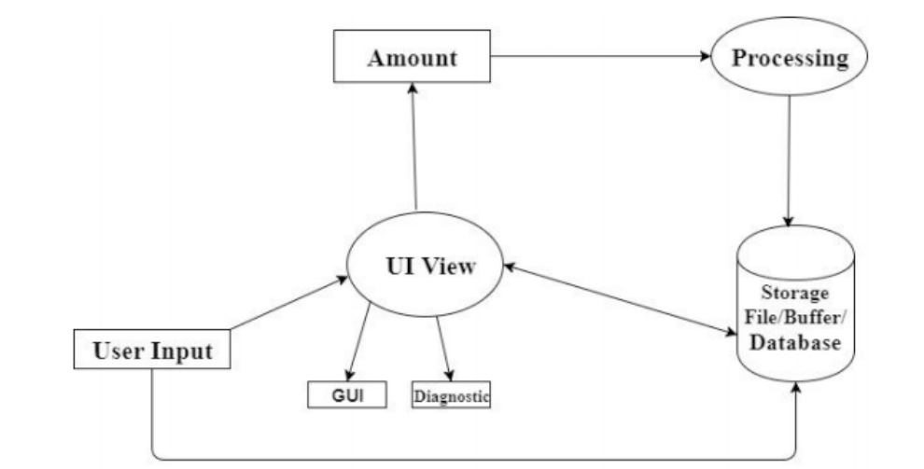
4.1 Data Flow Diagram

Fig. 4.1 Data Flow diagram

6
4.2 Entity Relationship (ER) Diagrams
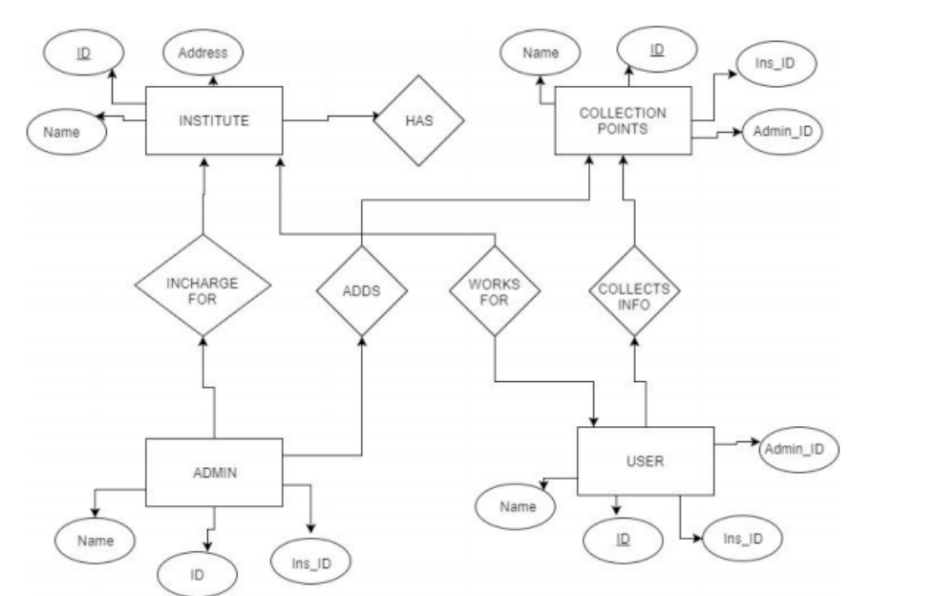
Fig. 4.2 Entity-Relationship (ER) diagram

7
4.3 Use Case Diagrams
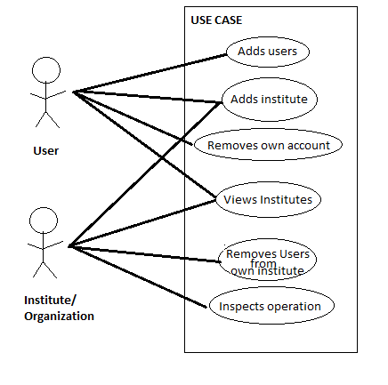

Fig. 4.3 Use Case diagram

8
Chapter 5. Implementation and Testing

5.1 Implementation Details

The implementation phase is the most important phase as it gets the final outcome of the project. It perfectly maps and materializes the project. The GoGreenCampus Application has two implemented parts:

5.1.1 Software Frontend
- The Software Frontend is a user-friendly Graphical User Interface(GUI).
- It supports native controls, has visible buttons and text boxes for the user to use the application easily.
- The Frontend of the is designed using Google’s XML Framework for Android Applications.
5.1.2 Software Backend
- The Software Backend is the most important part of the application that consists of algorithms for processing of the data entered by the user.
- The Backend of the Application is designed using Kotlin which is a new, object-oriented programming language used to develop Android applications and a MySQL database for the storage and retrieval of data from a highly secure MySQL server.
- The server connections are established in the PHP programming language.
- The database is queried using Structured Query Language (SQL).

9
5.2 Modules
The implementation phase is the most important phase as it gets the final outcome of the project. It perfectly maps and materializes the project. The GoGreenCampus Application has three implemented parts:

5.2.1 Waste Segregation

Waste segregation is the process by which waste is separated into different elements. Waste sorting occurs automatically in the application and sent to the server. Data is added via the Add page and is segregated and stored on the database using PHP.

5.2.2 Data Processing and Calculation

Data processing includes the collection and manipulation of items of data to produce some data. It can be considered a subset of the module and uses specialized algorithms and statistical calculations. Data is processed programmatically in PHP and is calculated in Kotlin.

5.2.3 Graphing and Display

Graphing is a mathematical method used to model the data obtained from calculation of inputs. A graph in this context is made up of vertices and lines which are directly plotted from the obtained results from the server. Data is graphed using a library and is displayed using Kotlin

10
5.3 Application Activities and Programs

5.3.1 Login
activity_login.xml
<?xml version="1.0" encoding="utf-8"?>
<android.support.constraint.ConstraintLayout xmlns:android="http://schemas.android.com/apk/res/android"
xmlns:app="http://schemas.android.com/apk/res-auto"
xmlns:tools="http://schemas.android.com/tools"
android:layout_width="match_parent"
android:layout_height="match_parent"
android:background="@color/bg"
tools:context="finalproject.ggcfinal.MainActivity">
<ImageView
android:id="@+id/imageView3"
android:layout_width="wrap_content"
android:layout_height="wrap_content"
app:srcCompat="@drawable/lbg"
tools:layout_editor_absoluteX="0dp"
tools:layout_editor_absoluteY="0dp" />
<ImageView
android:id="@+id/imageView4"
android:layout_width="228dp"
android:layout_height="103dp"
android:layout_marginBottom="13dp"
android:layout_marginStart="8dp"
android:layout_marginTop="1dp"
app:layout_constraintBottom_toTopOf="@+id/button"
app:layout_constraintEnd_toEndOf="parent"
app:layout_constraintHorizontal_bias="0.054"
app:layout_constraintStart_toStartOf="parent"
app:layout_constraintTop_toBottomOf="@+id/editText4"
app:layout_constraintVertical_bias="0.0"
11
app:srcCompat="@drawable/black" />
<EditText
android:id="@+id/Username"
android:layout_width="311dp"
android:layout_height="wrap_content"
android:layout_marginBottom="8dp"
android:layout_marginEnd="8dp"
android:layout_marginStart="8dp"
android:layout_marginTop="8dp"
android:backgroundTint="@android:color/darker_gray"
android:ems="10"
android:hint="Username"
android:maxLength="20"
android:inputType="textPersonName"
android:singleLine="true"
android:textColor="@android:color/darker_gray"
android:textColorHint="@android:color/darker_gray"
app:layout_constraintBottom_toBottomOf="parent"
app:layout_constraintEnd_toEndOf="parent"
app:layout_constraintHorizontal_bias="0.508"
app:layout_constraintStart_toStartOf="parent"
app:layout_constraintTop_toTopOf="parent"
app:layout_constraintVertical_bias="0.498" />
<EditText
android:id="@+id/passwordedit"
android:layout_width="308dp"
android:layout_height="wrap_content"
android:layout_marginBottom="8dp"
android:layout_marginEnd="8dp"
android:layout_marginStart="8dp"
android:layout_marginTop="8dp"
android:backgroundTint="@android:color/darker_gray"
android:maxLength="50"
12
android:ems="10"
android:hint="Password"
android:inputType="textPassword"
android:textColor="@android:color/darker_gray"
android:textColorHint="@android:color/darker_gray"
app:layout_constraintBottom_toBottomOf="parent"
app:layout_constraintEnd_toEndOf="parent"
app:layout_constraintStart_toStartOf="parent"
app:layout_constraintTop_toTopOf="parent"
app:layout_constraintVertical_bias="0.61" />
<Button
android:id="@+id/button"
android:hapticFeedbackEnab"0.508"
app:layout_constraintStart_toStartOf="parent"
app:layout_constraintTop_toTopOf="parent"
app:layout_constraintVertical_bias="0.718"
tools:background="@color/colorPrimary" />
<ImageView
android:id="@+id/imageView2"
android:layout_width="75dp"
android:layout_height="75dp"
app:layout_constraintBottom_toBottomOf="parent"
app:layout_constraintEnd_toEndOf="parent"
app:layout_constraintHorizontal_bias="0.501"
app:layout_constraintStart_toStartOf="parent"
app:layout_constraintTop_toTopOf="parent"
app:layout_constraintVertical_bias="0.134"
app:srcCompat="@drawable/logo" />
<TextView
android:id="@+id/editText4"
android:hapticFeedbackEnabled="true"
android:layout_width="341dp"
android:layout_height="30dp"
13
android:layout_marginBottom="8dp"
android:layout_marginEnd="8dp"
android:layout_marginStart="8dp"
android:layout_marginTop="8dp"
android:ems="10"
android:inputType="none"
android:text="@string/loginprompt"
android:textColor="@android:color/background_light"
app:layout_constraintBottom_toBottomOf="parent"
app:layout_constraintEnd_toEndOf="parent"
app:layout_constraintHorizontal_bias="0.518"
app:layout_constraintStart_toStartOf="parent"
app:layout_constraintTop_toTopOf="parent"
app:layout_constraintVertical_bias="0.427" />
<TextView
android:id="@+id/textView3"
android:layout_width="145dp"
android:layout_height="25dp"
android:layout_marginBottom="8dp"
android:layout_marginEnd="8dp"
android:layout_marginStart="8dp"
android:hapticFeedbackEnabled="true"
android:layout_marginTop="8dp"
android:text="@string/signupprompt"
android:textColor="@android:color/background_light"
android:textSize="14sp"
app:layout_constraintBottom_toBottomOf="parent"
app:layout_constraintEnd_toEndOf="parent"
app:layout_constraintHorizontal_bias="1.0"
app:layout_constraintStart_toStartOf="parent"
app:layout_constraintTop_toTopOf="parent"
app:layout_constraintVertical_bias="1.0" />
<TextView
14
android:id="@+id/textView6"
android:layout_width="145dp"
android:layout_height="25dp"
android:layout_marginBottom="8dp"
android:layout_marginEnd="8dp"
android:layout_marginStart="8dp"
android:layout_marginTop="8dp"
android:gravity="center"
android:text="@string/iforgot"
android:textColor="@android:color/background_light"
android:textSize="14sp"
app:layout_constraintBottom_toBottomOf="parent"
app:layout_constraintEnd_toEndOf="parent"
app:layout_constraintHorizontal_bias="0.502"
app:layout_constraintStart_toStartOf="parent"
app:layout_constraintTop_toTopOf="parent"
app:layout_constraintVertical_bias="0.788" />
</android.support.constraint.ConstraintLayout>led="true"
android:layout_width="307dp"
android:layout_height="36dp"
android:layout_marginBottom="8dp"
android:layout_marginEnd="8dp"
android:layout_marginStart="8dp"
android:layout_marginTop="8dp"
android:background="@color/colorPrimary"
android:text="LOG IN"
android:textColor="@android:color/background_light"
app:layout_constraintBottom_toBottomOf="parent"
app:layout_constraintEnd_toEndOf="parent"
app:layout_constraintHorizontal_bias=

15
LoginActivity.kt
package finalproject.ggcfinal
import android.app.AlertDialog
import android.app.SearchManager
import android.content.Context
import android.content.DialogInterface
import android.content.Intent
import android.support.v7.app.AppCompatActivity
import android.os.Bundle
import android.os.Vibrator
import android.support.design.widget.Snackbar
import android.support.v4.view.MenuItemCompat
import android.support.v7.widget.SearchView
import android.widget.EditText
import android.widget.SeekBar
import android.widget.TextView
import android.widget.SeekBar.OnSeekBarChangeListener
import android.text.Editable
import android.text.TextWatcher
import android.view.Menu
import android.view.MenuInflater
import android.view.MenuItem
import android.view.View
import com.android.volley.Request
import com.android.volley.Response
import com.android.volley.toolbox.StringRequest
import com.android.volley.toolbox.Volley
import kotlinx.android.synthetic.main.activity_add.*
import kotlinx.android.synthetic.main.activity_main.*
import org.jetbrains.anko.toast
import org.json.JSONException
import org.json.JSONObject
16

@Suppress("DEPRECATION")
class AddActivity : AppCompatActivity() {
var liter: Long = 0
var vol: Long = 0
var vis: Long = 0
var wType: String = ""
var wconvention: String = ""
var uid: Int = 0
var insid: Int = 0
var note: String = ""
var fname: String = ""
var uname: String = ""
var lname: String = ""
var inscode: Int = 0
override fun onCreate(savedInstanceState: Bundle?) {
super.onCreate(savedInstanceState)
setContentView(R.layout.activity_add)
fname = intent.extras.getString("FNAME")
uname = intent.extras.getString("UNAME")
lname = intent.extras.getString("LNAME")
uid = intent.extras.getInt("ID")
insid = intent.extras.getInt("INSID")
inscode = intent.extras.getInt("CODE")
val seekBar = findViewById<SeekBar>(R.id.seekBar) as SeekBar
val seekBarValue = findViewById<EditText>(R.id.seekvalue) as EditText
vis = 0
seekBar.setOnSeekBarChangeListener(object : SeekBar.OnSeekBarChangeListener {
override fun onProgressChanged(seekBar: SeekBar, progress: Int,
fromUser: Boolean) {
seekBarValue.setText(progress.toString())
liter = progress.toLong()
vol = liter * 1000
17
textView13.text = vol.toString()}
override fun onStartTrackingTouch(seekBar: SeekBar) {
}
override fun onStopTrackingTouch(seekBar: SeekBar) {
}})
seekv.setOnSeekBarChangeListener(object : SeekBar.OnSeekBarChangeListener {
override fun onProgressChanged(seekBar: SeekBar, progress: Int, fromUser: Boolean) {
vis = progress.toLong()
visText.text = progress.toString()
}
override fun onStartTrackingTouch(seekBar: SeekBar) {
}
override fun onStopTrackingTouch(seekBar: SeekBar) {
}})
seekBarValue.addTextChangedListener(object : TextWatcher {
override fun beforeTextChanged(s: CharSequence, start: Int, count: Int, after: Int) {
}
override fun onTextChanged(s: CharSequence, start: Int, before: Int, count: Int) {
}
override fun afterTextChanged(s: Editable) {
try {
seekBar.setProgress(Integer.parseInt(s.toString()))
} catch (ex: Exception) {}
}})
}
override fun onCreateOptionsMenu(menu: Menu): Boolean {
menuInflater.inflate(R.menu.done, menu)
return true
}
override fun onOptionsItemSelected(item: MenuItem): Boolean {
val v: Vibrator = getSystemService(Context.VIBRATOR_SERVICE) as Vibrator
when (item.itemId) {
R.id.action_done -> {
18
addData()
v.vibrate(25)
toast("Data added successfully")
val intent = Intent(this@AddActivity,DrawerActivity::class.java)
intent.putExtra("UNAME",uname)
intent.putExtra("FNAME",fname)
intent.putExtra("LNAME",lname)
intent.putExtra("ID",uid)
intent.putExtra("INSID",insid)
intent.putExtra("CODE",inscode)
startActivity(intent)
finish()
return true
}
else -> return super.onOptionsItemSelected(item)
}
}
override fun onBackPressed() {
AlertDialog.Builder(this, R.style.DialogDark)
.setMessage("Discard data?")
.setCancelable(true)
.setPositiveButton("DISCARD") { dialog, id -> this@AddActivity.finish() }
.setNegativeButton("CANCEL", null)
.show()
val intent = Intent(this@AddActivity,DrawerActivity::class.java)
intent.putExtra("UNAME",uname)
intent.putExtra("FNAME",fname)
intent.putExtra("LNAME",lname)
intent.putExtra("ID",uid)
intent.putExtra("INSID",insid)
startActivity(intent)
}
fun addData() {
19
val pref = SharedPrefManager.getInstance(this@AddActivity)
if(raddsolid.isChecked){
wType = "solid waste"
}else if (raddliquid.isChecked){
wType = "liquid waste"}
if(raddbiod.isChecked){
wconvention = "biodegradable"
}else if (radnonbio.isChecked){
wconvention = "non-biodegradable"}
if(rec.isChecked){
wconvention = "$wconvention"+" and"+" recyclable"
}
note = Note.text.toString()
val url = "http://192.168.43.147/add.php"
val q = Volley.newRequestQueue(this@AddActivity)
val stringRequest = object : StringRequest(Request.Method.POST, url,
Response.Listener { response ->
}, Response.ErrorListener { error -> toast("$error") }) {
public override fun getParams(): HashMap<String, String> {
val params = HashMap<String, String>()
params.put("uid", uid.toString())
params.put("insid", insid.toString())
params.put("wtype", wType)
params.put("wconvention", wconvention)
params.put("quantity", liter.toString())
params.put("plevel", vis.toString())
params.put("note", note)
return params
}
}
q.add(stringRequest)
}
}
20
5.3.2 Forgot Password
activity_iforgot.xml
<?xml version="1.0" encoding="utf-8"?>
<android.support.constraint.ConstraintLayout xmlns:android="http://schemas.android.com/apk/res/android"
xmlns:app="http://schemas.android.com/apk/res-auto"
xmlns:tools="http://schemas.android.com/tools"
android:layout_width="match_parent"
android:layout_height="match_parent"
tools:context="finalproject.ggcfinal.IforgotActivity"
android:background="@color/bg">
<ImageView
android:id="@+id/imageView2"
android:layout_width="75dp"
android:layout_height="75dp"
app:layout_constraintBottom_toBottomOf="parent"
app:layout_constraintEnd_toEndOf="parent"
app:layout_constraintStart_toStartOf="parent"
app:layout_constraintTop_toTopOf="parent”
app:layout_constraintVertical_bias="0.117"
app:srcCompat="@drawable/logo" />
<EditText
android:id="@+id/email"
android:layout_width="350dp"
android:layout_height="wrap_content"
android:layout_marginBottom="8dp"
android:layout_marginEnd="8dp"
android:layout_marginStart="8dp"
android:layout_marginTop="8dp"
android:backgroundTint="@android:color/darker_gray"
android:ems="10"
android:hint="Email"
21
android:inputType="textEmailAddress"
android:singleLine="true"
android:textColor="@android:color/darker_gray"
android:textColorHint="@android:color/darker_gray"
app:layout_constraintBottom_toBottomOf="parent"
app:layout_constraintEnd_toEndOf="parent"
app:layout_constraintHorizontal_bias="0.515"
app:layout_constraintStart_toStartOf="parent"
app:layout_constraintTop_toTopOf="parent"
app:layout_constraintVertical_bias="0.405" />
<EditText
android:id="@+id/phone"
android:layout_width="53dp"
android:layout_height="40dp"
android:backgroundTint="@android:color/darker_gray"
android:gravity="left"
android:hint="+XX"
android:inputType="phone"
android:maxLength="4"
android:textAlignment="textEnd"
android:textColor="@android:color/darker_gray"
android:textColorHint="@android:color/darker_gray"
app:layout_constraintBottom_toBottomOf="parent"
app:layout_constraintEnd_toEndOf="parent"
app:layout_constraintHorizontal_bias="0.086"
app:layout_constraintStart_toStartOf="parent"
app:layout_constraintTop_toTopOf="parent"
app:layout_constraintVertical_bias="0.499" />
<EditText
android:id="@+id/phone2"
android:layout_width="280dp"
android:layout_height="40dp"
android:layout_marginBottom="8dp"
22
android:layout_marginEnd="8dp"
android:layout_marginStart="8dp"
android:layout_marginTop="8dp"
android:backgroundTint="@android:color/darker_gray"
android:ems="10"
android:hint="Phone Number"
android:inputType="phone"
android:maxLength="10"
android:textColor="@android:color/darker_gray"
android:textColorHint="@android:color/darker_gray"
app:layout_constraintBottom_toBottomOf="parent"
app:layout_constraintEnd_toEndOf="parent"
app:layout_constraintHorizontal_bias="0.808"
app:layout_constraintStart_toStartOf="parent"
app:layout_constraintTop_toTopOf="parent"
app:layout_constraintVertical_bias="0.499" />
<TextView
android:id="@+id/textView11"
android:layout_width="wrap_content"
android:layout_height="20dp"
android:layout_marginBottom="8dp"
android:layout_marginEnd="8dp"
android:layout_marginStart="8dp"
android:layout_marginTop="8dp"
android:text="A link will be sent to your email to reset your password."
app:layout_constraintBottom_toBottomOf="parent"
app:layout_constraintEnd_toEndOf="parent"
app:layout_constraintHorizontal_bias="0.49"
app:layout_constraintStart_toStartOf="parent"
app:layout_constraintTop_toTopOf="parent"
app:layout_constraintVertical_bias="0.563" />
<Button
android:id="@+id/button"
23
android:layout_width="350dp"
android:layout_height="36dp"
android:layout_marginBottom="8dp"
android:layout_marginEnd="8dp"
android:layout_marginStart="8dp"
android:layout_marginTop="8dp"
android:background="@color/colorPrimary"
android:text="CONFIRM"
android:textColor="@android:color/background_light"
app:layout_constraintBottom_toBottomOf="parent"
app:layout_constraintEnd_toEndOf="parent"
app:layout_constraintHorizontal_bias="0.488"
app:layout_constraintStart_toStartOf="parent"
app:layout_constraintTop_toTopOf="parent"
app:layout_constraintVertical_bias="0.655"
tools:background="@color/colorPrimary" />
<TextView
android:id="@+id/textView16"
android:layout_width="wrap_content"
android:layout_height="wrap_content"
android:layout_marginBottom="8dp"
android:layout_marginEnd="8dp"
android:layout_marginStart="8dp"
android:layout_marginTop="8dp"
android:text="?"
android:textColor="@android:color/background_light"
android:textSize="40sp"
app:layout_constraintBottom_toBottomOf="parent"
app:layout_constraintEnd_toEndOf="parent"
app:layout_constraintStart_toStartOf="parent"
app:layout_constraintTop_toTopOf="parent"
app:layout_constraintVertical_bias="0.122" />
</android.support.constraint.ConstraintLayout>
24
iforgotActivity.kt
package finalproject.ggcfinal
import android.support.v7.app.AppCompatActivity
import android.os.Bundle
class IforgotActivity : AppCompatActivity() {
override fun onCreate(savedInstanceState: Bundle?) {
super.onCreate(savedInstanceState)
setContentView(R.layout.activity_iforgot)
}
}

5.3.3 User Sign Up
activity_signup.xml
<?xml version="1.0" encoding="utf-8"?>
<android.support.constraint.ConstraintLayout xmlns:android="http://schemas.android.com/apk/res/android"
xmlns:app="http://schemas.android.com/apk/res-auto"
xmlns:tools="http://schemas.android.com/tools"
android:layout_width="match_parent"
android:layout_height="match_parent"
tools:context="finalproject.ggcfinal.SignUpActivity"
android:background="@color/bg">
<ScrollView
android:layout_width="409dp"
android:layout_height="match_parent"
android:layout_marginBottom="8dp"
android:layout_marginEnd="8dp"
android:layout_marginStart="2dp"
android:layout_marginTop="8dp"
app:layout_constraintBottom_toBottomOf="parent"
app:layout_constraintEnd_toEndOf="parent"
app:layout_constraintStart_toStartOf="parent"
25
app:layout_constraintTop_toTopOf="parent">
<LinearLayout
android:layout_width="match_parent"
android:layout_height="wrap_content"
android:layout_marginTop="20dp"
android:gravity="center"
android:orientation="vertical">
<ImageView
android:id="@+id/imageView2"
android:layout_width="80dp"
android:layout_height="80dp"
android:layout_marginBottom="8dp"
android:layout_marginEnd="8dp"
android:layout_marginStart="8dp"
android:layout_marginTop="10dp"
app:layout_constraintBottom_toBottomOf="parent"
app:layout_constraintEnd_toEndOf="parent"
app:layout_constraintHorizontal_bias="0.501"
app:layout_constraintStart_toStartOf="parent"
app:layout_constraintTop_toTopOf="parent"
app:layout_constraintVertical_bias="0.057"
app:srcCompat="@drawable/personadd" />
<EditText
android:id="@+id/FirstName"
android:layout_width="350dp"
android:layout_height="wrap_content"
android:layout_marginBottom="8dp"
android:layout_marginEnd="8dp"
android:layout_marginStart="8dp"
android:layout_marginTop="30dp"
android:backgroundTint="@android:color/darker_gray"
android:ems="10"
android:hint="First Name"
26
android:inputType="textPersonName"
android:maxLength="20"
android:singleLine="false"
android:textAlignment="viewStart"
android:textColor="@color/colorAccent"
android:textColorHint="@android:color/darker_gray"
app:layout_constraintBottom_toBottomOf="parent"
app:layout_constraintEnd_toEndOf="parent"
app:layout_constraintHorizontal_bias="0.508"
app:layout_constraintStart_toStartOf="parent"
app:layout_constraintTop_toTopOf="parent"
app:layout_constraintVertical_bias="0.293" />
<EditText
android:id="@+id/LastName"
android:layout_width="350dp"
android:layout_height="wrap_content"
android:layout_marginBottom="8dp"
android:layout_marginEnd="8dp"
android:layout_marginStart="8dp"
android:layout_marginTop="8dp"
android:backgroundTint="@android:color/darker_gray"
android:ems="10"
android:hint="Last Name"
android:inputType="textPersonName"
android:maxLength="20"
android:singleLine="false"
android:textColor="@color/colorAccent"
android:textColorHint="@android:color/darker_gray"
app:layout_constraintBottom_toBottomOf="parent"
app:layout_constraintEnd_toEndOf="parent"
app:layout_constraintHorizontal_bias="0.508"
app:layout_constraintStart_toStartOf="parent"
app:layout_constraintTop_toTopOf="parent"
27
app:layout_constraintVertical_bias="0.396" />
<EditText
android:id="@+id/mail"
android:layout_width="350dp"
android:layout_height="wrap_content"
android:ems="10"
android:hint="Email"
android:inputType="textEmailAddress"
android:textColor="@color/colorAccent"
android:textColorHint="@android:color/darker_gray" />
<EditText
android:id="@+id/user"
android:layout_width="350dp"
android:layout_height="wrap_content"
android:layout_marginBottom="8dp"
android:layout_marginEnd="8dp"
android:layout_marginStart="8dp"
android:layout_marginTop="8dp"
android:backgroundTint="@android:color/darker_gray"
android:ems="10"
android:hint="Username"
android:inputType="textPersonName"
android:maxLength="20"
android:singleLine="true"
android:textColor="@color/colorAccent"
android:textColorHint="@android:color/darker_gray"
app:layout_constraintBottom_toBottomOf="parent"
app:layout_constraintEnd_toEndOf="parent"
app:layout_constraintHorizontal_bias="0.508"
app:layout_constraintStart_toStartOf="parent"
app:layout_constraintTop_toTopOf="parent"
app:layout_constraintVertical_bias="0.498" />
<EditText
28
android:id="@+id/pass"
android:layout_width="350dp"
android:layout_height="wrap_content"
android:layout_marginBottom="8dp"
android:layout_marginEnd="8dp"
android:layout_marginStart="8dp"
android:layout_marginTop="8dp"
android:backgroundTint="@android:color/darker_gray"
android:ems="10"
android:hint="Password"
android:inputType="textPersonName"
android:maxLength="50"
android:textColor="@color/colorAccent"
android:textColorHint="@android:color/darker_gray"
app:layout_constraintBottom_toBottomOf="parent"
app:layout_constraintEnd_toEndOf="parent"
app:layout_constraintStart_toStartOf="parent"
app:layout_constraintTop_toTopOf="parent"
app:layout_constraintVertical_bias="0.61" />
<EditText
android:id="@+id/institutecode"
android:layout_width="350dp"
android:layout_height="wrap_content"
android:layout_marginBottom="8dp"
android:layout_marginEnd="8dp"
android:layout_marginStart="8dp"
android:layout_marginTop="8dp"
android:backgroundTint="@android:color/darker_gray"
android:ems="10"
android:hint="Institute Code"
android:inputType="text"
android:maxLength="50"
android:textColor="@color/colorAccent"
29
android:textColorHint="@android:color/darker_gray"
app:layout_constraintBottom_toBottomOf="parent"
app:layout_constraintEnd_toEndOf="parent"
app:layout_constraintStart_toStartOf="parent"
app:layout_constraintTop_toTopOf="parent"
app:layout_constraintVertical_bias="0.61" />
<Spinner
android:id="@+id/spinnercities"
style="@android:style/Widget.Material.Spinner"
android:layout_width="350dp"
android:layout_height="35dp"
android:layout_marginTop="10dp"
android:background="@color/colorPrimaryDark"
android:drawSelectorOnTop="true"
android:entries="@array/cities"
android:minWidth="290dp"
android:popupBackground="@color/colorPrimaryDark"
android:spinnerMode="dropdown"
android:textColor="#FFFFFF" />
<Spinner
android:id="@+id/spinnerstates"
style="@android:style/Widget.Material.Spinner"
android:layout_width="350dp"
android:layout_height="35dp"
android:layout_marginTop="10dp"
android:background="@color/colorPrimaryDark"
android:drawSelectorOnTop="true"
android:entries="@array/states"
android:minWidth="290dp"
android:popupBackground="@color/colorPrimaryDark"
android:spinnerMode="dropdown"
android:textColor="#FFFFFF" />
<Spinner
30
android:id="@+id/spinnercountries"
style="@android:style/Widget.Material.Spinner"
android:layout_width="350dp"
android:layout_height="35dp"
android:layout_marginTop="10dp"
android:background="@color/colorPrimaryDark"
android:drawSelectorOnTop="true"
android:entries="@array/countries"
android:minWidth="290dp"
android:popupBackground="@color/colorPrimaryDark"
android:spinnerMode="dropdown"
android:textColor="#FFFFFF" />
<Button
android:id="@+id/signupbutton"
android:layout_width="350dp"
android:layout_height="36dp"
android:layout_marginBottom="8dp"
android:layout_marginEnd="8dp"
android:layout_marginStart="8dp"
android:layout_marginTop="10dp"
android:background="@color/colorPrimary"
android:text="SIGN UP"
android:textColor="@android:color/background_light"
app:layout_constraintBottom_toBottomOf="parent"
app:layout_constraintEnd_toEndOf="parent"
app:layout_constraintHorizontal_bias="0.508"
app:layout_constraintStart_toStartOf="parent"
app:layout_constraintTop_toTopOf="parent"
app:layout_constraintVertical_bias="0.718"
tools:background="@color/colorPrimary" />
<TextView
android:id="@+id/regins"
android:layout_width="match_parent"
31
android:layout_height="30dp"
android:layout_marginBottom="8dp"
android:layout_marginEnd="8dp"
android:layout_marginStart="128dp"
android:layout_marginTop="8dp"
android:text="@string/instituteprompt"
android:textAlignment="textEnd"
android:textColor="@android:color/background_light"
android:textSize="14sp"
app:layout_constraintBottom_toBottomOf="parent"
app:layout_constraintEnd_toEndOf="parent"
app:layout_constraintHorizontal_bias="1.0"
app:layout_constraintStart_toStartOf="parent"
app:layout_constraintTop_toTopOf="parent"
app:layout_constraintVertical_bias="1.0" />
</LinearLayout>
</ScrollView>
</android.support.constraint.ConstraintLayout>

SignupActivity.kt
package finalproject.ggcfinal
import android.content.Context
import android.content.Intent
import android.support.v7.app.AppCompatActivity
import android.os.Bundle
import android.os.Vibrator
import kotlinx.android.synthetic.main.activity_sign_up.*
import com.android.volley.Request
import com.android.volley.Response
import com.android.volley.toolbox.StringRequest
import com.android.volley.toolbox.Volley
import kotlinx.android.synthetic.main.activity_main.*
32
import org.jetbrains.anko.toast
import org.json.JSONException
import org.json.JSONObject
import android.widget.Toast
import android.widget.Spinner
import org.jetbrains.anko.sdk25.coroutines.onClick
@Suppress("DEPRECATION")
class SignUpActivity : AppCompatActivity() {
override fun onCreate(savedInstanceState: Bundle?) {
super.onCreate(savedInstanceState)
setContentView(R.layout.activity_sign_up)
//val adapter = ArrayAdapter(this,R.layout.spinner_item,spinnercountry)
val v: Vibrator = getSystemService(Context.VIBRATOR_SERVICE) as Vibrator
regins.onClick {
val intent = Intent(this@SignUpActivity,RegInstituteActivity::class.java)
startActivity(intent)
v.vibrate(25)
}
signupbutton.onClick {
v.vibrate(25)
putData()
}
}
fun putData() {
val fname = FirstName.text
val lname = LastName.text
val uname = user.text
val password = pass.text
val mail = mail.text
val country: String
val state: String
val city: String
val inscode = institutecode.text
33
val spin = findViewById<Spinner>(R.id.spinnercountries) as Spinner
val st = spin.selectedItem.toString()
val pos = spin.selectedItemPosition
if (pos != 0) {
country = spin.selectedItem.toString()
} else {
Toast.makeText(this@SignUpActivity,
"Please select a country", Toast.LENGTH_LONG)
.show()
return
}
val spinstate = findViewById<Spinner>(R.id.spinnerstates) as Spinner
val sst = spinstate.selectedItem.toString()
val spos = spinstate.selectedItemPosition
if (spos != 0) {
state = spinstate.selectedItem.toString()
} else {
Toast.makeText(this@SignUpActivity,
"Please select a state", Toast.LENGTH_LONG)
.show()
return
}
val spincity = findViewById<Spinner>(R.id.spinnercities) as Spinner
val cst = spincity.selectedItem.toString()
val cpos = spincity.selectedItemPosition
if (cpos != 0) {
city = spincity.selectedItem.toString()
} else {
Toast.makeText(this@SignUpActivity,
"Please select your city", Toast.LENGTH_LONG)
.show()
return
}
34
val v: Vibrator = getSystemService(Context.VIBRATOR_SERVICE) as Vibrator
val url = "http://192.168.43.147/signup.php"
val q = Volley.newRequestQueue(this@SignUpActivity)
val stringRequest = object : StringRequest(Request.Method.POST, url,
Response.Listener { response ->
toast("Account created successfully!")
finish()
}, Response.ErrorListener { error -> toast("$error") }) {
public override fun getParams(): HashMap<String, String> {
val params = HashMap<String, String>()
params.put("username", uname.toString())
params.put("password", password.toString())
params.put("fname", fname.toString())
params.put("lname", lname.toString())
params.put("country", country.toString())
params.put("state", state.toString())
params.put("city", city.toString())
params.put("inscode",inscode.toString())
params.put("mail", mail.toString())
return params
}
}
q.add(stringRequest)
}
}

35
5.3.4 Institute Registration
activity_reg_institute.xml
<?xml version="1.0" encoding="utf-8"?>
<android.support.constraint.ConstraintLayout xmlns:android="http://schemas.android.com/apk/res/android"
xmlns:app="http://schemas.android.com/apk/res-auto"
xmlns:tools="http://schemas.android.com/tools"
android:layout_width="match_parent"
android:layout_height="match_parent"
android:background="@color/bg"
tools:context="finalproject.ggcfinal.RegInstituteActivity">
<EditText
android:id="@+id/camparea"
android:layout_width="215dp"
android:layout_height="50dp"
android:layout_marginBottom="8dp"
android:layout_marginEnd="8dp"
android:layout_marginStart="8dp"
android:layout_marginTop="8dp"
android:backgroundTint="@android:color/darker_gray"
android:ems="10"
android:gravity="left"
android:hint="Campus Area (in km²)"
android:paddingRight="8dp"
android:singleLine="false"
android:textAlignment="textStart"
android:textColor="@android:color/darker_gray"
android:textColorHint="@android:color/darker_gray"
app:layout_constraintBottom_toBottomOf="parent"
app:layout_constraintEnd_toEndOf="parent"
app:layout_constraintHorizontal_bias="0.059"
app:layout_constraintStart_toStartOf="parent"
36
app:layout_constraintTop_toTopOf="parent"
app:layout_constraintVertical_bias="0.795" />
<EditText
android:id="@+id/code"
android:layout_width="130dp"
android:layout_height="50dp"
android:layout_marginBottom="8dp"
android:layout_marginEnd="8dp"
android:layout_marginStart="8dp"
android:layout_marginTop="8dp"
android:backgroundTint="@android:color/darker_gray"
android:ems="10"
android:hint="Institute Code"
android:inputType="textPersonName"
android:maxLength="4"
android:paddingRight="4dp"
android:singleLine="false"
android:textColor="@android:color/darker_gray"
android:textColorHint="@android:color/darker_gray"
app:layout_constraintBottom_toBottomOf="parent"
app:layout_constraintEnd_toEndOf="parent"
app:layout_constraintHorizontal_bias="0.962"
app:layout_constraintStart_toStartOf="parent"
app:layout_constraintTop_toTopOf="parent"
app:layout_constraintVertical_bias="0.795" />
<EditText
android:id="@+id/instituteAddress"
android:layout_width="350dp"
android:layout_height="49dp"
android:layout_marginBottom="8dp"
android:layout_marginEnd="8dp"
android:layout_marginStart="8dp"
android:layout_marginTop="8dp"
37
android:backgroundTint="@android:color/darker_gray"
android:ems="10"
android:hint="Address (Street, Area etc.)"
android:inputType="textPersonName"
android:singleLine="false"
android:textColor="@android:color/darker_gray"
android:textColorHint="@android:color/darker_gray"
app:layout_constraintBottom_toBottomOf="parent"
app:layout_constraintEnd_toEndOf="parent"
app:layout_constraintStart_toStartOf="parent"
app:layout_constraintTop_toTopOf="parent"
app:layout_constraintVertical_bias="0.405" />
<EditText
android:id="@+id/instituteName2"
android:layout_width="350dp"
android:layout_height="49dp"
android:layout_marginBottom="8dp"
android:layout_marginEnd="8dp"
android:layout_marginStart="8dp"
android:layout_marginTop="8dp"
android:backgroundTint="@android:color/darker_gray"
android:ems="10"
android:hint="Institute Name"
android:inputType="textPersonName"
android:singleLine="false"
android:textColor="@android:color/darker_gray"
android:textColorHint="@android:color/darker_gray"
app:layout_constraintBottom_toBottomOf="parent"
app:layout_constraintEnd_toEndOf="parent"
app:layout_constraintHorizontal_bias="0.488"
app:layout_constraintStart_toStartOf="parent"
app:layout_constraintTop_toTopOf="parent"
app:layout_constraintVertical_bias="0.306" />
38
<Spinner
android:id="@+id/spinnercity"
style="@android:style/Widget.Material.Light.Spinner.Underlined"
android:layout_width="350dp"
android:layout_height="35dp"
android:layout_marginBottom="8dp"
android:layout_marginEnd="8dp"
android:layout_marginStart="8dp"
android:layout_marginTop="4dp"
android:background="@color/colorPrimaryDark"
android:drawSelectorOnTop="true"
android:entries="@array/cities"
android:gravity="center_vertical"
android:minWidth="290dp"
android:popupBackground="@color/colorPrimaryDark"
android:spinnerMode="dropdown"
android:textColor="#FFFFFF"
app:layout_constraintBottom_toBottomOf="parent"
app:layout_constraintEnd_toEndOf="parent"
app:layout_constraintStart_toStartOf="parent"
app:layout_constraintTop_toTopOf="parent"
app:layout_constraintVertical_bias="0.696" />
<Spinner
android:id="@+id/spinnerstates"
style="@android:style/Widget.Material.Light.Spinner.Underlined"
android:layout_width="350dp"
android:layout_height="35dp"
android:layout_marginBottom="8dp"
android:layout_marginEnd="8dp"
android:layout_marginStart="8dp"
android:layout_marginTop="8dp"
android:background="@color/colorPrimaryDark"
android:drawSelectorOnTop="true"
39
android:entries="@array/states"
android:gravity="center_vertical"
android:minWidth="290dp"
android:popupBackground="@color/colorPrimaryDark"
android:spinnerMode="dropdown"
android:textColor="#FFFFFF"
app:layout_constraintBottom_toBottomOf="parent"
app:layout_constraintEnd_toEndOf="parent"
app:layout_constraintStart_toStartOf="parent"
app:layout_constraintTop_toTopOf="parent"
app:layout_constraintVertical_bias="0.595" />
<Spinner
android:id="@+id/spinnercountry"
style="@android:style/Widget.Material.Light.Spinner.Underlined"
android:layout_width="350dp"
android:layout_height="35dp"
android:layout_marginBottom="8dp"
android:layout_marginEnd="8dp"
android:layout_marginStart="8dp"
android:layout_marginTop="8dp"
android:background="@color/colorPrimaryDark"
android:drawSelectorOnTop="true"
android:entries="@array/countries"
android:gravity="center_vertical"
android:minWidth="290dp"
android:popupBackground="@color/colorPrimaryDark"
android:spinnerMode="dropdown"
android:textColor="#FFFFFF"
app:layout_constraintBottom_toBottomOf="parent"
app:layout_constraintEnd_toEndOf="parent"
app:layout_constraintStart_toStartOf="parent"
app:layout_constraintTop_toTopOf="parent" />
<ImageView
40
android:id="@+id/imageView8"
android:layout_width="wrap_content"
android:layout_height="wrap_content"
android:layout_marginBottom="8dp"
android:layout_marginEnd="8dp"
android:layout_marginStart="8dp"
android:layout_marginTop="8dp"
android:paddingRight="16dp"
app:layout_constraintBottom_toBottomOf="parent"
app:layout_constraintEnd_toEndOf="parent"
app:layout_constraintHorizontal_bias="0.948"
app:layout_constraintStart_toStartOf="parent"
app:layout_constraintTop_toTopOf="parent"
app:layout_constraintVertical_bias="0.498"
app:srcCompat="@android:drawable/arrow_down_float" />
<ImageView
android:id="@+id/imageView9"
android:layout_width="wrap_content"
android:layout_height="wrap_content"
android:layout_marginBottom="8dp"
android:layout_marginEnd="8dp"
android:layout_marginStart="8dp"
android:layout_marginTop="8dp"
android:paddingRight="16dp"
app:layout_constraintBottom_toBottomOf="parent"
app:layout_constraintEnd_toEndOf="parent"
app:layout_constraintHorizontal_bias="0.948"
app:layout_constraintStart_toStartOf="parent"
app:layout_constraintTop_toTopOf="parent"
app:layout_constraintVertical_bias="0.592"
app:srcCompat="@android:drawable/arrow_down_float" />
<ImageView
android:id="@+id/imageView10"
41
android:layout_width="wrap_content"
android:layout_height="wrap_content"
android:layout_marginBottom="8dp"
android:layout_marginEnd="8dp"
android:layout_marginStart="8dp"
android:layout_marginTop="8dp"
android:paddingRight="16dp"
app:layout_constraintBottom_toBottomOf="parent"
app:layout_constraintEnd_toEndOf="parent"
app:layout_constraintHorizontal_bias="0.948"
app:layout_constraintStart_toStartOf="parent"
app:layout_constraintTop_toTopOf="parent"
app:layout_constraintVertical_bias="0.683"
app:srcCompat="@android:drawable/arrow_down_float" />
<Button
android:id="@+id/regbutton"
android:layout_width="350dp"
android:layout_height="36dp"
android:layout_marginBottom="8dp"
android:layout_marginEnd="8dp"
android:layout_marginStart="8dp"
android:layout_marginTop="8dp"
android:background="@color/colorPrimary"
android:text="REGISTER YOUR INSITUTE"
android:textColor="@android:color/background_light"
app:layout_constraintBottom_toBottomOf="parent"
app:layout_constraintEnd_toEndOf="parent"
app:layout_constraintStart_toStartOf="parent"
app:layout_constraintTop_toTopOf="parent"
app:layout_constraintVertical_bias="0.908"
tools:background="@color/colorPrimary" />
<ImageView
android:id="@+id/imageView5"
42
android:layout_width="80dp"
android:layout_height="80dp"
android:layout_marginBottom="8dp"
android:layout_marginEnd="8dp"
android:layout_marginStart="8dp"
android:layout_marginTop="8dp"
app:layout_constraintBottom_toBottomOf="parent"
app:layout_constraintEnd_toEndOf="parent"
app:layout_constraintStart_toStartOf="parent"
app:layout_constraintTop_toTopOf="parent"
app:layout_constraintVertical_bias="0.06"
app:srcCompat="@drawable/building" />
<ImageView
android:id="@+id/imageView7"
android:layout_width="wrap_content"
android:layout_height="wrap_content"
android:layout_marginBottom="8dp"
android:layout_marginEnd="8dp"
android:layout_marginStart="8dp"
app:layout_constraintBottom_toBottomOf="parent"
app:layout_constraintEnd_toEndOf="parent"
app:layout_constraintHorizontal_bias="0.59"
app:layout_constraintStart_toStartOf="parent"
app:layout_constraintTop_toTopOf="parent"
app:layout_constraintVertical_bias="0.083"
app:srcCompat="@drawable/ic_add_white" />
</android.support.constraint.ConstraintLayout>

43
RegInstituteActivity.kt
package finalproject.ggcfinal
import android.content.Context
import android.support.v7.app.AppCompatActivity
import android.os.Bundle
import android.os.Vibrator
import android.widget.Spinner
import android.widget.Toast
import com.android.volley.Request
import com.android.volley.Response
import com.android.volley.toolbox.StringRequest
import com.android.volley.toolbox.Volley
import kotlinx.android.synthetic.main.activity_add.*
import kotlinx.android.synthetic.main.activity_reg_institute.*
import kotlinx.android.synthetic.main.activity_sign_up.*
import org.jetbrains.anko.sdk25.coroutines.onClick
import org.jetbrains.anko.toast
@Suppress("DEPRECATION")
class RegInstituteActivity : AppCompatActivity() {
override fun onCreate(savedInstanceState: Bundle?) {
super.onCreate(savedInstanceState)
setContentView(R.layout.activity_reg_institute)
regbutton.onClick {putData()}
}
fun putData() {
val iname = instituteName2.text
val inscode = code.text
val address = instituteAddress.text
var country: String = "India"
var state: String = "Karnataka"
var city: String = "Belgaum"
val area = camparea.text
44
val spin = findViewById<Spinner>(R.id.spinnercountry) as Spinner
val st = spin.selectedItem.toString()
val pos = spin.selectedItemPosition
if (pos != 0) {
country = spin.selectedItem.toString()
} else {
Toast.makeText(this@RegInstituteActivity,
"Please select a country", Toast.LENGTH_LONG)
.show()
return
}
val spinstate = findViewById<Spinner>(R.id.spinnerstates) as Spinner
val sst = spinstate.selectedItem.toString()
val spos = spinstate.selectedItemPosition
if (spos != 0) {
state = spinstate.selectedItem.toString()
} else {
Toast.makeText(this@RegInstituteActivity,
"Please select a state", Toast.LENGTH_LONG)
.show()
return
}
val spincity = findViewById<Spinner>(R.id.spinnercity) as Spinner
val cst = spincity.selectedItem.toString()
val cpos = spincity.selectedItemPosition
if (cpos != 0) {
city = spincity.selectedItem.toString()
} else {
Toast.makeText(this@RegInstituteActivity,
"Please select your city", Toast.LENGTH_LONG)
.show()
return
}
45
val v: Vibrator = getSystemService(Context.VIBRATOR_SERVICE) as Vibrator
val url = "http://192.168.43.147/regins.php"
val q = Volley.newRequestQueue(this@RegInstituteActivity)
val stringRequest = object : StringRequest(Request.Method.POST, url,
Response.Listener { response ->
toast("Instittute registered successfully!")
v.vibrate(25)
finish()
}, Response.ErrorListener { error -> toast("$error") }) {
public override fun getParams(): HashMap<String, String> {
val params = HashMap<String, String>()
params.put("iname", iname.toString())
params.put("code", inscode.toString())
params.put("area", area.toString())
params.put("address",address.toString())
params.put("country", country.toString())
params.put("state", state.toString())
params.put("city", city.toString())
return params
}
}
q.add(stringRequest)
}
}

46
5.3.5 Dashboard
activity_dashboard.xml
<?xml version="1.0" encoding="utf-8"?>
<android.support.v4.widget.DrawerLayout xmlns:android="http://schemas.android.com/apk/res/android"
xmlns:app="http://schemas.android.com/apk/res-auto"
xmlns:tools="http://schemas.android.com/tools"
android:id="@+id/drawer_layout"
app:itemTextColor="@color/colorAccent"
app:itemIconTint="@color/colorAccent"
android:layout_width="match_parent"
android:layout_height="match_parent"
android:fitsSystemWindows="true"
tools:openDrawer="start"
android:background="@color/bg">
<include
layout="@layout/app_bar_drawer"
android:layout_width="match_parent"
android:layout_height="match_parent" />
<android.support.design.widget.NavigationView
android:id="@+id/nav_view"
android:layout_width="wrap_content"
android:layout_height="match_parent"
android:layout_gravity="start"
android:background="@color/colorPrimaryDark"
android:fitsSystemWindows="true"
app:headerLayout="@layout/nav_header_drawer"
app:itemIconTint="#FAFAFA"
app:itemTextColor="#FAFAFA"
app:menu="@menu/activity_drawer_drawer" />
</android.support.v4.widget.DrawerLayout>
47
Dashcard.kt
package finalproject.ggcfinal
data class DashCard(var waste: String, var cardnote: String,var type: String,var date: String,var vol: String,var vis: String)

DashboardActivity.kt
package finalproject.ggcfina
import android.support.v4.app.Fragment
import android.content.Intent
import android.os.Bundle
import android.support.design.widget.Snackbar
import android.support.design.widget.NavigationView
import android.support.v4.view.GravityCompat
import android.support.v7.app.ActionBarDrawerToggle
import android.support.v7.app.AppCompatActivity
import android.view.Menu
import android.view.MenuItem
import kotlinx.android.synthetic.main.activity_drawer.*
import kotlinx.android.synthetic.main.app_bar_drawer.*
import android.R.attr.fragment
import android.R.attr.stateListAnimator
import android.app.SearchManager
import android.support.v4.widget.DrawerLayout
import android.support.v7.widget.SearchView
import android.view.View
import android.support.v7.widget.Toolbar
import android.support.v4.view.MenuItemCompat
import android.R.menu
import android.app.Activity
import android.app.AlertDialog
import android.content.Context
import android.graphics.Color
48
import android.os.Vibrator
import android.support.v7.widget.LinearLayoutManager
import android.support.v7.widget.RecyclerView
import android.widget.LinearLayout
import android.widget.TextView
import com.android.volley.Request
import com.android.volley.Response
import com.android.volley.toolbox.StringRequest
import com.android.volley.toolbox.Volley
import com.jjoe64.graphview.GraphView
import com.jjoe64.graphview.GridLabelRenderer
import com.jjoe64.graphview.series.DataPoint
import com.jjoe64.graphview.series.LineGraphSeries
import kotlinx.android.synthetic.main.activity_main.*
import kotlinx.android.synthetic.main.activity_reg_institute.*
import kotlinx.android.synthetic.main.content_drawer.*
import kotlinx.android.synthetic.main.nav_header_drawer.*
import org.jetbrains.anko.sdk25.coroutines.onClick
import org.jetbrains.anko.toast
import org.json.JSONException
import org.json.JSONObject
import java.util.*
@Suppress("DEPRECATION")
class DrawerActivity : AppCompatActivity(), NavigationView.OnNavigationItemSelectedListener {
var fname: String = ""
var uname: String = ""
var lname: String = ""
var id: Int = 0
var insid: Int = 0
var inscode: Int = 0
var per: Float = 0F
var ei: Float = 0F
49
var upper: Float = 0F
var day = 0
override fun onCreate(savedInstanceState: Bundle?) {
super.onCreate(savedInstanceState)
val v: Vibrator = getSystemService(Context.VIBRATOR_SERVICE) as Vibrator
setContentView(R.layout.activity_drawer)
setSupportActionBar(toolbar)
val toolbar = findViewById<View>(R.id.toolbar) as Toolbar
setSupportActionBar(toolbar)
fname = intent.extras.getString("FNAME")
uname = intent.extras.getString("UNAME")
lname = intent.extras.getString("LNAME")
id = intent.extras.getInt("ID")
insid = intent.extras.getInt("INSID")
inscode = intent.extras.getInt("CODE")
//toast("$id")
val header = nav_view.getHeaderView(0)
val userfullname = header.findViewById<TextView>(R.id.fullname)
val username = header.findViewById<TextView>(R.id.username)
loadData()
loadGraphData()
userfullname.text=fname+" "+lname
username.text = uname
fab.setOnClickListener { view ->
val intent = Intent(this@DrawerActivity,AddActivity::class.java)
intent.putExtra("UID",id)
intent.putExtra("INSID",insid)
v.vibrate(25)
intent.putExtra("UNAME",uname)
intent.putExtra("FNAME",fname)
intent.putExtra("LNAME",lname)
intent.putExtra("ID",id)
intent.putExtra("INSID",insid)
50
intent.putExtra("CODE",inscode)
startActivity(intent)
finish()
}
ins1.onClick { view ->
AlertDialog.Builder(this@DrawerActivity, R.style.DialogDark)
.setMessage("Waste collected this month: \nWaste recycled this month: \n\n\nTotal waste collected: \nTotal waste recycled:\n")
.setCancelable(false)
.setNegativeButton("BACK", null)
.show()
}
val toggle = ActionBarDrawerToggle(
this, drawer_layout, toolbar, R.string.navigation_drawer_open, R.string.navigation_drawer_close)
drawer_layout.addDrawerListener(toggle)
toggle.syncState()
nav_view.setNavigationItemSelectedListener(this)
}
override fun onBackPressed() {
if (drawer_layout.isDrawerOpen(GravityCompat.START)) {
drawer_layout.closeDrawer(GravityCompat.START)
} else {
moveTaskToBack(true)
}
}
override fun onCreateOptionsMenu(menu: Menu): Boolean {
menuInflater.inflate(R.menu.drawer, menu)
val v: Vibrator = getSystemService(Context.VIBRATOR_SERVICE) as Vibrator
val searchView = MenuItemCompat.getActionView(menu.findItem(R.id.action_search)) as SearchView
val searchManager = getSystemService(Context.SEARCH_SERVICE) as SearchManager
searchView.setSearchableInfo(searchManager.getSearchableInfo(componentName))
51
return true
menuInflater.inflate(R.menu.drawer, menu)
return true
}
override fun onOptionsItemSelected(item: MenuItem): Boolean {
val v: Vibrator = getSystemService(Context.VIBRATOR_SERVICE) as Vibrator
when (item.itemId) {
R.id.action_help -> return true
R.id.action_search -> {
v.vibrate(25)
return true
}
R.id.action_quit -> {
moveTaskToBack(true)
return true
}
R.id.action_logout ->{
val pref = SharedPrefManager.getInstance(this@DrawerActivity)
pref.logout()
finish()
toast("Goodbye, cruel world...")
v.vibrate(25)
v.vibrate(25)
v.vibrate(25)
return true
}
else -> return super.onOptionsItemSelected(item)
}
}
override fun onNavigationItemSelected(item: MenuItem): Boolean {
val fragment: Fragment? = null
when (item.itemId) {
R.id.nav_dashboard -> {
52
}
R.id.nav_spectate -> {
val spIntent = Intent(this@DrawerActivity,SpectateActivity::class.java)
spIntent.putExtra("UNAME",uname)
spIntent.putExtra("FNAME",fname)
spIntent.putExtra("LNAME",lname)
spIntent.putExtra("ID",id)
spIntent.putExtra("INSID",insid)
spIntent.putExtra("UP",upper)
startActivity(spIntent)
overridePendingTransition(0, 0);
finish()
}
R.id.nav_settings -> {
val sIntent = Intent(this@DrawerActivity,SettingsActivity::class.java)
startActivity(sIntent)
}
}
if (fragment != null) {
val ft = supportFragmentManager.beginTransaction()
ft.replace(R.id.content_frame, fragment)
ft.commit()
}
drawer_layout.closeDrawer(GravityCompat.START)
return true
}
fun loadData() {
val recyclerView = findViewById<RecyclerView>(R.id.recyclerview) as RecyclerView
recyclerView.layoutManager = LinearLayoutManager(this, LinearLayout.VERTICAL, false)
val url = "http://192.168.43.147/trash.php"
val q = Volley.newRequestQueue(this@DrawerActivity)
val stringRequest = object : StringRequest(Request.Method.POST, url,
53
Response.Listener { response ->
val dashCard = ArrayList<DashCard>()
try{
val obj = JSONObject(response)
val jsnobj = obj.getJSONArray("response")
for (i in 0 until jsnobj.length()) {
val jsonObject = jsnobj.getJSONObject(i)
val qty = jsonObject.getInt("Quantity")
val wtype = jsonObject.getString("Wtype")
val note = jsonObject.getString("Note")
val convention = jsonObject.getString("Wconvention")
val day = jsonObject.getString("TimeDay")
val month = jsonObject.getString("TimeMonth")
val year = jsonObject.getString("TimeYear")
val vis = jsonObject.getInt("Plevel")
val vol = qty*1000
dashCard.add(DashCard("Collected "+"$qty"+" liters of "+"$wtype","$note","Item is "+"$convention","$day"+"/"+"$month"+"/"+"$year","$vol"+" cm³","$vis"+"KM"))
val adapter = CustomAdapter (dashCard)
recyclerView.adapter = adapter
}
}catch(e: JSONException){
toast("Please check your credentials and try again")
}
}, Response.ErrorListener { error -> toast("The server could not process your request")}) {
public override fun getParams(): HashMap<String, String> {
val params = HashMap<String, String>()
params.put("uid", id.toString())
return params
}
}
54
q.add(stringRequest)
}
fun loadGraphData() {
val url = "http://192.168.43.147/gdata.php"
val q = Volley.newRequestQueue(this@DrawerActivity)
val stringRequest = object : StringRequest(Request.Method.POST, url,
Response.Listener { response ->
try{
val obj = JSONObject(response)
val num = obj.getInt("num")
val rec = obj.getInt("rec")
val total = obj.getInt("total")
toast("$total")
ei = (rec.toFloat()/num.toFloat())*5
ei = (Math.floor((ei*10).toDouble())/10
).toFloat()
per = ((num*0.83).toFloat())
graph()
var rper = (num.toFloat()/total.toFloat())*100
upper = rper
updateGi()
goal.text = "Goal: "+per.toString()+"%"+" | Environmental Index: "+"$ei"+"/5.0 (↑"+"$rper"+"%)"
}catch(e: JSONException){
toast("$e")
}
}, Response.ErrorListener { error -> toast("The server could not process your request") }) {
public override fun getParams(): HashMap<String, String> {
val params = HashMap<String, String>()
params.put("uid", id.toString())
return params
}
55
}
q.add(stringRequest)
}
fun updateGi() {
val url = "http://192.168.43.147/giupdate.php"
val q = Volley.newRequestQueue(this@DrawerActivity)
val stringRequest = object : StringRequest(Request.Method.POST, url,
Response.Listener { response ->
}, Response.ErrorListener { error -> toast("The server could not process your request") }) {
public override fun getParams(): HashMap<String, String> {
val params = HashMap<String, String>()
params.put("code", inscode.toString())
params.put("gi",ei.toString())
return params
}
}
q.add(stringRequest)
}
fun graph(){
var graphview : GraphView = findViewById<GraphView>(R.id.graph)
val cal = Calendar.getInstance()
val day = cal.get(Calendar.DAY_OF_MONTH)
val series = LineGraphSeries<DataPoint>()
series.setColor(Color.rgb(38,166,154))
series.setThickness(11)
graphview.viewport.setMaxX(30.0)
graphview.viewport.setMinX(0.0)
graphview.viewport.setMinY(0.0)
graphview.viewport.setMaxY(100.0)
val gridlabel = graphview.gridLabelRenderer
graphview.gridLabelRenderer.gridStyle = GridLabelRenderer.GridStyle.HORIZONTAL
graphview.viewport.isScalable = true
56
graphview.viewport.setScalableY(true)
graphview.viewport.setYAxisBoundsManual(true)
graphview.viewport.setXAxisBoundsManual(true)
var x = 0.0
var i: Int = 0
var j: Int = 0
while(i.compareTo(Math.abs(per).toInt()) < 0 || j<day){
x = i.toDouble()
val y = j.toDouble()
series.appendData(DataPoint(x,y), true, 500)
if(i.compareTo(Math.abs(per).toInt()) < 0 )
i=i+1
j=j+1
}
graphview.addSeries(series)
}
}

5.3.6 Add Data
activity_add.xml
<?xml version="1.0" encoding="utf-8"?>
<android.support.constraint.ConstraintLayout xmlns:android="http://schemas.android.com/apk/res/android"
xmlns:app="http://schemas.android.com/apk/res-auto"
xmlns:tools="http://schemas.android.com/tools"
android:layout_width="match_parent"
android:layout_height="match_parent"
android:background="@color/bg"
android:paddingBottom="8dp"
tools:context="finalproject.ggcfinal.AddActivity">
<TextView
android:id="@+id/textView7"
57
android:layout_width="wrap_content"
android:layout_height="wrap_content"
android:layout_marginBottom="8dp"
android:layout_marginEnd="8dp"
android:layout_marginStart="8dp"
android:layout_marginTop="8dp"
android:text="Select waste convention"
android:textColor="@color/cardview_light_background"
app:layout_constraintBottom_toBottomOf="parent"
app:layout_constraintEnd_toEndOf="parent"
app:layout_constraintHorizontal_bias="0.108"
app:layout_constraintStart_toStartOf="parent"
app:layout_constraintTop_toTopOf="parent"
app:layout_constraintVertical_bias="0.22" />
<TextView
android:id="@+id/textView2"
android:layout_width="wrap_content"
android:layout_height="wrap_content"
android:layout_marginBottom="8dp"
android:layout_marginEnd="8dp"
android:layout_marginStart="8dp"
android:layout_marginTop="8dp"
android:text="Select waste type"
android:textColor="@color/cardview_light_background"
app:layout_constraintBottom_toBottomOf="parent"
app:layout_constraintEnd_toEndOf="parent"
app:layout_constraintHorizontal_bias="0.089"
app:layout_constraintStart_toStartOf="parent"
app:layout_constraintTop_toTopOf="parent"
app:layout_constraintVertical_bias="0.016" />
<RadioGroup
android:id="@+id/radioGroup"
android:layout_width="wrap_content"
58
android:layout_height="wrap_content"
android:layout_marginBottom="8dp"
android:layout_marginEnd="8dp"
android:layout_marginStart="8dp"
android:layout_marginTop="8dp"
app:layout_constraintBottom_toBottomOf="parent"
app:layout_constraintEnd_toEndOf="parent"
app:layout_constraintHorizontal_bias="0.116"
app:layout_constraintStart_toStartOf="parent"
app:layout_constraintTop_toTopOf="parent"
app:layout_constraintVertical_bias="0.064">
<RadioButton
android:id="@+id/raddsolid"
android:layout_width="107dp"
android:layout_height="38dp"
android:layout_marginBottom="0dp"
android:layout_marginEnd="8dp"
android:layout_marginStart="8dp"
android:layout_marginTop="0dp"
android:buttonTint="#26A69A"
android:checked="true"
android:text="Solid Waste"
android:textColor="@color/cardview_light_background"
app:layout_constraintBottom_toBottomOf="parent"
app:layout_constraintEnd_toEndOf="parent"
app:layout_constraintHorizontal_bias="0.198"
app:layout_constraintStart_toStartOf="parent"
app:layout_constraintTop_toTopOf="parent"
app:layout_constraintVertical_bias="0.072" />
<RadioButton
android:id="@+id/raddliquid"
android:layout_width="148dp"
android:layout_height="32dp"
59
android:layout_marginBottom="8dp"
android:layout_marginEnd="8dp"
android:layout_marginStart="8dp"
android:layout_marginTop="0dp"
android:buttonTint="#26A69A"
android:text="Liquid Waste"
android:textColor="@color/cardview_light_background"
app:layout_constraintBottom_toBottomOf="parent"
app:layout_constraintEnd_toEndOf="parent"
app:layout_constraintHorizontal_bias="0.203"
app:layout_constraintStart_toStartOf="parent"
app:layout_constraintTop_toTopOf="parent"
app:layout_constraintVertical_bias="0.153" />
</RadioGroup>
<TextView
android:id="@+id/textView4"
android:layout_width="wrap_content"
android:layout_height="wrap_content"
android:layout_marginBottom="8dp"
android:layout_marginEnd="8dp"
android:layout_marginStart="8dp"
android:layout_marginTop="8dp"
android:text="Select waste convention"
android:textColor="@color/cardview_light_background"
app:layout_constraintBottom_toBottomOf="parent"
app:layout_constraintEnd_toEndOf="parent"
app:layout_constraintHorizontal_bias="0.108"
app:layout_constraintStart_toStartOf="parent"
app:layout_constraintTop_toTopOf="parent"
app:layout_constraintVertical_bias="0.22" />
<RadioGroup
android:id="@+id/radioGroup"
android:layout_width="wrap_content"
60
android:layout_height="wrap_content"
android:layout_marginBottom="8dp"
android:layout_marginEnd="8dp"
android:layout_marginStart="8dp"
android:layout_marginTop="8dp"
app:layout_constraintBottom_toBottomOf="parent"
app:layout_constraintEnd_toEndOf="parent"
app:layout_constraintHorizontal_bias="0.127"
app:layout_constraintStart_toStartOf="parent"
app:layout_constraintTop_toTopOf="parent"
app:layout_constraintVertical_bias="0.315">
<RadioButton
android:id="@+id/raddbiod"
android:layout_width="148dp"
android:layout_height="32dp"
android:layout_marginBottom="0dp"
android:layout_marginEnd="8dp"
android:layout_marginStart="8dp"
android:layout_marginTop="0dp"
android:buttonTint="#26A69A"
android:checked="true"
android:text="Biodegradable"
android:textColor="@color/cardview_light_background"
app:layout_constraintBottom_toBottomOf="parent"
app:layout_constraintEnd_toEndOf="parent"
app:layout_constraintHorizontal_bias="0.203"
app:layout_constraintStart_toStartOf="parent"
app:layout_constraintTop_toTopOf="parent"
app:layout_constraintVertical_bias="0.153" />
<RadioButton
android:id="@+id/radnonbio"
android:layout_width="163dp"
android:layout_height="32dp"
61
android:layout_marginBottom="0dp"
android:layout_marginEnd="8dp"
android:layout_marginStart="8dp"
android:layout_marginTop="0dp"
android:buttonTint="#26A69A"
android:text="Non-Biodegradable"
android:textColor="@color/cardview_light_background"
app:layout_constraintBottom_toBottomOf="parent"
app:layout_constraintEnd_toEndOf="parent"
app:layout_constraintHorizontal_bias="0.203"
app:layout_constraintStart_toStartOf="parent"
app:layout_constraintTop_toTopOf="parent"
app:layout_constraintVertical_bias="0.153" />
<CheckBox
android:id="@+id/rec"
android:layout_width="148dp"
android:layout_height="32dp"
android:layout_marginEnd="4dp"
android:layout_marginStart="8dp"
android:layout_weight="1"
android:buttonTint="@color/teal"
android:text="Recyclable" />
</RadioGroup>
<TextView
android:id="@+id/textView8"
android:layout_width="wrap_content"
android:layout_height="28dp"
android:layout_marginBottom="8dp"
android:layout_marginEnd="8dp"
android:layout_marginStart="8dp"
android:layout_marginTop="8dp"
android:text="Quantity"
android:textColor="@color/cardview_light_background"
62
app:layout_constraintBottom_toBottomOf="parent"
app:layout_constraintEnd_toEndOf="parent"
app:layout_constraintHorizontal_bias="0.089"
app:layout_constraintStart_toStartOf="parent"
app:layout_constraintTop_toTopOf="parent"
app:layout_constraintVertical_bias="0.498" />
<SeekBar
android:id="@+id/seekBar"
android:layout_width="270dp"
android:layout_height="29dp"
android:progressBackgroundTint="#80CBC4"
android:progressTint="#26A69A"
android:thumbTint="#26A69A"
app:layout_constraintBottom_toBottomOf="parent"
app:layout_constraintEnd_toEndOf="parent"
app:layout_constraintHorizontal_bias="0.377"
app:layout_constraintStart_toStartOf="parent"
app:layout_constraintTop_toTopOf="parent"
app:layout_constraintVertical_bias="0.549" />
<EditText
android:id="@+id/seekvalue"
android:layout_width="45dp"
android:layout_height="40dp"
android:backgroundTint="@android:color/darker_gray"
android:ems="10"
android:gravity="right"
android:hint="0.0"
android:inputType="numberDecimal"
android:maxLength="3"
android:textColor="@android:color/darker_gray"
android:textColorHint="@android:color/darker_gray"
app:layout_constraintBottom_toBottomOf="parent"
app:layout_constraintEnd_toEndOf="parent"
63
app:layout_constraintHorizontal_bias="0.947"
app:layout_constraintStart_toStartOf="parent"
app:layout_constraintTop_toTopOf="parent"
app:layout_constraintVertical_bias="0.552" />
<TextView
android:id="@+id/textView15"
android:layout_width="15dp"
android:layout_height="41dp"
android:text="L"
android:textColor="@android:color/darker_gray"
android:textSize="18sp"
app:layout_constraintBottom_toBottomOf="parent"
app:layout_constraintEnd_toEndOf="parent"
app:layout_constraintHorizontal_bias="0.997"
app:layout_constraintStart_toStartOf="parent"
app:layout_constraintTop_toTopOf="parent"
app:layout_constraintVertical_bias="0.563" />
<TextView
android:id="@+id/textView9"
android:layout_width="57dp"
android:layout_height="29dp"
android:layout_marginBottom="8dp"
android:layout_marginEnd="8dp"
android:layout_marginStart="8dp"
android:layout_marginTop="8dp"
android:paddingLeft="2dp"
android:text="Volume"
android:textColor="@color/cardview_light_background"
app:layout_constraintBottom_toBottomOf="parent"
app:layout_constraintEnd_toEndOf="parent"
app:layout_constraintHorizontal_bias="0.09"
app:layout_constraintStart_toStartOf="parent"
app:layout_constraintTop_toTopOf="parent"
64
app:layout_constraintVertical_bias="0.626" />
<TextView
android:id="@+id/textView13"
android:layout_width="66dp"
android:layout_height="37dp"
android:layout_marginBottom="8dp"
android:layout_marginEnd="8dp"
android:layout_marginStart="8dp"
android:layout_marginTop="8dp"
android:gravity="top|right"
android:paddingBottom="10dp"
android:text=" 0"
android:textColor="@android:color/darker_gray"
android:textSize="18sp"
app:layout_constraintBottom_toBottomOf="parent"
app:layout_constraintEnd_toEndOf="parent"
app:layout_constraintHorizontal_bias="0.264"
app:layout_constraintStart_toStartOf="parent"
app:layout_constraintTop_toTopOf="parent"
app:layout_constraintVertical_bias="0.63" />
<TextView
android:id="@+id/textView17"
android:layout_width="75dp"
android:layout_height="38dp"
android:layout_marginBottom="8dp"
android:layout_marginEnd="8dp"
android:layout_marginStart="8dp"
android:layout_marginTop="8dp"
android:gravity="top|right"
android:paddingBottom="10dp"
android:text="cm³"
android:textAlignment="textEnd"
android:textColor="@android:color/darker_gray"
65
android:textSize="18sp"
app:layout_constraintBottom_toBottomOf="parent"
app:layout_constraintEnd_toEndOf="parent"
app:layout_constraintHorizontal_bias="0.362"
app:layout_constraintStart_toStartOf="parent"
app:layout_constraintTop_toTopOf="parent"
app:layout_constraintVertical_bias="0.63" />
<TextView
android:id="@+id/textView12"
android:layout_width="204dp"
android:layout_height="19dp"
android:layout_marginBottom="8dp"
android:layout_marginEnd="8dp"
android:layout_marginStart="8dp"
android:layout_marginTop="8dp"
android:text="Ambient Pollution Levels"
android:textAlignment="center"
android:textColor="@color/cardview_light_background"
app:layout_constraintBottom_toBottomOf="parent"
app:layout_constraintEnd_toEndOf="parent"
app:layout_constraintHorizontal_bias="0.043"
app:layout_constraintStart_toStartOf="parent"
app:layout_constraintTop_toTopOf="parent"
app:layout_constraintVertical_bias="0.688" />
<TextView
android:id="@+id/textView14"
android:layout_width="wrap_content"
android:layout_height="28dp"
android:layout_marginEnd="8dp"
android:layout_marginStart="8dp"
android:layout_marginTop="10dp"
android:paddingLeft="5dp"
android:text="Visibility"
66
android:textColor="@color/cardview_light_background"
app:layout_constraintBottom_toBottomOf="parent"
app:layout_constraintEnd_toEndOf="parent"
app:layout_constraintHorizontal_bias="0.151"
app:layout_constraintStart_toStartOf="parent"
app:layout_constraintTop_toTopOf="parent"
app:layout_constraintVertical_bias="0.761" />
<SeekBar
android:id="@+id/seekv"
android:layout_width="188dp"
android:layout_height="33dp"
android:layout_marginBottom="4dp"
android:layout_marginEnd="8dp"
android:layout_marginStart="8dp"
android:max="15"
android:progressBackgroundTint="#80CBC4"
android:progressTint="#26A69A"
android:thumbTint="#26A69A"
app:layout_constraintBottom_toBottomOf="parent"
app:layout_constraintEnd_toEndOf="parent"
app:layout_constraintHorizontal_bias="0.615"
app:layout_constraintStart_toStartOf="parent"
app:layout_constraintTop_toTopOf="parent"
app:layout_constraintVertical_bias="0.767" />
<TextView
android:id="@+id/textView10"
android:layout_width="62dp"
android:layout_height="33dp"
android:gravity="right"
android:paddingTop="1dp"
android:text=" KM"
android:textColor="@android:color/darker_gray"
android:textSize="18sp"
67
app:layout_constraintBottom_toBottomOf="parent"
app:layout_constraintEnd_toEndOf="parent"
app:layout_constraintHorizontal_bias="0.996"
app:layout_constraintStart_toStartOf="parent"
app:layout_constraintTop_toTopOf="parent"
app:layout_constraintVertical_bias="0.761" />
<TextView
android:id="@+id/visText"
android:layout_width="38dp"
android:layout_height="32dp"
android:gravity="right"
android:paddingTop="1dp"
android:text=" 0"
android:textColor="@android:color/darker_gray"
android:textSize="18sp"
app:layout_constraintBottom_toBottomOf="parent"
app:layout_constraintEnd_toEndOf="parent"
app:layout_constraintHorizontal_bias="0.897"
app:layout_constraintStart_toStartOf="parent"
app:layout_constraintTop_toTopOf="parent"
app:layout_constraintVertical_bias="0.759" />
<EditText
android:id="@+id/Note"
android:layout_width="211dp"
android:layout_height="77dp"
android:layout_marginBottom="8dp"
android:layout_marginEnd="8dp"
android:layout_marginStart="8dp"
android:layout_marginTop="8dp"
android:backgroundTint="@android:color/darker_gray"
android:ems="10"
android:hint="Additional Notes\n"
android:inputType="textMultiLine"
68
android:maxLength="30"
android:textColor="@android:color/darker_gray"
android:textColorHint="@android:color/darker_gray"
app:layout_constraintBottom_toBottomOf="parent"
app:layout_constraintEnd_toEndOf="parent"
app:layout_constraintHorizontal_bias="0.195"
app:layout_constraintStart_toStartOf="parent"
app:layout_constraintTop_toTopOf="parent"
app:layout_constraintVertical_bias="0.98" />
</android.support.constraint.ConstraintLayout>

AddActivity.kt
package finalproject.ggcfinal
import android.app.AlertDialog
import android.app.SearchManager
import android.content.Context
import android.content.DialogInterface
import android.content.Intent
import android.support.v7.app.AppCompatActivity
import android.os.Bundle
import android.os.Vibrator
import android.support.design.widget.Snackbar
import android.support.v4.view.MenuItemCompat
import android.support.v7.widget.SearchView
import android.widget.EditText
import android.widget.SeekBar
import android.widget.TextView
import android.widget.SeekBar.OnSeekBarChangeListener
import android.text.Editable
import android.text.TextWatcher
import android.view.Menu
import android.view.MenuInflater
69
import android.view.MenuItem
import android.view.View
import com.android.volley.Request
import com.android.volley.Response
import com.android.volley.toolbox.StringRequest
import com.android.volley.toolbox.Volley
import kotlinx.android.synthetic.main.activity_add.*
import kotlinx.android.synthetic.main.activity_main.*
import org.jetbrains.anko.toast
import org.json.JSONException
import org.json.JSONObject
@Suppress("DEPRECATION")
class AddActivity : AppCompatActivity() {
var liter: Long = 0
var vol: Long = 0
var vis: Long = 0
var wType: String = ""
var wconvention: String = ""
var uid: Int = 0
var insid: Int = 0
var note: String = ""
var fname: String = ""
var uname: String = ""
var lname: String = ""
var inscode: Int = 0
override fun onCreate(savedInstanceState: Bundle?) {
super.onCreate(savedInstanceState)
setContentView(R.layout.activity_add)
fname = intent.extras.getString("FNAME")
uname = intent.extras.getString("UNAME")
lname = intent.extras.getString("LNAME")
uid = intent.extras.getInt("ID")
insid = intent.extras.getInt("INSID")
70
inscode = intent.extras.getInt("CODE")
val seekBar = findViewById<SeekBar>(R.id.seekBar) as SeekBar
val seekBarValue = findViewById<EditText>(R.id.seekvalue) as EditText
vis = 0
seekBar.setOnSeekBarChangeListener(object : SeekBar.OnSeekBarChangeListener {
override fun onProgressChanged(seekBar: SeekBar, progress: Int,
fromUser: Boolean) {
seekBarValue.setText(progress.toString())
liter = progress.toLong()
vol = liter * 1000
textView13.text = vol.toString()
}
override fun onStartTrackingTouch(seekBar: SeekBar) {
}
override fun onStopTrackingTouch(seekBar: SeekBar) {
}})
seekv.setOnSeekBarChangeListener(object : SeekBar.OnSeekBarChangeListener {
override fun onProgressChanged(seekBar: SeekBar, progress: Int, fromUser: Boolean) {
vis = progress.toLong()
visText.text = progress.toString()
}
override fun onStartTrackingTouch(seekBar: SeekBar) {}
override fun onStopTrackingTouch(seekBar: SeekBar) {
} })
seekBarValue.addTextChangedListener(object : TextWatcher {
override fun beforeTextChanged(s: CharSequence, start: Int, count: Int, after: Int) {
override fun onTextChanged(s: CharSequence, start: Int, before: Int, count: Int) {}
override fun afterTextChanged(s: Editable) {
try {
seekBar.setProgress(Integer.parseInt(s.toString()))
} catch (ex: Exception) { }} })}
override fun onCreateOptionsMenu(menu: Menu): Boolean {
menuInflater.inflate(R.menu.done, menu)
71
return true
}
override fun onOptionsItemSelected(item: MenuItem): Boolean {
val v: Vibrator = getSystemService(Context.VIBRATOR_SERVICE) as Vibrator
when (item.itemId) {
R.id.action_done -> {
addData()
v.vibrate(25)
toast("Data added successfully")
val intent = Intent(this@AddActivity,DrawerActivity::class.java)
intent.putExtra("UNAME",uname)
intent.putExtra("FNAME",fname)
intent.putExtra("LNAME",lname)
intent.putExtra("ID",uid)
intent.putExtra("INSID",insid)
intent.putExtra("CODE",inscode)
startActivity(intent)
finish()
return true
}
else -> return super.onOptionsItemSelected(item)
}
}
override fun onBackPressed() {
AlertDialog.Builder(this, R.style.DialogDark)
.setMessage("Discard data?")
.setCancelable(true)
.setPositiveButton("DISCARD") { dialog, id -> this@AddActivity.finish() }
.setNegativeButton("CANCEL", null)
.show()
val intent = Intent(this@AddActivity,DrawerActivity::class.java)
intent.putExtra("UNAME",uname)
intent.putExtra("FNAME",fname)
72
intent.putExtra("LNAME",lname)
intent.putExtra("ID",uid)
intent.putExtra("INSID",insid)
startActivity(intent)
}
fun addData() {
val pref = SharedPrefManager.getInstance(this@AddActivity)
if(raddsolid.isChecked){
wType = "solid waste"
}else if (raddliquid.isChecked){
wType = "liquid waste"
}
if(raddbiod.isChecked){
wconvention = "biodegradable"
} else if (radnonbio.isChecked){
wconvention = "non-biodegradable"
}
if(rec.isChecked){
wconvention = "$wconvention"+" and"+" recyclable"
}
note = Note.text.toString()
val url = "http://192.168.43.147/add.php"
val q = Volley.newRequestQueue(this@AddActivity)
val stringRequest = object : StringRequest(Request.Method.POST, url,
Response.Listener { response ->
}, Response.ErrorListener { error -> toast("$error") }) {
public override fun getParams(): HashMap<String, String> {
val params = HashMap<String, String>()
params.put("uid", uid.toString())
params.put("insid", insid.toString())
params.put("wtype", wType)
params.put("wconvention", wconvention)
params.put("quantity", liter.toString())
74
params.put("plevel", vis.toString())
params.put("note", note)
return params
}
}
q.add(stringRequest)
}
}

5.3.7 Spectator View
activity_spectate.xml
<?xml version="1.0" encoding="utf-8"?>
<android.support.v4.widget.DrawerLayout xmlns:android="http://schemas.android.com/apk/res/android"
xmlns:app="http://schemas.android.com/apk/res-auto"
xmlns:tools="http://schemas.android.com/tools"
android:id="@+id/drawer_layout"
android:fitsSystemWindows="true"
tools:openDrawer="start"
app:itemTextColor="@color/colorAccent"
app:itemIconTint="@color/colorAccent"
android:layout_width="match_parent"
android:layout_height="match_parent"
android:background="@color/bg" >
<include
layout="@layout/app_bar_spectate"
android:layout_width="match_parent"
android:layout_height="match_parent" />
<android.support.design.widget.NavigationView
android:id="@+id/nav_view"
android:layout_width="wrap_content"
android:layout_height="match_parent"
75
android:layout_gravity="start"
android:fitsSystemWindows="true"
app:headerLayout="@layout/nav_header_spectate"
app:menu="@menu/activity_spectate_drawer"
android:background="@color/colorPrimaryDark"
app:itemIconTint="#FAFAFA"
app:itemTextColor="#FAFAFA" />
</android.support.v4.widget.DrawerLayout>

SpecCard.kt
package finalproject.ggcfinal
data class SpectateCard(var indx: String, var name: String,var gi: String,var rating: String)

SpectateActivity.kt
package finalproject.ggcfinal
import android.content.Intent
import android.os.Bundle
import android.support.design.widget.Snackbar
import android.support.design.widget.NavigationView
import android.support.v4.view.GravityCompat
import android.support.v7.app.ActionBarDrawerToggle
import android.support.v7.app.AppCompatActivity
import android.support.v7.widget.LinearLayoutManager
import android.support.v7.widget.RecyclerView
import android.text.SpannableString
import android.text.style.UnderlineSpan
import android.view.Menu
import android.view.MenuItem
import android.widget.LinearLayout
import com.android.volley.Request
import com.android.volley.Response
import com.android.volley.toolbox.StringRequest
76
import com.android.volley.toolbox.Volley
import kotlinx.android.synthetic.main.activity_spectate.*
import kotlinx.android.synthetic.main.app_bar_spectate.*
import kotlinx.android.synthetic.main.content_drawer.*
import org.jetbrains.anko.toast
import org.json.JSONException
import org.json.JSONObject
import java.util.ArrayList
class SpectateActivity : AppCompatActivity(), NavigationView.OnNavigationItemSelectedListener {
var fname: String = ""
var uname: String = ""
var lname: String = ""
var id: Int = 0
var insid: Int = 0
var inscode: Int = 0
var up: Float = 0F
var ei: Float = 0F
var per: Float = 0F
override fun onCreate(savedInstanceState: Bundle?) {
super.onCreate(savedInstanceState)
setContentView(R.layout.activity_spectate)
setSupportActionBar(toolbar)

fname = intent.extras.getString("FNAME")
uname = intent.extras.getString("UNAME")
lname = intent.extras.getString("LNAME")
id = intent.extras.getInt("ID")
insid = intent.extras.getInt("INSID")
inscode = intent.extras.getInt("CODE")
val xup = intent.extras.getFloat("UP")
loadGData()
val toggle = ActionBarDrawerToggle(
77
this, drawer_layout, toolbar, R.string.navigation_drawer_open, R.string.navigation_drawer_close)
drawer_layout.addDrawerListener(toggle)
toggle.syncState()
nav_view.setNavigationItemSelectedListener(this)
}
override fun onBackPressed() {
if (drawer_layout.isDrawerOpen(GravityCompat.START)) {
drawer_layout.closeDrawer(GravityCompat.START)
} else {
moveTaskToBack(true)
}
}
override fun onCreateOptionsMenu(menu: Menu): Boolean {
menuInflater.inflate(R.menu.spectate, menu)
return true
}
override fun onOptionsItemSelected(item: MenuItem): Boolean {
when (item.itemId) {
R.id.action_help -> return true
R.id.action_quit -> {
moveTaskToBack(true)
return true
}
R.id.action_logout ->{
val pref = SharedPrefManager.getInstance(this@SpectateActivity)
pref.logout()
finish()
return true
}
else -> return super.onOptionsItemSelected(item)
}
}
78
override fun onNavigationItemSelected(item: MenuItem): Boolean {
when (item.itemId) {
R.id.nav_dash -> {
val spIntent = Intent(this@SpectateActivity,DrawerActivity::class.java)
spIntent.putExtra("UNAME",uname)
spIntent.putExtra("FNAME",fname)
spIntent.putExtra("LNAME",lname)
spIntent.putExtra("ID",id)
spIntent.putExtra("INSID",insid)
spIntent.putExtra("CODE",inscode)
startActivity(spIntent)
overridePendingTransition(0, 0)
finish()
}
R.id.nav_spec -> {}
R.id.nav_set -> {
val sIntent = Intent(this@SpectateActivity,SettingsActivity::class.java)
startActivity(sIntent)
}
}
drawer_layout.closeDrawer(GravityCompat.START)
return true
}
fun loadData() {
val recyclerView = findViewById<RecyclerView>(R.id.recyclerspectate) as RecyclerView
recyclerView.layoutManager = LinearLayoutManager(this, LinearLayout.VERTICAL, false)
val url = "http://192.168.43.147/spectate.php"
val q = Volley.newRequestQueue(this@SpectateActivity)
val stringRequest = object : StringRequest(Request.Method.POST, url,
Response.Listener { response ->
val specCard = ArrayList<SpectateCard>()
try{
79
val obj = JSONObject(response)
val jsnobj = obj.getJSONArray("response")
for (i in 0 until jsnobj.length()) {
val jsonObject = jsnobj.getJSONObject(i)
val gindex = jsonObject.getString("GreenIndex")
val insname = jsonObject.getString("InsName")
var rating: String = ""
val a=i+1
val leedindex=gindex.toFloat()*20
if(leedindex<=50){
rating = "Certified"
}else if(leedindex<60 && leedindex>=50){
rating = "Silver"
}else if(leedindex<80 && leedindex>=60){
rating="Gold"
}else if(leedindex>=80 && leedindex<100){
rating="Platinum"
}
specCard.add(SpectateCard("#"+"$a","$insname"," "+"$leedindex"+"/100"+" (↑"+"$up"+"%)"," "+"$rating"))
val adapter = SpectateAdapter (specCard)
recyclerView.adapter = adapter
}
}catch(e: JSONException){
toast("Please check your credentials and try again")
}
}, Response.ErrorListener { error -> toast("The server could not process your request")}) {
public override fun getParams(): HashMap<String, String> {
val params = HashMap<String, String>()
params.put("uid", id.toString())
return params
}
80
}
q.add(stringRequest)
}
fun loadGData() {
val url = "http://192.168.43.147/gdata.php"
val q = Volley.newRequestQueue(this@SpectateActivity)
val stringRequest = object : StringRequest(Request.Method.POST, url,
Response.Listener { response ->
try{
val obj = JSONObject(response)
val num = obj.getInt("num")
val rec = obj.getInt("rec")
val total = obj.getInt("total")
ei = (rec.toFloat()/num.toFloat())*5
ei = (Math.floor((ei*10).toDouble())/10).toFloat()
per = ((num*0.83).toFloat())
var rper = (num.toFloat()/total.toFloat())
up = rper
loadData()
}catch(e: JSONException){ toast("$e") }
}, Response.ErrorListener { error -> toast("The server could not process your request") }) {
public override fun getParams(): java.util.HashMap<String, String> {
val params = java.util.HashMap<String, String>()
params.put("uid", id.toString())
return params
}
}
q.add(stringRequest)
}
}

81
5.3.8 Drawer
activity_drawer.xml
<?xml version="1.0" encoding="utf-8"?>
<android.support.v4.widget.DrawerLayout xmlns:android="http://schemas.android.com/apk/res/android"
xmlns:app="http://schemas.android.com/apk/res-auto"
xmlns:tools="http://schemas.android.com/tools"
android:id="@+id/drawer_layout"
app:itemTextColor="@color/colorAccent"
app:itemIconTint="@color/colorAccent"
android:layout_width="match_parent"
android:layout_height="match_parent"
android:fitsSystemWindows="true"
tools:openDrawer="start"
android:background="@color/bg">
<include
layout="@layout/app_bar_drawer"
android:layout_width="match_parent"
android:layout_height="match_parent" />
<android.support.design.widget.NavigationView
android:id="@+id/nav_view"
android:layout_width="wrap_content"
android:layout_height="match_parent"
android:layout_gravity="start"
android:background="@color/colorPrimaryDark"
android:fitsSystemWindows="true"
app:headerLayout="@layout/nav_header_drawer"
app:itemIconTint="#FAFAFA"
app:itemTextColor="#FAFAFA"
app:menu="@menu/activity_drawer_drawer" />

82
5.4 Test Cases

5.4.1 User Login Attempt
TEST CASE | TEST DATA | EXPECTED RESULT | ACTUAL RESULT | STATUS
Checking login with valid credentials | Valid Username  Valid Password  Tap LOGIN | Toast notification saying “Welcome, ---” | Toast notification saying “Welcome, ---” | Pass
Checking login with invalid credentials | Invalid Username  Invalid Password  Tap LOGIN | Toast notification saying “Please check your info and try again” | Toast notification saying “Please check your info and try again” | Fail

5.4.2 Password Recovery Attempt
TEST CASE | TEST DATA | EXPECTED RESULT | ACTUAL RESULT | STATUS
Attempting account recovery with valid credentials | Valid Email  Valid Country code  Valid Phone  Tap LOGIN | Snackbar notification saying “Please check your email for recovery options” | Snackbar notification saying “Please check your email for recovery options” | Pass
Attempting account recovery with invalid credentials | Invalid Email  Invalid Country code  Invalid Phone  Tap LOGIN | Toast notification saying “Please check your input and try again” | Toast notification saying “Please check your input and try again” | Fail

5.4.3 New User Registration
TEST CASE | TEST DATA | EXPECTED RESULT | ACTUAL RESULT | STATUS
Registering for an account with valid information | Valid First Name  Valid Last Name  Valid Email  Valid Username  Valid Password  Valid Institute  Select Country  Select State  Select City | Toast notification saying “Account created successfully” | Toast notification saying “Account created successfully” | Pass
Registering for an account with a few invalid information | Valid First Name  Valid Last Name  Invalid Email  Valid Username  Valid Password  Invalid Institute  No Country  Select State  Select City  83 | Toast notification saying “Please check the form and try again” | Toast notification saying “Please check the form and try again” | Fail
5.4.4 New Institute Registration
TEST CASE | TEST DATA | EXPECTED RESULT | ACTUAL RESULT | STATUS
Registering an institute with valid information | Valid Institute Name  Select Address  Select Country  Select State  Select City  Valid Area  Valid Institute Code | Toast notification saying “Institute registered succefully” | Toast notification saying “Institute registered succefully” | Pass
Registering an institute with valid information | Invalid Institute Name  Select Address  No Country  Select State  Select City  Invalid Area  Valid Institute Code | Toast notification saying “Please check the form and try again” | Toast notification saying “Please check the form and try again” | Fail

5.4.5 Addition of Data
TEST CASE | TEST DATA | EXPECTED RESULT | ACTUAL RESULT | STATUS
Addition of valid data | Any Waste Type  Any Waste Convention  Slider quantity  Slider visibility  Any Notes | Toast notification saying “Data added successfully” | Toast notification saying “Data added successfully” | Pass
Addition of random data | Any Waste Type  Any Waste Convention  Slider quantity  Slider visibility  Any Notes | Toast notification saying “Data added successfully” | Toast notification saying “Data added successfully” | Pass

5.4.6 Searching for Existing Data Entries
TEST CASE | TEST DATA | EXPECTED RESULT | ACTUAL RESULT | STATUS
Enter data into search bar | Search string | Cards of data correlating with string | Cards of data correlating with string | Pass
Do not enter data into search bar | – | Blank fragment | Blank fragment | Pass

84
5.4.7 Checking connectivity to server and database during specific scenarios.
TEST CASE | TEST DATA | EXPECTED RESULT | ACTUAL RESULT | STATUS
Disabling WiFi, Bluetooth, Cellular Data, Tethering | Invalid connection method | Toast notification saying “Could not establish a connection to the server” | Toast notification saying “Could not establish a connection to the server” | Fail
Powering off the all servers (Apache, MySQL) | Invalid server configuration | Toast notification saying “The server could not process your request” | Toast notification saying “The server could not process your request” | Fail

5.4.8 Application performance profile
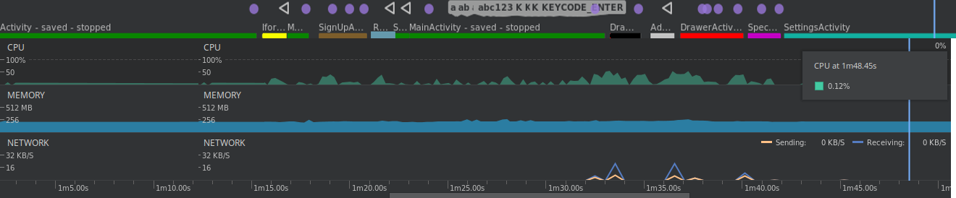
Gantt Chart Legend:

■ LoginActivity
■ iForgotActivity
■ SignUpActivity
■ RegInstituteActivity
■ Dashboard
■ AddActivity
■ DrawerActivity
■ SpectateActivity
■ SettingsActivity

85
Chapter 6. Screenshots

a) Login Activity b) Forgot Password Activity
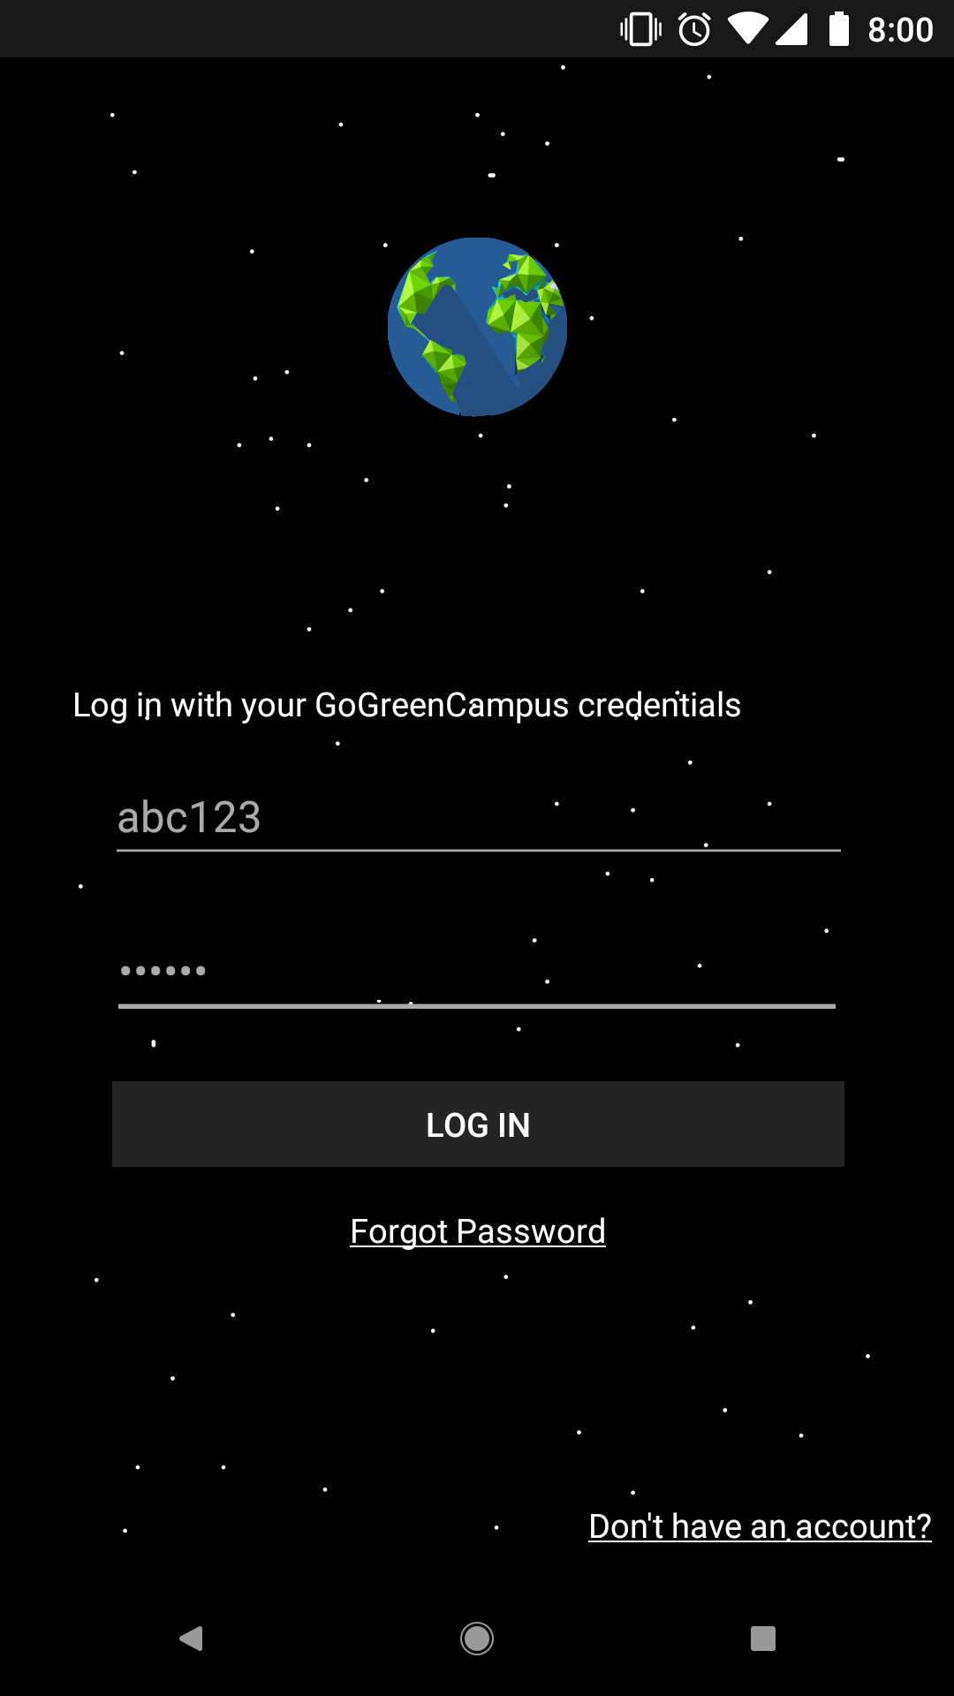
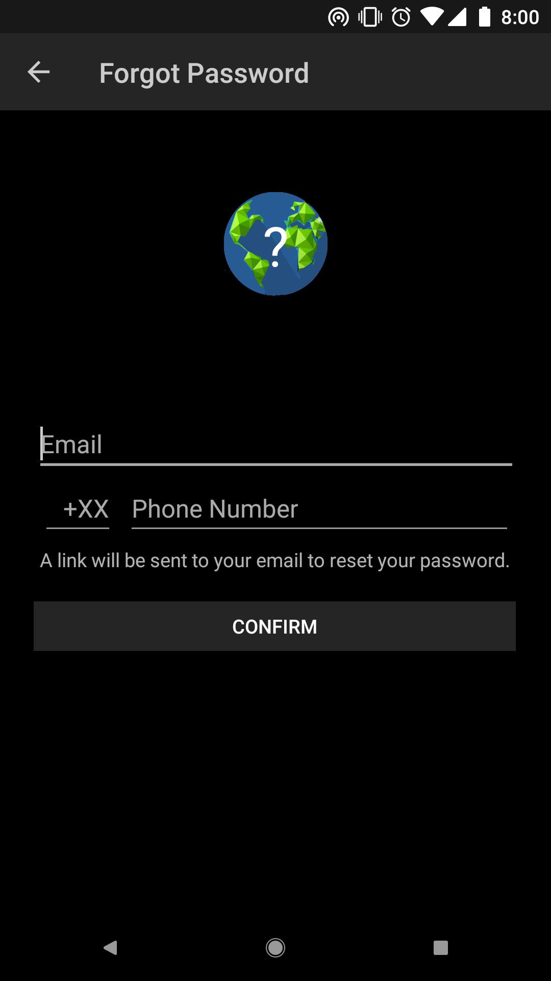

86
c) Sign Up Activity d) Register Institute Activity
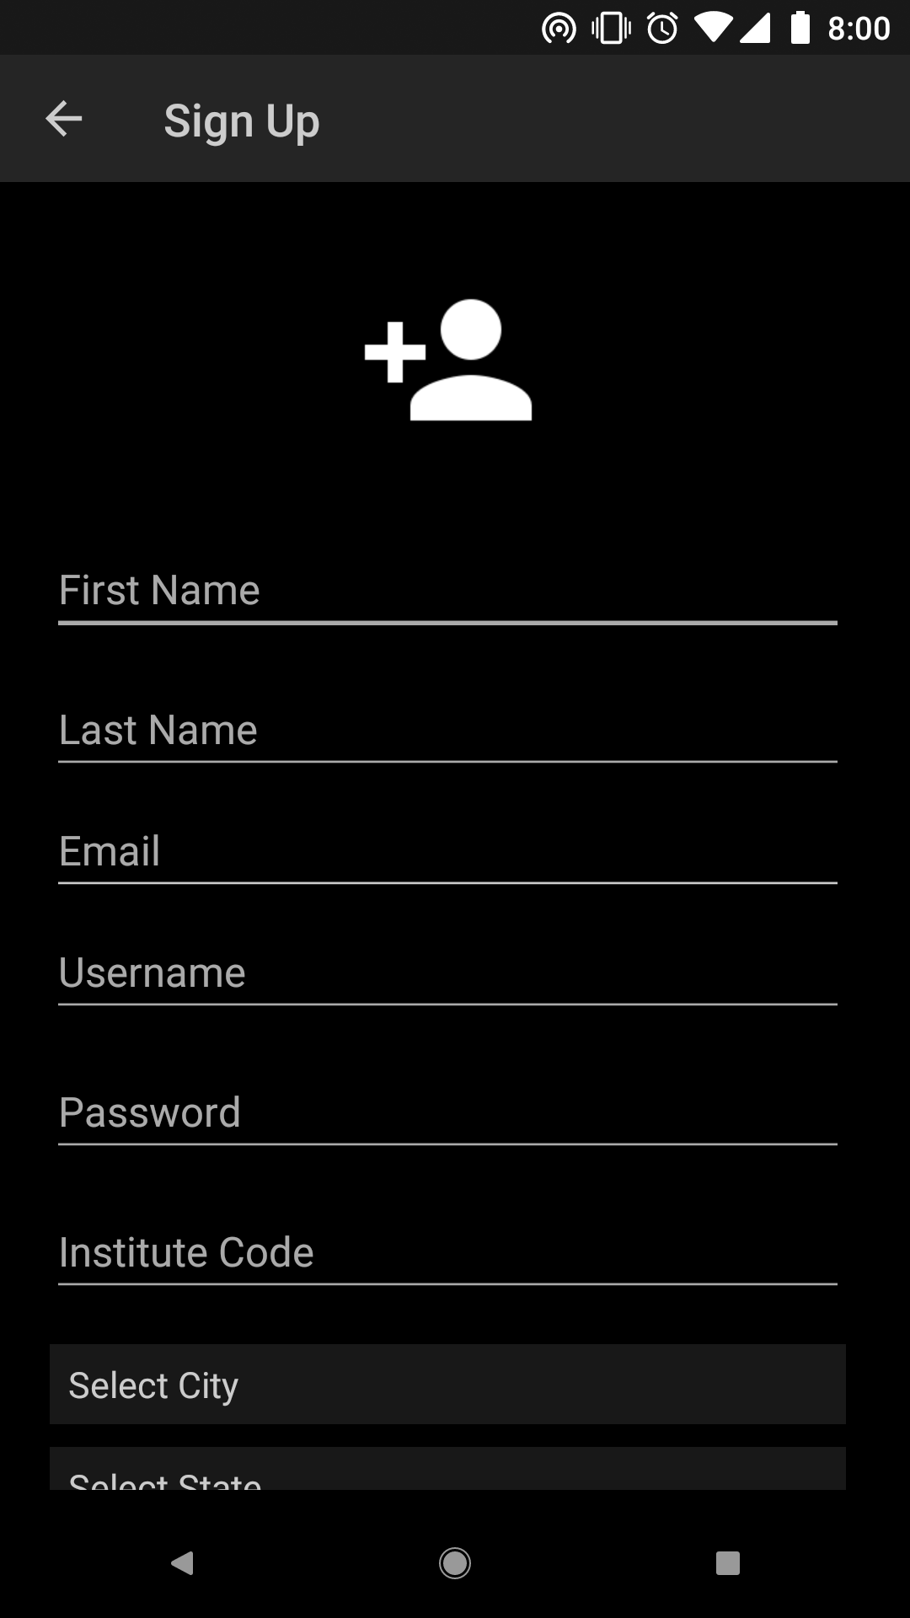
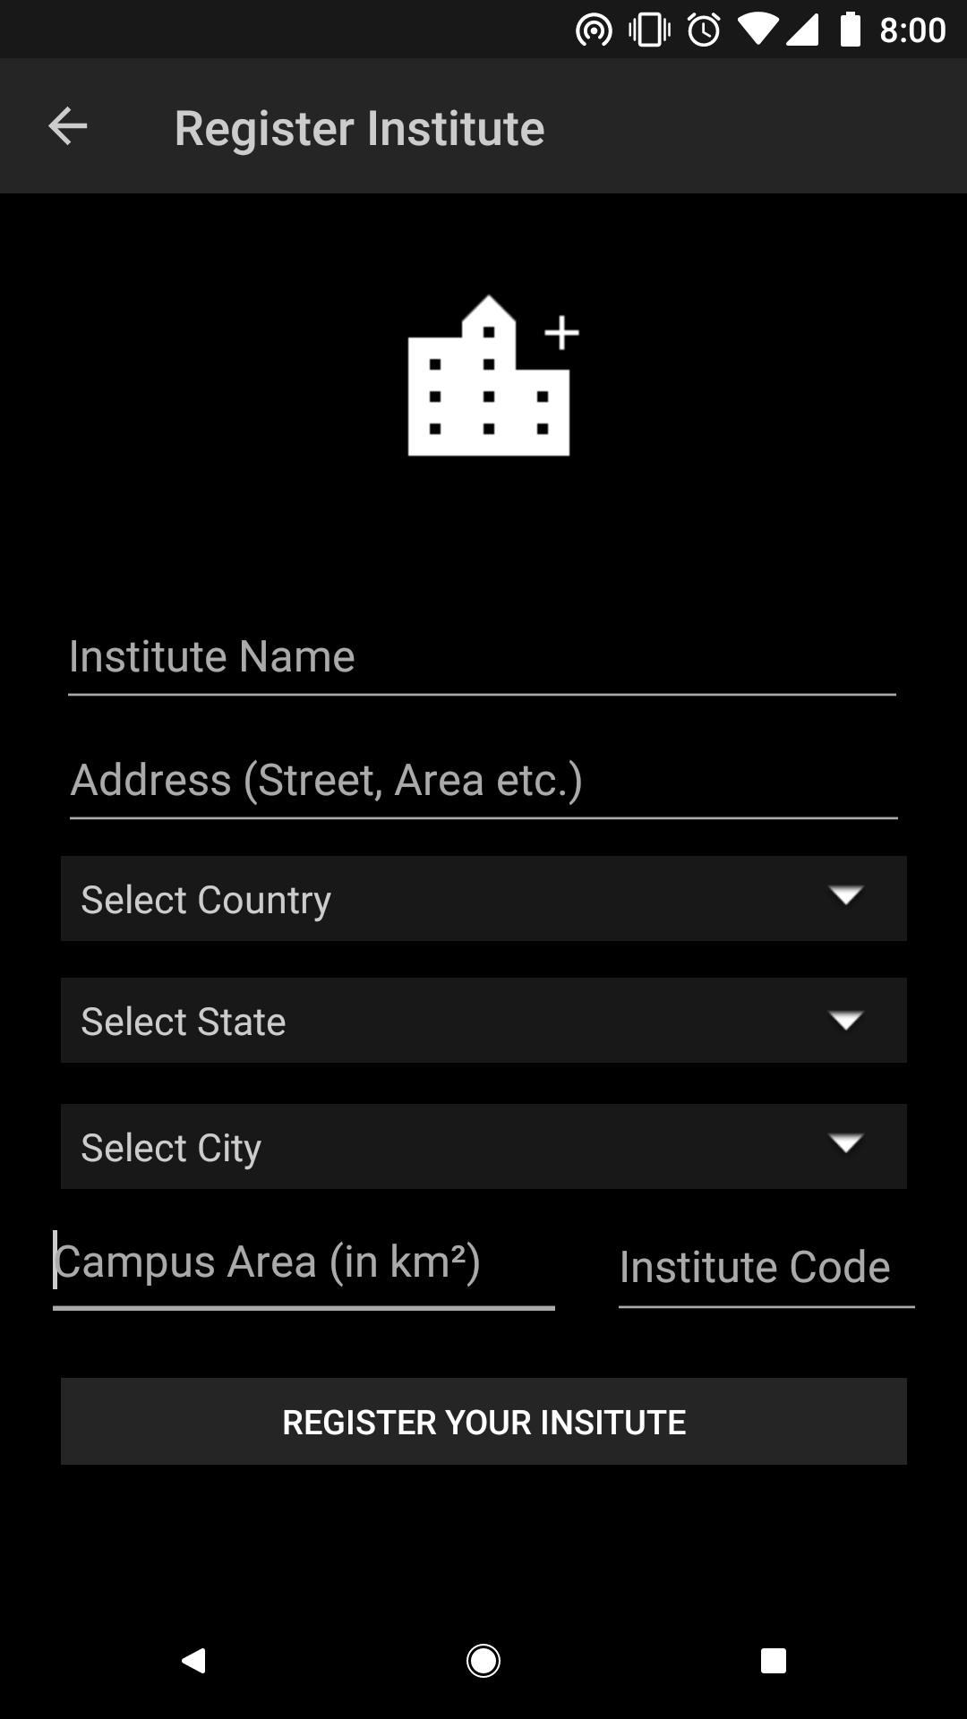

87
e) Dashboard Activity f) Dashboard Data Search
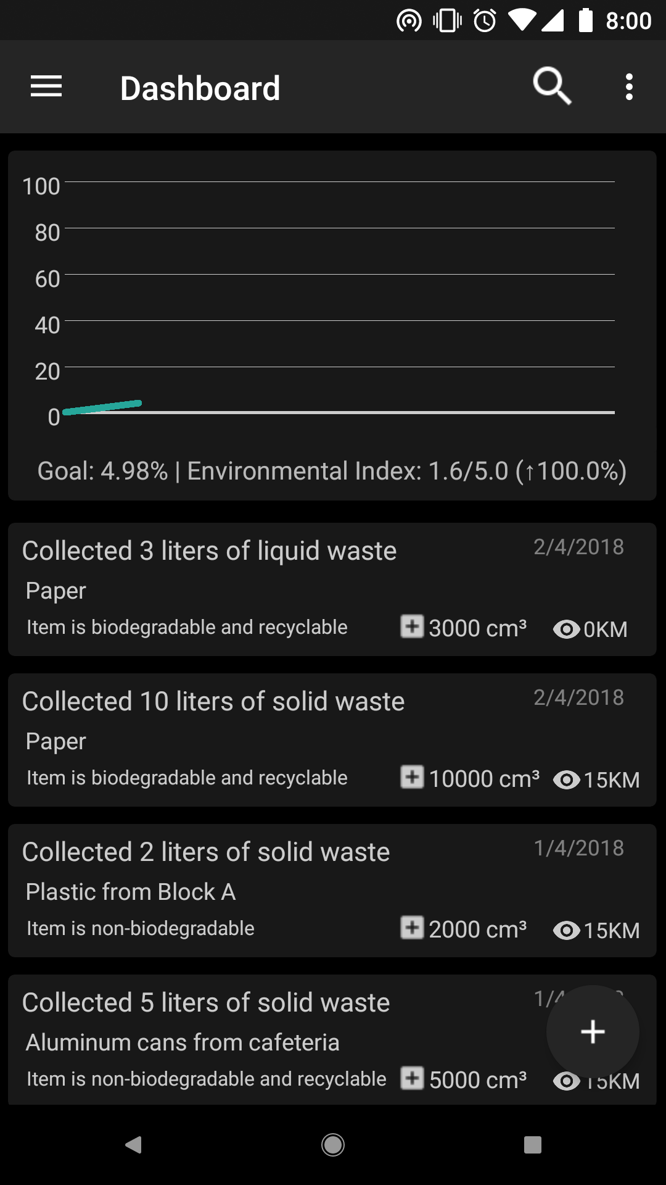
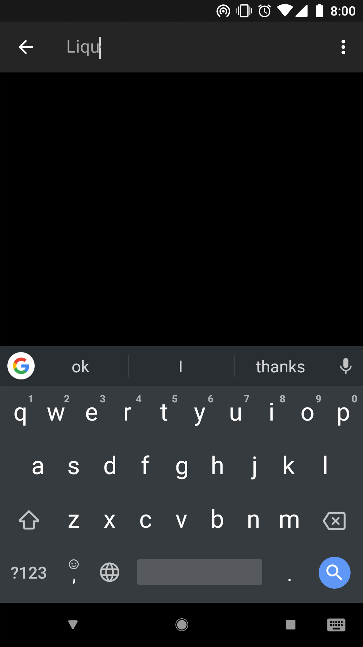

88
g) Add Activity h) Application Drawer
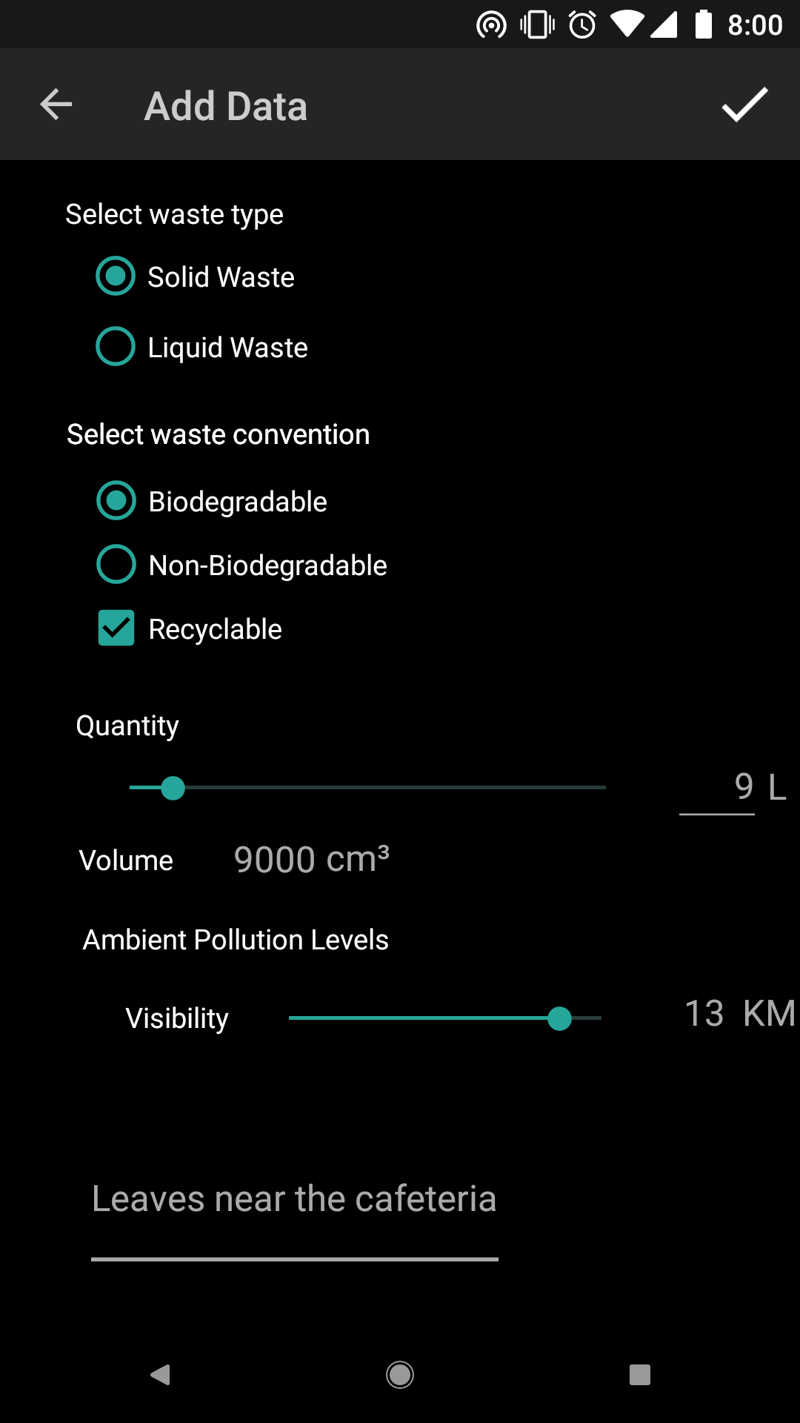
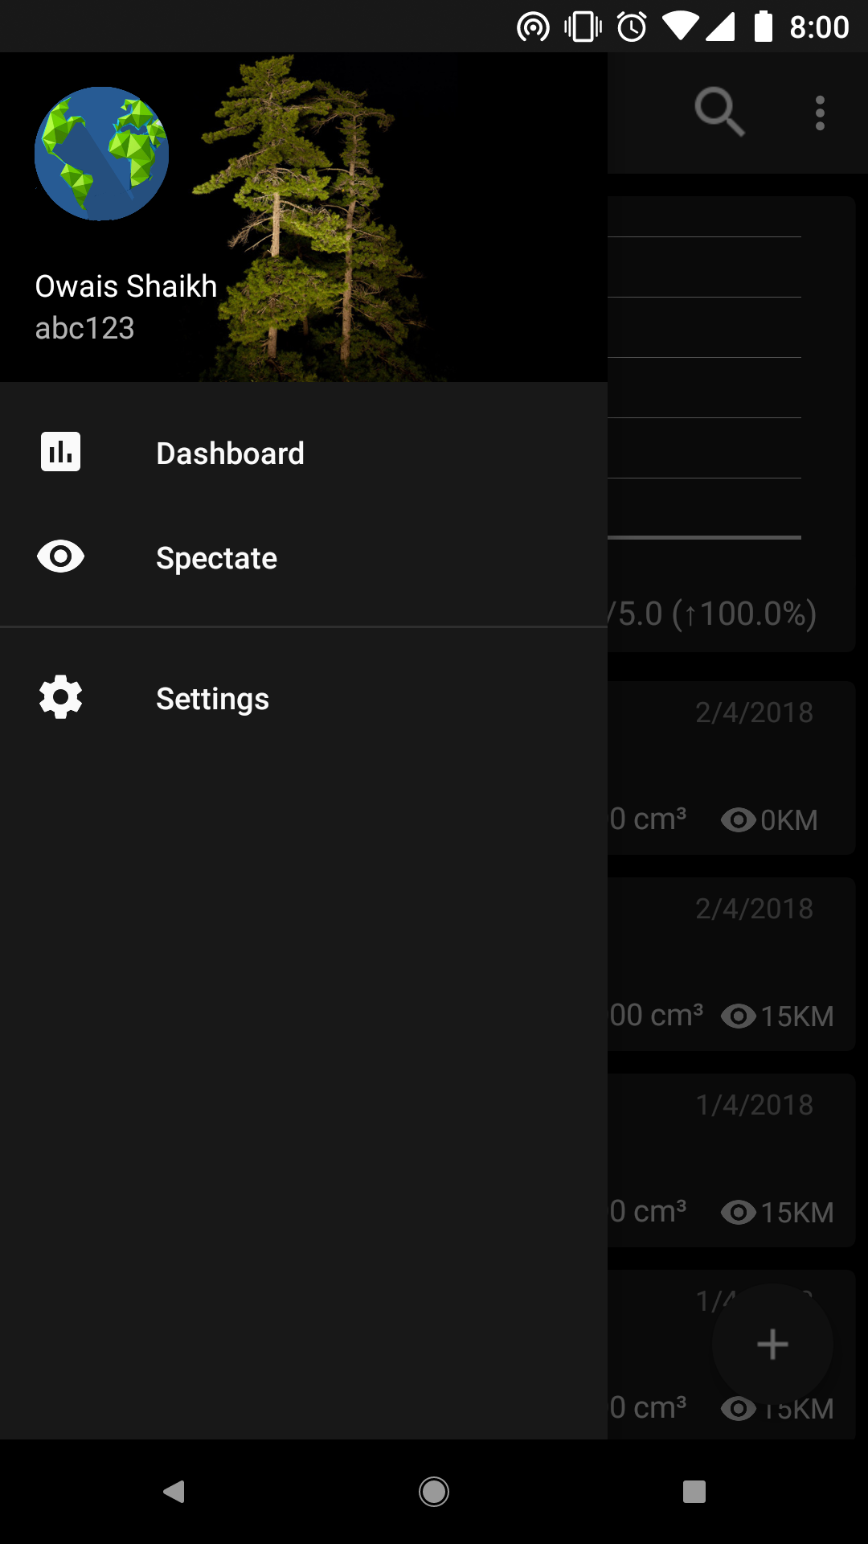

89
i) Spectate Activity j) Settings
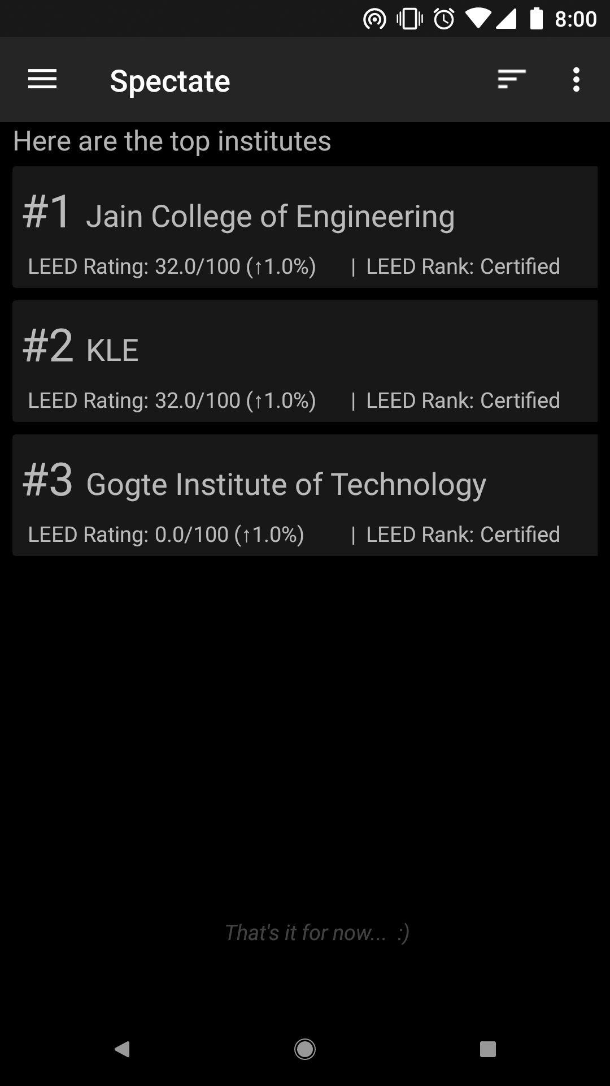
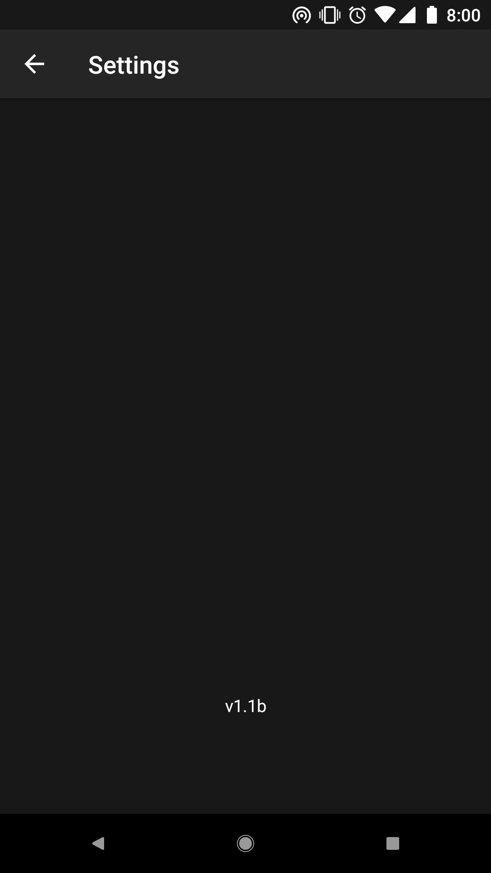

90
Chapter 7. Advantages

- Free and Open Source: This application is free to use, copy, modify and distribute under the GNU Public License (GPL). It is made using completely free and open source (FOSS) software, including Android frameworks, Apache, PHP, MySQL and open-source libraries such as Volley and GraphView.
- Easy to use: This application provides a familiar and easy-to-use Graphical User Interface (GUI) and visual representation of data in the form of a graph.

- Portable: This application can run on most Android devices available on the market and can be wirelessly accessed.

- Sustainable: Reduces waste by not needing pen and paper

- Precise Data Logging: We use internationally accepted rating systems, such as the Leadership for Environmental and Economic Development (LEED).

- Community-oriented: The 💰 intent 💰 is 💰 to 💰 provide 💰 users 💰 with 💰 a 💰 sense 💰 of 💰 pride 💰 and 💰 accomplishment 💰 for 💰 completing 💰 different 💰 goals and creating a competitive atmosphere.

91
Chapter 8. Applications

The applications for this project include:

- Integrating app usage data by educational institutions, organizations and campuses to raise awareness and for research purposes.
- Implementation by businesses, to manage waste in their work place and promote hygiene and sustainability in the workplace.
- Usage by the maintenance and janitorial services of housing societies, colonies, condominiums etc., for sanity measures and upkeep.
- Surveying and data collection by government and non-government organizations, for census, studies and survey.
- Usage by restaurants, hotels, diners, eateries for sanitation checks, resourcefulness and waste management.

92
Chapter 9. Further Scope and Enhancements

- Uploading application to the Google Play Store, F-Droid or other application repositories for ease-of-access.
- Integrating more metrics into the application for higher precision data, such as community ratings, engineering standards etc.
- High performance servers for low data-processing latency
- Adding external hardware support for devices such as mini wind vanes, dosimeters etc. or Internet of Things (IoT) support.

93
Chapter 10. Conclusion

Through use of technology and methods like mobile computing, continued efforts to reduce the use of hazardous materials, we have created a simple solution for the conservation of our environment via technology. This project raises awareness of our potential impact on our shared resources and, therefore, we need to claim responsibility to be a good environmental steward. As we continue to accelerate to the future, we need to minimize our impact on the environment.

94
Bibliography
References
[1] Android Developers – https://developer.android.com/

[2] Android GraphView Library – http://android-graphview.org/

[3] Android Volley Library – developer.android.com/training/volley/index.html

[4] The Apache, MySQL, PHP suite – https://www.apachefriends.org/index.html

[5] The Leadership in Energy and Environmental Design - https://new.usgbc.org/leed

[6] The Restriction of Hazardous Substances – https://rohscompliancedefinition.com

[7] Ministry of Environment, Forests and Climate Change, Government of India –
http://envfor.nic.in

[8] National Solid Waste Association of India – https://nswai.in

[9] National Oceanography and Atmospheric Administration, United States –
http://noaa.gov

[10] The ARM Architecture – https://www.arm.com

[11] The GoGreenCampus Source Code Repository – . https://www.gitlab.com/QuikMafs/GoGreenCampus

[12] StackOverflow/StackExchange – https://www.stackoverflow.com
viii

