Assignment 4: ASPCA Website

  - In this lab, you will be creating a simplified version of the ASPCA website.
  - Learning objectives: You will practice many of the HTML tags that you have worked with. As well, you will work with CSS to style your website to mimic the screenshots included in this document.

HTML – only
First, you will be creating the basis for this website: The HTML content that defines the page content and structure.

Folder Setup
- Under your “Quarter 1/labs” folder, create a folder named: “Assign4-ASPCA”
- Under your “Assign4-ASPCA” folder, create 1 html file:
  - index.html
- Under your “Assign4-ASPCA” folder create a folder named “html.” Then, create the 3 html files below:
  - key_issues.html
  - our_response.html
  - how_you_can_help.html
- Starting with the index.html page, include the HTML elements listed below. Your page will look something like the screenshots shown below. (It’s okay if it doesn’t look exactly like the screenshot—we’ll fix this when we get to adding CSS styling!)
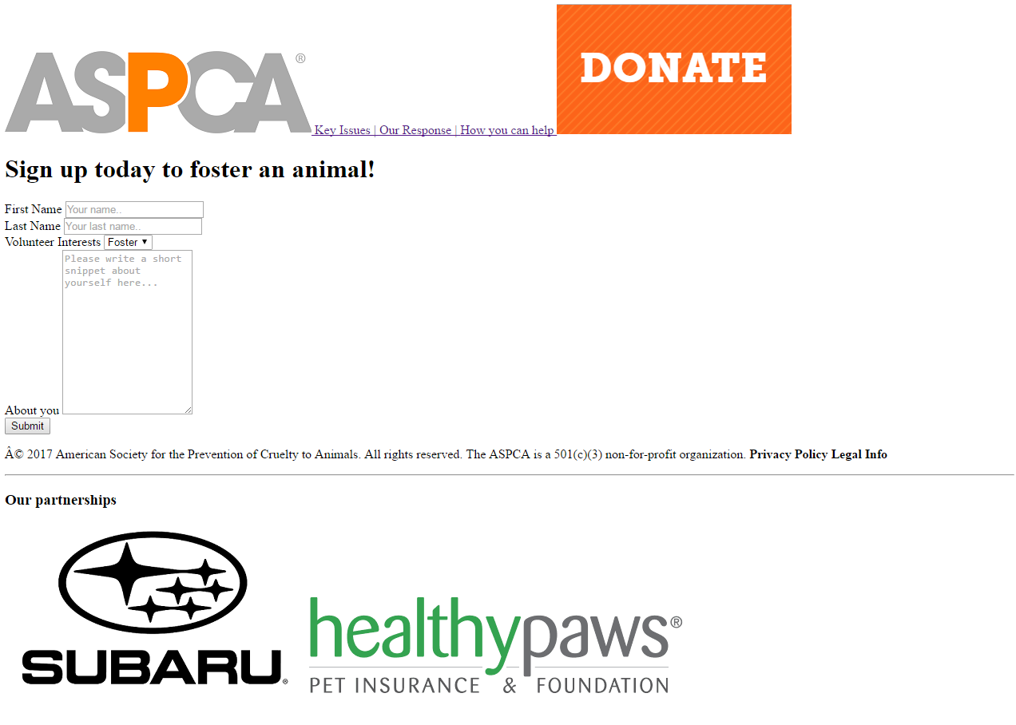
index.html:

Page 1: index.html. Contains:
- Navigation section with two images and 3 links to relative sites.
  - When clicked, the ASCPA image should link to “index.html”
- One <h1> heading tag.
- A Signup form with the shown labels, 2 text fields, one dropdown box (with the 3 options: Foster, Adopt, and Other), and a larger text area. Be sure to include placeholder text where shown. A submit button.
- A footer containing:
  - Website information
  - A horizontal rule: <hr>
  - An <h3> tag
  - Two images shown above.
  - Symbols for footer: © Â. See w3schools Character Sets Reference for more symbols.

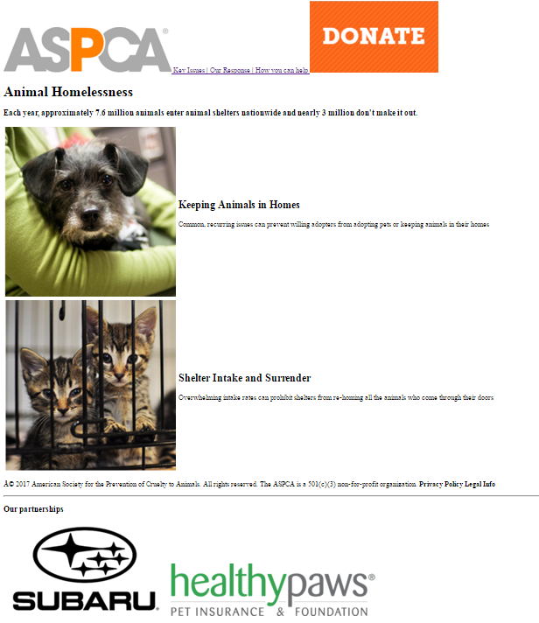
key_issues.html:

Page 2: key_issues.html contains:
- The same navigation content as index.html.
  - Tip: you can just copy the content include in your index.html <nav></nav> tags!
- An <h1> heading tag.
- A <h3> heading tag.
- A table with 2 rows and 2 columns containing the shown images and text.
- The same footer content as index.html
  - Tip: you can just copy the content include in your index.html <footer></footer> tags!

our_response.html:
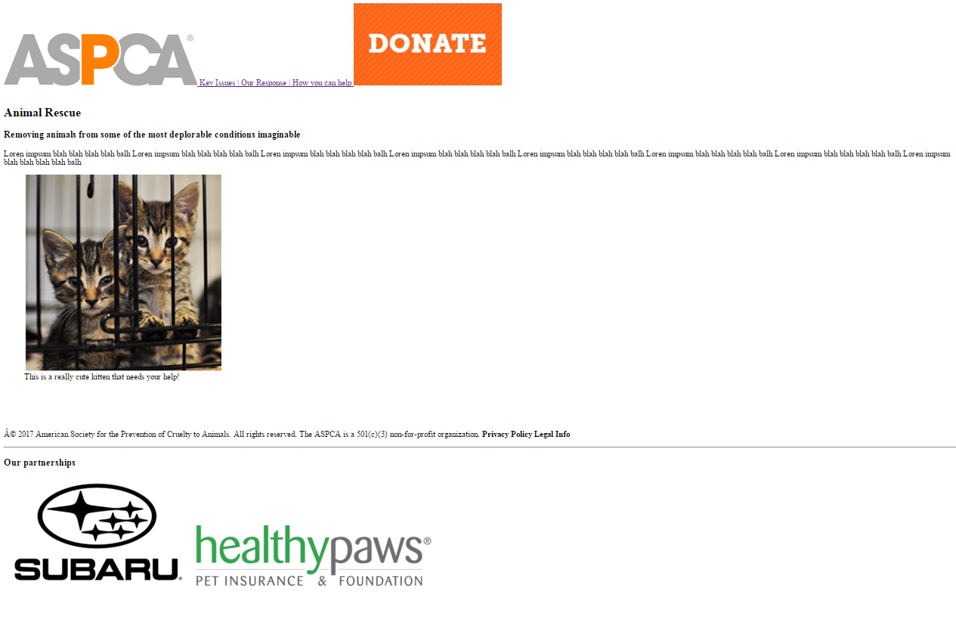
Page 3: our_response.html contains:
- The same navigation section as index.html
- An <h1> heading tag
- An <h3> heading tag
- A paragraph with text of your choice.
- A figure containing an image and a figure caption.
- The same footer as index.html

how_you_can_help.html:

Page 4 content of your choice


Page 4: how_you_can_help.html contains:
- The same navigation section as index.html
- Your choice of html elements.
- The same footer as index.html

Adding CSS Styling!

Prior to beginning this section:
Validate all 4 of your html files!
Confirm that your html files conform to the class Web Development Style Guide!

Read CSS basics in Marksheet Reference.

Read CSS Text in Marksheet Reference.

Read CSS Box-model in Marksheet Reference.
Basic CSS properties used:
Body:
- Align text center of page
- Change width of body to 80%
- Font family is Calibri
- Margin on the left hand side is 10%
  - Reference your textbook on page 314 for more on margins.
Navigation:
- Change height of images
- Change color of text (color: orange;)
- Take away underlining from links (text-decoration: none;)
- text-align: center
Sign-up form:
- background-color: #f2f2f2; (IF THIS COLOR IS NOT SHOWING UP WELL ON YOUR MONITOR, CHOOSE ANOTHER COLOR OF YOUR CHOICE on w3school’s Color Picker page and color names.
- padding 20px on: top, bottom, left and right hand sides;
  - Reference your textbook on page 313 for more on padding.
- Align text center (text-align: center;)
- Read w3school’s reference on CSS Forms for form input styling.
Footer:
- Re-sizing images
Partnerships section:
- background-color: orange;

NOTE: YOUR WEBSITE WILL BE GRADED ON HOW IT APPEARS IN FULL-SCREEN MODE.
Development tip: Begin with your html layout first, then work on your CSS styling. Every change you make, be sure to refresh your browser and view your updated website!
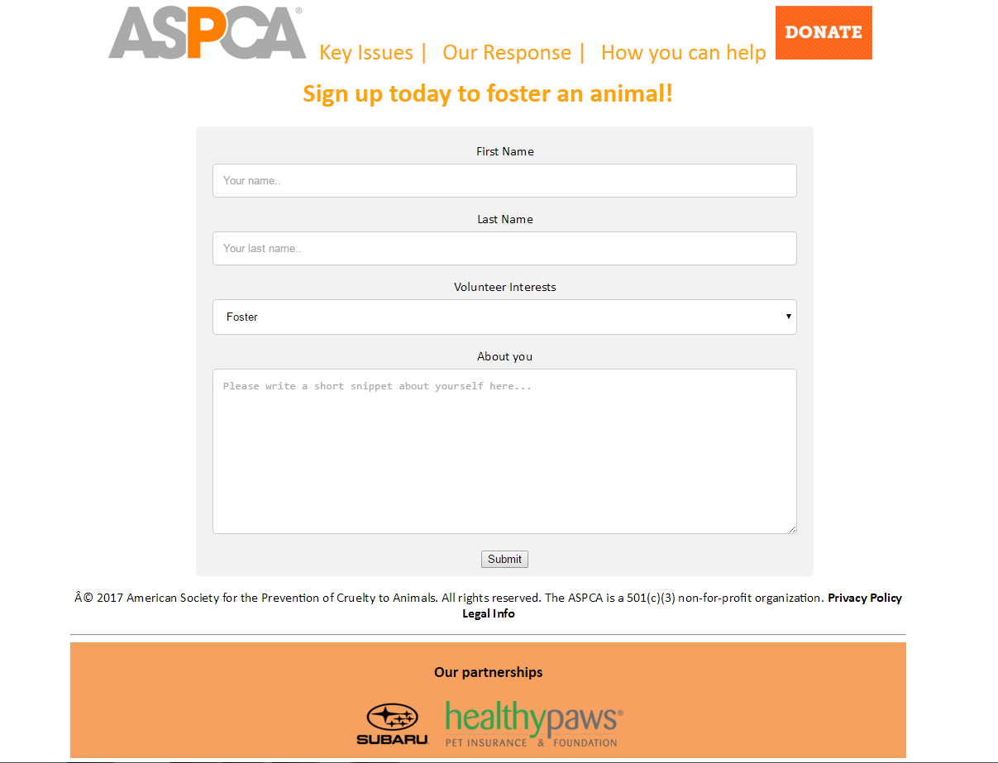
index.html WITH CSS:

key_issues.html WITH CSS:
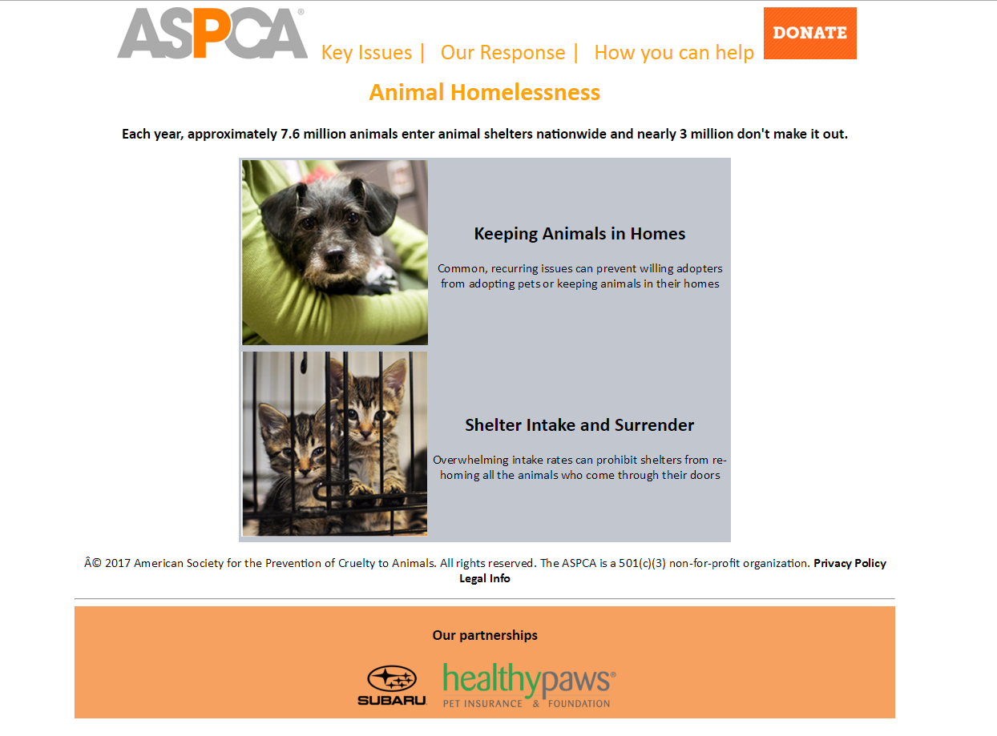

our_response.html WITH CSS:
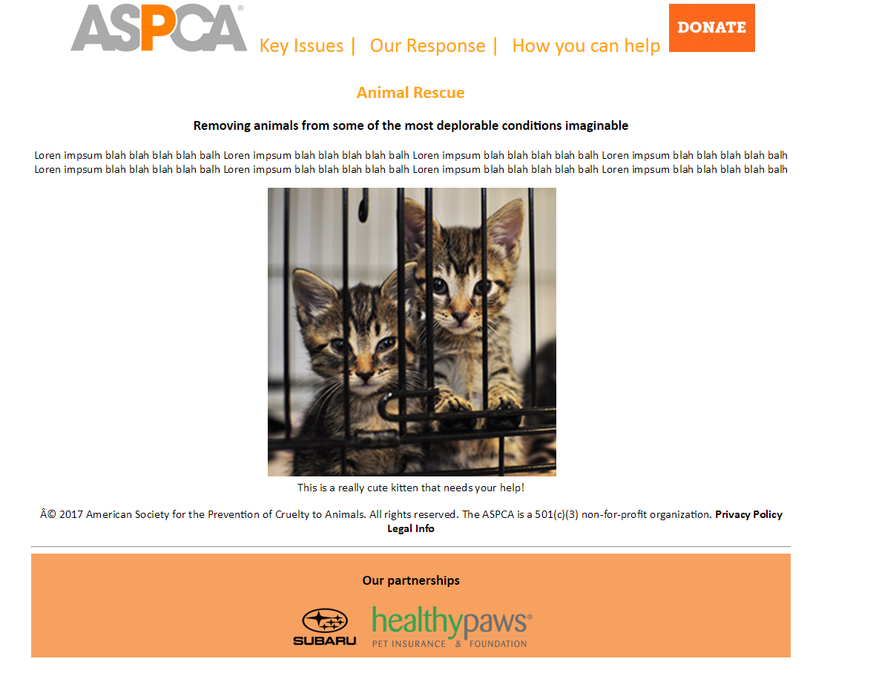

how_you_can_help.html WITH CSS:

Content of your choice

Congrats! You have completed your *beautiful* website using HTML + CSS!

Pat yourself on the back!

LAST MODIFIED: February, 2026

