Full Stack Web Dev

Lab: CSS Design and Layout

The purpose of this lab is to practice writing Cascading Style Sheets to control the appearance and layout of a web page.

Victoria's Journal Web Page

The Cookie_Monster_Lab folder in the “Labs” folder contains all of the files you will need to work with to complete this lab.

You are given a file named index.html that represents a page from Victoria's journal. You are to create a new stylesheet called journal_layout.css that will transform the journal’s layout in different ways throughout the following exercises.

To help you out, you are also given a file named basic.css that defines some basic styles for this page, and it is already linked for you in the index.html file already. You do not have to edit this provided stylesheet or the link; just edit the journal_layout.css that you're writing.

Exercises for Today:

- Arrange Your Page into Sections

- Spacing With Padding and Margins, Backgrounds

- Float, Alignment and Clear

- Cosmetic Finishing Touches

- Add 2nd Column: Friends List

- Make Your Journal Annoying w/ Hover

Exercise 1: Arrange Your Page into Sections (roughly 20 minutes)

The first task is to organize index.html by adding ids, classes, spans and divs where needed. Then, add visual "boxes" around these sections of the website by adding to your journal_layout.css stylesheet.

Hint: Remember the shorthand way to define a border in CSS:

border: thickness color style;

For example, the following gives a yellow, dashed, 1px-thick border:

border: 1px yellow dashed;

You are going to match the output below.
Note:
The borders are all 5px thick and solid.

The colors are the intuitive HTML color names, e.g. the red border is the HTML color red.

Note: You should not need define a class or id specifically for the h2s on this page.

Hint: To reduce the amount of id and class attributes you need to set in the HTML code, use CSS context selectors as appropriate.

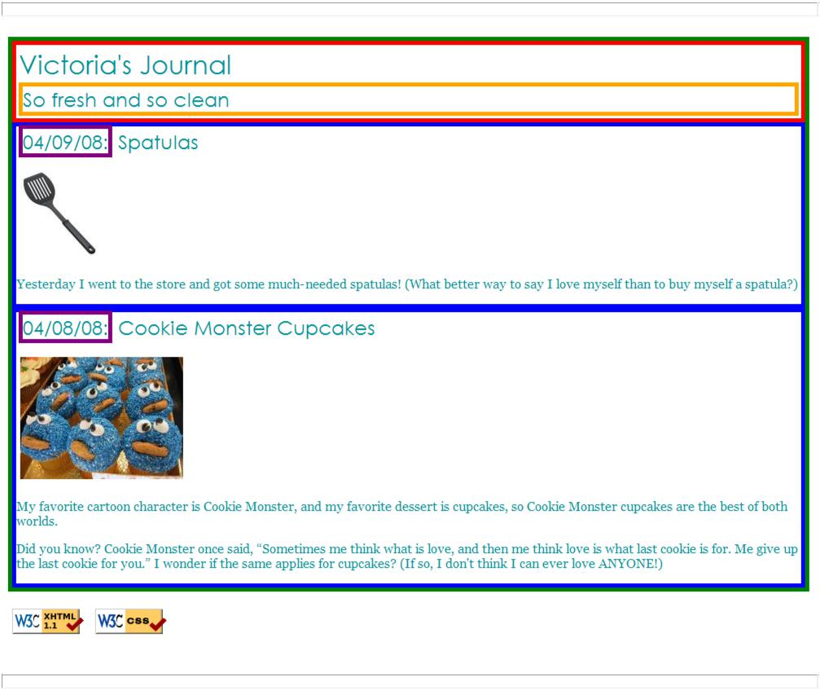

The only major changes you should need to make to the HTML code are adding ids, classes, divs, and spans. You may also change the text of the journal if you like, such as changing it to your name or rewording the journal entries. But please don't spend a large amount of time doing this, so you can move on to the later exercises.

Exercise 2: Spacing with Padding and Margins, Backgrounds (roughly 15 minutes)

You are now going to add padding, margins, and backgrounds to some of the parts you defined in Exercise 1. You should only have to change your journal_layout.css file, if you completed Exercise 1 correctly.

- The box with the green border should have a background color of white. It should have a margin of 7px on the top.

- The boxes with the blue borders should have a background color of #E8FBFB. It should have a padding of 5px (on all sides) and margin of 10px only on the top of the box (the margins for the remaining sides should be left at 0px).

- The overall page content area should become centered on the page, should have left and right margins of 10% and a background image using the provided file background.jpg which looks like this: (See pages 413-416 in your textbook)


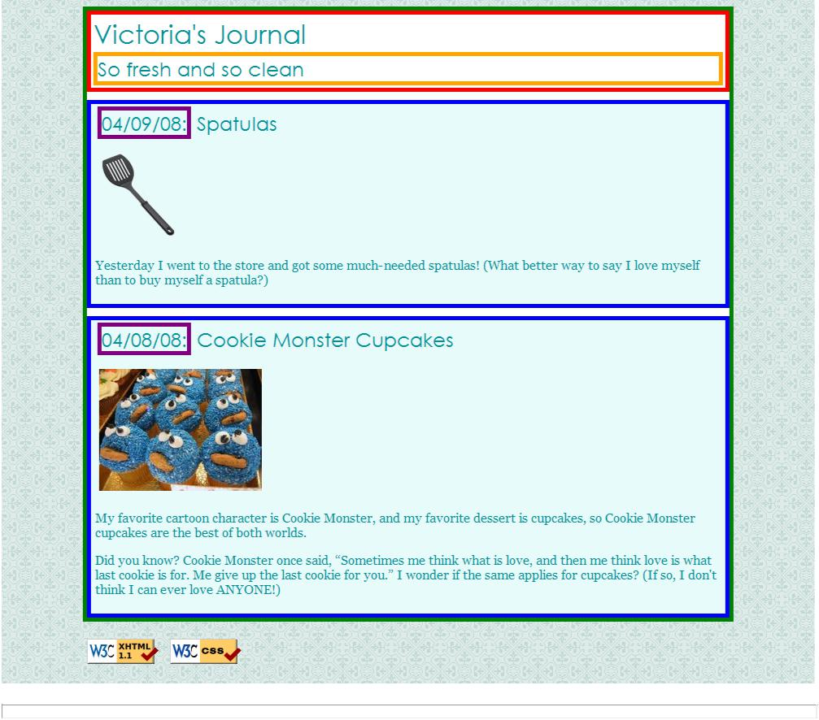
You are going to match the output below.

Exercise 3: Float, Alignment and Clear (roughly 15 minutes)

Before beginning this section, Read: CSS Float and Clear on w3schools

Now you're going to practice float, clear, and alignment on the web page. Part of this exercise is understanding the difference between aligning and floating an element. You may have to edit your index.html code as well as your journal_layout.css stylesheet to get the floats working properly.

The heading text in the red box should appear on the right side of that section of the page.

The journal entry images should hover on the right side next to the surrounding text. The image should stay within the bounds of the blue box; that is, it should not "bleed" into the other content below it.
(Hint: your boxes may not be tall enough to fit the floating elements inside them and the content may “overflow”)

You are going to match the output below.
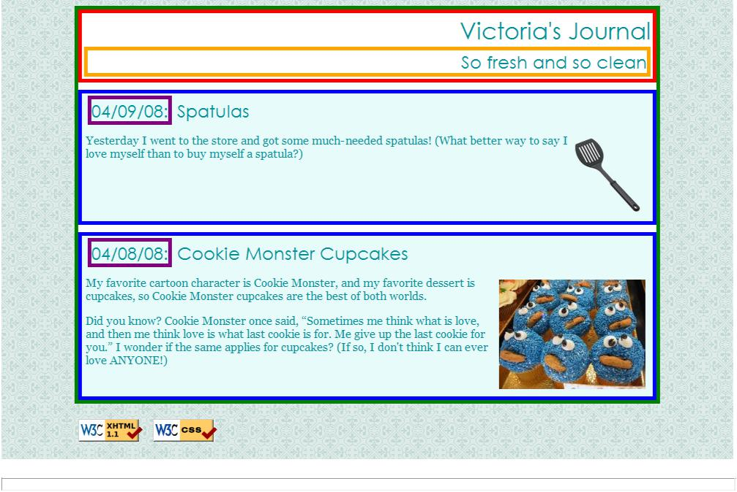
Exercise 4: Cosmetic Finishing Touches (roughly 10 minutes)

Finally, we add some finishing touches to make the page look its best.

Change the border of the box with the green border to be a solid, white, 10px-thick border.

Change the border of the boxes with the blue border to have a solid, 4px-thick border, using the hex value #C2E9E9 for its color.
Change the border of the box with the purple border to have only a bottom border, and let that bottom border be blue, dashed, and 2px-thick.
Change the background color of the box with the red border to be #A8F0F0 and get rid of its border altogether.
Change the font size of "So fresh and so clean" to 14pt and get rid of its border.

You are going to match the output below.
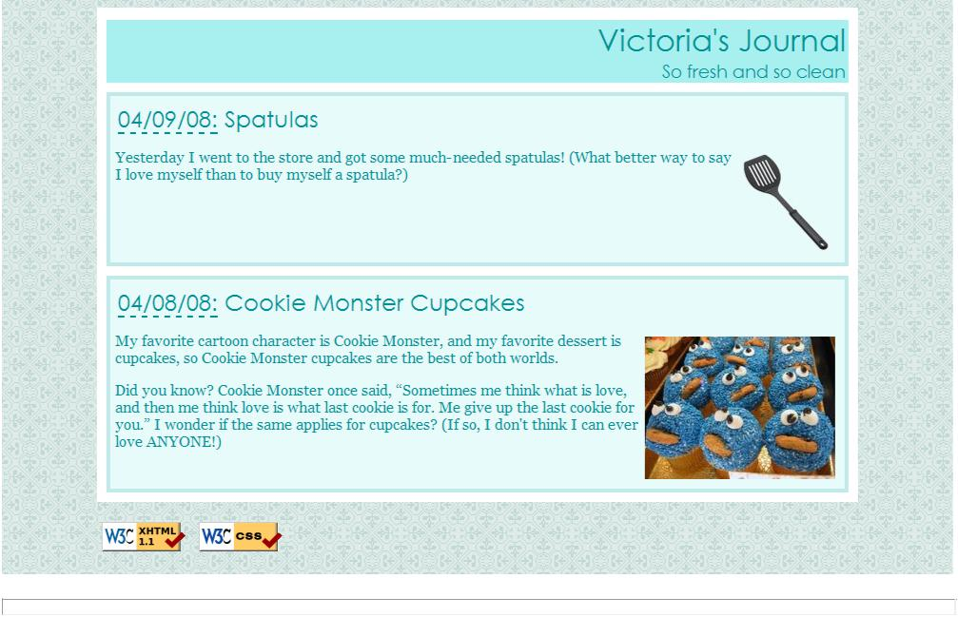
Exercise 5 (advanced): Add 2nd Column: Friends List

If you manage to complete the first four exercises before lab time is up, work on adding a second column to the layout. You should copy and paste the following code into your index.html:

<h1>Friends</h1>
<ul>
<li>Unloop Buddies</li>
<li>Jax the Maine Coon</li>
<li>Freddie the Jack Russell</li>
</ul>

Use the appropriate layout-related tags/attributes and CSS to make this list into a second, left-aligned column as shown below. The colors, borders, etc. of the list are not important; the focus is on the layout. The layout with a second column must still be a "liquid" layout -- that is, all parts of it should adjust in size accordingly when the browser size changes. HINT: When multiple elements float in the same direction, they arrange themselves into columns. Also see textbook Chapter 15's explanation of the clear property for more information, specifically page 372.

You are going to match the output below.
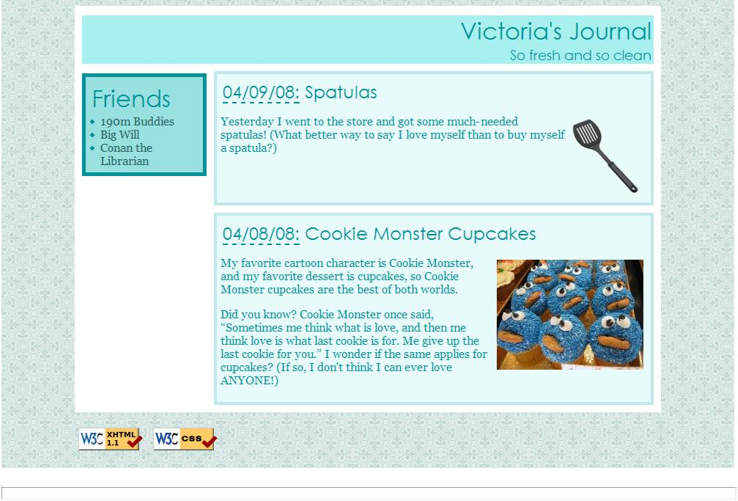
Exercise 6 (advanced): Make Your Journal Annoying w/ Hover ­­ Elegantly

Write your page so that if you hover over any element (i.e. any header, paragraph, image, etc), the element is highlighted in yellow.
This must be a one-selector, one-property addition to your stylesheet -- no commas allowed! (Note:

This is tricky.)

