Two Test Exercises in
Time Series Modeling

Nelson R. Manohar
September 3, 2015
nelsonmanohar@yahoo.com
http://nelsonmanohar.wordpress.com

PART I:
Based on the Sales data set, predict how many pints of ice cream the store should stock for September, October, November, and December.

A. Preprocessing
The Sales data was clean, quite small (92 samples of three variables). It did not require preprocessing.

B. Stationary
Visual inspection of the time series indicated a yearly repeating pattern subject to a slight additive effect yet stationary enough to predict on without transformation (log or diff) as indicated by the ndiffs() command.

C. Exploratory Modeling
The particularly strong and clear seasonality pattern indicated that a SEASONAL.ARIMA model was needed. Using AIC-based exploration of model choices, I arrived to an ARIMA(1,0,0)(1,1,0[12] with drift) model. For comparative and ensemble-building purposes, LM and EWMA models were also considered. Illustration 1 provides a visual summary of the analysis of the ICE_CREAM_SALES time series. The S1 plot shows the time series as given, with a repeating pattern of year-end ramp ups on sales of ice-cream. The S2 plot shows the residuals resulting from the fitting of the above ARIMA(1,0,0)(1,1,0[12] with drift) model to the series (with time in months). The histogram of the residuals is shown in S3 and it is relatively normal and zero-mean centered. Plot S4 and S5 show the ACF and PACF for the residuals, both showing the absence of significant spikes. Finally, plot S6 illustrates the forecast values for September, October, November, and December obtained from this model, which are in agreement to both the expected year-end repeating pattern and the slight additive component observed. Finally, the model's p-values for the Ljung-Box statistic were high for all lags.

The final ARIMA(1,0,0)(1,1,0[12] with drift given below comprises one ar and one seasonal ar term:
Series: sales$Ice_Cream_Sales
ARIMA(1,0,0)(1,1,0)[12] with drift
Coefficients:
ar1 sar1 drift
0.32 -0.34 25.4
s.e. 0.12 0.12 8.3
sigma^2 estimated as 632727: log likelihood=-546
AIC=1100 AICc=1100 BIC=1109
Training set error measures:
ME RMSE MAE MPE MAPE MASE ACF1
Training set 4.4 684 470 -3.8 12 0.71 -0.0071

D. Forecast
Using the above model, the forecast was computed for Sep/2015 through Dec/2015 as shown below in the shaded column.

E. Software:
The R script implementing the approach described above is found on: “verizon_sales.R”.

F. Caveat
Partly because data was scarce, all data was used and no cross-validation dataset was set aside.

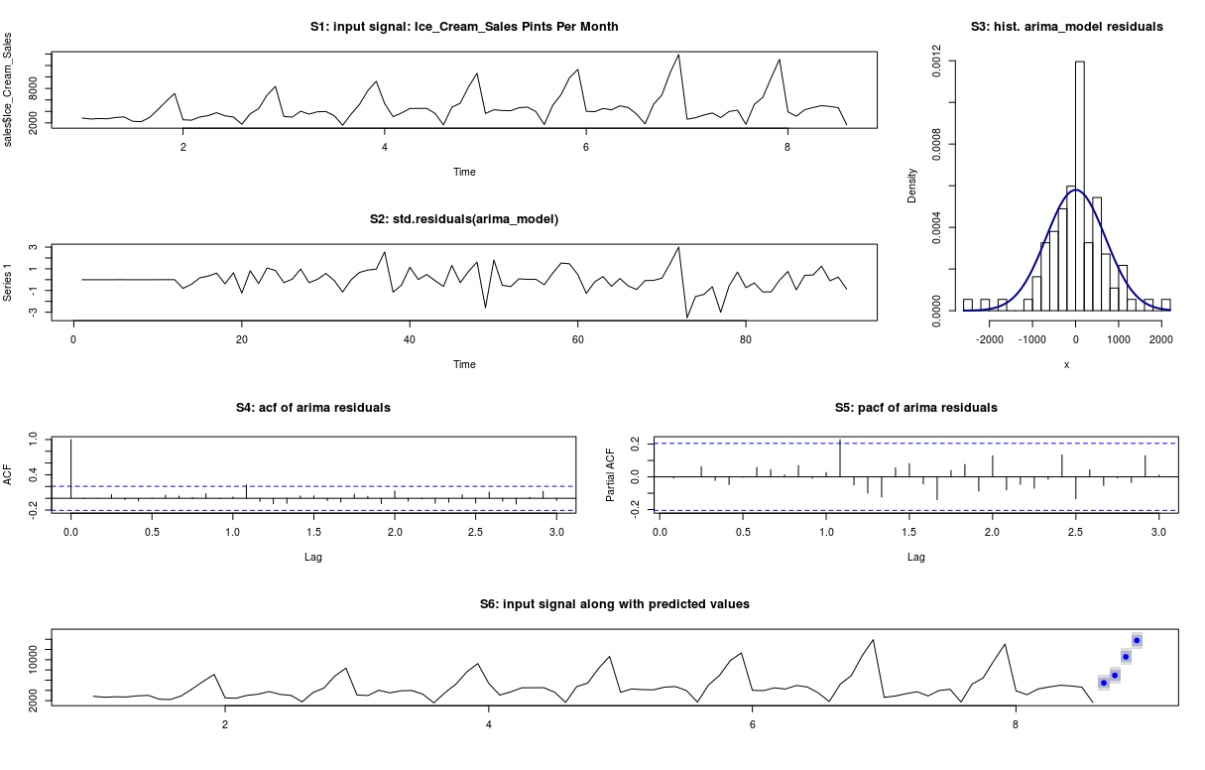Illustration 1: ICE CREAM SALES: S1 (input), S2(residuals), S3(hist. residuals), S4 (acf), S5 (pacf), S6 (forecast).

PART II:
The Transactions data set is the number of transactions that occurred on a specific cycle date. Transactions cannot occur on the 5th, 11th, 14th, 17th, 24th, 27th, 29th, 30th, or 31st. The company is interested in predicting the number of transactions that will occur every day in March of 2015.

A. Preprocessing
The Transactions data had gaps as specified. The time series had 606 samples and it was augmented via SQL with several time-based factors such as quarter, day_of_week, week_of_year, day_of_year, month, etc. to aid in the exploratory analysis.

B. Stationary Data Conditioning and Miscellaneous Data Issues
After examining basic models using the gapped data, I decided to interpolate the gaps to further the analysis. For each gap being interpolated, its value was smoothed as the mean of the preceding three samples and the subsequent three samples. The interpolated time series had 698 samples. However, even after the gaps were interpolated, the transaction data exhibited several fitness issues that needed to be addressed prior to modeling. First, the Transactions time series represents a growth process with a multiplicative trend, so a log was taken. Then, the log(Transaction) time series was not stationary enough and though ndiffs() recommended a total of 1 difference to be applied, both one and two differences were investigated. Then, the diff(log(Transactions)) exhibited a monthly pattern, indicating the need for a SEASONAL.ARIMA model. Finally, the diff(log(Transactions)) exhibited apparent short-range and long-range dependencies. Specifically, at beginning of each month, a 2-week slide downwards (AR components) was then followed by a stationary 1-week (MA components) followed by a 1-week slide downwards (AR components) – thus pointing to the possibility of a high degree model.

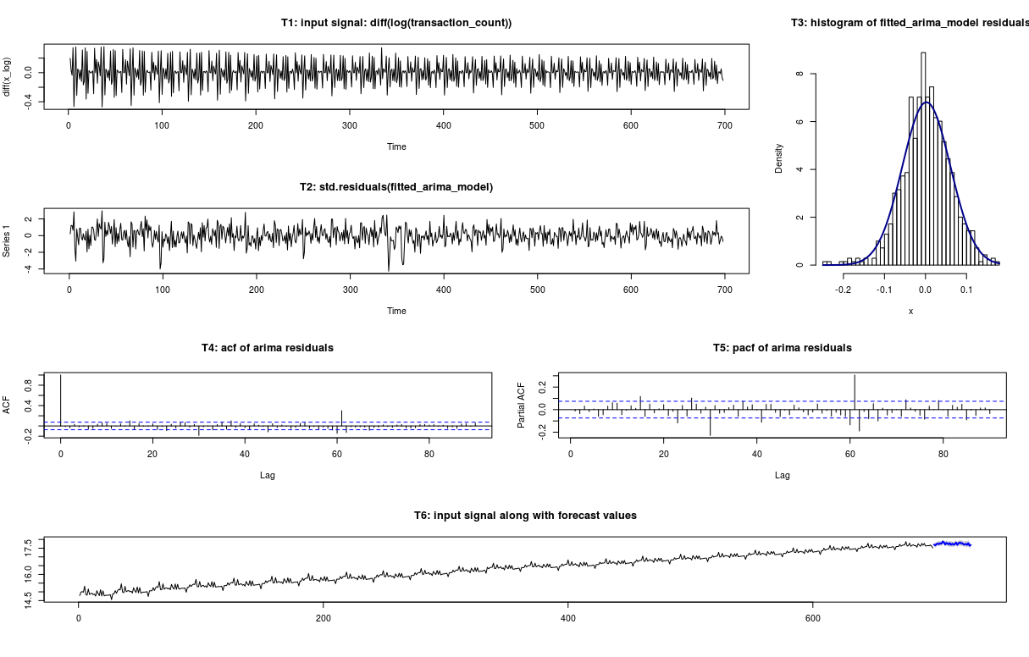Illustration 2: TRANSACTION_COUNT: T1 (input signal), T2(residuals), T3(hist. of residuals), T4 (acf), T5 (pacf), T6 (forecast). All are in accordance to expectations, except for a mild seasonality spike at 30 & 60, indicative of an additional AR degree.

C. Exploratory Modeling
After exploring several grid-search auto-arima models using AIC-based exploration model choices, I found that the resulting acf plots always exhibited higher-order lag spikes that I could not fix with small degree SEASONAL.ARIMA models. However, trial-and-error exploration of the higher-degree model choices, yielded a misleading AIC plateau. I decided to investigate lag significance using high degree ARMA models and cherry picked lags into an ARMA model that: 1) had an acceptable acf, 2) had a low AIC, and 3) had only few and all highly significant lags. I integrated these highly significant lags back into a high-order SEASONAL.ARIMA model and via trial-and-error, I stepwise added missing lags to remove spike in the resulting acf plot. At the end, the resulting model had better residuals, lower AIC, large p-values for more lags on the Ljuang-Box test, almost no significant spikes but along with a seemingly random pattern on its acf plot, etc. The resulting model however, had only one statistically significant seasonal acf spike at lag 30 which at the current time I been not able to remove.

An cherry-picked lag SEASONAL.ARIMA(30,1,3)(1,0,1)[12] model was built using the most significant lags as given below. Note that lags 6, 7, 11, 17, 18, 19, 20, 21, 24, 25, 26, 27, 28, 29 of this high degree model are actually set to 0. The hints of which lags to retain was obtained from the statistical significant of lags under a similar ARMA model and then followed by migration and trial-and-error under to the SEASONAL.ARIMA model. The analysis is documented on the attached R script.

Series: x_log
ARIMA(30,1,3)(1,0,1)[12]
Coefficients:
ar1 ar2 ar3 ar4 ar5 ar6 ar7 ar8 ar9 ar10 ar11 ar12 ar13 ar14 ar15 ar16 ar17 ar18
0.68 -0.10 0 -0.08 0.07 0 0 0 -0.25 0.32 0 -0.33 0.30 -0.10 0.18 -0.17 0 0
s.e. 0.03 0.03 0 0.03 0.03 0 0 0 0.03 0.03 0 0.04 0.05 0.04 0.04 0.03 0 0
ar19 ar20 ar21 ar22 ar23 ar24 ar25 ar26 ar27 ar28 ar29 ar30 ma1 ma2 ma3 sar1 sma1
0 0 0 -0.06 0.09 0 0 0 0 0 0 0.43 -2.23 1.93 -0.66 0.45 -0.1
s.e. 0 0 0 0.03 0.03 0 0 0 0 0 0 0.02 0.04 0.06 0.03 0.09 0.1
sigma^2 estimated as 0.00344: log likelihood=973
AIC=-1906 AICc=-1905 BIC=-1816
Training set error measures:
ME RMSE MAE MPE MAPE MASE ACF1
Training set 0.002 0.06 0.04 0.01 0.3 0.4 -0.01

Illustration 2 provides a visual summary of the analysis of the TRANSACTION_COUNT time series. The T1 plot shows the diff(log(TRANSACTION_COUNT), -1) time series, showing a stationary time series. Plot T2 shows the residuals resulting from the fitting of the above SEASONAL.ARIMA(30,1,3)(1,0,1)[12] model to the series (with time shown in calendar days). The histogram of the residuals is shown in T3 and it is relatively normal and zero-centered. Plot T4 and T5 show the ACF and PACF for the residuals, both showing the almost absence of statistically significant spikes – with the one acf exception stated at lag 30, such repeating seasonally. Plot T6 illustrates, within the context of the original Transaction_Count series, the March 2015 forecast. Finally, although not shown, the model's p-values for the Ljung-Box statistic were high to relatively high for a reasonable number of initial lags.

D. Forecast
The forecast values for the month of March 2015 are given below. As given in the specified input data, a gap format is also used. Specifically, even though the model implicitly generates forecasts for 5th, 11th, 14th, 17th, 24th, 27th, 29th, 30th, or 31st, the semantics of the problem specify such as gaps and as a result, the forecasts for these dates are simply dropped as itemized and tabulated below.

2015-03-01 2015-03-02 2015-03-03 2015-03-04 2015-03-05 2015-03-06 2015-03-07 2015-03-08 2015-03-09 2015-03-10 2015-03-11 2015-03-12
48752739 46908092 50811312 51554365 50408377 52808374 51688047 57742391 56451900 49137468 53537048 52391271
2015-03-13 2015-03-14 2015-03-15 2015-03-16 2015-03-17 2015-03-18 2015-03-19 2015-03-20 2015-03-21 2015-03-22 2015-03-23 2015-03-24
49715902 53141755 48785146 51353173 49213658 50904072 54861214 48335033 52857320 55128337 52662197 53203991
2015-03-25 2015-03-26 2015-03-27 2015-03-28 2015-03-29 2015-03-30 2015-03-31
49984087 49674495 50619107 48692084 52903100 46163523 47674723

E. Software:
The script implementing the approach described above is found on: “verizon_transactions.R”.

