Week 11 Case Study: Data-to-Decision — Full Pipeline Workshop
Module: Synthesis (Technical Tools → Agentic AI bridge) Data files:
- meridian_finance.db — a ready-to-query SQLite database with 4 linked tables (see schema below)
- general_ledger.csv, chart_of_accounts.csv, department_master.csv, monthly_budget.csv — the same data as flat files, in case a team prefers to import into Power Query or pandas directly instead of querying SQLite Estimated time: 1 hour 55 minutes (team-based; this is the semester’s heaviest single-session workshop by design)

Schema
Table | Grain | Key columns
general_ledger | One row per GL transaction (950 rows) | gl_entry_id, txn_date, department_id, account_id, amount
monthly_budget | One row per dept/account/month budget | budget_month, department_id, account_id, budget_amount
chart_of_accounts | One row per GL account | account_id, account_name, account_category
department_master | One row per department | department_id, department_name
Revenue accounts (4000, 4100) are stored as negative amounts in general_ledger (a credit-normal convention); all expense/COGS accounts are positive. Flag this for your team early — it’s easy to sum revenue and expenses together by mistake and get a nonsensical total.

Scenario
You are a small analytics team supporting Meridian Fixtures’ CFO ahead of a board meeting. The CFO wants one clear finding, well-supported and well-visualized, about how the company’s actual spending/revenue for Jan-Jul 2026 compares to budget — plus a one-paragraph AI-assisted narrative a board member with no finance background could understand.

Team Workflow (assign roles within your group)
In order to complete this task you will need to download SQLite from this webpage: https://sqlitebrowser.org/dl/
Be sure to select windows or Mac for the download. Once you download the file, open SQLite. You will see this screen:
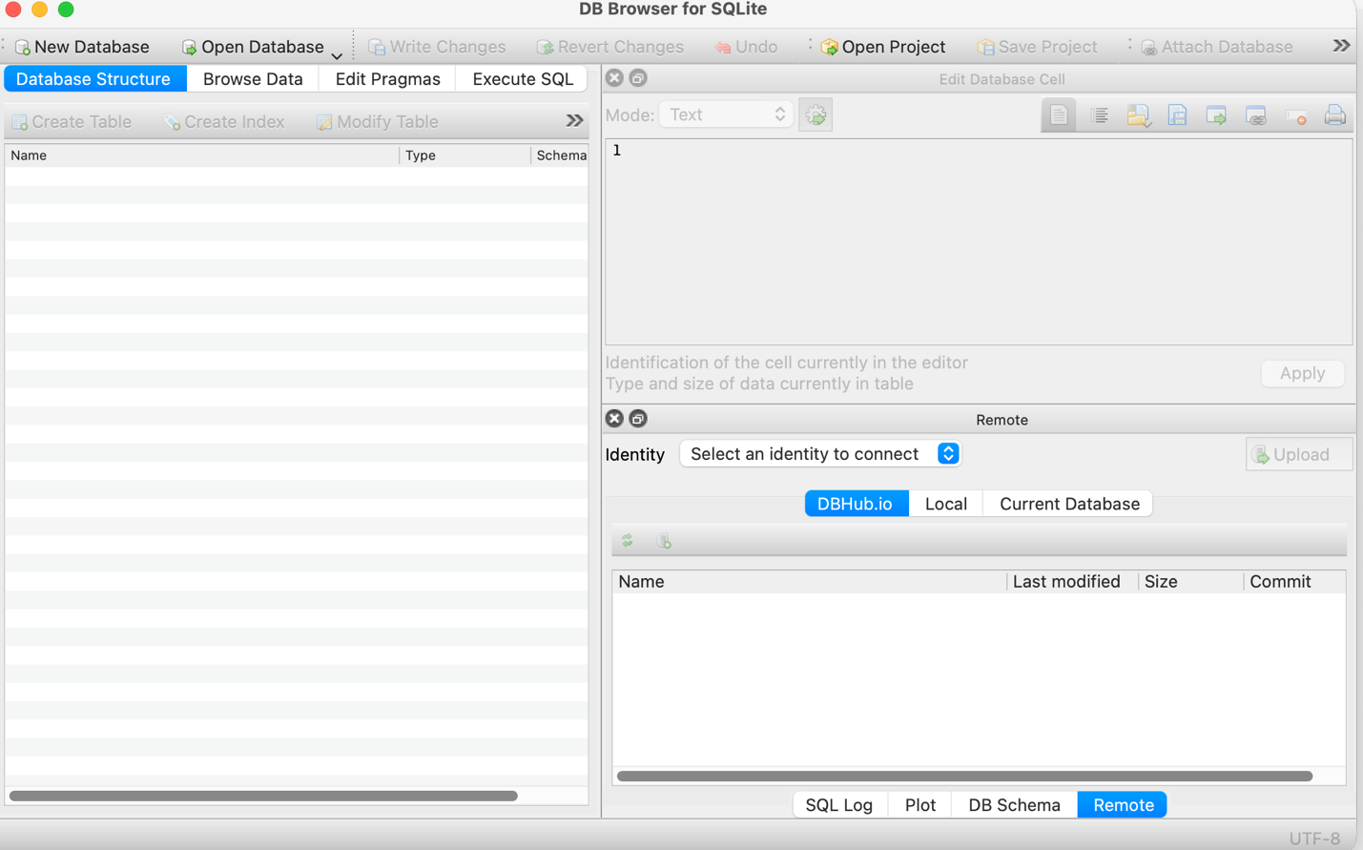
Select Open Database and point to the db file:
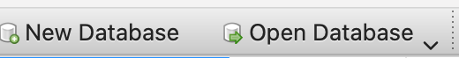
From here, you can browse the data by selecting whichever table you need:
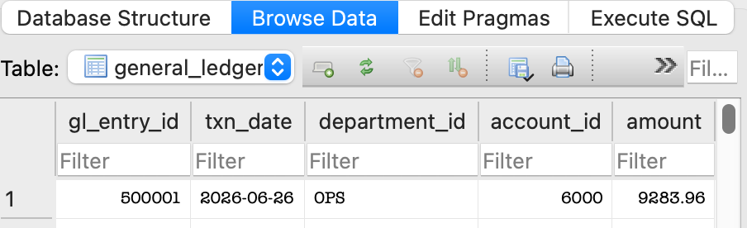
From here you will need to use the Execute SQL tab to write the SQL code to get the data you need.
When you are ready, here is a tutorial to download your data from SQLite into a csv file: https://www.sqlitetutorial.net/sqlite-export-csv/
Step 1 — SQL (Assign one of these to each team member). Write SQL \queries against meridian_finance.db to answer:
- Total actual spend/revenue by department and account category (Revenue, COGS, Operating Expense), Jan-Jul 2026
- Total budgeted amount by the same grouping (note: budget is monthly, actuals are transaction-level — you’ll need to aggregate actuals by month to compare properly)
- A budget-vs-actual variance table: department × account category, with $ and % variance
- A second cut: the same variance table but by month, not just by the full period, so you can see whether a variance is a one-time spike or a persistent trend Export your final variance query results to CSV — this becomes your team’s shared starting point for the next step.
Step 2 — Python or Power Query (pick one per team). Take the variance CSVs from Step 1 and:
- Identify the 3 largest variances by dollar amount and the 3 largest by percentage — note they’re often not the same line items, and both matter for different reasons
- Calculate a simple “materiality flag”: any variance over 15% AND over $10,000 gets flagged for board attention (a real materiality threshold has to combine both a percentage and a dollar test — a $500 variance can be 200% over budget and still not matter)
- Using your monthly cut, classify each flagged item as “one-time spike” or “persistent trend” (e.g., over/under budget in most months vs. just one)
Step 3 — Visualize (Power BI or Tableau, your choice). Build one interactive dashboard page with:
- A variance chart (budget vs. actual) by department
- The materiality-flagged line items called out visually (color, callout, or separate table)
- A trend view (by month) for at least the single largest flagged variance, showing whether it’s a spike or persistent
- Add notations to the dashboard if and where appropriate
Step 4 — AI-assisted narrative. Using an AI tool, draft a 150-word summary for the board, written in plain language, that:
- States the single most important finding from your materiality-flagged items
- Distinguishes explicitly between a one-time spike and a persistent trend, since a board should react differently to each
- Explicitly avoids speculating on why a variance occurred unless your data actually shows a cause (same discipline as Weeks 2 and 6)
- Is checked, line by line, against your Step 1-3 numbers before it’s finalized
Step 5 — Team sync and gap check (5 min). Before submitting, have each team member independently answer: “what is our single biggest finding?” If team members give different answers, take 5 minutes to resolve why — that’s a sign the team didn’t actually agree on what the data shows, which is worth catching now rather than in front of the CFO.

Deliverables
Submit
- Your SQLite database using ONLY File Save File As. The file name must be one of your group members’ name, and the extension of the file should be .sqbpro. If this is not the case, your group will lose 50% of the points of this assignment.
- Your Python/Power Query file with the relevant csv files included in the upload to Canvas,
- Your dashboard (.pbix or .tbwx file). Wrong file format loses 2 points
- Your AI-drafted narrative, and a short note on any place the AI narrative needed correction.
- For Step 5, indicate at the end of the narrative whether there was agreement by all team members or differing opinions among team members on the single biggest finding.
- Also indicate at the end of the narrative if any group member did not carry their weight in this project.

THIS IS A GROUP PROJECT. One submission per group; however, non-participating group members or group members who did not carry their weight will receive 0 points.

