The Food GPS

Lara Marques, 125413
Nelson Ramos, 124921
Rodrigo Gonçalves, 124750

Universidade de Aveiro
Departamento de Eletrónica, Telecomunicações e Informática (DETI)

nelsonramos@ua.pt

Design Thinking Module
Competências Transferíveis 1

Resumo

The project “Food GPS” aims to reduce food waste and fight food insecurity through a smart redistribution platform that connects food donors, volunteers, and recipients. Based on the Design Thinking (E62) model, the project explored each creative phase—from context analysis to prototyping and exposition—to design a system guided by empathy, experimentation, and innovation. Inspired by the analogy of a GPS, the solution uses AI to suggest the optimal routes for food surplus collection and delivery, ensuring that food reaches those in need efficiently and sustainably. The process included benchmarking, empathy mapping, analogy generation, and prototyping through storyboards, leading to a clear and communicable concept.
Palavras-chave: Food GPS, food waste, empathy.

- Introdução
This project was developed within the Design Thinking module as a proposal aligned with the United Nations Sustainable Development Goals, particularly SDG 2 – Zero Hunger.
The goal was to design an innovative and socially impactful solution addressing food waste and insecurity through a human-centered and technology-driven approach.
The “Food GPS” concept evolved from understanding the food redistribution system’s inefficiencies to creating an interactive, intelligent model that improves coordination and reduces waste.
In Portugal alone, over 1 million tons of food is wasted annually, while many families still face food insecurity. This paradox inspired us to act through design and empathy, exploring how technology could bridge this gap. “Food GPS” emerged as both a logistical and emotional solution – an invitation to rethink how we treat food as a resource rather than disposable waste.

- Método
The work followed the E6² Design Thinking model, presented in class, divided into the following phases:

2.1 Emergence

The starting point was the definition of the Intent Statement:

“How might we optimize the redistribution of surplus food to reduce waste and ensure fair access for those experiencing food insecurity?”

A benchmarking study identified existing initiatives such as Too Good To Go, OLIO, and Refood, highlighting the need for improved real-time coordination, volunteer engagement, and data-driven logistics.
The analysis confirmed that current solutions often focus on commercial surplus sale rather than direct redistribution, motivating the development of a community-oriented and technology-enhanced platform.
Early brainstorming explored several directions – from educational campaigns to smart waste-tracking containers – but these lacked scalability. Through benchmarking, we discovered that many existing initiatives depend heavily on manual coordination and voluntary effort, which limits their reach. The insight was clear: the next generation of solutions must automate decision-making while keeping human empathy at its core. This realization set the foundation for “Food GPS”.
Please, refer back to the dossier annexes “Statement of Intent.pdf” “& “Benchmarking.pdf” and analyze them.

2.2 Empathy

An Empathy Map was created to explore the experiences of key stakeholders:
Donors (restaurants, supermarkets): want simplicity and reliability – In this case, João, 29, owner of a restaurant.
Volunteers: seek clarity, timing, and efficient routes – In this case, Ana, 23, a volunteer in the local food association.
Recipients (families, NGOs): value dignity, consistency, and transparency – In this case, Maria, 43, a single mom of 2 who deals with food scarcity.

This phase emphasized emotional insight: understanding the satisfaction of contributing and frustration caused by food waste. We concluded that the system must be intuitive, empathetic, and responsive, addressing both functional and emotional needs.

When mapping João’s daily experience as a restaurant owner, we realized that food waste is often not a choice but a consequence of timing and logistics. Ana, the volunteer, emphasized the need for efficiency – she wants to help, but only if the process is organized and rewarding. Meanwhile, Maria’s empathy map revealed a deeper emotional dimension: the fear of dependency and the desire to maintain dignity. These findings shaped design principles focused on transparency, trust, and autonomy. The system needed to “speak softly” – offering help without stigma.

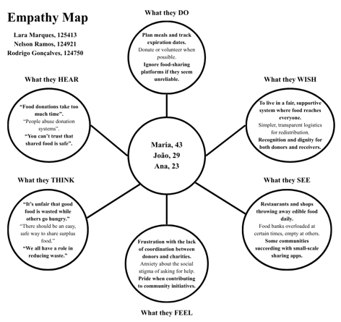
Fig. 1: Empathy Map.

2.3 Experimentation

In the creative exploration stage, the team developed the central analogy:
“Just as a GPS guides a vehicle from point A to point B, the Food GPS guides surplus food from its origin to those who need it most.”

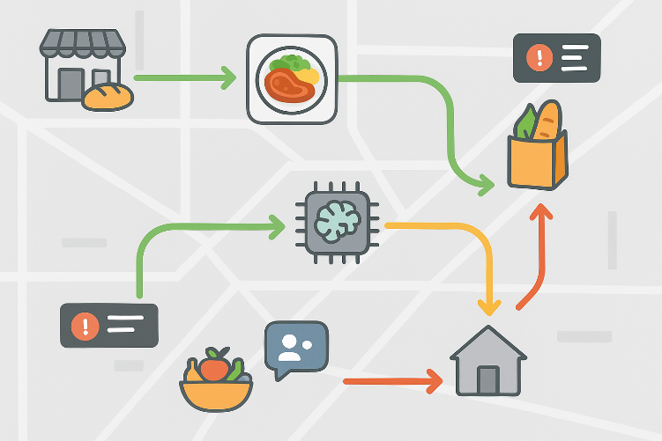
Fig. 2: Analogy image.

The analogy inspired the first visual concept (Fig. 2), featuring a map background, food icons as “moving units” and color-coded routes: Green – available routes; Yellow – moderate delay; Red – urgent, risk of waste.
These visual cues represent how artificial intelligence continuously adjusts to real-time conditions to ensure that food reaches its destination efficiently.
Through the semantic confrontation exercise, we explored combinations such as “food + map”, “waste + compass” and “hunger + route.” The GPS metaphor stood out for its familiarity and optimism – as in, it suggests movement, direction, and control, values that contrast with the chaos of waste. This analogy also established our visual identity: a map background, dynamic routes, and real-time updates symbolizing constant adaptation. It became the creative anchor for the whole project.

2.4 Elaboration

Building upon the analogy, the team developed a storyboard (Fig. 3) to represent the complete process:
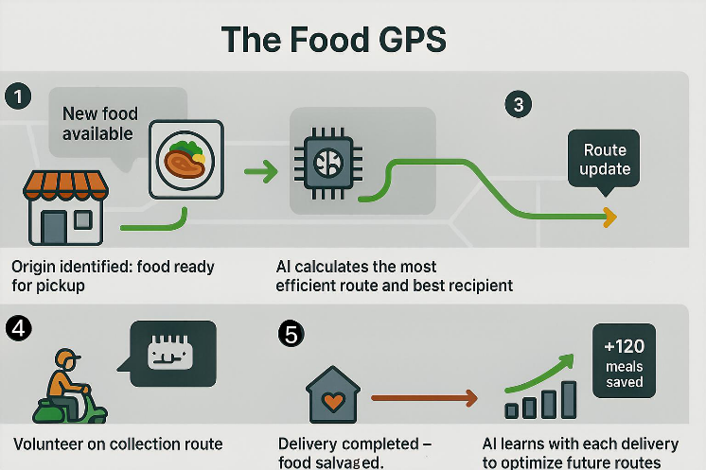
Fig. 3: Storyboard.

Operational Flow:
Food Available: a restaurant or supermarket registers surplus food.
Route Calculation: AI defines the optimal route and recipient.
Pick-Up Notification: volunteers receive real-time alerts and collect food.
Delivery and Update: delivery is confirmed; the system learns and improves future suggestions.

During the elaboration phase, we used digital sketching tools to visualize the user journey and validate emotional responses. Each scene of the storyboard was discussed collaboratively, testing whether the message of empathy and efficiency was clear. Feedback from peers helped simplify the user interface and make transitions smoother. The final storyboard communicates not only the operational logic but also the emotional experience – relief, purpose, and community connection.

2.5 Exposition

The final stage focused on communicating the “Food GPS” concept effectively.
An integrated prototype visualization (Fig. 4) combined these steps, illustrating the entire operational flow—from availability to redistribution—supported by continuous data learning.
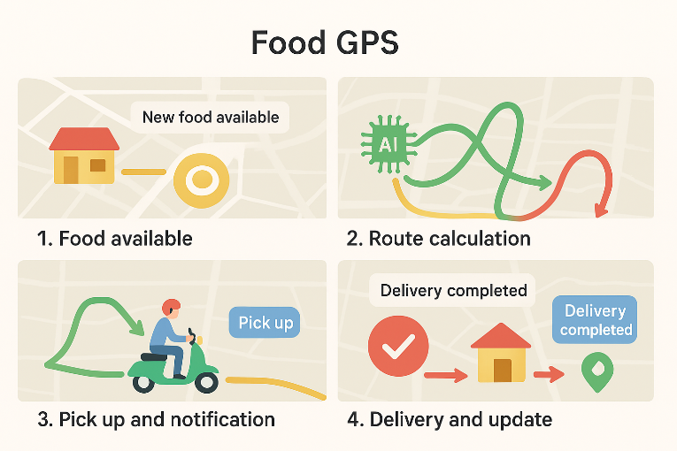
Fig. 4: Overview of the final flux.

Thus, the Exposition Phase emphasized visual storytelling, presenting:
The analogy visual, representing the concept intuitively.
The experience storyboard, illustrating user interactions.
The system overview, showing feedback loops and AI coordination.

During exposition, the message centered on impact—showing how the system contributes to reducing waste, promoting social responsibility, and strengthening community connections.

The exposition phase was not only about showing visuals but also about creating a narrative. The presentation was designed as a “journey map”, guiding the audience through discovery, empathy, and solution. Color-coding (green, yellow, and red) was reused from the analogy to create immediate visual coherence. Feedback from colleagues confirmed that the concept was easily understood and emotionally engaging, validating our design choices.

- Resultado

The outcome of this process was a clear and communicable concept represented by three main prototypes:

Figure 2 – Conceptual Analogy: “The Food GPS” as a navigation metaphor for food flow.
Figure 3 – Experience Storyboard: Step-by-step user journey from food registration to delivery.
Figure 4 – Integrated System Visualization: Synthesis of data flow, actors, and outcomes.

These visuals demonstrate how the idea can be implemented in real contexts, supported by artificial intelligence, human empathy, and collective action.

Beyond its conceptual visualization, the “Food GPS” prototype represents a scalable framework that could be integrated into local food ecosystems. In practical terms, donors would access a web or mobile interface to register available items, while AI automatically matches them to nearby recipients through optimized routes. Volunteers act as the system’s dynamic link, ensuring last-mile efficiency and human connection. The platform’s database would continuously learn from patterns of donation frequency, demand density, and delivery time, improving logistics and minimizing resource waste. In future iterations, features such as predictive alerts, gamified volunteer rewards, and sustainability tracking could be introduced, reinforcing long-term engagement.
This result demonstrates how a creative concept can evolve into an actionable system – where empathy, data, and collaboration converge to address one of society’s most persistent challenges.

- Reflexão final
The creative process revealed the importance of iteration, collaboration, and empathy in design.
Through this project, the team learned to:
- Embrace divergent and convergent thinking to refine ideas.
- Translate abstract problems into tangible, human-centered solutions.
- Use visual tools (analogies, storyboards) to communicate complex systems clearly.

Challenges included managing scope and ensuring that the solution remained both technically feasible and socially meaningful. Overall, the “Food GPS” reflects how design thinking can merge creativity and technology to produce sustainable social impact.

Looking ahead, the “Food GPS” could evolve into a real platform integrating AI with local networks such as Refood or Banco Alimentar. The impact could be measurable –not only in tons of food saved but also in human stories transformed. The project also strengthened our teamwork: combining technical, visual, and social perspectives, we learned how design thinking fosters collaboration through shared empathy and purpose.

