Experimentation Phase
“The Food GPS” Analogy
Just as a navigation system guides a car from point A to point B, “The Food GPS” would guide surplus food from its point of origin (restaurants, supermarkets) to its best destination (families or community centers in need).
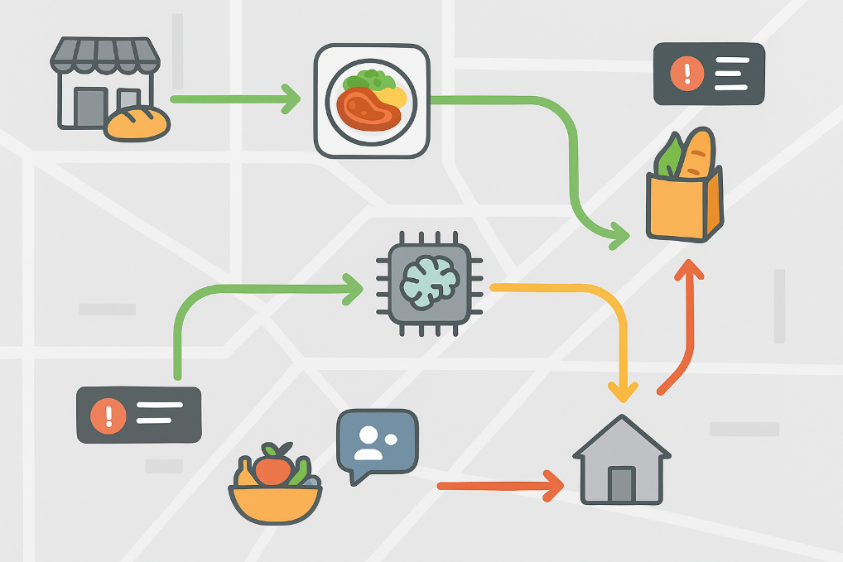
The map background represents the operational area; the food icons symbolize the available surplus (e.g., meals, fruits, or groceries). The routes are promptly color-coded: Green – fast and available routes; yellow – moderate delay or alert; red – urgent, risk of waste. Destinations: households, NGOs, or community hubs. The notifications and the AI symbol indicate real-time decision-making and route optimization.
Experience Storyboard: “The Food GPS”
To move from concept to experience, a second prototype – the storyboard – was developed to illustrate the complete process.
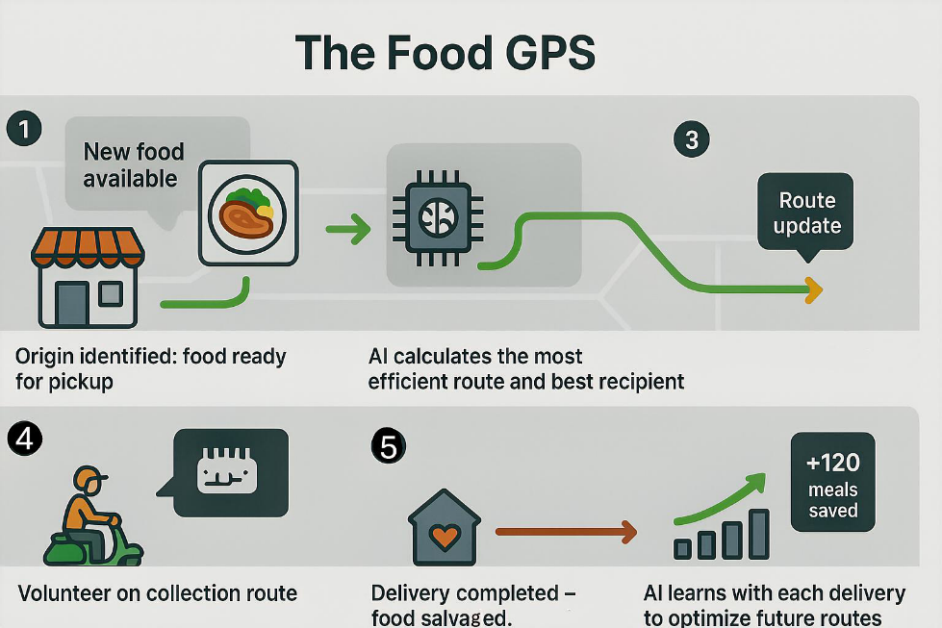
Food available: a restaurant or shop registers surplus food on the platform. Route calculation: the AI suggests the optimal route and best recipient based on proximity, availability, and urgency. Pick-up and notification: volunteers receive real-time alerts to collect and deliver the food. Delivery and update: successful delivery is confirmed, and the system updates the status, learning from data for future improvements.
Integrated Prototype Visualization
Finally, a combined visual storyboard was created to summarize the logic, experience, and feedback loop of the “Food GPS.”
