Four-Mode Automated Testing for Browser-Based Cognitive Assessments
  - Technical white paper of Proposed architecture
Prepared by: Nelson, Flora, ChatGPT dictation
  - Presented: 22 October 2026

Executive summary
This paper proposes a local Playwright-based testing workbench for cognitive assessments, using M2C2 Symbol Search as the first target. The system separates response policy (what answer to give) from observation and action (how to perceive and interact). It supports four user-facing modes: scripted, AI-driven, simulated participant, and DOM-driven. The first three operate from visible screen content; DOM-driven testing is explicitly privileged and separately labeled. A reusable strategy library minimizes repeat model calls, while evidence-rich execution logs make runs auditable. Synthetic and AI-generated responses must never be interpreted as human cognitive measurements or merged into participant datasets.

1. Testing objectives and scope
The primary objective is software quality assurance: verify navigation, input handling, error recovery, trial transitions, completion, and timing behavior. A secondary objective is scoring. A tertiary research objective is to evaluate how different automated agents perform cognitive tasks.
Initial assessment: M2C2 Symbol Search v0.8.35, at https://runner.m2c2kit.com/assessments/@m2c2kit/assessment-symbol-search@0.8.35/index.html?study_id=demo&api_key=demo.
This is the supplied target URL, not a claim that its current UI or scoring implementation has been verified.

2. The four testing modes
Mode | Response policy | Observation and action
Scripted | Fixed rules, recorded demonstrations, expected answers, or deterministic sequences. | Screenshots plus mouse/keyboard; no DOM.
AI-driven | Vision model interprets instructions and chooses responses; can compile reusable strategy. | Screenshots plus mouse/keyboard; no DOM.
Simulated participant | Statistical response generator controls errors, latency, omissions, and variability. | Screenshots plus mouse/keyboard; no DOM.
DOM-driven | Rules or model can use page semantics and selectors for robust QA. | DOM/locators permitted; clearly segregated.
The modes are user-facing presets, not four separate browser engines. Internally, the response policy and interaction adapter are composable, enabling controlled comparisons without blurring the screen-only versus DOM-access boundary.

3. Reusable strategy architecture
A strategy contains an assessment identity and version, viewport assumptions, visual state definitions, input mapping, trial loop, response policy, completion detector, timeout/recovery rules, and provenance. Discovery may be assisted by a user demonstration or bounded autonomous exploration. Validation is mandatory before marking a strategy reliable.
Execution proceeds through: load URL → identify expected screen state → choose response → schedule action → capture outcome → advance or recover. In screen-only mode, screenshots and input events are the sole task-facing channels. DOM, accessibility trees, injected page scripts, and network response bodies are prohibited as observation sources. Playwright may still manage browser lifecycle and capture traces outside the agent’s decision channel.
A replay strategy based only on absolute coordinates cannot reliably solve randomized trials. Stable replay requires visual anchors, task-specific deterministic recognition, or selective vision-model inference. Cache task instructions and stable geometry (fixed seed). Strategy versioning should track assessment version, viewport, and relevant assets.

4. Timing and measurement integrity
Record at least stimulus onset as reported by the assessment when available, screenshot capture time, decision completion time, scheduled input time, actual Playwright input time, and assessment-recorded response time. Use monotonic clocks for local durations and document clock domains. Browser automation timing is not equivalent to human motor reaction time; vision-model latency is particularly variable. For simulated participants, draw intended delays from a seeded distribution and report both intended and observed delays.

5. Auditability, safeguards, and reproducibility
Each run should record a unique run ID, assessment URL/version, strategy ID/hash, mode, random seed, browser version, viewport, timestamps, actions, errors, screenshots, and Playwright trace. Export JSON/CSV summaries. Use demo or isolated test accounts, synthetic IDs, and clearly marked test sessions. Do not persist API keys in logs; redact query parameters that contain secrets. Avoid sending participant data or identifiable screenshots to external models without appropriate authorization.

6. MVP: narrow, demonstrable scope
Today’s deliverable is a local Node.js + Playwright application with a minimal web control panel, URL launcher, manual interaction recorder, JSON strategy storage, deterministic replay, screenshots, and a run log. Add a bounded screenshot-based AI suggestion action using Codex Device Auth. Provide a basic DOM locator demonstration as a separate privileged mode. Full autonomous discovery, generalized randomized-stimulus solving, sophisticated participant simulation, and Electron packaging are explicitly out of scope for the same-day milestone.

7. Acceptance criteria
- The supplied Symbol Search URL launches in visible Chromium and can be controlled from the local interface.
- A user can record one test interaction sequence and save it as a named, versioned JSON strategy.
- Replay performs the saved interactions with no AI calls and produces a timestamped execution log.
- Screen-only modes have no DOM or network-content access in their decision path; DOM mode is visibly labeled.
- The application detects a failed or unexpected step and stops safely rather than silently reporting success.
- A run can be identified as synthetic/test data and its logs exported without exposing credentials.

8. Validation plan and next steps
Validate the MVP first against a deterministic Symbol Search path. Then run repeatability tests at a fixed viewport and measure replay success, unexpected-state frequency, timing deviation, and token use. Next add visual anchors and trial-level recognition for randomized stimuli, followed by seeded participant models and bounded autonomous discovery. Compare screen-only and DOM-driven runs as separate experimental conditions; do not equate their information access.

Conclusion
A four-mode workbench is feasible if the implementation prioritizes shared infrastructure, strict observation boundaries, reusable strategies, and honest limits on replay. For this demonstration, dependable recording, replay, and evidence capture provide a stronger foundation than an unvalidated claim of fully autonomous cognitive testing.

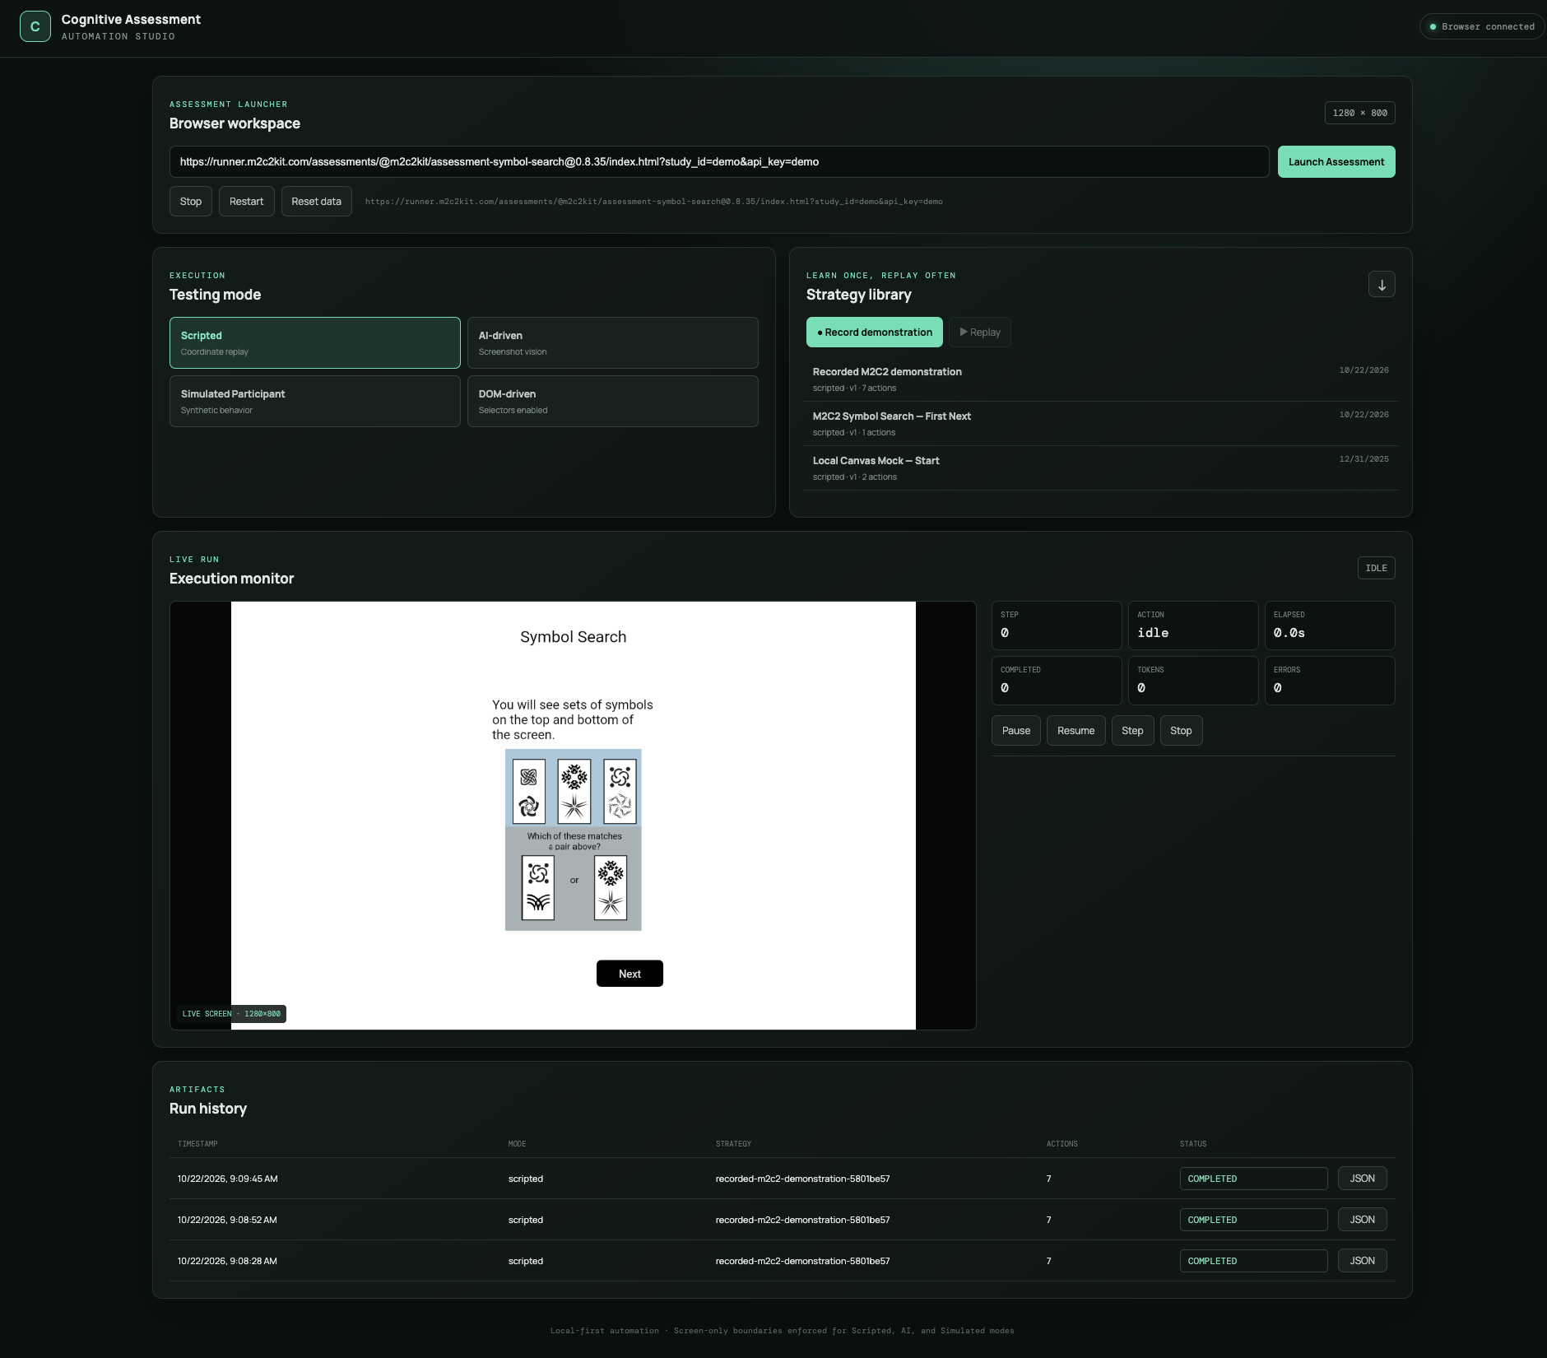
Figure 1. Live demonstration of the scripted testing.

