NELSON TRINITY HOLDINGS
2025 Strategic Outlook & Investment Forecast
Dual-Mandate Investment Framework
Real Estate Assets • Biomedical Technology Infrastructure
FISCAL YEAR 2025
Classification: Internal Use
Prepared: November 2025

Table of Contents
This outlook document provides comprehensive analysis across the following sections:
- Executive Summary
- Portfolio Overview & Asset Allocation
- Real Estate Investment Analysis
- Biomedical Technology Sector Analysis
- Financial Projections (2025-2029)
- Strategic Initiatives & Milestones
- Risk Assessment & Mitigation
- Conclusion & Recommendations

1. Executive Summary
Nelson Trinity Holdings operates under a disciplined dual-mandate investment framework, strategically allocating capital across income-generating real estate assets and transformative biomedical software infrastructure. This outlook presents our strategic positioning and growth projections for fiscal year 2025 and the subsequent four-year planning horizon through 2029.

Portfolio Composition
Our portfolio maintains a 65/35 allocation between real estate assets and biomedical technology investments, designed to optimize risk-adjusted returns while maintaining liquidity thresholds appropriate for institutional capital deployment.

Key Performance Indicators (2025 Projections)
Metric | 2025 Target | 5-Year CAGR
Total Portfolio Value | $23.7M | 14.8%
Real Estate Revenue | $15.2M | 12.4%
Biomedical Software Revenue | $8.5M | 35.7%
Occupancy Rate (Real Estate) | 94.5% | 96.0% by 2029
Portfolio ROI | 18.3% | 22.1% by 2029

Strategic Priorities for 2025
- Expand Buckhead portfolio with two additional Class-A multi-family acquisitions targeting 8-12% cap rates
- Accelerate biomedical AI deployment with Imperial College London and Oxford partnerships
- Establish Los Angeles mixed-use footprint with $18M capital deployment
- Secure Series A funding for Robotic Surgical Vision platform at $45M pre-money valuation
- Maintain debt-to-equity ratio below 0.65 across all investment vehicles

2. Portfolio Overview & Asset Allocation
Nelson Trinity Holdings maintains a strategically diversified portfolio designed to capture stable income through real estate while participating in high-growth biomedical technology markets. This section presents our current allocation framework and geographic distribution.

2.1 Asset Allocation Strategy
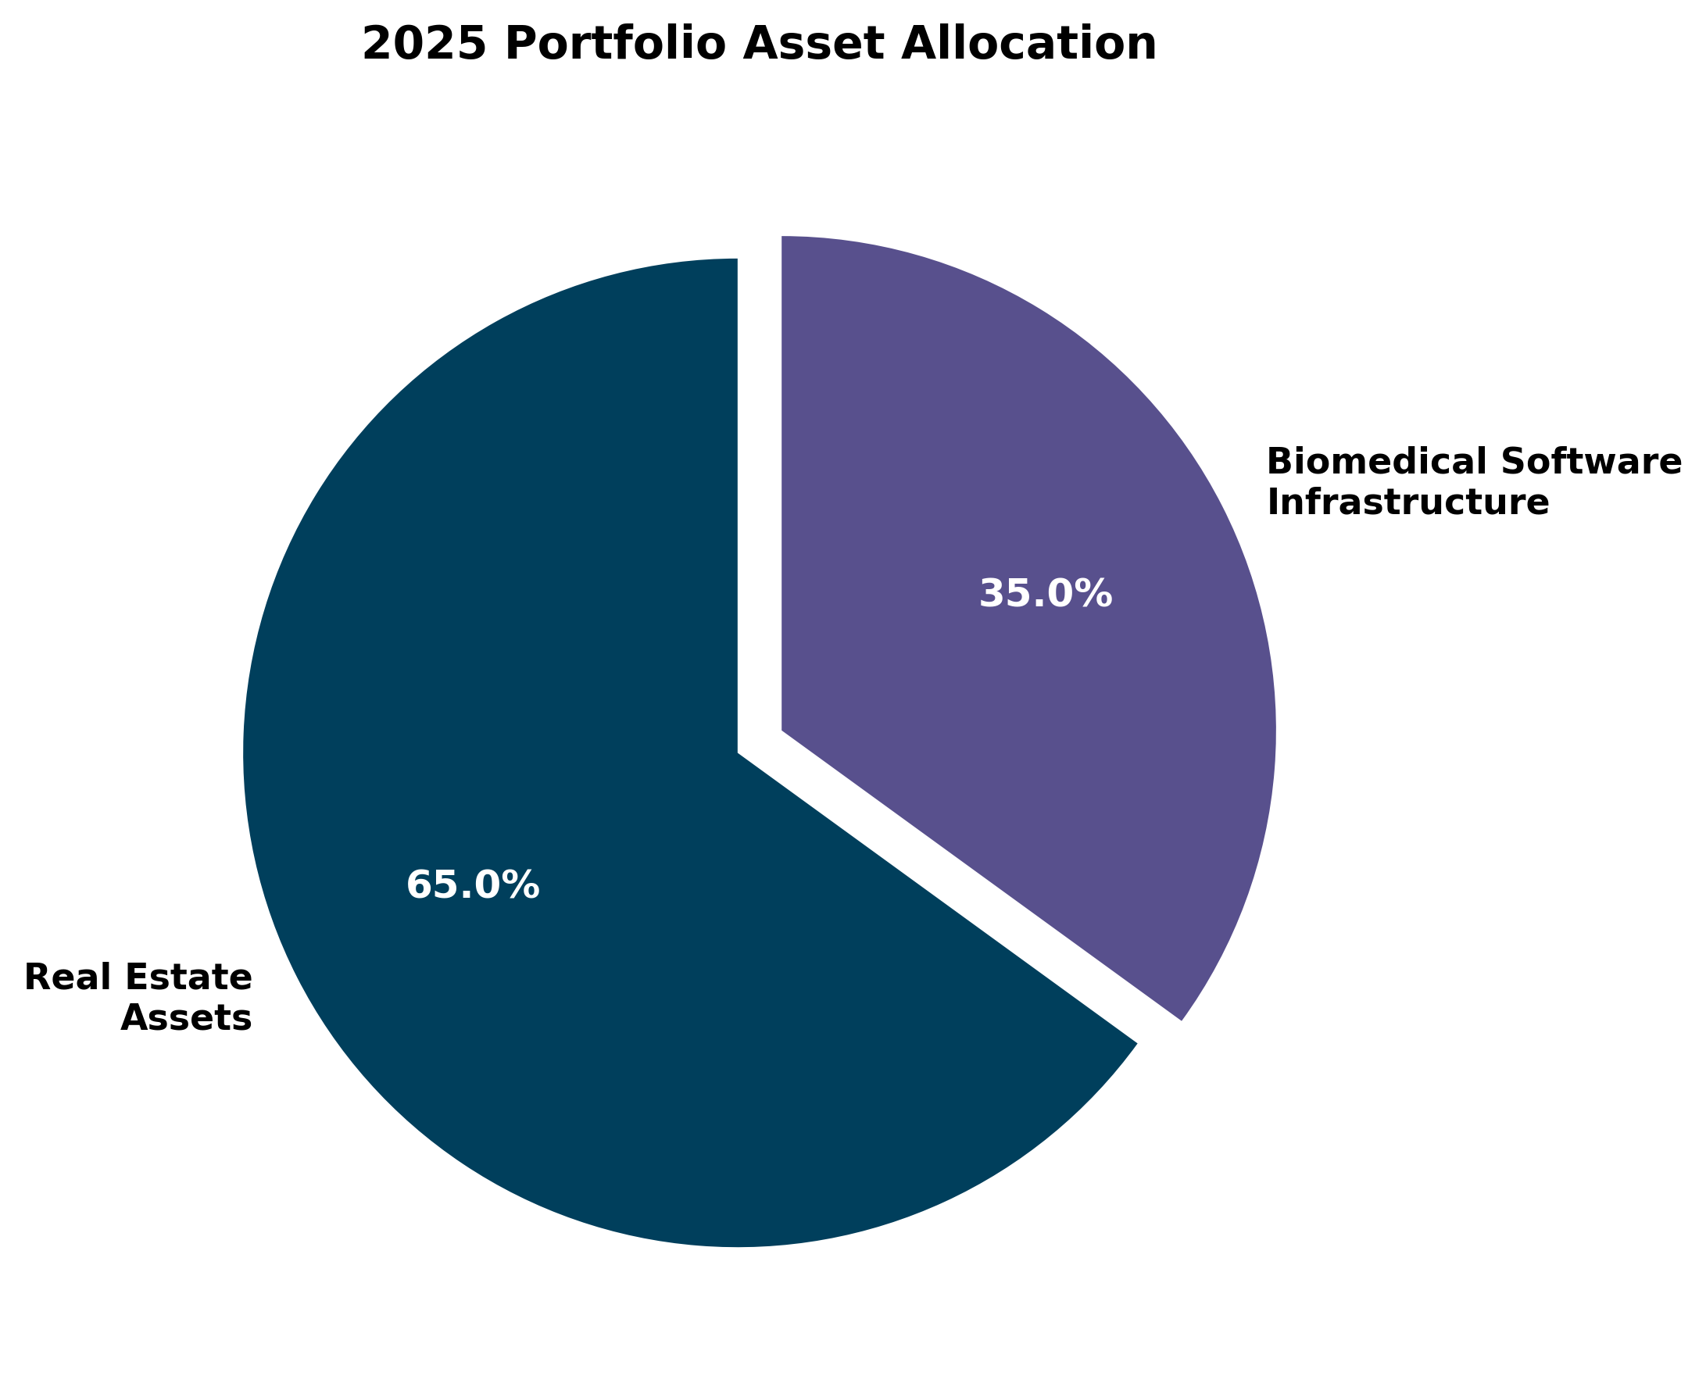
Figure 1: 2025 Portfolio Asset Allocation
Our allocation maintains 65% exposure to income-producing real estate assets, providing stable cash flows with capital appreciation potential. The remaining 35% is allocated to biomedical software infrastructure, offering asymmetric return profiles with managed risk through institutional partnerships with Imperial College London Hamlyn Centre and University of Oxford.

2.2 Geographic & Sector Distribution
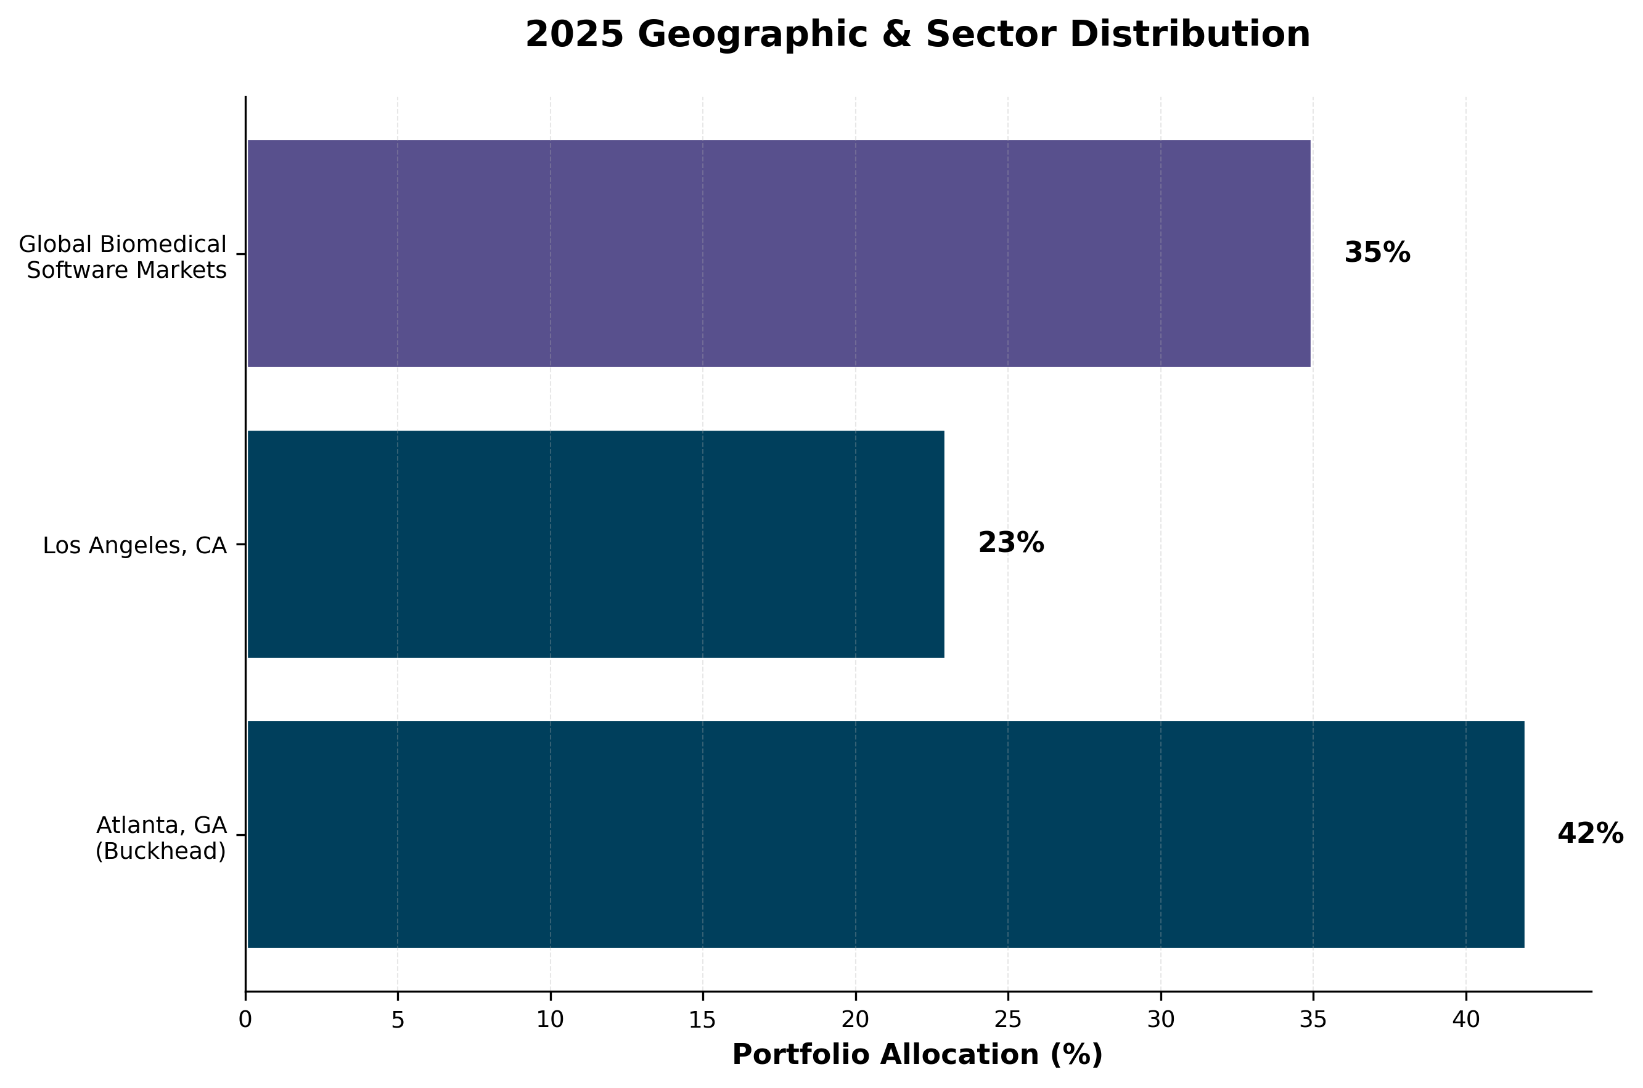
Figure 2: 2025 Geographic & Sector Distribution

3. Real Estate Investment Analysis
Our real estate portfolio focuses on institutional-grade assets in high-growth metropolitan markets, specifically targeting the Buckhead district of Atlanta and emerging opportunities in Los Angeles. This section details our current holdings, performance metrics, and expansion strategy.

3.1 Buckhead Income Fund
Location: Lenox and West Paces Corridor, Buckhead, Atlanta, GA
The Buckhead Income Fund represents our flagship real estate investment vehicle, comprising a curated portfolio of Class-A multi-family and mixed-use assets in Atlanta's premier Buckhead district. Current portfolio value stands at $42M with a stabilized occupancy rate of 92%.
Property Type | Units/Sq Ft | Occupancy | Cap Rate
Multi-Family A | 124 units | 94% | 7.8%
Multi-Family B | 89 units | 91% | 8.2%
Mixed-Use Retail | 32,400 sq ft | 89% | 9.1%

3.2 Quarterly Performance Projections
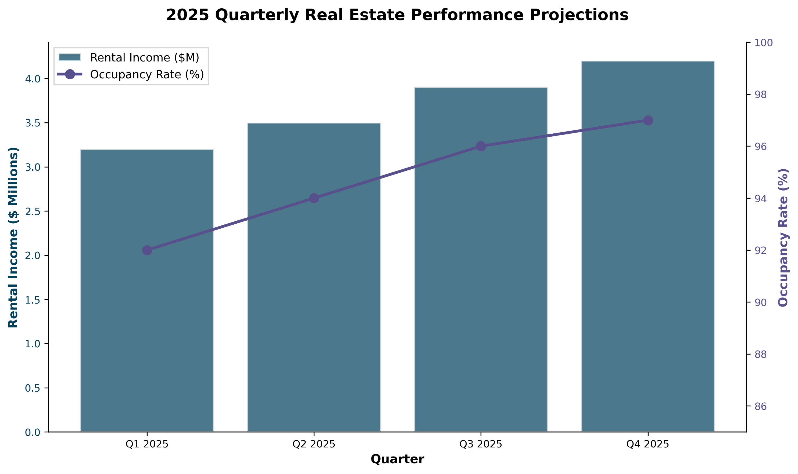
Figure 3: 2025 Quarterly Real Estate Performance Projections

4. Biomedical Technology Sector Analysis
Our biomedical software infrastructure investments focus on transformative AI-powered surgical vision technology developed in collaboration with leading academic institutions. This strategic positioning offers exposure to the rapidly expanding surgical robotics market, projected to reach $20B by 2028.

4.1 Robotic Surgical Vision Platform
Partnership: Imperial College London Hamlyn Centre & University of Oxford
This flagship technology investment focuses on real-time AI-powered surgical vision systems for robotic surgery applications. Our partnership with Oxford and Imperial College London provides access to cutting-edge research infrastructure while maintaining strategic control over commercialization pathways.
Phase | Timeline | Key Milestones
Development | Q1-Q2 2025 | Algorithm refinement, dataset expansion, pre-clinical validation
Clinical Trials | Q3 2025-Q2 2026 | Multi-center trials, regulatory data collection, FDA submission prep
Commercialization | Q3 2026 onwards | Market entry, partnership agreements, revenue generation

Market Opportunity
- Global surgical robotics market growing at 15.4% CAGR through 2030
- AI-powered surgical vision represents $4.2B addressable market by 2028
- Strategic positioning ahead of major OEM partnerships with surgical robotics platforms
- Regulatory pathway well-defined with FDA 510(k) classification anticipated

5. Financial Projections (2025-2029)
This section presents our five-year financial projections across both investment verticals, with conservative assumptions applied to real estate appreciation and aggressive but achievable targets for biomedical technology commercialization.

5.1 Five-Year Revenue Growth Projections
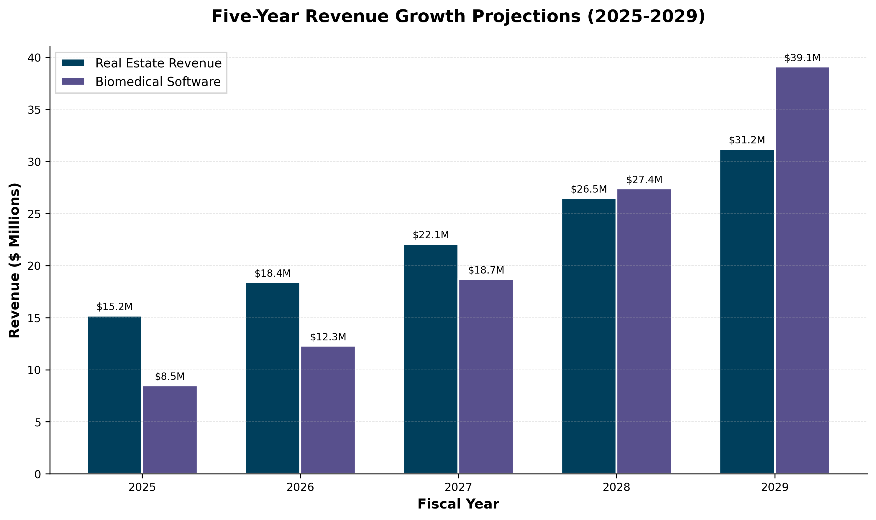
Figure 4: Five-Year Revenue Growth Projections (2025-2029)

5.2 Detailed Financial Projections
Metric | 2025 | 2026 | 2027 | 2029
Total Revenue | $23.7M | $30.7M | $40.8M | $70.3M
Real Estate | $15.2M | $18.4M | $22.1M | $31.2M
Biomedical Tech | $8.5M | $12.3M | $18.7M | $39.1M
EBITDA | $8.9M | $12.4M | $17.1M | $31.8M
Portfolio ROI | 18.3% | 19.1% | 20.5% | 22.1%

6. Risk Assessment & Mitigation
This section provides a comprehensive analysis of portfolio risk factors and our strategic mitigation frameworks designed to protect capital while maintaining exposure to asymmetric upside opportunities.

6.1 Risk-Return Profile Analysis
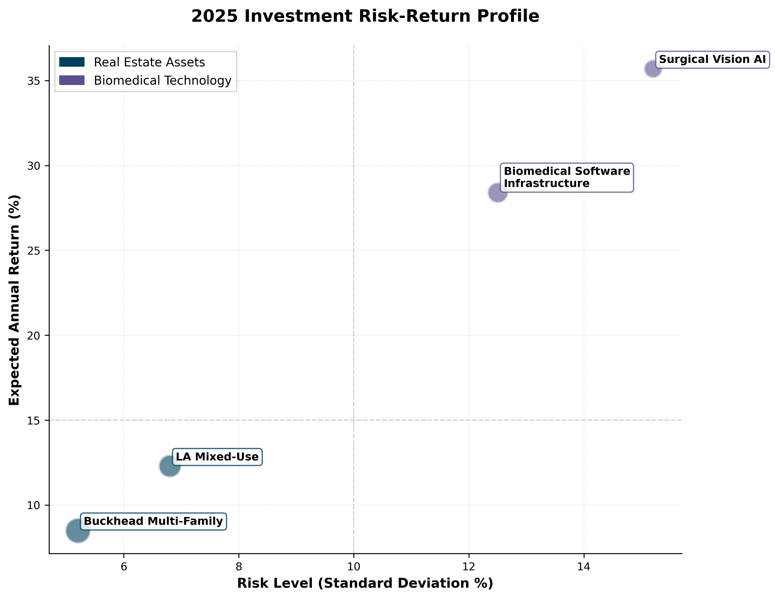
Figure 5: 2025 Investment Risk-Return Profile

6.2 Key Risk Factors & Mitigation Strategies
Risk Category | Probability | Mitigation Strategy
Market Correction (Real Estate) | Medium | Geographic diversification, long-term lease structures, conservative LTV ratios
Regulatory Delays (Biomedical) | Medium-High | Early regulatory engagement, parallel pathway development, strategic partnerships
Technology Obsolescence | Low-Medium | Academic partnerships, continuous R&D investment, patent portfolio development
Funding/Liquidity Risk | Low | Maintained debt covenants, diversified capital sources, strategic cash reserves

7. Strategic Initiatives & Milestones
This section outlines our key strategic initiatives for 2025, organized by quarter and aligned with our dual-mandate investment framework.

7.1 Q1 2025 Initiatives
- Complete acquisition due diligence on two additional Buckhead multi-family properties
- Initiate Series A fundraising roadshow for Robotic Surgical Vision platform
- Establish Los Angeles market presence with broker partnerships and deal flow pipeline

7.2 Q2-Q3 2025 Initiatives
- Close $18M Los Angeles mixed-use acquisition with institutional co-investment partners
- Launch multi-center clinical trials for surgical vision AI with three partner hospitals
- Complete Series A round at target $45M pre-money valuation
- Expand Buckhead portfolio with strategic asset acquisitions targeting 10%+ cap rates

7.3 Q4 2025 Initiatives
- Submit FDA 510(k) application for surgical vision platform
- Initiate strategic partnership discussions with major surgical robotics OEMs
- Complete portfolio optimization across Buckhead assets, targeting 96% stabilized occupancy
- Establish 2026 capital deployment framework and pipeline development

8. Conclusion & Recommendations
Nelson Trinity Holdings is strategically positioned to deliver exceptional risk-adjusted returns through our disciplined dual-mandate investment framework. Our portfolio balances stable income generation through institutional-grade real estate with asymmetric growth opportunities in biomedical software infrastructure.

Investment Thesis Summary
The convergence of stable real estate cash flows and transformative biomedical technology creates a compelling value proposition for institutional capital. Our partnerships with Imperial College London and Oxford University provide technical validation while minimizing development risk, positioning us for optimal outcomes across both investment verticals.

Key Success Factors
- Maintain disciplined capital allocation with target debt-to-equity below 0.65
- Execute strategic real estate acquisitions in Buckhead and Los Angeles markets
- Advance biomedical technology through clinical validation and regulatory milestones
- Leverage institutional partnerships for technical validation and market access
- Optimize portfolio performance through active asset management and strategic capital recycling

Looking Forward
The 2025-2029 planning horizon represents a transformative period for Nelson Trinity Holdings. Our diversified approach positions us to capture value across multiple economic scenarios while maintaining appropriate risk controls. We remain committed to delivering institutional-grade returns through disciplined execution and strategic partnership development.
For additional information regarding this outlook or investment opportunities with Nelson Trinity Holdings, please contact our investment relations team.

Appendix A: Assumptions & Methodology
This outlook document is based on assumptions and projections developed through comprehensive market analysis, historical performance data, and forward-looking strategic planning. Key assumptions include:
- Real estate appreciation rates: 3.5-4.2% annually across primary markets
- Biomedical technology commercialization timeline: Q3 2026 with progressive market penetration
- Interest rate environment: Stabilization at 4.5-5.5% for commercial real estate financing
- Regulatory approval timelines: 18-24 months for FDA 510(k) clearance
- Capital availability: Maintained access to institutional capital at target cost of capital
Disclaimer: This document contains forward-looking statements subject to risks and uncertainties. Actual results may differ materially from projections. This document is for informational purposes only and does not constitute an offer to sell or solicitation of an offer to purchase securities.
© 2025 Nelson Trinity Holdings. All Rights Reserved.
Prepared: November 2025 | Classification: Internal Use

