Eye-Tracking Data Set

We set out to outperform the performance of a study done by four researchers, Raimondas Zemblys, Diederick Niehorster, Oleg Komogortsev, and Kenneth Holmqvist. Their research and results were recorded and published in a 2017 paper titled ***Using Machine Learning to Detect Events in Eye-tracking Data.*** Why eye movement research? Event detection methods are heavily used to classify events within eye movement research such as fixations, saccades, post saccades oscillations, and smooth pursuit to name a few. We will take a brief moment to clarify the terms we will work with in our study. **Fixation** is the maintenance of a visual gaze on a single location (Wikipedia, 2017) and it makes up the bulk of the dataset. **Saccades** is a quick, simultaneous movement of both eyes between two or more phases of fixation in the same direction (Wikipedia, 2017). **Post-saccadic oscillations**, or **POS**, happen after the saccade where the eye experiences instability before reaching a stable state. The researchers used a baseline dataset consisting of 560 fixations, 555 saccades, and 549 PSOs. This is obviously a small dataset from which to perform a convincing study. To remedy this, the researchers used a number of different mathematical methods to augment the data. Through this augmentation process, they were able to create approximately 10 million data points with a total of 14 features. They then trained and test the data in a random forest algorithm documenting their findings along the way. We similarly used a random forest algorithm; however, we decided to extend the study by employing other machine learning algorithms we felt would classify the labels more accurately. We also employed logistic regression, SVMs, and RNNs.

Data Preprocessing

Before we began tackling the problem, we had to preprocess our data in a way that would help us draw the most accurate conclusions. We needed to create features that hone in on the characteristics of the labels and eliminate the ones that created too much noise.

**Jonas, you may want to talk about your preprocessing process**

We settled on a total of 32 features and approximately 180 thousand data points. These data points were ultimately split into a training set, test set, and validation set.

Random Forest

The use of Decision trees is a good starting point for classifying eye movement categories. They use a process similar to traditional handwritten event detection algorithms. There is a particular categorical binary threshold a label must meet in order belong to a certain class and at each threshold a decision is made eliminating ineffectual variables along the way. It’s a very methodical and intuitive process. Training random forest can be somewhat of a sensitive process. We found it very easy to overfit the training set, effectively rendering it useless on the test/validation set. We found balance at 100 estimators, using gini impurity, at a max depth of 13.

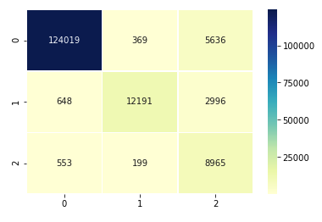

We were able to train at 93% accuracy and produce the following confusion matrix (left). The confusion matrix shows that we were able to accurately classify fixations and saccades (labels 0 and 1, respectively) but had trouble convincingly classifying PSOs. This is most likely attributable to the nature of a PSO. **(View DATA)**