Furniture Sales Data Analysis

Institution: Infotact Solutions
Authors: Karan Kumar R, Nema Nag, Rupali, Jahnavi
Tools Used: Python, Excel, Power BI

1. Introduction
The Furniture Sales Data Analysis project aims to explore sales performance across various dimensions including product categories, store types, pricing, and materials. Through effective use of Python, Excel, and Power BI, this analysis identifies business trends, profitability insights, and areas for strategic improvement. The dataset includes information on profit, sales quantity, delivery timelines, and costs.

2. Objectives
The key objectives of this project are:
- To analyze total revenue, profit, and sales across product categories.
- To study the relationship between price, delivery days, and cost by material.
- To identify the performance of different store types and geographic locations.
- To visualize insights interactively using Power BI for decision-making.

3. Methodology
The project followed a multi-tool approach to ensure data accuracy, insight clarity, and professional visualization:
• Python: Used for data cleaning, transformation, and preprocessing. Missing values were handled, data types standardized, and irrelevant columns removed.
• Excel: Employed for creating KPIs, calculated fields, and pivot tables to summarize key performance indicators.
• Power BI: Integrated visualizations to create an interactive dashboard displaying metrics such as revenue by category, profit margin by location, and average cost by material.
• GitHub: Version control and documentation of each stage in the analysis process.

4. Key Metrics Overview
Metric | Value
Total Profit | 14.34M
Total Sales | 62K
Total Revenue by Brand | 3.70M
Highest Revenue Category | Table (~3.2M)
Top Performing Store Type | Online (51.29%)
Top Location by Profit Margin | Rural (26.88K)

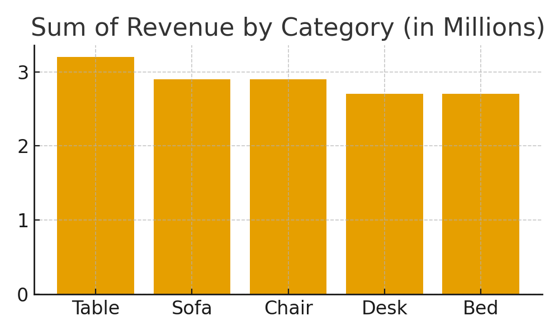

5. Results and Insights
The Power BI dashboard highlights key insights from the sales data:
- The total profit recorded was 14.34M, derived from 62K total sales.
- Retail stores contributed slightly more (51.29%) than online stores (48.71%) to total revenue.
- The highest-performing category was 'Table' with approximately 3.2M revenue.
- Fabric materials had the highest average cost, while glass materials were the least costly.
- Rural locations recorded the highest profit margin (26.88K), followed by suburban and urban areas.
- Medium-priced products had the longest delivery duration, indicating a possible optimization area.

6. Conclusion and Future Scope
The Furniture Sales Data Analysis project effectively utilized Python, Excel, and Power BI to generate actionable insights into sales performance. The findings help businesses understand where profits are maximized and which product categories or store types drive revenue.
For future improvements, integrating predictive analytics models could help forecast sales trends, customer preferences, and seasonal demand patterns. Additionally, expanding data sources (such as customer feedback) would enable more robust decision-making in furniture retail strategy.

