Tinplate Company of India Ltd.

1

1. **Tinplate Company of India Ltd.**

TCIL is today the largest indigenous producer of tin coated and tin free steel sheets in India, enjoying 35-40% market share and undoubtedly the industry leader for more than 90 years. The company exports about 20-25% of its production directly to end-users (can-makers) and its products are well accepted in the markets of SE Asia, Middle East and some developed countries in Europe.

Headquartered in Kolkata, the Company’s Works is located at Jamshedpur, Jharkhand. There are presently 11 offices in India and a distribution network with 16 stocking points.

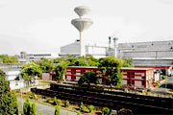 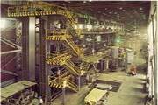  
 figure 1.1 View of TCIL figure 1.2 ETP Line

TCIL Works, situated at Golmuri, Jamshedpur has presently two Electrolytic Tinning Lines (ETLs) and Cold Rolling Mills (CRMs).The Company is in the business of manufacturing and supplying reliable, cost-effective, value-added tin mill products. It manufactures various grades of electrolytic tin plates, tin-free steel sheets and Full Hard Cold Rolled Sheets (FHCR) used for metal packaging. In pursuit of its downstream agenda, the company has been bonding with food processors and fillers by way of world class printing and lacquering facilities at the "Solution Centre".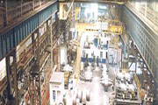 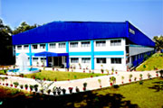  
 figure 1.3 CRM Complex figure 1.4 Solution Centre

* 1. **COMPANY HISTORY**

The company was incorporated in 1920 and the site chosen was Golmuri, Jamshedpur. The first steel plate of Tinplate gauge was rolled on 18th Dec 1922 at the Hot Dip Plant (HDP) producing Hot Dip Tinplate, from tin bars supplied by Tata Steel and this continued till 1979 albeit with capacity enhancements. For 50 years, TCIL thus almost single-handedly built up the Indian Tinplate Industry.

To keep pace with technological developments, TCIL was the first to set up a combination line capable of producing both Electrolytic Tinplate (ETP) and Tin Free Steel (TFS). This plant, the first of its kind in India, was commissioned in 1978 and commenced production in January 1979. In 1982, Tata Steel bought the shareholding of Burmah Oil, the then major shareholder and took over management of the company.

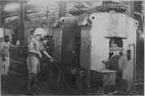 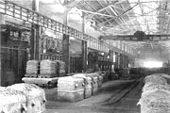  
 figure 1.5 First hot-rolled tin sheet- 1922 figure 1.6 Annealing Bay - 1972

In 1991-92, TCIL undertook backward integration to setup a Cold Rolling Mill (CRM) for production of TMBP Coils, based on Hot Rolled Coil supplies from Tata Steel, which was also setting up its Hot Strip Mill (HSM) at the same time. The CRM was thus a strategic fit for TCIL with Tata Steel. The Cold Rolling Mill (CRM) was commissioned in 1996-97 but with heavy time and cost over-runs, the company started incurring severe losses. A turnaround strategy was developed focusing on:

* Operational Improvements
* Financial Restructuring
* Hot Dip Plant(HDP) phase out and downsizing

Since April 1998, TCIL operates under a conversion arrangement with Tata Steel for its business and with its continuing yearn for quality and customer service, looks forward to the future with confidence.

* 1. **STAGES OF PRODUCTION**

All tinplate originates as in the steel-making furnace (Tata Steel), where the proper chemistry for steel is obtained to meet the specific needs of the end user. All tin mill products start their production process in a Basic Oxygen Furnace (Tata Steel).

• Hot Rolled Coil manufacture • Cold Rolling to produce TMBP Coils • Electro- tinplating

* + 1. **Hot Rolled Coil Manufacture**

Once the steel is produced, the continuous casting process transforms molten steel into slabs in one continuous operation. Continuous casting is a highly energy- and cost-efficient process that produces a slab of excellent quality and consistency. Continuous casting methods are now used in virtually all carbon steel production facilities to produce products of consistent, high quality. Next, the slab goes into the Hot Strip Mill (HSM) of Tata Steel where its thickness is reduced and it is wound in a down coiler into coil form. This is where the Hot Rolled Coil (HRC) is procured as the basic raw material by TCIL from Tata Steel.

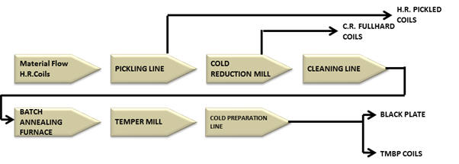  
 figure 1.7 CRM Process Flow Diagram

* + 1. **Pickling Process**

To remove the scales adhering to the hot rolled coils Tinplate Company uses its Push-Pull shallow bath Hydrochloric Acid Pickling Line. The line has 3 pickling tanks and 5 rinse tanks. The Pinch Roll # 1 in the entry section pushes the strip that is "paid off" and the Pinch Roll # 3 in the delivery section pulls it through the process section of the line. The line has a cascading system for rinse water and online trimming facility.

Quality check:-

1. Incoming coils are checked for its shape and steel composition.

2. Acid baths are checked for free acid levels.

3. Rinse water is checked for chlorides.

4. Pickled coils are checked for substrate related defects such as rolled in scale, sliver and process related pickling quality and surface finish.

If all checks conform to standards of delivery to next process the coil is cleared for processing in cold rolling mill.

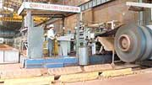 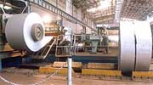  
figure 1.8 PICKLING LINE (ENTRY) figure 1.9 PICKLING LINE (EXIT)

* + 1. **6 Hi Cold Rolling Mill**

Tinplate, as a packaging material, continues to be most preferred, both in packaging food products like processed food, Vanaspati, ghee, etc., and also where criticality of application is important, as in the case of battery jackets and pesticide cans, to name a few select areas.

Understanding the need of increased indigenization, TCIL commissioned its state-of-the-art 120,000 tonnes per annum Cold Rolling Mill having the benefit of synergy with TATA STEEL, from where raw material is available in the form of Hot Rolled Coils for the manufacturing of TMBP coils.

Process

The mother mill of the complex is a 6 High, continuous variable crown-reversing mill. The pickled strip is "paid off" from a Pay-Off Reel and fed into the cold rolling mill. Depending on the input thickness, desired output gauge and pass schedule designed by the mill operator, the hydraulic system sets the draught. After the first pass that has run between the POR and Reversing Reel # 2, the tail end is fed into the Reversing Reel #1. The strip is run reverse and forward between RR1/ETR and RR2/DTR, through the CR mill, with the thickness being

reduced in each pass. The thickness gauges at the entry and the exit side of the mill gives real time feedback through the automation system to the mill's hydraulic system for online correction of roll force and hence the thickness.

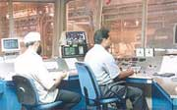 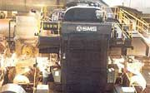  
figure 1.10 6HI PULPIT figure 1.11 Front view of 6HI mill

Quality checks

1. Shape of CR strip

2. Gauge tolerance or conformity

3. Surface finish

4. Surface defects .Full hard CR material from here is routed to Coil Preparation Line for trimming or directly packed and sent to the customer.

* + 1. **Full hard material**

Full hard steel is made without the usual subsequent annealing step. The resulting product has a particularly high stability. Due to the elimination of the grain recrystallization process associated with annealing, the material retains high internal stresses. Its deformability is therefore restricted, i.e., very high forces must be employed in any downstream metal forming process. Classic applications for this material include products such as corrugated roofing sheet and some white goods (furniture items).

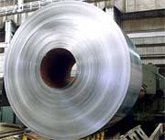  
 figure 1.12 Full hard material

* + 1. **Electrolytic Cleaning**

Process

During the process of cold rolling cooling oil is used to keep the temperature of the roll and the strip within limits. This cooling oil mixed with water in an emulsion has to be removed for further processing. This is achieved in the Electrolytic Cleaning Line. The line uses alkaline dunk and ortho-silicate electrolytic cleaning to remove the emulsion oil coating. The strip is then scrubbed, rinsed, dried and rewound on a reel into coils. These coils are then tilted 90o and taken for annealing.

Quality checks - Plate out on strip to check for the cleaning efficiency.

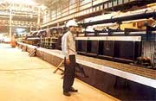 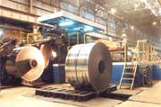  
figure 1.13 Degreasing Line Process Section figure 1.14 Degreasing Line (Exit side)

* + 1. **Annealing**

Process

Annealing is done to relieve the stresses that are built into it during the process of cold rolling which makes the steel strip hard and brittle. Annealing is done using the batch annealing process. Degreased coils are stacked four high on a base. An annealing cover is placed over this stack and pure hydrogen is pumped in. Then the heating hood is placed and programmed to heat the coils to predesigned temperatures. This follows a heating - soaking - cooling cycle with cut off temperatures and times depending on the hardness required by the customer. After the process that takes 32 - 38 hours, the coils are discharged from the base.

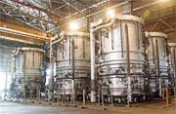

Figure 1.15 Annealing Furnace Area

Quality checks

1. In the base the temperature and cycle of heating, soaking and cooling.

2. Annealed hardness of the coil at the Temper Mill entry.

* + 1. **Temper Mill**

Process

The mill is a four high two-stand tandem mill with a facility to give a further reduction of up to 30%. After the process of annealing the strip becomes soft. To put it to further use the surface has to be given the proper finish and hardness. For this purpose the strip is passed through the temper mill. Normally a skin pass is given (80% of product). This is dry temper rolling; where the hardness and shape is controlled in the first stand and the surface finish in the second stand. In the rest (20%) of cases a post annealing secondary cold reduction of up to 30% is given by controlling the draught in the first stand. This process is known as Double Cold Reduction. This process also uses a cooling emulsion for roll and strip cooling. This imparts higher hardness and strength to the strip enabling thinner sections to be put to use in place of thicker plates

Quality checks

1. Shape of coil with regard to bowness in the strip.

2. Thickness.

3. Surface finish and defects.

4. Temper (hardness) for SR/Proof stress for DR

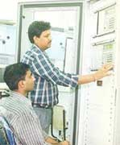 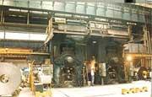   
 figure 1.16 Temper Mill Automation figure 1.17 Temper Mill Full View

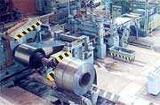 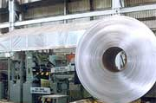  
 figure 1.18 Coil Preparation Line figure 1.19 CPL Exit

* + 1. **Coil Preparation Line (CPL)**

Process

Full hard and / or tempered coil before being tin plated has to be trimmed to the required width as per the customer's order. For this purpose the coil is passed through' the CPL with edge trimming facility. The coil is "paid off" and passed through' the trimmer to cut off both sides to the ordered width of the end product and then rewound. While rewinding the edge guide system through a continuous feedback process ensures that the two sides of the coil winding is without any projected edges. This is done to facilitate handling of the coils. The full hard cold rolled coils are packed and shipped out of this mill to customers.

Quality checks

1. Shape of coil - edge waviness and bow.

2. Edge burr on the strip.

3. Width tolerance (0 to +2 mm)

Electrolytic Tinplating Line

2

1. **Electrolytic Tinplating Line**

The unique properties of tin provide a coating on the steel that protects the contents, while providing the steel with an attractive appearance, corrosion resistance and ease in bonding, welding and painting. Tin is applied to both sides of the black plate coil through an electrolytic process. The thickness of the tin coating (called coating weight) is dependent upon the end-use application. Typical applications for electrolytic tinplate include food and beverage containers, paint trays, battery tops and paint, varnish and aerosol cans.

The Tinplate Company of India Limited pioneered the Indian Industry when they put up the country's first tinning line in 1922. The growth of TCIL has been a continuous process of development and modernization to keep Indian Tinplate at par with international standards.

The technological advances had led to the introduction of Electrolytic Tinplate (ETP), while the spiraling and prohibitive cost of tin resulted in the manufacture of a suitable substitute, namely Tin Free Steel (TFS) or Electrolytic ally Chromium coated steel(ECCS). To keep pace with these developments, TCIL was the first to set up a combination line capable of producing both ETP and TFS. The plant was commissioned in 1978 and has an installed capacity of 179000 tonnes per annum. The line can be run upto a speed of 300 m/min and is capable of processing coils ranging from 0.14 mm to 0.60 mm in thickness and 600 mm to 965 mm in width.

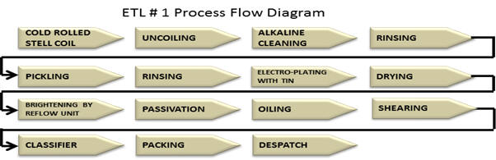  
figure 2.1 Process flow Diagram of Electrolytic Tinplating plants

Process

The Electrolytic Tinplating line is the only one of its kind in India. It has a facility to coat the line with tin or with chromium / chromium oxide (Tin Free Steel). The ETP uses the FEROSTAN process, where in an acidic bath of Stannous Sulphate is the electrolyte. The strip is "paid off" and passed through the looping tower - which stores material to enable the line to run continuously, even while the entry is stopped for welding the tail end of one coil to the head of the next. The strip then passes into the cleaner solution to remove any remnant traces of oil or emulsion. Then it goes through the pickling bath where the Sulphuric acid removes any oxide that may have formed in the CRM complex. This acid also etches the plate, to prepare it for the electro-deposition of tin. After the surface is fully prepared for plating it passes into the plating section. Here the strip enters the bath with pure tin being used as anode and the strip itself as the cathode. By passing the required direct current - this is dependent on the coating weight required by the customer - in the bath the plate is coated. Thereafter it passes into the melting furnace where the deposited tin is melted to give it a brighter finish and also make it adhere to the base material better. After this the strip is chemically treated to reduce the action of atmosphere on tin and then coated with oil to facilitate handling.

In case the order is for tin free steel, the strip is passed directly from the pickling bath to the chrome plating section. Here by using chromic acid bath and inert anodes a layer each of chromium and chromium oxide is deposited on the strip. Since this coated steel does not have any tin plating on its surface it is called tin free steel.

The strip is then passed through the online inspection to segregate any sheet that falls outside the acceptable range of thickness, sheets with pinholes in them and then cut up as per order and piled into packets of about 1500 KGs. This is then shipped out to customers in trucks or containers, the latter mainly for overseas customers.

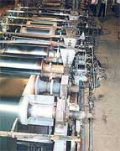figure 2.2 Electro Tinplating (Process) Section ETP/TFS Line

Quality checks

1. Cut length and width of sheet

2. Surface finish and defects (Tin in Tinplate sheets and Cr in TFS)

3. Temper and other physical properties of the sheet

* 1. Tin-free Steel/Electrolytic Chrome Coated Steel

Unlike the multiplicity of coating weights with tin, only one standardized chromium-coated product is manufactured. The chromium coating process was developed in the 1960s as an alternative to tin coatings for packaging products cost-effectively, with desirable material properties. Chromium offers excellent lacquer adhesion, storage properties and strong resistance to food corrosion with proper applications of lacquer. Chromium-coated steels are most frequently used for can tops, screw and lug caps, snap and press-on closures and shallow-drawn food cans. Packaging steels are coated with different protective and decorative coatings, depending on their intended use.

* 1. **SOLUTION CENTRE**

To enhance the value proposition of its product offerings to the customers along the industry value chain, and provide further impetus to its business purpose of being a cost-effective metal packaging solution provider, TCIL has set up Solution Centre at Jamshedpur. Presently, Solution Centre is equipped with state of the art Printing and Lacquering lines and offers printed and lacquered tinplate sheets as per the customer’s end requirements.

The objective of Printing & Lacquering line is to strengthen the value

chain and showcase the latest design and colour combinations to

Improve aesthetics and shelf appeal.

**PROCESS FLOWCHART**

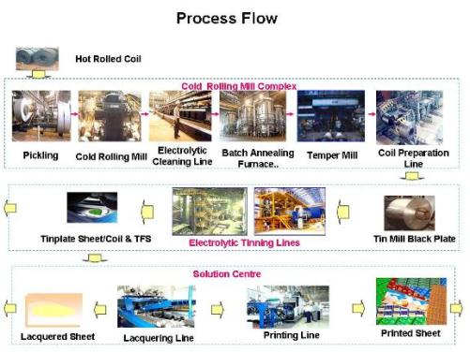

Figure 2.3 Process Flow TCIL

Communication System

3

1. **Communication System**

In [telecommunication](https://en.wikipedia.org/wiki/Telecommunication), a **communications system** is a collection of individual [communications](https://en.wikipedia.org/wiki/Information_transfer) networks, [transmission](https://en.wikipedia.org/wiki/Transmission_(telecommunications)) systems, [relay](https://en.wikipedia.org/wiki/Relay)stations, tributary stations, and [data](https://en.wikipedia.org/wiki/Data) [terminal equipment](https://en.wikipedia.org/wiki/Terminal_equipment) ([DTE](https://en.wikipedia.org/wiki/Data_terminal_equipment)) usually capable of [interconnection](https://en.wikipedia.org/wiki/Interconnection) and [interoperation](https://en.wikipedia.org/wiki/Interoperation) to form an integrated whole. The components of a communications [system](https://en.wikipedia.org/wiki/System) serve a common purpose, are technically compatible, use common procedures, respond to controls, and operate in union.

### **Types**

### **By media**

An [optical communication](https://en.wikipedia.org/wiki/Optical_communication) system is any form of telecommunication that uses [light](https://en.wikipedia.org/wiki/Light) as the transmission medium. Equipment consists of a transmitter, which encodes a *message* into an optical [*signal*](https://en.wikipedia.org/wiki/Signal), a [*communication channel*](https://en.wikipedia.org/wiki/Communication_channel), which carries the signal to its destination, and a receiver, which reproduces the message from the received optical signal. [Fibre-optic communication](https://en.wikipedia.org/wiki/Fiber-optic_communication) systems transmit information from one place to another by sending [light](https://en.wikipedia.org/wiki/Light) through an [optical fibre](https://en.wikipedia.org/wiki/Optical_fiber). The light forms a [carrier signal](https://en.wikipedia.org/wiki/Carrier_signal) that is [modulated](https://en.wikipedia.org/wiki/Modulation) to carry information.

A [radio communication system](https://en.wikipedia.org/wiki/Radio_communication_system) is composed of several communications subsystems that give exterior communications capabilities. A radio communication system comprises a transmitting conductor in which electrical oscillations or currents are produced and which is arranged to cause such currents or oscillations to be propagated through the [free space](https://en.wikipedia.org/wiki/Free_space) medium from one point to another remote therefrom and a receiving conductor at such distant point adapted to be excited by the oscillations or currents propagated from the transmitter.

[Power line communication](https://en.wikipedia.org/wiki/Power_line_communication) systems operate by impressing a modulated carrier signal on power wires. Different types of powerline communications use different frequency bands, depending on the signal transmission characteristics of the power wiring used. Since the power wiring system was originally intended for transmission of AC power, the power wire circuits have only a limited ability to carry higher frequencies. The propagation problem is a limiting factor for each type of power line communications.

### **By Technology**

A [duplex communication system](https://en.wikipedia.org/wiki/Duplex_(telecommunications)) is a system composed of two connected parties or devices which can communicate with one another in both directions. Duplex systems are employed in nearly all communications networks, either to allow for a communication "two-way street" between two connected parties or to provide a "reverse path" for the monitoring and remote adjustment of equipment in the field. An [Antenna](https://en.wikipedia.org/wiki/Antenna_(radio)) is basically a small length of a qwert conductor that is used to radiate or receive electromagnetic waves. At the transmitting end it converts high frequency current into electromagnetic waves. At the receiving end it transforms electromagnetic waves into electrical signals that is fed into the input of the receiver. Several types of antenna are used in communication.

### **By Application area**

A [tactical communications system](https://en.wikipedia.org/wiki/Tactical_communications_system) is a communications system that (a) is used within, or in direct support of [tactical forces](https://en.wikipedia.org/wiki/Military_tactics) (b) is designed to meet the requirements of changing tactical situations and varying environmental conditions, (c) provides securable communications, such as voice, [data](https://en.wikipedia.org/wiki/Data), and [video](https://en.wikipedia.org/wiki/Video), among mobile users to facilitate [command and control](https://en.wikipedia.org/wiki/Command_and_Control_(Military)) within, and in support of, tactical forces, and (d) usually requires extremely short installation times, usually on the order of hours, in order to meet the requirements of frequent relocation.

An [Emergency communication system](https://en.wikipedia.org/wiki/Emergency_communication_system) is any system (typically computer based) that is organized for the primary purpose of supporting the two way communication of emergency messages between both individuals and groups of individuals. These systems are commonly designed to integrate the cross-communication of messages between are variety of communication technologies.

An [Automatic call distributor](https://en.wikipedia.org/wiki/Automatic_call_distributor) (ACD) is a communication system that automatically queues, assigns and connects callers to handlers. This is used often in customer service (such as for product or service complaints), ordering by telephone (such as in a ticket office), or coordination services (such as in air traffic control).

A [Voice Communication Control System](https://en.wikipedia.org/w/index.php?title=Voice_Communication_Control_System&action=edit&redlink=1) (VCCS) is essentially an ACD with characteristics that make it more adapted to use in critical situations (no waiting for dial tone, or lengthy recorded announcements, radio and telephone lines equally easily connected to, individual lines immediately accessible etc..)

### **Key components of Communication**

### Sources - classified as **electric** or **non-electric**; they are the origins of a message or input signal

### Input Transducers (Sensors) - Sensors, like microphones and cameras, capture non-electric sources, like sound and light (respectively), and convert them into electrical signals.

### Transmitter - Once the source signal has been converted into an electric signal, the transmitter will modify this signal for efficient transmission

### Communication Channel - the medium by which a signal travels. There are two types of media by which electrical signals travel, i.e. **guided** and **unguided**. Guided media refers to any medium that can be directed from transmitter to receiver by means of connecting cables. In optical fibre communication, the medium is an optical (glass-like) fibre. The other type of media, unguided media, refers to any communication channel that creates space between the transmitter and receiver. For radio or RF communication, the medium is air.

### Receiver - Once the signal has passed through the communication channel, it must be effectively captured by a receiver. The goal of the receiver is to capture and reconstruct the signal before it passed through the transmitter (i.e. the A/D converter, modulator and encoder). This is done by passing the "received" signal through a receiver circuit. Most likely the signal will have lost some of its energy after having passed through the communication channel or medium. The signal can be boosted by passing it through a signal amplifier. When the analog signal converted into digital signal.

### Output Transducer - The output transducer simply converts the electric signal (created by the input transducer) back into its original form.

Optical Fibre

4

1. **Optical Fibre**

An **optical fibre cable**, also known as a **fibre optic cable**, is an assembly similar to an [electrical cable](https://en.wikipedia.org/wiki/Electrical_cable), but containing one or more [optical fibres](https://en.wikipedia.org/wiki/Optical_fiber) that are used to carry light. The optical fibre elements are typically individually coated with plastic layers and contained in a protective tube suitable for the environment where the cable will be deployed. Different types of cable are used for different applications, for example long distance [telecommunication](https://en.wikipedia.org/wiki/Telecommunication), or providing a high-speed data connection between different parts of a building.

* 1. **Design**

Optical fibre consists of a [core](https://en.wikipedia.org/wiki/Core_(optical_fiber)) and a [cladding](https://en.wikipedia.org/wiki/Cladding_(fiber_optics)) layer, selected for [total internal reflection](https://en.wikipedia.org/wiki/Total_internal_reflection) due to the difference in the [refractive index](https://en.wikipedia.org/wiki/Refractive_index) between the two. In practical fibres, the cladding is usually coated with a layer of [acrylate polymer](https://en.wikipedia.org/wiki/Acrylate_polymer) or [polyimide](https://en.wikipedia.org/wiki/Polyimide). This coating protects the fibre from damage but does not contribute to its [optical wave guide](https://en.wikipedia.org/wiki/Optical_waveguide) properties. Individual coated fibres (or fibres formed into ribbons or bundles) then have a tough [resin](https://en.wikipedia.org/wiki/Resin) [buffer](https://en.wikipedia.org/wiki/Buffer_(optical_fiber)) layer or core tube(s) extruded around them to form the cable core. Several layers of protective sheathing, depending on the application, are added to form the cable. Rigid fibre assemblies sometimes put light-absorbing ("dark") glass between the fibres, to prevent light that leaks out of one fibre from entering another. This reduces [cross-talk](https://en.wikipedia.org/wiki/Cross-talk) between the fibres, or reduces [flare](https://en.wikipedia.org/wiki/Lens_flare) in fibre bundle imaging applications.

[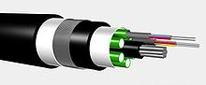](https://en.wikipedia.org/wiki/File:Optical_fiber_cable.jpg) [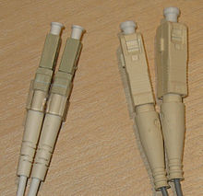](https://en.wikipedia.org/wiki/File:Lc-sc-fiber-connectors.jpg)  
 figure 4.1 Multifibre cable figure 4.2 PC connectors

For indoor applications, the jacketed fibre is generally enclosed, with a bundle of flexible fibrous [polymer](https://en.wikipedia.org/wiki/Polymer) *strength members* like [aramid](https://en.wikipedia.org/wiki/Aramid) (e.g. [Twaron](https://en.wikipedia.org/wiki/Twaron) or [Kevlar](https://en.wikipedia.org/wiki/Kevlar)), in a lightweight plastic cover to form a simple cable. Each end of the cable may be [terminated](https://en.wikipedia.org/wiki/Fiber_cable_termination) with a specialized [optical fibre connector](https://en.wikipedia.org/wiki/Optical_fiber_connector) to allow it to be easily connected and disconnected from transmitting and receiving equipment.

For use in more strenuous environments, a much more robust cable construction is required. In *loose-tube construction* the fibre is laid [helically](https://en.wikipedia.org/wiki/Helix) into semi-rigid tubes, allowing the cable to stretch without stretching the fibre itself. This protects the fibre from tension during laying. Loose-tube fibre may be "dry block" or gel-filled. Dry block offers less protection to the fibres than gel-filled, but costs considerably less. Instead of a loose tube, the fibre may be embedded in a heavy polymer jacket, commonly called "tight buffer" construction. Tight buffer cables are offered for a variety of applications, but the two most common are "[Breakout](https://en.wikipedia.org/wiki/Breakout_cable)" and "[Distribution](https://en.wikipedia.org/w/index.php?title=Distribution_cable&action=edit&redlink=1)". Breakout cables normally contain a ripcord, two non-conductive dielectric strengthening members (normally a glass rod epoxy), an aramid yarn, and 3 mm buffer tubing with an additional layer of Kevlar surrounding each fibre. The ripcord is a parallel cord of strong yarn that is situated under the jacket(s) of the cable for jacket removal. Distribution cables have an overall Kevlar wrapping, a ripcord, and a 900 micrometre buffer coating surrounding each fibre. These *fibre units* are commonly bundled with additional steel strength members, again with a helical twist to allow for stretching.

A critical concern in outdoor cabling is to protect the fibre from contamination by water. This is accomplished by use of solid barriers such as copper tubes, and water-repellent jelly or water-absorbing powder surrounding the fibre.

Finally, the cable may be armoured to protect it from environmental hazards, such as construction work or gnawing animals. Undersea cables are more heavily armoured in their near-shore portions to protect them from boat anchors, fishing gear, and even [sharks](https://en.wikipedia.org/wiki/Shark), which may be attracted to the electrical power that is carried to power amplifiers or repeaters in the cable.

Modern cables come in a wide variety of sheathings and armour, designed for applications such as direct burial in trenches, dual use as power lines, installation in conduit, lashing to aerial telephone poles, [submarine installation](https://en.wikipedia.org/wiki/Submarine_communications_cable), and insertion in paved streets.

* 1. **Reliability and quality**

Optical fibres are very strong, but the strength is drastically reduced by unavoidable microscopic surface flaws inherent in the manufacturing process. The initial fibre strength, as well as its change with time, must be considered relative to the stress imposed on the fibre during handling, cabling, and installation for a given set of environmental conditions. There are three basic scenarios that can lead to strength degradation and failure by inducing flaw growth: dynamic fatigue, static fatigues, and zero-stress aging.

Telcordia GR-20, *Generic Requirements for Optical Fibre and Optical Fibre Cable*, contains reliability and quality criteria to protect optical fibre in all operating conditions. The criteria is for outside plant (OSP) environment. For the indoor plant, GR-409, *Generic Requirements for Indoor Fibre Optic Cable*.

* 1. **Hybrid Cables**

There are hybrid optical and electrical cables that are used in wireless outdoor Fibre To The Antenna (FTTA) applications. In these cables, the optical fibres carry information, and the electrical conductors are used to transmit power. These cables can be placed in several environments to serve antennas mounted on poles, towers, and other structures.

According to [Telcordia](https://en.wikipedia.org/wiki/Telcordia) [GR-3173,](http://telecom-info.telcordia.com/site-cgi/ido/docs.cgi?ID=SEARCH&DOCUMENT=GR-3173&) *Generic Requirements for Hybrid Optical and Electrical Cables for Use in Wireless Outdoor Fibre To The Antenna (FTTA) Applications,* the hybrid cables have optical fibres, twisted pair/quad elements, coaxial cables or current-carrying electrical conductors under a common outer jacket. The power conductors used in these hybrid cables are for directly powering an antenna or for powering tower-mounted electronics exclusively serving an antenna. They have a nominal voltage normally less than 60 V DC or 108/120 V AC.

Hybrid cables are also useful in other environments such as Distributed Antenna System (DAS) plants where they will serve antennas in indoor, outdoor, and roof-top locations. Considerations such as fire resistance, Nationally Recognized Testing Laboratory (NRTL) Listings, placement in vertical shafts, and other performance-related issues need to be fully addressed for these environments.

**Process automation protocols**

* [AS-i](https://en.wikipedia.org/wiki/AS-Interface) – Actuator-sensor interface, a low level 2-wire bus establishing power and communications to basic digital and analog devices
* [BSAP](https://en.wikipedia.org/wiki/Bristol_Standard_Asynchronous_Protocol) – Bristol Standard Asynchronous Protocol, developed by Bristol Babcock Inc.
* [CC-Link Industrial Networks](https://en.wikipedia.org/wiki/CC-Link_Industrial_Networks) – Supported by the CLPA
* [CIP](https://en.wikipedia.org/wiki/Common_Industrial_Protocol) (Common Industrial Protocol) – can be treated as application layer common to [DeviceNet](https://en.wikipedia.org/wiki/DeviceNet), [CompoNet](https://en.wikipedia.org/w/index.php?title=CompoNet&action=edit&redlink=1), [ControlNet](https://en.wikipedia.org/wiki/ControlNet) and [EtherNet/IP](https://en.wikipedia.org/wiki/EtherNet/IP)
* [ControlNet](https://en.wikipedia.org/wiki/ControlNet) – an implementation of [CIP](https://en.wikipedia.org/wiki/Common_Industrial_Protocol), originally by [Allen-Bradley](https://en.wikipedia.org/wiki/Allen-Bradley)
* [DC-BUS](https://en.wikipedia.org/wiki/DC-BUS) – communication over DC power lines, originally by [Yamar Electronics Ltd](https://en.wikipedia.org/wiki/Yamar_Electronics_Ltd)
* [DeviceNet](https://en.wikipedia.org/wiki/DeviceNet) – an implementation of [CIP](https://en.wikipedia.org/wiki/Common_Industrial_Protocol), originally by [Allen-Bradley](https://en.wikipedia.org/wiki/Allen-Bradley)
* [DF-1](https://en.wikipedia.org/wiki/DF-1_Protocol) - used by [Allen-Bradley](https://en.wikipedia.org/wiki/Allen-Bradley) ControlLogix, CompactLogix, PLC-5, SLC-500, and MicroLogix class devices
* [EtherCAT](https://en.wikipedia.org/wiki/EtherCAT)
* [Ethernet Global Data (EGD)](https://en.wikipedia.org/wiki/Ethernet_Global_Data_Protocol) – [GE Fanuc](https://en.wikipedia.org/wiki/GE_Fanuc_Automation_North_America,_Inc.) [PLCs](https://en.wikipedia.org/wiki/Programmable_logic_controller) (see also [SRTP](https://en.wikipedia.org/wiki/Service_Request_Transport_Protocol))
* [EtherNet/IP](https://en.wikipedia.org/wiki/EtherNet/IP) – IP stands for "Industrial Protocol". An implementation of [CIP](https://en.wikipedia.org/wiki/Common_Industrial_Protocol), originally created by [Rockwell Automation](https://en.wikipedia.org/wiki/Rockwell_Automation)
* [FOUNDATION fieldbus](https://en.wikipedia.org/wiki/FOUNDATION_fieldbus) – [H1](https://en.wikipedia.org/wiki/Foundation_Fieldbus_H1) & HSE
* [HART Protocol](https://en.wikipedia.org/wiki/HART_Protocol)
* [HostLink Protocol](https://en.wikipedia.org/wiki/HostLink_Protocol), [Omron](https://en.wikipedia.org/wiki/Omron)'s protocol for communication over serial links.
* [Interbus](https://en.wikipedia.org/wiki/Interbus), Phoenix Contact's protocol for communication over serial links, now part of PROFINET IO
* IO-Link, for sensors, actuators and such[[1]](https://en.wikipedia.org/wiki/List_of_automation_protocols#cite_note-1)
* [Modbus](https://en.wikipedia.org/wiki/Modbus) RTU or ASCII or TCP
* [OpenADR](https://en.wikipedia.org/wiki/OpenADR) – Open Automated Demand Response; protocol to manage electricity consuming/controlling devices
* [Profibus](https://en.wikipedia.org/wiki/Profibus) – by PROFIBUS International.
* [PROFINET IO](https://en.wikipedia.org/wiki/PROFINET_IO)
* [RAPIEnet](https://en.wikipedia.org/wiki/RAPIEnet) – Real-time Automation Protocols for Industrial Ethernet
* [Honeywell SDS](https://en.wikipedia.org/wiki/SDS_Protocol) – Smart Distributed System – Originally developed by [Honeywell](https://en.wikipedia.org/wiki/Honeywell). Currently supported by Holjeron.
* [SERCOS III](https://en.wikipedia.org/wiki/SERCOS_III), Ethernet-based version of SERCOS real-time interface standard
* [SERCOS interface](https://en.wikipedia.org/wiki/SERCOS_interface), Open Protocol for [hard real-time](https://en.wikipedia.org/wiki/Hard_real-time) control of motion and I/O
* [Sinec H1](https://en.wikipedia.org/wiki/Sinec_H1) – [Siemens](https://en.wikipedia.org/wiki/Siemens_AG)
* [TTEthernet](https://en.wikipedia.org/wiki/TTEthernet) – [TTTech](https://en.wikipedia.org/wiki/TTTech)
* [MPI](https://en.wikipedia.org/wiki/Multi-Point_Interface) – [Multi Point Interface](https://en.wikipedia.org/wiki/Multi_Point_Interface)

PROFIBUS

5

1. **PROFIBUS**

Profibus (Process Field Bus) is a standard for [fieldbus](https://en.wikipedia.org/wiki/Fieldbus) communication in [automation](https://en.wikipedia.org/wiki/Automation) technology and was first promoted in 1989 by [BMBF](https://en.wikipedia.org/wiki/BMBF) (German department of education and research) and then used by [Siemens](https://en.wikipedia.org/wiki/Siemens). It should not be confused with the [PROFINET](https://en.wikipedia.org/wiki/PROFINET) standard for [Industrial Ethernet](https://en.wikipedia.org/wiki/Industrial_Ethernet). PROFIBUS is openly published as part of IEC 61158.

|  |  |
| --- | --- |
| **PROFIBUS** | |
| **Protocol Information** | |
| **Type of Network** | Device Bus, [Process Control](https://en.wikipedia.org/wiki/Process_Control) |
| **Physical Media** | [Twisted pair](https://en.wikipedia.org/wiki/Twisted_pair), fibre |
| **Network Topology** | Bus |
| **Device Addressing** | [DIP switch](https://en.wikipedia.org/wiki/DIP_switch) or hardware/software |
| **Governing Body** | PROFIBUS&PROFINET International (PI) |
| **Website** | [www.profibus.com](http://www.profibus.com/) |

[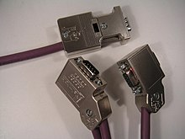](https://en.wikipedia.org/wiki/File:0x-pb-stecker-verschieden.jpg)  
 figure 5.1 Profibus Electrical connector

* 1. **Origin**

The history of PROFIBUS goes back to a publicly promoted plan for an association which started in Germany in 1986 and for which 21 companies and institutes devised a master project plan called "[fieldbus](https://en.wikipedia.org/wiki/Fieldbus)". The goal was to implement and spread the use of a [bit-serial](https://en.wikipedia.org/wiki/Bit-serial) field bus based on the basic requirements of the field device interfaces. For this purpose, member companies agreed to support a common technical concept for production (i.e. discrete or factory [automation](https://en.wikipedia.org/wiki/Automation)) and [process automation](https://en.wikipedia.org/wiki/Process_automation). First, the complex communication protocol Profibus FMS (Field bus Message Specification), which was tailored for demanding communication tasks, was specified. Subsequently, in 1993, the specification for the simpler and thus considerably faster protocol PROFIBUS DP (Decentralised Peripherals) was completed. Profibus FMS is used for (non-deterministic) communication of data between Profibus Masters. Profibus DP is a protocol made for (deterministic) communication between Profibus masters and their remote I/O slaves.

There are two variations of PROFIBUS in use today: the most commonly used PROFIBUS DP, and the lesser used, application specific, PROFIBUS PA:

* **PROFIBUS DP** (Decentralised Peripherals) is used to operate sensors and actuators via a centralized controller in production (factory) automation applications. The many standard diagnostic options, in particular, are focused on here.
* **PROFIBUS PA** (Process Automation) is used to monitor measuring equipment via a process control system in process automation applications. This variant is designed for use in explosion/hazardous areas. The Physical Layer conforms to IEC 61158-2, which allows power to be delivered over the bus to field instruments, while limiting current flows so that explosive conditions are not created, even if a malfunction occurs. The number of devices attached to a PA segment is limited by this feature. PA has a data transmission rate of 31.25 kbit/s. However, PA uses the same protocol as DP, and can be linked to a DP network using a coupler device. The much faster DP acts as a backbone network for transmitting process signals to the controller. This means that DP and PA can work tightly together, especially in hybrid applications where process and factory automation networks operate side by side.
  1. **Technology**

PROFIBUS is an open serial communication standard that enables data exchange between all kinds of automation components. Profibus uses the OSI model for data transmission. There are three main variations of PROFIBUS: PROFIBUS-FMS (Fieldbus Message Specification), PROFIBUS-DP (Decentralised Periphery) and PROFIBUS-PA (Process Automation). The physical transmission medium of the bus is a twisted pair cable. The maximum length of the bus cable is 100 to 1200 meters, depending on the selected transmission rate. Up to 31 stations can be connected to the same PROFIBUS system without the use of repeaters. With repeaters, it is possible to connect 127 stations. In PROFIBUS communication, the master station – usually a programmable logic controller (PLC) – polls the slaves which respond and take the actions requested by the master. It is also possible to send a command to several slaves at the same time; in this case the slaves send no response message to the master. Communication between the slaves is not possible on a PROFIBUS link. The PROFIBUS protocol family is specified in the EN 50170 Standard. The communication with a drive is discussed in PROFIDRIVEPROFILE – The PROFIBUS Profile for Adjustable Speed Drives.

|  |  |  |  |  |
| --- | --- | --- | --- | --- |
| OSI-Layer | | PROFIBUS | | |
| 7 | Application | DPV0 | DPV1 | DPV2 | Management |
| 6 | Presentation | -- | | |
| 5 | Session |
| 4 | Transport |
| 3 | Network |
| 2 | Data Link | FDL | | |
| 1 | Physical | [EIA-485](https://en.wikipedia.org/wiki/EIA-485) | Optical | MBP |

Figure 5.2 Profibus Protocol

### Application layer

### To use these functions, various service levels of the DP protocol were defined:

* DP-V0 for cyclic exchange of data and diagnosis
* DP-V1 for acyclic data exchange and alarm handling
* DP-V2 for [isochronous](https://en.wikipedia.org/wiki/Isochronous) mode and data exchange broadcast

### Security layer

Security layer **FDL** (Field bus Data Link) works with a hybrid access method that combines [token passing](https://en.wikipedia.org/wiki/Token_passing) with a master-slave method. In PROFIBUS DP network, the controllers or process control systems are masters and the sensors and actuators are slaves.

Each byte is secured with an even parity and transferred asynchronously with a start and stop bit. There may not be a pause between a stop bit and the following start bit when the bytes of a telegram are transmitted. The master signals the start of a new telegram with a SYN pause of at least 33 bits (logical "1" = bus idle).

### Bit-transmission layer

Three different methods are specified for the bit-transmission layer:

* With electrical transmission pursuant to [EIA-485](https://en.wikipedia.org/wiki/EIA-485), [twisted pair](https://en.wikipedia.org/wiki/Twisted_pair) cables with [impedances](https://en.wikipedia.org/wiki/Characteristic_impedance) of 150 [ohms](https://en.wikipedia.org/wiki/Ohm) are used in a [bus topology](https://en.wikipedia.org/wiki/Bus_topology). [Bit rates](https://en.wikipedia.org/wiki/Bit_rate) from 9.6 kbit/s to 12 Mbit/s can be used. The cable length between two [repeaters](https://en.wikipedia.org/wiki/Repeater) is limited from 100 to 1200 m, depending on the bit rate used. This transmission method is primarily used with PROFIBUS DP.
* With optical transmission via [fibre optics](https://en.wikipedia.org/wiki/Fiber_optics), [star-](https://en.wikipedia.org/wiki/Star_topology), [bus-](https://en.wikipedia.org/wiki/Bus_topology) and [ring-topologies](https://en.wikipedia.org/wiki/Ring_topology) are used. The distance between the repeaters can be up to 15 km. The ring topology can also be executed redundantly.
* With MBP (Manchester Bus Powered) transmission technology, data and field bus power are fed through the same cable. The power can be reduced in such a way that use in explosion-hazardous environments is possible. The bus topology can be up to 1900 m long and permits branching to field devices (max. 60 m branches). The bit rate here is a fixed 31.25 kbit/s. This technology was specially established for use in process automation for PROFIBUS PA.

For data transfer via sliding contacts for mobile devices or optical or radio data transmission in open spaces, products from various manufacturers can be obtained, however they do not conform to any standard.

**PROFIBUS DP** uses two core screened cable with a violet sheath, and runs at speeds between 9.6 kbit/s and 12 Mbit/s. A particular speed can be chosen for a network to give enough time for communication with all the devices present in the network. If systems change slowly then lower communication speed is suitable, and if the systems change quickly then effective communication will happen through faster speed. The RS485 balanced transmission used in PROFIBUS DP only allows 126 devices to be connected at once; however, more devices can be connected or the network expanded with the use of hubs or repeaters.

**PROFIBUS PA** is slower than PROFIBUS DP and runs at fixed speed of 31.2 kbit/s via blue sheathed two core screened cable. The communication may be initiated to minimise the risk of explosion or for the systems that intrinsically need safe equipment. The message formats in PROFIBUS PA are identical to PROFIBUS DP.

* + 1. Profiles

Profiles are pre-defined configurations of the functions and features available from PROFIBUS for use in specific devices or applications. They are specified by PI working groups and published by PI. Profiles are important for openness, interoperability and interchangeability, so that the end user can be sure that similar equipments from different vendors perform in a standardised way. User choice also encourages competition that drives vendors towards enhanced performance and lower costs.

There are PROFIBUS profiles for Encoders, Laboratory instruments, [Intelligent pumps](https://en.wikipedia.org/wiki/Intelligent_pump), Robots and Numerically Controlled machines, for example. Profiles also exist for applications such as using HART and wireless with PROFIBUS, and process automation devices via PROFIBUS PA. Other profiles have been specified for Motion Control (PROFIdrive) and Functional Safety ([PROFIsafe](https://en.wikipedia.org/wiki/PROFIsafe)).

* 1. **PROFIBUS Adapter Module NPBA-12**

The NPBA-12 PROFIBUS Adapter Module supports the PROFIBUS-DP and PROFIBUS-DPV1 protocols.

The NPBA-12 PROFIBUS Adapter Module is an device for ABB drives which enables the connection of the drive to a PROFIBUS system. The drive is considered as a slave in the PROFIBUS network. Through the NPBA-12 PROFIBUS Adapter Module it is possible to: • Give control commands to the drive (Start, Stop, Run enable, etc.) • Feed a motor speed or torque reference to the drive • Give a process actual value or a process reference to the PID controller of the drive • Read status information and actual values from the drive • Change drive parameter values • Reset a drive fault. The PROFIBUS commands and services are supported by the NPBA-12 PROFIBUS Adapter Module.

PROFIBUS-DP the NPBA-12 module supports the PROFIBUS-DP protocol, including the DPV1 Extensions to the EN 50170 standard. PROFIBUS-DP is a distributed I/O system which enables the master to use a large number of peripheral modules and field devices. The data transfer is mainly cyclic: the master reads the input information from the slaves and sends the output information back to the slaves. The PROFIBUS-DP protocol uses so-called PPOs (Parameter/Process Data Objects) in cyclic communication. See Figure 6-1 for the different PPO types and their composition. Service Access Points The services of the PROFIBUS Data Link Layer (Layer 2) are used by PROFIBUS-DP through Service Access Points (SAPs). Precisely defined functions are assigned to individual SAPs. For further information on Service Access Points, refer to the manual of the PROFIBUS master, PROFIDRIVE – The PROFIBUS Profile for Adjustable Speed Drives, or the EN 50170 standard.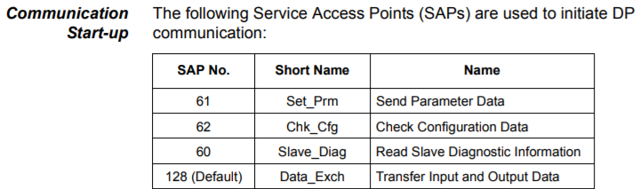 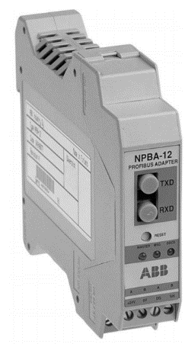  
figure 5.3 Profibus DP communication start-up figure 5.4 NPBA-12

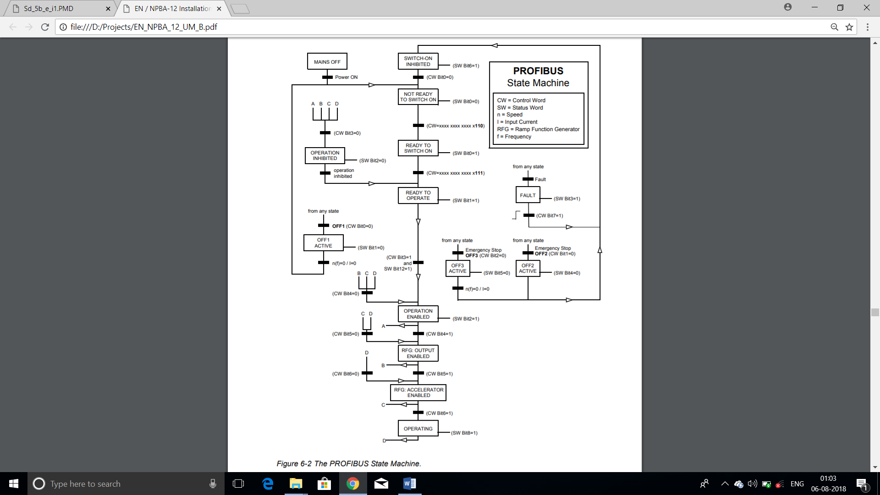  
figure 5.5 PROFIBUS state machine

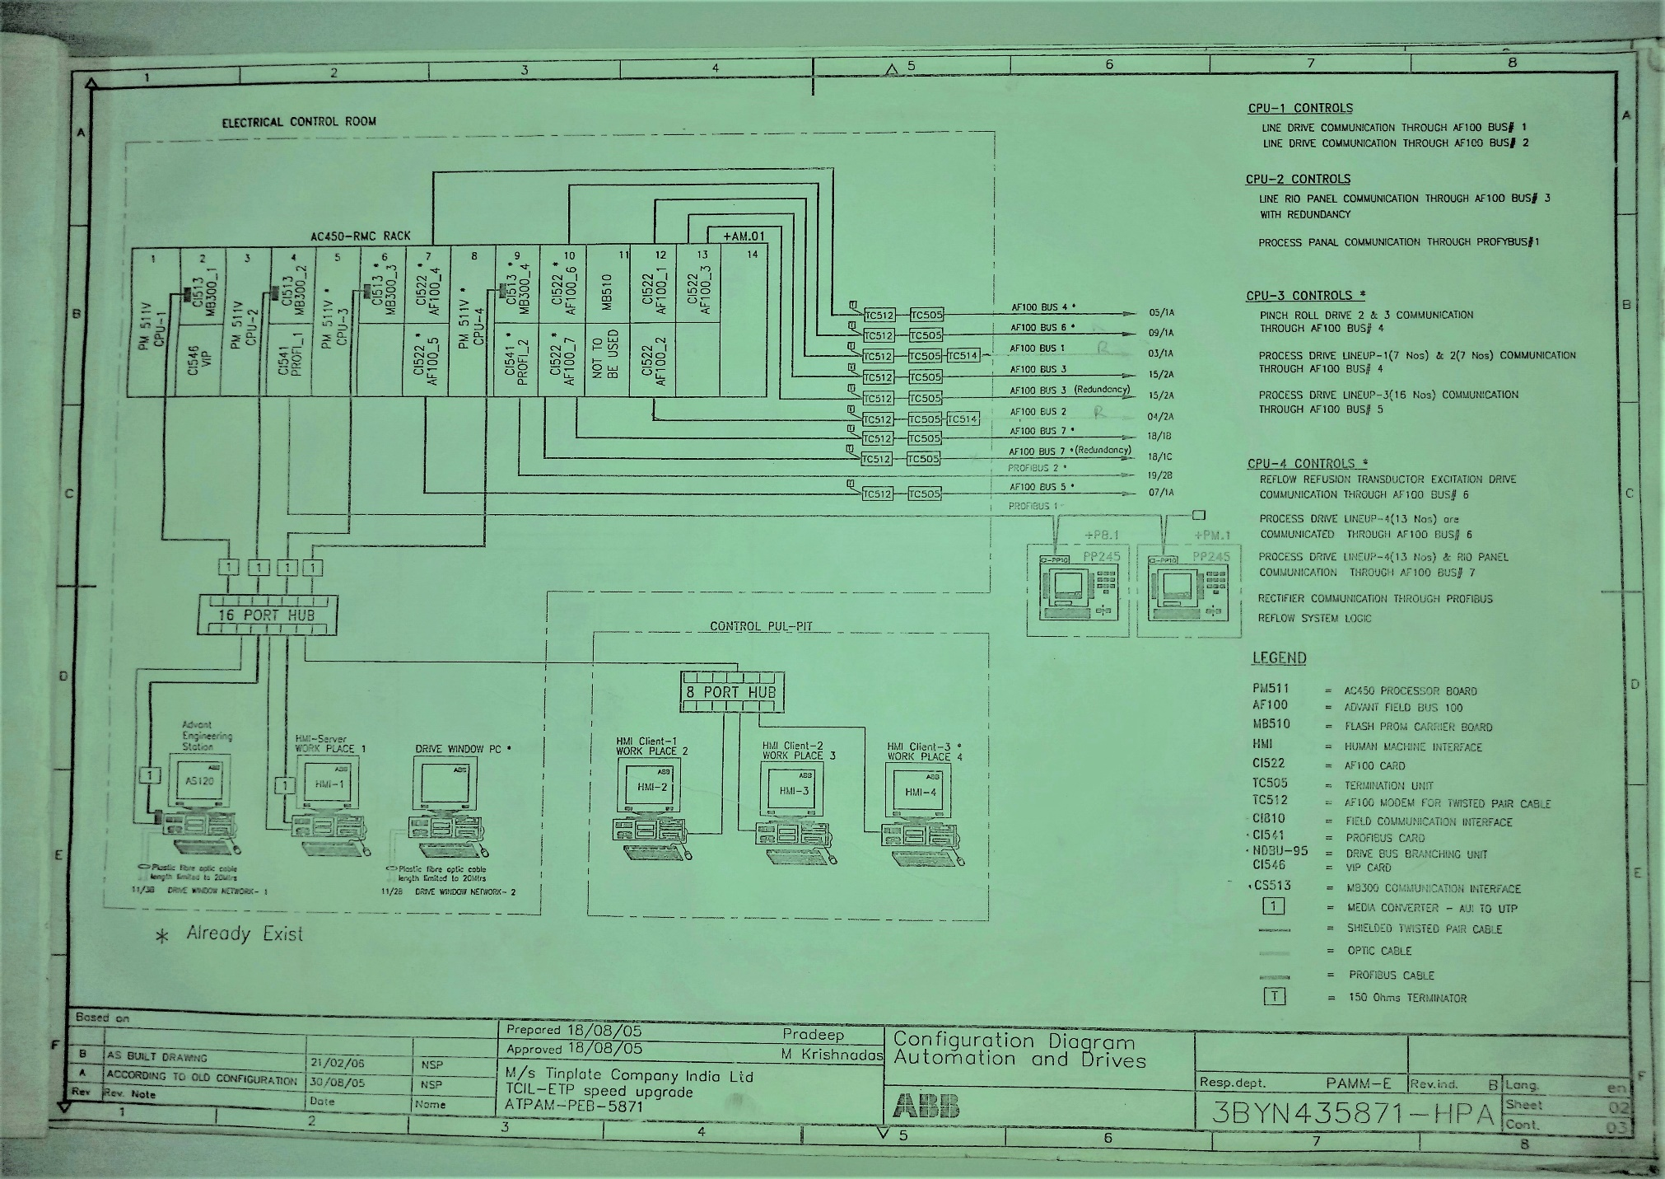

Figure 6 Communication Network in TCIL

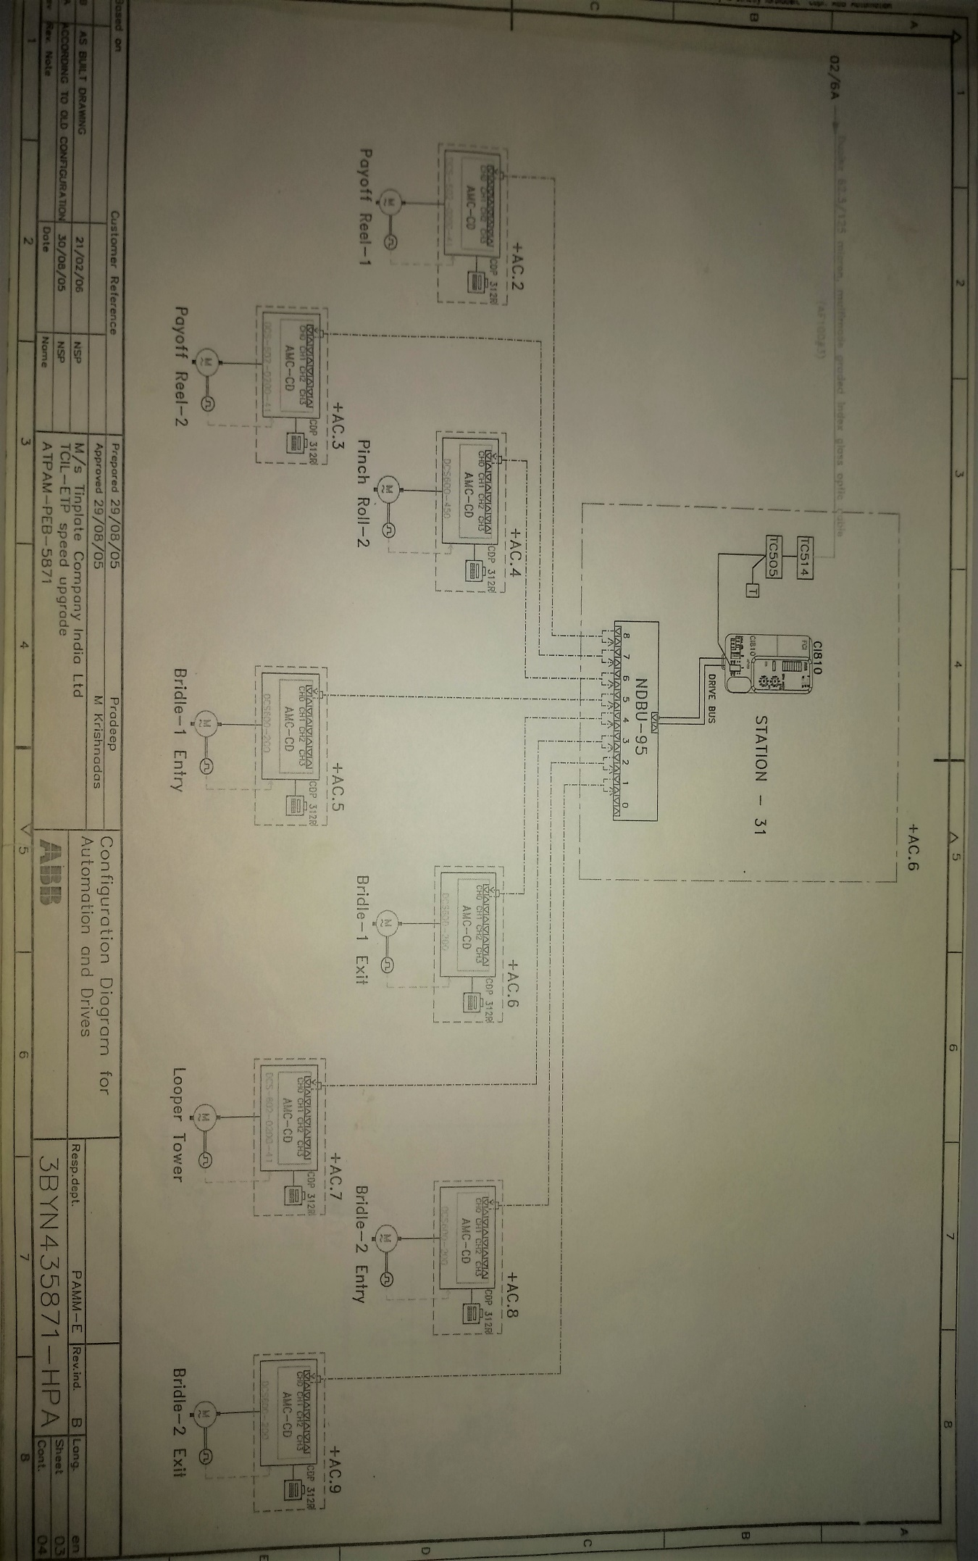

Figure 7 Connection from Station31

**CONCLUSION**

At the end of this project, I would like to conclude that my internship in this company (TCIL) was a successful one.

I came through many exciting and informative stuffs, ex. As generation of problems and troubleshooting them.

Man and machine interfacing is extremely important in any type of industry. There is no scope for any mistake in any industry as it can cost your life.

My trainer Mr. Awadhesh Kumar demonstrated me many things which were totally afresh to me.

I also came to know that working in college laboratories is totally different from the industry environment. In colleges teachers are ready to help at every step and continuously keep an eye over the progress of the experiment, but that’s not in the case of an industry. We have to work on our own and continuously check our work without making any mistakes.

At this point I would like to thanks all those who have helped me in gaining invaluable knowledge that will be very helpful to me.

**REFERENCE**

* [www.tatatinplate.com](http://WWW.TATATINPLATE.COM)
* [www.wikipedia.com](http://WWW.WIKIPEDIA.COM)
* <www.abb.com>
* [www.quora.com](http://WWW.QUORA.COM)