NemAcquire Software User Guide

Revision date: May 8, 2017

Computer Requirements

1. Windows 10 64-bit OS or Mac OS X 10.11
2. USB 2.0 port

Installation

1. Download the NemAcquire software installation file to your computer. You can find this at the following website: <http://www.nemametrix.com/downloads/> For Windows this will be an .msi file. For Mac OS X this will be a .dmg file.
2. Double-click on the file and follow the on-screen directions to complete installation.
3. For Mac Users:

After opening the downloaded .dmg file, a new Finder window with the NemAcquire icon will open. Do not double-click this icon to run the program. Instead, drag the icon to either your desktop or to your Applications folder. This will install the program. To run the program, double-click on the new NemAcquire icon.

Quick Start

1. Setup the screen chip system according to the ScreenChip Setup Guide.
2. Open the NemAcquire software by double-clicking on the Desktop shortcut.
3. If the NemaMetrix Amplifier is plugged into computer via the USB cable, NemAcquire will automatically connect to the amplifier and start displaying the signal on the Waveform Display, as well as attributes about the waveform. The green LED on the amplifier will be on.
4. Use the ‘Record’ button in the upper-right Button Panel to start recording data to a file.
5. Select the ‘Stop Recording’ button in the Button Panel to complete the recording.
6. An Experiment Notes dialog is shown once the recording is finished and this allows the user to customize special information that is then packaged with the recording for future reference.
7. In order to finalize the file with the added notes, select ‘Save’ in the bottom left corner of the Experiment Notes Dialog.
8. Congratulations! You have now recorded and saved your first ScreenChip file!

Reference Guide

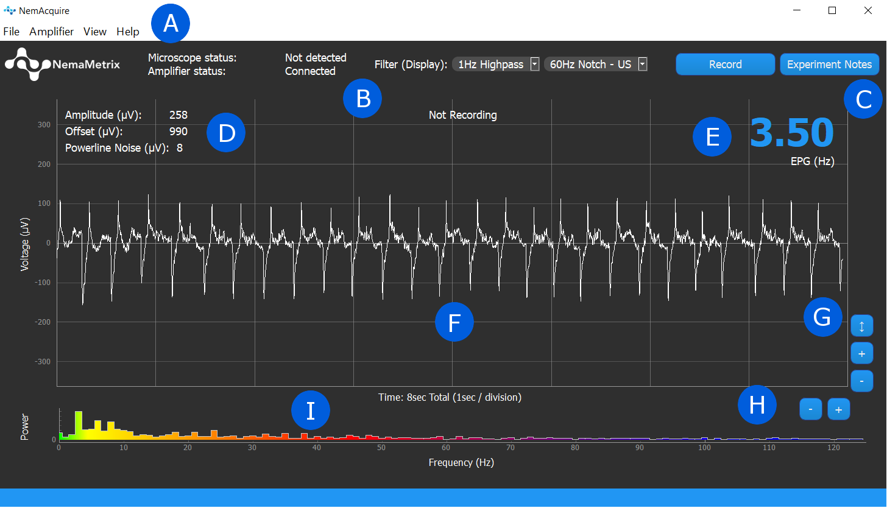

|  |  |
| --- | --- |
| A: Main Menu  B: Status and Filter Panel  C: Button Panel  D: Waveform Attribute Display  E: EPG Frequency | F: Waveform Display  G: Y Axis Scaling Buttons  H: X Axis Scaling Buttons  I: Frequency Distribution Plot |

Button Panel

1. Record/Stop Recording

This button is only enabled once the amplifier has connected to NemAcquire. Select this button to begin a recording. The waveform will be read over the duration of the recording, and the elapsed time of the recording will be shown in the top-center of the Waveform Display. Once ready to end the recording, select the same button, now named “Stop Recording”. This will bring up the Experiment Notes Field before saving the file.

1. Experiment Notes

Selecting this button opens the Experiment Notes dialog. In this window, the user can enter experiment notes about the recording. These notes are then attached to the next recording. This window can be opened anytime, both during and between recordings. The fields that appear in this window can be customized using the File > Experiment Note Fields menu option.

The “Worm Number” Field will automatically increment by one in between recordings, although this can be edited by the user. After a recording has concluded, the Experiment Notes dialog is shown once more. This is a final time to review or change data before that data is attached to the recording.

1. Clear All: Pressing this button will remove all data from the note fields.
2. Revert:Selecting this button will restore previously saved data to the note fields. The Experiment Notes data is saved each time the window is closed.
3. Discard Recording: This button only appears after a recording has been completed. It erases the latest recording. This decision must be confirmed by a warning before it occurs.
4. Save: Once the Experiment Notes data has been reviewed, select this button to save the file and attach the data.

Scaling Buttons

1. Y Axis Scaling Buttons

*Use these buttons to change the scaling of the Y Axis.*

1. Zoom In (+):Halves the height of the Waveform Display, so the waveform appears larger.
2. Zoom Out (-)**:** Doubles the height of the Waveform Display, so the waveform appears smaller.
3. Fit:Aligns the Y Axis to frame the waveform based on the largest amplitude shown in the Waveform Display.
4. X Axis Scaling Buttons

*Use these buttons to change the scaling of the X Axis, changing the displayed duration of the waveform.*

1. Zoom In (+):Halves the width of the Waveform Display, so the waveform appears over a shorter duration.
2. Zoom Out (-):Doubles the width of the Waveform Display, so the waveform appears over twice as long a duration.

Status and Filter Panel

1. Status

*The status text displays the Connection Status.*

* “Disconnected” is displayed by default, and is shown if no Amplifier is connected and the Demo mode is off.
* “Demo Mode” is displayed if Offline Demo Mode is selected from the Amplifier Menu.
* “Connected” is displayed once the software is connected to an Amplifier.

1. Filter (Display Only)

There are two display filters that are available. It is important to note that these filters only affect the displayed waveform and do not change the recorded data. These filters can be applied using the drop-down menus in the Filter Panel (See B in the graphic on page 2)

Highpass

A 1 Hz second-order Butterworth Highpass filter can be applied to the visual output of the data. This filter does not change the values recorded to the file. To enable the filter, simply select the 1Hz Highpass option from the first drop-down menu.

Notch Filter:

Due to power grid frequency standards, 60Hz noise is typical in North America, whereas 50Hz noise is typical in Europe.

Two Butterworth Notch filters are available in the Notch Filter drop-down Menu: one at 50Hz and another at 60Hz. These are second-order bandstop filters with corners at 59Hz and 61Hz for the 60Hz notch filter and 49Hz and 51Hz for the 50Hz Notch. Simply select either the 50Hz or 60Hz option from the second drop-down menu to apply the respective filters. Note that only one Notch filter can be applied at once, and these filters will not change the recorded data, they only change the displayed waveform and the displayed Frequency Distribution Plot.

To view if the 60Hz or 50Hz is significant, the powerline noise metric can be activated to view the amplitude of powerline noise. See View Menu for a detailed description.

II. Menu Contents

File Menu

1. Experiment Notes Fields

An Experiment Notes dialog will be shown after ending a recording or clicking on the “Experiment Notes” button. Using this menu, a user can customize what fields appear in this dialog, removing fields not frequently used or adding fields as required.

1. Select Recording Folder

Selecting this menu option opens a new file system window where a user can select a default folder location for storing recordings.

1. Show Recording Folder

The user can open a file explorer window showing where recordings are stored simply by selecting this option from the File menu.

Amplifier Menu

1. Connection Information

Selecting this menu option will display important information about the connection status with the amplifier. This includes:

* 1. Amplifier Version: Disconnected, Amplifier Version (eg. V16.11.02)
  2. Samples received from the Amplifier
  3. Samples lost (a warning will appear if any data is lost)

1. Offline Demo Mode

A waveform can be generated by the software. The main component of this waveform is a 5Hz, 150uV amplitude sine wave with a 60 Hz, 20uV sine wave superimposed.

1. Enable Test Signal on Amplifier

The Amplifier can emit a test signal in order to check the connection of the device before recording data. Simply select this menu option to have the amplifier generate the test signal, or un-check this menu item to return the amplifier to the normal data collection mode. The amplifier test signal is a 1Hz, 3.75mV amplitude square wave.

View Menu

1. Show….

Several waveform attributes are gathered and displayed alongside the live data, including:

* 1. Show EPG Hz: The dominant frequency of the waveform
  2. Show Amplitude: The peak-to-peak amplitude of the waveform
  3. Show Offset: The voltage offset of the waveform
  4. Show Powerline Noise: Displays the amplitude value of the dominant powerline frequency at 50Hz or 60Hz present in the signal. Calculated by using the most recent one second of signal and bandpass filtering around the powerline frequency. This setting does not affect the display of the waveform.

All of these attributes can be displayed on the chart and update once every second. The display for each property can be toggled on or off simply by selecting the menu option corresponding to the attribute.

1. Powerline Noise Threshold

Displays current noise threshold which can be modified by clicking this button. If signal powerline noise is higher than the threshold, the powerline noise metric will be displayed in red regardless of show powerline noise setting.

1. Show Frequency Distribution Plot

The power spectrum (distribution of frequencies) can be visualized using the Frequency Distribution Plot. This plot is displayed under the Waveform Display and updates every second. Each section of frequencies is color-coded for easy recognition. The Frequency Distribution Plot can be toggled on and off by checking this menu item.

1. Show Grid

The grid placed behind the signal can be turned off so that the signal can be seen more clearly. Checking this menu item will turn the grid back on, so that values associated with the waveform are more easily defined.

1. Show Microscope Panel

This is a placeholder for a future feature of the software.

Help Menu

1. About NemAcquire

This window displays information about the software version, build date and copyright.

1. NemAcquire User Guide

It opens this document.