Electronic control unit for interactive game
  - Manual
This documentation provides an overview of all parts of the control unit for controlling the engines, sensors and time display of the game.

Main electronic parts of system

This system consists of several parts that are in charge of controlling a certain part of the game. This parts are:
- MainBoard – receives input signals from sensors and buttons and giving 5V outputs. This system can’t control DC motors itself, it need an external driver for that. This part also controls timing display.
- PneuBoard – this board has 8 input signals and 8 output signals. It receives signals from MainBoard and on their basis turns on or off the transistors that provide the output for the pump.
- MotorBoard – this board is a driver for DC motor. It turns on MOSFET transistor that can turn ON or OFF motor speed controller.
- Speed Motor Controller – part used to change speed of motor by remote controller or potentiometer.
- PowerBoard – this board has a 10A relay so it can switch ON or OFF certain part of system that has AC or DC power supply.
- DislpayBoard – one board consists of two digit display. There is one port for Serial Input and one port for Serial Output for connecting more displays.
- Power supply – there is two power supplies [ 12V, 30A & 5V, 30A ].
- Sensors and buttons – there is two sensors and two buttons in this system.

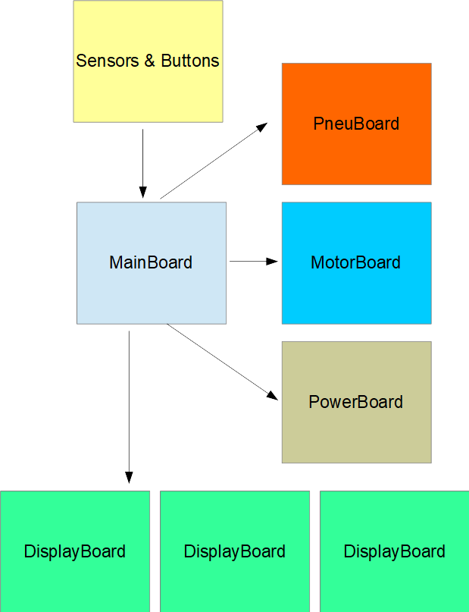
Figure 1: Block diagram of system

Main Board

Main board consists of processors for receiving inputs from sensors and buttons. All inputs are pull-up type, so sensor or button need to give a 0V signal when pressed or activated. There is 6 inputs that can be used. On a picture bellow is a schematic of input part.
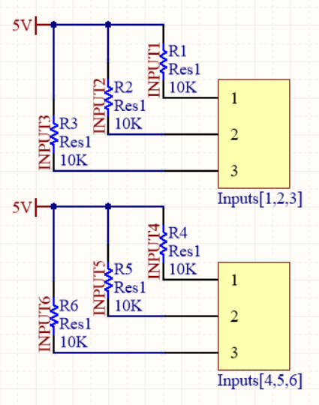
Figure 2: Input connectors schematic

As shown in figure 2, inputs are pull -up type, so when connecting a button you need to connect one wire on a corresponding input and other one on a GND. This is shown in figure 3.

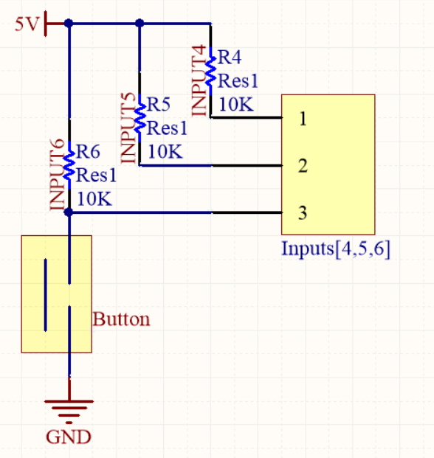
Figure 3: Connecting button to system
If you want to connect a sensor you need to use a pull – up NPN type sensor that is giving 0V when active and high resistance when not active. The connection is same as button. On a figure 4 you can see where to connect inputs on a PCB.
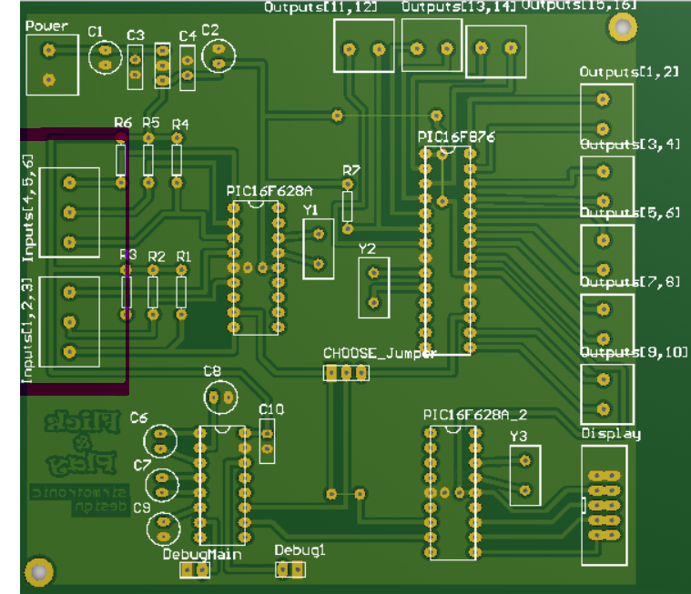
Figure 4: Connectors for input devices on a PCB

There is 16 possible outputs on a right side of a board. Outputs are not driven, push pull type (giving 0V and 5V on it). Those outputs need to connect on a driver if it need to control some power part of system.
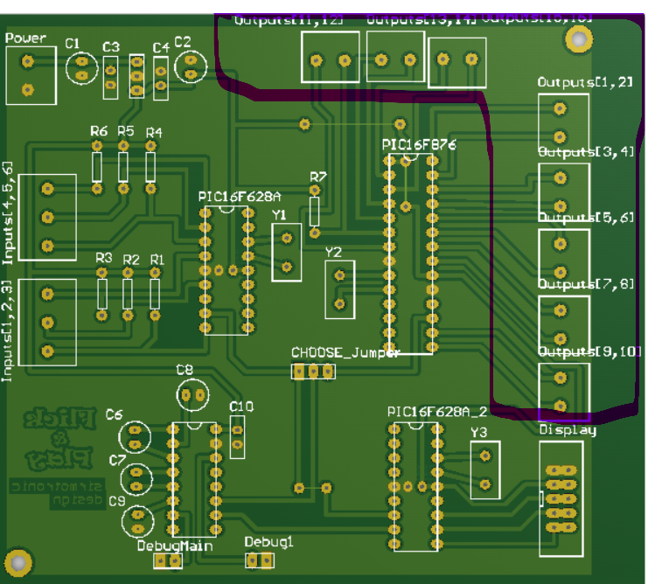
Figure 5: Outputs connectors on Main Board

Outputs 1-8 are used for pneumatic pump and outputs 9 and 10 are used for Motor1 and Motor2.

On main board there is a male flat display connector. There you need to connect Serial Input connector from first display.
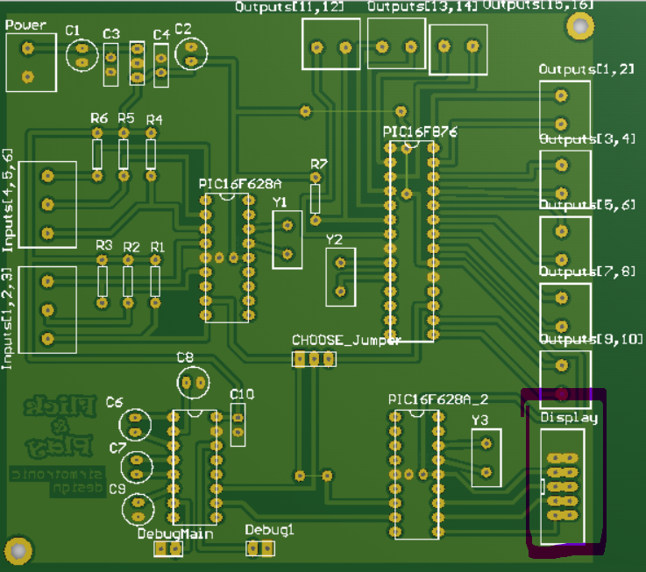
Figure 6: Display connector on Main Board

Main board power supply is 12 – 24V. Plus and minus lines are connected on screw terminal in top left corner of a board.
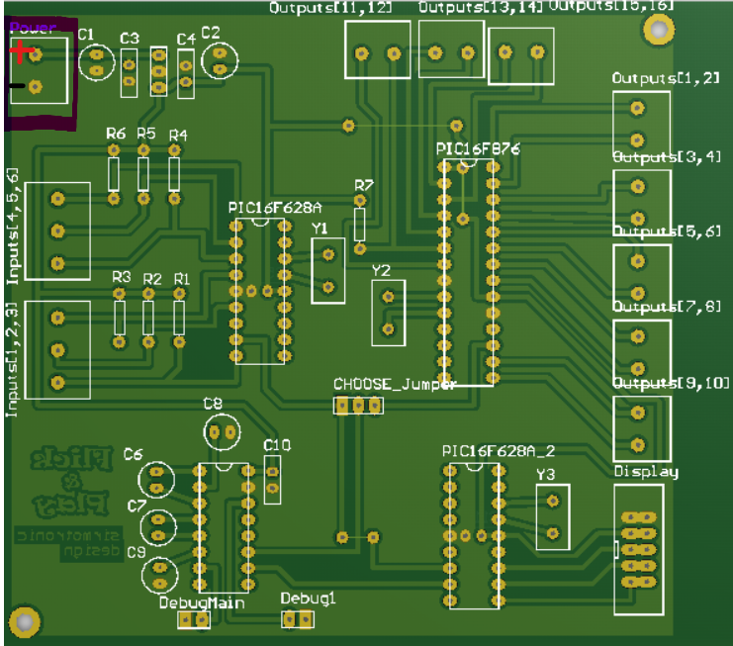
Figure 7: Power supply terminal

PneuBoard

PneuBoard is a board with 8 inputs and 8 outputs for controlling pneumatic pumps. There is also two 2 – input screw terminals on top left side of PCB for connecting power supply. On a figure 7 there is picture of PCB design of this board.
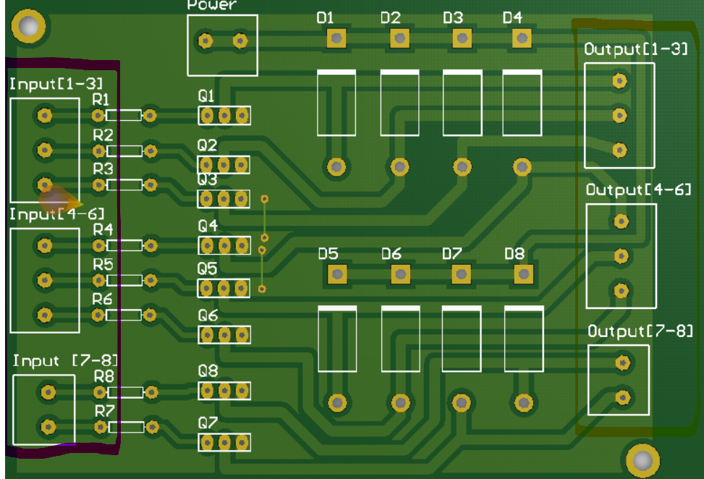
Figure 8: PneuBoard PCB
On left side of a board there is 8 inputs, and on right side there is 8 outputs. Outputs are NPN type, so when corresponding input is high (5V), output will be 0V. Power supply of this board need to be the same as power supply of pneumatic pumps (12V).

MotorBoard

Motor board is simple board with MOSFET transistor that can turn ON or OFF speed motor controller. There is three 2-input screw terminals:
- Power (12V, GND),
- Input from main board (Input, GND),
- Output (12V, output signal).

When input from main board is high (5V), output signal value is 0V, so on output screw terminal there is power supply for speed motor controller (12V, GND).

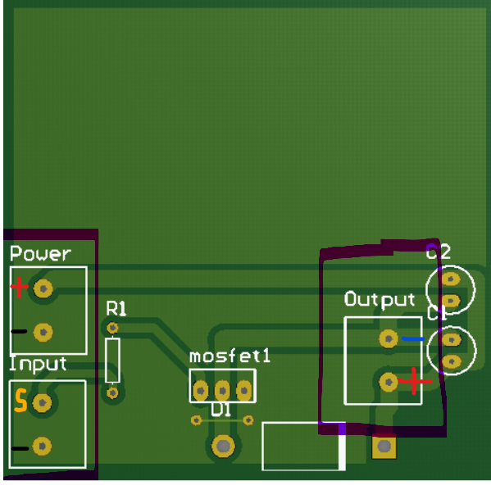
Figure 9: MotorBoard

PowerBoard

Power board is relay board that can switch any AC or DC signal. Maximum current for this output is 10A. There is four 2-input screw terminals:
- Power (12V, GND),
- Input from main board (Input, GND),
- Load Terminal (short circuit, signal that need to be switched),
- Output (short circuit high impedance or Load)

If input from main board is high (5V), output will be the same as Load (Switch is closed). If input from main board is low, output will be high impedance (open contact).
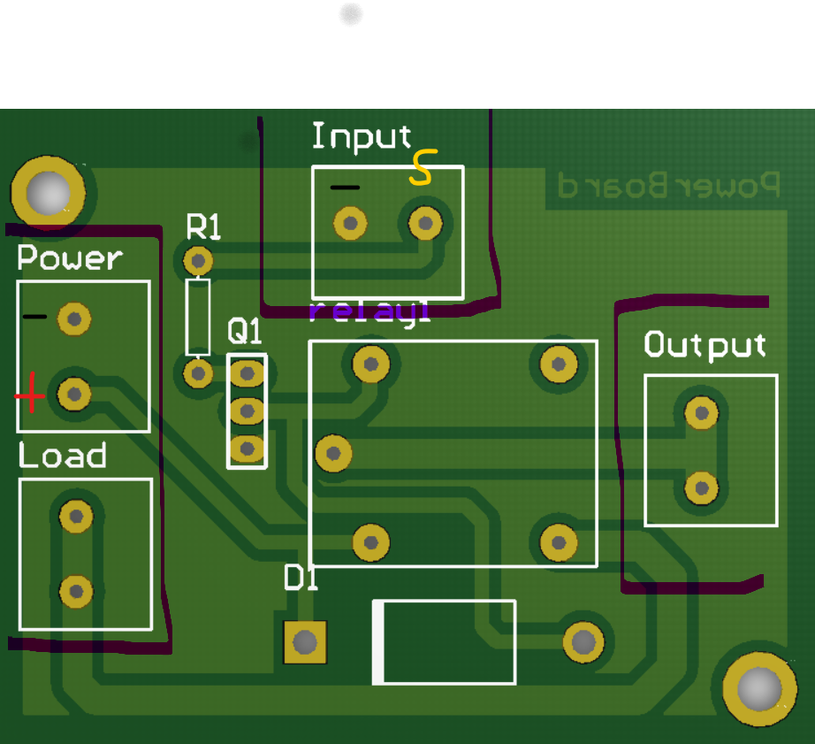
Figure 9: PowerBoard

DisplayBoard

Display board consists of one screw terminal for connecting 12V power supply and two male flat connectors. First connector is Serial input, that is used to receive data from main board or from previous display, and Serial out that is used to sent data to next 2 digit display.
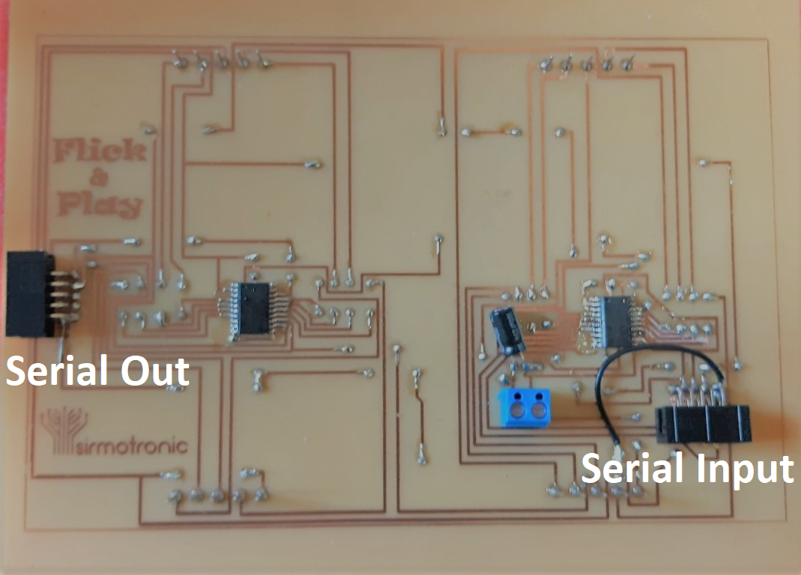
Figure 10: Back side of display connector

Connection diagram



