Dear Fellow ECoG Researcher,

These are the visual search data described in the Frontiers in Human Neuroscience manuscript titled “Dynamic modulation of local population activity by rhythm phase in human occipital cortex during a visual search task”.
Miller, Kai J., Dora Hermes, Christopher J. Honey, Mohit Sharma, Rajesh PN Rao, Marcel Den Nijs, Eberhard E. Fetz et al. "Dynamic modulation of local population activity by rhythm phase in human occipital cortex during a visual search task." Frontiers in human neuroscience 4 (2010): 197.

Please keep in mind that these anonymized data are from real patients who donated time in a difficult period of their lives to advance our understanding of the brain. Any publication involving these data MUST include the following in the methods section of the manuscript, without modification:
Ethics statement: All patients participated in a purely voluntary manner, after providing informed written consent, under experimental protocols approved by the Institutional Review Board of the University of Washington (#12193). All patient data was anonymized according to IRB protocol, in accordance with HIPAA mandate. These data originally appeared in the manuscript “Dynamic modulation of local population activity by rhythm phase in human occipital cortex during a visual search task” published in Frontiers in Human Neuroscience in 2010 [Reference].

The visual search task experiment datafiles (in MATLAB format) are named “##_vissearch.mat” in the folder data/##, where ## denotes the 2-letter patient code. This code is not the patient’s initials. The corresponding subject number for each patient from the manuscript is:

 | subject | age | sex
wc | 1 | 32 | M
rr | 2
rn | 3
jm | 4 | 41 | M
jt | 5

Each datafile has 3 variables:

"stim" (time x 1): This is what is displayed on the screen at each point in time, corresponding to the data
-values
0: Pre-post task run
01-10: Right-ward arrow
11-20: Left-ward arrow
12-30: Down-ward arrow
13-40: Up-ward arrow
41: Interstimulus Interval (blank screen)

"data" (time x number of channels): These are the data.
- sampled at 1000Hz
- Note that these data were re-referenced with respect to a global common average (after rejecting epileptic and artifactual channels), and then retaining occipital strip electrodes.
- built-in band pass 0.15 to 200 Hz,
- but a 1 pole band pass, so there is no sharp corner at 200Hz.
-The amplitude roll-off function is in the file “ns_1k_1_300_filt.mat”

"brain": This is a structure representing the tessellated brain surface. It can easily be plotted with the CTMR package (see “Automated electrocorticographic electrode localization on individually rendered brain surfaces” by D Hermes, et al in Journal of Neuroscience Methods, 2009)

"locs" (number of channels x 3): Electrode locations, for plotting on the rendered brain.

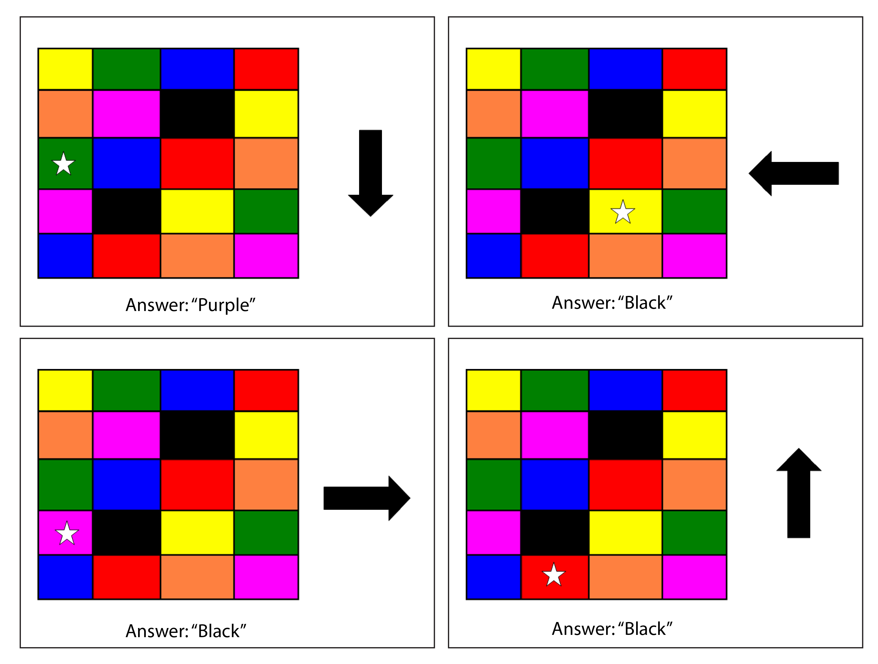
Task – Patients participated in a visual search task presented on a LCD monitor 1m away, in which 2s visual search stimuli were interleaved with 2s inter-stimulus-intervals (ISIs) during which the screen was blank. Each visual search stimulus consisted of three parts: (1) a 5-row by 4-column array of colored boxes (1cm by 1cm), (2) a white star positioned in the center of one of these boxes, and (3) a black arrow (2cm by 1cm) centered 1.5cm to the right of the right-most box in the middle row. In each visual search stimulus, the star appeared randomly in one of the colored boxes, and the arrow pointed randomly in one of four cardinal directions (“right,” “left,” “up,” or “down”). The subjects’ task was to state the color of the box that was adjacent to the star in the direction of the arrow. Since fixation was not constrained, and eye position was not measured, we cannot know whether dif- ferential effects between different arrow directions were due to attention or a late visual microsaccade between the star and the arrow, or different box position.

In order to reproduce the analyses from the manuscript, open and examine the file “vispac_master.m”. Each step of analysis is shown clearly in the functions called from this file. I have annotated the basic analysis code in a manner that should be clear if read alongside the methods of the manuscript. vispac_master.m will call a function for plotting figures for all individual channels and put them in the appropriate folder.

Note that the folders “ctmr” and “toolbox” from the root directory (zip files of the ECoG library) must be included in your MATLAB path for the analyses / figure generation to work properly.

Best Wishes!
Kai Miller, Stanford University, 2015 (revised 2018)
kai.miller@stanford.edu, miller.kai@mayo.edu

