

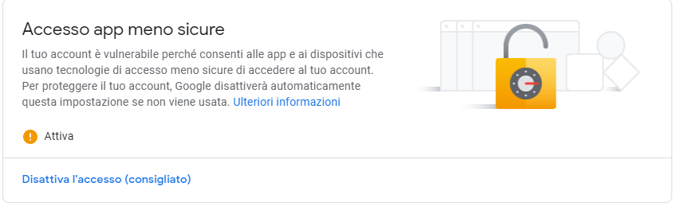



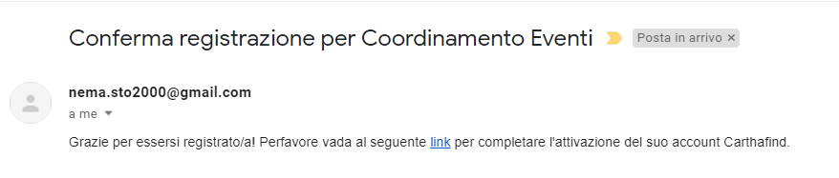

<https://stackoverflow.com/questions/15965376/how-to-configure-xampp-to-send-mail-from-localhost>

