S3_Aeration: Formulae

Summary Sheet:
The calculation process is outlined as follows:
INPUTS in Summary Sheet & Summary of OUTPUTS ->
OUTPUTS in AOR ->
OUTPUTS in SOR ->
OUTPUTS in Performance Sheet (Air Flow, Pressure, Power, Efficiency, Turndown)

The Summary sheet presents the key results (Air Flow, Pressure, Power, Efficiency, Turndown) to the user based on inputs provided or sourced from Facility datasheet.
The user is also provided links to the AOR, SOR, Outputs, Tables sheet if they are keen to understand the calculation. There are no Inputs in these sheets.

AOR: This sheet specifies how to calculate AOR from the following steps:

- Total Oxygen required (in lbs per day):
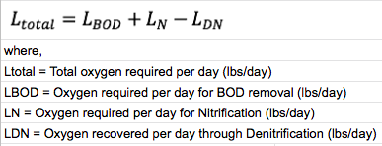

- $L_{BOD}=\left(Oxygen reqd per unit BOD\right) . BOD entering Aeration Basin (QBODi)$
where,
Oxygen reqd per unit BOD = $0.904-\left(0.129 . ln \left(FM Ratio\right) \right)$
$BOD entering Aeration Basin (QBODi)$ = F_{AB} . C_{BODi} . 8.34
F_{AB} : Total Flow entering Aeration Basins (MGD)
FM Ratio = Q_{BODi} / Q_{MLVSS}
Q_{MLVSS} = V_{AB} . C_{MLVSS} . 8.34

- IF(User does not select “No Nitrification-Denitrification”,Apply formula below, ELSE 0)
$L_{N}= 4.6 . {[(F}_{AB} . {TN}_{AB} . 8.34)-(0.08 . Biological sludge produced)]$
where,
F_{AB} : Total Flow entering Aeration Basins (MGD)
TN_{AB} : Avg Total Nitrogen concentration in Aeration Basin influent (mg/L or ppm)
Biological sludge produced (lbs/d)
= {(F_{WASp} . C_{WASp} . T_{WASp} . 24) + (F_{WASs} . C_{RAS} . T_{WASs} . 24) - (F_{Fil} . C_{TSS_fil})} . 8.34 . 10⁻⁶
- IF(User selects “Yes - Nitrification & Denitrification”, Apply formula below, ELSE 0)
$L_{DN}=2.86 . ( \frac{L_{N}}{4.6}-\left({[F}_{AB}{-F}_{RAS}{-\{F}_{WASs}{ .T}_{WASs }.24 . 10^{-6}\}] . {TN}_{DL} . 8.34\right))$
where,
F_{AB} : Total Flow entering Aeration Basins (MGD)
F_{RAS} : RAS Flow (MGD)
F_{WASs} : Secondary WAS Flow (GPM)
T_{WASs} : Minutes of operation of Secondary WAS pump per hour, on average (minutes)
TN_{DL} : Weekly Total Nitrogen (TN) Discharge Limit (mg/L or ppm)

- Calculating Total Hourly Oxygen requirement (AOR):

- Target Organic Load Removal
= ((F_{AB} . C_{BODi}) $-$ (${[F}_{AB}{-F}_{RAS}{-\{F}_{WASs}{ .T}_{WASs }.24 . 10^{-6}\}]{ . BOD}_{DL}$)) . 8.34

- PE = Target Organic Load Removal / 0.17
- $PF=4.7 . (PE^{-0.11})$
- Avg Hourly Flow = $F_{AB} . 10^{6}/ 24$
- Peak Hourly Flow = Avg Hourly Flow . PF
- IF(FM <= 0.2): L(BODsub) = L(BOD) . PF . 0.4 / 24 ;
L(BODer) = L(BOD) . 0.6 / 24
ELSE: L(BODsub) = L(BOD) . PF . 0.6 / 24
L(BODer) = L(BOD) . 0.4 / 24
- L(N) hourly = L(N) . PF / 24
- L(DN) hourly = L(DN) . PF / 24
- $AOR (lbs{ O}_{2}/hr) =L_{BOD,sub}+L_{BOD,er} + L_{N}-L_{DN})$

SOR: This sheet specifies how to calculate SOR from the following steps:

- SOR Formula:
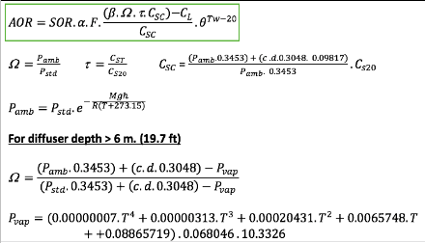
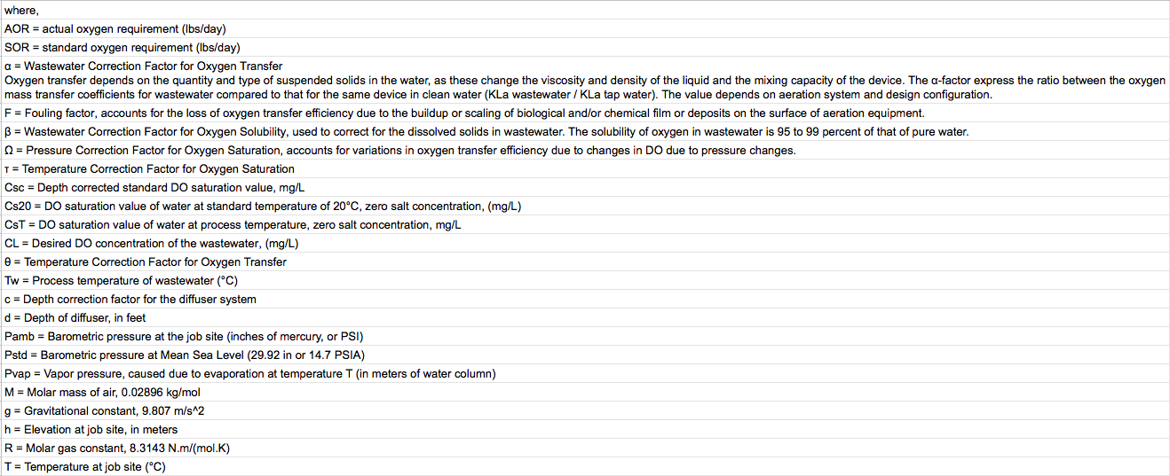

- User Inputs/Sourced from Summary sheet for the above calculation:
The calculated AOR along with the following parameters will be the Inputs in formula:
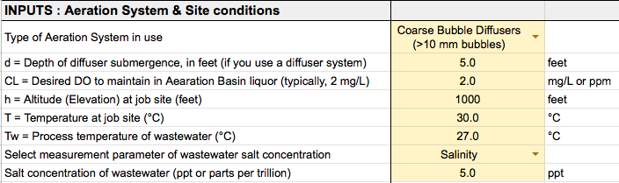

- Remaining Inputs: Remaining Inputs for the above calculation:
- Sourced from Tables sheet: “Typical values” from Tables 1, 2, 3, 4 based on inputs in Summary sheet.
- Table 4 is a matrix containing Temperature as Row heads and DO associated with the particular Chlorinity or Salinity as Column heads.
- If user enters values for Temperature (T) and Chlorinity or Salinity that are in between the values in the table columns or rows, round the values to the nearest value on the table and recorded corresponding DO values.
- For eg., if user enters Temp = 27.8°C, Chlorinity = 6 or Salinity = 10
=> Round Temp to 28.0°C, Round Chlorinity = 5 or Salinity = 9 and Retrieve corresponding DO values from Table 4
- Graphs are only for representation/education purpose – not involved in calculation

- AOR/SOR Ratio = 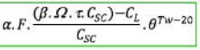
- SOR = AOR / [AOR/SOR Ratio]

Performance: This sheet specifies how to calculate Outputs from the following steps:

- Formulae:
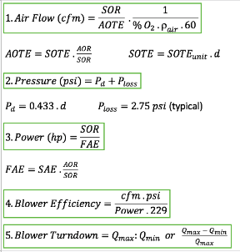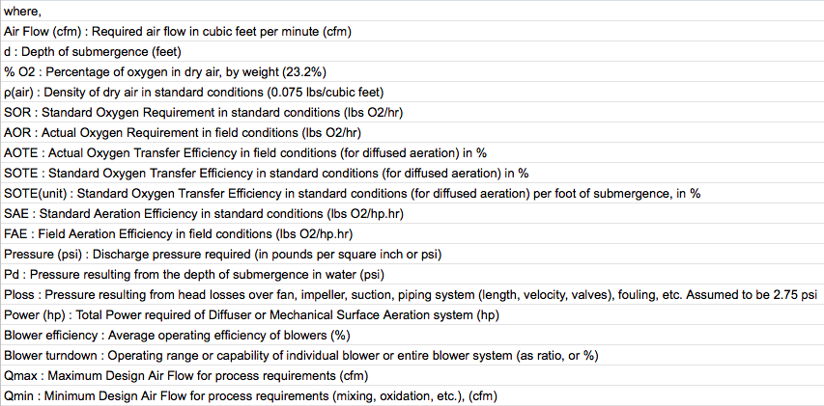

- User Inputs for the above from Summary sheet: Specific Aeration Equipment, Depth of submergence (d)
- Remaining from Tables sheet: SOTE_{unit}, SAE, Q_{min,unit}, Power_{min} sourced from “Typical values” in Tables 5, 6, 7.
There are two broad categories of Aeration Systems:
Blowers or Diffused Aeration, Mechanical Surface Aeration.
If User selects one, the Output values for the other are shown as ‘N/A’.

- ${Power}_{max}= SOR / FAE$

For Diffused Aeration (Blowers):
${Power}_{min}= {Power}_{max} / [Q_{max}/Q_{min} ]$
For Mechanical Surface Aeration: Power(min_unit) Table 7
${Power}_{min}= {Power}_{min,unit} . V_{AB}$
where,
V_{AB} : Total Volume of Aeration Basins (million gal)

- $Blower Efficiency=\frac{Air Flow . Pressure}{Power_{max} . 229}$
- $Turndown= Q_{max}:Q_{min}\left(round to whole nos.\right) or \frac{{Q_{max} - Q}_{min}}{Q_{max}} in \%$
where:
Q_{max}: Same value as Air Flow calculated as per Formula #1
$Q_{min}= Q_{min,unit} . V_{AB}$ Table 7

