A1. Veb texnologiyalar arxitekturasi va brauzer xavfsizlik modeli
1-VARIANT — Ikki originli veb laboratoriyada HTTP, DOM, cookie, SOP, CORS va CSP ni tekshirish

Veb Texnologiyalar Arxitekturasi
Klassik veb ilovalar 3 ta asosiy qatlamdan tashkil topadi:
- Mijoz (Brauzer): Foydalanuvchiga interfeysni ko'rsatadi, JavaScript dastur kodini ishga tushiradi, foydalanuvchi harakatlarini boshqaradi.
- Veb Server (Origin A — 127.0.0.1:8000): Asosiy statik resurslarni (index.html, style.css, app.js) yetkazib beradi.
- API Server (Origin B — 127.0.0.1:8001): Dinamik ma'lumotlarni JSON formatida taqdim etuvchi xizmat.
1-QADAM. Ishchi katalogini yaratish, ishchi kodni tayyorlash va ikkita xizmat terminalni ishga tushurish
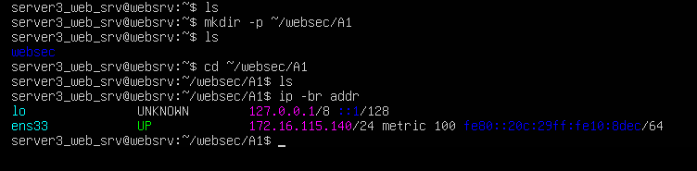
1-rasm. web_srv nomli vm ichida kerakli papka va fayllar tayyorlandi va bajarmochi bo’lgan ishimizni qulay qilishimiz uchun Vmware dan tashqarida local kompyuter ichida terminal dan turib SSH key orqali ulab
“ip -br addr”=> (tashqi ulanish IP ni olish uchun) berilgan vazifani bajaramiz:
va terminal orali yaratilgan /websec/A1/a1_lab.py faylini yaratib ichiga python kod yoziladi:
a1_lab.py
import argparse
import json
from http.server import BaseHTTPRequestHandler, ThreadingHTTPServer
from urllib.parse import urlsplit
HTML = """<!doctype html>
<html lang="uz">
<head>
<meta charset="utf-8">
<title>A1 - Brauzer laboratoriyasi</title>
<link rel="stylesheet" href="/style.css">
</head>
<body>
<h1 id="title">A1: veb arxitektura</h1>
<p id="inline">Inline: bajarilmadi</p>
<p id="external">Tashqi JS: bajarilmadi</p>
<button id="same">Bir xil origin</button>
<button id="cross">Boshqa origin</button>
<button id="cookie">Cookie o'rnatish</button>
<pre id="result">Natija shu yerda chiqadi.</pre>
<script>document.getElementById('inline').textContent = 'Inline: ishladi';</script>
<script src="/app.js"></script>
</body>
</html>"""
JS = """const out = document.getElementById('result');
document.getElementById('external').textContent = 'Tashqi JS: ishladi';
async function run(url) {
try {
const r = await fetch(url);
const data = await r.json();
out.textContent = JSON.stringify(data, null, 2);
} catch (e) {
out.textContent = 'Xato: ' + e.message;
console.error(e);
}
}
document.getElementById('same').addEventListener('click',
() => run('/api/info'));
document.getElementById('cross').addEventListener('click',
() => run('http://127.0.0.1:8001/api/info'));
document.getElementById('cookie').addEventListener('click',
() => run('/cookie'));"""
CSS = "body{font:18px sans-serif;margin:40px}button{margin:6px}"
CSP = ("default-src 'self'; script-src 'self'; "
"style-src 'self'; connect-src 'self' http://127.0.0.1:8001; "
"object-src 'none'; base-uri 'none'; frame-ancestors 'none'")
parser = argparse.ArgumentParser()
parser.add_argument('--port', type=int, required=True)
parser.add_argument('--cors-origin', default='')
parser.add_argument('--csp', action='store_true')
args = parser.parse_args()
class Handler(BaseHTTPRequestHandler):
def do_GET(self):
path = urlsplit(self.path).path
headers = {}
status = 200
content_type = 'application/json; charset=utf-8'
if path == '/':
body = HTML
content_type = 'text/html; charset=utf-8'
elif path == '/app.js':
body = JS
content_type = 'text/javascript; charset=utf-8'
elif path == '/style.css':
body = CSS
content_type = 'text/css; charset=utf-8'
elif path == '/api/info':
body = json.dumps({
'course': 'Veb dasturlar xavfsizligi',
'port': self.server.server_port,
'origin_received': self.headers.get('Origin', '(yoq)'),
'cookie_received': bool(self.headers.get('Cookie'))
})
if args.cors_origin:
headers['Access-Control-Allow-Origin'] = args.cors_origin
elif path == '/cookie':
headers['Set-Cookie'] = (
'lab_session=A1-DEMO; Path=/; HttpOnly; SameSite=Lax')
body = json.dumps({'message': 'Demo cookie ornatildi'})
else:
status = 404
body = json.dumps({'error': 'Topilmadi'})
data = body.encode('utf-8')
self.send_response(status)
self.send_header('Content-Type', content_type)
self.send_header('Content-Length', str(len(data)))
self.send_header('Cache-Control', 'no-store')
self.send_header('X-Content-Type-Options', 'nosniff')
if args.csp:
self.send_header('Content-Security-Policy', CSP)
for name, value in headers.items():
self.send_header(name, value)
self.end_headers()
self.wfile.write(data)
if __name__ == '__main__':
server = ThreadingHTTPServer(('127.0.0.1', args.port), Handler)
print(f'A1: http://127.0.0.1:{args.port}', flush=True)
try:
server.serve_forever()
except KeyboardInterrupt:
pass
finally:
server.server_close()
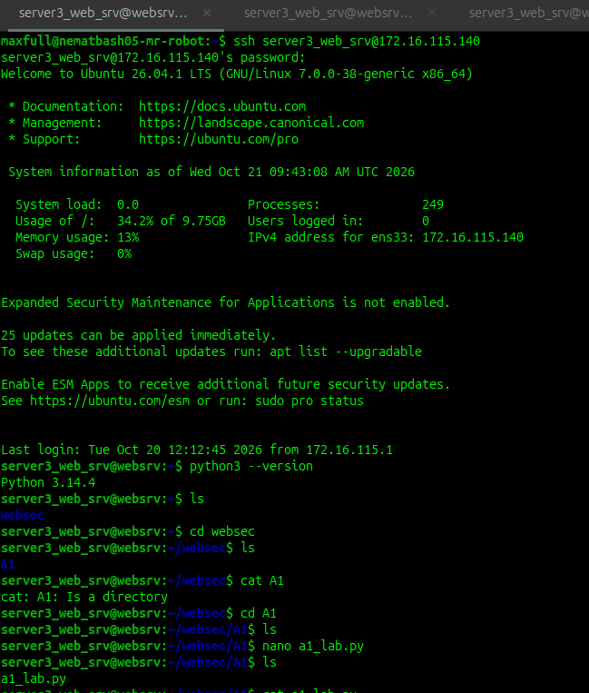
2-rasm. 1-terminal ochildi va ichiga a1_lab.py fayl ichiga python kod yozildi

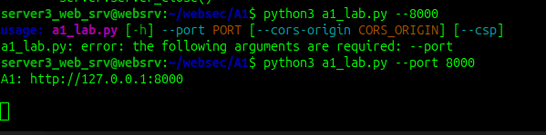
3-rasm. 1-terminal o’zida shu a1_lab.py fayli run time holatiga keltirildi(kod 8000 portda ishga tushurildi

1-terminalda 8000 portda kodni ishga tushurgandan keyin 2-terminal ochiladi va u terminal ssh key orqali web_srv ga ulanadi (4-rasm)

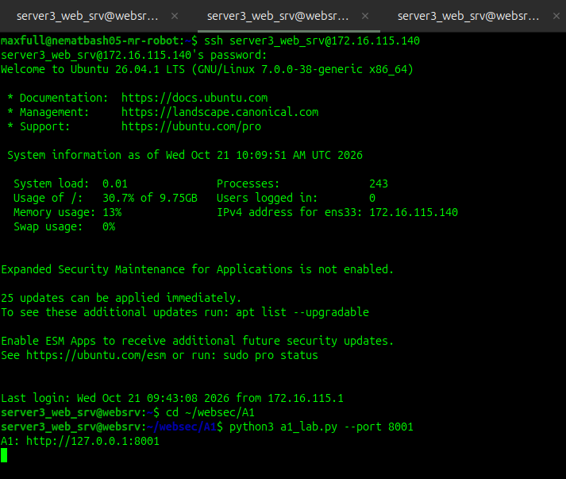
4-rasm. 2-terminal ssh key orqali ulanib 8001 portda yana o’sha a1_lab.py fayl ishga tushuriladi

Ikkala terminal ham run holatiga keltiriladi va 3-terminal ochiladi va ssh key orqali ulanadi, endi bu terminal orqali yuqoridagi ishga tushurilgan 1,2 terminallarni portlarini tingalyotgan holatga keltiramiz
(5-rasm)
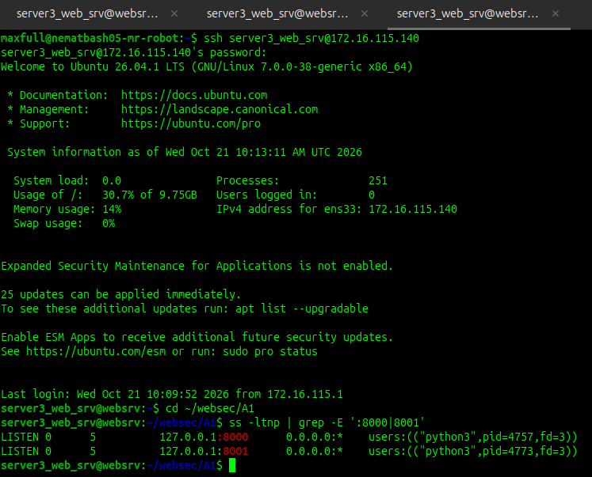
5-rasm. 3-terminal, yuqoridagi ikkita ishga tushgan portlarni tinglash uchun foydalaniladi

2-QADAM. VM dagi portni Noutbokni brauzeridan ochish

Buni hal qilishning eng qulay va laboratoriya qoidalarini buzmaydigan usuli — SSH Port Forwarding (tunnel) orqali ulanishdir:
Noutbokdan (Host tizimidan) yangi terminal ochib va VMga ulanishda 8000 va 8001 portlarni noutbokga yo‘naltirib olish kerak bo’ladi:
ssh -L 8000:127.0.0.1:8000 -L 8001:127.0.0.1:8001 <vm_foydalanuvchi@<vm_ip>
(Bu yerda <vm_foydalanuvchi> — VMdagi loginingiz, <vm_ip> — VMning IP manzili, masalan 192.168.x.x).
Bu qanday ishlaydi?
- SSH noutbokdagi 127.0.0.1:8000 portini VM ichidagi 127.0.0.1:8000 porti bilan xavfsiz ulab beradi.
Brauzer orqali: http://127.0.0.1:8000/ yoziladi va ekranda bu page paydo bo’ladi(6-rasm):
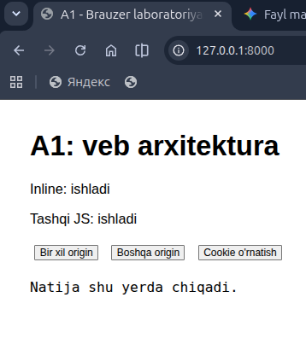
6-rasm. Ikkala terminal da ham 8000 va 8001 portlarida server run holatida va Vmware dagi port vavsiz usulda o’zimizni lokal noutbokimizga tunel ochdik va ekranda shu page hosil bo’ldi

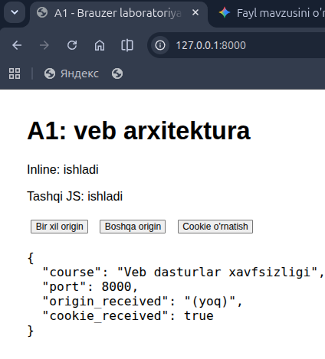

7-rasm. “bir xil origin” bo’limidagi resutl

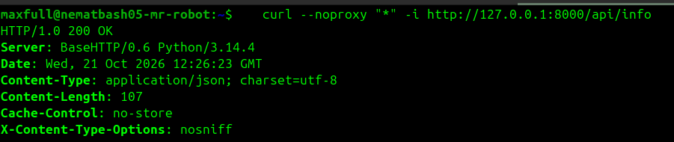
8-rasm. yangi terminal ochin curl orqali url pathni teshkiramiz:

3-QADAM. DOM manipulyatsiyasini ko’rish
DOM brauzerning tezkor xotirasidagi nusxasi xolos. U yerda qilingan o'zgarishlar serverdagi faylni o'zgartirmaydi. Sahifa qayta yuklanganda serverdan asl HTML yana tortib olinadi.(9-rasm)
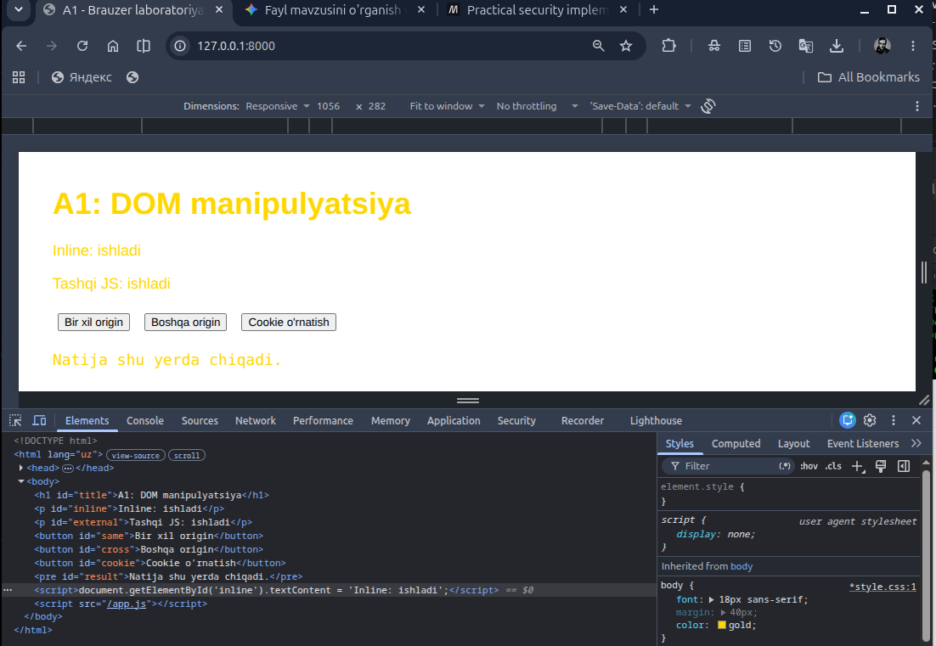
9-rasm. DOM manipulyatsiyasi

4-QADAM. SOP cheklovini teshkirish
Terminalda 127.0.0.1 - - "GET /api/info HTTP/1.1" 200 - yozuvi paydo bo'lgan!
Ya'ni so'rov serverga BORGAN va server 200 qaytargan! (10-rasm)
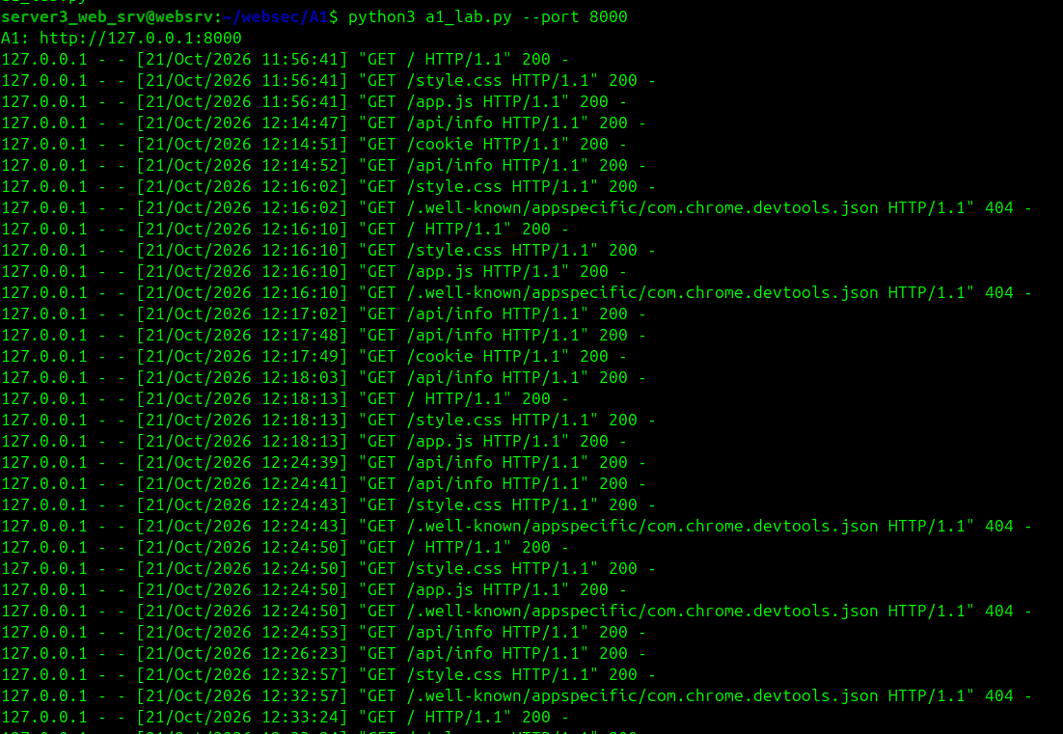
10-rasm.
5-QADAM. CORS ruxsatini berish
1.To'g'ri CORS sozlamasi:
serverni quyidagicha qayta ishga tushiring:
python3 a1_lab.py --port 8001 --cors-origin http://127.0.0.1:8000
Brauzerga qaytib, "Boshqa origin" tugmasini bosing.
- Natija: Endi xato yo'q! JSON ma'lumotlari chiqadi, unda "port": 8001 aks etadi.
- Network panelida /api/info so'rovining Response Headers qismida:
Access-Control-Allow-Origin: http://127.0.0.1:8000 mavjudligini ko'rasiz. (11-rasm)

2. Noto'g'ri CORS sozlamasi (Nosozlik yaratish):
T2 terminalida yana Ctrl+C bosing va ataylab portni 8002 qilib ishga tushiring:
python3 a1_lab.py --port 8001 --cors-origin http://127.0.0.1:8002
Brauzerda "Boshqa origin" tugmasini bosing:
- Qayta CORS xatosi chiqadi! Chunki so'rov kelgan origin http://127.0.0.1:8000, server ruxsat bergan origin esa http://127.0.0.1:8002. Ular mos emas.

3. Xatoni tuzatish:
T2 ni to'xtatib, yana --cors-origin http://127.0.0.1:8000 bilan ishga tushiring. Tugma yana muvaffaqiyatli ishlaydi.
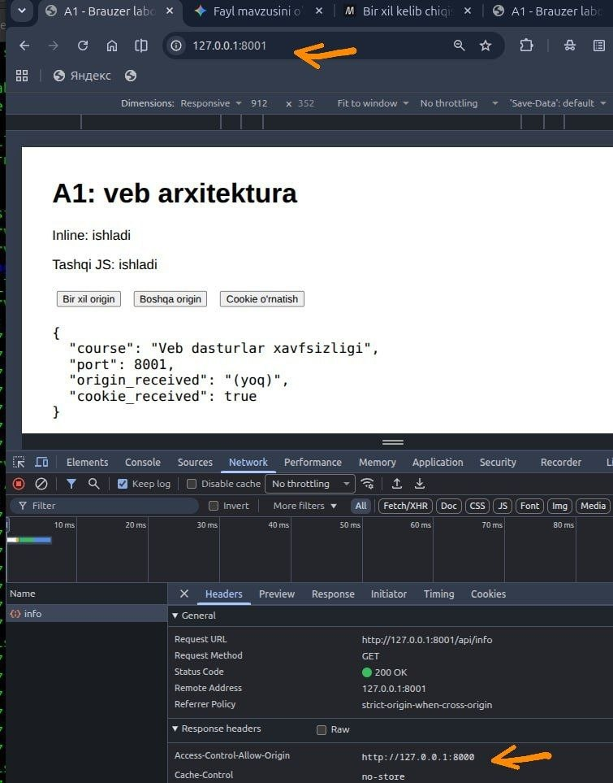
11-rasm
6-QADAM. COOKIE va HttpOnly ni tekshirish
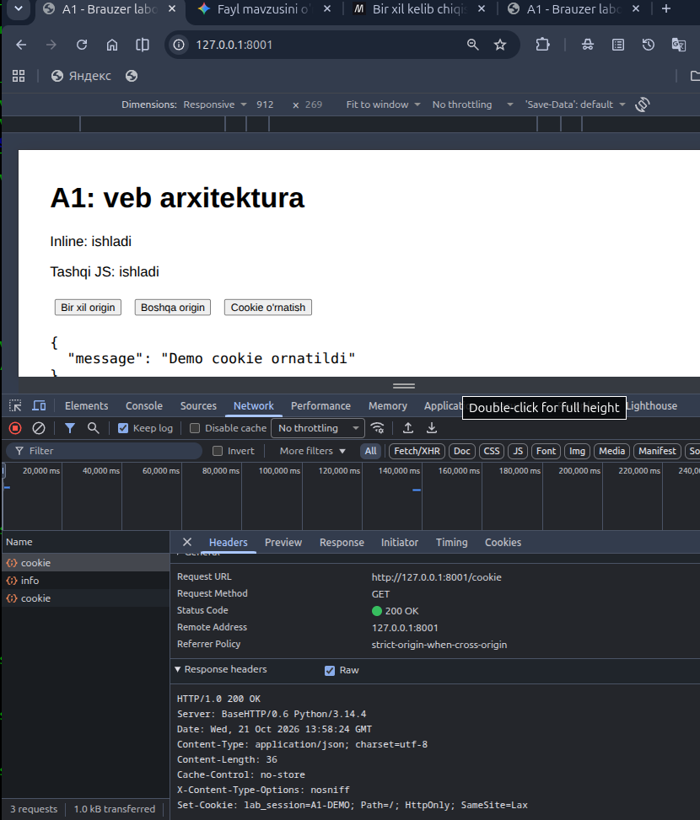
12-rasm.
7-QADAM. CSP(Content Security Policy) ni yoqish
T1 terminalida Ctrl+C bosing va serverni --csp bayrog'i bilan ishga tushiring:
python3 a1_lab.py --port 8000 --csp
Brauzer sahifasini Ctrl+R bilan yangilang.
Kuzatuv:
  - Ekranda: Inline: bajarilmadi
  - Ekranda: Tashqi JS: ishladi
DevTools Console bo'limida qizil xabar:
Content-Securit![[Screenshot from 2026-10-23 17-34-28.png]]y-Policy: The page’s settings blocked the loading of a resource (script-src) at inline (“default-src”). (13-rasm)
Nega bunday bo'ldi?
Chunki server yuborgan sarlavhada script-src 'self' ko'rsatilgan. Bu degani: "Skriptlarni faqat alohida fayl ko'rinishida (/app.js) shu serverdan yuklash mumkin, HTML kodi ichidagi inline skriptlarni ishga tushirish taqiqlanadi!".
Sahifadagi "Boshqa origin" tugmasini bosing:
  - Tugma ishlaydi va JSON qaytadi! Chunki CSP qoidasida connect-src 'self' http://127.0.0.1:8001; orqali 8001 portga ulanishga aniq ruxsat berilgan.

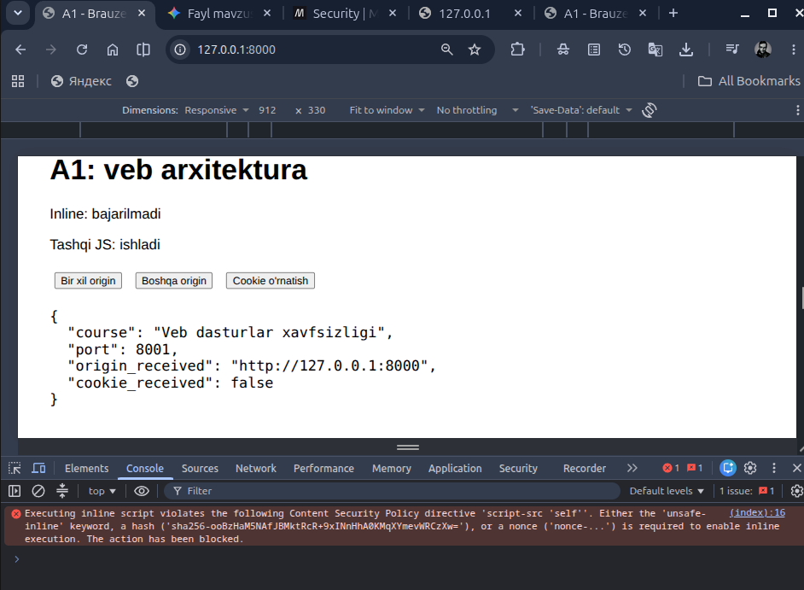
13_rasm.

