**STROOP EFFECT**

*12­­th Sept. 2017*

VISHNU PRASANTH REDDY

**INTRODUCTION :**

In a Stroop task, participants are presented with a list of words, with each word displayed in a color of ink. The participant’s task is to say out loud the *color of the ink* in which the word is printed. The task has two conditions: a congruent words condition, and an incongruent words condition. In the *congruent words* condition, the words being displayed are color words whose names match the colors in which they are printed: for example RED, BLUE. In the *incongruent words* condition, the words displayed are color words whose names do not match the colors in which they are printed: for example PURPLE, ORANGE. In each case, we measure the time it takes to name the ink colors in equally-sized lists. Each participant will go through and record a time from each condition.

Task : https://faculty.washington.edu/chudler/java/ready.html

Reference (data set) : <https://drive.google.com/file/d/0B9Yf01UaIbUgQXpYb2NhZ29yX1U/view>

**ANALYSIS:**

1. **What is our independent variable? What is our dependent variable?**

Here the **TIME TAKEN** is the dependent variable and **FONT COLOR** is the independent variable .Because, the Time Taken to identify the colour of the font differ from one participant to another and the approach that participant utilise to identify the font colour depends on his own grasping power .

1. **What is an appropriate set of hypotheses for this task? What kind of statistical test do you expect to perform? Justify your choices .**

There are two samples *congruent words*  and the *incongruent words* with each sample size **n = 24 .**

I prefer to conduct **t-test** since only samples were given in the dataset. If entire population **was** given **z-test** would be preferred for hypothesis testing.

**Null-Hypothesis :** The mean time taken for ***congruent words***  and ***incongruent words***  is same .

**Alternative-Hypothesis :** The mean time taken for ***congruent words***  and ***incongruent words***  is not same .

Null - Ho­­ : µcongruent -µincongruent = 0

Alt - Ha­ : µcongruent -µincongruent ≠ 0

1. **Report some descriptive statistics regarding this dataset. Include at least one measure of central tendency and at least one measure of variability**.

|  |  |  |
| --- | --- | --- |
|  | **congruent words**  n=24 | **incongruent words**  n=24 |
| Mean | 14.05 | 22.01 |
| Median | 14.36 | 21.02 |
| Standard Deviation | 3.55 | 4.79 |
| IQR | 4.30 | 5.33 |

**Note :** All the values are calculated in R language by using functions Summary (), sd() and IQR ()

Here Mean and Median are measures of central tendency ,Standard Deviation and IQR are measures of variability.

1. **Provide one or two visualizations that show the distribution of the sample data. Write one or two sentences noting what you observe about the plot or plots.**

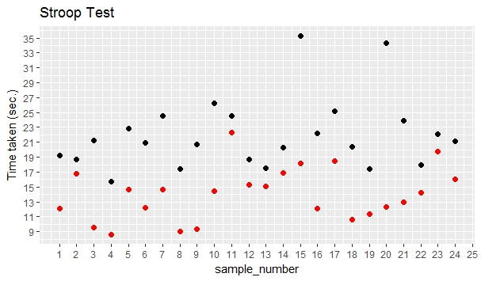

* **RED** dots represent congruent words and **BLACK** dots represent Incongruent words.

We can observe that the time taken to identify incongruent words is greater than the time taken to identify Congruent words. Among the 24 samples in congruent words the participant took more time to identify 15th sample than any other sample and less time is for 4th sample .

1. **Now, perform the statistical test and report your results. What is your confidence level and your critical statistic value? Do you reject the null hypothesis or fail to reject it? Come to a conclusion in terms of the experiment task. Did the results match up with your expectations?**

Standard deviation of difference – 4.86

Now we are conduct t-test with p < .05

Standard error = 0.99

t-static = -8.03

df = 24 -1 = 23

**t(23) = 2.069, p < .05, two-tailed**

confidence Interval = (-7.96 – 2.069 *0.99 ,-7.96 + 2.069*0.99) = (-10,-5.91)

coherence d = -8.04

r2  = 1.55

since the t-static value falls in the critical region we **reject the null** and p<.05 is statistically not significant .

so, the mean time taken to identify the congruent words will be less than the mean time taken to identify incongruent words .

1. **Optional: What do you think is responsible for the effects observed? Can you think of an alternative or similar task that would result in a similar effect? Some research about the problem will be helpful for thinking about these two questions!**

This task truly depends on two variables “Observing ” and “ Reading ” . A participant will read the font before identifying the color of the font .In congruent word’s font text and the font color are unique and represent the same color while Incongruent word’s font text and font color are 2 different colors . suppose , BLACK you just read it as black and later u’ve identified it as red . Here a participant’s brain and eyes should function simultaneously to read it as red which is only possible for participants with high grasping and IQ power . For an ordinary participant brain functions first where he’ll read it as black followed by eyes where he identifies it as red . so, it will take more time to identify incongruent words than congruent words or may be double the time taken to identify congruent words .

Other test like these can be randoms names or protests with shading yet these wont be that noticeable. One other thing is enthusiastic stroop impact where the words are adverse, for example, pain, remorse.etc A discouraged individual will set aside more opportunity to discuss this test than a typical individual.