AI DEFENSE LAB FOR PAYMENT SECURITY

FraudGuard 360
  - Identify. Generate. Defend. Learn.
Solution Walkthrough | Mastercard Innovation Challenge @ GFF 2026
One-line pitch: FraudGuard 360 turns emerging fraud into a controlled synthetic moving target so the defense learns before an attack reaches the payment decision path.

Submission artifact | Current prototype
System shape | Modular monolith with offline training and deterministic real-time scoring
Dataset | 9,000 traceable synthetic training transactions plus one unseen attack-family holdout
Model | Regularized logistic regression + transparent rules (fg-linear-ad2919e91e)
Safety | Synthetic-only data, no real credentials, no GenAI in the authorization path

Executive Summary
Generative AI makes payment fraud cheaper to vary, faster to scale, and harder for static defenses to anticipate. FraudGuard 360 answers the competition brief with one measurable closed loop: discover plausible attack families, generate safe synthetic payment behavior, score it through a live-style defense, identify misses and false positives, and route those gaps into reviewed hardening work.
Competition fit: The challenge provides no dataset. Creating a high-fidelity, versioned simulation dataset is therefore a core deliverable, not a workaround.

What the judges can see
• Attack diversity - ten structured families spanning identity, device, merchant, network, bot, and payment behavior.
• Simulation fidelity - seeded, constrained transactions with provenance, time order, fictional entities, and explicit synthetic labels.
• Detection efficacy - precision, recall, F1, false-positive rate, confusion matrix, reason codes, and latency.
• Novelty - an attack-family holdout and a safe fallback comparison create measurable evidence of generalization.
• Live-payment feasibility - a dependency-light synchronous API keeps generative AI outside the authorization path.

Architecture decision
The planning brief proposed six services. For the hackathon, the same boundaries are implemented as modules inside one deployable process. This makes the five-minute demo reliable while preserving clean extraction points for a Python model service, Redis, PostgreSQL, and event streaming.
Path | Components | Purpose
Offline | Scenario registry, generator, training | Discover and harden
Nearline | Evaluation, feedback, drift candidates | Measure and learn
Real-time | Features, model adapter, rules, policy | Score and decide

STEP 01

Identify: build a defensible attack landscape
The red team is a research and simulation layer, not a mechanism for interacting with victims or live payment rails.
ID | Attack family | Observable defensive signals
ATO_001 | Account takeover | New device, velocity, location shift
CNP_001 | Card-not-present burst | Remote payment, device novelty, amount deviation
MULE_001 | Mule network | Shared entity, new payee, velocity
BOT_001 | Bot card testing | Small bursts, repeated attempts, velocity
REFUND_001 | Refund abuse | Merchant risk, clustering, amount shift
UPI_001 | Urgent instant-payment scam | New payee, unusual time, amount shift
SYNID_001 | Synthetic identity | New account, inconsistent identity, velocity
LAUNDER_001 | Transaction layering | Split/merge behavior, graph density, new payee
PROMO_001 | Promotion abuse | Shared device, new accounts, small bursts
FRIENDLY_001 | Friendly fraud | Stable device, amount anomaly, merchant context

Scenario governance
• Every scenario has a stable ID, version, severity, feature coverage, and simulation-ready state.
• Mutation is limited to safe attributes such as timing, amount distribution, device novelty, geography, merchant context, and relationship patterns.
• Every generated dataset records its scenario version and seed so results can be reproduced.
• Human review is required before a proposed scenario enters the approved registry.
Responsible-use boundary: No real card numbers, CVVs, credentials, customer PII, phishing delivery, or unauthorized transaction execution is used or produced.

STEP 02

Generate: create a traceable synthetic dataset
Because the challenge supplies no dataset, simulation quality is part of the product and must be audited like a model.

Current dataset
Property | Implementation
Size | 9,000 training/validation/test feature rows
Coverage | Nine training attack families; LAUNDER_001 excluded as holdout
Class balance | Approximately 25% fraud per scenario for the current controlled benchmark
Reproducibility | Fixed seeds, generator version, feature version, and scenario provenance
Privacy | All identifiers and events are fictional; rows are marked synthetic
Storage | Runtime JSONL is ignored by Git; only the small model artifact is committed

Generation sequence
1. Select an approved scenario and fixed seed.
2. Generate baseline legitimate behavior across customers, merchants, devices, amounts, channels, and time.
3. Condition fraud rows on the scenario's observable signals.
4. Process transactions in timestamp order through the production FeatureEngine.
5. Hash customer/scenario entities into leakage-safe train, validation, and test partitions.
6. Write labels, provenance, feature version, and holdout metadata.

Fidelity controls
• Implemented - 12 automated gates covering deterministic replay, schema, class rates, hard-negative coverage, amount overlap, correlation, feature ranges, and privacy.
• Next - comparison with an authorized aggregate reference distribution, sequence similarity, and graph-structure reports.
Honest limitation: The fidelity suite validates generator consistency and controlled class overlap. Without an authorized production reference, it cannot prove production realism.

STEP 03

Feature engineering: represent behavior consistently
Training and inference call the same stateful feature module to reduce training-serving skew.
Feature | Meaning | Domain
velocity_1h | Transactions observed for the customer in the prior hour | Velocity
amount_deviation | Distance from the customer's prior average amount | Behavior
new_device | Device not observed in prior customer history | Device
shared_device_count | Customers associated with the device | Graph proxy
location_shift | Country differs from current home-country assumption | Context
new_payee | Payment introduces a new recipient | Payment
card_not_present | Remote/e-commerce transaction | Channel
unusual_hour | Event falls in a configured high-risk UTC window | Time
new_account | Account age is below 30 days | Account
identity_mismatch | Synthetic identity attributes are inconsistent | Identity
merchant_risk | Normalized merchant-risk context | Merchant

Parity rules
• Process events in timestamp order.
• Version the feature schema independently from the model.
• Log the feature version with every decision.
• Treat stateful history and device relationships as part of the scoring contract.

STEP 04

Defend: train an explainable model and safe policy
The first trained benchmark is intentionally simple, inspectable, and inexpensive to serve.

Why logistic regression first
• Transparent coefficients make the benchmark easy to inspect and challenge.
• A small JSON artifact supports dependency-free inference in the Node service.
• Deterministic training creates a stable baseline for later LightGBM/XGBoost experiments.
• If the artifact is missing or invalid, the system continues with transparent rule scoring.

Training flow
1. Load versioned feature rows.
2. Calculate means and standard deviations using training rows only.
3. Balance fraud and legitimate examples.
4. Train regularized logistic regression with deterministic gradient descent.
5. Select a validation threshold under a false-positive constraint.
6. Evaluate the untouched test set and save a locked artifact.
Artifact field | Value
Model version | fg-linear-ad2919e91e
Model type | logistic_regression
Feature version | features-1.0
Validation threshold | 0.57
Training examples | 6235
Validation examples | 1049
Test examples | 1716

Real-time ensemble and policy
The runtime score blends 70% trained fraud probability with 30% transparent rule score. Configurable thresholds map the result to ALLOW, STEP_UP, REVIEW, or BLOCK. Every response records probability, rule score, reason codes, feature/model versions, scoring mode, and latency.

STEP 05

Evaluate: measure security and customer friction
F1 and recall matter, but false positives, explainability, and latency are equally visible in the prototype.
Evaluation | Precision | Recall | F1 | False-positive rate
Entity-aware test split | 0.749 | 0.756 | 0.752 | 0.084
Novel holdout ensemble | 0.673 | 0.877 | 0.762 | 0.138
Novel holdout safe fallback | 0.766 | 0.590 | 0.667 | 0.058

How to read the result
• Test split - measures held-out customers within the nine known attack families.
• Novel holdout - uses LAUNDER_001, which is absent from the training dataset.
• Fallback - shows the deterministic rules-only result if the model cannot be used.
• Lift - shows whether the trained ensemble improves the unseen-family defense and at what false-positive cost.
Metric caution: Hard negatives reduce synthetic separability and expose the security/customer-friction tradeoff. These values remain prototype evidence, not production claims.

Prototype evidence
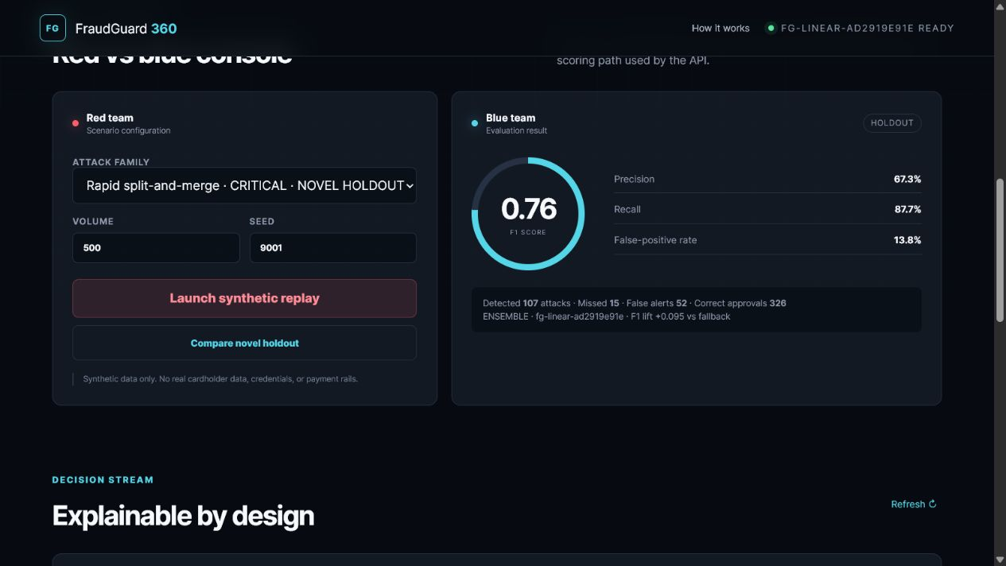
Figure 1. Interactive holdout comparison and explainable transaction decisions.

STEP 06

Learn: turn gaps into reviewed hardening work
The feedback loop creates candidates for improvement; it never silently updates the live model.
Input | Classification | Controlled next action
Predicted FRAUD, actual LEGITIMATE | False positive | Create benign hard negative; review threshold impact
Predicted LEGITIMATE, actual FRAUD | False negative | Seed safe defense-guided mutation
Prediction matches outcome | Correct | Retain for monitoring and calibration

Defense-guided mutation
1. Replay the unseen scenario and select actual false negatives.
2. Create traceable amount, payee, device, and merchant-context stress variants.
3. Replay each variant through exactly the same feature and decision path.
4. Mark the batch HUMAN_REVIEW_REQUIRED; never change the active artifact.
5. Next, train an isolated candidate only from approved batches.
6. Compare locked metrics before any human-approved promotion.
Novelty mechanism: The red team does not generate random fraud. It searches the defender's uncertainty and blind spots, then creates traceable, plausible synthetic variants for stress testing.

Real-world Feasibility
Stage | Deployment mode | Control objective
1 | Offline simulation | Validate diversity, fidelity, model lift, and limitations
2 | Shadow mode | Score authorized live-like traffic without changing approvals
3 | Step-up recommendation | Use medium risk for extra authentication or review
4 | Selective blocking | Block only calibrated high-confidence patterns with rollback
5 | Continuous hardening | Schedule reviewed mutations, retraining, and governance

Why the prototype can evolve
• Module boundaries allow feature, model, generator, and monitoring components to split into independent services when scale requires it.
• The model adapter can replace the linear artifact with LightGBM/XGBoost or a Python service without changing the score API.
• Redis can hold online feature state, PostgreSQL can persist scenarios and feedback, and a queue can carry nearline events.
• The hot path remains deterministic, versioned, observable, and independent of generative-model availability.

Responsible-use and security controls
• Synthetic and authorized test data only.
• No real payment credentials or customer PII in the red-team layer.
• Every scenario and decision carries provenance and version metadata.
• No uncontrolled self-training or automatic model promotion.
• Prototype metrics are never presented as production readiness.

Five-minute Demonstration
1. 0:00-0:35 - Problem. Explain why GenAI changes the speed and variety of payment fraud.
2. 0:35-1:10 - Identify. Show ten attack families and select the unseen layering scenario.
3. 1:10-1:55 - Generate. Launch a seeded synthetic replay and explain provenance and fidelity controls.
4. 1:55-2:50 - Defend. Show precision, recall, F1, false positives, decision latency, and reason codes.
5. 2:50-3:40 - Learn. Generate a governed mutation batch from observed holdout misses.
6. 3:40-4:30 - Feasibility. Explain deterministic hot path, fallback, staged deployment, and human approval.
7. 4:30-5:00 - Close. State limitations and the defense-guided mutation roadmap.

Implementation roadmap
Priority | Next deliverable | Evidence of completion
P0 | Candidate training | Before/after artifact on approved mutation batches
P0 | Reference fidelity | Compare against authorized aggregate distributions when available
P1 | Nonlinear model benchmark | LightGBM/XGBoost comparison on locked data
P1 | Graph intelligence | Shared-entity and ring-density lift
P1 | Observability | Drift test, metrics endpoint, durable audit trail

Submission checklist
• Runnable repository covers Identify, Generate, Defend, and Learn.
• DOCX explains attacks, generation, detection efficacy, and live-payment feasibility.
• Web prototype demonstrates the closed loop with a presentable UI.
• All synthetic metrics and limitations are labeled honestly.
• Public deployment and links are tested without requiring judge login.

Sources
• Mastercard Innovation Challenge 2026 private Kaggle overview (accessed 22 August 2026): https://www.kaggle.com/competitions/mastercard-innovation-challenge-2026
• Mastercard Innovation Challenge @ GFF 2026 public Luma brief (accessed 22 August 2026): https://luma.com/kyz978xv
• FraudGuard 360 repository implementation, model artifact, automated tests, and browser-verified prototype.
• User-provided planning documents: FraudGuard 360 Team Work Plan and Mastercard GFF 2026 AI Defense Lab Project Report.

