AI DEFENSE LAB FOR PAYMENT SECURITY

Auralis Risk
  - Identify. Generate. Defend. Learn.
Solution Walkthrough | Mastercard Innovation Challenge @ GFF 2026
One-line pitch: Auralis Risk turns emerging fraud into a governed synthetic moving target so defenders can discover, test, detect, and learn before an attack reaches the payment decision path.

Submission artifact | Current prototype
System shape | Modular monolith with offline training and deterministic real-time scoring
Dataset | 210,000 traceable synthetic training transactions plus one unseen attack-family holdout
Model | Portable 280-tree XGBoost + transparent rules (auralis-xgb-210k-932b64e9bc)
Safety | Synthetic-only data; human-approved GenAI scenarios; no LLM in the authorization path

Executive Summary
Generative AI makes payment fraud cheaper to vary, faster to scale, and harder for static defenses to anticipate. Auralis Risk answers the competition brief with one measurable closed loop: discover plausible attack families, generate safe synthetic payment behavior, score it through a live-style defense, identify misses and false positives, and route those gaps into reviewed hardening work.
Competition fit: The challenge provides no dataset. Creating a high-fidelity, versioned simulation dataset is therefore a core deliverable, not a workaround.

What the judges can see
• Attack diversity - 22 structured families spanning identity, device, merchant, network, bot, and payment behavior.
• Simulation fidelity - seeded, constrained transactions with provenance, time order, fictional entities, and explicit synthetic labels.
• Detection efficacy - precision, recall, F1, false-positive rate, confusion matrix, reason codes, and latency.
• Novelty - a completely excluded attack-family holdout and a linear-baseline comparison create measurable evidence of generalization.
• Live-payment feasibility - a dependency-light synchronous API keeps generative AI outside the authorization path.

Architecture decision
The planning brief proposed six services. For the hackathon, the same boundaries are implemented as modules inside one deployable process. This makes the five-minute demo reliable while preserving clean extraction points for a Python model service, Redis, PostgreSQL, and event streaming.
Path | Components | Purpose
Offline | Scenario registry, generator, training | Discover and harden
Nearline | Evaluation, feedback, drift candidates | Measure and learn
Real-time | Features, model adapter, rules, policy | Score and decide
STEP 01

Identify: build a defensible attack landscape
The red team is a research and simulation layer, not a mechanism for interacting with victims or live payment rails.
ID | Attack family | Observable defensive signals
ATO_001 | Account takeover | New device, velocity, location shift
CNP_001 | Card-not-present burst | Remote payment, device novelty, amount deviation
MULE_001 | Mule network | Shared entity, new payee, velocity
BOT_001 | Bot card testing | Small bursts, repeated attempts, velocity
REFUND_001 | Refund abuse | Merchant risk, clustering, amount shift
UPI_001 | Urgent instant-payment scam | New payee, unusual time, amount shift
SYNID_001 | Synthetic identity | New account, inconsistent identity, velocity
LAUNDER_001 | Transaction layering | Split/merge behavior, graph density, new payee
PROMO_001 | Promotion abuse | Shared device, new accounts, small bursts
FRIENDLY_001 | Friendly fraud | Stable device, amount anomaly, merchant context
SIMSWAP_001 | Recovery-channel takeover | New device, identity mismatch, location shift
TOKEN_001 | Token provisioning abuse | Device novelty, shared infrastructure, remote use
QR_001 | QR destination substitution | New payee, merchant mismatch, geography
BNPL_001 | Cross-provider credit bust-out | New account, velocity, high-value deviation
INVOICE_001 | Business payment redirection | New beneficiary, amount shift, merchant context
LOYALTY_001 | Loyalty value theft | New device, redemption velocity, small-value bursts
SUBSCRIPTION_001 | Synthetic subscription farm | Shared device, remote payment, new accounts
MERCHANT_001 | Transaction laundering | Merchant risk, graph density, amount distribution
NFC_001 | Contactless proximity relay | Location contradiction, stable device, amount shift
REMIT_001 | Remittance corridor abuse | Cross-border paths, new payees, graph density
PAYROLL_001 | Payroll redirection | New destination, amount shift, identity mismatch
GIFT_001 | Gift-card conversion cascade | Small-value bursts, velocity, merchant risk

Scenario governance
• Every scenario has a stable ID, version, severity, feature coverage, and simulation-ready state.
• Mutation is limited to safe attributes such as timing, amount distribution, device novelty, geography, merchant context, and relationship patterns.
• Every generated dataset records its scenario version and seed so results can be reproduced.
• Human review is required before a proposed scenario enters the approved registry.
Responsible-use boundary: No real card numbers, CVVs, credentials, customer PII, phishing delivery, or unauthorized transaction execution is used or produced.

Governed GenAI threat discovery
• An optional Groq-hosted analyst proposes strictly structured, defensive simulation drafts; a labeled local analyst fallback keeps the demo reproducible without an API key.
• Every response is schema-validated, safety-filtered, bounded to synthetic parameters, and stored with provider/model provenance.
• A new draft starts as PENDING_REVIEW. Simulation remains disabled until a human explicitly approves it; rejected drafts cannot run.
• False negatives can seed new reviewed drafts, but neither GenAI nor feedback can train or promote a production model automatically.
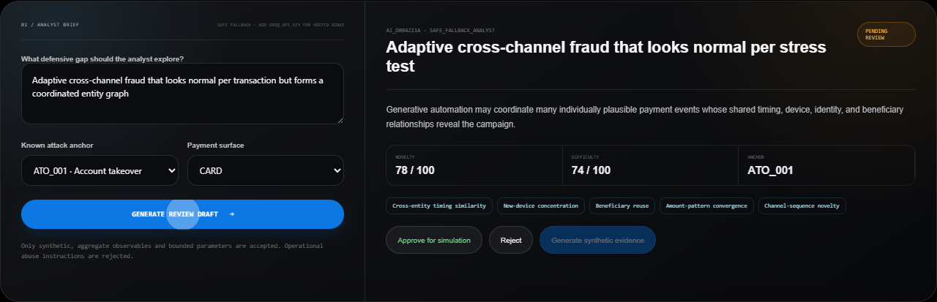
Figure 1. A threat draft cannot generate evidence before human approval.
STEP 02

Generate: create a traceable synthetic dataset
Because the challenge supplies no dataset, simulation quality is part of the product and must be audited like a model.

Current dataset
Property | Implementation
Size | 210,000 training/validation/test feature rows
Coverage | 21 training attack families; LAUNDER_001 excluded as holdout
Class balance | Approximately 25% fraud per scenario for the current controlled benchmark
Reproducibility | Fixed seeds, generator version, feature version, and scenario provenance
Privacy | All identifiers and events are fictional; rows are marked synthetic
Storage | The versioned 210,000-row release archive, manifest, model artifact, and evaluation evidence are committed

Generation sequence
1. Select an approved scenario and fixed seed.
2. Generate baseline legitimate behavior across customers, merchants, devices, amounts, channels, and time.
3. Condition fraud rows on the scenario's observable signals.
4. Process transactions in timestamp order through the production FeatureEngine.
5. Hash customer/scenario entities into leakage-safe train, validation, and test partitions.
6. Write labels, provenance, feature version, and holdout metadata.

Fidelity controls
• Implemented - 12 automated gates covering deterministic replay, schema, class rates, hard-negative coverage, amount overlap, correlation, feature ranges, and privacy.
• Next - comparison with an authorized aggregate reference distribution, sequence similarity, and graph-structure reports.
Honest limitation: The fidelity suite validates generator consistency and controlled class overlap. Without an authorized production reference, it cannot prove production realism.

STEP 03

Feature engineering: represent behavior consistently
Training and inference call the same stateful feature module to reduce training-serving skew.
Feature | Meaning | Domain
velocity_1h | Transactions observed for the customer in the prior hour | Velocity
amount_deviation | Distance from the customer's prior average amount | Behavior
new_device | Device not observed in prior customer history | Device
shared_device_count | Customers associated with the device | Graph proxy
location_shift | Country differs from current home-country assumption | Context
new_payee | Payment introduces a new recipient | Payment
card_not_present | Remote/e-commerce transaction | Channel
unusual_hour | Event falls in a configured high-risk UTC window | Time
new_account | Account age is below 30 days | Account
identity_mismatch | Synthetic identity attributes are inconsistent | Identity
merchant_risk | Normalized merchant-risk context | Merchant

Parity rules
• Process events in timestamp order.
• Version the feature schema independently from the model.
• Log the feature version with every decision.
• Treat stateful history and device relationships as part of the scoring contract.
STEP 04

Defend: train an explainable model and safe policy
A compact nonlinear detector improves recall while remaining inexpensive and reproducible to serve.

Why portable XGBoost
• Gradient-boosted trees capture nonlinear interactions between velocity, deviation, device, graph, identity, and merchant signals.
• A portable JSON artifact supports dependency-light inference in the Node service without a separate Python runtime.
• Deterministic training on the locked 210,000-row release makes the comparison against the original linear baseline reproducible.
• If the artifact is missing or invalid, the system continues with transparent rule scoring.

Training flow
1. Load versioned feature rows.
2. Preserve customer-entity train, validation, and test partitions to reduce leakage.
3. Train a 280-tree XGBoost classifier with fixed seed and controlled class weighting.
4. Select a validation threshold under a false-positive constraint.
5. Evaluate the untouched test split and the completely excluded LAUNDER_001 family, then save locked artifacts.
Artifact field | Value
Model version | auralis-xgb-210k-932b64e9bc
Model type | xgboost_json
Feature version | features-1.0
Validation threshold | 0.405
Training examples | 146997
Validation examples | 20865
Test examples | 42138

Real-time ensemble and policy
The runtime score blends 70% trained fraud probability with 30% transparent rule score. Configurable thresholds map the result to ALLOW, STEP_UP, REVIEW, or BLOCK. Every response records probability, rule score, reason codes, feature/model versions, scoring mode, and latency.
STEP 05

Evaluate: measure security and customer friction
F1 and recall matter, but false positives, explainability, and latency are equally visible in the prototype.
Evaluation | Precision | Recall | F1 | False-positive rate
Entity-aware test split | 0.785 | 0.830 | 0.807 | 0.076
Excluded LAUNDER_001 holdout | 0.764 | 0.856 | 0.807 | 0.085
Original linear test baseline | 0.772 | 0.773 | 0.773 | 0.076

How to read the result
• Test split - measures held-out customers within the 21 known attack families.
• Novel holdout - uses LAUNDER_001, which is absent from the training dataset.
• Holdout - measures 10,000 LAUNDER_001 rows from a family completely absent from training.
• Measured lift - XGBoost improves test F1 by 3.42 points and recall by 5.70 points over the linear baseline with essentially unchanged false-positive rate.
Metric caution: Hard negatives reduce synthetic separability and expose the security/customer-friction tradeoff. These values remain prototype evidence, not production claims.

Prototype evidence
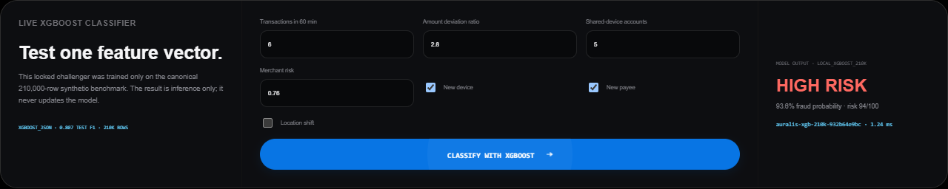
Figure 2. Browser-verified local XGBoost inference with explicit artifact version and latency.
STEP 06

Learn: turn gaps into reviewed hardening work
The feedback loop creates candidates for improvement; it never silently updates the live model.
Input | Classification | Controlled next action
Predicted FRAUD, actual LEGITIMATE | False positive | Create benign hard negative; review threshold impact
Predicted LEGITIMATE, actual FRAUD | False negative | Seed safe defense-guided mutation
Prediction matches outcome | Correct | Retain for monitoring and calibration

Defense-guided mutation
1. Replay the unseen scenario and select actual false negatives.
2. Create traceable amount, payee, device, and merchant-context stress variants.
3. Replay each variant through exactly the same feature and decision path.
4. Mark the batch HUMAN_REVIEW_REQUIRED; never change the active artifact.
5. Next, train an isolated candidate only from approved batches.
6. Compare locked metrics before any human-approved promotion.
Novelty mechanism: The red team does not generate random fraud. It searches the defender's uncertainty and blind spots, then creates traceable, plausible synthetic variants for stress testing.

Real-world Feasibility
Stage | Deployment mode | Control objective
1 | Offline simulation | Validate diversity, fidelity, model lift, and limitations
2 | Shadow mode | Score authorized live-like traffic without changing approvals
3 | Step-up recommendation | Use medium risk for extra authentication or review
4 | Selective blocking | Block only calibrated high-confidence patterns with rollback
5 | Continuous hardening | Schedule reviewed mutations, retraining, and governance

Why the prototype can evolve
• Module boundaries allow feature, model, generator, and monitoring components to split into independent services when scale requires it.
• The model adapter now serves the portable XGBoost artifact locally and can later call a separately governed model service without changing the score API.
• Redis can hold online feature state, PostgreSQL can persist scenarios and feedback, and a queue can carry nearline events.
• The hot path remains deterministic, versioned, observable, and independent of generative-model availability.

Responsible-use and security controls
• Synthetic and authorized test data only.
• No real payment credentials or customer PII in the red-team layer.
• Every scenario and decision carries provenance and version metadata.
• No uncontrolled self-training or automatic model promotion.
• Prototype metrics are never presented as production readiness.

Five-minute Demonstration
1. 0:00-0:35 - Problem. Explain why GenAI changes the speed and variety of payment fraud.
2. 0:35-1:20 - Identify. Generate a GenAI threat draft, show the blocked simulation button, approve it, then run the safe synthetic scenario.
3. 1:20-2:00 - Generate. Launch a seeded replay and explain provenance, 210,000-row lineage, and fidelity controls.
4. 2:00-2:55 - Defend. Enter a feature vector in the website and show the live XGBoost probability, decision, model version, and latency.
5. 2:50-3:40 - Learn. Generate a governed mutation batch from observed holdout misses.
6. 3:40-4:30 - Feasibility. Explain deterministic hot path, fallback, staged deployment, and human approval.
7. 4:30-5:00 - Close. State limitations and the defense-guided mutation roadmap.

Implementation roadmap
Priority | Next deliverable | Evidence of completion
P0 | Candidate training | Before/after artifact on approved mutation batches
P0 | Reference fidelity | Compare against authorized aggregate distributions when available
P1 | Calibration benchmark | Probability calibration and cost-sensitive threshold comparison on locked data
P1 | Graph intelligence | Shared-entity and ring-density lift
P1 | Observability | Drift test, metrics endpoint, durable audit trail

Submission checklist
• Runnable repository covers Identify, Generate, Defend, and Learn.
• DOCX explains attacks, generation, detection efficacy, and live-payment feasibility.
• Web prototype demonstrates the closed loop with a presentable UI.
• All synthetic metrics and limitations are labeled honestly.
• Public deployment and links are tested without requiring judge login.

Sources
• Mastercard Innovation Challenge 2026 private Kaggle overview (accessed 22 August 2026): https://www.kaggle.com/competitions/mastercard-innovation-challenge-2026
• Mastercard Innovation Challenge @ GFF 2026 public Luma brief (accessed 22 August 2026): https://luma.com/kyz978xv
• Auralis Risk repository implementation, portable XGBoost artifact, automated tests, and browser-verified prototype.
• User-provided planning documents: team work plan and Mastercard GFF 2026 AI Defense Lab Project Report.

