COrtai Sentry — operator console
UX/UI audit of the prototype and implementation instructions

Contents
Summary
Method and scope
Section 1. Critical defects
C1. The letters a, b, m and h fire as commands while text is being typed
C2. Keyboard focus is destroyed every second
C3. The focused lane can collapse to 210 px
C4. Action buttons are unreachable on two lanes out of three
C5. The Working counter is always one higher than the number of open lanes
C6. Esc does not close the modal, and the memo minimum is never stated
C7. Microphone hand-off uses the native confirm()
C8. The three-lane maximum cannot be exercised with the current data
C9. Plurals are not handled

Section 2. UX improvements
A1. Video slot takes 72 % of the lane, decision block gets 23 %
A2. Three unlabelled timers in the lane header
A3. The most urgent shift state is styled as an ordinary pill
A4. Empty centre in the top bar
A5. The console does not work from the keyboard
A6. Keyboard shortcuts are never shown
A7. The ledger is made of noise
A8. The transcript shows about 3 % of its content
A9. The same data repeats in three to five places
A10. The counters contradict each other
A11. Camera wall: the lock works, the contents do not
A12. The three-lane layout is built incorrectly
A13. Below 1180 px the console becomes a scroll strip
A14. The closeout modal
A15. Lane actions carry no risk distinction and no lane binding
A16. The note field does not show where it writes
A17. Empty states are not designed
A18. Tooltips are available on mouse hover only
A19. State changes are never announced
A20. System refusals appear far from the point of action

Section 3. UI improvements
B1. Thirteen font sizes, ten of them below 12 px
B2. Utility text falls below the contrast minimum
B3. Borders and surfaces are invisible
B4. Button, tab, chip, badge and tag are built on the same values
B5. Card and group headings are suppressed
B6. Selected and hover states are not readable
B7. Target sizes fall below the minimum
B8. The interface renders in a different typeface than specified
B9. Numeric values are set at different sizes in different places
B10. Colour is the sole carrier of meaning in three places
B11. The 24-hour heat strip has indistinguishable levels
B12. No spacing or radius scale is defined
B13. Content is clipped, and the wrong content goes first
B14. Two right-rail blocks are unstyled
B15. The focus ring is too thin
B16. Five infinite animations run in view at once
B17. Button state is expressed two ways
B18. The scrollbar is effectively invisible
B19. Input labels live only in placeholders
B20. Tinted semantic backings sit at the limit

Appendices
Appendix 1. Type scale
Appendix 2. Colour tokens
Appendix 3. Contrast audit
Appendix 4. Target sizes
Appendix 5. Component separation
Appendix 6. Spacing and radii

Acceptance checklist

Summary
The operator console prototype was reviewed as the specification for the application to be built: layout, typography, contrast, target sizes, behaviour at four screen widths, and interaction in a live run. The concept holds. The lane model, the priority-ordered queue, the voice ladder, the operator presence ledger and the mandatory closeout memo all do their job and should carry into implementation substantially unchanged.
Forty-nine findings are recorded. Nine are behavioural defects that should be fixed before visual work starts: the a, b, m and h keys fire while text is being typed and send a note to the wrong incident; keyboard focus is destroyed every second by a full re-render; with three incidents open the focused lane can collapse to 210 px, and the action buttons are hidden on two lanes out of three.
The remainder are split into UX and UI. On UX the priorities are to redistribute lane area in favour of the decision rather than the video, remove eight groups of duplicated data, and make the console operable from the keyboard. On UI the priorities are to define a type scale in place of thirteen sizes, lift utility text contrast from 2.65:1 to AA, and separate buttons, chips and tabs, which currently share the same border and radius values.
Every number in this document comes from measurement on the rendered prototype, not from visual estimation. Contrast ratios follow the WCAG 2.2 formula; sizes come from getBoundingClientRect at a 1440 px window width.

Method and scope
What was reviewed. The file COrtai Sentry — operator console.htm was opened in Chromium and checked at 1920, 1440, 1180 and 980 px.
Live run. Scenarios exercised: taking alerts from the queue until it ran dry, switching focus with A and B, binding and handing off the microphone with M, halting the ladder with H, closing an incident through the modal with memos of varying length, attempting to expand the camera wall with incidents open, checking tab order, and checking whether focus and text survive between ticks.
Criteria. WCAG 2.2 level AA — 4.5:1 text contrast, 3:1 for non-text elements and state indicators, 24×24 px target size. Because this console is worked 8–12 hours a shift, places where AAA 7:1 and a 32×32 px target are the sensible target are called out separately.
Out of scope. Performance against a real video stream, behaviour when a camera or the voice gateway drops, interface localisation, report printing and export, and second-monitor use. These are worth covering separately after phase 1.
Figures were captured from the prototype at a 1440 px window width unless the caption says otherwise. The frame marks the object the finding is about: red for the current state, green for the proposed one.

Section 1. Critical defects
Behavioural defects reproduced in a live run of the prototype. These should be fixed before visual work begins: they are independent of styling and will carry into the application along with the code.

C1. The letters a, b, m and h fire as commands while text is being typed
Observation. The global key handler does not check whether the cursor is in an input. The operator types a note or the closeout memo, and every «a» moves focus to lane A, «b» to lane B, «m» takes or releases the microphone, «h» halts the automatic voice ladder. The text still types normally, so the operator does not see what happened and the note is filed against the wrong incident.
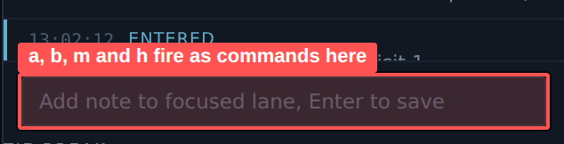
▸ Note field: while typing, the letters a, b, m and h reach the global handler

C2. Keyboard focus is destroyed every second
Observation. Once a second the whole centre column and right rail are re-rendered through innerHTML. Whatever element holds focus is removed from the DOM and focus returns to body. Driving the console from the keyboard is physically impossible: focus is gone before Enter can be pressed.
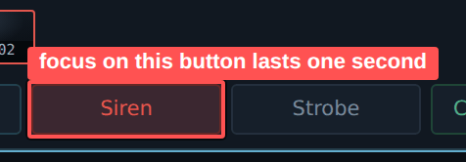
▸ Focus on the Siren button: after 1.6 s document.activeElement is BODY again

C3. The focused lane can collapse to 210 px
Observation. With three incidents open, geometry is bound to array order rather than to which lane has focus. If the focused incident happens to be the second in the array, the operator works in the narrowest column on screen while two idle lanes take 640 px each.
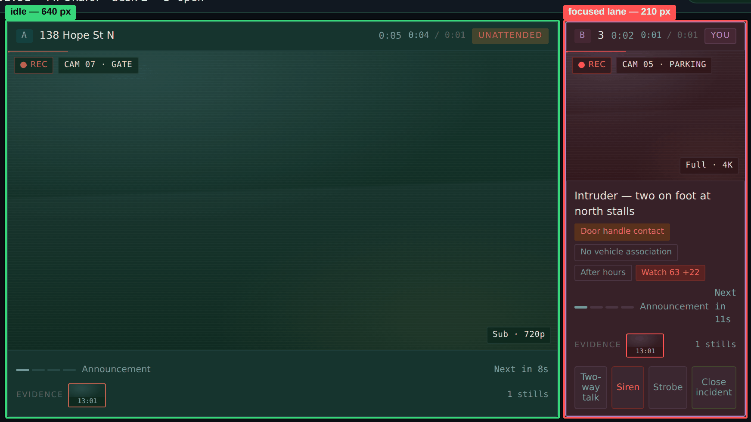
▸ Three incidents, focus on lane B: the focused lane gets 210 px, the idle one 640 px
Measurement. Measured at 1440, three incidents, focus on lane B: lane A (unfocused) — 640 px, lane B (focused) — 210 px, lane C (unfocused) — 640 px. In the narrow column the ladder row wraps onto three lines («Next» / «Announcement in» / «11s») and the evidence strip shows a single frame. Cause in CSS: .lanes.stacked is grid-template-columns: 1fr 210px with no grid-template-areas, so children are placed automatically in source order.
Instruction. Bind geometry to focus, not to index. Declare grid-template-areas with focus / mini / mini roles and assign the area by focus state. The focused lane always takes the wide area, idle lanes the narrow ones. Changing focus swaps content between areas, not their sizes.
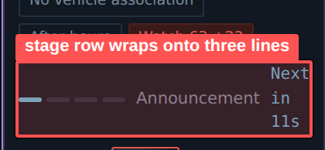
▸ In the narrow column the ladder stage row wraps onto three lines

C4. Action buttons are unreachable on two lanes out of three
Observation. With three incidents open, the .lane.mini rule hides the action block on every lane except the focused one. Triggering the siren on lane C requires moving focus there first. In exactly the situation three-lane mode exists for, this adds a step to the most urgent action.
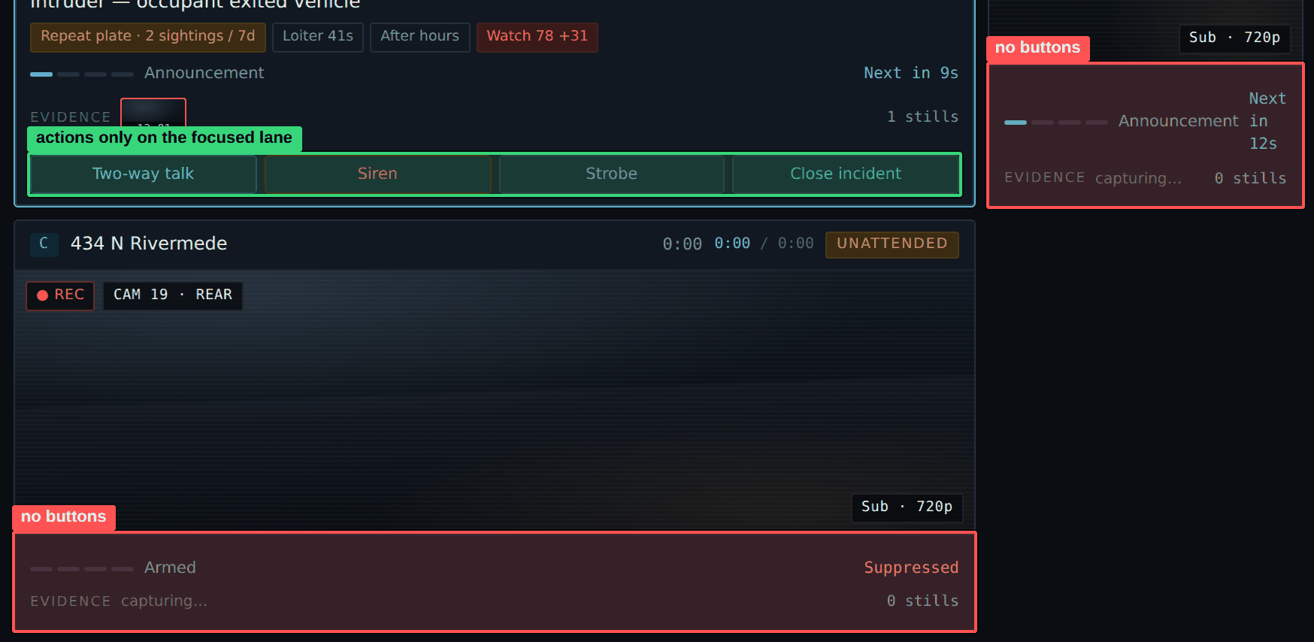
▸ Three incidents: the action block renders only on the focused lane
Measurement. Verified: with three incidents, display on .lane-acts is none for both unfocused lanes. Separately, lane C renders a «C» key badge (KEYS = ['A','B','C']) while the handler only processes 'a' and 'b' — the promised key does not exist.

C5. The Working counter is always one higher than the number of open lanes
Observation. The top bar and the queue tab count the same thing in two different ways, and the discrepancy is constant.
▸ The top bar shows «2 open», the Working tab shows «3»
Measurement. Reproduced twice: with two lanes open the top bar shows «2 open» and the Working tab shows «3». After opening a third: «3 open» and Working «4».

C6. Esc does not close the modal, and the memo minimum is never stated
Observation. The closeout modal blocks the screen and ignores Esc. The length requirement exists in code but is never shown: the operator learns it only by being refused.
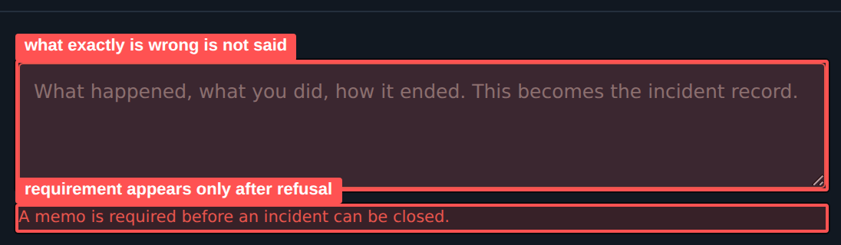
▸ The memo requirement appears only after a failed close attempt
Measurement. Reproduced: Esc on the open modal does not change the class and the window stays open. The threshold in code is memo.length < 12. A 2-character and a 10-character memo are refused, a 38-character one is accepted. The message does not say what is wrong. After a successful close the .req error class stays on. Autofocus into the memo field on open works correctly and should be kept.
Instruction. Bind Esc to «Keep open», with a confirm if text has been entered. Show a «0 / 12 characters minimum» counter from the moment the window opens, not after a refusal. Reset the error state on close.
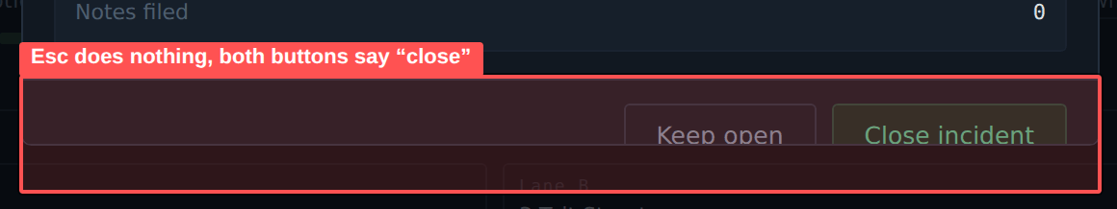
▸ Footer: Esc does nothing and both buttons say «close»

C7. Microphone hand-off uses the native confirm()
Observation. Moving focus to another lane with the microphone open shows the browser's standard dialog. It is unstyled, untranslatable, outside the interface and — most importantly — it blocks execution: while it is open everything stops, including the ladder countdowns on the other lanes.
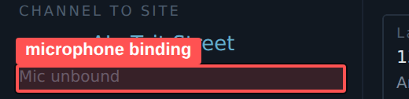
▸ Microphone binding: switching lanes raises the browser’s native dialog
Measurement. Reproduced: pressing B with the mic bound to lane A raises a confirm reading «Microphone is open to 138 Hope St N. Switch focus and close that channel?». The code contains two confirm() calls.

C8. The three-lane maximum cannot be exercised with the current data
Observation. The limit is implemented and returns a correct refusal, but it cannot be reached through the interface: the queue runs dry at the third incident.
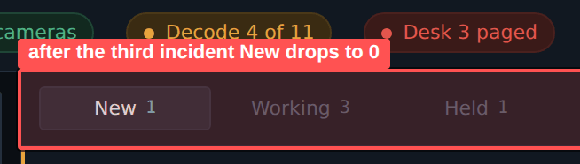
▸ After the third incident opens, the New counter drops to 0 — nothing left to open a fourth from
Measurement. Reproduced: after opening the third incident the New counter drops to 0, leaving nothing to open a fourth from.

C9. Plurals are not handled
Observation. The stills counter prints «1 stills» and «0 stills».
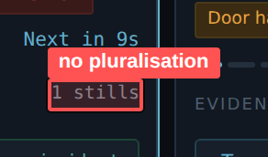
▸ The stills counter prints «1 stills»
Measurement. Reproduced in the live run on both lanes immediately after an incident opens.

Section 2. UX improvements
Findings on behaviour, information structure and operator scenarios.

A1. Video slot takes 72 % of the lane, decision block gets 23 %
Observation. The incident card gives most of its area to the video window. Everything the operator actually decides on — event title, signal chips, voice ladder stage, evidence strip and action buttons — is compressed into the bottom band. Video adds the least information here: the operator already knows there is motion on site; what is needed is what it means and what to do.
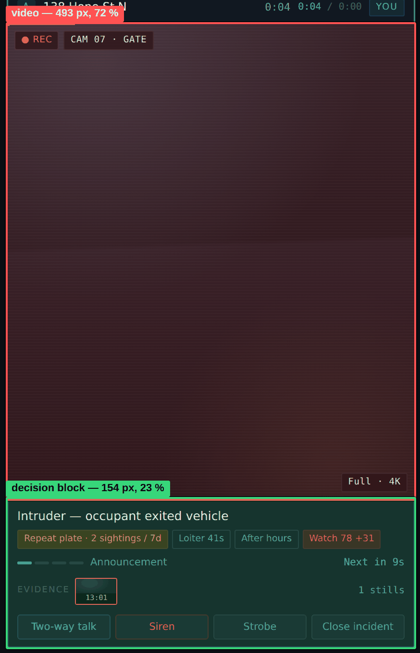
▸ Video slot 493 px against 154 px for the decision block
Measurement. Measured at 1440×900: lane height 682 px, of which .lfeed = 493 px (72 %) and .lane-b = 154 px (23 %). The rest is the header.
Instruction. Cap the video slot: 16:9 with max-height 46 % of lane height when two or three lanes are open, up to 60 % with one. Move .lane-b to flex: 1 1 auto with its own scroll and min-height 220 px. Fix the internal order: title → chips → ladder → evidence → actions.
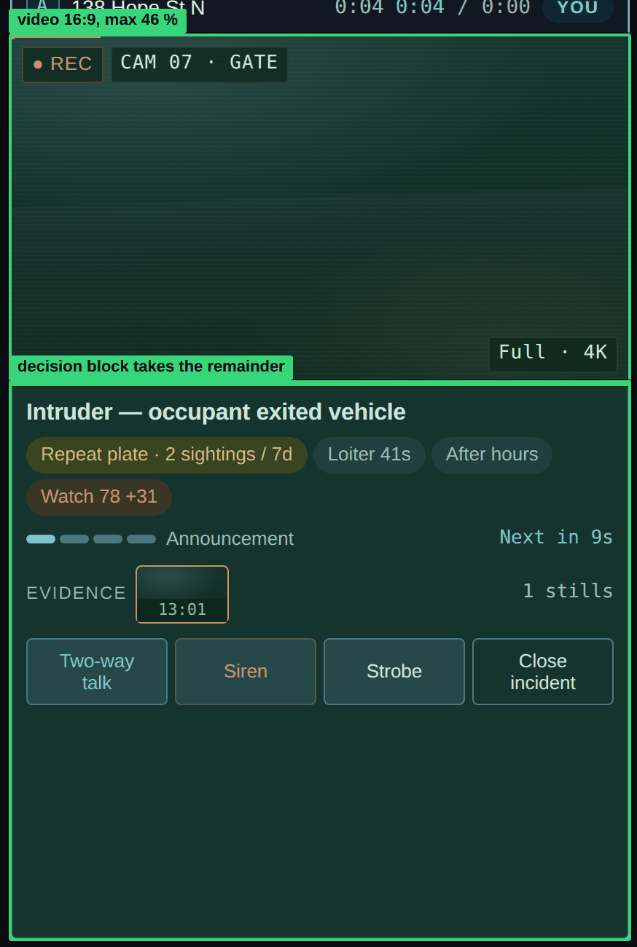
▸ Video capped at 16:9; the remainder goes to the decision block

A2. Three unlabelled timers in the lane header
Observation. The header prints «64:21 64:16 / 0:05» followed by the owner badge. Three numbers, no labels, identical formatting, three different meanings: incident age, attended time, unattended time. Only prior knowledge separates them.
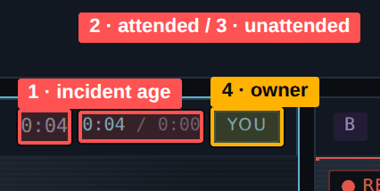
▸ Four values in a row, three of them unlabelled
Measurement. Markup: .lane-h .t (age) + .lane-h .split (attended / unattended) + .owner. The same attended/unattended pair is repeated in the right rail and in shift stats — three renderings of one value.
Instruction. Keep one timer in the header — incident age — with a text label: «Open 64:21». Remove attended/unattended from the header; the Lane activity block in the right rail already owns them. Keep the owner badge.

A3. The most urgent shift state is styled as an ordinary pill
Observation. «Desk 3 paged» means the voice ladder reached siren stage with no operator present and the system called the second desk. It is the most serious condition currently on screen. It renders as the third pill in the top right corner, same size and shape as «42 / 44 cameras».
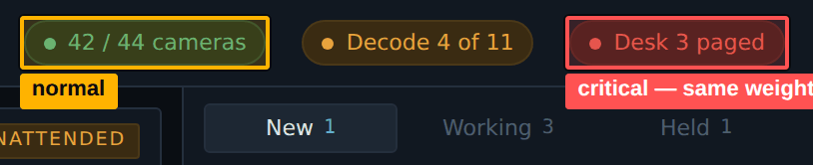
▸ «Desk 3 paged» is styled exactly like «42 / 44 cameras»
Measurement. All three pills: font-size 11 px, height 23.9 px, border-radius 100 px, identical 1 px border. Only text and background colour differ.
Instruction. Introduce three status levels. Normal («42 / 44 cameras») — plain text, no border, no fill. Warning («Decode 4 of 11») — pill. Critical — a full-width band under the top bar with icon, text, event time and an «Acknowledge» action. The band does not time out; the operator dismisses it.
▸ Critical state as a band under the top bar with an «Acknowledge» action

A4. Empty centre in the top bar
Observation. Brand and the three shift readouts are pinned left, health pills pinned right. The gap between them grows with the monitor. On a wide display the data group sits far enough left that the eye makes two separate journeys instead of one.
▸ 1440 px: the gap between the data group and the pills is 543 px, 37.7 % of the width
▸ 1920 px: the same gap is 1023 px, 53.3 % of the bar width
Measurement. Measured gap between the right edge of the last .topstat and the left edge of the first .pill: 1023 px at 1920 (53.3 % of bar width), 543 px at 1440 (37.7 %).
Instruction. Move .topbar to grid-template-columns: max-content 1fr max-content. Brand in column one, the Shift / Operator / Incidents group in column two with justify-self: center, pills in column three. Give the reclaimed space to the critical band from A3.
▸ The shift data group is centred on the screen

A5. The console does not work from the keyboard
Observation. The estate tree, watch list, queue rows, camera pips, evidence thumbnails and the lanes themselves respond to the mouse but never take focus and do not handle Enter. For a desk console built around A / B / M / H shortcuts, this breaks the primary way of working.
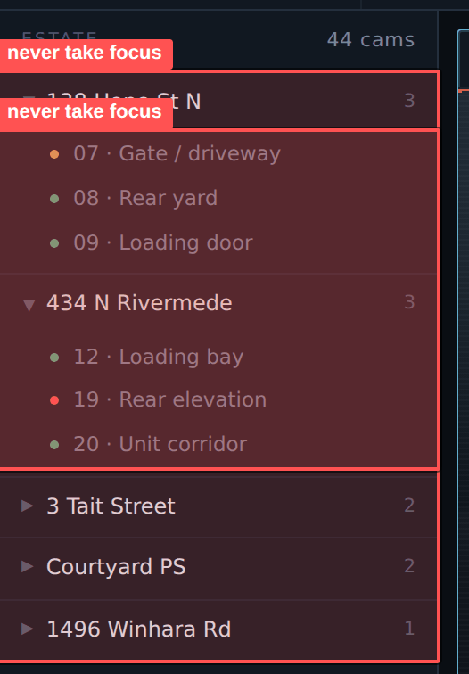
▸ Estate tree: 16 rows respond to the mouse and never take focus
Measurement. Measured at 1440: 341 elements carry cursor: pointer, 19 elements are focusable. The remaining 322 are div and span with no tabindex and no role. The document contains 19 real controls: eight lane actions, three queue tabs, the wall toggle, modal buttons and two inputs.
Instruction. Convert every clickable row to button, or give it role="button" and tabindex="0" with Enter and Space handlers. Apply roving tabindex inside the tree, the queue and the camera strip: one Tab stop, arrow keys to move. Align tab order with visual order: top bar → centre (lanes) → right rail → left rail → voice strip.
After
<!-- Old -->
<div class="cam"><span class="s live"></span><span class="n">08 · Rear yard</span></div>

<!-- New -->
<button class="cam" role="option" aria-selected="false" tabindex="-1">
<span class="s live" aria-hidden="true"></span>
<span class="n">08 · Rear yard</span>
<span class="sr-only">online</span>
</button>

A6. Keyboard shortcuts are never shown
Observation. A, B, M and H are mandatory per the brief, yet the interface mentions none of them. The «A» and «B» badges in lane headers read as identifiers, not as key hints.
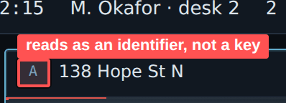
▸ The «A» badge in the lane header is the only hint at a key, and it does not read as one
Measurement. No element carries a key hint, no help panel, no legend. The only instructional text in the whole console is the note field placeholder.
Instruction. Style .lane-key as a key cap (monospace glyph in a border) with a hint on hover and focus: «Focus — key A». Add a «Keyboard shortcuts» button in the right rail header opening a legend modal. Annotate every lane action with its key in the tooltip.

A7. The ledger is made of noise
Observation. The lane ledger is filled with identical «Still captured» entries. Finding what matters during a review — operator entry and exit, voice stages, notes, manual actions — is close to impossible.
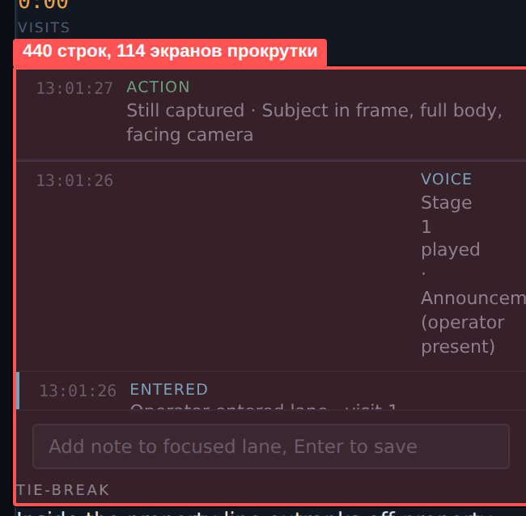
▸ Ledger: 440 rows, nearly all of them «Still captured»
Measurement. Measured: 440 .led rows, content height 23,890 px in a 209 px viewport. About 114 screens of scroll. Entered / Left / Voice events in that list: five.
Instruction. Collapse consecutive identical events into one row: «12 stills captured · 10:31–10:44 ▸», expandable on click. Show Entered, Left, Voice, Note and manual operator actions by default. Put filter chips above the ledger and an «All events» toggle.
New
12 frames captured · 10:31 – 10:44 ▸
10:44:02 Entered Оператор вошёл в лейн · визит 3
10:31:20 Voice Стадия 4 · Сирена, затем ожидание
10:22:14 Note Подтверждён тот же автомобиль, что во вторник

[ All ] [ Entered ] [ Voice ] [ Notes ] [ Actions ]

A8. The transcript shows about 3 % of its content
Observation. The voice transcript is marked «audit logged», so it is a legally significant record. It occupies a two-line window in the bottom right corner.
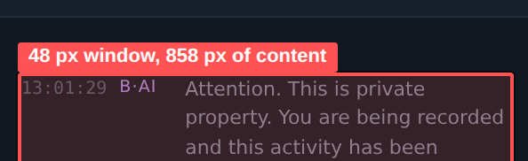
▸ Transcript: roughly two of eighteen lines are visible
Measurement. Measured: content height 858 px, visible height 48 px. Eighteen lines are in the markup; roughly two are visible at a time.
Instruction. Raise the collapsed height to at least three lines (72 px). Add expansion to 240 px by button and by key. Auto-scroll to the latest line, pausing when the operator scrolls manually. Add search and make the timestamp clickable through to the ledger.

A9. The same data repeats in three to five places
Observation. The redundancy is not cosmetic: one value is named differently in each place, so the operator has to reconcile them. Documented cases: incident count (top bar, queue tabs, shift stats); attended/unattended (lane header, Lane activity, shift stats); ladder state (.lstage in the lane, mini card in the voice strip, transcript) — and three different wordings for it: «Complete», «Siren done, no operator», «Ladder complete»; camera status (coloured dots in the tree and pips in the strip — two visual languages for the same 11 cameras); the camera 19 fault (red dot in the tree, «1 fault» counter, fault list row, queue row — four representations of one event); site name (up to five simultaneous occurrences).
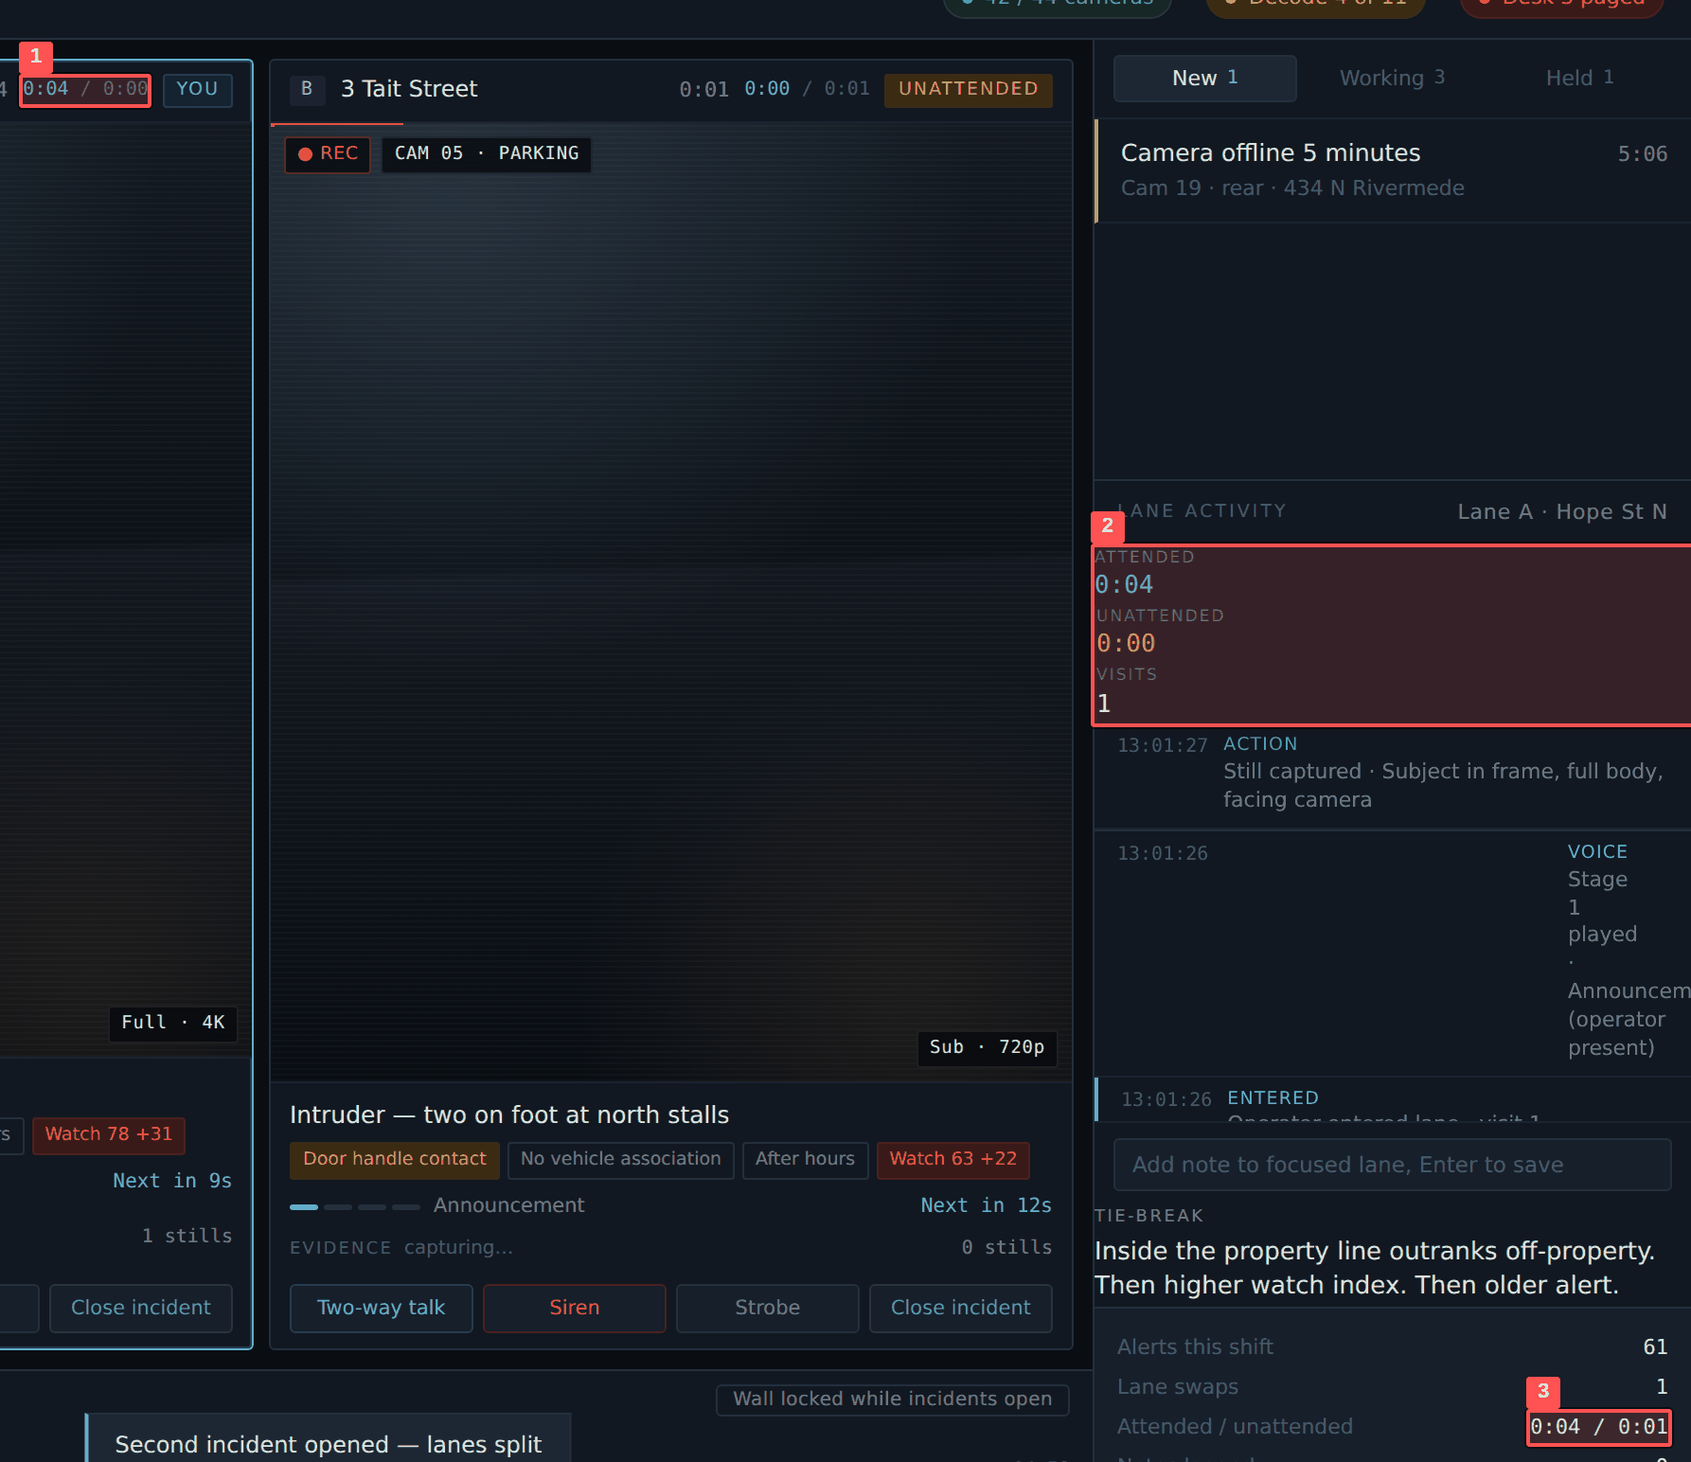
▸ The attended / unattended pair appears in three places on one screen
Measurement. Eight duplication groups on a single screen without scrolling.
Instruction. Single-source rule: each fact appears once, in the region where it is acted on. Remove attended/unattended from the lane header. Remove the ladder summary from the voice strip, keeping .lstage in the lane and the transcript entry. Reduce ladder state wording to one vocabulary. Leave only motion and faults in the camera strip; let the tree own «live».

A10. The counters contradict each other
Observation. The top bar shows «2 open», the Working tab shows «3». The operator cannot tell what counts as open or why the numbers disagree.
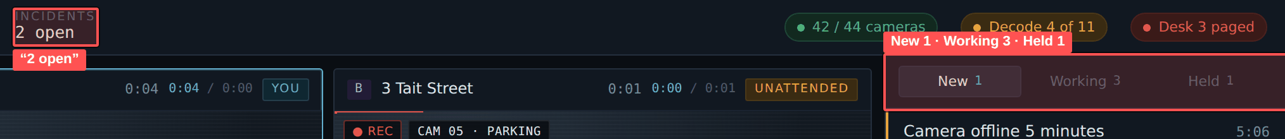
▸ «2 open» in the top bar and «Working 3» in the queue tab
Measurement. Markup: #inc-count = «2 open», #c-working = 3, #c-new = 1, #c-held = 1, open lanes = 2.
Instruction. Fix the incident state vocabulary: New — in queue, Working — holds a lane, Held — parked, Closed — closed. Define «open» as Working + Held and use the same label in both places. Make the top bar counter clickable through to the matching tab.

A11. Camera wall: the lock works, the contents do not
Observation. The lock itself is implemented correctly: with incidents open the toggle refuses to expand and explains why («Wall stays collapsed while incidents are open — lanes need the pixels»). That is a good decision and should be kept. The problems are elsewhere: the brief requires motion cameras only, but all cameras render; and expansion happens inside the camera strip flow, so the strip grows downward and pushes the lanes up.
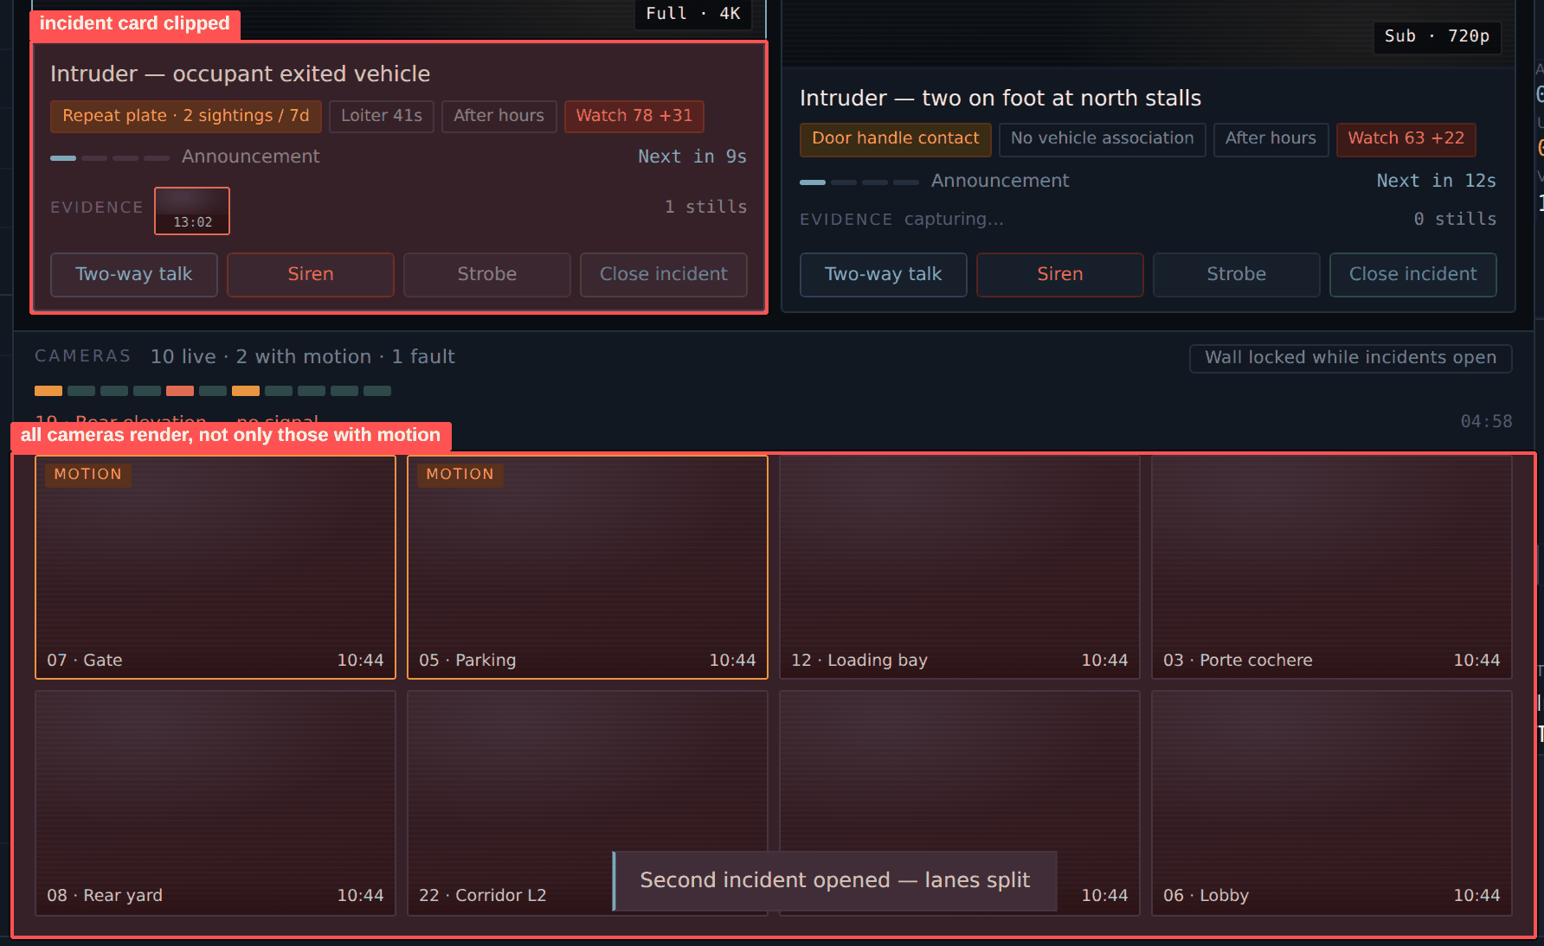
▸ Wall expanded: all cameras render and the incident card is clipped at the bottom
Measurement. Verified in the live run: clicking #rib-toggle with two incidents open leaves the wall hide class in place and shows the correct toast. When force-expanded, the strip grows downward and the bottom of the incident card is clipped mid-line.
Instruction. Filter the wall by motion as the brief specifies and show a «showing N of M» counter. Open it as an overlay above the centre column, or as a separate right-hand panel, without changing lane height. Close on Esc and on a second press. Keep the refusal copy and add an action to it: «Close an incident to open the wall».

A12. The three-lane layout is built incorrectly
Observation. With three incidents open the third lane lands under the first, lane A loses part of its content, and the second column gets an empty area half a screen tall.
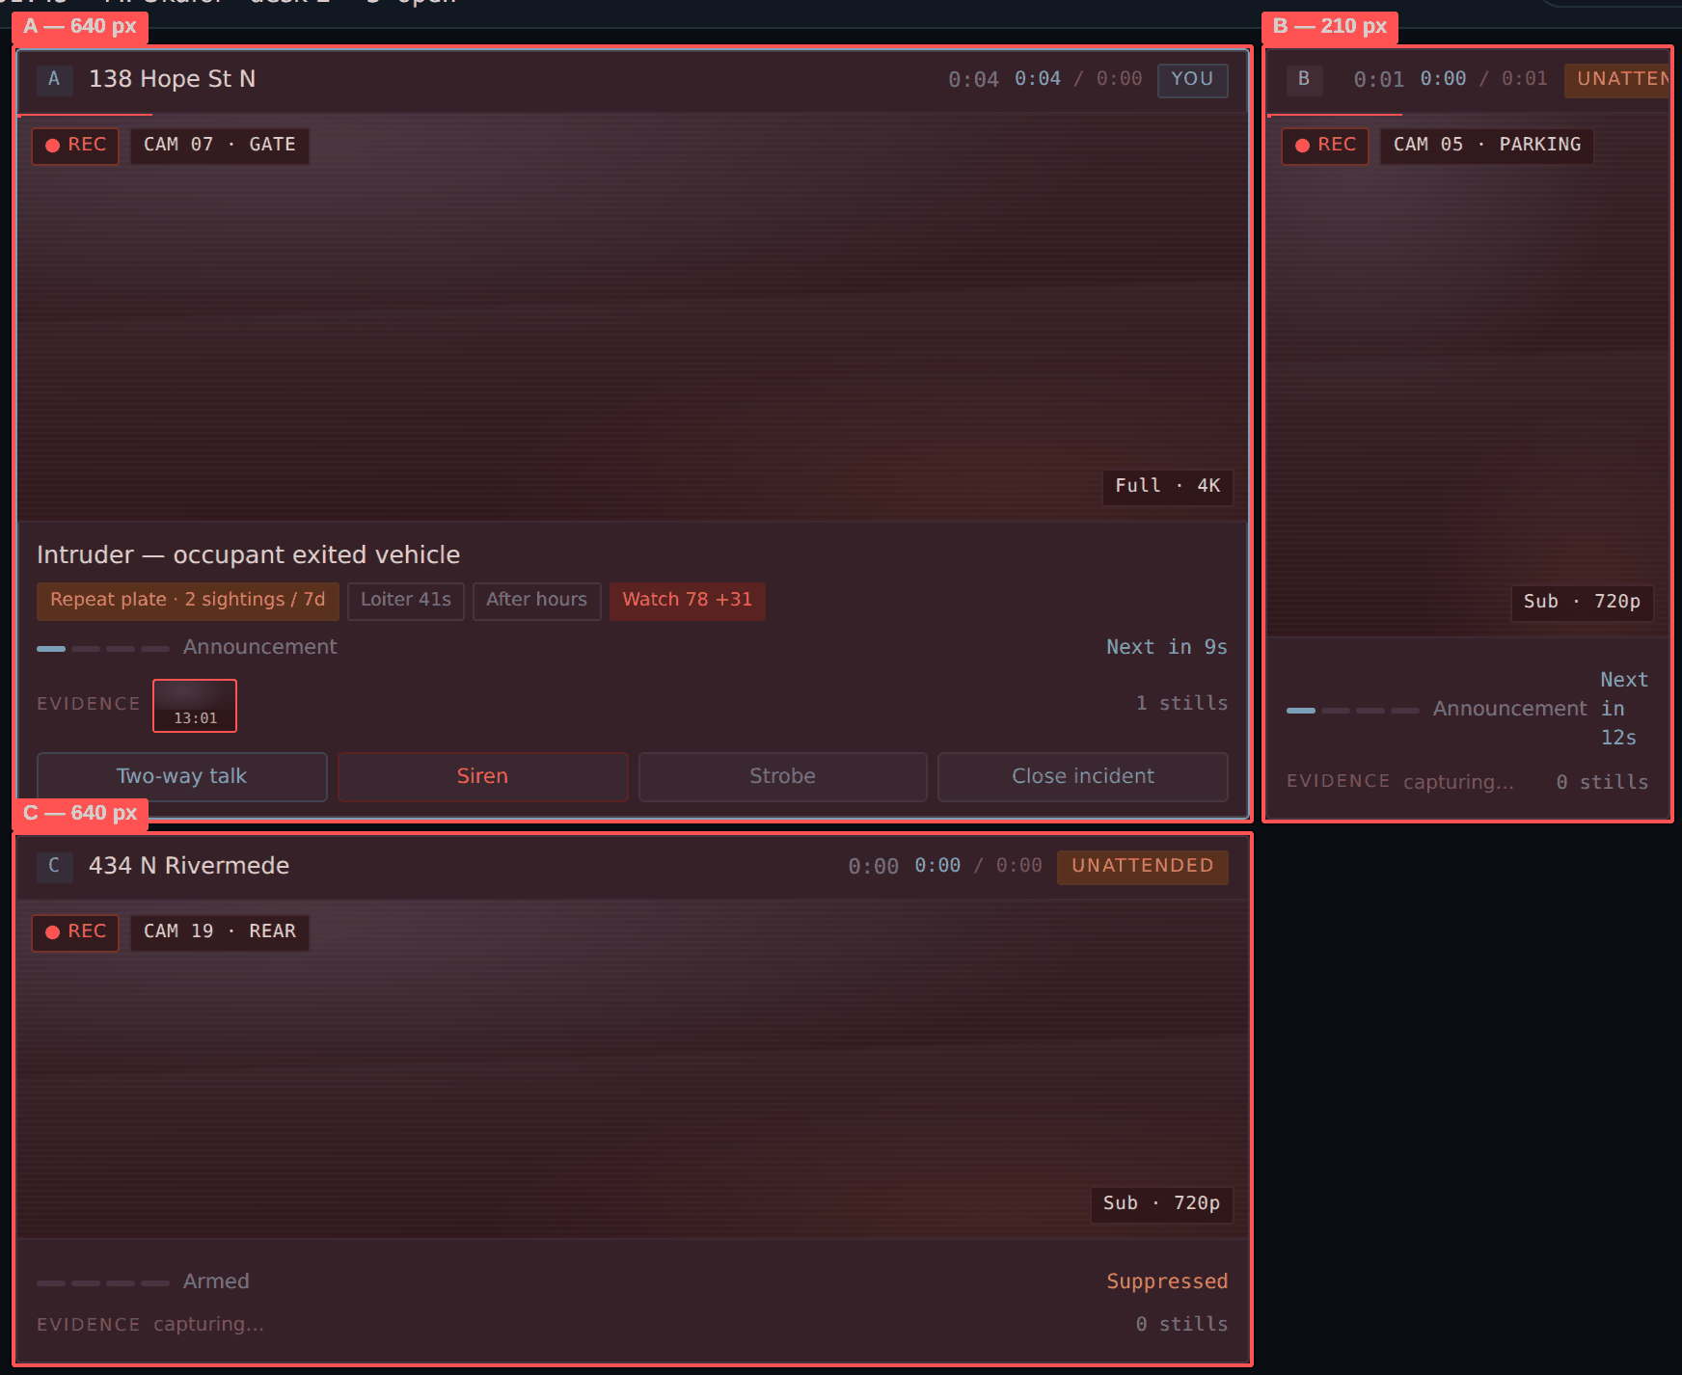
▸ Three incidents: lane C lands under lane A and the second column gets an empty area
Measurement. Cause in CSS: .lanes.stacked is grid-template-columns: 1fr 210px with no grid-template-areas. Three children are placed automatically, so the third falls into column one, row two.
Instruction. Declare explicit areas with grid-template-areas and fixed roles: focus lane / mini / mini. With three lanes the focus lane takes the full-width top row and the two minis share the bottom row. Changing focus swaps content between areas, not the geometry, so cards do not jump.

A13. Below 1180 px the console becomes a scroll strip
Observation. At 980 px the layout collapses to one column. The active incident moves off screen, the new-alert queue falls below the fold, and the video slot shrinks to its minimum.
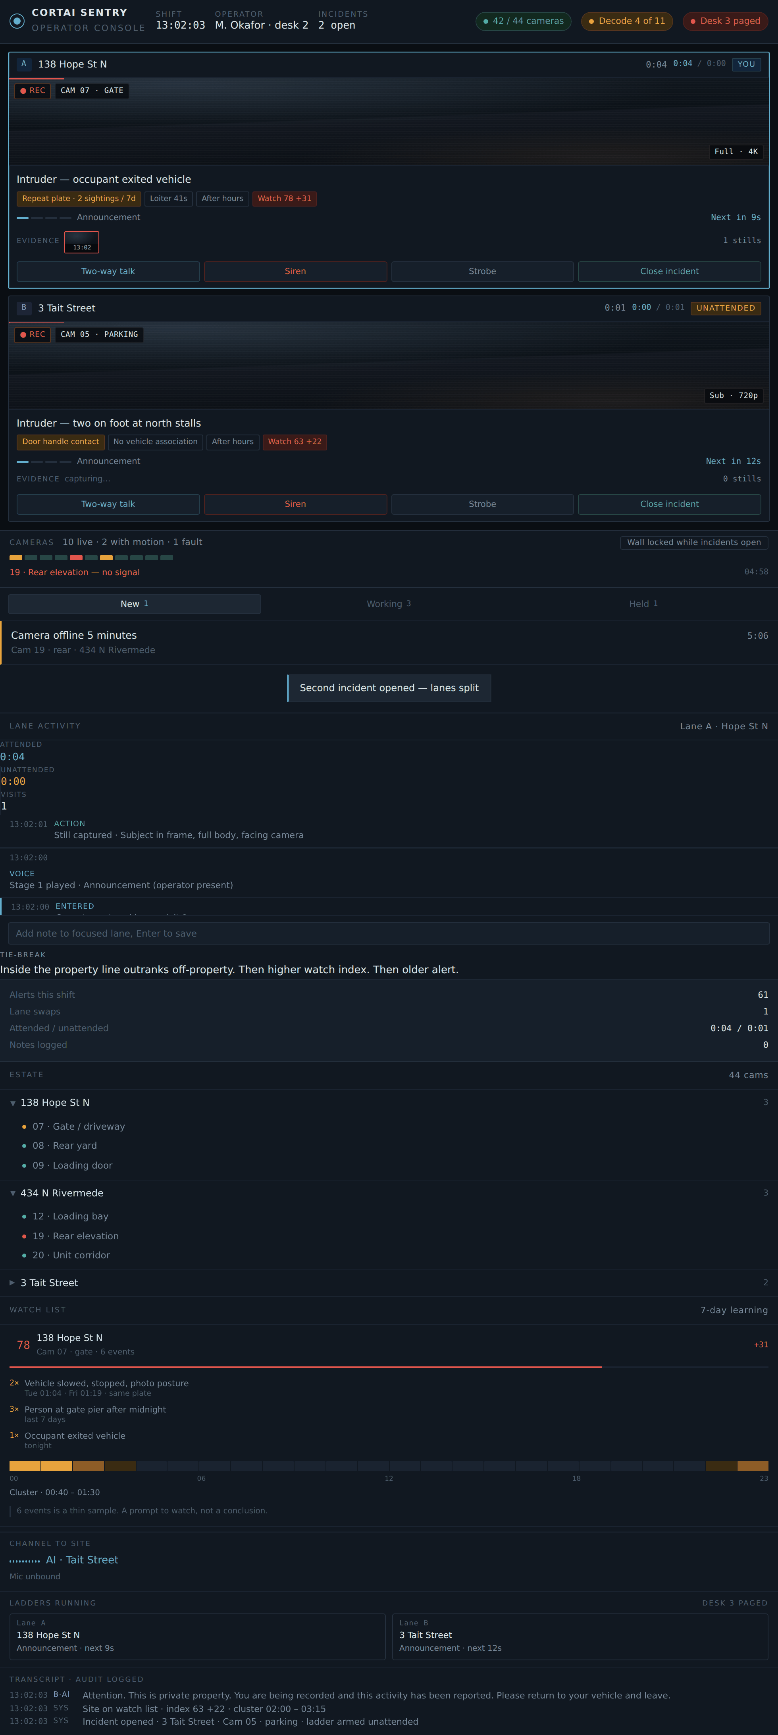
▸ 980 px: document height 4546 px; the active incident moves off screen
Measurement. Measured at 980 px width: total document height 4546 px, about five screens. .lfeed shrinks to min-height 110 px. The .scroll { max-height: 260px } rule leaves roughly 130 px of empty space in the queue area.
Instruction. A dispatch console must not scroll vertically. Below 1180 px switch to «full-height centre plus two rails as button-triggered drawers» rather than stacking. Below 1024 px show a gate screen: «This console is designed for widths from 1280 px» with a «Continue anyway» button. Remove the .scroll { max-height: 260px } rule.

A14. The closeout modal
Observation. The memo requirement surfaces only after a failed attempt. The minimum length is never stated. The footer button carries the same name as the button that opened the modal and sits next to a ✕ that also means «close» — two different closes in one dialog. The next-steps list is marked neither required nor optional.
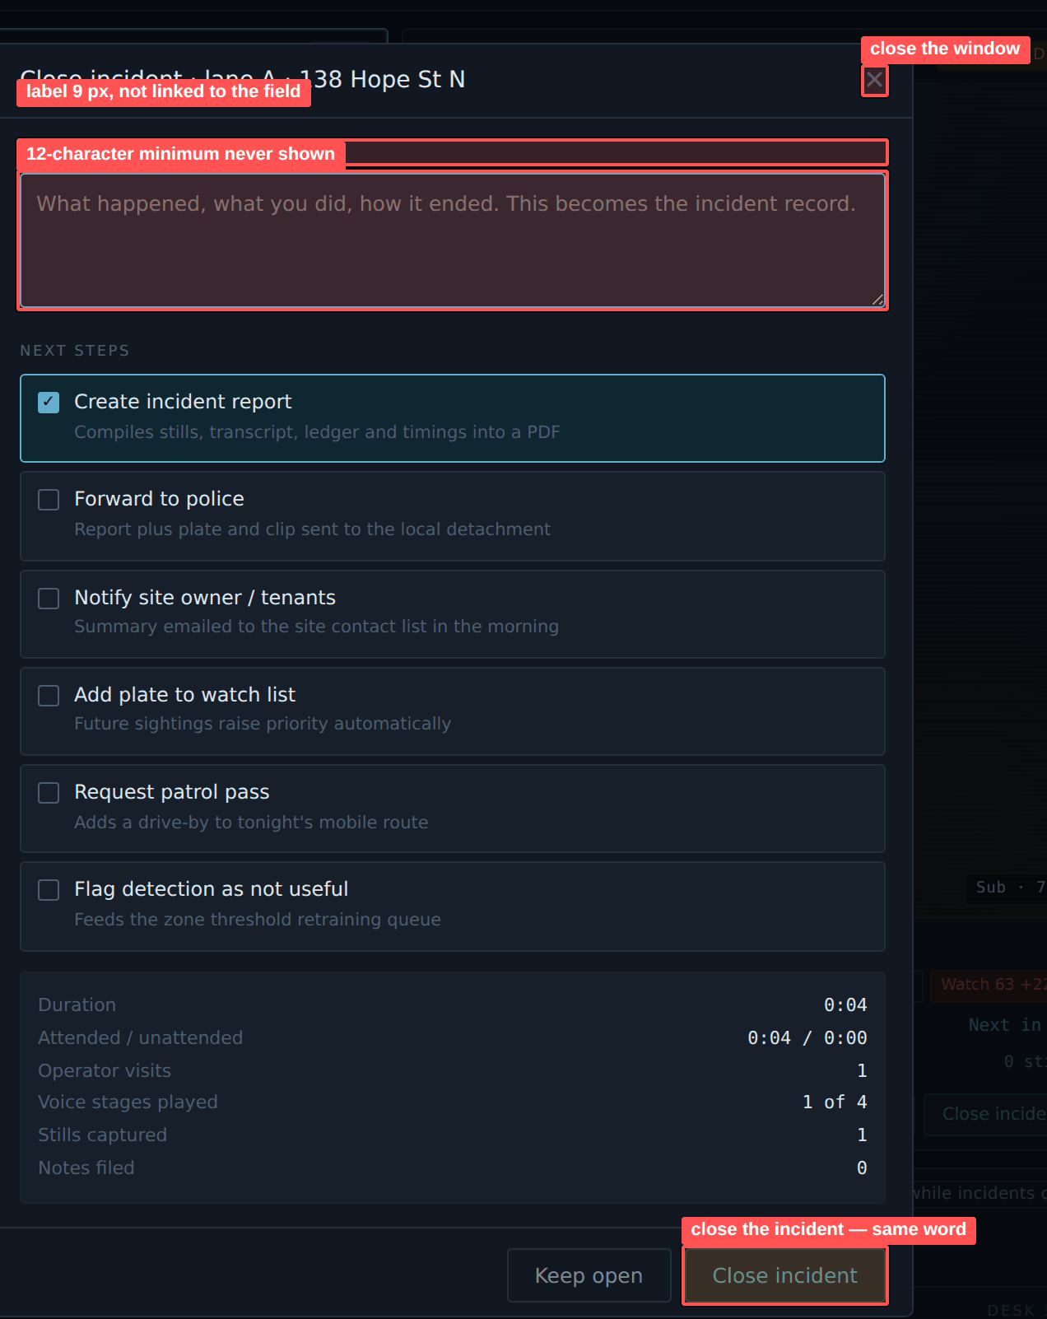
▸ Closeout modal: the label is unlinked, the minimum is unstated, two different «close»
Measurement. Markup: the label is not tied to the textarea via for; the modal has no role="dialog", no aria-modal, no link to its title. The .req message is hidden until submission.
Instruction. Show a counter under the memo field from the start: «0 / 40 characters minimum». Rename the footer buttons to «Keep open» and «Record and close». Label the next-steps block «Optional» or add a «Nothing required» option. Add role="dialog", aria-modal="true", aria-labelledby on the title, a focus trap, autofocus into the memo field, and Esc = «Keep open» with a confirm if text has been entered.

A15. Lane actions carry no risk distinction and no lane binding
Observation. Four equal-width buttons sit in one row. Siren and strobe are physical interventions on site; closing an incident is an irreversible record. The difference in consequence is not expressed by shape, size or confirmation. The same row also repeats in every lane with no indication of which lane it belongs to, while the brief makes the mic exclusive to one lane.
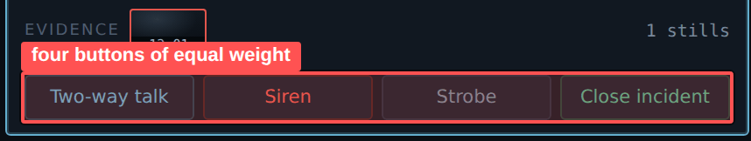
▸ Four equal-width buttons: on-site intervention and an irreversible close carry the same weight
Measurement. Markup: .lane-acts is grid-template-columns: repeat(4, 1fr); every .btn is 97×26 px. Only text colour differs: cyan, red, neutral, green.
Instruction. Split the row into two groups with a visual divider: «Intervene» (Two-way talk, Siren, Strobe) and «Resolve» (Close incident). Make Close neutral-outlined rather than green — green reads as «safe» for an action that cannot be undone. Add confirmation to Siren and Strobe: 600 ms press-and-hold, or a second click within 3 s. Dim the buttons of an unfocused lane; the first click moves focus and shows «Focus moved to lane B, repeat the action».
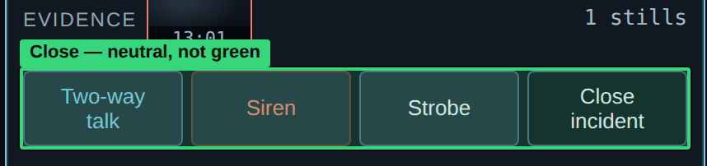
▸ Close is neutral-outlined; the green is removed, it read as «safe»

A16. The note field does not show where it writes
Observation. The only label is a placeholder that disappears on the first keystroke. The field sits under the ledger, while its target — the focused lane — can change by keypress while the cursor is in the field.
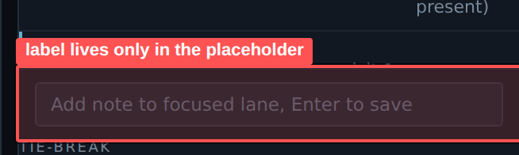
▸ Note field: the target is named only in the placeholder, which disappears on typing
Measurement. Markup: input#note-in, placeholder «Add note to focused lane, Enter to save», no associated label.
Instruction. Put a persistent label above the field reflecting current focus: «Note → Lane A · 138 Hope St N», updating as focus changes. Tint the field border to the lane colour (cyan for A, violet for B). On save, confirm with the lane name and increment the «Notes logged» counter.

A17. Empty states are not designed
Observation. The CSS carries an .empty class but no copy was written for it. An empty queue tab, no faults, an empty watch list and an empty transcript are not represented in the prototype.
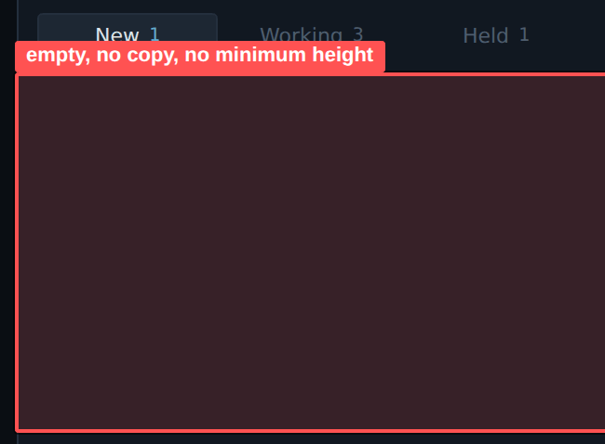
▸ Empty queue tab: no copy and no minimum container height
Measurement. At 980 px the queue area shows roughly 130 px of unexplained blank space. The .empty class appears in the stylesheet and never in the markup.
Instruction. Write copy for every empty state: what the emptiness means and what to do next. «No new alerts — queue clear since 10:31.» «No faults, all 44 cameras responding.» Give the containers a minimum height so the first row appearing does not shift neighbouring blocks.

A18. Tooltips are available on mouse hover only
Observation. Camera names in the strip and evidence still descriptions exist only as hover tooltips. They are unreachable from the keyboard, unread by screen readers and unavailable on a touch panel.
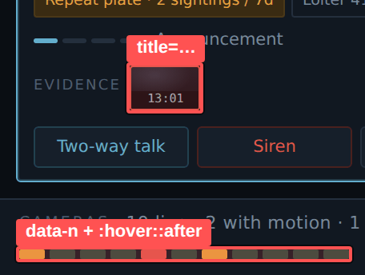
▸ Camera names and still descriptions exist only as hover tooltips
Measurement. Measured: 11 pips are described via data-n and the .pip:hover::after rule; 14 thumbnails via the title attribute. The title attribute appears after roughly a second and cannot be styled.
Instruction. Replace with a real tooltip component that opens on hover and on focus with a 300 ms delay. Give evidence thumbnails a visible caption and full-size view on click and on Enter. Print the camera number on the pip itself or under the strip.

A19. State changes are never announced
Observation. A new alert, a ladder stage change, siren engagement and the second desk being paged are communicated visually only, and only in one place on screen. An operator looking at lane B will miss an event in lane A.
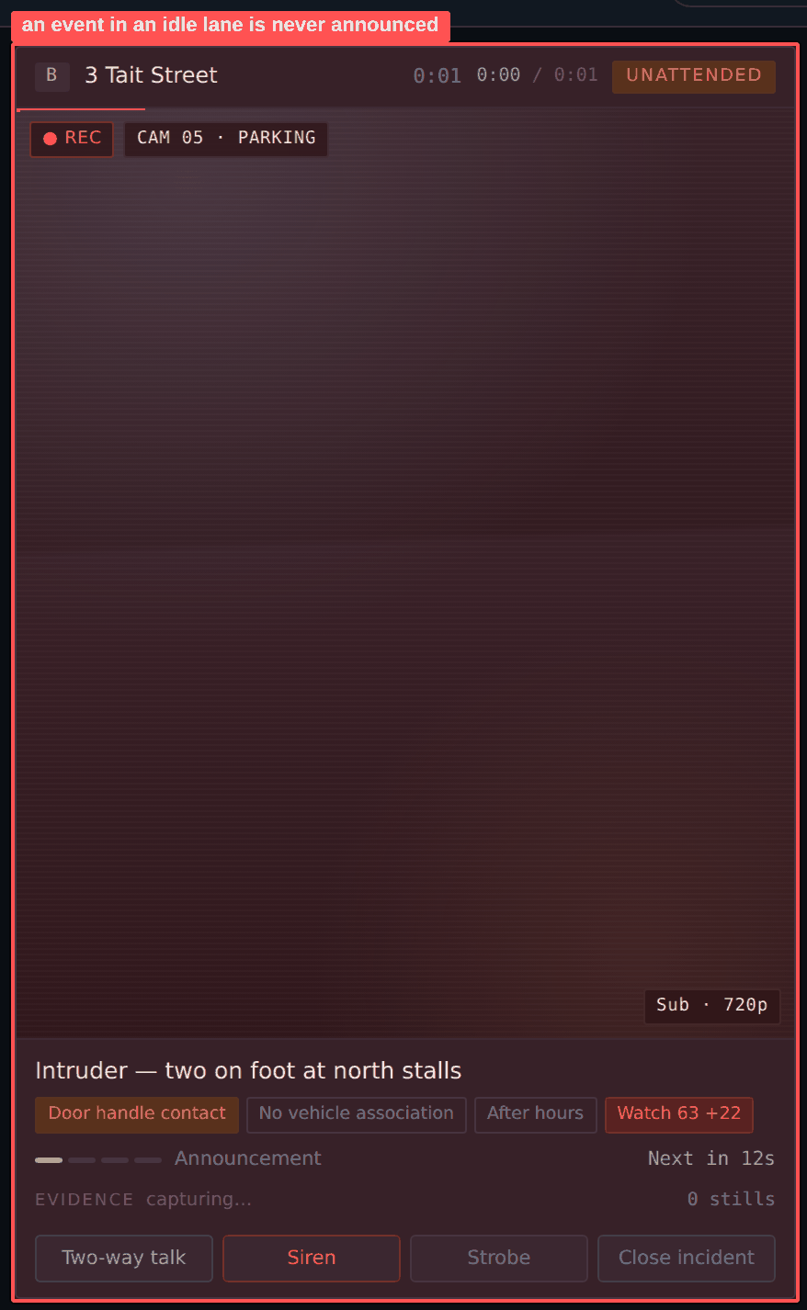
▸ An event in an idle lane: no aria-live region, no audio channel
Measurement. Measured: aria-live regions in the document: 0. aria-label attributes: 0. The only notification channel is a toast at bottom centre that times out.
Instruction. Add aria-live="assertive" to the toast container and the critical band, aria-live="polite" to the queue counters and the ladder status. Add an audio channel with three distinguishable signals: new alert, ladder reached siren, second desk paged. Volume and mute belong in shift settings.

A20. System refusals appear far from the point of action
Observation. An attempt to open a fourth lane is refused by a toast at bottom centre. The action itself happens in the right rail, in the queue. The toast times out leaving no trace, and offers no way forward.
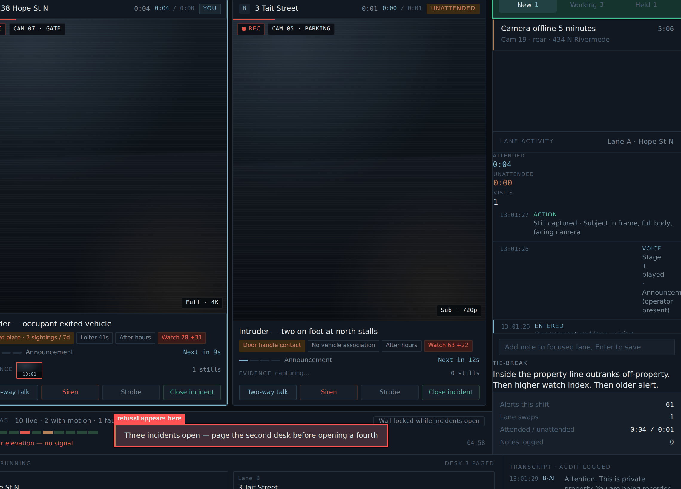
▸ The refusal arrives as a toast at bottom centre; the action happened in the queue on the right
Measurement. Markup: .toast is positioned bottom: 96px; left: 50%. The message text is «page the second desk», with no action control.
Instruction. Show the refusal where the action happened: under the queue tabs, persisting until the operator responds. Give the text a way out: «All three lanes are in use. Free lane B · Page the second desk». Reserve toasts for confirmations that require no decision.

Section 3. UI improvements
Findings on the visual layer: typography, colour, component shape, grid and states.

B1. Thirteen font sizes, ten of them below 12 px
Observation. No type scale was defined. Sizes were assigned locally, and the resulting cluster of small values in half-pixel steps has become a legibility problem in its own right.
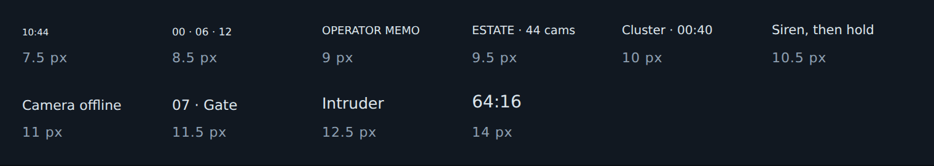
▸ Ten of thirteen sizes are below 12 px, in places stepping by half a pixel
Measurement. Census taken on the rendered page: 7.5 / 8.5 / 9 / 9.5 / 10 / 10.5 / 11 / 11.5 / 12 / 12.5 / 13 / 14 / 16 px. Most used: 10 px — 504 elements, 9.5 px — 491, 11 px — 484. The bulk of the interface is set at 9.5–11 px.
Instruction. Reduce to six steps with an 11 px floor (Appendix 1). Ban fractional values: 9.5 and 10.5 px round differently across system scaling factors and yield inconsistent line heights. Remove the 7.5 and 8.5 px micro-labels entirely.
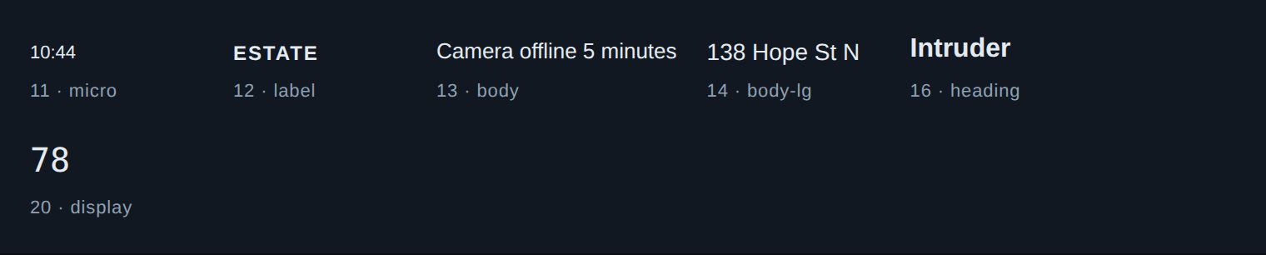
▸ Six steps, an 11 px floor, integer values only
After
/* Fractional sizes result in different rounding at system scale settings of 125% and 150% */
7.5px 8.5px 9.5px 10.5px 11.5px 12.5px → delete

/* keep only whole steps */
11px 12px 13px 14px 16px 20px

B2. Utility text falls below the contrast minimum
Observation. The --faint token sets every micro-label, section heading .hd, queue row descriptions, watch list notes, form labels in the modal and unselected tabs. This is not decorative text; it carries meaning.
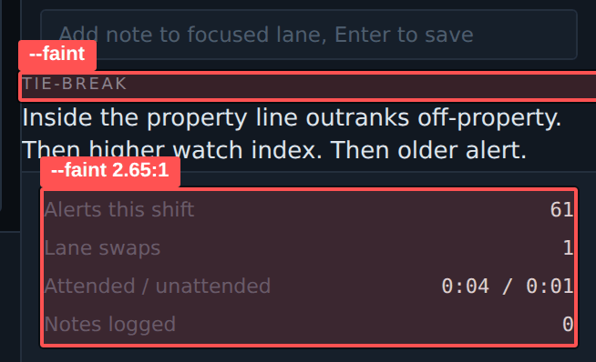
▸ --faint sets section headings and shift statistics — 2.65:1
Measurement. Measured ratios: #4E5D6E on #111821 = 2.65:1; on #161F2A = 2.47:1; on #1D2733 = 2.24:1. WCAG 2.2 AA requires 4.5:1 for body text and 3:1 for large text. None of these clears even the lower bar. The --dim token (#78889A) gives 4.92:1 on panel and 4.58:1 on .panel-2 — a formal pass with no margin.
Instruction. Remove the --faint token. Introduce four text levels (Appendix 1), the lowest of which yields 5.05:1. For a console worked 8–12 hours a shift in a darkened room, target AAA 7:1 for anything that is read rather than merely scanned.
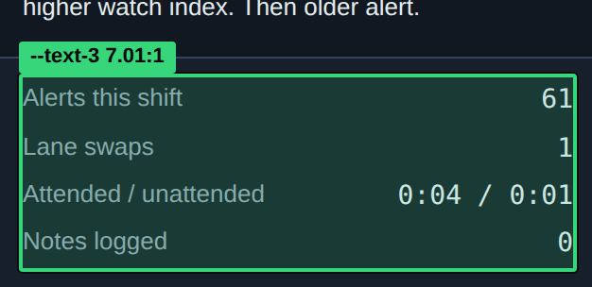
▸ Heading 8.73:1, statistics 7.01:1

B3. Borders and surfaces are invisible
Observation. This is the root cause of buttons, badges and tabs looking alike. An element is recognised by its border and its surface. Neither works here.
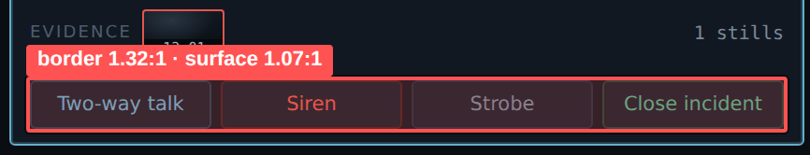
▸ Button border against panel 1.32:1, surface against lane background 1.07:1
Measurement. Measurements: --line (#242F3D) against panel — 1.32:1; the --line-soft divider — 1.13:1; the .btn surface (#161F2A) against lane background (#111821) — 1.07:1; button hover changes the fill by 1.1:1; a selected tab differs from the rail by 1.18:1; inactive ladder pips — 1.32:1; the watch bar track — 1.13:1. WCAG 2.2 criterion 1.4.11 requires 3:1 for borders and state indicators.
Instruction. Introduce three border levels: --line-subtle #232E3C (1.30:1) for decorative dividers only; --line #33445C (1.80:1) for panel and card boundaries; --line-strong #4E6684 (3.02:1) for everything interactive and for state indication. Raise the button surface to #243040 (1.34:1 against panel).
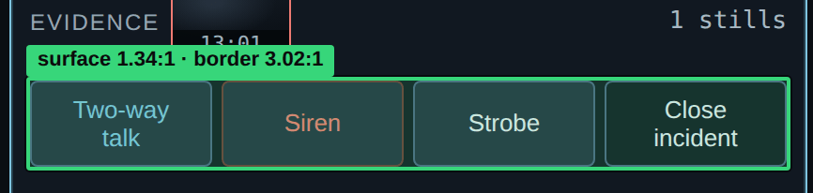
▸ Surface 1.34:1, border 3.02:1 — a button reads as a button

B4. Button, tab, chip, badge and tag are built on the same values
Observation. Five components with different purposes share one border, one radius and a near-identical type size. The only differentiator is height, and its full range is nine pixels.
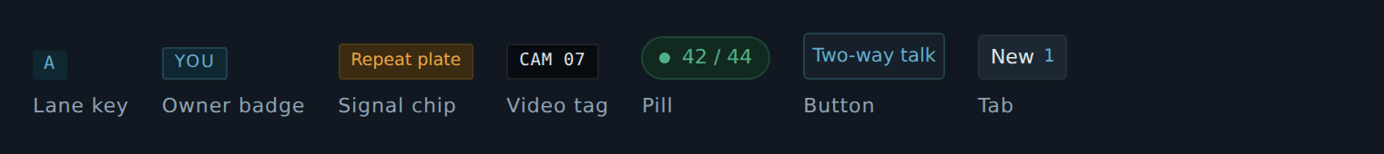
▸ Seven elements with different purposes sharing one border and a near-identical radius
Measurement. Measurements: .btn 97×26 px, radius 3, border --line. .tab 97×25, radius 3, border --line. .chip height 19.8, radius 2, border --line. .owner height 17.8, radius 2, border --line. .tag height 19.8, radius 2, border. .lane-key height 16.5, radius 2. .pill height 23.9, radius 100.
Instruction. Separate the components on three axes at once — shape, surface, type. Button: height 32, radius 4, surface --surface-raised, border --line-strong, type 14/500, mandatory hover, active, focus and disabled states. Tab: height 32, no border; selected state uses the .panel-3 surface plus a 2 px cyan bottom border. Chip: height 22, radius 999, no border, tinted fill, type 12/500, default cursor. Count badge: height 18, radius 999, number only, monospace 11. Video overlay tag: height 20, radius 2, translucent backing, monospace 11. Rule: the rectangular border is reserved for interactive elements — if it cannot be pressed, it has no border.
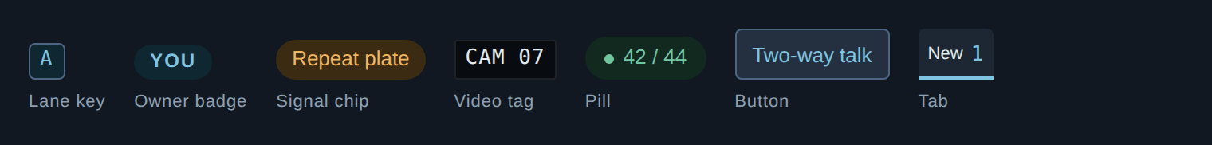
▸ Shape, surface and type separated: the border stays only on interactive elements

B5. Card and group headings are suppressed
Observation. A section heading is set smaller and paler than its own content. Groups therefore do not read as groups, and the panel reads as one continuous sheet.
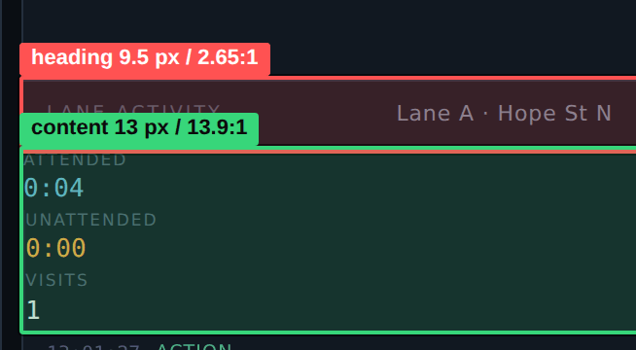
▸ The section heading is smaller and paler than its own content
Measurement. Measurements for .hd: 9.5 px, uppercase, letter-spacing 0.16em, colour --faint (2.65:1). Section content runs at 11–13 px in --text (13.92:1) and --dim (4.92:1). Semantics: the whole document contains two headings, both h3, with no h1; «Estate», «Watch list», «Lane activity», «Cameras» and «Tie-break» are marked up as div.
Instruction. Section heading: 12 px, weight 600, uppercase, letter-spacing 0.08em, colour --text-2 (8.73:1), line box 36 px, top border --line. Incident title .lane-b h3: 16 px, weight 600, colour --text-1. Hierarchy inside a card: 16 (title) → 12 (labels) → 13 (body). Bring the markup to h1 → h2 (rail sections) → h3 (incident title).
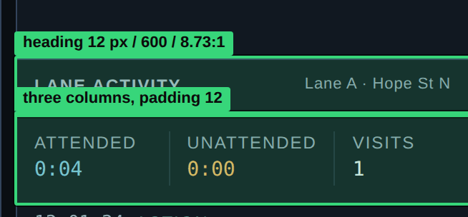
▸ Heading 12 px / 600 / 8.73:1, content laid out in three columns

B6. Selected and hover states are not readable
Observation. A selected tab, an active queue row, a hovered button and a focused lane differ from their default state by less than is needed to read them reliably.
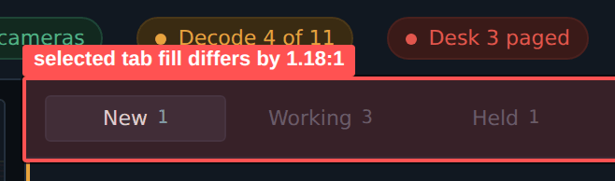
▸ The selected tab differs by 1.18:1 in fill; only text colour is dependable
Measurement. Measurements: selected tab — fill differs by 1.18:1, the only dependable cue being text colour (5.26:1 between selected and unselected). Button hover — 1.1:1. Row .row.live — 1.18:1. Inactive ladder pips — 1.32:1.
Instruction. Give every state change at least 3:1 on border or surface, and back it with a second, non-colour cue: a 3 px left bar, a 2 px underline, or a change in font weight. Text colour must not remain the sole carrier of state.
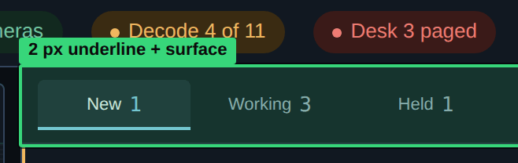
▸ 2 px underline plus surface — a second, non-colour cue

B7. Target sizes fall below the minimum
Observation. Several controls are physically smaller than needed for confident mouse acquisition, and some fall below the WCAG 2.2 minimum.
▸ Camera pip 16 × 6 px, wall toggle 187 × 17 px
Measurement. Measured at 1440 (criterion 2.5.8 requires 24×24 px): .pip 16×6 — fails; camera strip toggle #rib-toggle 187×17 — fails; .caret 13×7 — fails as a standalone target; .pips i 15×3 — decorative; the modal ✕ is 16 px of type with no declared box. Formal passes with no margin: .btn 97×26, .tab 97×25, .cam 245×24.7, .thumb 44×28.
Instruction. For a desk console take 32×32 px as the working minimum, not 24×24. Specifically: camera pip — 24×10 with a transparent hit area padded to 24×24; camera strip toggle — height 32; camera row in the tree — height 32; evidence thumbnail — 64×40; next-step checkbox — 18×18; modal ✕ — 32×32; disclosure caret — 12 px inside a 32 px row.
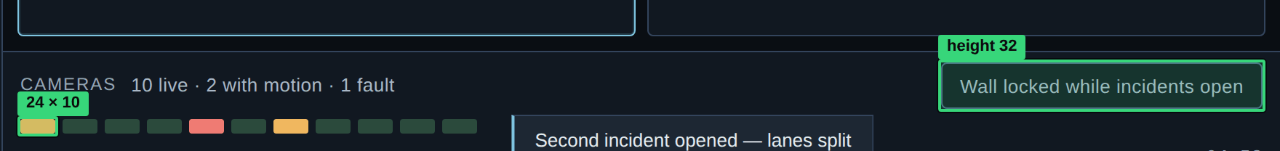
▸ Pip 24 × 10 with a 24 × 24 hit area, toggle at height 32

B8. The interface renders in a different typeface than specified
Observation. The brief fixes Archivo and JetBrains Mono. The font files are linked. Body type, however, is declared as Inter, which is not linked, so the entire interface is drawn in the operating system font — one on macOS, another on Windows.
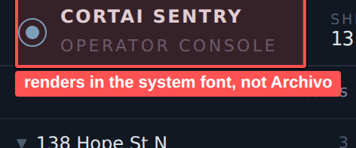
▸ The interface renders in the system font: Inter is not linked and Archivo is barely used
Measurement. Verified in browser: getComputedStyle(body).fontFamily = «Inter, system-ui, sans-serif». Archivo is declared in three weights and used in exactly one rule — .report h4. JetBrains Mono is applied correctly through the .mono class.
Instruction. Change the declaration to font-family: Archivo, «Helvetica Neue», Arial, sans-serif. Link weights 400, 500 and 600, set font-display: swap and fallback metrics via size-adjust so there is no reflow on load. Archivo keeps glyph width close to a neutral grotesque, so rail lines should not grow — verify this against the longest site names.
After
/* old */
body { font-family: Inter, system-ui, sans-serif; } /* Inter is not connected */

/* new */
@font-face {
font-family: "Archivo Fallback";
src: local("Helvetica Neue"), local("Arial");
size-adjust: 101%; /* without layout shift on load */
}
body { font-family: Archivo, "Archivo Fallback", sans-serif; }
/* connect only 400, 500, 600 · font-display: swap */

B9. Numeric values are set at different sizes in different places
Observation. The same attended/unattended pair is printed in three places at three different sizes. Comparing the values by eye is harder than it needs to be.
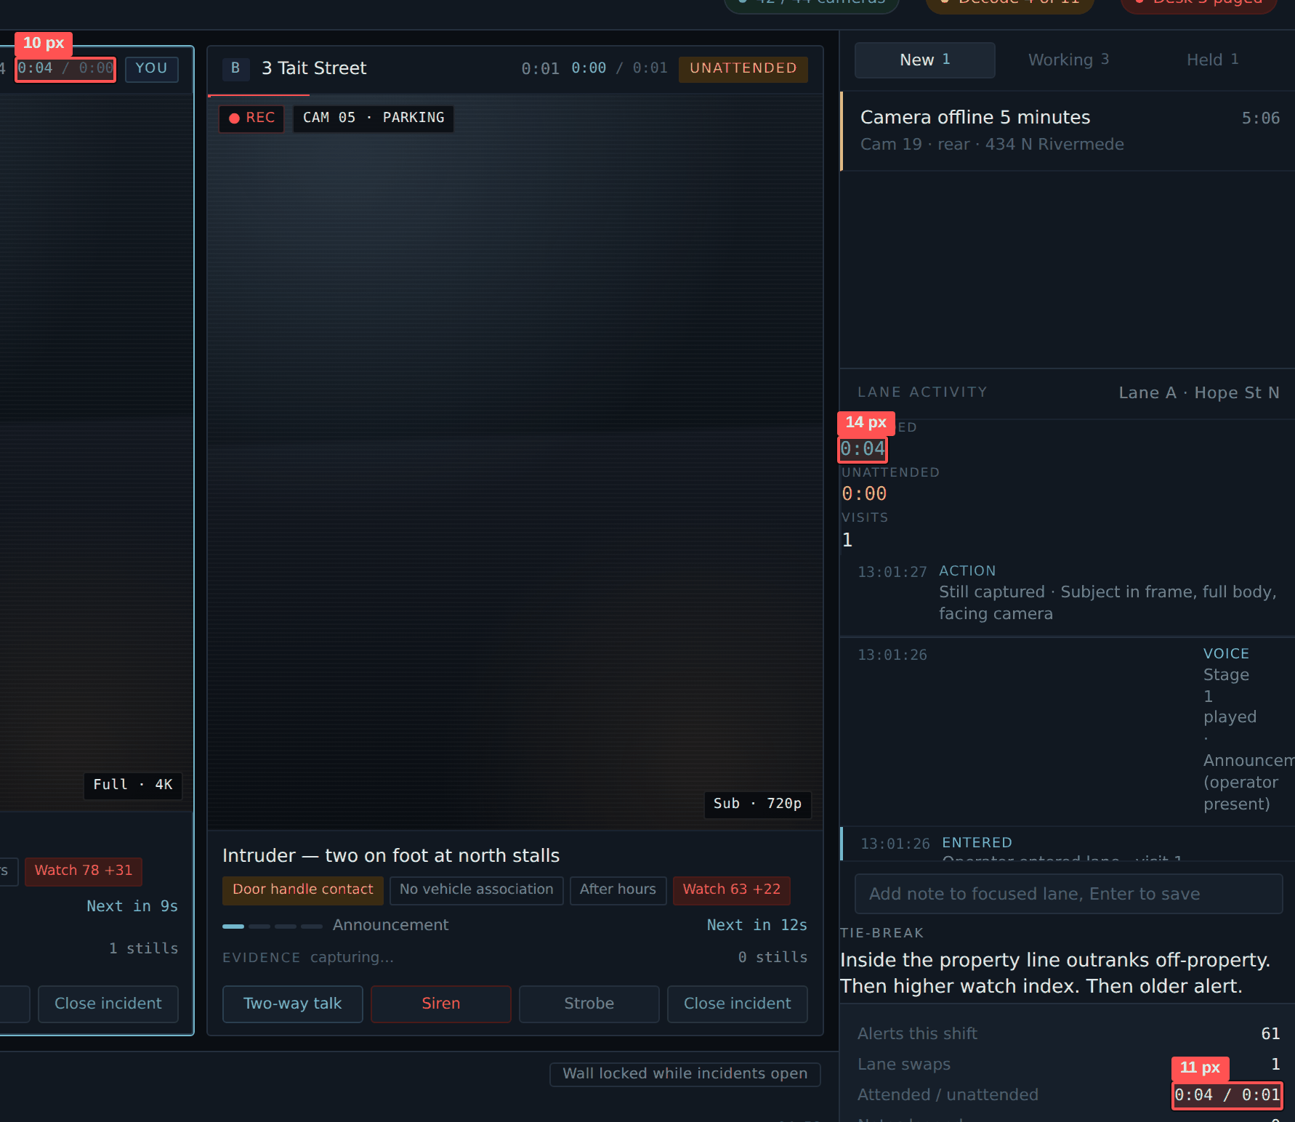
▸ The same pair is set at 14, 11 and 10 px
Measurement. Measurements: .times b — 14 px monospace; .stat b — 11 px monospace; .lane-h .split — 10 px monospace. The font-variant-numeric: tabular-nums property is declared only on the .mono class, so it does not apply everywhere.
Instruction. Bring all timers and numeric readouts to one token: 14 px, monospace, tabular-nums, right-aligned in paired blocks. Declare tabular-nums at document level for numeric elements so digits do not shift on each one-second tick.
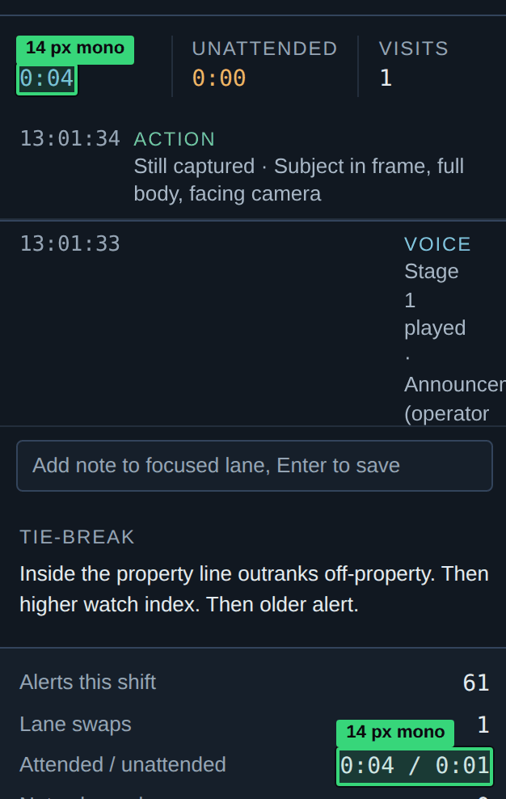
▸ All numeric readouts unified at 14 px monospace with tabular-nums

B10. Colour is the sole carrier of meaning in three places
Observation. Camera status, lane membership and action character are encoded by colour alone. Under deuteranopia red and green converge — and those are exactly the two colours marking «camera down» versus «camera healthy», and «siren» versus «close incident».
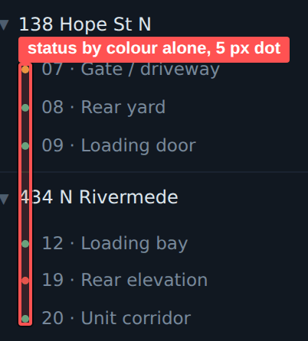
▸ Camera status is colour-only: a 5 px dot with no label and no shape
Measurement. The .cam .s status dot is a 5 px circle in --green / --amber / --red, with no label and no shape distinction. The strip pip is a 16×6 rectangle in the same three colours. Lane buttons differ only by text colour.
Instruction. Add shape as a second cue: live — circle, motion — diamond, down — square; or use icons. Print the status as text on hover and focus in both the tree and the strip. Distinguish lanes by letter as well as colour — render A and B larger. Distinguish buttons by grouping and shape rather than fill.
AFTER
live ● circle --green "online"
motion ◆ diamond --amber "motion"
down ■ square --red "no signal"

/* text state available on hover and focus,
not just on hover */

B11. The 24-hour heat strip has indistinguishable levels
Observation. The watch list strip encodes event density across four levels. The lower two are separable neither from the track nor from each other.
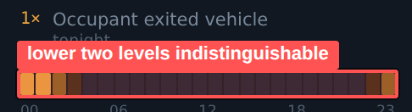
▸ Four density levels; the lower two differ neither from the track nor from each other
Measurement. Measurements: level h1 (#3A2B12) against the track (#1A2330) — 1.16:1; level h2 (#8A6220) against level h3 (#E8A33D) — 2.53:1. Element size 8.3×13 px, no hour labels beyond five markers at 8.5 px.
Instruction. Reduce to three levels with at least a 2:1 contrast step between neighbours. Raise the strip height to 16 px. Set hour labels at 11 px in --text-3. Add a focus tooltip with the event count for the specific hour.
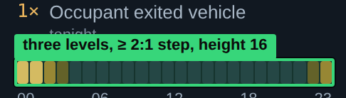
▸ Three levels with at least a 2:1 step, strip height 16 px

B12. No spacing or radius scale is defined
Observation. Values were assigned locally. As a result blocks within one rail align to different verticals and adjacent elements differ by a pixel at the corners.
Measurement. The stylesheet contains spacing values of 1, 2, 2.5, 3, 4, 5, 6, 7, 8, 9, 10, 11, 12, 14, 16, 18, 20 and 26 px, and radii of 1, 2, 3, 4, 5 and 100 px.
Instruction. Adopt a 4 pt grid: 4 / 8 / 12 / 16 / 24 / 32 as tokens --sp-1…--sp-6. Panel padding 12, gap between blocks 16, padding inside a card 8. Reduce radii to four: 2 (labels), 4 (interactive and cards), 8 (modals), 999 (pills).
After
/* 4pt grid instead of 19 arbitrary values ​​*/
--sp-1: 4px; /* gap between chips, icon-to-text spacing */
--sp-2: 8px; /* inside cards, between buttons */
--sp-3: 12px; /* panel padding, row spacing */
--sp-4: 16px; /* between rail blocks */
--sp-5: 24px; /* modal content */
--sp-6: 32px; /* major section spacing */

--r-1: 2px; /* labels: chips, tags, badges */
--r-2: 4px; /* interactive elements and cards */
--r-3: 8px; /* modal windows */
--r-full: 999px;

B13. Content is clipped, and the wrong content goes first
Observation. As the window narrows, the most important element is the first to disappear. At 1180 px the site name in the lane B header collapses to «3 …», while the three unlabelled timers keep their full width.
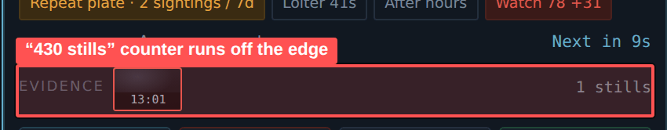
▸ 1440 px: the «430 stills» counter runs off the right edge of the evidence strip
Measurement. Measured at 1440: the .ev evidence strip has scrollWidth 457 px against clientWidth 403 px, so the «430 stills» counter runs off the edge and displays as «4». At 1180 px .lane-h b truncates with an ellipsis.
Instruction. Declare the collapse priority explicitly. Site name: flex: 1 1 auto with min-width: 12ch — truncates last. Timers: flex: 0 0 auto, first into overflow. Move the evidence counter out of the scrolling strip into the block heading where it cannot be clipped.
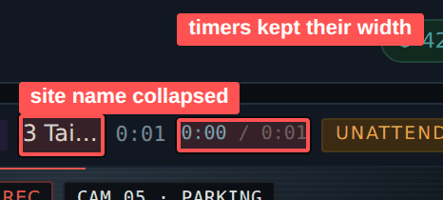
▸ 1180 px: the site name collapses to «3 Tai…» while the timers keep their width
After
.lane-h b { flex: 1 1 auto; min-width: 12ch; } /* truncated last */
.lane-h .t { flex: 0 0 auto; } /* overflows first */
.ev-n { /* moved from the scrollable strip to the block header */ }

B14. Two right-rail blocks are unstyled
Observation. The Attended / Unattended / Visits readouts are designed as three columns with dividers but render as a stack. The tie-break rule is set at base size and reads larger and more important than the shift statistics, although it is a reference footnote.
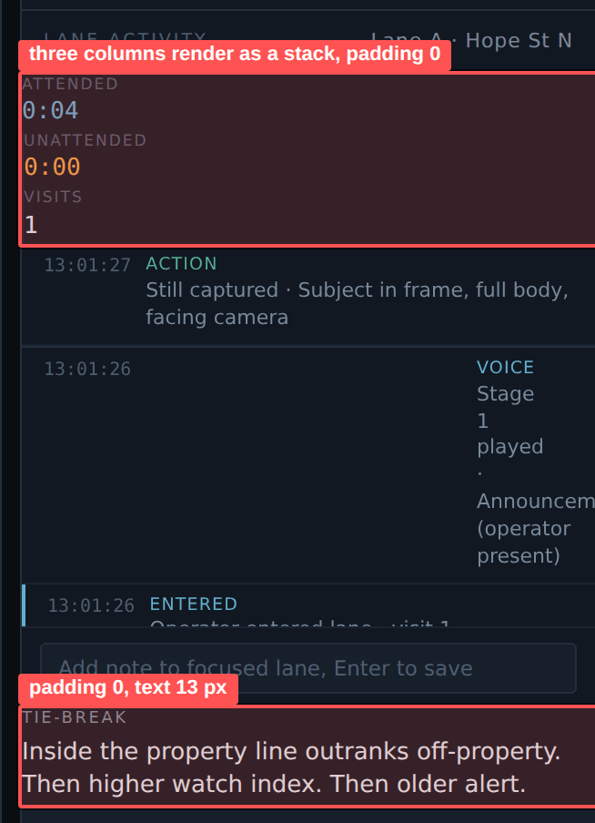
▸ .times renders as a stack; .times and .rule both have padding 0
Measurement. In CSS, .times has no display: grid — only the .times div + div { border-left } rule, so the divider is drawn to the left of the block. Both .times and .rule have padding 0, while neighbouring blocks carry 12 px, so their text sits flush against the panel edge. The tie-break rule inherits 13 px from body.
Instruction. Set .times { display: grid; grid-template-columns: repeat(3, 1fr); padding: 12px; gap: 12px } with dividers between columns. Set .rule { padding: 12px 12px 16px }. Set the rule text at 12 px in --text-3.
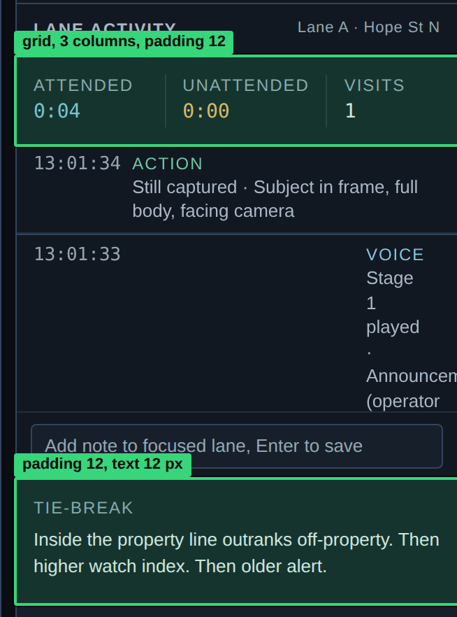
▸ Three columns with dividers, 12 px padding like the neighbouring blocks

B15. The focus ring is too thin
Observation. A one-pixel ring is discernible on panels but lost on the video slot and on tinted backings. For a console intended to be driven from the keyboard, this matters.
Measurement. Current rule: :focus-visible { outline: 1px solid var(--cyan); outline-offset: 1px }. Cyan against the --line border is 5.47:1 and against the background 7.80:1. The problem is thickness and the absence of an outer halo, not colour.
Instruction. Use a 2 px --cyan ring with 2 px offset plus an outer shadow of 0 0 0 4px rgba(99,174,205,0.25). Over video, add a 1 px white inner stroke so the ring reads against any frame. Use violet for elements inside lane B so focus also signals membership.
After
/* old */
:focus-visible { outline: 1px solid var(--cyan); outline-offset: 1px; }

/* after */
:focus-visible {
outline: 2px solid var(--cyan);
outline-offset: 2px;
box-shadow: 0 0 0 4px rgba(127, 196, 224, .25);
}
.lfeed :focus-visible { box-shadow: 0 0 0 1px #fff, 0 0 0 5px rgba(127,196,224,.3); }
.lane.b :focus-visible { outline-color: var(--violet); }

B16. Five infinite animations run in view at once
Observation. Pulsing dots, the pulsing current ladder stage, the moving detection box, the voice channel equaliser and the strobe all run continuously and compete for attention. Motion stops meaning «look here».
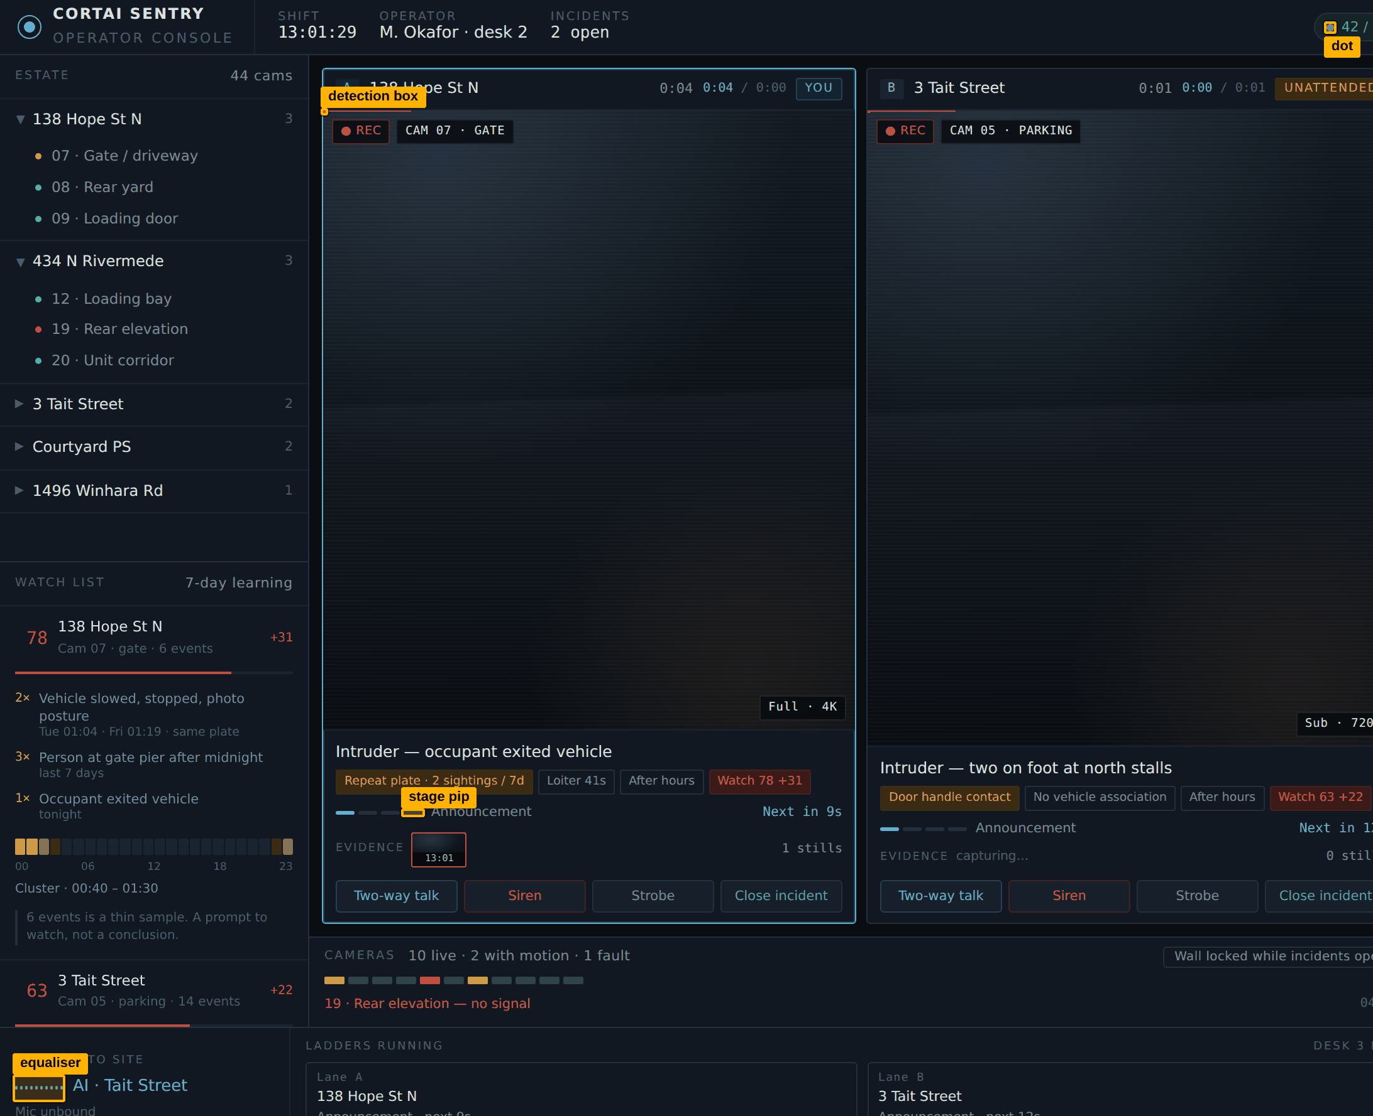
▸ Five infinite animations run in view at the same time
Measurement. Inventory: .dot.beat — 2 s; .pips i.now — 1.1 s; .bbox track — 9 s; .wave vu — 0.7 s; .lane.strobe — 1.1 s at steps(1) with 0.3 opacity white. A prefers-reduced-motion block exists in the stylesheet and disables all of the above — that part is done correctly.
Instruction. Keep pulsing only on elements that demand action, and never more than two in view. Replace the interface strobe effect with a static indicator, «Strobe active · 00:14»: reproducing an actual strobe on the operator's screen serves no purpose, and white flashing over a dark field is a photosensitivity risk. Keep any flashing indicator below 3 Hz.

B17. Button state is expressed two ways
Observation. The active state of a button is declared both through the aria-pressed attribute and through an .on class. Two sources of truth will diverge, and the visual state will then disagree with what assistive technology reports.
Measurement. The stylesheet contains both rules, .btn[aria-pressed="true"] and .btn.on, with identical styling.
Instruction. Keep aria-pressed as the single source of state and style through the attribute selector. Delete the .on class. Apply the same rule to tabs: aria-selected holds the state, not a class.
After
/* was: two sources of truth for the state */
.btn[aria-pressed="true"] { … }
.btn.on { … }

/* is now: the attribute is the single source of truth */
.btn[aria-pressed="true"] { background: var(--cyan-bg); color: var(--cyan);
border-color: var(--cyan);
}
/* the .on class has been removed; for tabs, aria-selected maintains the state */

B18. The scrollbar is effectively invisible
Observation. The thumb is painted in the same token as the invisible borders. In the ledger this is acute: with 114 screens of content the operator can see neither position nor volume.
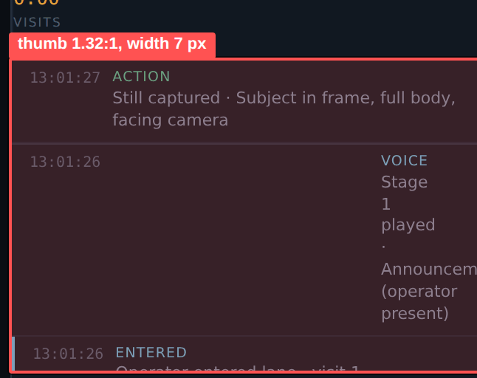
▸ Thumb at 1.32:1 with 114 screens of content
Measurement. Rule: scrollbar-width: thin; scrollbar-color: var(--line) transparent. Thumb contrast #242F3D against panel — 1.32:1. Width via the webkit pseudo-element — 7 px.
Instruction. Paint the thumb in --line-strong (3.02:1), raise width to 10 px, set the track to --line-subtle. In long lists add a persistent position readout: «showing 1–24 of 440».
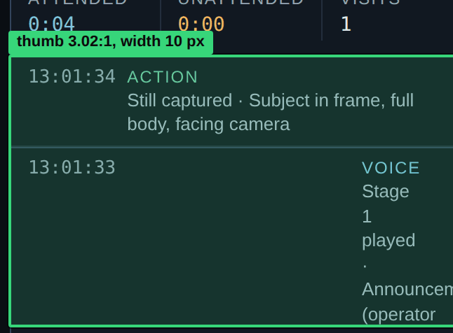
▸ Thumb at --line-strong 3.02:1, width 10 px
After
/* was */
.scroll { scrollbar-color: var(--line) transparent; } /* 1.32:1 */

/* now */
.scroll { scrollbar-width: auto;
scrollbar-color: var(--line-strong) var(--line-subtle); } /* 3.02:1 */
.scroll::-webkit-scrollbar { width: 10px; }
.scroll::-webkit-scrollbar-thumb { background: var(--line-strong); border-radius: 5px; }

/* persistent position indicator for long lists */
<span class="scroll-pos">showing 1–24 of 440</span>

B19. Input labels live only in placeholders
Observation. Neither the note field nor the modal memo has an associated label. The placeholder disappears on the first character, so the operator loses context exactly when writing begins.
▸ Note field: the label exists only as a placeholder and vanishes on the first character
Measurement. Verified in markup: input#note-in has neither a label with a for attribute nor an aria-label. The textarea#co-memo label is visually present but not linked by for.
Instruction. Add persistent labels above the fields and link them with for. Use placeholders for input examples only, never for the field name. Set the memo label, «Operator memo · required», at 12 px in --text-2 instead of 9 px in --faint.
After
<!-- was: label only in placeholder, textarea not linked to label -->
<input id="note-in" placeholder="Add note to focused lane, Enter to save">
<label>Operator memo · required</label><textarea id="co-memo"></textarea>

<!-- is now: persistent label linked via 'for' attribute -->
<label for="note-in">Note → Lane A · 138 Hope St N</label>
<input id="note-in" placeholder="Enter — save">

<label for="co-memo">Operator memo · required</label>
<textarea id="co-memo"></textarea>

/* memo label: 12px, --text-2 (8.73:1) instead of 9px, --faint (2.65:1) */

B20. Tinted semantic backings sit at the limit
Observation. Chips and pills place a saturated colour over a tinted backing of the same hue. For red this lands below the minimum.
▸ Red sets the critical chips and fault rows — 4.23:1 on its backing
Measurement. Measurements: red #E2564D on the #3A1A18 backing — 4.23:1 (below the 4.5:1 threshold), on panel — 4.82:1. Amber on its backing — 6.35:1. Green — 5.90:1. Cyan — 6.25:1. Violet — 5.44:1. Red, meanwhile, sets the critical signal chips and the fault rows, that is, the text that must be read first.
Instruction. Lighten the semantic palette: red #EF7B73 (5.78:1 on backing, 6.59:1 on panel), amber #F0B75F (7.59 / 9.90), green #6FC79E (7.59 / 8.79), cyan #7FC4E0 (8.03 / 9.24), violet #B8A6E4 (7.47 / 8.17). Keep the backings unchanged — they set the tone, not the legibility.
After
/* old → new, tinted backgrounds unchanged */
--red #E2564D → #EF7B73 4.23 → 5.78 (background) · 4.82 → 6.59 (panel)
--amber #E8A33D → #F0B75F 6.35 → 7.59 · 8.28 → 9.90
--green #4FB286 → #6FC79E 5.90 → 7.59 · 6.84 → 8.79
--cyan #63AECD → #7FC4E0 6.25 → 8.03 · 7.20 → 9.24
--violet #A088D8 → #B8A6E4 5.44 → 7.47 · 5.96 → 8.17

Appendices

Appendix 1. Type scale
Six steps instead of thirteen. The floor moves from 7.5 px to 11 px and fractional values are removed. The «Replaces» column shows which current sizes fold into each step.
Token | Size / LH | Weight | Replaces | Usage
--fs-micro | 11 / 16 | 400–500 | 7.5 · 8.5 · 9 · 9.5 | Timestamps, counters, hour labels, OSD captions
--fs-label | 12 / 16 | 600, uppercase, ls 0.08em | 9 · 9.5 · 10 | Section headings, chip text, field labels
--fs-body | 13 / 18 | 400 | 11 · 11.5 · 12 | Body text, list rows, ledger
--fs-body-lg | 14 / 20 | 500 | 12.5 · 13 | Site names, queue row titles, button text, timers
--fs-h | 16 / 22 | 600 | 14 | Incident title, panel headings
--fs-display | 20 / 26 | 500, tabular-nums | 14 | Watch index, focused lane timer, modal title

Appendix 2. Colour tokens
The «Ratio vs --panel» column is the computed ratio against the panel surface #111821. For semantic colours the pair shows the ratio against the panel and against its own tinted backing.
Token | Current | Proposed | Ratio vs --panel | Usage
--ink | #0A0E13 | #0A0E13 | — | Application background
--panel | #111821 | #111821 | — | Panel and card surface
--panel-2 | #161F2A | #161F2A | — | Inputs, nested blocks
--panel-3 | #1D2733 | #1D2733 | — | Hover, selected row
--surface-raised | none | #243040 | 1.34 vs panel | Button and tab surface
--line-subtle | none | #232E3C | 1.30 | Decorative dividers
--line | #242F3D | #33445C | 1.80 | Panel and card borders
--line-strong | none | #4E6684 | 3.02 | Interactive borders, state indication
--text-1 | #DDE4EB | #E4EAF0 | 14.73 | Primary text
--text-2 | none | #A9B7C6 | 8.73 | Section headings, secondary text
--text-3 | #78889A | #95A4B4 | 7.01 | Labels, metadata
--text-4 | #4E5D6E | #7A8A9C | 5.05 | Lowest level, reading minimum
--red | #E2564D | #EF7B73 | 6.59 / 5.78 | Critical, fault, siren
--amber | #E8A33D | #F0B75F | 9.90 / 7.59 | Warning, motion, halt
--green | #4FB286 | #6FC79E | 8.79 / 7.59 | Healthy, camera online
--cyan | #63AECD | #7FC4E0 | 9.24 / 8.03 | Lane A, focus, AI voice
--violet | #A088D8 | #B8A6E4 | 8.17 / 7.47 | Lane B

Appendix 3. Contrast audit
Measured on the current prototype. The 4.5:1 threshold is WCAG 2.2 AA for body text; 3:1 applies to non-text elements and state indicators (criterion 1.4.11).
Pair | Measured | Required | Verdict | Where it applies
--faint on --panel | 2.65 | 4.5 | Fails | All micro-labels, .hd, .row p, .wnote, form labels
--faint on --panel-2 | 2.47 | 4.5 | Fails | --faint over input surfaces
--faint on --panel-3 | 2.24 | 4.5 | Fails | Unselected queue tabs
--dim on --panel | 4.92 | 4.5 | Passes, no margin | Button text, camera rows, queue age
--dim on --panel-2 | 4.58 | 4.5 | Passes, no margin | Button text on its own surface
--red on --red-bg | 4.23 | 4.5 | Fails | Critical chips, fault rows
--red on --panel | 4.82 | 4.5 | Passes, no margin | Fault text
--violet on --violet-bg | 5.44 | 4.5 | Passes | Lane B key
--green on --green-bg | 5.90 | 4.5 | Passes | Camera health pill
--line against --panel | 1.32 | 3.0 | Fails | Every button, chip, tab and card border
--line-soft against --panel | 1.13 | 3.0 | Fails | Section dividers
.btn surface against background | 1.07 | 3.0 | Fails | A button does not read as a button
.btn hover | 1.10 | 3.0 | Fails | Hover feedback is invisible
Selected tab against rail | 1.18 | 3.0 | Fails | Tab selection state
Inactive ladder pip | 1.32 | 3.0 | Fails | Unreached voice ladder stages
Watch bar track | 1.13 | 3.0 | Fails | Watch index scale
Heat strip level h1 | 1.16 | 3.0 | Fails | Lowest event density level

Appendix 4. Target sizes
Measured at a 1440 px window width. WCAG 2.2 AA (criterion 2.5.8) requires 24 × 24 px. For a desk console 32 × 32 px is recommended.
Element | Measured, px | Verdict | Proposed
.pip — camera in strip | 16 × 6 | Fails | 24 × 10 + 24 × 24 hit area
#rib-toggle — wall toggle | 187 × 17 | Fails | height 32
.caret — site disclosure | 13 × 7 | Fails | 12 px inside a 32 px row
✕ in modal | 16 px type, no box | Fails | 32 × 32
.btn — lane action | 97 × 26 | Passes, no margin | height 32
.tab — queue tab | 97 × 25 | Passes, no margin | height 32
.cam — camera row | 245 × 25 | Passes, no margin | height 32
.thumb — evidence still | 44 × 28 | Passes, no margin | 64 × 40
.step .bx — step checkbox | 13 × 13 | Part of a row | 18 × 18
.site-h — site row | 245 × 33 | Passes | no change

Appendix 5. Component separation
This table sets the minimum set of differences at which the five element types stop being confused. The governing rule: a rectangular border is reserved for interactive elements.
Component | H | Radius | Surface | Border | Type | Cursor
Button | 32 | 4 | --surface-raised | --line-strong 1px | 14 / 500 | pointer
Tab | 32 | 4 top | transparent / --panel-3 | 2px cyan bottom when selected | 13 / 500 | pointer
Signal chip | 22 | 999 | tinted fill | none | 12 / 500 | default
Count badge | 18 | 999 | tinted fill | none | 11 mono | default
Status pill | 24 | 999 | tinted fill | none | 12 / 500 | default
Video overlay tag | 20 | 2 | rgba(6,9,13,.78) | none | 11 mono | default
Lane key cap | 22 | 4 | tinted fill | --line-strong 1px | 12 mono | pointer

Appendix 6. Spacing and radii
A 4 pt grid. Current spacing values range from 1 to 26 px with no rule; radii use six different values.
Token | Value | Usage
--sp-1 | 4 px | Gap between chips, icon-to-text gap
--sp-2 | 8 px | Card padding, gap between buttons
--sp-3 | 12 px | Panel padding, list row insets
--sp-4 | 16 px | Gap between blocks inside a rail
--sp-5 | 24 px | Padding around modal content
--sp-6 | 32 px | Major separations, header insets

Token | Value | Usage
--r-1 | 2 px | Non-interactive labels: chips, tags, badges
--r-2 | 4 px | Interactive and cards: buttons, inputs, tabs, lanes
--r-3 | 8 px | Modal windows
--r-full | 999 px | Status pills and count badges

Acceptance checklist
Acceptance list for phase 1. Each item is verified against the built application, not the mockup.
- No keyboard command fires while the cursor is in an input. Test: type «alarm at back» into the note field and confirm lane focus, microphone and ladder are unchanged.
- Keyboard focus stays on an element for at least 10 seconds without interaction.
- The focused lane always occupies the widest area, regardless of how many incidents are open or the order they arrived in.
- Acting on any open incident takes no more than one step.
- The top bar counter and the Working tab counter agree at any incident count.
- Esc closes every modal; modals have a focus trap, role and aria-modal.
- The memo length requirement is shown before the first close attempt.
- No interface text is smaller than 11 px and no fractional sizes remain.
- Any readable text is at least 4.5:1; utility labels are at least 7:1.
- Interactive borders and state indicators are at least 3:1.
- Button, tab, chip, badge and tag are distinguishable by shape and surface, not by text colour alone.
- Every click target is at least 32 × 32 px including transparent padding.
- Section headings are larger and higher-contrast than their own content and use heading markup.
- Every colour-coded state carries a second cue: shape, icon or text.
- Tab order matches visual order: top bar, centre, right rail, left rail, voice strip.
- All inputs have persistent labels linked with for.
- Every empty state has copy and a fixed minimum height.
- At 1280 px and above the console fits the screen with no vertical scrolling.
- No more than two infinite animations in view at once; the strobe is replaced by a static indicator.
- The interface renders in Archivo, not the system font.

