Exploring Weather Trends

1. I used Python in Spyder IDE for extracting the data from csv file as well as for writing the scripts.
   1. Used following SQL queries for extracting the data:
      1. *select * from city_list* : For reading my city from city list
      2. *select * from city_data where country='India' and city='Pune'* : for extracting Pune city’s data from the table.
      3. *select * from global_data* : for extracting the global data from the table
   2. Used the pandas package for reading the file , numpy for the array operations on the data and matplotlib for creating the line chart.
   3. I created averages for the common years from 1796 – 2013 for which the data was available for both my city and the global data.
   4. Moving averages of 7 years were calculated using numpy.convolve() method.
   5. Removing null/blank data was necessary as that would cause problem while calculating averages and plotting.
   6. Replaced null values in both city and global temperature data with the mean of that particular column.
   7. I decided to plot both the data on a single chart as it would be easier to visualize and compare.
2. Line Chart

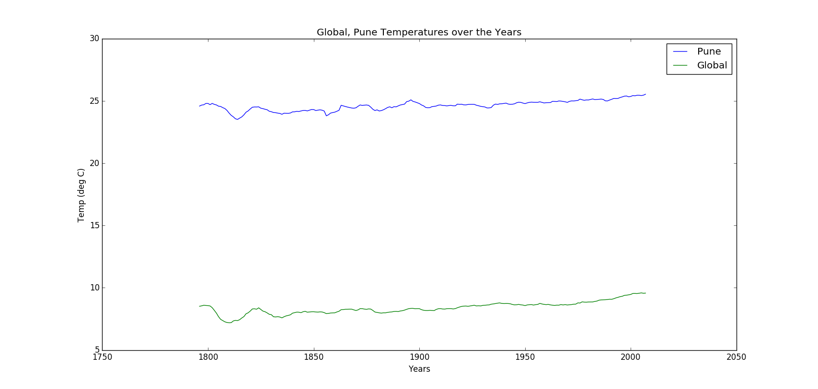

1. Observations
   1. Pune is comparatively hotter than the average global temperature over many years and which is pretty much the case for every year.
   2. Temperature dip in global over a period of time has caused same dips in Pune for that time also which shows variations in both the cases are consistent.
   3. The global temperatures have been rising from the past 100 years which is evident from the plot.
   4. Pune has slightly more fluctuations in temperature ranges whereas global temperatures have been fairly constant and increasing.
   5. Average difference between global and Pune temperatures are 15deg C over the years.
   6. Average Global Temperature : 8.4 degC
   7. Average Pune Temperature: 24.6 degC
   8. Correlation Coefficient Between Pune city’s Temperature and Global Temperature : 0.743094