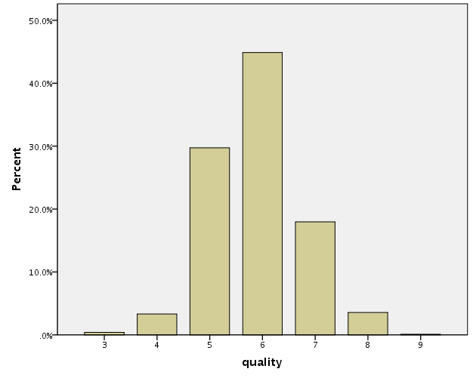

quality
 |  | Frequency | Percent | Valid Percent | Cumulative Percent
Valid | 3 | 20 | .4 | .4 | .4
 | 4 | 163 | 3.3 | 3.3 | 3.7
 | 5 | 1457 | 29.7 | 29.7 | 33.5
 | 6 | 2198 | 44.9 | 44.9 | 78.4
 | 7 | 880 | 18.0 | 18.0 | 96.3
 | 8 | 175 | 3.6 | 3.6 | 99.9
 | 9 | 5 | .1 | .1 | 100.0
 | Total | 4898 | 100.0 | 100.0

