**Chapter 3** Analysis

**3. UML Diagrams**

**3.1 Activity Diagram**

Activity Diagrams Activity diagrams are graphical representations of workflows of stepwise activities and actions with support for choice, iteration and concurrency. In the Unified Modeling Language, activity diagrams are intended to model both computational and organizational processes (i.e., workflows), as well as the data flows intersecting with the related activities. Although activity diagrams primarily show the overall flow of control, they can also include elements showing the flow of data between activities through one or more data stores.

**3.1.1 activity diagram for order**

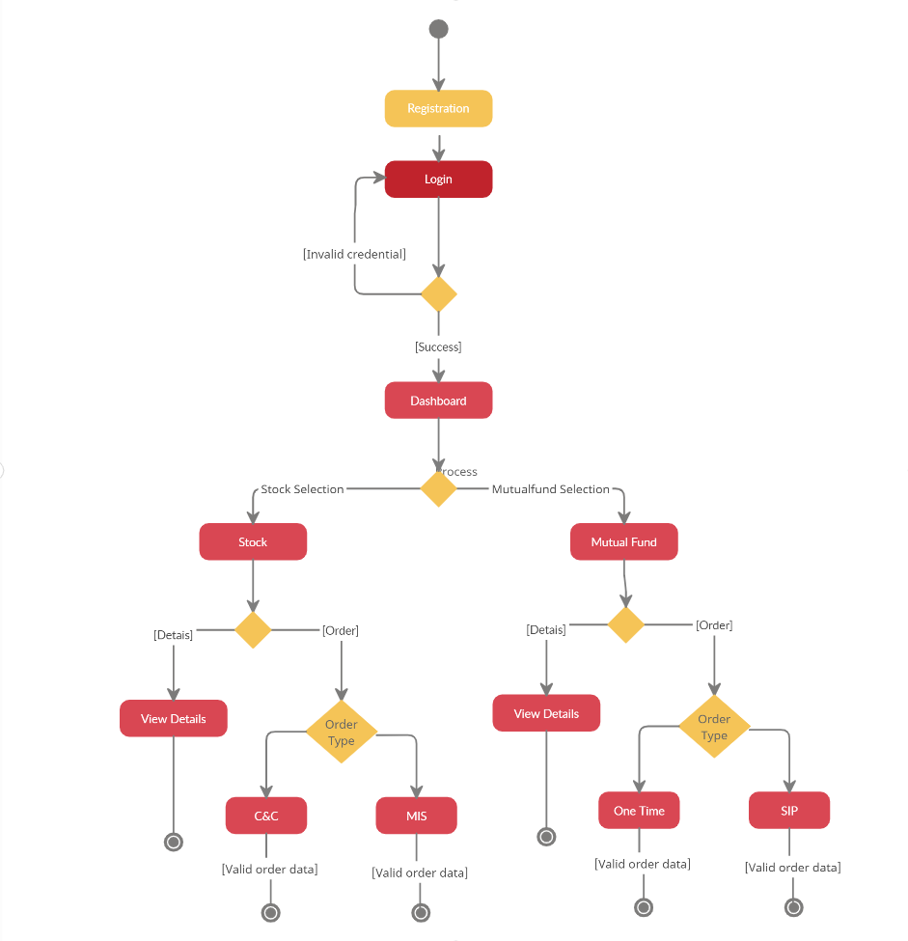

**3.1.2 Activity diagram for position**

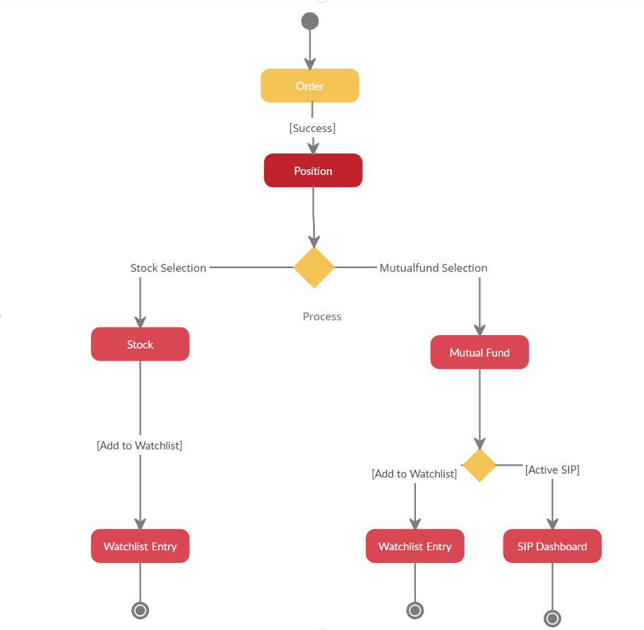

**3.2 Sequence diagram**

A sequence diagram is an interaction diagram that shows how objects operate with one another and in what order. It is a construct of a message sequence chart. A sequence diagram shows object interactions arranged in time sequence.

**3.2.1 Sequence diagram for pricing flow**

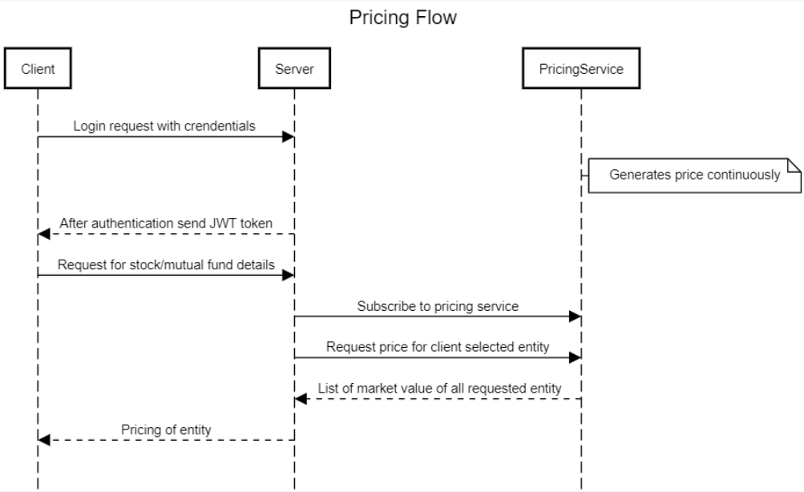

**3.2.1 Sequence diagram for order flow**

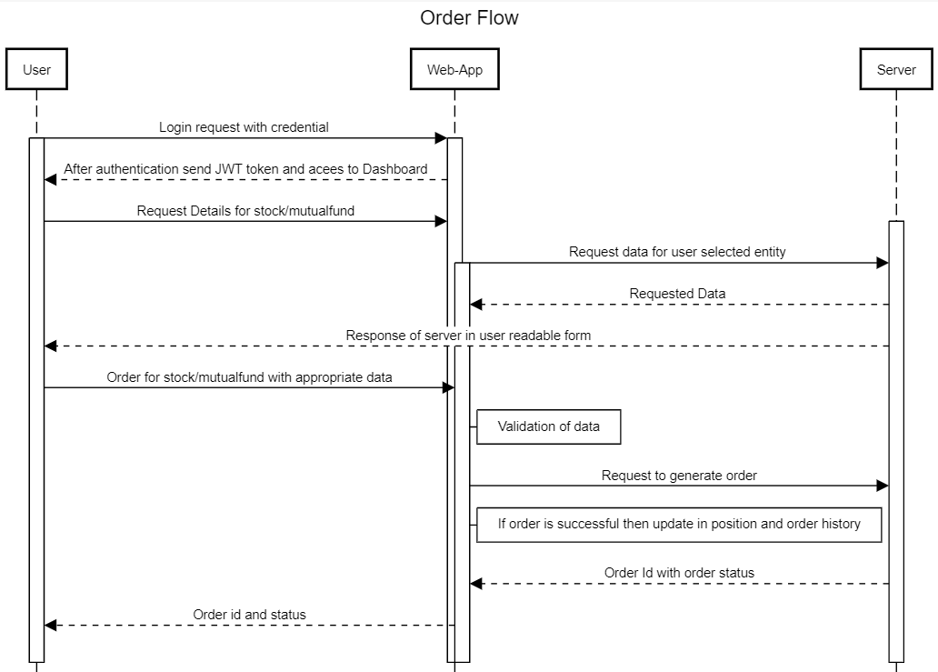

**3.3 High-Level Development Flow**

It shows high level development flow for the whole application from scratch development to deployments on kubernetes. As depicted in images first phase is of development and after building any module its tested in unit testing and after that its pushed on gitlab where CI/CD trigger the build to create an image on docker and after completion of this phase it’s deployed on kubernetes.

**3.3.1 Overall application flow in development**

