**4**

**Design**

**4.1. UI Mocks**

**Pirimid Trading Platform**

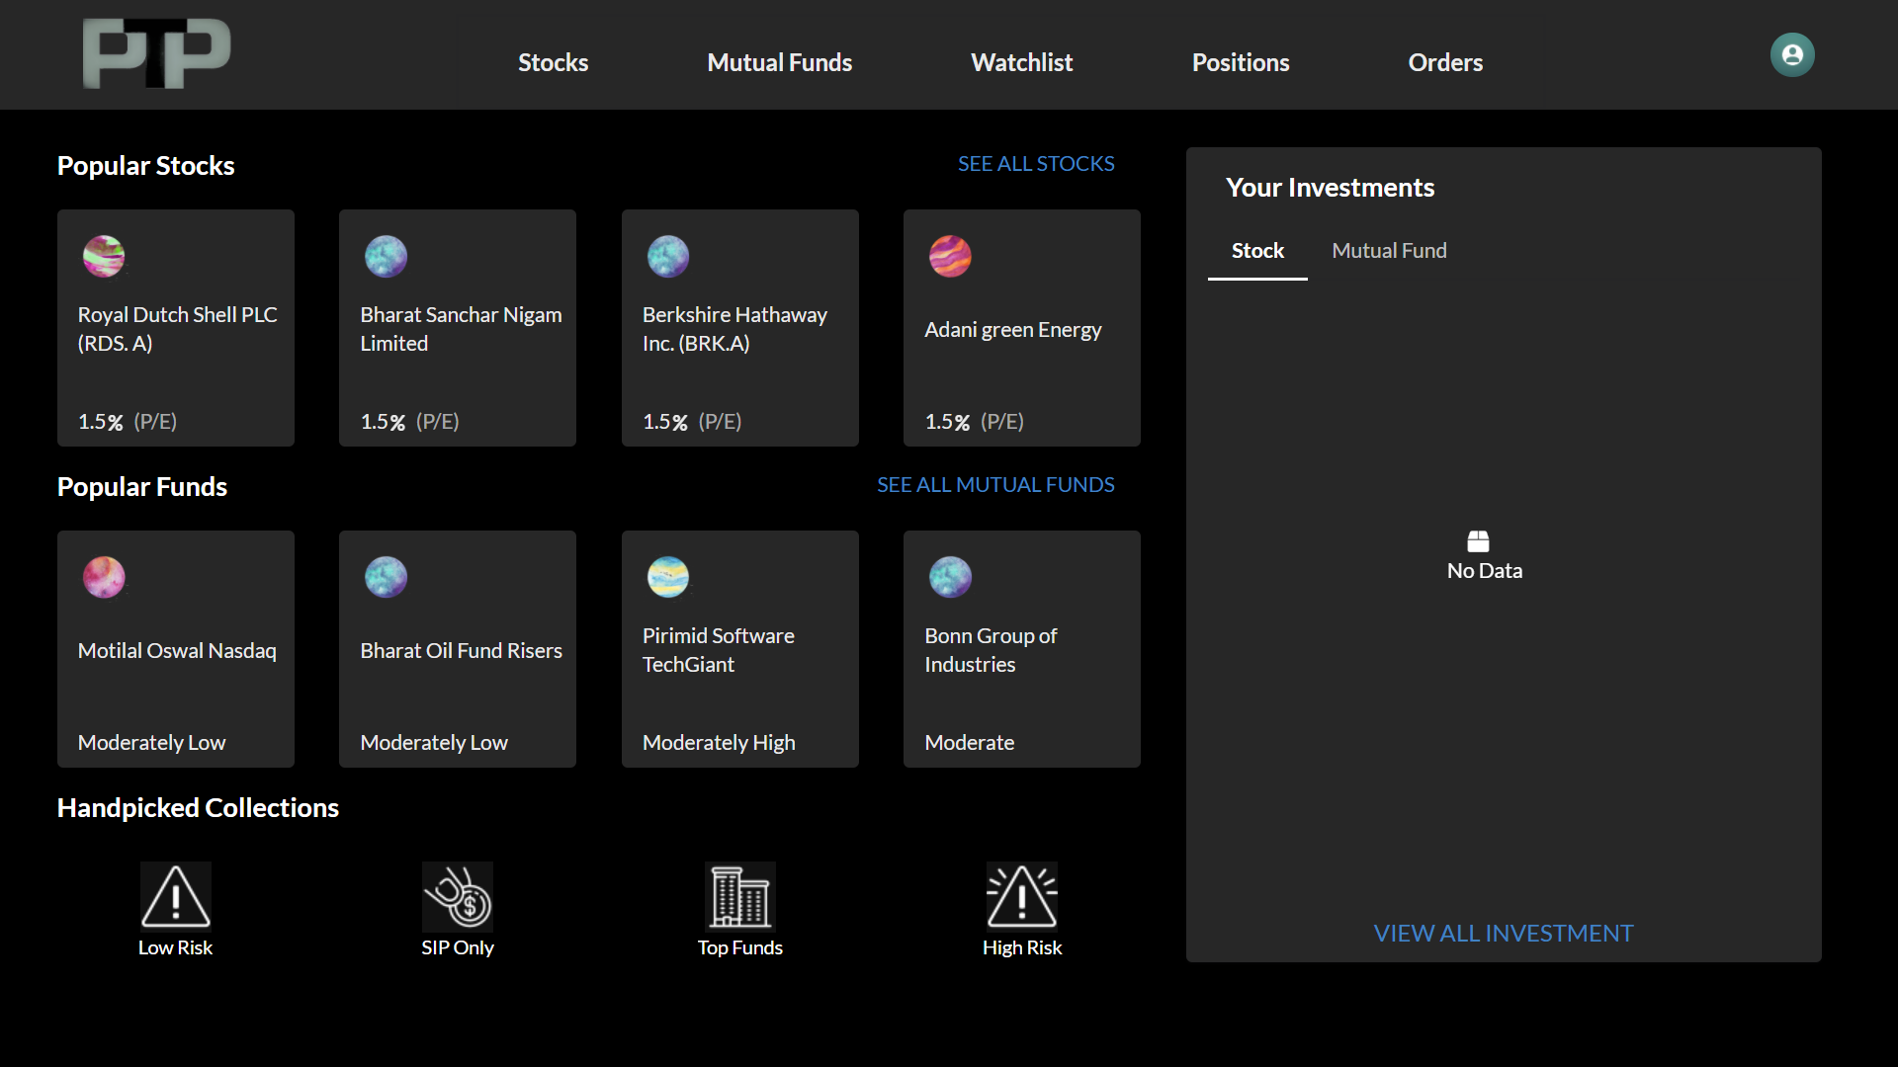

Figure4.1-Pirimid Trading Platform-Dashboard

**Authentication of user**

* Users have to go through the registration and login process, which involves simple registration with email and password.
* For further authentication of user in our session less system we are using

JWT (Json Web Token) as base for authentication

**KYC**

* Without KYC verification user can not involved in buying or selling of any asset of this system
* Users have to have KYC verified to utilize full benefit of the system.

**Dashboard**

* Figure3.1 shows the landing page for the user in the system. When we have most popular assets to invest in as well as their current standing in the share market.
* System also suggests handpicked collections for our assets, formed by experts to give amateur investors a good idea about where to start.
* Dashboard also provides navigation to respective screens for assets, portfolio management and watch over particular assets.

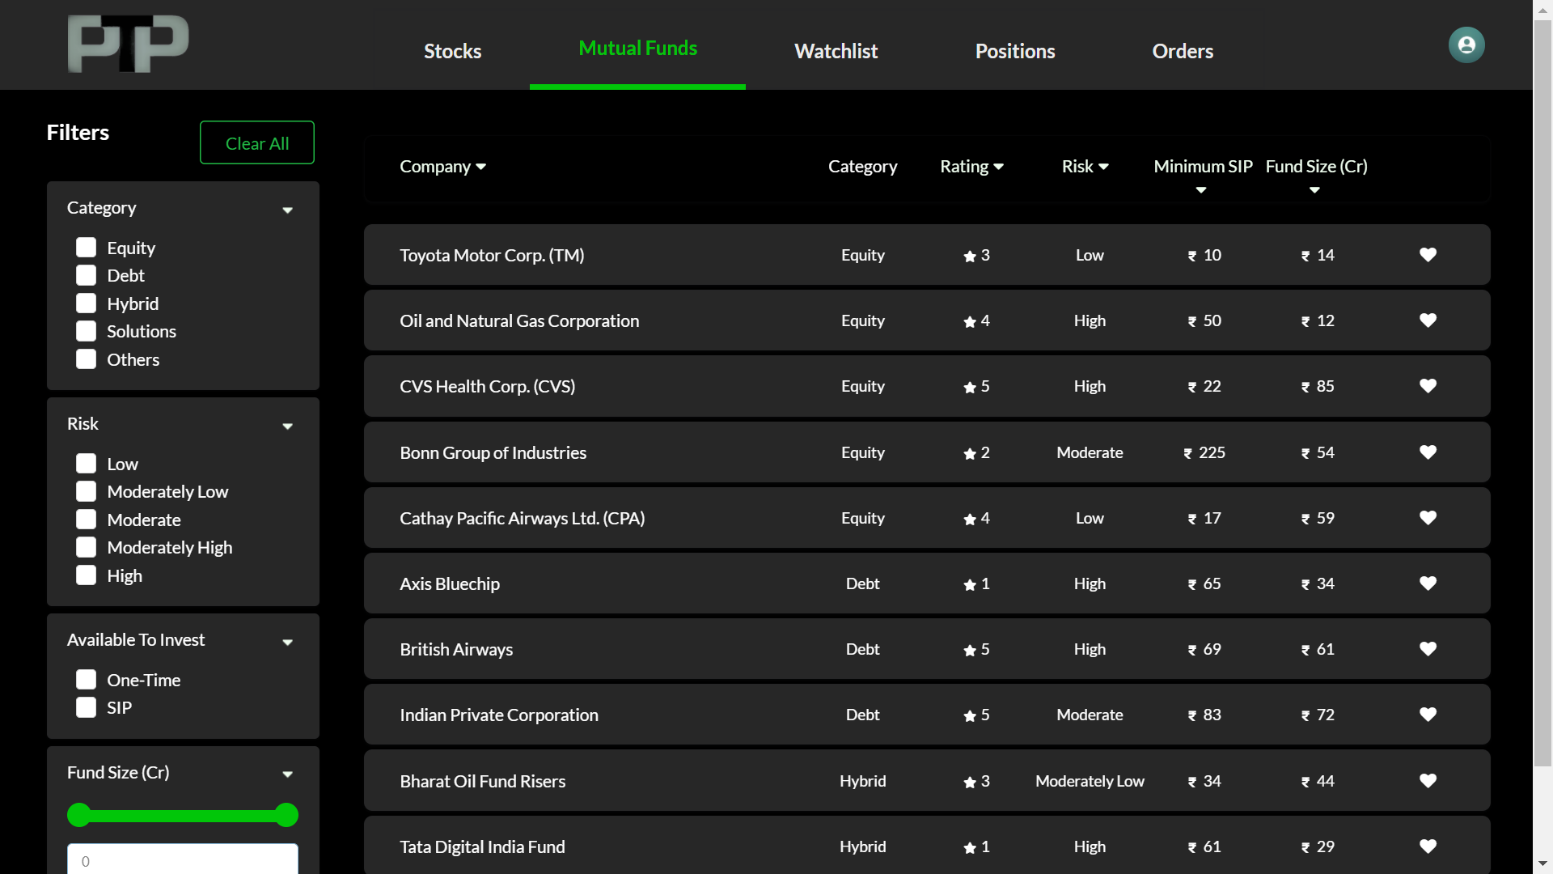

Figure3.2-mutualfunds

**Mutual Funds**

* On selecting Mutual funds from navigation, it will land on screen which looks like Figure3.2.
* On this screen we have all the Mutual funds available to invest in the system. Which also supports a variety of filters.
* Filters are meant to provide ease in searching appropriate assets to invest in. Mutual fund page also shows lots of details regarding it’s ratings, various factors related to investing to help investors evaluate the asset.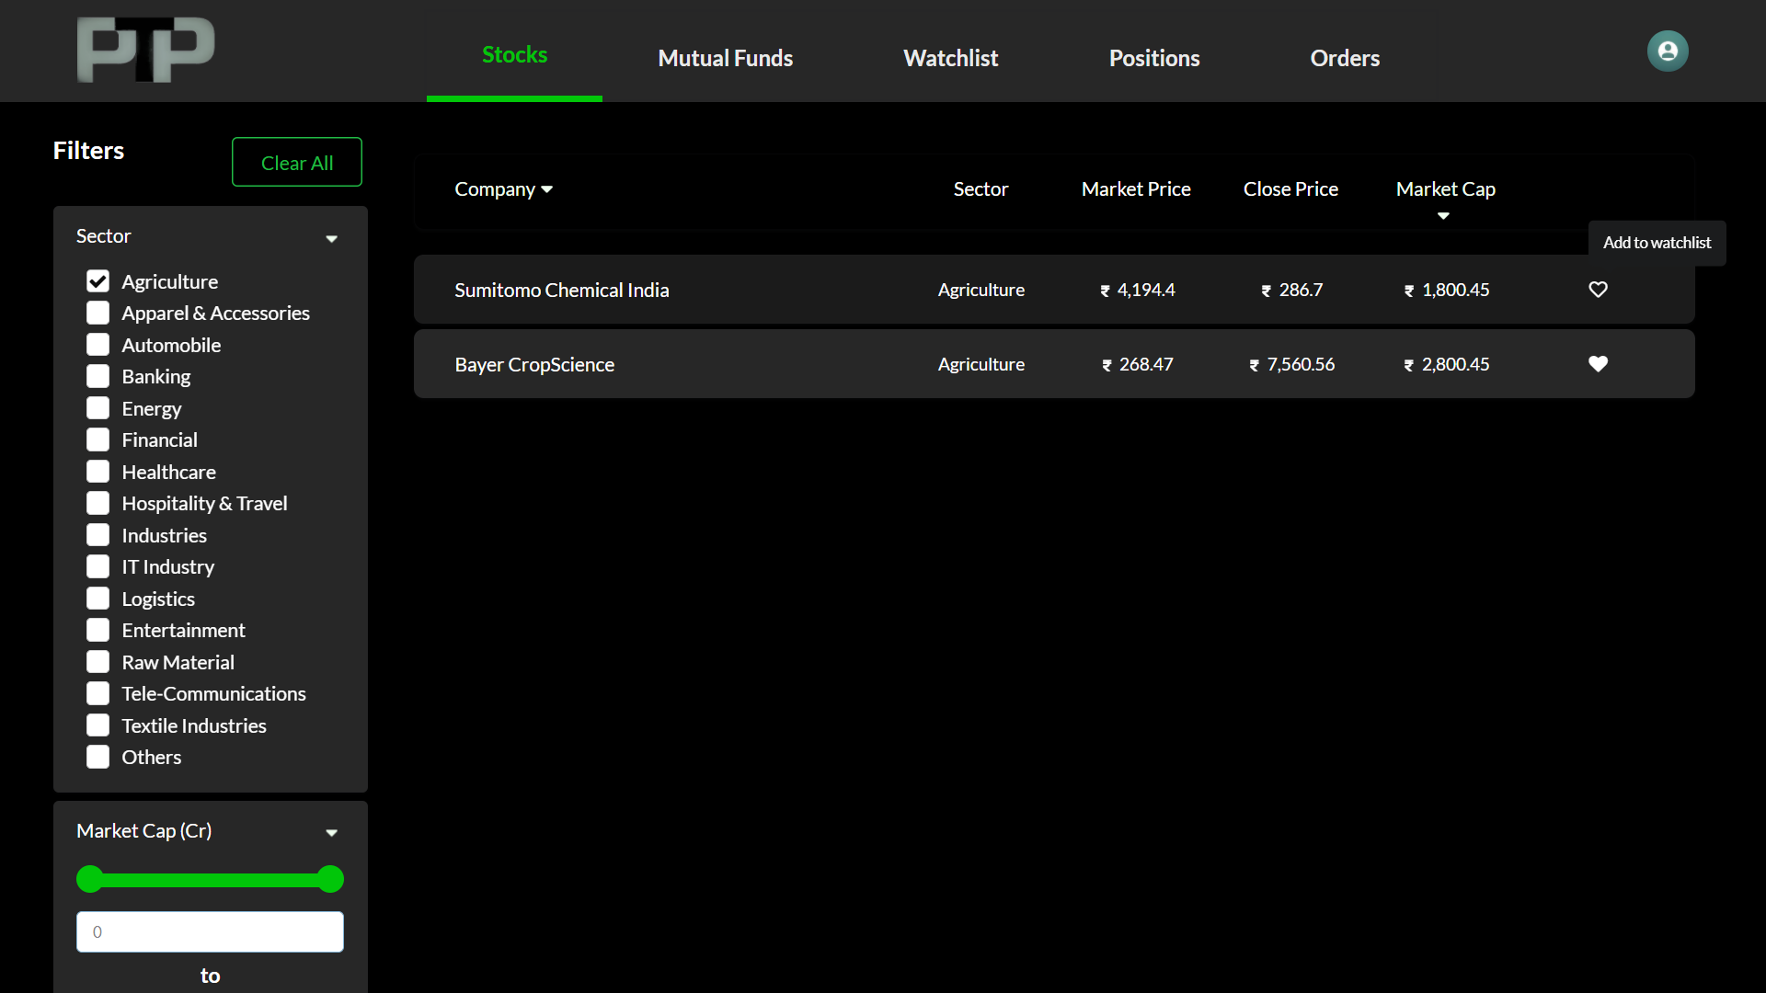
* There is also a heart shaped icon at last to add individual assets to the watchlist for quick access. For reference Figure3.2.1-add to watchlist.

Figure3.2.1-add to watchlist

**Results of Mutual funds filters**

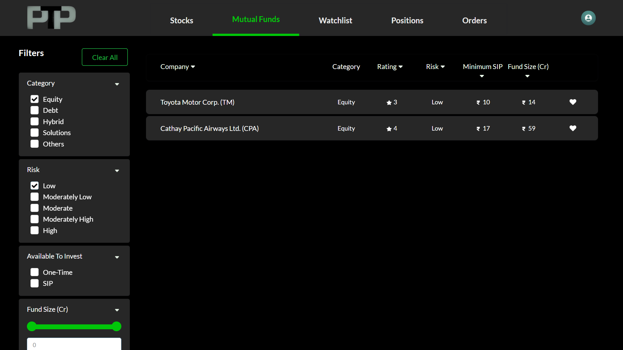

Figure3.3-mutual funds filtered by equity and low risk

* As shown in Figure3.3, it uses filters to get results for assets involving categories such as equity and where investment Risk is Low.
* There are also headers available to provide sorting in ascending or descending order.

**Before Start Investing**

* Users have to be a KYC verified, our system uses Pan card scanning which will be matched with id for validation.
* Figure3.4.1, Figure3.4.2 and Figure 3.4.3 show screens for validating users in the system.
* Screen 1 takes users information, Screen 2 takes pan card as an image and Screen 3 takes signature and users photo for the system.

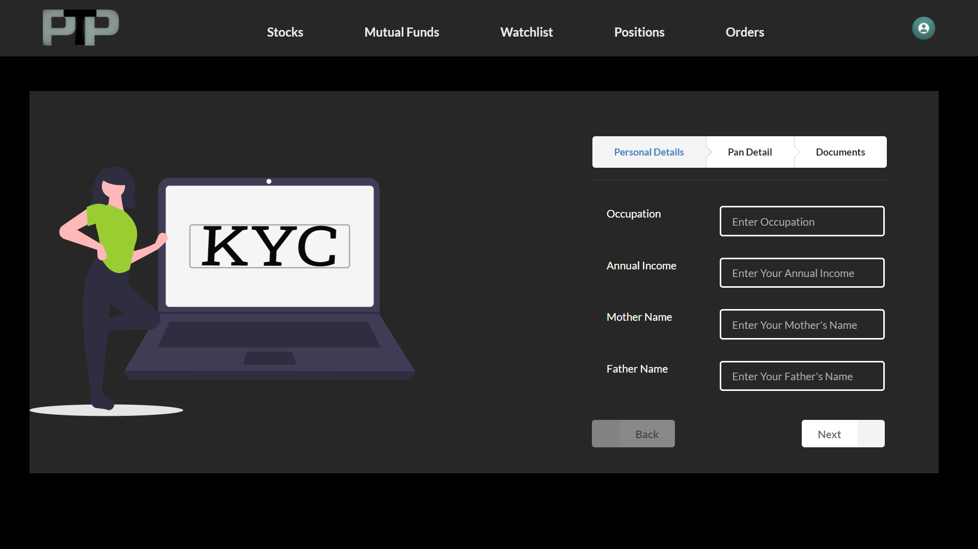

Figure3.4.1-kyc step 1

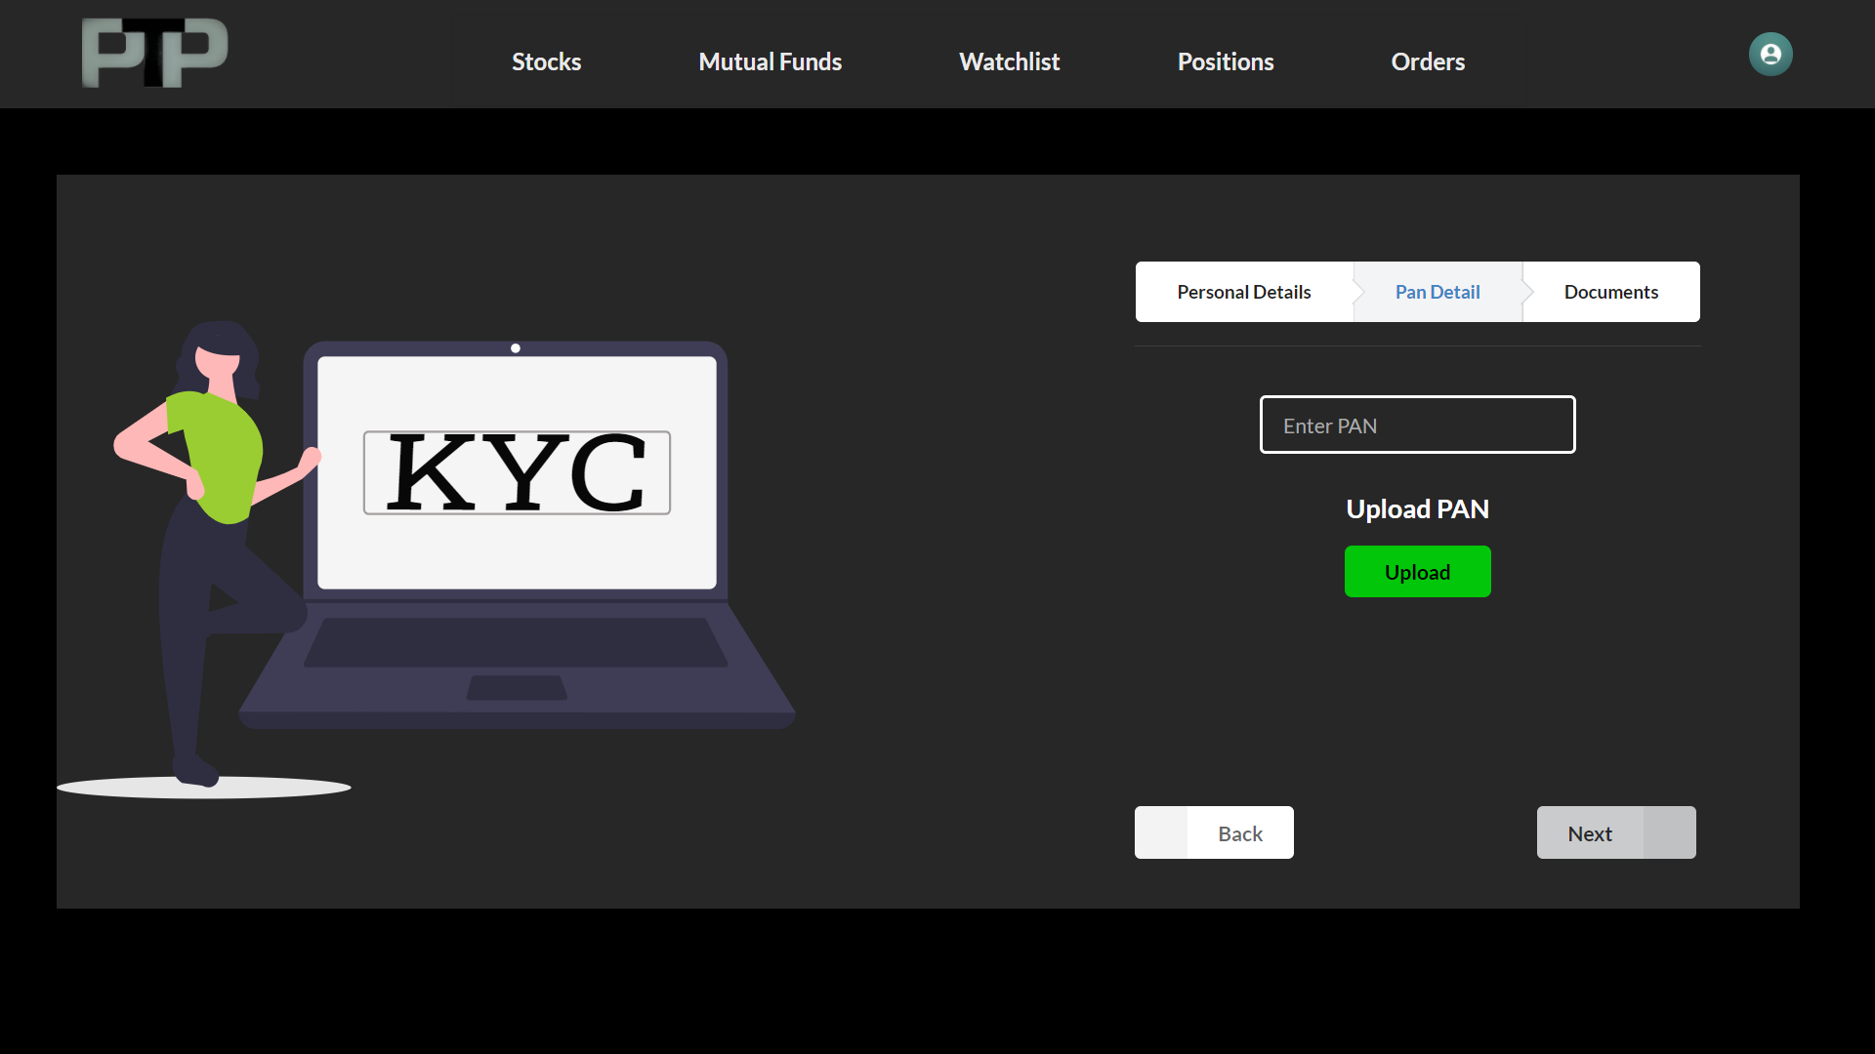

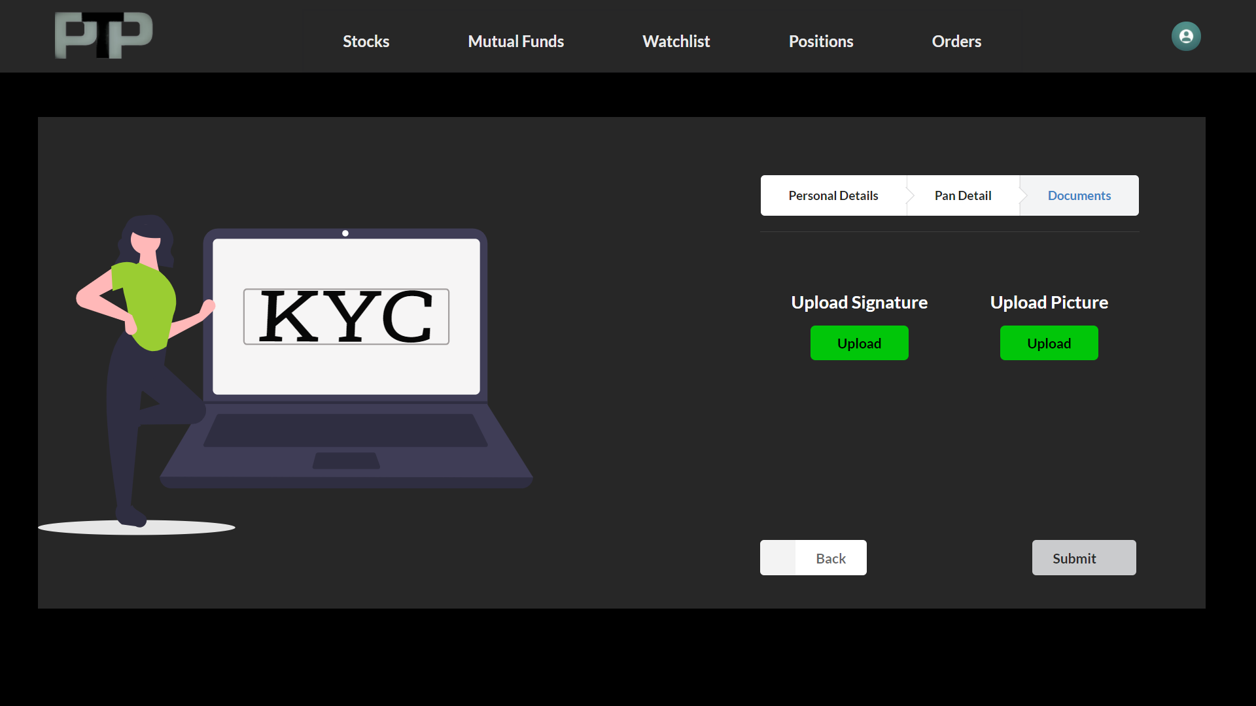

Figure3.4.1-kyc step 2 Figure3.4.2-kyc step 3

* Here these screens take required documents and information about users to start investing in assets. It will take a signature, current user picture and pan card.

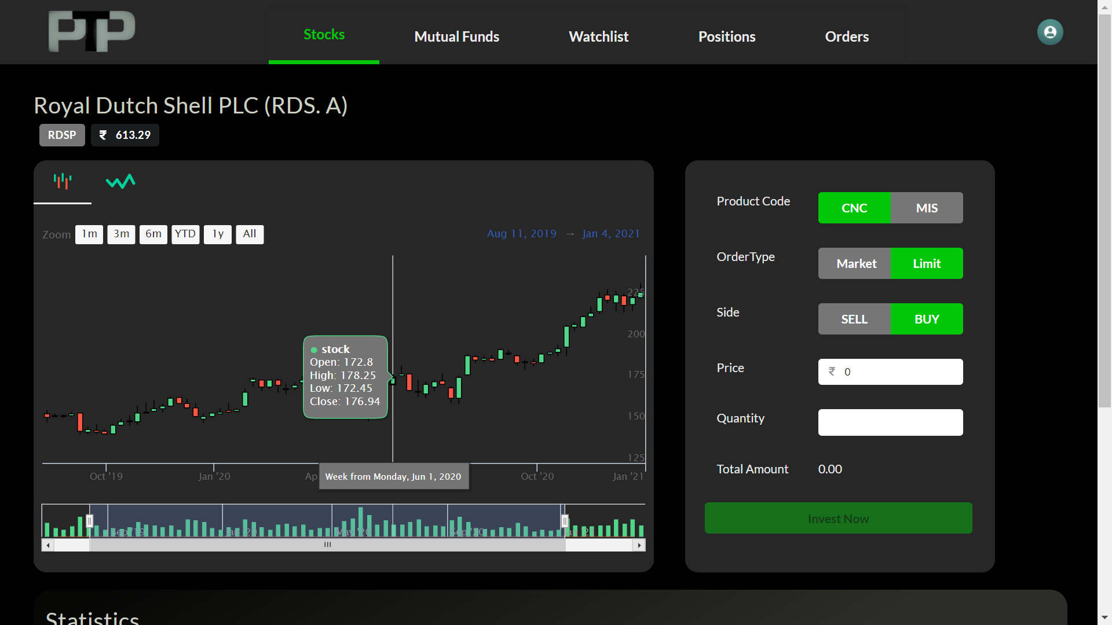

Figure 3.5-Stock Asset Screen

**Stocks Detail Screen**

* Figure3.5 shows detail screen for particular stock which shows,
  + Candle chart with informative details on particular time for the same stock for evaluation of asset.
  + Line chart comparatively easy to understand for checking jitters in stock prices.
* Stocks also have a ticker to buy or sell the available stocks. Process to buy and sell is very easy, where the user has to select options by which they want to proceed with investments.
* Screen also has basic information about the asset like the founder, when this fund or stock has started, it’s important static values like P/E, P/B ratios etc.
* To verify the success or failure in the system, we provide toast as shown in Figures 3.6.

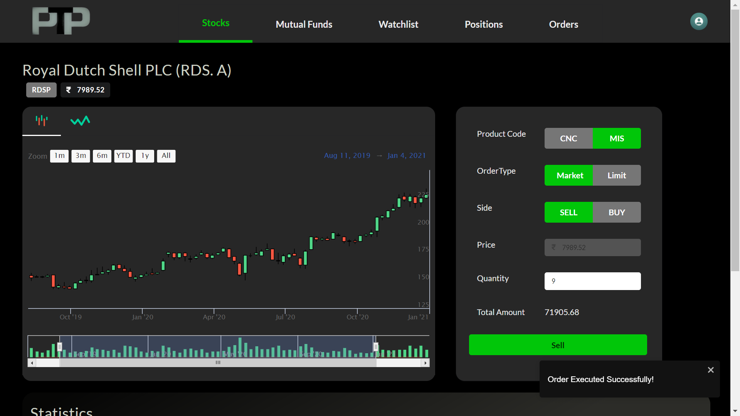

When a user performs operations, these pop ups will verify that process is success or failure as a notification.

Figure 3.6-Notification Toasts

**Watchlist**

* Figure3.7 shows watchlist screen on system. Which helps to get access to the favorite assets quickly.
* If a user wants to look over their favorite stocks or mutual funds then they can add it to the watchlist for rapid access.

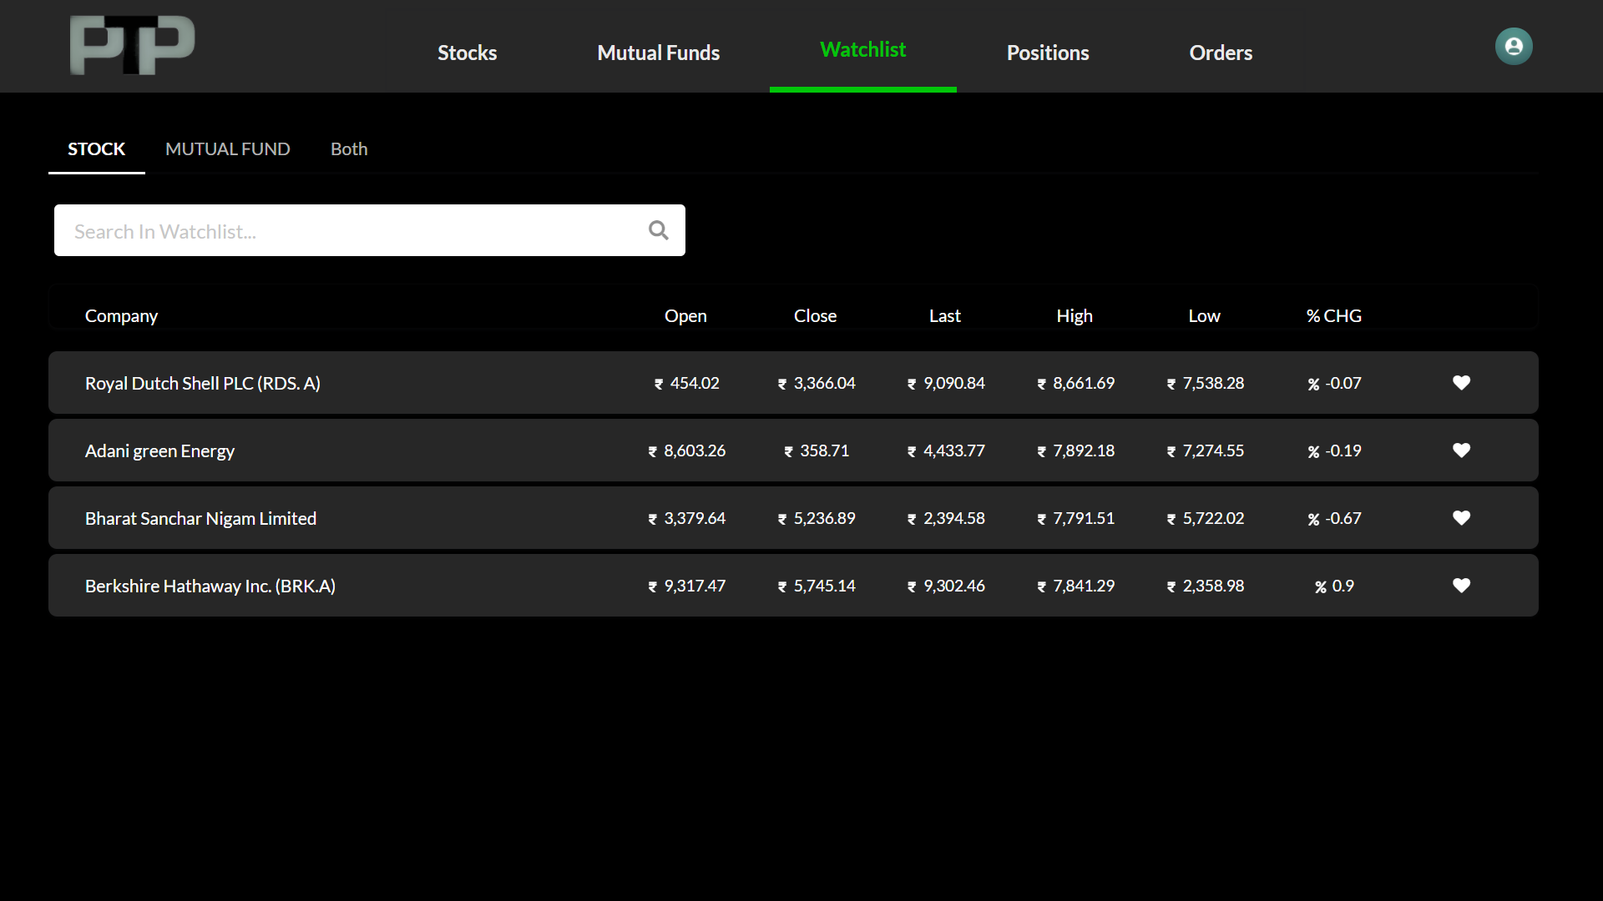

Figure3.7.1-Watchlist Stocks

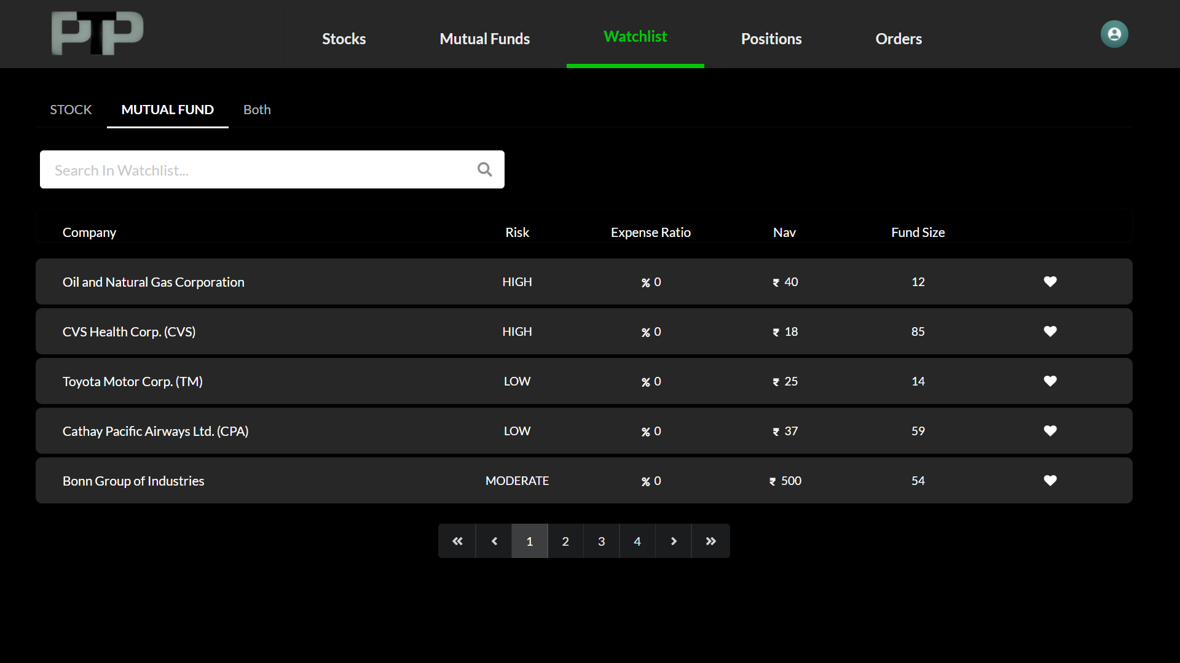

Figure3.7.2-Watchlist Mutual Funds

**Orders**

* Users also want to track their investment and see the live changes in prices as per the market change.
* Order screen help and provides all the necessary details regarding Bought assets, and also shows all the corresponding calculations regarding profit/loss percentages and position of their earning.

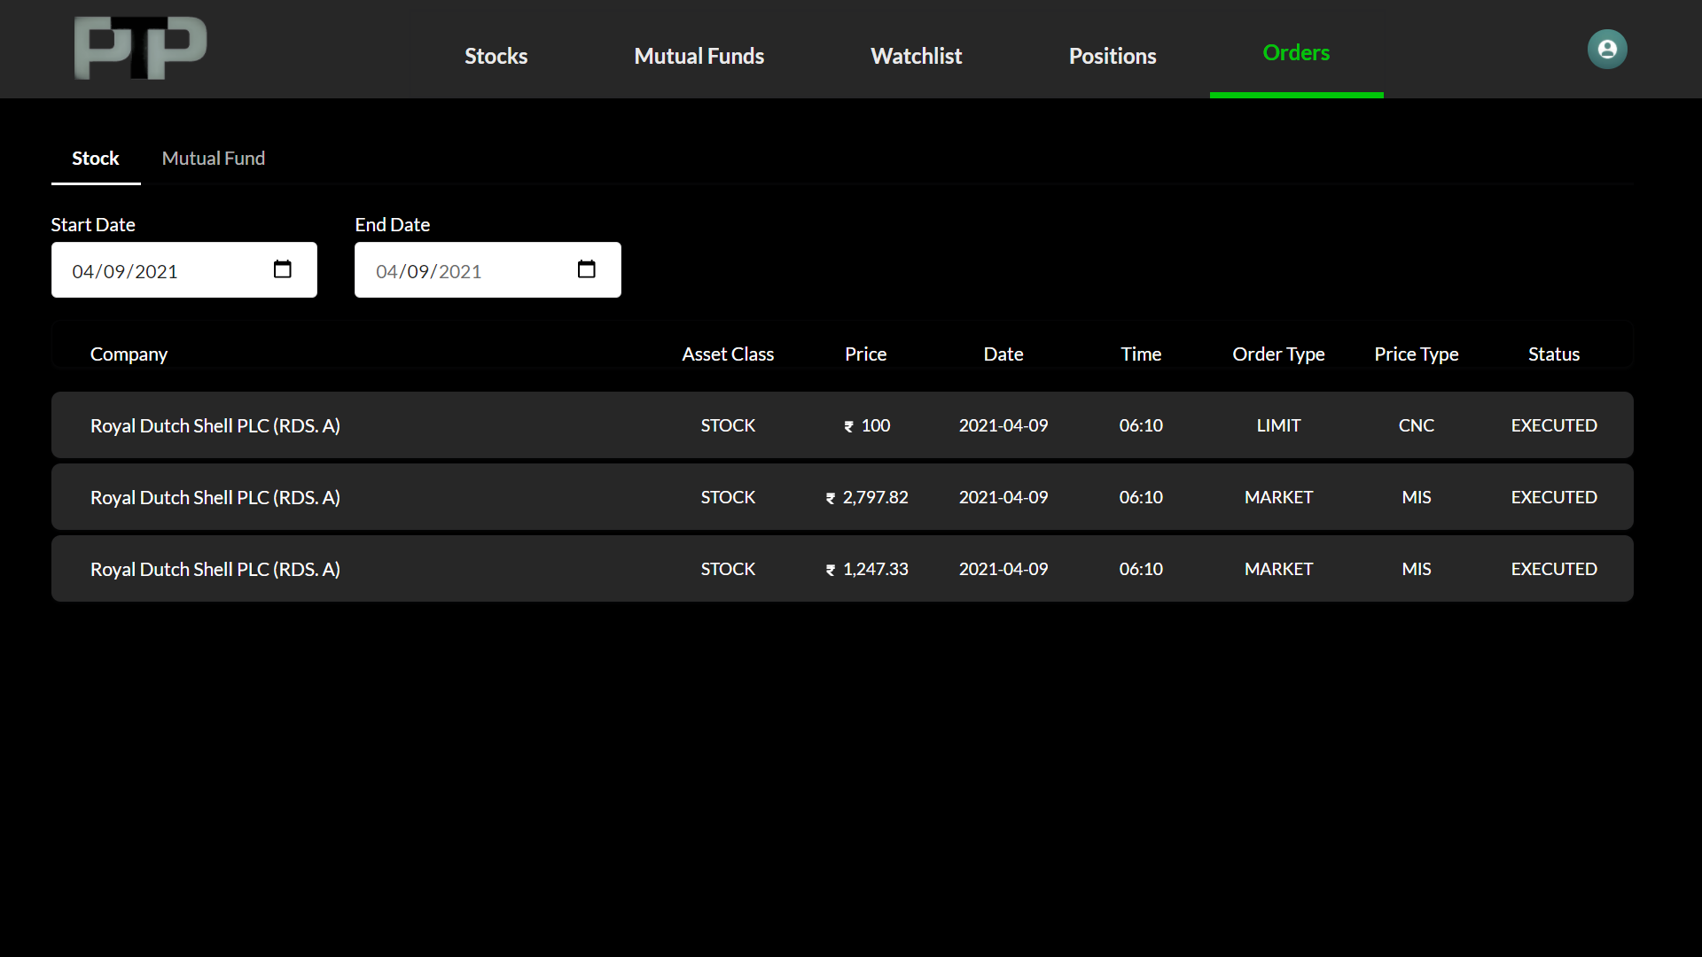

Figure3.8-Order Blotter

**Position**

* Users can see their portfolios here. Their current standing for particular assets, they bought. Also, able to see the live price jitters in the market to decide whether to keep this stock or sell it.

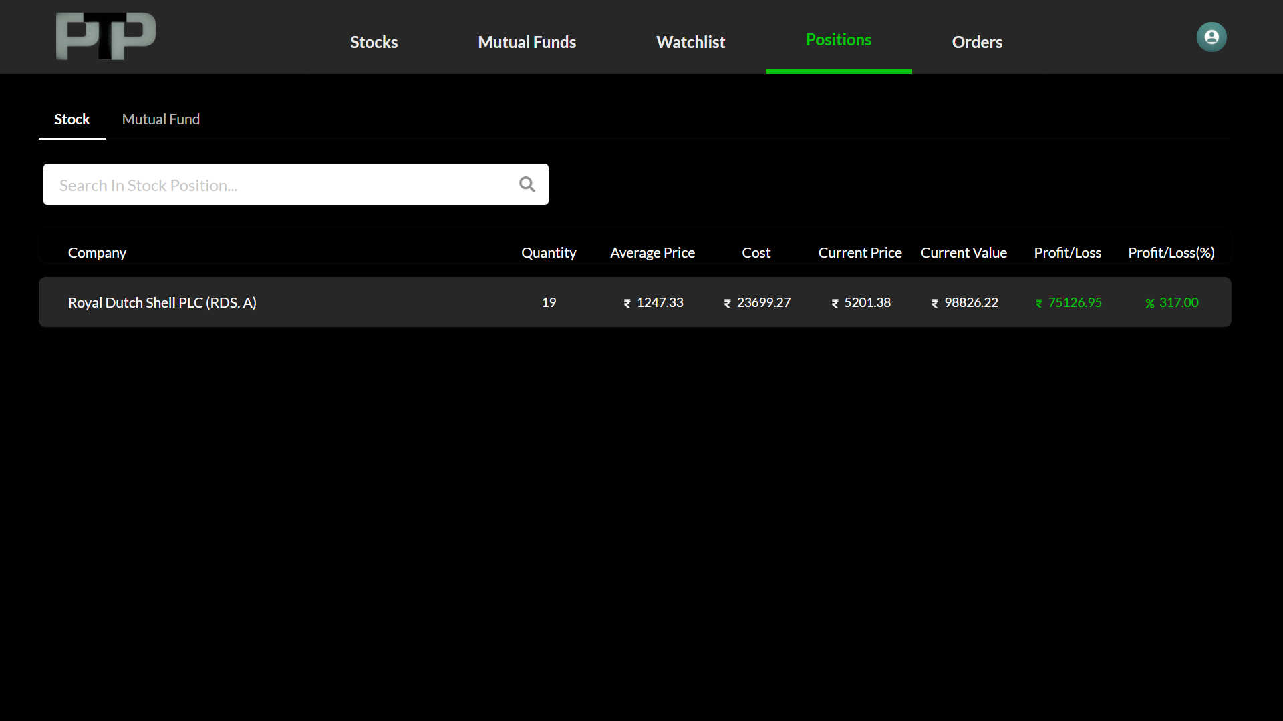

*Figure3.9-Portfolio*

**Users Profile**

* Figure3.10, shows the user profile, they can update it directly from here using edit action on top right corner of the detail box.
* The KYC field shows whether the user has verified it or not. Users can request KYC verification using KYC Verification action.

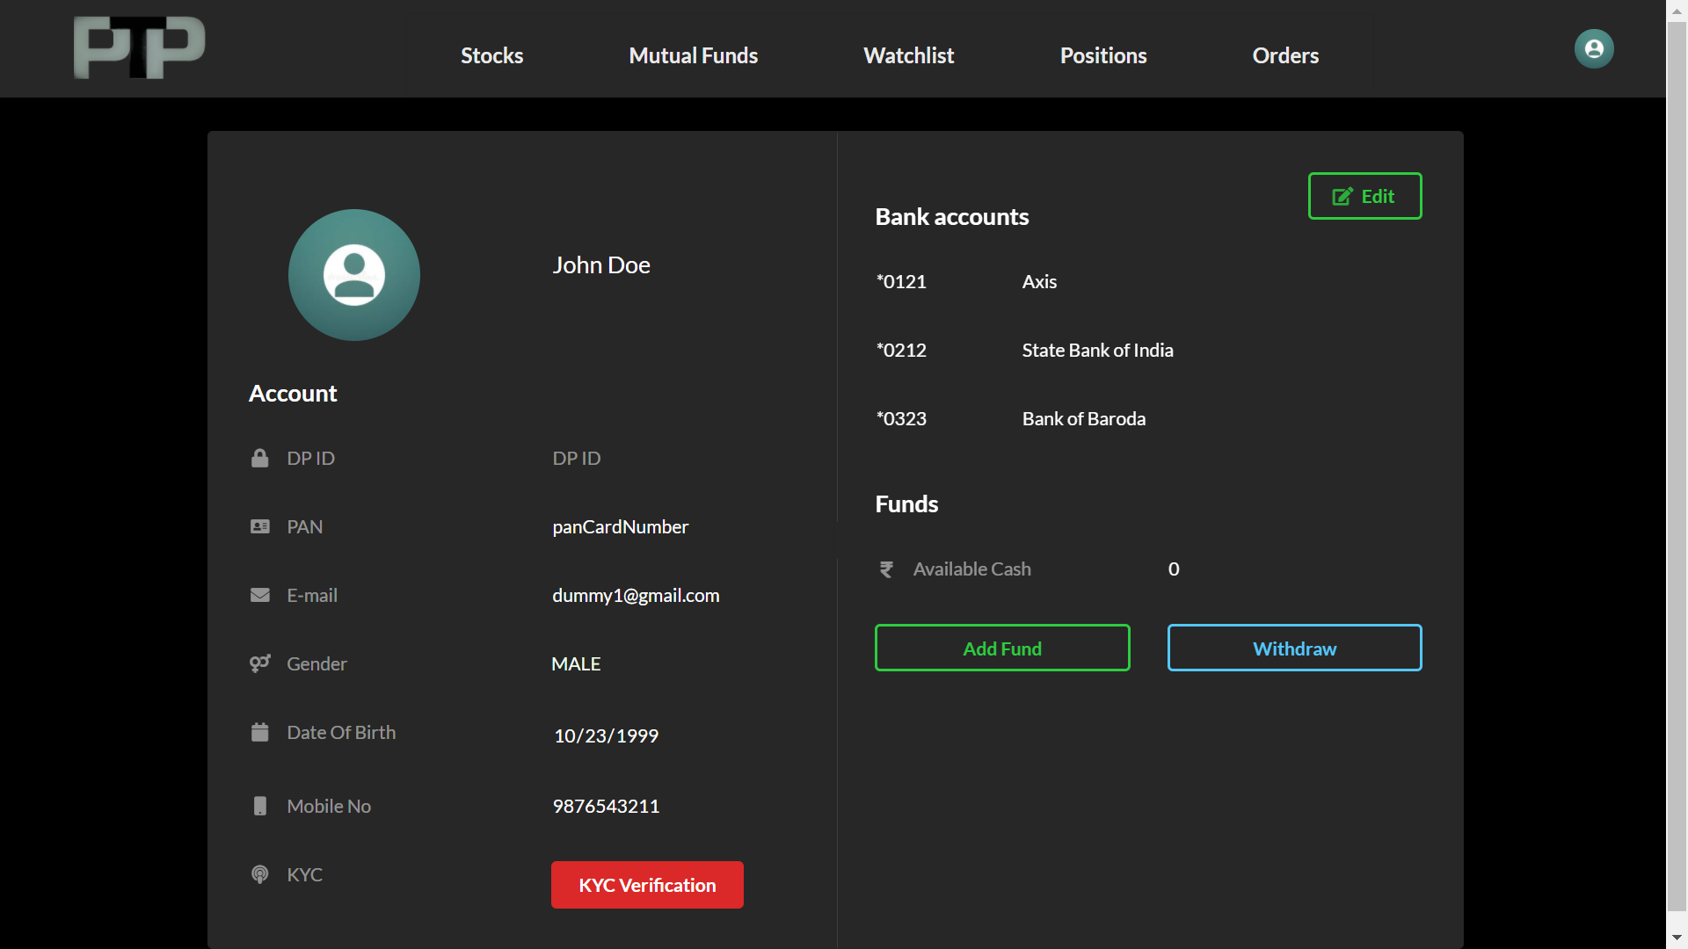

*Figure3.10-User Profile*

**4.2 Database**

**Postgres**

* PostgreSQL is a powerful, open-source object-relational database system with over 30 years of active development that has earned it a strong reputation for reliability, feature robustness, and performance.
* We will be using it as a data store. We have data in the form of tables. And Postgres is easy to maintain for the same.

As per **Pirimid Fintech LLP** Policies, the corresponding design and code cannot be shared.

**4.3 Deployment**

**GitLab - Docker - Kubernetes**

* Docker is a set of platforms as a service product that use OS-level virtualization to deliver software in packages called containers. Containers are isolated from one another and bundle their own software, libraries and configuration files; they can communicate with each other through well-defined channels
* We are using it to create images and give it to production for fast development with Kubernetes.
* Gitlab will be used for CI/CD development and images will be pushed to Kubernetes containers for continuous development, testing and deployment.