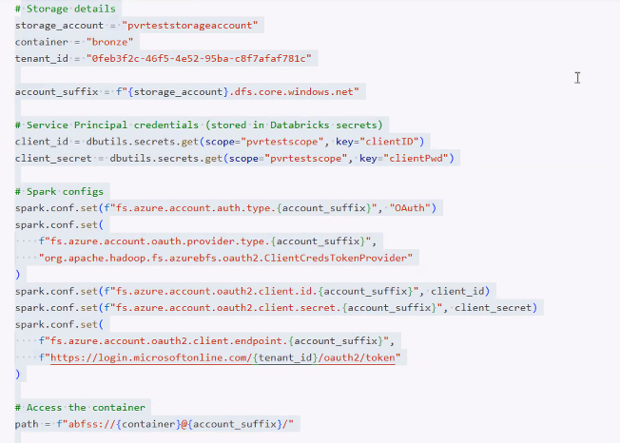
# Storage details
storage_account = "pvrteststorageaccount"
container = "bronze"
tenant_id = "0feb3f2c-46f5-4e52-95ba-c8f7afaf781c"

account_suffix = f"{storage_account}.dfs.core.windows.net"

# Service Principal credentials (stored in Databricks secrets)
client_id = dbutils.secrets.get(
scope="pvrtestscope",
key="clientID"
)

client_secret = dbutils.secrets.get(
scope="pvrtestscope",
key="clientPwd"
)

# Spark configs
spark.conf.set(
f"fs.azure.account.auth.type.{account_suffix}",
"OAuth"
)

spark.conf.set(
f"fs.azure.account.oauth.provider.type.{account_suffix}",
"org.apache.hadoop.fs.azurebfs.oauth2.ClientCredsTokenProvider"
)

spark.conf.set(
f"fs.azure.account.oauth2.client.id.{account_suffix}",
client_id
)

spark.conf.set(
f"fs.azure.account.oauth2.client.secret.{account_suffix}",
client_secret
)

spark.conf.set(
f"fs.azure.account.oauth2.client.endpoint.{account_suffix}",
f"https://login.microsoftonline.com/{tenant_id}/oauth2/token"
)

# Access the container
path = f"abfss://{container}@{account_suffix}/"

# Read CSV files
df = (
spark.read
.format("csv")
.option("header", "true")
.option("inferSchema", "true")
.load(path)
)

display(df)

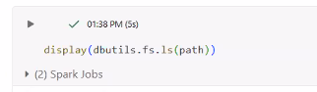
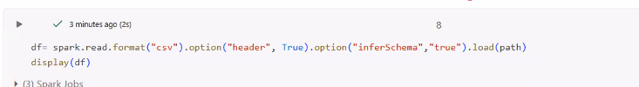
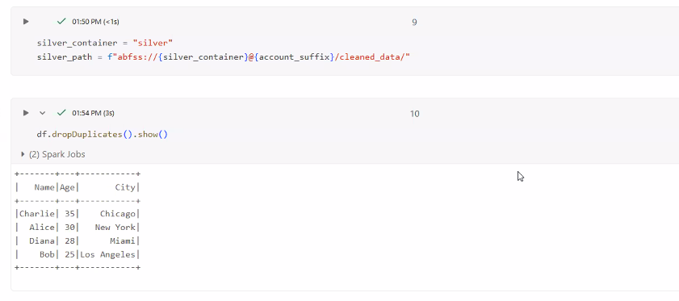
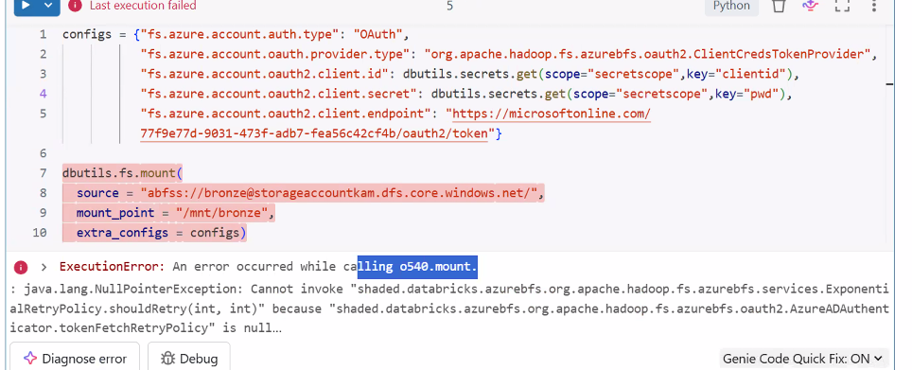
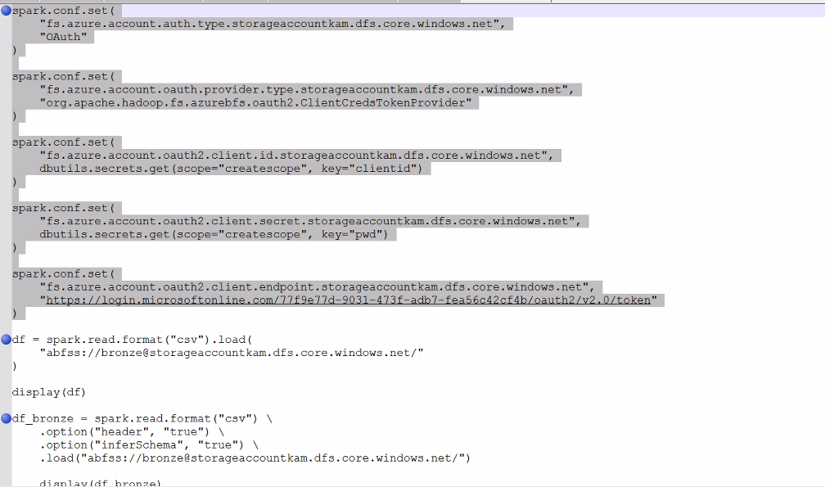
spark.conf.set(
"fs.azure.account.auth.type.storageaccountkam.dfs.core.windows.net",
"OAuth"
)

spark.conf.set(
"fs.azure.account.oauth.provider.type.storageaccountkam.dfs.core.windows.net",
"org.apache.hadoop.fs.azurebfs.oauth2.ClientCredsTokenProvider"
)

spark.conf.set(
"fs.azure.account.oauth2.client.id.storageaccountkam.dfs.core.windows.net",
dbutils.secrets.get(scope="createscope", key="clientid")
)

spark.conf.set(
"fs.azure.account.oauth2.client.secret.storageaccountkam.dfs.core.windows.net",
dbutils.secrets.get(scope="createscope", key="pwd")
)

spark.conf.set(
"fs.azure.account.oauth2.client.endpoint.storageaccountkam.dfs.core.windows.net",
"https://login.microsoftonline.com/77f9e77d-9031-4f3f-adb7-fea56c42cf4b/oauth2/v2.0/token"
)

df = spark.read.format("csv").load(
"abfss://bronze@storageaccountkam.dfs.core.windows.net/"
)

display(df)

df_bronze = (
spark.read.format("csv")
.option("header", "true")
.option("inferSchema", "true")
.load("abfss://bronze@storageaccountkam.dfs.core.windows.net/")
)

display(df_bronze)

