- Load data from different REST API’s to ADLS Gen2 with foreach
Web service-

Estimations:
--------------
- REST API’s URL
- ADLS Gen2
- Azure data factory
- One linked service for REST API’s, Another linked service for ADLS Gen2
- Datasets
- Pipeline
- Foreach, copy activity
- Schedule trigger
Scenarios:
- Copying data from different REST URL’s
- How to create REST URL’s dynamically
- How to create linked service parameters
- How to create dataset parameters
- How to create pipeline parameters
- Copy data from REST API to ADLS Gen2

https://jsonplaceholder.typicode.com/todos/{id}
https://jsonplaceholder.typicode.com/todos/1
https://jsonplaceholder.typicode.com/todos/2
https://jsonplaceholder.typicode.com/todos/3
https://jsonplaceholder.typicode.com/todos/4
https://jsonplaceholder.typicode.com/todos/5

range(1,5)
URL end with id
Simple logic:
- Pipeline parameter (Base_URL)
- Dataset parameter
- Linked service parameter - done

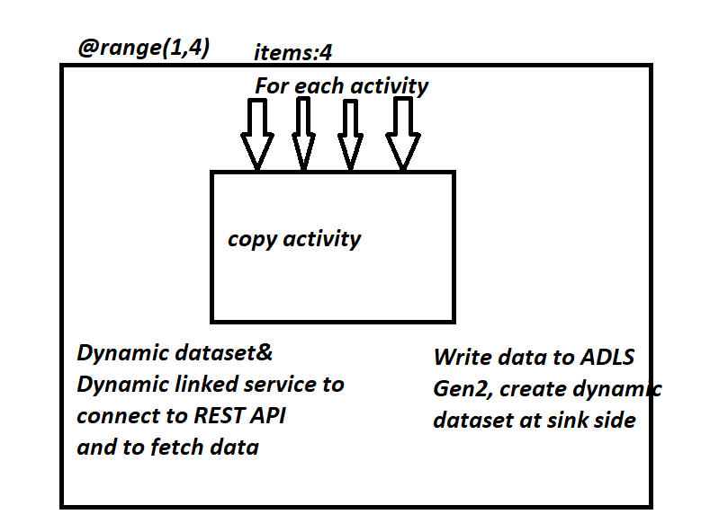

Create linked service for REST API AS GIVEN BELOW.
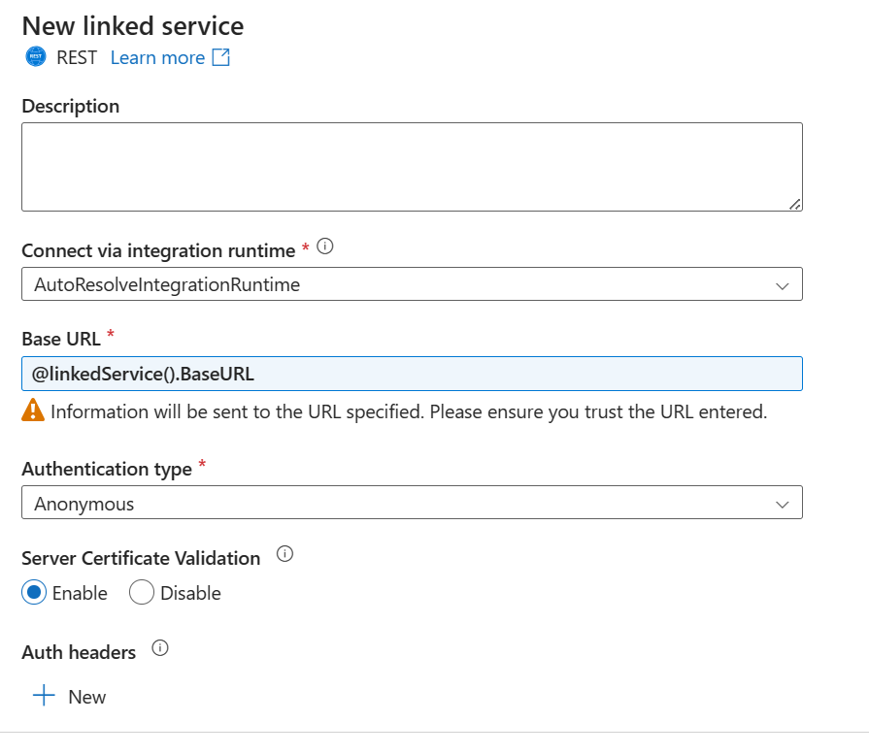
Create Linked service parameter.
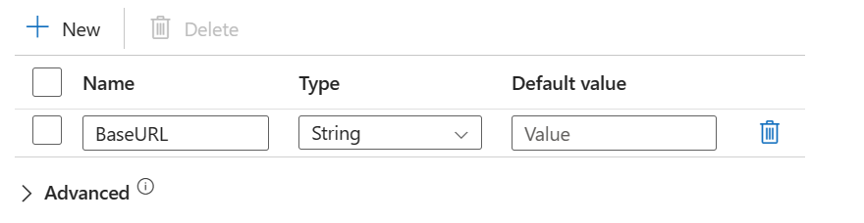
Define Dataset parameters.
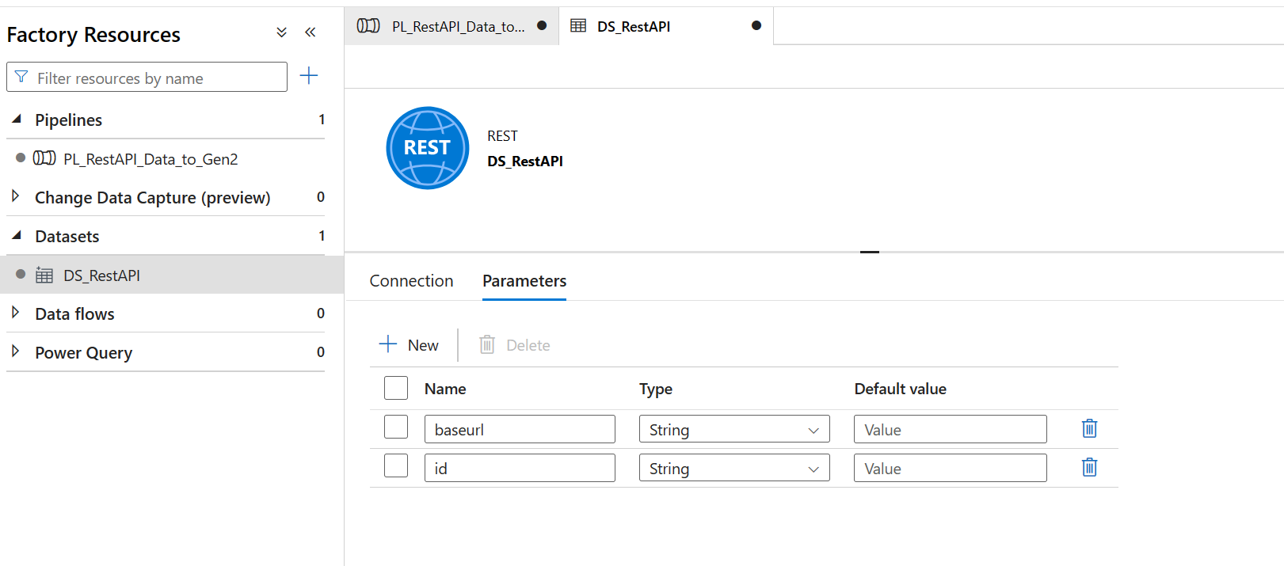
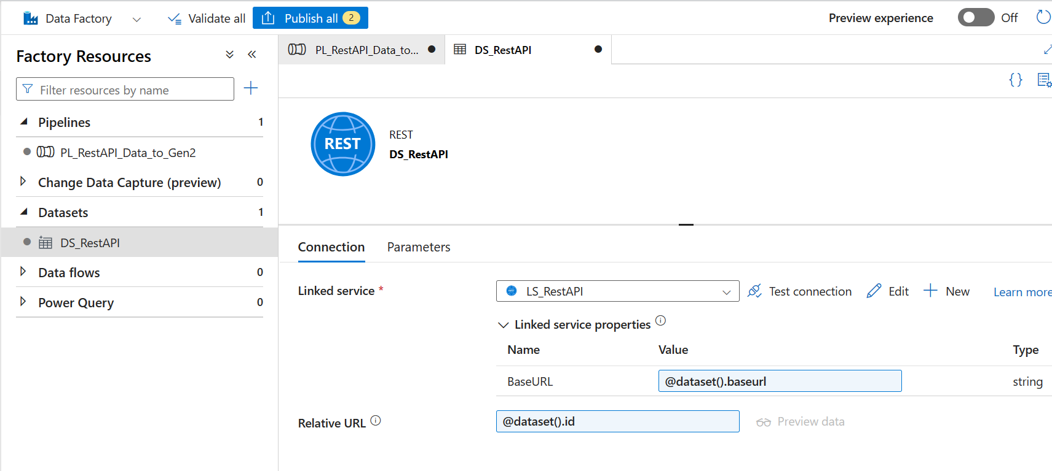
Create Pipeline parameters.
