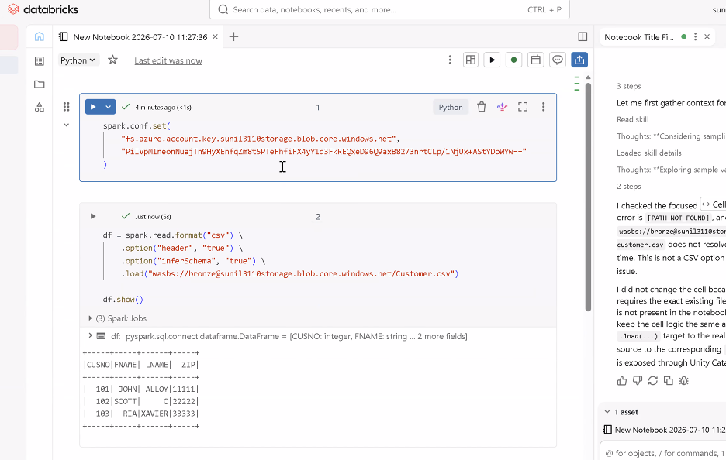

spark.conf.set(
"fs.azure.account.key.sundi3110storage.blob.core.windows.net",
"YOUR_STORAGE_ACCOUNT_ACCESS_KEY"
)

df = spark.read.format("csv") \
.option("header", "true") \
.option("inferSchema", "true") \
.load("wasbs://bronze@sundi3110storage.blob.core.windows.net/Customer.csv")

df.show()

