Cryptography
Cryptography is a process in which the data is converted into unintelligible text, transmitted, then converted back into a comprehensible form so it can only be read and processed by whom it’s intended.
Cryptography is associated with the process of preparing protected and secure data for communication.
There are three main types of cryptography
Symmetric Key Cryptography:
A single key is used for both encryption and decryption. It is used for bulk data transmission.
Asymmetric Key Cryptography:
Like the symmetric key one key is required for encryption but asymmetric key also requires another key, i.e Public Key for decryption. It is used for higher confidentiality.
Cryptographic Protocols:
Deals with the application of cryptography.

Shift Cipher

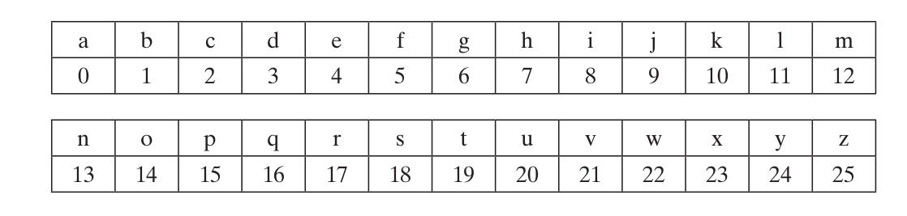
Let x,y,k belong to Z.
Encryption: ek(x) = x + k mod

Decryption: dk(y) = y – k mod 26

Example: Let the key be k = 4, and the plaintext is:
hello = x1,x2,...x5 =7, 4, 11, 11, 14.
The cipher text is then computed as
y1,y2,…,y5 = 11, 8, 15, 15, 18 = lippo

RSA
The RSA algorithm provides:
- Key-pair generation: generate random private key (typically of size 1024-4096 bits) and corresponding public key.
- Encryption: encrypt a secret message (integer in the range [0...key_length]) using the public key and decrypt it back using the secret key.
- Digital signatures: sign messages (using the private key) and verify message signature (using the public key).
- Key exchange: securely transport a secret key, used for encrypted communication later.

RSA Key Generation
Generating an RSA public + private key pair involves the following:
Using some non-trivial math computations from the number theory, find three very large integers e, d and n, such that:
- (me)d ≡ m (mod n) for all m in the range [0...n)
The integer number n is called "modulus" and it defines the RSA key length. It is typically very large prime number (e.g. 2048 bits).
The pair {n, e} is the public key. It is designed to be shared with everyone. The number e is called "public key exponent". It is usually 65537 (0x010001).
The pair {n, d} is the private key. It is designed to be kept in secret. It is practically infeasible to calculate the private key from the public key {n, e}. The number d is called "private key exponent" (the secret exponent).

RSA Cryptography: Encrypt a Message
Encrypting a message using certain RSA public key {n, e} is done by the following transformation:
- encryptedMsg = (msg)e mod n
The msg here is a number in the range [0...n). Text messages should be encoded as integers in the range [0...n) before encryption (see EAOP). For larger texts, hybrid encryption should be used (encrypt a secret key and use it to symmetrically encrypt the text, see RSA-KEM).
The above operation cannot be reversed: no efficient algorithm exists to calculate msg from encryptedMsg, e and n (see the RSA problem), which all are public (non-secret) by design.

RSA Cryptography: Decrypt a Message
Decrypting the encrypted message using the corresponding RSA private key {n, d} is done by the following transformation:
- decryptedMsg = (encryptedMsg)d mod n
Why this is correct? Recall, that by definition the RSA key-pair has the following property:
- (me)d ≡ m (mod n) for any m in the range [0...n)
From the encryption transformation we have:
- encryptedMsg = (msg)e mod n
Hence:
- decryptedMsg = (encryptedMsg)d mod n = ((msg)e mod n)d = ((msg)e)d mod n = (msg) mod n = msg

RSA Encrypt and Decrypt - Example
Let examine one example of RSA encryption and decryption, along with the calculations, following the above formulas. Assume we have generated the RSA public-private key pair:
- modulus n = 143
- public exponent e = 7
- private exponent d = 103
- public key = {n, e} = {143, 7}
- private key = {n, d} = {143, 103}
Let's encrypt a secret message msg = 83. Just follow the formula:
- encryptedMsg = msge mod n = 837 mod 143 = 27136050989627 mod 143 = 8
Now, let's decrypt the encrypted message back to its original value:
- decryptedMsg = encryptedMsgd mod n = 8103 mod 143 = 1042962419883256876169444192465601618458351817556959360325703910069443225478828393565899456512 mod 143 = 83
The RSA calculations work correctly. This is because the key-pair meets the RSA property:
- (me)d ≡ m (mod n) for all m in the range [0...n)
- (m7)103 ≡ m (mod 143) for all m in the range [0...143)
In the real world, typically the RSA modulus n and the private exponent d are 3072-bit or 4096-bit integers and the public exponent e is 65537.

A practical key generation algorithm
Incorporating the advice given in the notes below, a practical algorithm to generate an RSA key pair is given below. Typical bit lengths are k=1024,2048,3072,4096,...
, with increasing computational expense for larger values. You will not go far wrong if you choose e
as 65537 (=0x10001) in step (1).

Algorithm: Generate an RSA key pair.

INPUT: Required modulus bit length, k.
OUTPUT: An RSA key pair ((N,e),d) where N is the modulus, the product of two primes (N=pq) not exceeding k bits in length; e is the public exponent, a number less than and coprime to (p−1)(q−1); and d is the private exponent such that ed≡1mod(p−1)(q−1).
- Select a value of e
from 3,5,17,257,65537
- repeat
- p ← genprime(k/2)
- until (pmode)≠1
- repeat
- q ← genprime(k - k/2)
- until (qmode)≠1
- N ← pq
- L ← (p-1)(q-1)
- d ← modinv(e, L)
- return (N,e,d)

References

Papers
https://www.researchgate.net/publication/276317739_Cryptography

Websites
https://en.wikipedia.org/wiki/Cryptography
https://cryptobook.nakov.com/asymmetric-key-ciphers/the-rsa-cryptosystem-concepts
https://www.di-mgt.com.au/rsa_alg.html#:~:text=For%20example%2C%20if%20we%20have,work%20if%20me%3En.

Books
William Stallings, Cryptography and Network Security, 3 rd edition, Pearson Education (2004).
Christof Paar,Understanding Cryptography, Springer

