Documentation
Wendy's Stables

Jozef Mesaros
Mnr. 1228153
e1228153@student.tuwien.ac.at 30.3.2014

Stundenliste

date hours description
16.3. 4:00 layer design, UML diagram
17.3. 6:00 SQL + HSLQDB
18.3. 5:00 JavaFX basic interafce
19.3. 6:00 SQL new design, JavaFX
20.3. 8:00 service layer implementation, JavaFX
21.3. 7:00 DAO layer
22.3. 8:50 javaFX, Box GUI, Exception classes
23.3. 11:00 CRUD BoxDAO, input checking, Reservation layers
25.3. 3:00 Reservation layers
26.3. 5:00 Reservation input checking, Date checking, Sql statements
27.3. 4:00 javaFX multiple table selection and input checking
29.3. 5:00 JUnit tests
30.3. 10:00 SVN, javaFX, code corrections

TOTAL: 82:50

Use Case Diagram

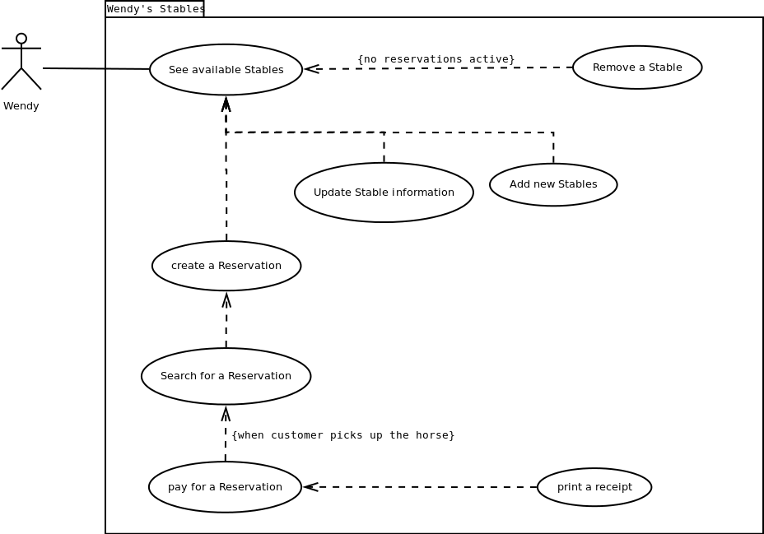

Class Diagram
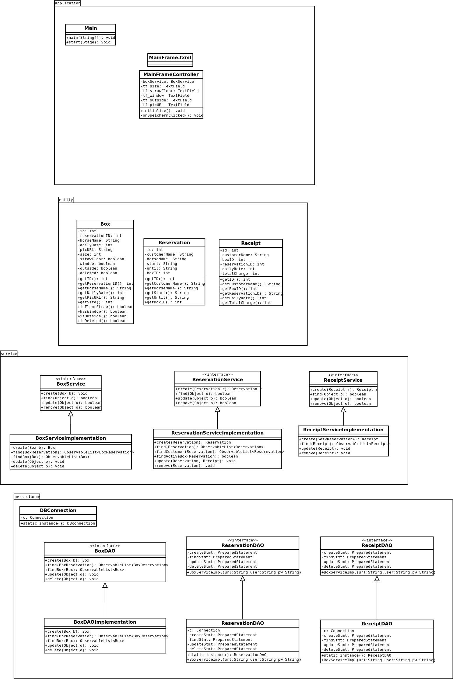

SQL Diagram

