CptS 484: Software Requirements

WRS Evolution
Phase I: Requirements Elicitation (Initial Understanding)
Project THEIA
Indoor Navigation Assistant for Blind and Visually Impaired Users
Team EV · Fall 2026 · Version 1.0 · October 18, 2026
Team member | Role in Phase I
Zichuo Wang | Team liaison; Project Plan; WRS §3 owner (took over in the final week); AI Usage and Teamwork Report; prototype co-author; document assembly
James Zuniga | AS-IS/TO-BE presentation owner; WRS §2 co-author; Project Plan co-author
Austin Aragon | WRS §2 owner; AS-IS/TO-BE presentation co-author
Young Kim | Prototype mock-up and User Manual owner; WRS §3 co-author; AI report co-author
Justus Jones | Assigned WRS §3 in the preliminary plan; did not contribute to this submission
Team repository: https://github.com/nemonto/cpts484-theia-ev
Presentation video: https://youtu.be/0aHIRkDOK3E

Table of Contents
B. Revision History 4
C. Process 4
C.1 Team organization 4
C.2 Meetings and communication 4
C.3 Inputs 5
C.4 Activities 5
C.5 Resources and tools 5
1. Introduction 5
1.1 Purpose 5
1.2 Scope 6
1.3 Objectives and Success Criteria 6
1.4 Definitions, Acronyms, and Abbreviations 7
1.5 Overview 7
2. Issues with the Preliminary Definition Given 8
2.1 Issues with “Domain, Stakeholders, Functional and Non-Functional Objectives” 8
2.1.1 DI1: Stakeholder roles 8
2.1.2 DI2: Connected buildings 8
2.1.3 DI3: Destinations inside shared spaces 9
2.1.4 DI4: Navigating between floors 9
2.1.5 DI5: “Use as many sensors as possible” 9
2.2 Issues with “Functional Requirements” 10
2.2.1 FRI1: Suggesting the next action from schedule or habit 10
2.2.2 FRI2: Emergency calls when location is lost 10
2.2.3 FRI3: Distance and direction instructions 10
2.2.4 FRI4: Detecting obstacles 11
2.2.5 FRI5: Presenting route options 11
2.2.6 FRI6: Missing “Where am I?” function 11
2.3 Issues with “Non-functional Requirements” 12
2.3.1 NFRI1: “Ubiquitous” 12
2.3.2 NFRI2: “Fastest route” 12
2.3.3 NFRI3: Safe, fast, and comfortable navigation 12
2.3.4 NFRI4: Who customizes the app 13
2.3.5 NFRI5: Alerting nearby pedestrians 13
2.3.6 NFRI6: “Usable for blind people” 13
2.3.7 NFRI7: “Easily extensible” 14
2.4 Summary of Issues 14
3. WRS 14
3.1 W (World) 14
3.1.1 Problems 14
3.1.2 Goals 15
3.1.3 Improved Understanding of Domain, Stakeholders, Functional and Non-Functional Objectives 15
3.2 RS (Requirements and Specifications) 17
3.2.1 Functional Requirements 17
3.2.2 Non-Functional Requirements 21
4. Preliminary Prototype and User Manual 23
4.1 Interaction Model 23
4.2 Prototype Screens 23
4.3 Preliminary User Manual 27
4.4 Voice Commands 28
5. Traceability 28
5.1 Forward and Backward Traceability 28
5.2 Issue → Resolution 29
5.3 Scenario → Requirements → Prototype → Manual 29
References 29
Appendix A. Source Drafts 30
Appendix B. Reconciliation Log (Before → After) 30

B. Revision History
Date | Version | Changes | Editor(s)
2026-09-21 – 09-27 | 0.1 | Candidate issues collected from all members in #wrs (each member at least 3) | All contributing members
2026-10-13 | 0.2 | Issues list consolidated into the §2 draft (Issues.md) | Austin Aragon
2026-10-14 | 0.3 | Front matter, §2 options/decisions, and §3 Improved Understanding drafted as templates | Zichuo Wang (AI-assisted)
2026-10-15 | 0.4 | Prototype mock-up and preliminary User Manual drafted (§4) | Young Kim, Zichuo Wang
2026-10-16 | 0.5 | §2 finalized with options, decisions, and rationale | Austin Aragon, James Zuniga
2026-10-17 | 0.6 | §3 finalized and reconciled with the AS-IS/TO-BE slides, prototype, and manual; §4, §5 completed; document assembled | Zichuo Wang, Young Kim
2026-10-18 | 1.0 | Final Phase I proofing and submission | Zichuo Wang, all review

C. Process

C.1 Team organization
Team EV has five members. Each work product has one owner, who is responsible for it, and one co-author, who writes part of it and can take it over if needed. Every member is expected to review every work product. The full assignment is in the Project Plan, §2.3.
Work product | Owner | Co-author
AS-IS/TO-BE presentation and video | James Zuniga | Austin Aragon
WRS §2 Issues | Austin Aragon | James Zuniga
WRS §3 Improved Understanding and traceability | Zichuo Wang | Young Kim
Prototype mock-up and User Manual | Young Kim | Zichuo Wang
Project Plan | Zichuo Wang | James Zuniga
AI Usage and Teamwork Report | Zichuo Wang | Young Kim
Change from the preliminary plan. The preliminary plan made Justus Jones the owner of WRS §3 and the co-author of WRS §2. He did not report progress or deliver work for this submission, so Zichuo Wang took over §3 (with Young Kim as co-author) and James Zuniga became the §2 co-author. Justus Jones remains a member of Team EV.

C.2 Meetings and communication
The course is online and every member has a full course load, so the team worked asynchronously. There were no live meetings; instead:
- Discord was the main channel, with a channel per work product (e.g., #wrs). Issues, scenario ideas, drafts, and review feedback were posted there.
- Weekly written checkpoints (Sundays) were posted by the liaison. Each one summarized progress, assigned the next week’s tasks, and asked members to review.
- GitHub repository holds the working drafts and the submitted versions.

C.3 Inputs
- Cpt S 484 Team Project Specification, Phase I, v2.0
- Cpt S 484 Project THEIA Preliminary Definition, v1.0
- World Assumptions Masterlist, v1.0
- CPTS 484 FAQ
- WRS template, WRS sample documents, and the Requirements Review Checklist
- AS-IS/TO-BE presentation template (Theia-AS-IS_and_TO-BE_v2.0.pptx)

C.4 Activities
The team followed the spiral requirements engineering process (Kotonya & Sommerville):
Step | Activity | Output
Elicitation | Members read the Preliminary Definition and the Masterlist and posted at least 3 candidate issues and a scenario idea in Discord. No real blind users were available to interview, so members reasoned from the position of a potential user. | Raw issues list; scenario ideas
Analysis and negotiation | Duplicate issues were merged and sorted into §2.1–2.3. For each issue the team listed options and chose one with a rationale. Out-of-scope items were decided against the Masterlist. | WRS §2
Documentation | Problems and Goals were derived from the issues, broken down into functional and non-functional objectives, then into requirements and specifications with traceability. The same decisions were used to write four AS-IS/TO-BE scenario pairs, the mock-up, and the user manual. | WRS §3, slides, §4
Validation | Drafts were reviewed against the Requirements Review Checklist and checked for consistency across the WRS, the slides, the prototype, and the manual before submission. Where they disagreed, the recorded slides were treated as fixed and the WRS was aligned to them; the prototype and manual were then aligned to the WRS (Appendix B). | Final Phase I documents

C.5 Resources and tools
Discord, Google Drive, GitHub, Microsoft PowerPoint/Word, and generative AI tools (ChatGPT, Gemini / NotebookLM, Claude / Claude Code). AI was used for drafting, critique, and assembly, and all AI output was reviewed by team members; details and evidence are in the AI Usage and Teamwork Report.

1. Introduction

1.1 Purpose
Blind and visually impaired people must often find their way through unfamiliar or changing indoor spaces: from a classroom to an office, a lab, or a restroom, sometimes on another floor or in a connected building. A white cane detects nearby obstacles and a guide dog helps avoid them, but neither tells the user where they are, which way to go, when to turn, or how to get help with an exact location when they are lost.
THEIA is a smartphone app that helps blind and visually impaired users navigate indoors using voice, gestures, audio, and vibration. This document records Team EV’s requirements engineering work for Phase I. It starts from the informal THEIA Preliminary Definition, identifies its issues and resolves them (§2), and builds an improved, traceable model of the World, Requirements, and Specifications (§3). It also includes a preliminary prototype and user manual (§4). It is intended for the course instructor and the team, and it is the basis for the Phase II prototype.

1.2 Scope
In scope. THEIA supports a blind or visually impaired user (student, staff, or visitor) moving between rooms and significant locations inside mapped university campus buildings. This includes moving between floors and through mapped indoor connectors between buildings. Main functions:
- telling the user their current location,
- accepting a destination by voice and offering route options,
- step-by-step walk, turn, and stop guidance,
- warnings about known static obstacles and rerouting around blockages,
- guidance to elevators and stairs, with floor confirmation,
- off-route detection and recovery,
- help and emergency contact that sends the user’s location,
- personal settings and navigation modes (Fast, Safe, Comfortable),
- suggestions based on the user’s schedule.
Caretakers configure safety settings and receive alerts. Campus accessibility staff maintain the building maps.
Out of scope (based on the World Assumptions Masterlist):
- outdoor navigation between unconnected buildings,
- navigation inside a room (finding a chair or desk),
- detecting moving obstacles such as pedestrians,
- operating elevators or stairs for the user.
THEIA assumes beacons at each room and significant location, and it complements a cane or guide dog rather than replacing them. No working software is delivered in Phase I; the prototype is a mock-up.

1.3 Objectives and Success Criteria
THEIA should let a blind user:
- know where they are at any time inside a mapped building;
- reach a chosen destination, including on another floor or in a connected building, without sighted help;
- receive clear and timely walk, turn, and stop instructions, and warnings about known obstacles;
- recover when off route, and get help with an exact location when needed, without false alarms;
- adjust the app to their own needs by voice, while caretakers control the safety settings;
- use every function without seeing the screen.
This Phase I document is successful if:
- every issue in §2 has options, a decision, and a rationale;
- every Goal in §3 traces back to a Problem and forward to an Objective, and every requirement traces to an Objective;
- the four AS-IS/TO-BE scenarios, the prototype, and the user manual are consistent with the requirements in §3.

1.4 Definitions, Acronyms, and Abbreviations
Term | Definition
THEIA | The indoor navigation app being specified (named after the Greek goddess of vision).
Primary user | A blind or visually impaired person using THEIA to navigate.
Caretaker | A family member or assistant who configures safety settings and responds to alerts.
Beacon | A small wireless (Bluetooth) transmitter at a room or significant location that broadcasts its identity to the phone.
Building map | Digital floor plans with beacon positions, walkable segments, static obstacles, and closures, maintained by accessibility staff.
Connector | An indoor passage joining two buildings (skybridge, tunnel, shared hallway).
Off route | The user is no longer on the planned route: an unexpected beacon is detected, or the expected one is not detected in time.
Static obstacle | A non-moving object on a route (pillar, bench, trash can, construction barrier).
Haptic | Feedback by vibration.
Navigation mode | Fast, Safe, or Comfortable route preference selected by the user.
WRS | World, Requirements, Specification: the model relating the domain (W) to the system’s requirements (R) and specifications (S).
FR / NFR | Functional Requirement / Non-Functional Requirement.
FS | Functional Specification (detailed, verifiable behavior under an FR).
DI / FRI / NFRI | Domain Issue / Functional Requirement Issue / Non-Functional Requirement Issue (§2).
P / G | Problem / Goal (§3.1).
IFO / INFO | Improved Functional Objective / Improved Non-Functional Objective (§3.1.3).
ID / WA | Improved Domain description / World Assumption (§3.1.3.1).
AS-IS / TO-BE | A scenario describing how a task is done today / how it would be done with THEIA.
S1–S4 | The four AS-IS/TO-BE scenario pairs: S1 Basic step-by-step guidance (Stevie), S2 Off-route recovery and emergency escalation (Alfred, Top Priority), S3 Multi-floor navigation by elevator (Mark), S4 Personal settings and navigation modes (Elena).

1.5 Overview
- §2 Issues with the Preliminary Definition Given: issues found in the Preliminary Definition (ambiguity, incompleteness, inconsistency, redundancy, unsoundness), each with options, a decision, and a rationale. §2.1 covers the domain, stakeholders, and objectives; §2.2 the functional requirements; §2.3 the non-functional requirements.
- §3 WRS: §3.1 (World) states the Problems and Goals and the improved understanding of the domain, world assumptions, stakeholders, and functional and non-functional objectives. §3.2 (RS) gives the functional and non-functional requirements and their specifications, each traced to the issues and objectives it satisfies.
- §4 Preliminary Prototype and User Manual: the mock-up of THEIA’s voice, gesture, and vibration interface, and a user manual organized around the TO-BE scenarios.
- §5 Traceability: summary matrices linking Problems → Goals → Objectives → Requirements → Issues → Scenarios → Prototype screens.
The References list the course materials, and the Appendix records the source drafts and the changes made when the work products were reconciled.

2. Issues with the Preliminary Definition Given

2.1 Issues with “Domain, Stakeholders, Functional and Non-Functional Objectives”

2.1.1 DI1: Stakeholder roles
Original statement | “Staff members in the accessibility department and the police might also be considered secondary stakeholders.”
Classification | Ambiguous, Incomplete
Issue | Accessibility staff and police are listed as stakeholders, but nothing says what they do in the system or what the system expects from them. Nothing says who creates or maintains the building maps either, though navigation can’t work without them.
Option 1 | List them as stakeholders only, with no defined role.
Option 2 | Give each stakeholder a concrete responsibility tied to an app function.
Decision | Option 2
Rationale | Every stakeholder should justify a requirement. Accessibility staff manage spatial data (maps, temporary closures); Facilities manage physical infrastructure (beacons); Campus Police receive emergency escalations through ordinary phone calls. This settles who maintains the maps.
Satisfied by | §3.1.3.2 Stakeholders, WA7

2.1.2 DI2: Connected buildings
Original statement | “…going from one location to another in the same or different buildings that are connected to each other.”
Classification | Inconsistent
Issue | The domain is described as “indoors” (a multi-floor building the user is familiar with), but this objective adds travel between buildings without saying whether the connectors (skybridges, tunnels, outdoor walkways) are in scope.
Option 1 | A single building only.
Option 2 | Multiple buildings, joined only by indoor connectors that are mapped.
Option 3 | The whole campus, including outdoor paths between buildings.
Decision | Option 2
Rationale | This keeps the definition’s own objective (connected buildings) while staying indoors. Outdoor travel adds GPS, traffic, and weather, which are outside an indoor app.
Satisfied by | ID1, FR8

2.1.3 DI3: Destinations inside shared spaces
Original statement | Masterlist: “Navigation is limited for going from one room/location to another, NOT inside each room.”
Classification | Ambiguous
Issue | Some locations can only be reached by walking through another room (e.g., a study room inside a library, or an office inside a department suite). It isn’t clear whether routing through a room breaks the “not inside rooms” rule.
Option 1 | Never route through any room; such destinations are unreachable.
Option 2 | Route through rooms the map tags as public pass-through spaces (library, lobby, atrium); never through private rooms.
Decision | Option 2
Rationale | Option 1 would leave real destinations unreachable. Public pass-through spaces act like hallways, so the room-to-room rule still holds for private rooms.
Satisfied by | ID2, FR3

2.1.4 DI4: Navigating between floors
Original statement | “…the domain will be indoors, which can consist of multiple floors…”
Classification | Incomplete
Issue | The domain mentions multiple floors, but no requirement covers changing floors: finding the elevator or stairs, choosing between them, or confirming the user reached the right floor. The Masterlist assumes users can operate an elevator or stairs, but not that they can find one.
Option 1 | Leave floor changes entirely to the user.
Option 2 | THEIA guides the user to the elevator or stairs (by preference), says which floor to go to, and confirms the floor afterwards from beacons. The user operates the elevator or stairs.
Decision | Option 2
Rationale | Finding the elevator is the hard part for a blind user, not operating it (Scenario 3: Mark). Beacons confirm the floor on entry and exit, so the user never walks a wrong floor without knowing it.
Satisfied by | ID3, FR8

2.1.5 DI5: “Use as many sensors as possible”
Original statement | “…use of as many sensors that are available on an advanced smartphone would make your app more helpful.”
Classification | Ambiguous, Unsound
Issue | “As many as possible” isn’t a testable requirement. Running every sensor all the time drains the battery and raises privacy concerns (camera, microphone), and some sensors add nothing for indoor navigation.
Option 1 | Use every available sensor all the time.
Option 2 | Use a defined set of sensors, each tied to a function.
Decision | Option 2
Rationale | Each sensor must justify itself: Bluetooth (beacons → location), accelerometer and gyroscope (steps, falls), compass (heading), microphone (voice commands), speaker and vibration (output). The camera is used only when the user chooses to send a photo in an emergency.
Satisfied by | WA9, NFR5

2.2 Issues with “Functional Requirements”

2.2.1 FRI1: Suggesting the next action from schedule or habit
Original statement | “Figuring out what the next action(s) would be, based on the user’s schedule or habit, and suggesting/accepting the user’s choice.” Also bullet 1: “…suggest or confirm a possible destination location, utilizing the user’s routine schedule or habit.”
Classification | Ambiguous, Redundant
Issue | It doesn’t say how THEIA “figures out” the next action: from location history, a schedule, or caretaker setup. The same idea also appears twice (bullets 1 and 7), which is redundant.
Option 1 | Learn habits automatically from location history.
Option 2 | Use a schedule and favorites entered by the user or caretaker.
Option 3 | Both.
Decision | Option 2 (merge the two bullets into one requirement)
Rationale | An entered schedule is predictable and avoids tracking the user’s movements. The user always confirms, so a wrong suggestion costs only one “No.” Automatic learning can be reconsidered in Phase II.
Satisfied by | FR13

2.2.2 FRI2: Emergency calls when location is lost
Original statement | “Placing emergency calls and messages, possibly after detecting a fall or when the system has lost its current location.”
Classification | Unsound, Incomplete
Issue | Losing the location happens routinely (between beacons, phone in a pocket). Treating that as an emergency would cause frequent false alarms. The statement also doesn’t say who is contacted, or whether the user confirms first.
Option 1 | Automatically call for help whenever location is lost or a fall is detected.
Option 2 | Treat lost location as off-route and try to recover first. Contact someone only when the user says “Help,” or after a fall with no response within 30 s. Text the caretaker first and offer campus police.
Decision | Option 2
Rationale | A 30-second check after a fall, and a cancel window after “Help,” prevent false alarms. The outgoing text carries the last confirmed beacon location, so the helper knows where to go instead of searching a whole floor (Scenario 2).
Satisfied by | FR9, FR10

2.2.3 FRI3: Distance and direction instructions
Original statement | “Telling the user to walk a distance (e.g., 2 minutes before turning, or walk for 30 steps, etc.)” and “Telling the user to stop at the right place to turn.”
Classification | Ambiguous, Incomplete
Issue | It isn’t clear which unit to use (minutes, steps, meters) or how early to warn before a turn. It also doesn’t cover non-straight paths, such as a curved hallway or walking around a pillar or fountain.
Option 1 | Distances in meters or feet.
Option 2 | Steps plus approximate seconds, with left/right/slight-left directions.
Option 3 | Clock-face directions (“go to 2 o’clock”).
Decision | Option 2, plus a warning about 5 steps before each turn, “stop” at the turn, and descriptions of curves and fixtures to go around
Rationale | Steps are relative to the body and many blind users already count them, while meters are hard to judge without sight. Step length is calibrated per user. The early warning gives time to slow down, fixing Stevie’s early turn (Scenario 1).
Satisfied by | FR4, FR5

2.2.4 FRI4: Detecting obstacles
Original statement | “Detecting obstacles and telling the user what to do in order to avoid collision.”
Classification | Unsound, Ambiguous
Issue | A phone in a pocket or hand can’t reliably detect obstacles with its sensors, and the statement doesn’t say which obstacles count. Promising detection the app can’t deliver is a safety risk.
Option 1 | Camera-based obstacle detection (the user holds the phone up).
Option 2 | Static obstacles stored in the building map, plus blockages reported by users and staff. Moving obstacles are left to the cane or guide dog.
Decision | Option 2
Rationale | The cane and guide dog already handle moving and nearby obstacles. THEIA is responsible only for static obstacles in the map and reported blockages. This keeps the phone out of the user’s hands, which are already busy with the cane or the dog’s harness.
Satisfied by | FR6, FR7, WA5

2.2.5 FRI5: Presenting route options
Original statement | “Figuring out the routes to reach the destination, and informing the user of the options (if there are more than one), and accepting user’s preference.”
Classification | Incomplete
Issue | It doesn’t say how many options to give or how to describe them by voice, since the user can’t see a map. A long list read aloud is hard to remember.
Option 1 | Always pick one route automatically.
Option 2 | Read up to 3 routes, each with estimated time, number of turns, and floor changes; the user picks by number.
Decision | Option 2
Rationale | Three options can be held in memory. The summary (time, turns, elevator or stairs) is what users need to choose. If the user doesn’t answer within 10 s, THEIA picks the best route for the current mode.
Satisfied by | FR3

2.2.6 FRI6: Missing “Where am I?” function
Original statement | “More that you can think of.”
Classification | Incomplete
Issue | The list has no way for the user to simply ask their current location, which is the first thing a blind user needs when disoriented. It’s also needed before starting a route and when reporting a location to a helper.
Option 1 | Announce location only during navigation.
Option 2 | A “Where am I?” voice command (and gesture) available at any time.
Decision | Option 2
Rationale | It’s cheap to provide (beacons already give the location) and supports recovery when lost (Scenario 2).
Satisfied by | FR1

2.3 Issues with “Non-functional Requirements”

2.3.1 NFRI1: “Ubiquitous”
Original statement | “The system shall be ubiquitous.”
Classification | Ambiguous
Issue | “Ubiquitous” isn’t defined or testable. It could mean every building, every phone, with or without internet, or always running.
Option 1 | Works everywhere (not feasible without beacons and maps).
Option 2 | Works in every mapped building, including without internet, and locates the user quickly.
Option 3 | Works on every phone model.
Decision | Option 2
Rationale | It’s measurable: maps are stored on the phone, location updates within 2 s of entering a beacon’s range, and THEIA can be launched from the lock screen by voice. Emergency texts still need cellular.
Satisfied by | NFR5

2.3.2 NFRI2: “Fastest route”
Original statement | “The system shall lead the user through the fastest route.”
Classification | Ambiguous
Issue | “Fastest” isn’t defined. It could mean shortest distance, fewest turns, or least time. For a blind user, a short route with many turns or an elevator wait may not be the quickest.
Option 1 | Shortest distance.
Option 2 | Fewest turns.
Option 3 | Least estimated walking time over accessible segments, adding time for turns and elevator waits.
Decision | Option 3
Rationale | Time is what the user actually cares about when late for class. Adding time for each turn reflects how blind users slow down at turns. Scenario 3 asks for the shortest accessible route with minimal turns; counting turn and elevator time covers both.
Satisfied by | NFR2

2.3.3 NFRI3: Safe, fast, and comfortable navigation
Original statement | “…safe navigation, fast navigation, and comfortable navigation” (§1), and the matching NFRs in §3.
Classification | Incomplete, Inconsistent (they can conflict)
Issue | None of the three is defined in terms of what the app does, and they can conflict: the fastest route may use stairs or a crowded atrium, which is less safe or comfortable. Nothing says which one wins.
Option 1 | One fixed balance of the three, decided by the app.
Option 2 | The user picks a mode (Fast, Safe, or Comfortable), and the basic safety rules apply in every mode.
Decision | Option 2
Rationale | Users’ needs differ, and even one user’s needs change between trips (late for class vs. tired). Keeping safety rules in every mode means choosing “Fast” never makes a route unsafe.
Satisfied by | FR12, NFR1, NFR3

2.3.4 NFRI4: Who customizes the app
Original statement | “The system shall be customizable to every user: e.g. volume, the interval of instructions, etc.” vs. §1: “a caretaker … who sets the configuration of the app.”
Classification | Inconsistent
Issue | §1 says the caretaker sets the configuration, while §3 says it is customizable to every user. It’s unclear who may change which settings.
Option 1 | Caretaker only.
Option 2 | User only.
Option 3 | Two levels: the caretaker sets safety settings (emergency contacts, fall detection, default mode) behind a PIN, and the user changes comfort settings (volume, speech rate, interval, current mode) by voice at any time.
Decision | Option 3
Rationale | Settings are split by their effect. Comfort settings (volume, speech rate) change often and are harmless to change, so the user controls them by voice. Safety settings (emergency contacts, fall detection) sit behind a caretaker PIN so they can’t be turned off by accident (Scenario 4).
Satisfied by | FR11, NFR6

2.3.5 NFRI5: Alerting nearby pedestrians
Original statement | “The system shall help the user safely navigate indoors.”
Classification | Incomplete
Issue | Safety could include making nearby pedestrians aware of the user so they step aside, but the definition doesn’t mention people around the user.
Option 1 | THEIA plays an audible alert to warn nearby pedestrians.
Option 2 | Treat moving people as out of scope; the cane or guide dog already signals the user to others.
Decision | Option 2
Rationale | The Masterlist puts moving obstacles (pedestrians) out of scope. An alert sound would be socially awkward for the user and could compete with THEIA’s own voice instructions. It can be revisited in Phase II.
Satisfied by | WA5 (documented as out of scope), FR6

2.3.6 NFRI6: “Usable for blind people”
Original statement | “The system shall be usable for blind people.”
Classification | Ambiguous
Issue | “Usable” isn’t defined or measurable. The definition mentions voice recognition, but voice fails in noisy hallways, and nothing says how the user interacts without the screen.
Option 1 | Voice only.
Option 2 | Voice plus a standard screen reader over a normal visual interface.
Option 3 | Every function is available by voice and by a simple gesture, with audio and vibration feedback, and nothing requires reading the screen.
Decision | Option 3
Rationale | Gestures back up voice in noise, vibration backs up audio when it’s hard to hear, and the result is testable: core tasks can be completed without sighted help, and navigation starts within 2 voice commands.
Satisfied by | NFR4

2.3.7 NFRI7: “Easily extensible”
Original statement | “The system shall be easily extensible to accommodate the following typical variations: variations in interface, language, definitive needs of the user, new features, new sensors and hardware, etc.”
Classification | Ambiguous
Issue | “Easily extensible” has no measure, and the list ends in “etc.” Without limits, this could mean anything.
Option 1 | Every variation needs a new app release.
Option 2 | Define extension points: new buildings via map data, new languages via resource files, new sensors via a sensor module.
Decision | Option 2
Rationale | Adding a building is the most common change and shouldn’t need an app update. Separating languages and sensors makes the other listed variations testable.
Satisfied by | NFR7

2.4 Summary of Issues
Section | Issues | Count
2.1 Domain / Stakeholders / Objectives | DI1–DI5 | 5
2.2 Functional | FRI1–FRI6 | 6
2.3 Non-Functional | NFRI1–NFRI7 | 7
Total |  | 18

3. WRS

3.1 W (World)

3.1.1 Problems
Problem ID | Problem Description | Corresponding Goals
P1 | A blind user inside a building can’t easily tell where they are or which direction leads to the destination. A cane or guide dog gives no room-level information. | G1, G2
P2 | A blind user doesn’t know how far to walk, or exactly when to turn or stop. This leads to wrong turns and collisions (S1: Stevie turns too early and hits the corridor corner). | G3
P3 | Static obstacles and temporary blockages (construction, closed hallways) on a route aren’t known in advance. A cane only detects them at arm’s length. | G4
P4 | Changing floors or moving into a connected building is hard: finding the elevator or stairs, and knowing which floor you’re on (S3). | G5
P5 | When a blind user gets lost or hurt, they can’t tell helpers where they are, so help arrives slowly (S2: “somewhere on the 3rd floor”). | G6
P6 | Users have different needs (speed vs. safety vs. comfort, volume, instruction frequency), and existing aids are hard to adjust without sighted help (S4). | G7
P7 | Typical smartphone apps depend on the screen. Blind users can’t read it, and voice input can fail in noisy places. | G8
P8 | Users repeat the same daily trips (classes, office, cafeteria) and have to start each one from scratch. | G9

3.1.2 Goals
Goal ID | Goal Description | Backward Traceability | Forward Traceability
G1 | The user can find out their current location (building, floor, nearest room) at any time. | P1 | IFO1, INFO5
G2 | The user reaches a chosen destination by a route they accept. | P1 | IFO2, INFO2
G3 | The user gets timely and precise walk, turn, and stop instructions. | P2 | IFO3, INFO1
G4 | The user avoids known obstacles and blocked paths. | P3 | IFO4, INFO1
G5 | The user can change floors and move between connected buildings. | P4 | IFO5
G6 | An off-route user is guided back, and when help is really needed it reaches them quickly with their location. | P5 | IFO6, INFO1
G7 | The app adapts to each user, and it is clear what the user can change and what the caretaker controls. | P6 | IFO7, INFO3, INFO6, INFO7
G8 | Every function can be used without seeing the screen. | P7 | INFO4
G9 | Frequent trips can be started quickly. | P8 | IFO8

3.1.3 Improved Understanding of Domain, Stakeholders, Functional and Non-Functional Objectives

3.1.3.1 Improved Domain
ID | Improved Domain Description | Resolves
ID1 | THEIA is used indoors in university campus buildings that have been mapped and fitted with beacons. This includes buildings joined by indoor connectors (skybridge, tunnel, shared hallway), as long as the connector is mapped. Outdoor walking between unconnected buildings is out of scope. | DI2
ID2 | Navigation goes from one location (room, office, restroom, elevator, entrance) to another. It does not cover locations inside a room (chairs, desks). A route may pass through a room only if the map tags it as a public pass-through space (e.g., a library or lobby). Private rooms are never used as pass-throughs. | DI3
ID3 | Buildings may have multiple floors. THEIA guides the user to the elevator or stairs and confirms the new floor afterwards. The user operates the elevator or stairs on their own. | DI4
World assumptions. Based on the World Assumptions Masterlist v1.0, plus our additions marked (+):
ID | Assumption
WA1 | Primary users can hear, understand, and speak English, are reasonably familiar with the building, and already use smartphone accessibility features (voice commands, volume and home buttons).
WA2 | Primary users can operate a normal elevator and/or use stairs. (+) Some users may set a “no stairs” preference.
WA3 | Users may use a cane or guide dog alongside THEIA. THEIA complements these aids and doesn’t replace them.
WA4 | Every room and significant location has a wireless beacon that broadcasts its ID (e.g., “Room 301”). (+) Corridor junctions, elevator lobbies, and stair entrances also have beacons.
WA5 | Only static obstacles are in scope (pillars, trash cans, benches, corners, construction barriers). Moving obstacles such as pedestrians are out of scope, and the cane or dog handles them. (Resolves NFRI5)
WA6 | Emergency dial-out is necessary. The phone has cellular service for calls and SMS.
WA7 | (+) The campus accessibility office keeps a digital map of each building up to date: floor plans, beacon positions, walkable segments, static obstacles, accessible/inaccessible segments, busy or noisy areas, and temporary closures.
WA8 | Caretakers are familiar with regular smartphone apps and can hear, understand, and speak English.
WA9 | (+) Phone sensors used are Bluetooth (beacons), accelerometer and gyroscope (steps, falls), compass (heading), microphone (voice), speaker/earphone, and vibration motor. The camera is used only if the user chooses to send a photo in an emergency. (Resolves DI5)

3.1.3.2 Stakeholders
Resolves DI1.
Stakeholder | Type | Role / Responsibilities in THEIA
Blind or visually impaired user (student, staff, visitor) | Primary | Chooses destinations, follows guidance, adjusts personal preferences by voice, asks for help.
Caretaker (family member or assistant) | Secondary | Sets up the app and the safety settings (emergency contacts, fall detection, default mode). Receives off-route and emergency texts and comes to help when needed.
Accessibility services staff | Secondary | Create and maintain building maps and beacon lists, and mark temporary closures and obstacles. They also receive the blockage reports users send.
Campus police | Secondary | Receive emergency calls placed through the phone’s normal calling. No special system integration; THEIA reads or texts the location so the user can tell them.
Facilities / building management | Secondary | Install and maintain beacons, and tell accessibility services about construction.
Development / maintenance team | Other | Add new buildings, languages, and sensor support (see NFR7).

3.1.3.3 Improved Functional Objectives
Objective ID | Objective Description | Alleviates Problems | Achieves Goals | Resolves Issues
IFO1 | Determine the user’s current location from beacons and announce it on request and on arrival. | P1 | G1 | FRI6
IFO2 | Accept a destination (and optionally a starting point) by voice, compute routes, present the options by voice, and accept the user’s choice. | P1 | G2 | FRI5
IFO3 | Give step-by-step guidance with distances in steps and approximate time, warn before each turn, and say “stop” at the turn or destination. | P2 | G3 | FRI3
IFO4 | Warn about known static obstacles and blocked segments on the route, and reroute around reported blockages. | P3 | G4 | FRI4, NFRI5
IFO5 | Guide the user across floors (by elevator or stairs, per preference) and through mapped connectors between buildings, confirming the floor. | P4 | G5 | DI2, DI4
IFO6 | Detect when the user is off route, try to recover, and contact the caretaker or campus police only when the user asks for help or a fall goes unanswered, with a chance to cancel. | P5 | G6 | FRI2
IFO7 | Provide two-level settings (caretaker safety settings, user comfort settings) and three navigation modes (Fast, Safe, Comfortable). | P6 | G7 | NFRI3, NFRI4
IFO8 | Suggest the next destination from the user’s entered schedule and favorites. The user confirms or declines. | P8 | G9 | FRI1

3.1.3.4 Improved Non-Functional Objectives
Objective ID | Objective Description | Alleviates Problems | Achieves Goals | Resolves Issues
INFO1 | Safety: routes and instructions minimize the risk of collision or falls. When safety and speed conflict, safety wins. | P2, P3, P5 | G3, G4, G6 | NFRI3
INFO2 | Fast navigation: “fastest” means the least estimated walking time over accessible segments. | P1, P6 | G2 | NFRI2
INFO3 | Comfortable navigation: prefer simpler, familiar, quieter routes when the user asks for it. | P6 | G7 | NFRI3
INFO4 | Usability for blind users: every function is available by voice and simple gestures, with audio and haptic feedback. Nothing is visual-only. | P7 | G8 | NFRI6
INFO5 | Ubiquity: THEIA works in every mapped building, including without an internet connection, and locates the user quickly. | P1 | G1 | NFRI1
INFO6 | Customizability: output and pacing can be adjusted per user, and the change takes effect immediately. | P6 | G7 | NFRI4
INFO7 | Extensibility: new buildings, languages, and sensors can be added without redesigning the app. | P6 | G7 | NFRI7

3.2 RS (Requirements and Specifications)

3.2.1 Functional Requirements

FR1: Where am I
Description | When the user says “Where am I?” (or double-taps with two fingers), THEIA announces the building, floor, nearest room or landmark, and the direction the user is facing.
Specifications | FS1.1 Location comes from the strongest beacon signal received in the last 3 s. FS1.2 Facing direction comes from the compass (“You are facing the elevators”). FS1.3 If no beacon is received for 10 s, THEIA says “Location unknown, last known location was ___” (see FR9).
Satisfies Issue | FRI6
Satisfies Objectives | IFO1
Scenario / Prototype | S2 / Screen 2 Navigation

FR2: Destination and starting point input
Description | THEIA asks “Where would you like to go?” The user gives a destination by voice (“Take me to Spark 233,” “I’m heading to lunch at the cafeteria”) or picks a saved favorite. The starting point is the user’s current location (FR1); the user may instead dictate or type a different starting point. THEIA repeats the destination and asks for confirmation.
Specifications | FS2.1 Confirmation is “Yes” or a double-tap, with one short vibration. FS2.2 If the name matches several places, THEIA lists up to 3 (“Did you mean Spark 233 or Spark 223?”). FS2.3 If the destination isn’t in the map, THEIA says so and asks again. FS2.4 If the user gives no starting point, the current beacon location is used; a dictated or typed starting point is checked against the map the same way as a destination.
Satisfies Issue | — (preliminary FR bullet 1)
Satisfies Objectives | IFO2
Scenario / Prototype | S1, S3, S4 / Screen 1 Voice Home

FR3: Route options
Description | THEIA computes up to 3 routes and reads each one’s estimated time, number of turns, and floor changes (elevator or stairs). The user picks one by saying its number.
Specifications | FS3.1 Routes use only walkable segments in the map, and public pass-through rooms only (ID2). FS3.2 Routes with stairs are excluded if “no stairs” is set. FS3.3 If the user gives no answer within 10 s, THEIA picks the best route for the current mode (FR12). FS3.4 If only one route exists, THEIA says so and starts. FS3.5 If the user names the elevator or stairs (“via elevator”), only routes using it are offered, and the first one offered is the shortest accessible route with the fewest turns.
Satisfies Issue | FRI5, DI3
Satisfies Objectives | IFO2
Scenario / Prototype | S3 / Screen 1 Voice Home

FR4: Step-by-step guidance
Description | THEIA gives each leg as “Walk about 20 steps, around 15 seconds, then turn left,” and describes the path shape, such as curving hallways or going around a pillar or fountain.
Specifications | FS4.1 Step length is calibrated per user during setup (default 0.7 m). FS4.2 A pre-turn alert is given 5 steps before the turn (“In 5 steps, turn left”). FS4.3 “Stop. Turn left now” is given at the turn, with one short vibration. FS4.4 Directions use left/right/slight left/slight right/straight. FS4.5 The user can say “Repeat” or double-tap at any time.
Satisfies Issue | FRI3
Satisfies Objectives | IFO3
Scenario / Prototype | S1, S3 / Screen 2 Navigation

FR5: Arrival
Description | THEIA announces arrival and the side of the door (“Spark 233 is on your right”), with one long vibration.
Specifications | FS5.1 Triggered when the destination beacon is the strongest one and the user is within about 2 steps of the door position in the map.
Satisfies Issue | FRI3
Satisfies Objectives | IFO3, IFO1
Scenario / Prototype | S1 / Screen 2 Navigation

FR6: Static obstacle warning
Description | THEIA warns about static obstacles recorded in the map ahead on the route and says how to avoid them (“Bench on your right in 5 steps, keep left”).
Specifications | FS6.1 The warning comes 5 steps before the obstacle. FS6.2 Only map-recorded static obstacles are announced. Moving obstacles are left to the cane or dog (WA5).
Satisfies Issue | FRI4, NFRI5
Satisfies Objectives | IFO4
Scenario / Prototype | S1 / Screen 2 Navigation

FR7: Blockage report and reroute
Description | When the user says “This way is blocked,” THEIA answers “OK. Finding a detour,” marks that segment closed for the current trip, computes a detour, and sends a blockage report to accessibility services.
Specifications | FS7.1 The detour starts within 3 s. FS7.2 Closures that staff enter in the map are avoided automatically on every route. FS7.3 If no safe detour exists, THEIA says so and offers Help (FR10).
Satisfies Issue | FRI4
Satisfies Objectives | IFO4
Scenario / Prototype | S2 / Screen 3 Off-route

FR8: Floor and building change
Description | THEIA guides the user to the elevator or stairs, by preference or choice (“THEIA, lead me to TFLO 131 via elevator”), says which floor to go to, and confirms the floor afterwards.
Specifications | FS8.1 Audio cues lead the user to the elevator doors; one short vibration confirms arrival at the elevator, and THEIA says “Call button on your right. Go to floor 1.” FS8.2 After leaving the elevator or stairs, THEIA checks the floor from beacons, says “You are on floor 1,” switches to that floor’s map automatically, and continues guidance. If it’s the wrong floor, it says so. FS8.3 Mapped connectors between buildings are treated like hallways, and THEIA announces “Entering building ___”.
Satisfies Issue | DI2, DI4
Satisfies Objectives | IFO5
Scenario / Prototype | S3 / Screen 2 Navigation (elevator)

FR9: Off-route detection and recovery
Description | If the user leaves the planned route, THEIA gives three short vibrations, says “You may be off route. Say 1 to find a new route, or 2 to go back to ___,” and either (1) reroutes from the current position or (2) guides the user back to the last known location.
Specifications | FS9.1 Off route means an unexpected beacon is received, or the next expected beacon isn’t received within the expected time plus 30 s. FS9.2 The user answers by saying “1” or “2,” or by tapping the top or bottom half of the screen. FS9.3 If there is no beacon at all, THEIA tells the user the last confirmed location and guides them along the nearest wall until a beacon is found. FS9.4 Losing location does not trigger an emergency call by itself. If recovery fails after 2 minutes, THEIA asks “Do you want me to text your caretaker your last location?”
Satisfies Issue | FRI2
Satisfies Objectives | IFO6
Scenario / Prototype | S2 / Screen 3 Off-route

FR10: Help and emergency
Description | When the user says “Help” (or holds two fingers on the screen for 2 s), the Help screen opens with a strong vibration and THEIA asks “Do you need help? Text caretaker, call caretaker, call campus police, or cancel?” and acts on the answer. If there is no answer, THEIA texts the caretaker the user’s location automatically. THEIA also checks for falls.
Specifications | FS10.1 Every help text includes the building, floor, nearest room (last confirmed beacon), last-update time, and a map link. FS10.2 If the user gives no answer to the Help question within 10 s, THEIA texts the caretaker automatically. FS10.3 On a detected fall (accelerometer), THEIA gives a strong continuous vibration and says “Are you OK? I will text ___ in 30 seconds. Say Cancel to stop.” If there’s no response within 30 s, it texts the caretaker and then calls the first emergency contact. FS10.4 The user can say “Cancel” (or tap Cancel) to stop either countdown. FS10.5 If the caretaker doesn’t answer the call, or doesn’t reply to the text within 2 minutes, THEIA immediately offers to call campus police. FS10.6 Optionally, the user can send a photo from the phone camera.
Satisfies Issue | FRI2
Satisfies Objectives | IFO6
Scenario / Prototype | S2 / Screen 4 Help, Screen 4 Help (fall check)

FR11: Two-level settings
Description | The caretaker sets the safety settings (emergency contacts, fall detection on/off, default mode, “no stairs”). The user changes comfort settings by voice at any time (“THEIA, louder,” “Speak slower,” “Give instructions every 10 seconds”).
Specifications | FS11.1 Safety settings are changed from a caretaker screen protected by a PIN. FS11.2 The user cannot remove emergency contacts or turn off fall detection without the caretaker PIN. FS11.3 Every voice change is confirmed aloud (“Volume 80 percent”).
Satisfies Issue | NFRI4
Satisfies Objectives | IFO7
Scenario / Prototype | S4 / Screen 5 Settings

FR12: Navigation modes
Description | The user selects Fast, Safe, or Comfortable mode by voice before or during a trip. The caretaker’s default mode (FR11) is used until the user changes it.
Specifications | FS12.1 Fast: minimum estimated time (NFR2). FS12.2 Safe: avoids stairs and segments with recorded obstacles, and confirms every turn. FS12.3 Comfortable: fewest turns, prefers previously used routes and avoids areas the map tags as busy or noisy (e.g., the main lobby), at the cost of up to 25% more time. FS12.4 The safety rules in NFR1 apply in every mode.
Satisfies Issue | NFRI2, NFRI3
Satisfies Objectives | IFO7
Scenario / Prototype | S3, S4 / Screen 5 Settings, Screen 1 Voice Home

FR13: Schedule-based suggestion
Description | Using a class schedule and favorites entered by the user or caretaker, THEIA suggests the next destination about 10 minutes before a scheduled event (“Your next class is TFLO 131 at 10:10. Start navigation?”).
Specifications | FS13.1 The user answers “Yes” or “No”. Nothing starts without confirmation. FS13.2 In Phase I, THEIA does not learn habits automatically from location history (privacy and predictability). This can be revisited in Phase II.
Satisfies Issue | FRI1
Satisfies Objectives | IFO8
Scenario / Prototype | — / Screen 1 Voice Home

3.2.2 Non-Functional Requirements

NFR1: Safety
Description | Routes never use map segments marked inaccessible or closed. Obstacle and turn warnings are given 5 steps ahead, early enough to act on. When speed and safety conflict, the safer option is chosen.
Operationalized FRs | FR4, FR6, FR7, FR10, FR12
Satisfies Issue | NFRI3
Satisfies Objective | INFO1
Constrains | FR3, FR8, FR9
Scenario / Prototype | S1, S2 / Screen 2 Navigation, Screen 4 Help

NFR2: Fastest route (definition)
Description | The “fastest” route is the one with the least estimated walking time over accessible segments, using the user’s walking speed plus about 5 s per turn and about 60 s per elevator wait. Shortest distance alone is not used.
Operationalized FRs | FR3, FR12
Satisfies Issue | NFRI2
Satisfies Objective | INFO2
Constrains | FR3
Scenario / Prototype | S3 / Screen 1 Voice Home

NFR3: Comfort
Description | In Comfortable mode, routes prefer fewer turns, routes the user has taken before, and areas not tagged busy or noisy, with at most 25% extra time.
Operationalized FRs | FR12
Satisfies Issue | NFRI3
Satisfies Objective | INFO3
Constrains | FR3
Scenario / Prototype | S4 / Screen 5 Settings

NFR4: Usability for blind users
Description | (a) Every function is available by voice and by a simple gesture, so it still works where voice recognition fails because of noise. (b) No function requires reading the screen or tapping a small target. (c) Every action gets both audio and haptic confirmation. (d) Navigation can be started with at most 2 voice commands. (e) Large high-contrast text is shown for low-vision users, but no information is shown only visually.
Operationalized FRs | All FRs
Satisfies Issue | NFRI6
Satisfies Objective | INFO4
Constrains | FR1–FR13
Scenario / Prototype | S1–S4 / All screens

NFR5: Ubiquity / availability
Description | THEIA works in every mapped building. Building maps are stored on the phone, so navigation works without internet (emergency calls and texts still need cellular). The location updates within 2 s of entering a beacon’s range. THEIA can be launched from the lock screen with the phone’s voice assistant (“Hey Siri / Hey Google, open THEIA”).
Operationalized FRs | FR1, FR4, FR9
Satisfies Issue | NFRI1, DI5
Satisfies Objective | INFO5
Constrains | FR1–FR9
Scenario / Prototype | S1–S3 / Screen 2 Navigation

NFR6: Customizability
Description | The user can adjust volume, speech rate (0.5×–2×), instruction interval (every 5–30 s, or at turns only), haptic strength (off/low/high), and the current navigation mode. Changes take effect immediately. Safety settings, including the default mode, are caretaker-level (FR11).
Operationalized FRs | FR11, FR12
Satisfies Issue | NFRI4
Satisfies Objective | INFO6
Constrains | FR4, FR5, FR6
Scenario / Prototype | S4 / Screen 5 Settings

NFR7: Extensibility
Description | New buildings are added by loading map data, without an app update. New languages are added through text and voice resource files. New sensors (e.g., smart-cane input) plug into a sensor module without changing the navigation logic.
Operationalized FRs | FR1, FR3, FR6
Satisfies Issue | NFRI7
Satisfies Objective | INFO7
Constrains | —
Scenario / Prototype | —

4. Preliminary Prototype and User Manual
The prototype is a non-functional mock-up (Theia Prototype Mock-Up, submitted separately as .pptx and .pdf). The preliminary user manual (Theia-Preliminary User Manual v1.1) is also submitted separately. This section summarizes both and shows how they map to the requirements in §3.

4.1 Interaction Model
THEIA is used by voice, touch, and vibration; the screen is a bonus, not a must (NFR4). Every action can be done by voice or by one of four gestures, and every response is spoken and felt.
Gesture | Meaning | Requirement
Tap anywhere (Voice Home) | Start talking | FR2
Double-tap | Yes / repeat the last instruction | FR2, FR4
Two-finger double-tap | “Where am I?” | FR1
Two-finger hold (2 s) | Help | FR10
Tap top half / bottom half (Off-route screen) | Option 1 / option 2 | FR9

Vibration | Meaning | Requirement
1 short buzz | Turn now; confirmation; arrived at the elevator | FR2, FR4, FR8
1 long buzz | You have arrived | FR5
3 buzzes | Off-route warning | FR9
Strong continuous buzz | Help screen or fall check opened | FR10

4.2 Prototype Screens
Screen | Purpose | Reached without sight by | Scenario | Requirements
1 Voice Home | Destination input, route choice, class reminder | Opening THEIA (voice assistant) or tapping anywhere | S1, S3, S4 | FR2, FR3, FR12, FR13
2 Navigation | Walk, turn, stop, arrival, obstacle warnings | Confirming a destination | S1 | FR1, FR4, FR5, FR6
2 Navigation (elevator) | Elevator guidance and floor check | Route reaches an elevator | S3 | FR8
3 Off-route | Reroute or go back; blocked path | Automatic (3 buzzes) or “This way is blocked” | S2 | FR7, FR9
4 Help | Text/call caretaker, call campus police, cancel | “Help” or two-finger hold | S2 | FR10
4 Help (fall check) | 30-second fall countdown | Automatic on a detected fall | S2 | FR10
5 Settings | User comfort settings; caretaker PIN settings | “THEIA, louder” etc.; caretaker opens with PIN | S4 | FR11, FR12, NFR6
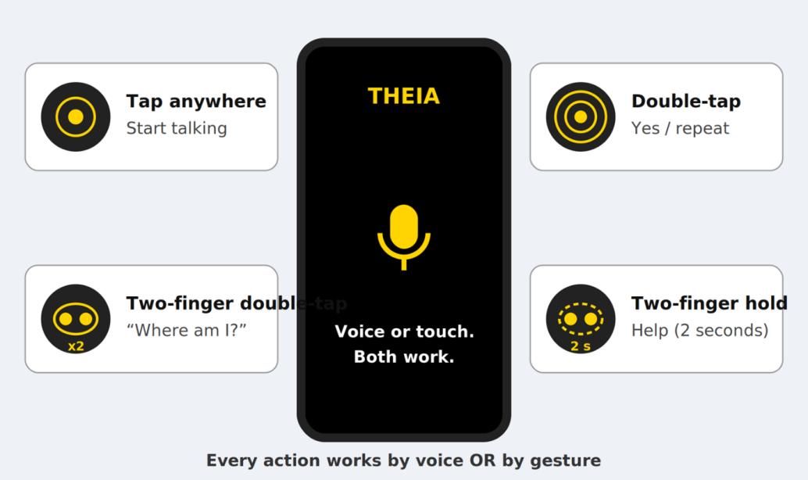
How the user controls THEIA: four gestures (tap anywhere, double-tap, two-finger double-tap, two-finger hold).
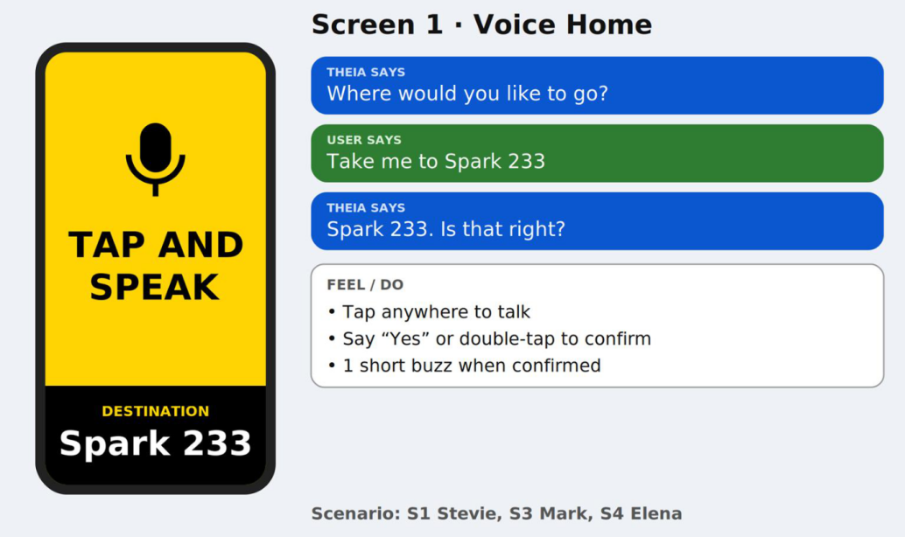
Screen 1, Voice Home: THEIA asks “Where would you like to go?”, the user says “Take me to Spark 233”, THEIA confirms.
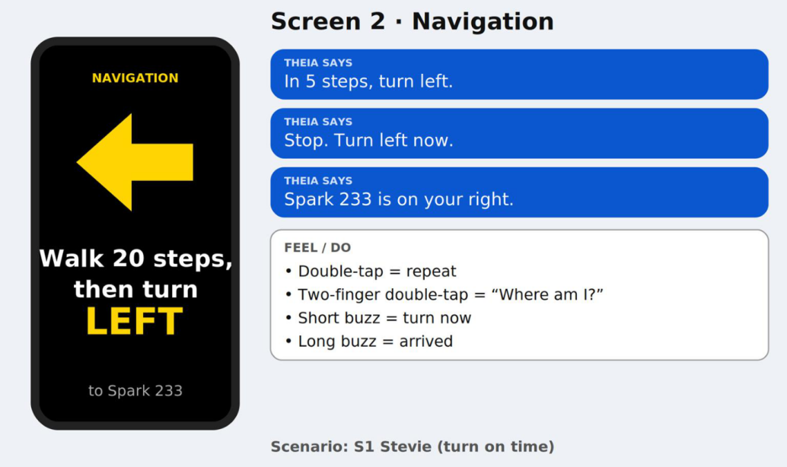
Screen 2, Navigation: “Walk 20 steps, then turn left”, the 5-step turn warning, “Stop. Turn left now”, and arrival.
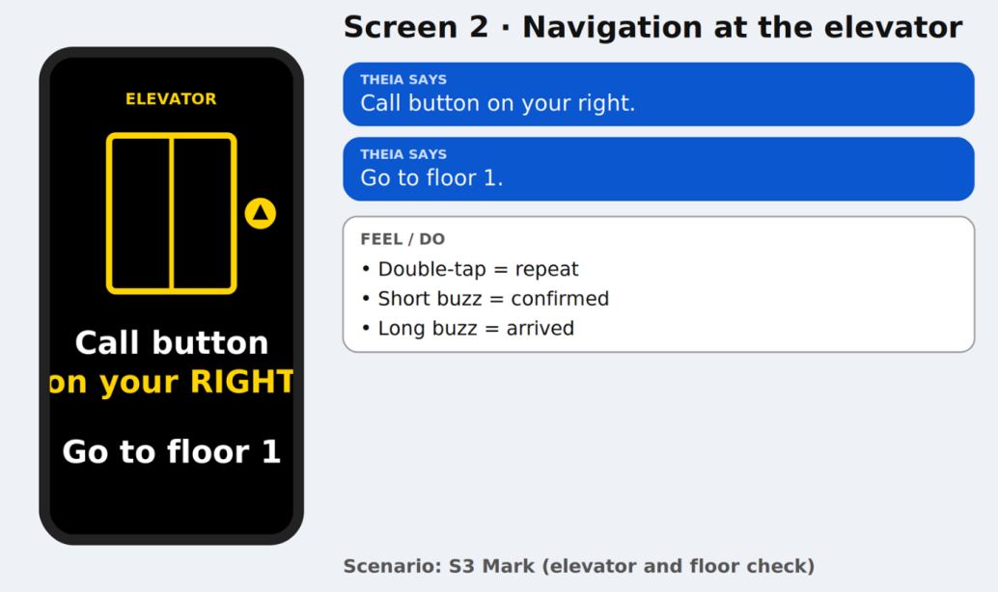
Screen 2, Navigation at the elevator: “Call button on your right. Go to floor 1.”
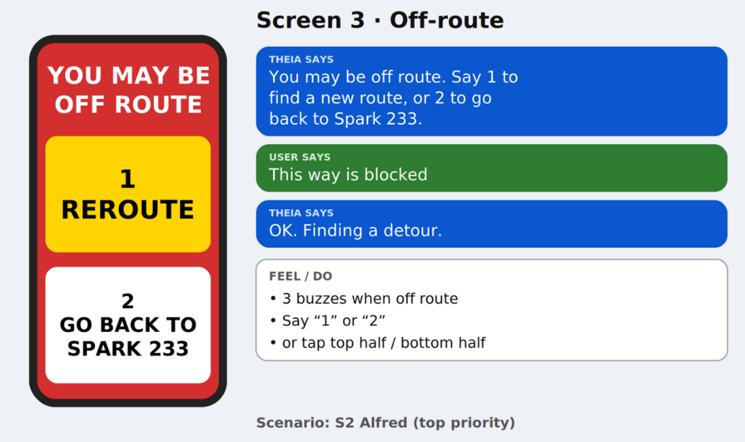
Screen 3, Off-route: “You may be off route. Say 1 to find a new route, or 2 to go back to Spark 233”, and the “This way is blocked” command.
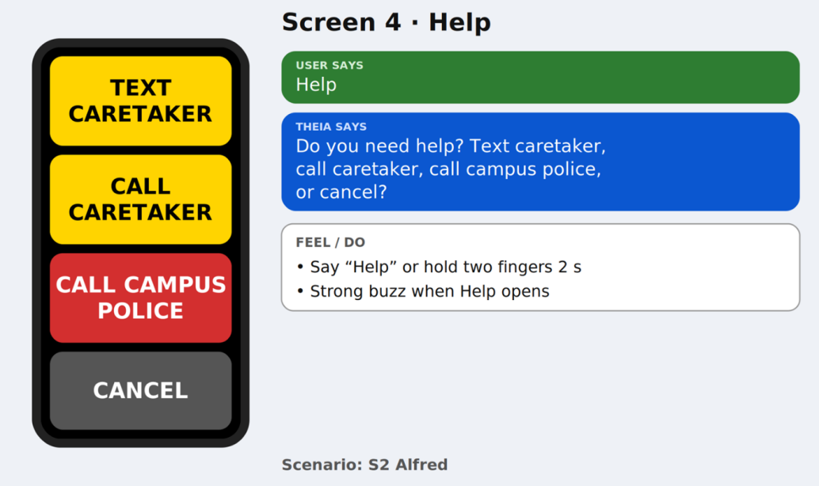
Screen 4, Help: text caretaker, call caretaker, call campus police, or cancel.
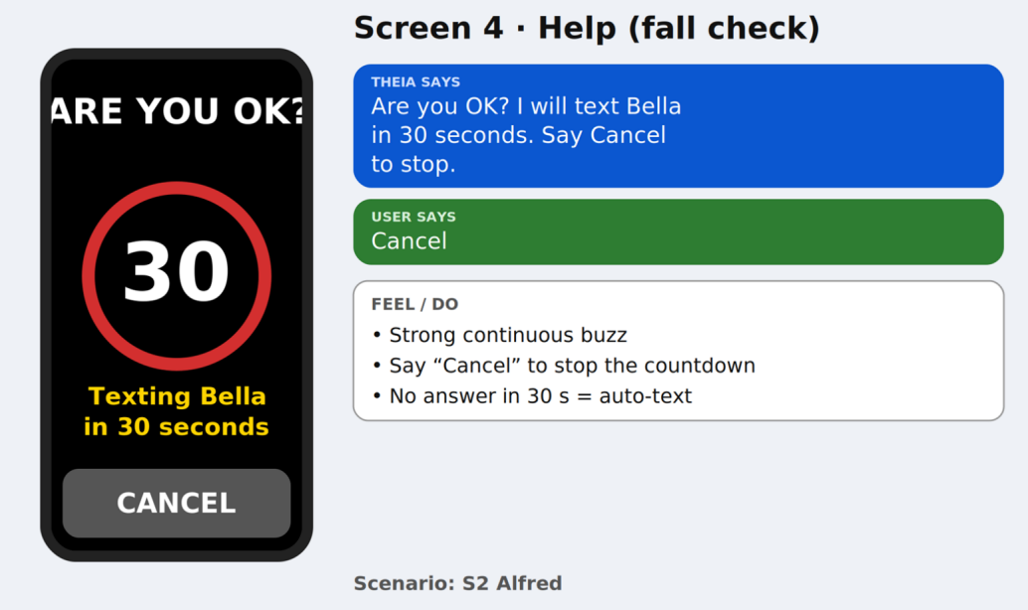
Screen 4, Help (fall check): “Are you OK? I will text Bella in 30 seconds. Say Cancel to stop.”
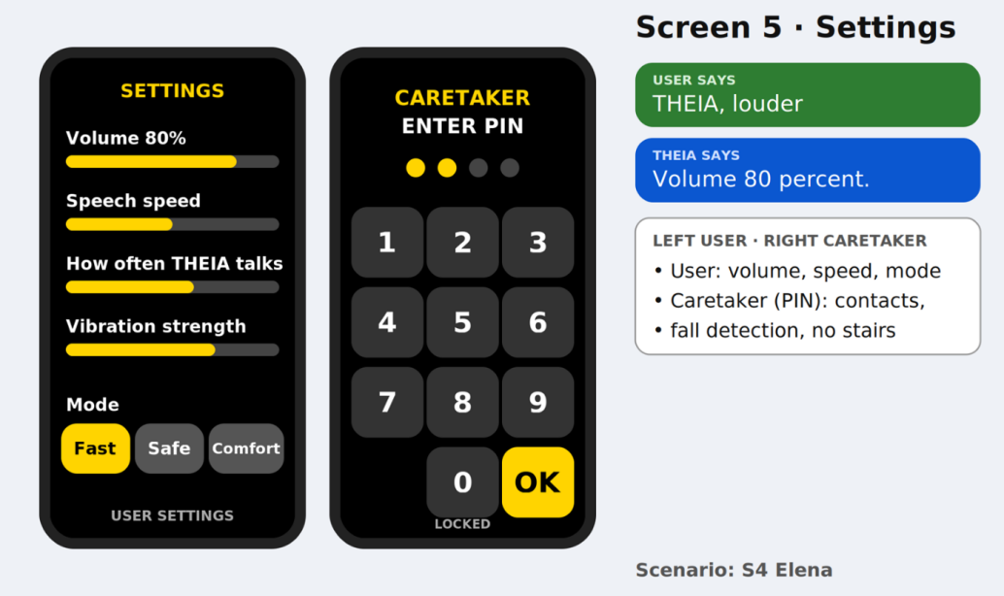
Screen 5, Settings: user settings (volume, speech speed, instruction frequency, vibration strength, mode) next to the caretaker PIN keypad.

4.3 Preliminary User Manual
The user manual is written to be read aloud by a screen reader: numbered steps, no instructions that depend on seeing the screen, and every step says what the user will hear or feel. It is organized around the TO-BE scenarios.
Manual section | Scenario | Requirements
1 About THEIA | — | NFR4, NFR5
2 First-Time Setup (Caretaker) | S4 | FR11, FR13, FS4.1
3 Basic Controls | All | FR1, FR2, FR4, NFR4
4 Going to a Room | S1 Stevie | FR2, FR3, FR4, FR5, FR6
5 Changing Floors by Elevator | S3 Mark | FR3, FR8
6 If You Are Lost or Need Help | S2 Alfred | FR7, FR9, FR10
7 Settings and Navigation Modes | S4 Elena | FR11, FR12, FR13, NFR6
8 Quick Reference | All | FR1–FR12
9 Limitations | — | WA3, WA5, WA6, ID2

4.4 Voice Commands
User says | THEIA does | Requirement
“Take me to ___” / “I’m heading to ___” | Starts a route | FR2
“Start from ___” | Uses a different starting point | FR2
“Yes” / “No” | Confirms or declines | FR2, FR13
“1”, “2”, “3” | Picks a route or an off-route option | FR3, FR9
“Where am I?” | Tells building, floor, nearest room, and which way you face | FR1
“Repeat” | Says the last instruction again | FR4
“This way is blocked” | Finds a detour | FR7
“Help” | Opens the Help screen | FR10
“Cancel” | Stops the current action or countdown | FR10
“Louder” / “Quieter”, “Speak faster” / “Speak slower”, “Instructions every ___ seconds” | Changes a comfort setting | FR11, NFR6
“Fast mode” / “Safe mode” / “Comfortable mode” | Changes the route style | FR12

5. Traceability

5.1 Forward and Backward Traceability
Forward, read left to right: Problem → Goal → Objective → Requirement. Backward, read right to left: every requirement traces to an Objective, Goal, and Problem.
Problem | Goal | Functional Obj. | Non-Functional Obj. | FR | NFR | Issues (§2) | Scenario
P1 | G1 | IFO1 | INFO5 | FR1, FR5 | NFR5 | FRI6, NFRI1, DI5 | S2
P1 | G2 | IFO2 | INFO2 | FR2, FR3 | NFR2 | FRI5, DI3, NFRI2 | S1, S3, S4
P2 | G3 | IFO3 | INFO1 | FR4, FR5 | NFR1 | FRI3 | S1
P3 | G4 | IFO4 | INFO1 | FR6, FR7 | NFR1 | FRI4, NFRI5 | S1, S2
P4 | G5 | IFO5 | — | FR8 | NFR1 | DI2, DI4 | S3
P5 | G6 | IFO6 | INFO1 | FR9, FR10 | NFR1 | FRI2 | S2
P6 | G7 | IFO7 | INFO3, INFO6, INFO7 | FR11, FR12 | NFR3, NFR6, NFR7 | NFRI3, NFRI4, NFRI7 | S4
P7 | G8 | — | INFO4 | all | NFR4 | NFRI6 | S1–S4
P8 | G9 | IFO8 | — | FR13 | — | FRI1 | —
— | — | — | — | — | — | DI1 → resolved by §3.1.3.2 Stakeholders | S2

5.2 Issue → Resolution
Every §2 issue lands somewhere in §3.
Issue | Resolved in
DI1 Stakeholder roles | 3.1.3.2, WA7
DI2 Connected buildings | ID1, FR8
DI3 Shared spaces | ID2, FR3
DI4 Multi-floor | ID3, FR8
DI5 Sensors | WA9, NFR5
FRI1 Next action / schedule | IFO8, FR13
FRI2 Emergency on lost location | IFO6, FR9, FR10
FRI3 Distance and direction | IFO3, FR4, FR5
FRI4 Obstacle detection | IFO4, FR6, FR7
FRI5 Route options | IFO2, FR3
FRI6 “Where am I” | IFO1, FR1
NFRI1 Ubiquitous | INFO5, NFR5
NFRI2 Fastest | INFO2, NFR2
NFRI3 Safe/Fast/Comfortable | INFO1, INFO3, FR12, NFR1, NFR3
NFRI4 Who customizes | IFO7, FR11, NFR6
NFRI5 Alerting pedestrians | WA5 (out of scope), FR6
NFRI6 Usability | INFO4, NFR4
NFRI7 Extensibility | INFO7, NFR7

5.3 Scenario → Requirements → Prototype → Manual
Scenario | TO-BE behavior | Requirements | Prototype screens | Manual
S1 Basic step-by-step guidance (Stevie) | Destination (and start point) by voice; “Walk ahead 10 steps, then turn left”; turn on time | FR2, FR3, FR4, FR5, FR6, NFR1 | 1, 2 | §4
S2 Off-route recovery and emergency escalation (Alfred), Top Priority | “This way is blocked” → detour; missed beacon → “may be off route” → reroute or back to Spark 233; “Help” or unanswered fall → text to Bella with location; campus police offered | FR1, FR7, FR9, FR10, NFR1 | 3, 4, 4 (fall check) | §6
S3 Multi-floor navigation by elevator (Mark) | “Lead me to TFLO 131 via elevator”; audio to the elevator, buzz on arrival; floor confirmed and map switched | FR2, FR3, FR8, NFR2 | 1, 2 (elevator) | §5
S4 Personal settings and navigation modes (Elena) | “I’m heading to lunch at the cafeteria” + double-tap; “THEIA, louder”, “instructions every 10 seconds”; route avoids the busy lobby; caretaker contacts stay locked | FR2, FR11, FR12, NFR3, NFR6 | 1, 5 | §7

References
- Cpt S 484 Team Project Specification, Phase I, v2.0 (course materials).
- Cpt S 484 Project THEIA, Preliminary Definition, v1.0 (course materials).
- CPTS 484 FAQ (course materials).
- World Assumptions Masterlist, v1.0 (course materials).
- WRS-template.rtf and WRS-Sample-Incomplete.docx (course materials).
- Requirements Review Checklist (course materials).
- Team EV, Theia AS-IS and TO-BE v2.1 Final (slides) and presentation video, https://youtu.be/0aHIRkDOK3E.
- Team EV, Theia Prototype Mock-Up and Theia-Preliminary User Manual v1.1.
- Team EV, Project Plan, Final Phase I Version 1.1.
- Team EV, AI Usage and Teamwork Report.

