AI Usage and Teamwork Report
Team EV · CptS 484 Project THEIA · Phase I · October 17, 2026
Owner: Zichuo Wang · Co-author: Young Kim

1. Summary
Team EV used generative AI on every Phase I work product: to generate candidate scenarios, draft document templates, critique drafts, draw mock-up screens, and help assemble and cross-check the final submission. The team’s rule (success criterion SC-5 in the Project Plan) was that no AI output enters a deliverable until its owner has checked it against the course documents and a second member has reviewed it.
This report lists the tools used (§2), how each work product used them (§3), the review process (§4), and concrete cases where AI output was rejected or corrected (§5). §6 covers how the team worked together. The evidence (screenshots and logs) is in Appendix A.
The record is uneven. James Zuniga kept a detailed log; Zichuo Wang, Young Kim, and Austin Aragon posted shorter notes in Discord; Justus Jones submitted no evidence. The report says so where it matters instead of filling the gaps.

2. Tools Used
Member | Tool(s) | Used for | Work product
James Zuniga | Gemini, NotebookLM | Turning the team’s issues list into AS-IS/TO-BE scenario candidates; comparing scenario strengths to pick the Top Priority; applying review feedback to the slides | D-1 slides
Austin Aragon | Gemini | Reviewing and critiquing the WRS §2 draft | D-2 WRS §2
Young Kim | ChatGPT; Claude | Checking which requirements could be shown in a mock-up; drawing the 10 mock-up screen images | D-4 prototype
Zichuo Wang | Claude Code | Weekly check-in messages; review feedback on all work products; WRS templates (front matter, §2, §3); final assembly, consistency check, plan and report drafting | D-2, D-3, D-5, D-6, assembly
Justus Jones | — | No AI usage evidence submitted | —

3. How the Team Used AI, by Work Product
D-1 AS-IS/TO-BE slides (James Zuniga). On Oct 4 James gave Gemini/NotebookLM the team’s issues list from Discord and asked for help building scenario pairs. The first exchange produced 11 candidates, all rejected (they restated his request instead of using the issues). With the issues list pasted in, it produced 4 scenario candidates; he kept 2 and rejected 2, then chose the three pairs that best covered the issues. He then asked it to list the strengths of each pair and used that list to choose the Top Priority scenario (off-route recovery and emergency escalation). On Oct 15 he used Gemini to turn Zichuo’s review feedback into a list of slide changes, and then rewrote the wording in his own words, rebuilt the layout, and added animations himself.
D-2 WRS §2 Issues (Austin Aragon, James Zuniga). The issues came from the members’ own elicitation (Issues.md). Zichuo turned the consolidated list into an AI-assisted §2 template on Oct 14, with options, decisions, and rationales marked as drafts. Austin used Gemini to critique the draft on Oct 16 and rewrote the rationale for five issues (DI1, DI4, FRI2, FRI4, NFRI4) in his own terms.
D-3 WRS §3 Improved Understanding (Zichuo Wang, Young Kim). Zichuo drafted §3 (Problems, Goals, objectives, FR/NFR with specifications, traceability) with AI help on Oct 14 as a template for the §3 owner, labeled as AI-generated. When the original owner did not deliver, Zichuo and Young completed it at assembly, checking every requirement against §2, the recorded slides, and the prototype.
D-4 Prototype and User Manual (Young Kim, Zichuo Wang). On Oct 1 Young asked ChatGPT to look over the requirements and flag anything that could not be mocked up; it also suggested ideas for customizing settings. On Oct 15 Young used Claude to draw 10 screen images (phone screen, speech bubbles, and a “Feel / Do” box per screen), which became the slides of the mock-up. The manual was written by Young and revised to v1.1 at assembly.
D-5 Project Plan (Zichuo Wang, James Zuniga). AI helped draft the weekly check-ins (e.g., the Oct 1 Week 3 check-in) and the final plan update. The schedule, roles, and reassignment decisions were made by the team liaison.

4. Review and Evaluation Process
The rule (SC-5). Every AI-assisted passage is checked by the owner of the work product against the source documents, and by one other member, before it ships. “Checked” means: every claim traced to the Preliminary Definition, the World Assumptions Masterlist, or a team decision; nothing invented (numbers, features, stakeholders); and the wording rewritten so it reads as the team’s own.
Source documents used for checking: THEIA Preliminary Definition v1.0, World Assumptions Masterlist v1.0, Project Specification Phase I v2.0, the WRS template and sample, and the Requirements Review Checklist.
Work product | Owner check | Second review
D-1 slides | James Zuniga: kept 2 of 4 scenario candidates; picked the Top Priority himself; rewrote wording | Zichuo Wang’s Oct 14 feedback (checked against the spec, the WRS template, and the Masterlist); James applied it Oct 15
D-2 WRS §2 | Austin Aragon: critique with Gemini, five rationales rewritten | Zichuo Wang at assembly: plain-language edits, typo fixes
D-3 WRS §3 | Zichuo Wang: draft labeled AI-generated, every item traced to a §2 issue | Young Kim (co-author); cross-check against slides and prototype at assembly
D-4 prototype, manual | Young Kim: screens checked against the TO-BE scenarios | Zichuo Wang at assembly: screens and manual checked against WRS §3
D-5 plan, D-6 report | Zichuo Wang | Team review before submission
Decisions people made. AI produced candidates and checks. The team made the decisions, including:
- the scope calls (indoor connectors only; static obstacles only; public pass-through rooms; the sensor list);
- which issues to keep, and the decision and rationale for each;
- the three-plus-one scenario pairs and the Top Priority choice (James Zuniga);
- at assembly, how to resolve conflicts between work products (Zichuo Wang): the recorded slides are fixed, the WRS follows the slides, and the prototype and manual follow the WRS; one warning distance (5 steps) everywhere; the D-2 and D-3 reassignments.

5. What the Team Caught and Corrected
1. Scenario candidates that ignored the issues (D-1, Oct 4). The first 11 candidates from Gemini/NotebookLM were all rejected because they restated the request rather than working from the issues list. Of the next 4 candidates, 2 were rejected. (Appendix A, Figures A6–A7.)
2. Out-of-scope features in the slides (D-1, Oct 14–15). The AI-drafted scenarios included features the Masterlist rules out. Review feedback caught them and James changed the slides: “dynamic crowd” detection in Scenario 4 was replaced by “avoids areas the map marks as busy” (moving obstacles are out of scope, WA5), and “3D spatial audio” on the comparison slide was replaced by “hands-free voice + vibration guidance”. Name errors (“Stevie calls caretaker Bella”) were also fixed. (Figures A17–A18.)
3. A habit-learning assumption (D-1 / D-2). The AI’s Elena scenario had THEIA “check Elena’s calendar and path history”. The team’s decision in FRI1 is to use an entered schedule only, without learning from location history. The final slide does not use path history. (Figure A11.)
4. Generic rationale in §2 (D-2, Oct 16). Austin replaced five AI-drafted rationales with his own. At assembly, the rewritten rationales were edited into plain language and a typo (“usering”) was fixed. The decisions themselves did not change.
5. Conflicts between work products (assembly, Oct 17). The cross-check found, among others:
- the user manual’s gesture and vibration tables were copies of its voice-command table;
- the manual said Comfortable mode “ignores congestion”, while the WRS and Scenario 4 say it avoids busy areas;
- the WRS gave three different turn-warning distances, and disagreed with itself on who sets the default mode;
- the prototype listed “two-finger tap” for “Where am I?” while its own screens showed a two-finger double-tap;
- the manual described a caretaker-reply feature with no requirement behind it.
Each was fixed in the direction the team set (Appendix B of the WRS lists all 12 before/after changes). The AI found the conflicts; the resolution rules were the liaison’s.

6. Teamwork
Organization. Five members, one owner and one co-author per work product, everyone reviewing. Discord was the main channel (one channel per work product), with weekly written checkpoints on Sundays posted by the liaison. Drafts lived in Google Drive; submitted versions are in the GitHub repository.
Who did what.
Member | Contribution to Phase I
Zichuo Wang | Liaison; Project Plan (preliminary and final); weekly check-ins and review feedback; WRS templates; WRS §3 after the reassignment; prototype co-author; this report; final assembly and consistency check
James Zuniga | AS-IS/TO-BE slides and the recorded presentation; Top Priority analysis; WRS §2 co-author; Project Plan co-author
Austin Aragon | WRS §2 Issues: consolidated issues list, options, decisions, rationale; slides co-author
Young Kim | Prototype mock-up (5 screens, 10 images) and preliminary user manual; WRS §3 co-author; this report’s co-author
Justus Jones | Assigned WRS §3 owner and §2 co-author. Did not reply to the team or deliver work during the final week, and produced no work product for this submission
What worked. The co-author model limited the damage of a missing member: §3 already had a co-author and a draft, so it could be completed in the last week without losing a work product. The Oct 14 feedback round, with fixed deadlines (Thu Oct 15 fixes, Fri Oct 16 video, Sat Oct 17 assembly, Sun Oct 18 submission), held.
What we would change. The WRS §2 internal deadline (Oct 4) slipped to Oct 16, and AI evidence was collected at the end instead of continuously, which is why parts of this record are thin.

Appendix A. Evidence

A.1 Zichuo Wang
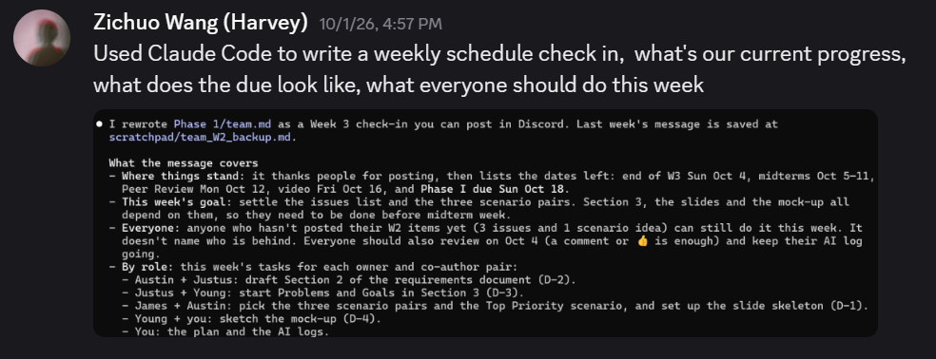
Figure A1. Oct 1: Week 3 check-in drafted with Claude Code.
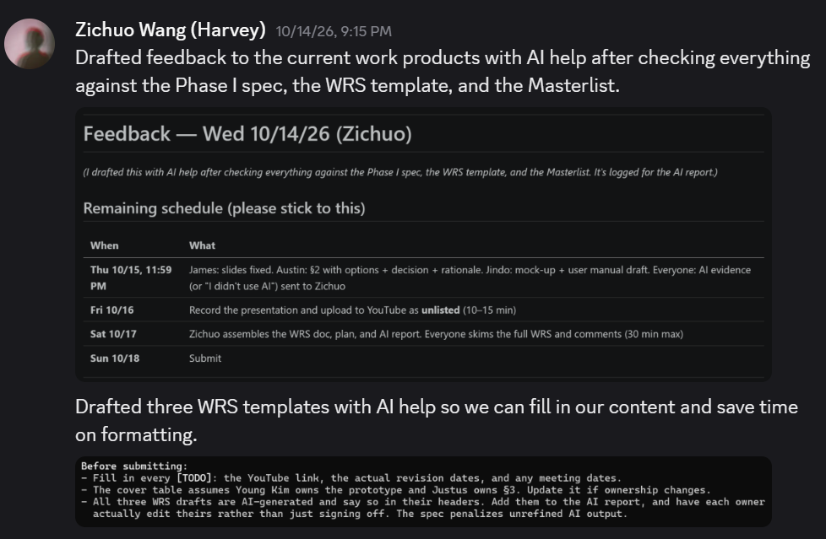
Figure A2. Oct 14: review feedback drafted with AI after checking every work product against the Phase I spec, WRS template, and Masterlist; WRS templates labeled as AI-generated with [TODO]s.

A.2 Young Kim
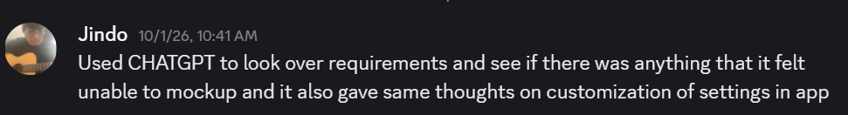
Figure A3. Oct 1: ChatGPT used to check which requirements could be mocked up.
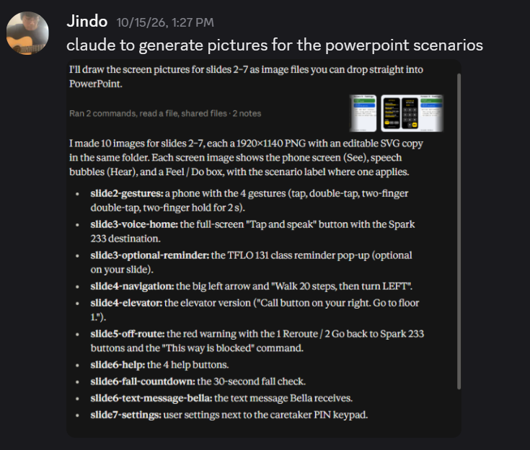
Figure A4. Oct 15: Claude used to draw the mock-up screen images.

A.3 Austin Aragon
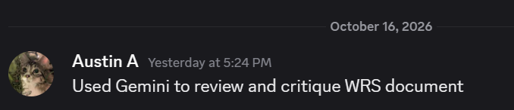
Figure A5. Oct 16: Gemini used to review and critique the WRS §2 draft.

A.4 James Zuniga
From AI Usage Report V1.2 (James Zuniga), which also contains the full log text.
Date | Time | Asked for | Came back | Changed by James | Verified against
Oct 4 | ~40 min | Help building AS-IS/TO-BE scenarios | 11 candidates, 11 rejected (confirmed the request, waited for input) | Supplied the issues list from Discord | Issues list (Discord)
Oct 4 | — | Scenarios from the pasted issues list | 4 candidates, 2 accepted, 2 rejected | Chose the pairs that best fit the issues | Issues list (Discord)
Oct 4 | ~3 min | Strengths of each scenario pair for the Top Priority choice | 3 candidates, 1 accepted, 2 rejected | Decided the Top Priority scenario himself | Issues list (Discord)
Oct 15 | ~20 min | Changes needed to apply the review feedback | 9 changes, all accepted | Reworded in his own words, rebuilt layout, added animations | Feedback image from Zichuo Wang (#as-is-to-be)
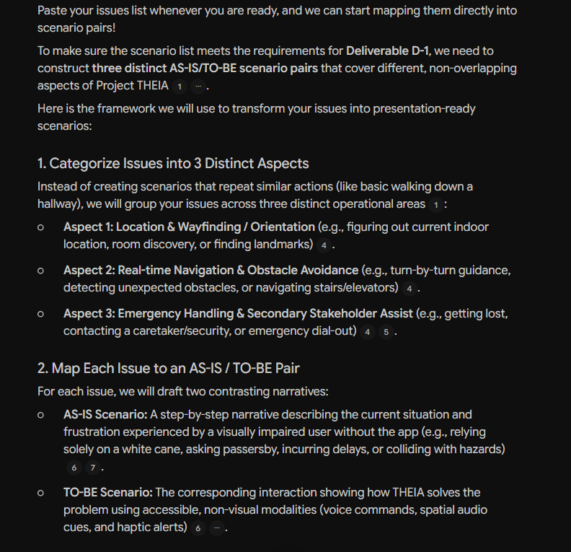
Figure A6. Oct 4: scenario framework proposed by the AI.
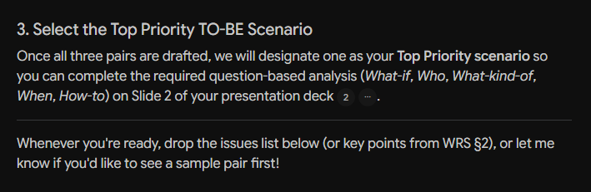
Figure A7. Oct 4: Top Priority selection step.
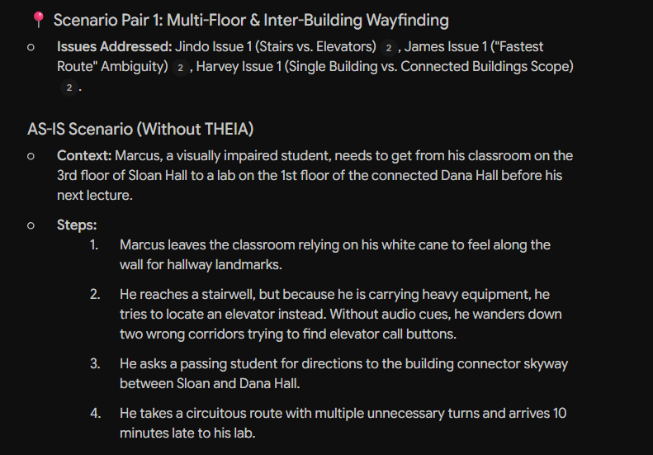
Figure A8. AI draft, Scenario Pair 1 AS-IS (Marcus).
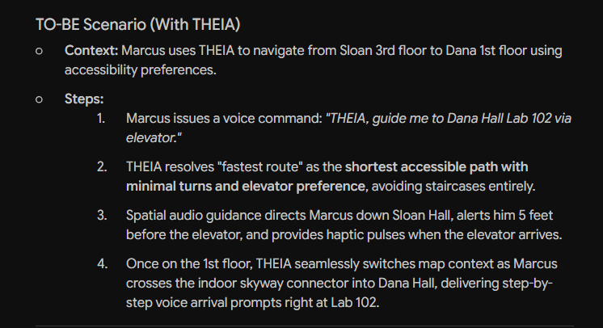
Figure A9. AI draft, Scenario Pair 1 TO-BE.
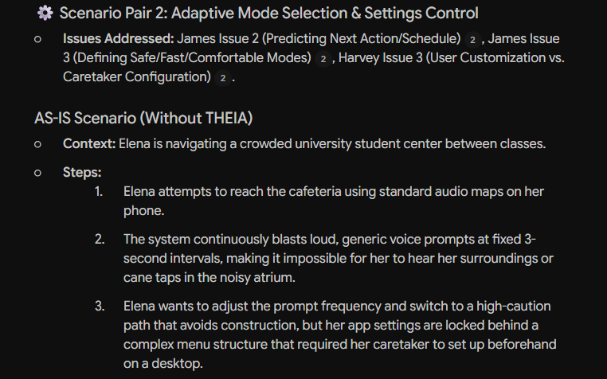
Figure A10. AI draft, Scenario Pair 2 AS-IS (Elena).
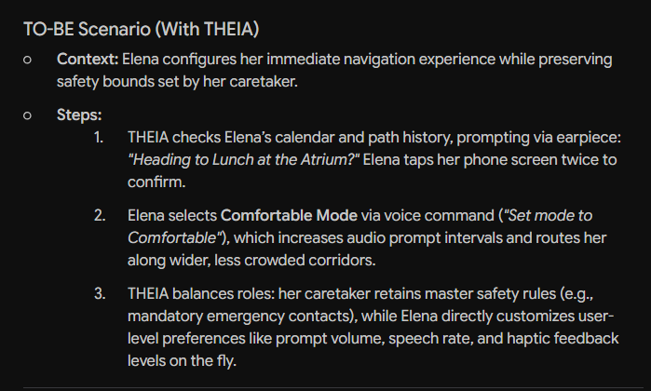
Figure A11. AI draft, Scenario Pair 2 TO-BE: “checks Elena’s calendar and path history” (not used).
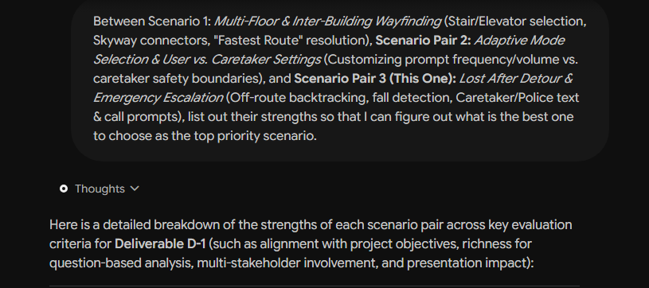
Figure A12. Oct 4: request to compare the scenario pairs.
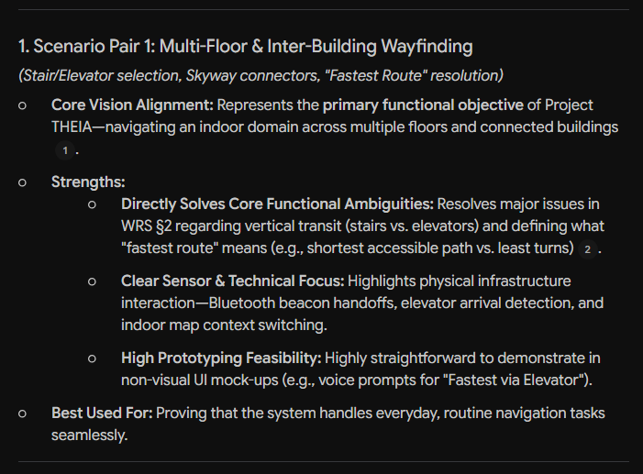
Figure A13. Strengths, Scenario Pair 1.
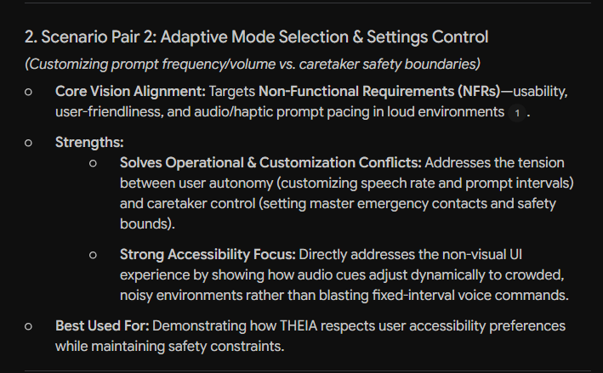
Figure A14. Strengths, Scenario Pair 2.
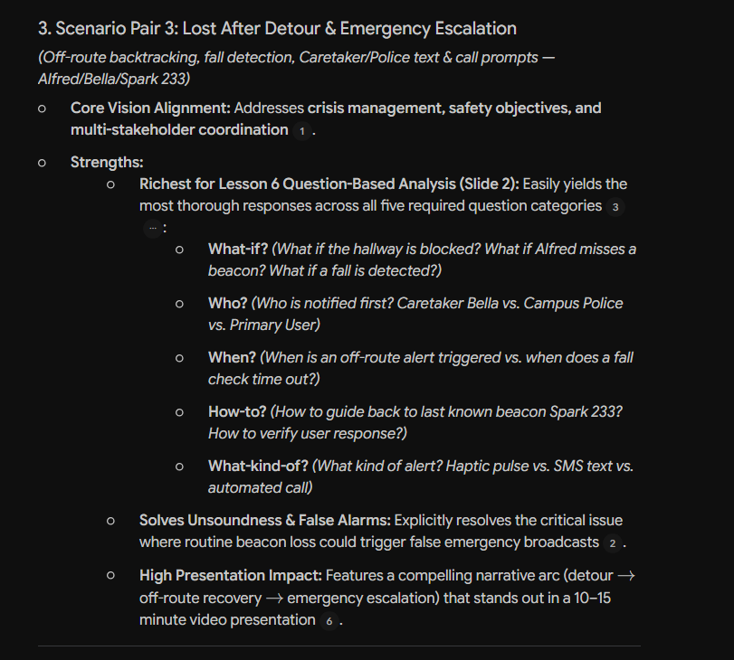
Figure A15. Strengths, Scenario Pair 3 (chosen as Top Priority).
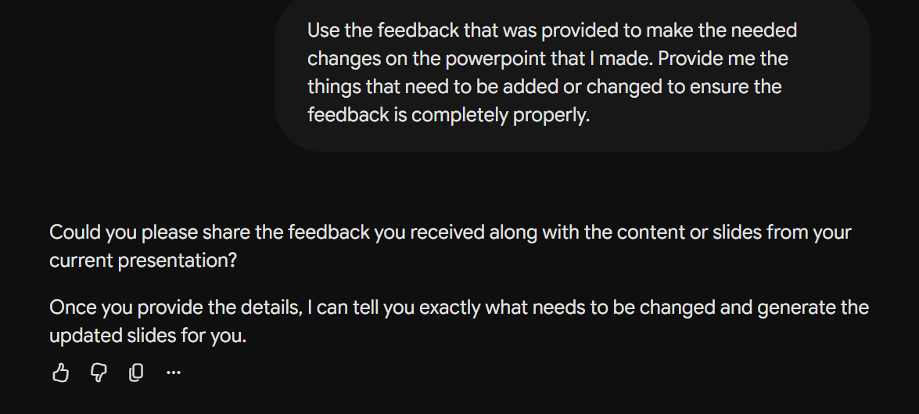
Figure A16. Oct 15: request to apply the review feedback.
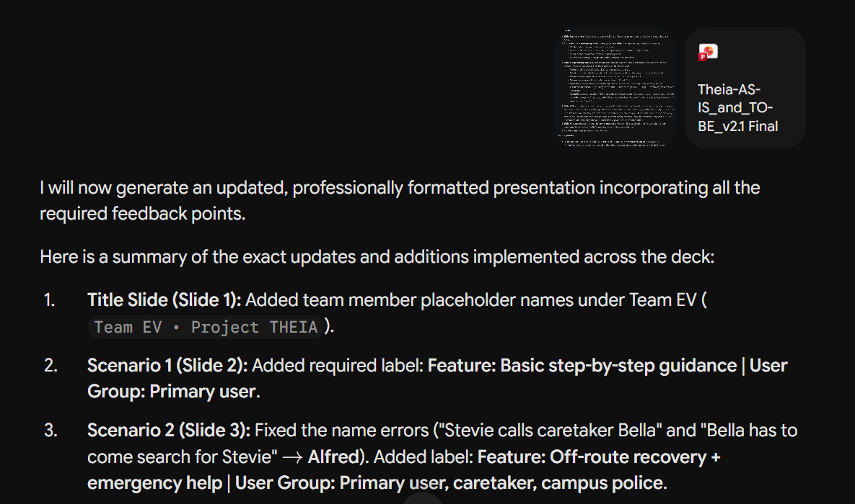
Figure A17. Oct 15: changes from the feedback (slides 1–3).
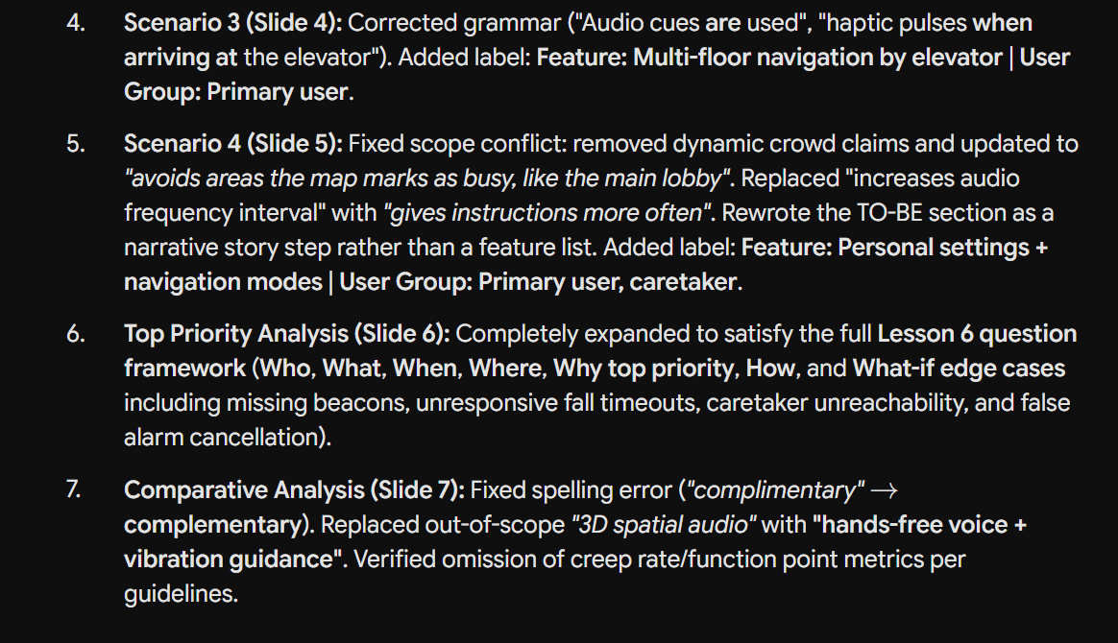
Figure A18. Oct 15: changes from the feedback (slides 4–7), including the removed out-of-scope claims.

A.5 Justus Jones
No AI usage evidence was submitted.

