Glowy Space V1.0
By Ricardo Concha – Nemoris Games
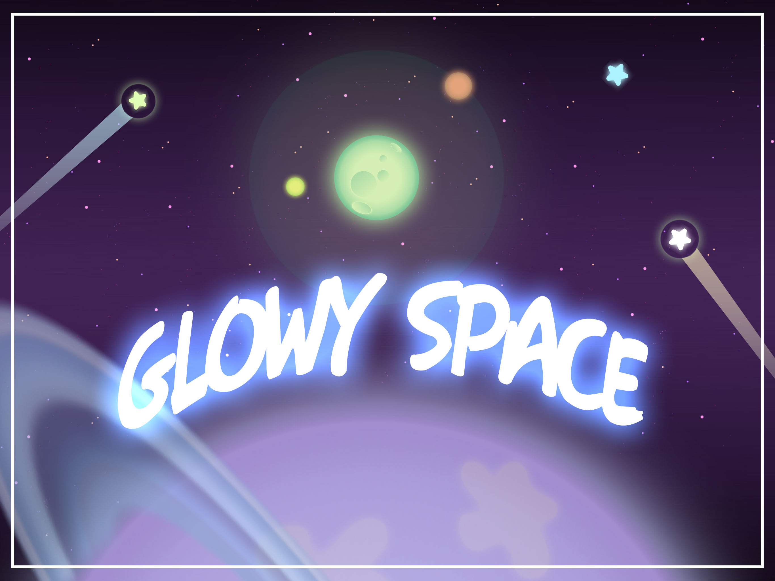

“Thank you for getting this pack. Let’s check how it can
help you to improve your game or make things easier”

Glowy Space is an art pack to create space scenes with just a few images and a lot of customization. The strong point in this assets are the scripts that controls the behaviours of all the elements in screen including a 4-Direction parallax effect fully customizable.
Art Assets

The art assets were created having in mind to consume the minimal amount of memory and with as few sprites as possible to get full quality without incrementing the draw calls.

All art assets allows to scale up without loosing quality (the maximun scale amount allowed depends on the objective screen resolution)

This pack allow the user compose complex assets for his project. The sprites included in this pack are:

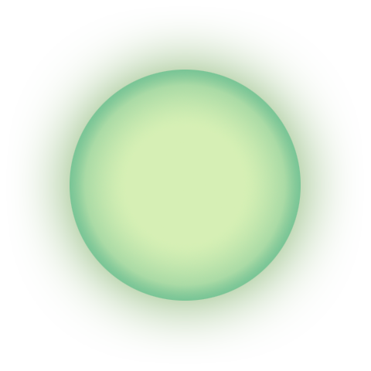
- Planet: This asset is the most used and important in the pack. It represent a generic planet but with a green color that create a great effect when color is applyied to it.

- Star: This asset is prepared to call the attention with is own glow and it’s perfect to add any color and even can be used in GUI.

- Small Star Group: This asset solve the problem that we want that the stars move in parallax as individuals, but if they are too many, the amount of memory used it will be too much, in the other hand, too many stars in a single image it doesn’t look good in the parallax effect. So this asset is the middle between both.

- Big Planet: This asset is a very big planet to use as part of the background. It has a fade effect to reduce his image size without lose quality when is scaled too high.
- Space Background: This asset is a very long image vertical wise. It has been created to be scaled horizontally and fill any background needed.


- External Glow: This asset is a effect that creates something like a energy bubble. Ideal for shiny elements.









- Planet Layers: This assets are for using over the planets, because of the glow effects, they can be used in the normal planet or in the big planet.

- Planet Ring: This ring works also as a layer over a planet. Is mainly thought to add and extra layer to the big planets.
Scrips, Behavious and Components

As said, the tipping point in this assets are the behaviours controlled by easy customizable scripts. This scripts are created to be used in any other way or object that the user may need.

- SpaceManager.cs
This script is used to store important information. In this case, only store and define the scroll direction.
- ParallaxMovement.cs
This is a very important script, it manages the parallax effect in each object using the scroll direction given by the selection in the SpaceManager object(check prefabs).
The parallax effect uses a random speed given by minSpeed and maxSpeed. A 0f value will make the object to move along with the camera, a value less than 0f will make the object to move ahead of the camera
To determine if the object is completely out of screen the script add a limitOffScreen parameter that is the viewport’s value. For example, if the user want that the object’s limit is a half size of the screen, then the limitOffScreen value should be 0.5f
The behaviourOnExit determinate what the object should do when exit the screen (plus the limit). Destroy will destroy the object and Regenerate take the object, repositionate it according to the scroll direction and if it or his children has any random type component, it gets randomize again.
- CameraMovement.cs
This script moves the camera according to the speed set by the user and in the scroll direction given by the selection in the SpaceManager object(check prefabs).
- ShootingStar.cs
This script control the shooting star and meteor prefabs in the assets. It position it according to the scroll direction, set the direction pointing to the center of the screen and put the object to ‘sleep’ until the spawnTime value is reached.
- RandomColor.cs
This script chooses randomly a color from a list of colors settled by the user and applies it to the <SpriteRenderer> in the same object.
It also has a invisibleProbability value that, if the random number from 0f to 100f is less than the invisibleProbability, make the sprite invisible.
- RandomSprite.cs
This script chooses randomly a sprite from a list of sprites settled by the user and applies it to the <SpriteRenderer> in the same object.
- RandomRotation.cs
Make the object rotate at the speed given by rotationSpeedMax. If the randomize bool is true, the script will choose a speed between 0f and rotationSpeedMax.
- RandomSize.cs
This script apply the multiplierMax value to the current object’s localScale, multipliying it. For example, if the object has a localScale of (1f, 2f, 3f), the new size, asuming that the random multiplier generated is 4f, it will be (4f, 8f, 12f). The multiplier used is a random number generated between 1f and multiplierMax.

Prefabs

To have all the components working for you and just pick the prefabs and incorporate them into your project, we have prepared a scene ExampleScene and a this prefabs:

- SceneManager
This prefab determine the scroll direction of the scene. Other prefabs use this value to change their behaviour. The user can change this value at will.
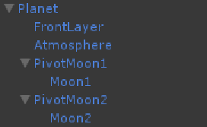
- Planet
This prefab is a planet with random behaviours. Such as RandomColor, RandomSize, RandomRotation and the ParallaxMovement to move in the scene. As children:
- FrontLayer: Is a layer that contains different sprites in the RandomSprite component that are located over the planet sprite.
- Atmosphere: Based on the planet sprite, this object simulates this effect over the planet.
- PivotMoon and Moon: The pivot create the orbit rotation for the moon object that uses the planet sprite.
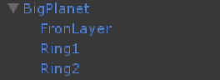
- BigPlanet
This prefab works just like the Planet prefab. With the difference that theres no moons and theres two rings in the planet with high probabilities of been hided.
- Star
This prefab has random behaviours. Such as RandomColor, RandomSize, RandomRotation and the ParallaxMovement to move in the scene.
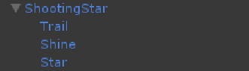
- ShootingStar
This prefab has the ShootingStar component to set their behaviour. The children object show the trail behind the star, the shining (represented by the Glow sprite) and the star that is the main sprite.

- Comet
This prefab behaves just like the ShootingStar, with the difference that instead of a star, if uses a comet body that is represented by the planet sprite.
- SmallStarGroup
This prefab represent a group of stars that are perfect for background and create a depth effect using the parallax effect. This prefab has been optimized to use the less resources possible because it has to be replicated several times to create a perfect effect. A prove of this is that in the ExampleScene, this prefab is replicated 20 times and having this as the main consumption of memory, it doesn’t represent trouble.

Final Note
Thanks for using this library. I hope you find it useful. I'll try my best to provide support regarding any issue.

I aim to provide unprecedented support within my best ability. For any question, contact me directly at rconcha@nemorisgames.com

I definitely hope to expand and add more features. So any idea and feedback are welcome.

Please rate this asset and comment it so more people can get awared and improve thir games.

Best regards,
Ricardo Concha – Nemoris Games

