**ASHA: SEMI AUTOMATED HOUSE using ARDUINO**

Submitted by

1. Niraj Singh Tomar
2. Rushikesh Girgaonkar
3. Srivitthal Biradar

**G.H.RAISONI COLLEGE OF ENGINEERING & MANAGEMENT WAGHOLI, PUNE**

(An Autonomous Institute Affiliated to Savitribai Phule Pune University)

Department of Computer Engineering

S.Y. BTech (Semester III 2017-18)

Under the supervision of

Dr. Vikram **G.H.R.C.E.M , Wagholi Pune**

**CERTIFICATE**

This is to certify that Mini Model Project Report titled **ASHA: Semi Automated House using Arduino** is a bonafide work carried out by

1. **NIRAJ SINGH TOMAR**
2. **RUSHIKESH GIRGAONKAR**
3. **SRIVITTHAL BIRADAR**

of our **G.H. RAISONI COLLEGE OF ENGINEERING & MANAGEMENT , WAGHOLI , PUNE (**Department of Computer Engineering Semester III 2017-18) for fulfilment of project work. They have worked under the guidance and supervision. The material referred from other sources has been duly acknowledged.

(Signature of Faculty)

Name:-

Designation:-

Date:

**ACKNOWLEDGMENT**

The most sincere thanks and gratitude to the Al-Mighty God who has eased the

difficulty and cleared the ambiguity for us to fulfil this achievement which is my mini modelling of S.Y.

First, we would like to thank Dr. Vikram to be our mini model project supervisor.

We would like to thank her for the guidance, support and encouragement she provided to us throughout the entire duration while we were doing and preparing our project.

I also would like to take a moment thank our HOD Madam, Poonam Gupta

for the support and guidance, she showed towards us throughout the journey whenever we needed her.

Last but definitely not least, we would like to thank our parents and

friends for the constant encouragement and constant support they showed me throughout our project development.

From the bottom of my heart THANK you all very much.

**ABSTRACT**

This report presents implementation of cost effective Home Automation System.

With the increase in consumption of energy and population, there is a grave need to conserve energy in every way possible. This framework is intended to do the same and to help and give help to satisfy the needs of the elderly and the handicapped at houses. Additionally, the idea of home automation system will improve the normal living status at houses. A smart home will take advantage of its environment and allow seamless control whether the user is present or away. With a home that has this advantage, you can know that your home is performing at its best in energy performance. The system design does not remove the existing electrical switches and gives a safer control over the switches with low voltage usage technique. The switches status is synchronized everywhere each person interface demonstrates the current existing switch status. This system is designed to control electrical devices throughout the house with ease of installing it, ease of use and cost effective design and implement.

**CONTENTS**

|  |  |  |
| --- | --- | --- |
| Sl No | Topic | Pg. No |
|  |  |  |
| I | Listing of figures |  |
|  |  |  |
| 1. | Chapter 1: Introduction |  |
| 1.1 | Research Background |  |
| 1.2 | Problem Statement |  |
| 1.3 | Objective of Study |  |
| 1.4 | Scope of Study |  |
|  |  |  |
| 2 | Chapter 2: Literature Review |  |
| 2.1 | Introduction |  |
| 2.2 | Home Automation System |  |
| 2.3 | Arduino Uno |  |
|  |  |  |
| 3 | Chapter 3: Development of Model |  |
| 3.1 | Components Required |  |
| 3.1.1 | Arduino Uno |  |
| 3.1.2 | Ultrasonic Sensor |  |
| 3.1.3 | LDR |  |
| 3.1.4 | LED |  |
| 3.1.5 | PIR Sensor |  |
| 3.1.6 | Jumper Wires |  |
| 3.2 | Sketch |  |
| 3.2.1 | Sketch for Ultrasonic Sensor |  |
| 3.2.2 | Sketch for LDR |  |
| 3.2.3 | Sketch for PIR |  |
| 3.2.4 | Complete sketch of ASHA |  |
| 3.3 | Circuit Diagram |  |
|  |  |  |
| 4 | Chapter 4: Analysis |  |
|  |  |  |
| 5. | Chapter 5: Conclusion |  |
|  |  |  |
| 6. | Chapter 6: Future Scope |  |
|  |  |  |
| 7. | References |  |
|  |  |  |

**Listing of Figures**

|  |  |  |
| --- | --- | --- |
| **Fig No.** | **Description** | **Page No.** |
|  |  |  |
| 3.1 | Arduino Uno |  |
| 3.2 | Circuit of Ultrasonic Sensor |  |
| 3.3 | LDR |  |
| 3.4 | Configuration of LDR |  |
| 3.5 | Calibration of LDR |  |
| 3.6 | LED |  |
| 3.7 | LED Circuit |  |
| 3.8 | Passive Infrared Sensor |  |
| 3.9 | Male to Male Jumper wires |  |
| 3.10 | Male to Female Jumper wires |  |
| 3.11 | Complete Circuit of ASHA |  |
|  |  |  |
| 4.1 | Output window |  |
|  |  |  |

**Chapter 1**

**INTRODUCTION**

* 1. **Research background**

Automated home system is getting popular and widely used in a lot of houses

worldwide. It has tons of merits to users even more to the handicapped and/or elderly users in which it will make it easier for them to control their home appliances. Home automation systems can be labelled to two medium in which how it is connected and they are either wired or wirelessly connected. The main difference between these two kinds is that home appliances are linked wirelessly a central controller if it a wireless home automation system. On the other hand, the appliances are connected to a central controller if the medium use wired communication method.

* 1. **Problem statement**

In the present day home automation is becoming essential for the purpose of improving our life condition. Convenience and ease of using home appliances is what home automation is offering. Home automation offers an efficient use of energy.

But to get or acquire such system installed will cost a lot of money and that is the major reason of why home automation has not received much demand and attention, adding to that also the complexity of installing it and configuring it. Thus it is essential to make it cost effective and easy to configure, if this is granted to people then they will be willing to acquire it in their homes, offices and schools. In other words, a system modification for the home automation is required in order to lower the price of applying it to houses.

* 1. **Objective of the study**
* To construct a wired home automation system controlled by sensors and an arduino Uno.
* To design and implement cost effective home automation system yet an efficient one.
* To design a user friendly and a safe system to control home appliances especially aimed to aid the elders and handicapped.
  1. **Scope of study**

In order to fulfil the stated objectives several steps must be taken. These steps involve

both software programming and hardware implementation.

These steps are as follows:

* Establishing a wired network communication between the arduino and the home automation system, using various sensors.
* Create a simple yet reliable home automation system using Arduino-Uno as a

microcontroller that will be the medium between the sensors and the home.

* Program the Arduino-Uno board in a way that will let it interact with the home.

**Chapter 2**

**LITERATURE REVIEW**

**2.1 Introduction**

This chapter will describe anything related to home automation, arduino and its operation system, arduino development tools.

**2.2 Home Automation System**

Home automation is computerization of the home, housework or household action. Home automation may incorporate a control unit for controlling of lighting,

Automation has been around for quite a while and items have been available for a considerable number of years, however nobody’s arrangement has gotten through to the standard yet. Home computerization for the elderly and debilitated can give expanded personal satisfaction to persons who may generally need parental figures or institutional consideration.

**2.3 Arduino Uno**

Arduino Uno is open source physical processing which is based on a microcontroller board and an incorporated development environment for the board to be programmed. Arduino gains a few inputs, for example, switches or sensors and control a few multiple outputs, for example, lights, engine and others. Arduino program can run on Windows, Macintosh and Linux operating systems (OS) opposite to most microcontrollers’ frameworks which run only on Windows.

Arduino programming is easy to learn and apply to beginners and amateurs.

Arduino is an instrument used to build a better version of a computer which can control, interact and sense more than a normal desktop computer. It's an open-source physical processing stage focused around a straightforward microcontroller board, and an environment for composing programs for the board.

Arduino can be utilized to create interactive items, taking inputs from a diverse collection of switches or sensors, and controlling an assortment of lights, engines, and other physical outputs. Arduino activities can be remaining solitary, or they can be associated with programs.

**Chapter 3**

**DEVELOPMENT OF MODEL**

**3.1 Components used:**

**3.1.1 Arduino Uno**

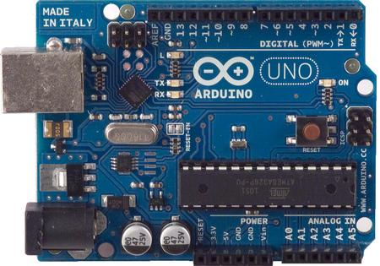

**Fig 3.1 Arduino uno**

* Arduino is an open-source electronics prototyping platform based on flexible, easy-to-use hardware and software.
* Founded by Massimo Banzi and David Cuartielles in 2005.
* An open-source hardware platform based on Atmel AVR microcontroller and a C++ based IDE
* Simple and easy to learn programing.
* Controller independent programming language.
* One language compatibility with all boards.
* Single software for programming, compiling and burning the code.

**3.1.2 Ultrasonic sensor**

The HC-SR04 ultrasonic sensor uses SONAR to determine the distance of an object just like the bats do. It offers excellent non-contact range detection with high accuracy and stable readings in an easy-to-use package from 2 cm to 400 cm or 1” to 13 feet.

The operation is not affected by sunlight or black material, although acoustically, soft

materials like cloth can be difficult to detect. It comes complete with ultrasonic transmitter and receiver module.

**Technical Specifications**

* Power Supply: +5V DC
* Quiescent Current: <2mA
* Working Current: 15mA
* Effectual Angle: <15°
* Ranging Distance: 2cm – 400 cm/1″ – 13ft
* Resolution: 0.3 cm
* Measuring Angle: 30 degree

**Components Required**

You will need the following components:

* 1x Breadboard
* 1x Arduino Uno R3
* 1x ULTRASONIC Sensor (HC-SR04)

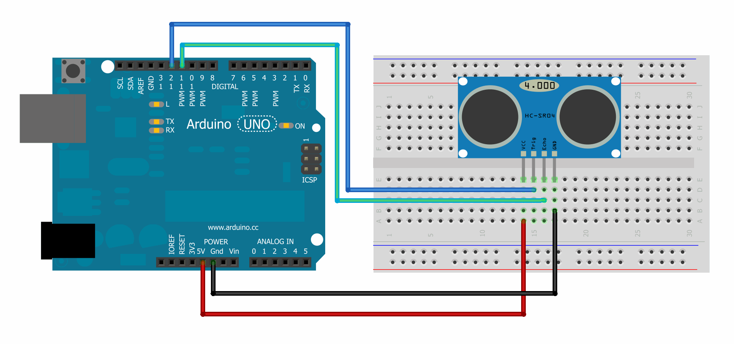

**Fig 3.2 Circuit of ultrasonic Sensor**

**3.1.3 LDR**

* LDR Sensor: - Light Dependent Resistor.
* Changes the value of resistance according to ambient light.
* Resistance is inversely proportional to the light intensity.

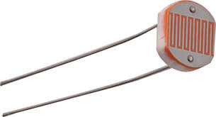 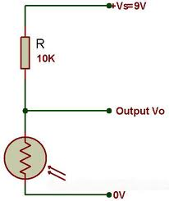

**Fig 3.3 LDR Fig 3.4 Configuration of LDR**

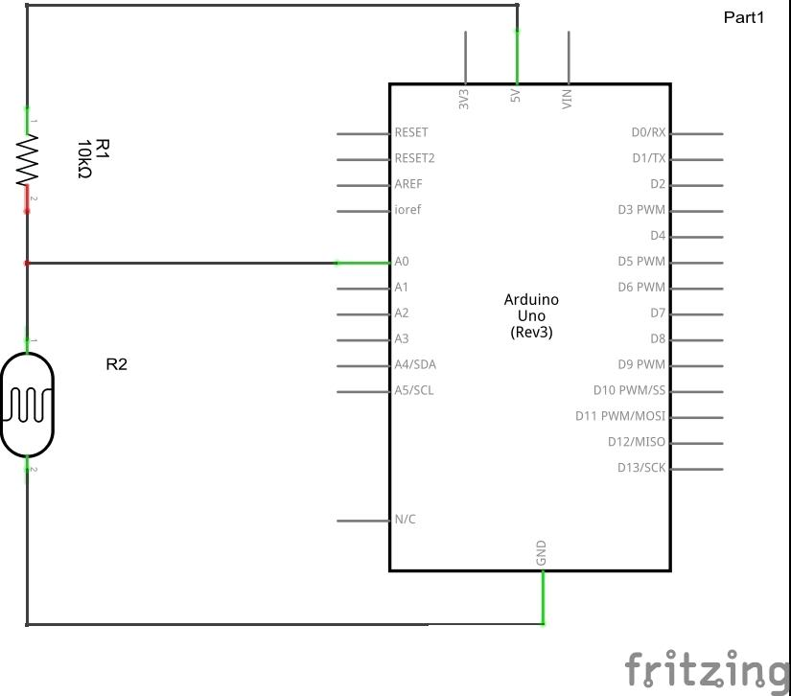

**Fig 3.5 Calibration of LDR**

**3.1.4 LED**

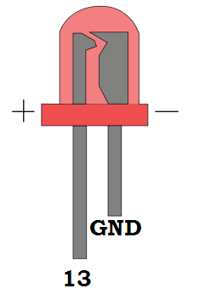

**Fig 3.6 LED**

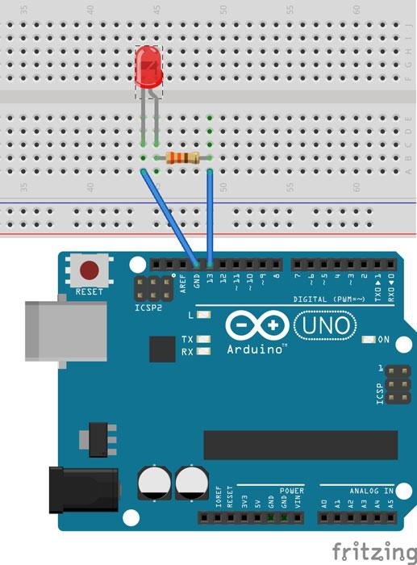

**Fig 3.7 LED circuit**

* A light-emitting diode (LED) is a two-lead semiconductor light source.
* When a suitable voltage is applied to the leads it emits light.
* This effect is called electroluminescence

**3.1.5 Passive Infrared Sensor**

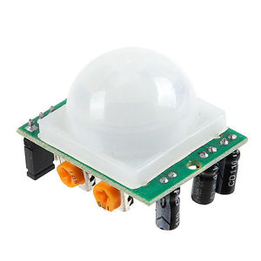

**Fig 3.8 Passive Infrared Sensor**

* PIR sensors allow you to sense motion.
* They are used to detect whether a human has moved in or out of the sensor’s range. They are commonly found in appliances and gadgets used at home or for businesses.
* They are often referred to as PIR, "Passive Infrared", "Pyroelectric", or "IR motion" sensors.

**3.1.6 Jumper wires**

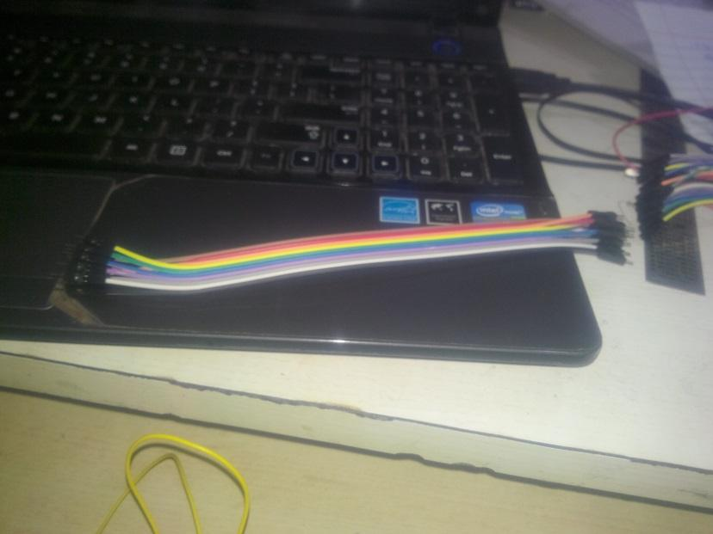

**Fig 3.9 Male to Male Jumper wires**

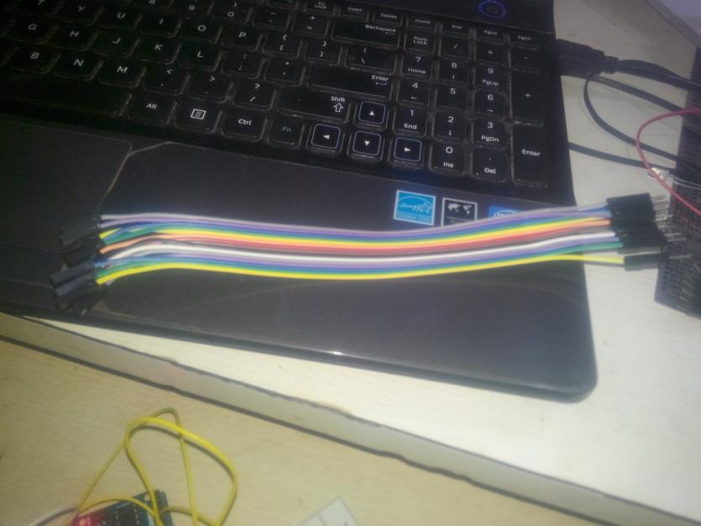

**Fig 3.10 Male to Female Jumper wires**

**3.2 Sketch**

Sketch is the program code done in Arduino IDE which is to be compiled and uploaded to the Arduino uno board.

**3.2.1 Sketch for Ultrasonic Sensor**

const int trigpin = 6;

const int echopin = 5;

const int ledpin = 13;

long duration;

float distance;

void setup()

{

pinMode(trigpin,OUTPUT);

pinMode(echopin,INPUT);

pinMode(ledpin,OUTPUT);

Serial.begin(9600);

}

void loop()

{

digitalWrite(trigpin,LOW);

delay(200);

digitalWrite(trigpin,HIGH);

delay(100);

digitalWrite(trigpin,LOW);

duration = pulseIn(echopin,HIGH);

distance = (duration/58.2);

Serial.print("Distance:");

Serial.println(distance);

if(distance < 17.16)

{

digitalWrite(ledpin , HIGH);

}

else

{

digitalWrite(ledpin,LOW);

}

}

**3.2.2 Sketch for LDR**

void setup()

{

pinMode(A0,INPUT);

Serial.begin(9600);

}

void loop()

{

int x;

x=analogRead(A0);

Serial.println(x);

delay(400);

int light;

light = analogRead(A0);

Serial.println(light);

delay(1000);

if(light>505)

{

digitalWrite(2,HIGH);

}

else

{

digitalWrite(2,LOW);

}

}

**3.2.3 Sketch for PIR**

void setup()

{

pinMode(7,INPUT);

pinMode(13,OUTPUT);

digitalWrite(13,LOW);

}

void loop()

{

if(digitalRead(7)==HIGH)

{

digitalWrite(13,HIGH);

delay(4000);

digitalWrite(13,LOW);

}

}

**3.2.4 Complete Sketch of ASHA**

const int trigpin = 6;

const int echopin = 5;

const int ledpin = 13;

long duration;

float distance;

void setup()

{

pinMode(trigpin,OUTPUT);

pinMode(echopin,INPUT);

pinMode(ledpin,OUTPUT);

pinMode(A0,INPUT);

pinMode(2,OUTPUT);

pinMode(7,INPUT);

Serial.begin(9600);

}

void loop()

{

digitalWrite(trigpin,LOW);

delay(200);

digitalWrite(trigpin,HIGH);

delay(100);

digitalWrite(trigpin,LOW);

duration = pulseIn(echopin,HIGH);

distance = (duration/58.2);

Serial.print("Distance:");

Serial.println(distance);

if(distance < 17.16)

{

digitalWrite(ledpin , HIGH);

}

else

{

digitalWrite(ledpin,LOW);

}

int lightresistance;

lightresistance = analogRead(A0);

Serial.println(“Resistance:”);

Serial.println(lightresistance);

delay(1000);

if(digitalRead(7)==HIGH && light>505)

{

digitalWrite(2,HIGH);

delay(400);

}

else

{

digitalWrite(2,LOW);

}

}

**3.3 Circuit Diagram:**

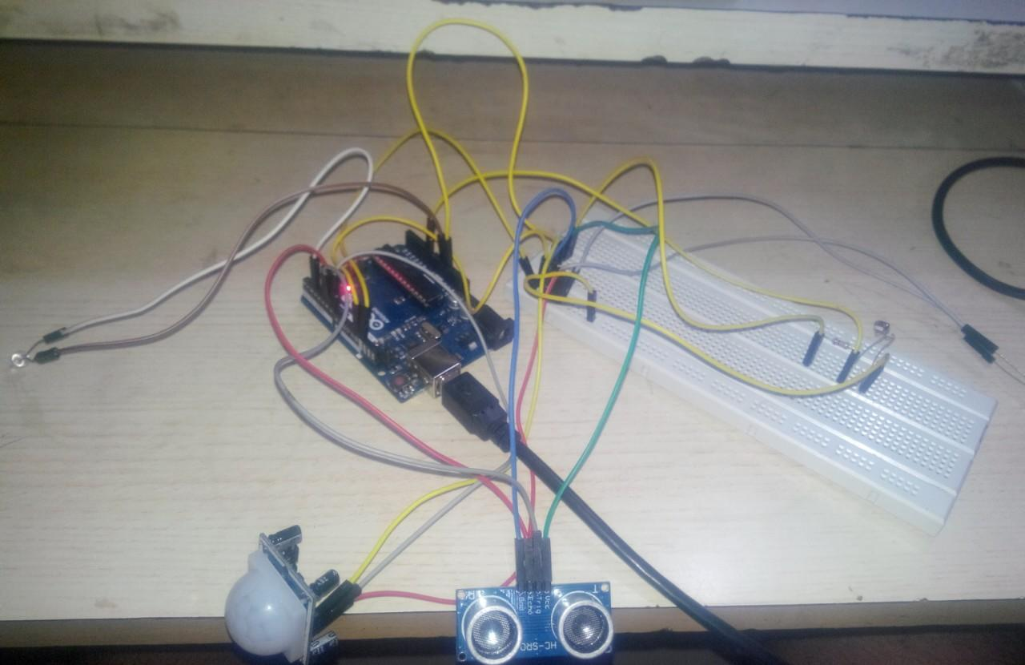

**Fig 3.11 Complete circuit of ASHA**

**CHAPTER 4**

**ANALYSIS**

The project works on various sensors enlisted above. The above shown circuit is fitted in a dummy house for ease in visualisation of automation. Various cases are involved in the dummy house for energy conservation, ease for the elderly living in the house.

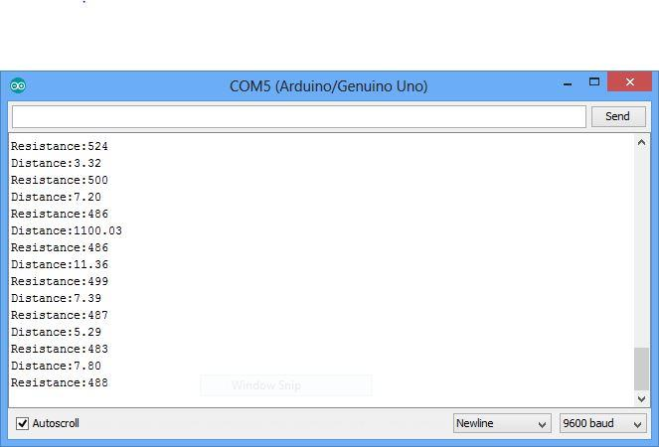

**Fig 4.1 Output Window**

Case 1: Prediction of someone outside the door

An ultrasonic sensor is attached at the ceiling outside the door which shows a constant reading between the ceiling and the floor. If an intruder comes near the door the the reading becomes shorter than the main reading which results in the glowing of LED.

Now the distance between the ceiling and the floor of the dummy house is ~ 17 cms, if an intruder comes near the door the readings become less than 17 cm hence light glows.

Case 2: Glowing of LED when luminescence goes down

A Light Dependent Resistor (LDR) is attached inside a room, which is inversely proportional to the luminescence. When the luminescence of the room goes down the resistance goes up and an LED glows inside a room, **but** there is a demerit in this i.e. if there is no one present in the room then also the LED glows which results in energy loss. So to recover this loss a motion sensor is attached to the ceiling of the room which checks the presence of something in the room.

Now if both the cases i.e. reduction of luminescence and presence of something in the room then the LED glows.

If the resistance of the room goes up to ~500 and the presence of someone in the room is confirmed then the LED glows.

**CHAPTER 5**

**CONCLUSION**

It can be concluded that **ASHA: Semi Automated House using Arduino** was a success. This system consists of an Arduino-Uno board, a Passive Infrared Sensor, an Ultrasonic Sensor, a LDR and a LED, power sockets. It is user friendly and it is cost effective.

Also it can be concluded that the objectives of this project has been successfully met and they are as follows:

* Establishing a wired network communication between the arduino and the home automation system, using various sensors.
* Create a simple yet reliable home automation system using Arduino-Uno as a microcontroller that will be the medium between the sensors and the home.
* Program the Arduino-Uno board in a way that will let it interact with the home.

**CHAPTER 6**

**FUTURE RECOMENDATIONS**

There are some recommendations for Future works. Some of them are:

1. Better to use relay modules and connect it directly than using normal relays with breadboard.
2. Try to find a way to use a Bluetooth module to make it wireless and work in an efficient way.
3. Test each and every component before using them especially the relays for safety purposes.

**REFERENCES**

1. [www.google.com](http://www.google.com)
2. [www.arduino.cc](http://www.arduino.cc)
3. [www.instructibles.com](http://www.instructibles.com)
4. [www.youtube.com](http://www.youtube.com)
5. [www.millionlights.com](http://www.millionlights.com)
6. [www.wikipedia.com](http://www.wikipedia.com)
7. [www.homeautomation.com](http://www.homeautomation.com)
8. [www.ieee.com](http://www.ieee.com)