NemosMiner relies on the 3rd party tool HWiNFO64 to read power usage from the miner devices
The following document describes the necessary integration steps:
1. Download and install HWiNFO64
https://www.hwinfo.com/download/
Both variants (Installer & Portable) will do, just ensure you are using the x64 version.
Accept the default installation directory (any other directory will be fine too).
2. Run HWiNFO64 and configure like this
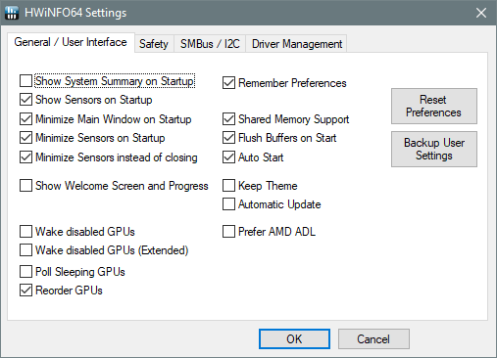

This will autostart HWiNFO64 on each boot and will keep it running in the task bar.
Important:
HWiNFO64 needs to be left running while MPM is running, otherwise the power usage readout will fail.
3. Configure the hardware sensors
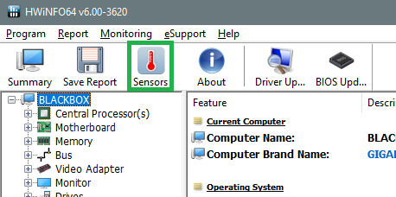

4. Identify the power usage relevant sensors
E.g. for a Nvidia GTX 1080ti
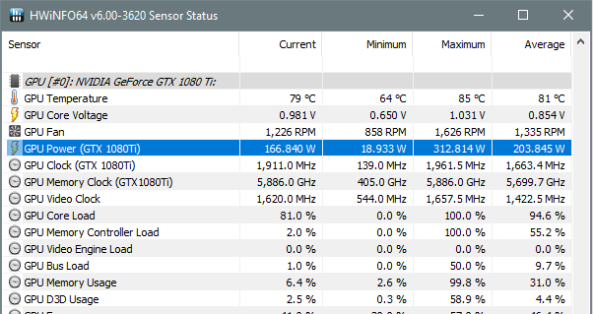

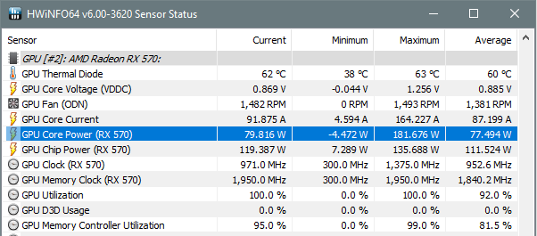
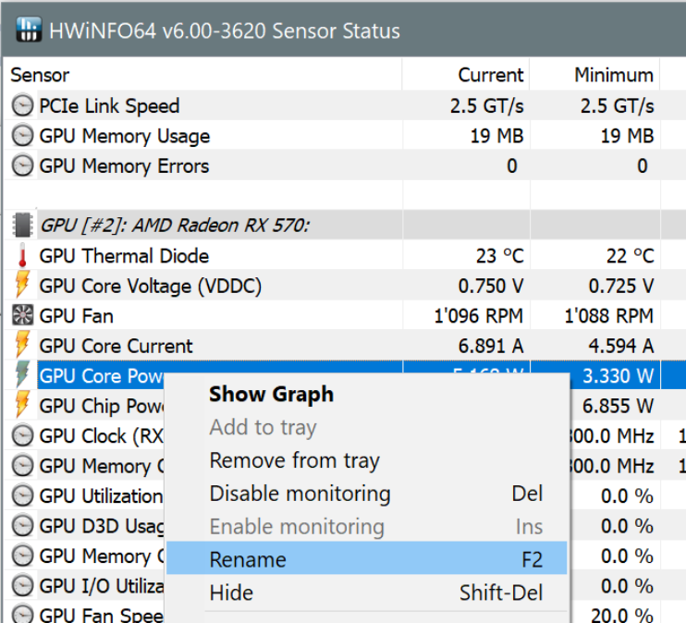
or for a AMD RX 570:

Important: for AMD make sure you select 'GPU Core Power' and NOT 'GPU Chip Power'!
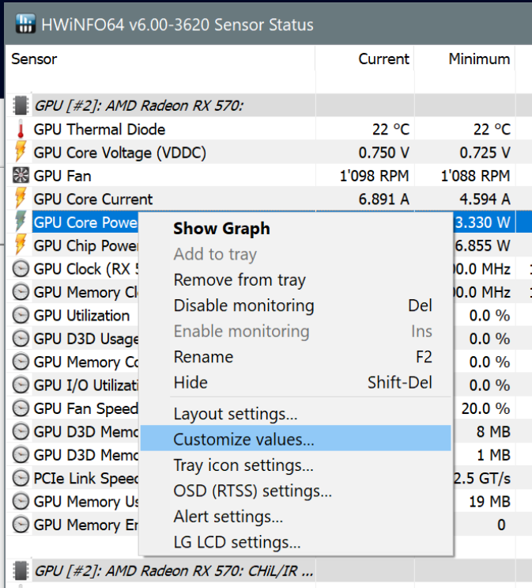
for your CPU:
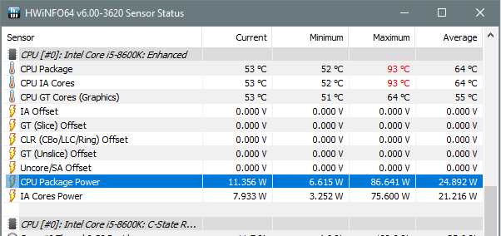

5. Rename the sensor (optional but very helpful in steps 8 & 9)
Important: Steps 5 and 6 need to be done for each and every possible mining device (including CPU even when you are not enabling CPU )!!!
Select the sensor, then right-click and select 'Rename F2':
Then add the GPU name and device number, e.g (RX570#2):
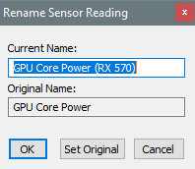

6. Configure each relevant power usage sensor
Important: This step needs to be done foreach possile miningdevice (also CPU even if you are not using CPU mining)
Select the sensor, then right-click and select 'Customize values...':

then select the tab 'HWiNFO Gadget':
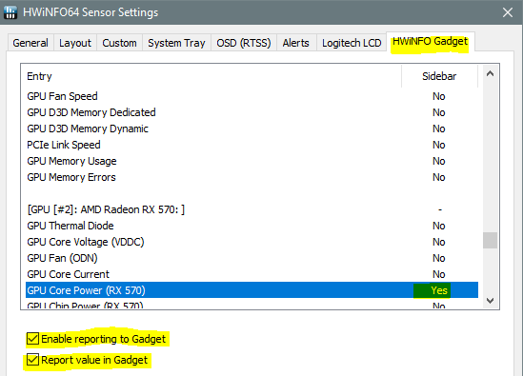

and tick both checkboxes:
- Enable reporting to Gadget
- Report value in Gadget
This will tell HWiNFO64 to constantly update the sensor values to the following registry key
Computer\HKEY_CURRENT_USER\Software\HWiNFO64\VSB
7. Configure the sensor polling interval
In the sonsors dialog click on

Then configure the polling period to something small like 997ms
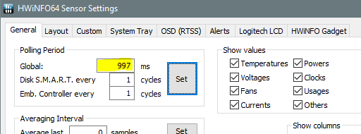

Important: The polling period shoud be smaller than 2 seconds to ensure thar MPM will have access to current data
8. Run Regedit.exe and verify that the sensor mapping information is available
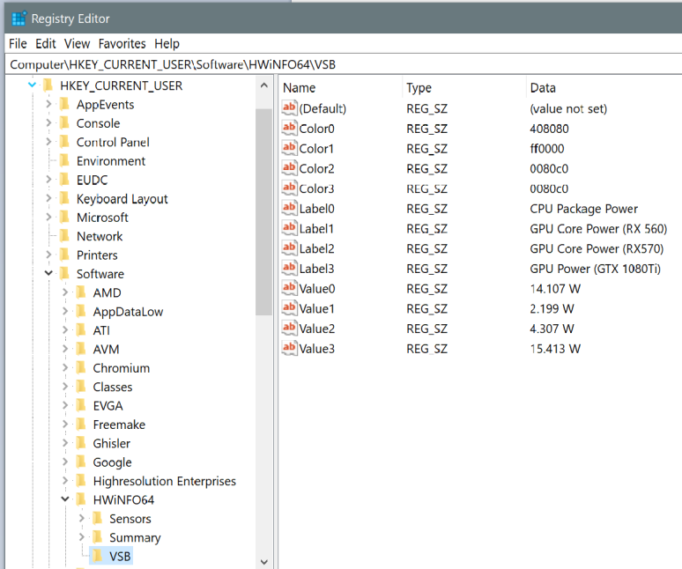
(press F5 repeatedly to veryfy that the values will get updated periodically)
Note that for each configured sensor there is a 'LabelX' and 'ValueX' entry. In the above example the value in 'Value1' contains the current power usage of the RX 560 card.
9. Create scheduled task to restart HWiNFO64 after a driver crash (optional)
Under some circumstances HWiNFO64 needs to be restarted after a GPU driver crash.
The following scheduled task takes care of this.
1. the scheduled task editior: CMD -> schtasks.exe
2. Create a new scheduled task as shown
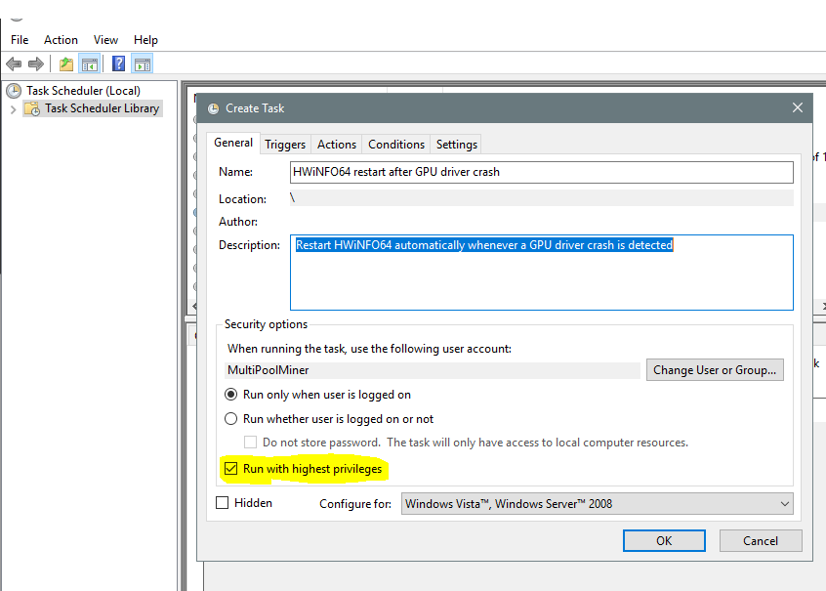

Make sure you tick ‘Run with highest privileges’
